# Compte Rendu java Lab 11/12

Realise par: Ala Ben Hamouda GL2 Grp 1

Question 4.4: Use of Product interface

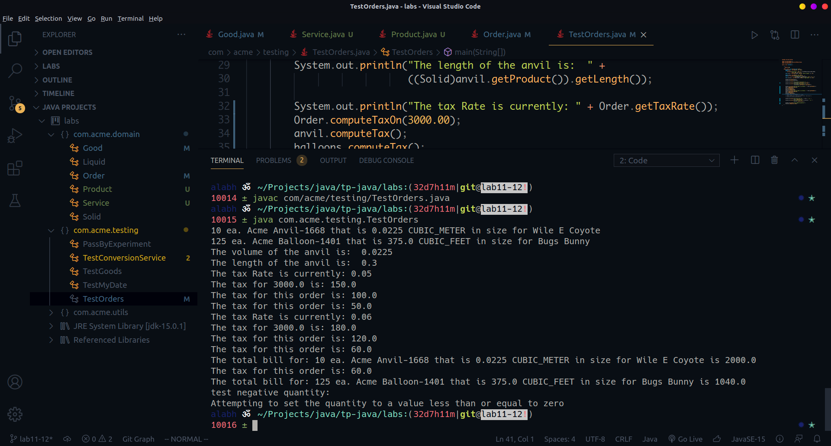

Question 5.3: Add service order

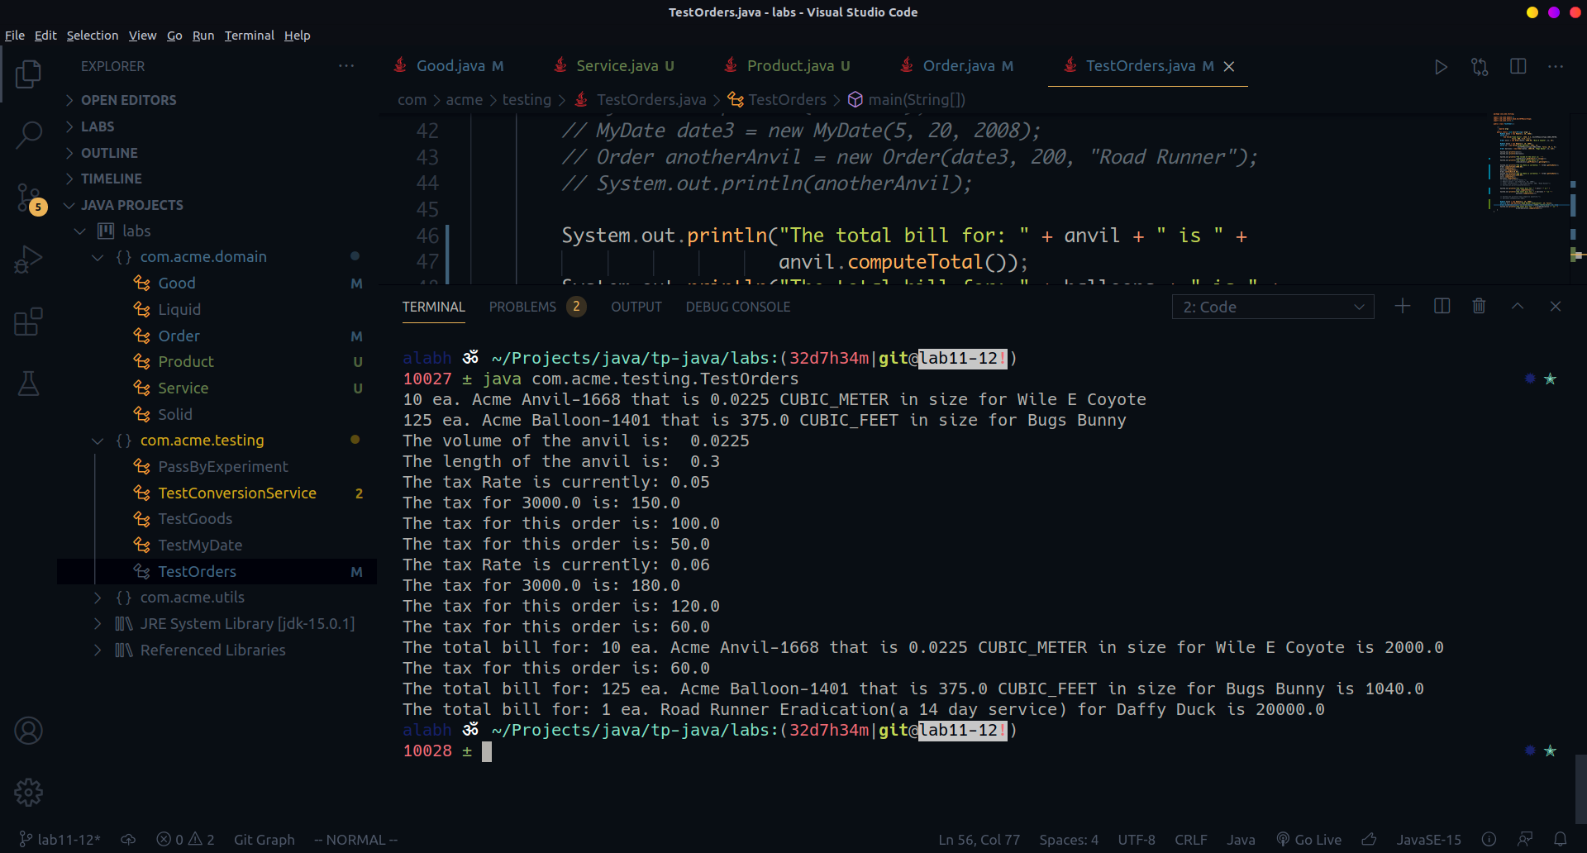

## Lab 12:

