# Compte Rendu labs 13-14 Java

by Ala Ben Hamouda GL2 Groupe 1

**Lab 13:**

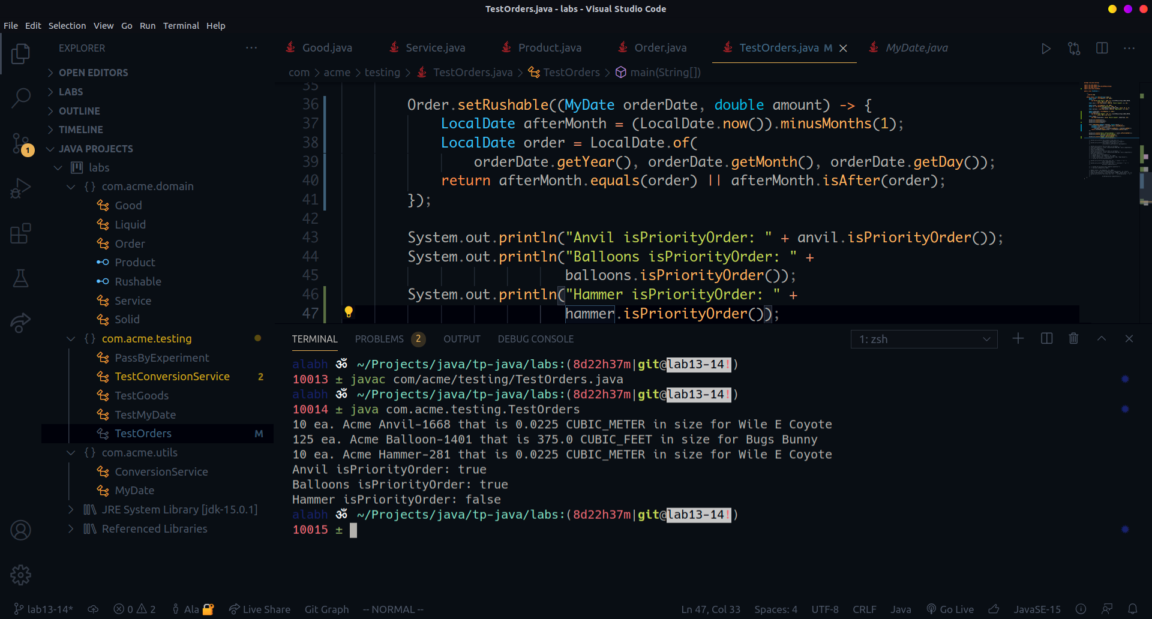**Lab 14:**

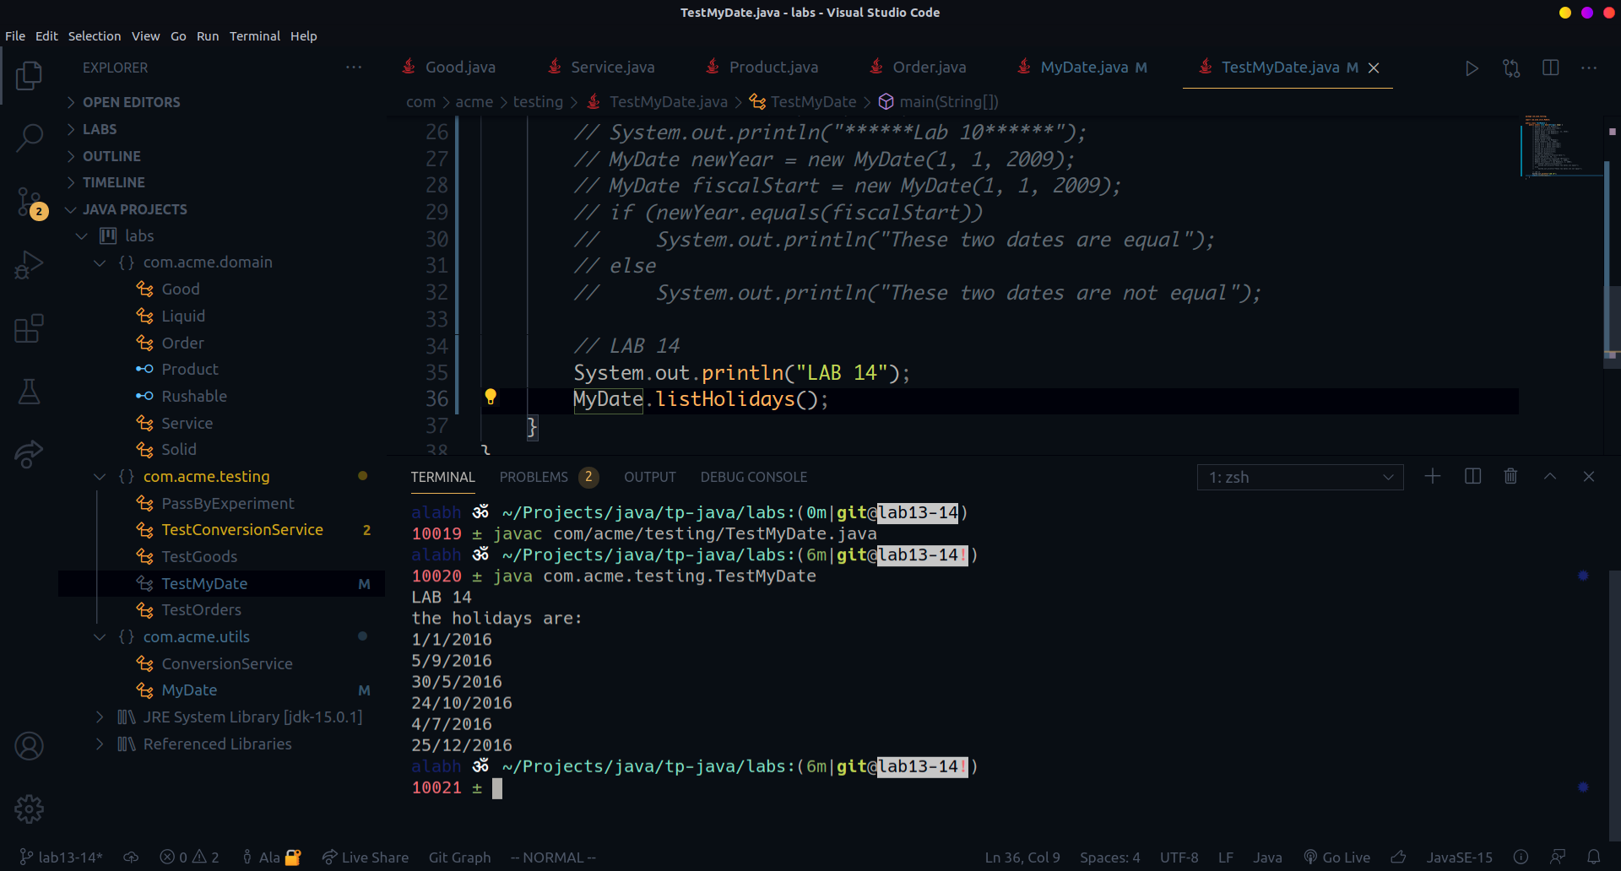

#### Even if we pass integers to allKgToPounds, it still works because it can implicitly cast integers to double without any issue.