Solution Architecture
Smart Garage follows a client-server architecture, where the frontend and backend are clearly separated but work in close coordination. This model was chosen for its simplicity and its suitability for web-based enterprise applications, where the presentation layer and the business logic must remain independent yet tightly integrated (Rubin, 2021).
The frontend is a Single Page Application that communicates with the backend through RESTful HTTP requests. Both layers share the same Git repository as a monorepo, which kept version control straightforward and ensured that changes on either side stayed in sync throughout development.
The system is organized around business domains. Each functional area — customer management, invoicing, inventory, and appointment scheduling — has its own dedicated frontend and backend module. On the frontend, this translates into isolated Angular components, services, and routing, with lazy loading enabled so that each module is only fetched when the user actually navigates to it. On the backend, each domain maps to a NestJS module with its own controller, service layer, and data transfer objects.
Access control is handled through JSON Web Tokens, with two defined roles: an Owner with full privileges and a standard User with restricted permissions. Authorization is enforced on both the frontend and the backend independently, so that a compromised client cannot bypass server-side rules.

Technical Stack
One of the first decisions made was to standardize on TypeScript across the entire stack. Both Angular on the frontend and NestJS on the backend share the same language and type system, which allows interface definitions and data models to be aligned across both layers. This eliminates a common category of integration bugs that arise from mismatches between what the frontend expects and what the backend returns.
Angular was chosen for the frontend because its opinionated architecture — built around modules, services, dependency injection, and routing — naturally fits the structure of an enterprise application. Rather than making these organizational decisions from scratch, Angular enforces them, which supports consistency across a codebase maintained by a small team.
NestJS was the natural counterpart on the backend. It borrows Angular's modular structure and decorator-based patterns, making the two codebases feel familiar and consistent. For the database layer, PostgreSQL was selected given the deeply relational nature of ERP data. A customer owns multiple vehicles, each vehicle has a maintenance history, and each maintenance job may generate an invoice referencing parts from inventory. PostgreSQL handles these multi-table relationships efficiently. Prisma was chosen as the ORM for its type safety, readable schema definition, and structured migration workflow, which simplified coordination during development.
The application also integrates FullCalendar for appointment views, Chart.js for analytics dashboards, and internationalisation support for Arabic, French, and English. AI features are handled by forwarding requests from the backend to external LLM APIs, keeping credentials server-side.
For deployment, the frontend is hosted on Vercel, the NestJS backend on Render, and PostgreSQL is managed through Supabase as a hosted database service.

MVP Definition
Defining the scope of the minimum viable product required a deliberate balance between academic ambition and delivery realism. Rather than shipping a stripped-down prototype, Smart Garage was built as a fully functional ERP platform covering all core operational domains of an automotive workshop, structured around a freemium, per-module pricing model.
The free tier forms the entry point and covers four modules: customer management, vehicle management, appointment scheduling, and a basic dashboard displaying key performance indicators. These modules represent the fundamental workflow loop of any garage. A customer is registered, their vehicle is added to the system, an appointment is created, and the owner has an immediate view of daily activity. This alone is a significant improvement over the paper-based processes that most workshops in Tunisia currently rely on.
Beyond the free tier, all major paid modules were included in the MVP scope. The calendar module delivered visual month, week, and day views with drag-and-drop rescheduling. The maintenance module handled job tracking with mechanic assignments and status workflows. Invoicing and inventory modules covered the financial and supply-chain dimensions of the business. A reporting module provided owners with data-driven insights into revenue, mechanic utilization, and job distribution.
Artificial intelligence was treated as a core differentiator rather than an optional add-on. Four AI-powered features were integrated into the platform: a predictive maintenance engine that estimates upcoming service needs based on vehicle mileage and service history, a smart scheduling optimizer that balances mechanic workload and bay availability when assigning appointments, an analytics narrator that generates natural-language summaries of dashboard data, and a customer churn prediction model that identifies at-risk clients based on visit frequency and engagement patterns.

The Product Full Mockup
Before any code was written, a full product mockup was produced to align the team on visual direction and validate the user experience early. The mockup follows a dark glassmorphism design language, combining translucent surfaces, subtle blur effects, and layered depth to create a modern, professional interface suited to a daily-use enterprise tool.
Several established UI/UX principles guided the layout decisions. The eight-point grid system was applied consistently across all screens, ensuring that spacing, padding, and component sizing follow a uniform scale that produces visual harmony without manual adjustment. Typography is hierarchically structured, with clear distinctions between headings, labels, and body text to support fast scanning in an operational context. Navigation follows a persistent left sidebar pattern, which is standard in enterprise applications because it keeps all modules accessible without disrupting the current workflow. Interactive elements such as buttons, modals, and status badges maintain sufficient contrast ratios to meet accessibility standards even on dark backgrounds.

Product Roadmap — Development Phases
Development was structured into five sequential phases spanning six months. The first phase covered planning and requirements, during which the feature scope was defined, user stories were written, and the system architecture was finalized. The second phase focused on design, producing the full product mockup, establishing the dark glassmorphism design system, and defining the database schema.
The third and longest phase covered core development, where all functional modules were built incrementally — starting with the free tier modules and progressively adding the paid ones. The fourth phase was dedicated to AI integration, incorporating the predictive maintenance engine, smart scheduling optimizer, analytics narrator, and churn prediction model. The fifth and final phase covered testing and refinement, addressing bugs, improving performance, and polishing the user experience based on internal feedback.
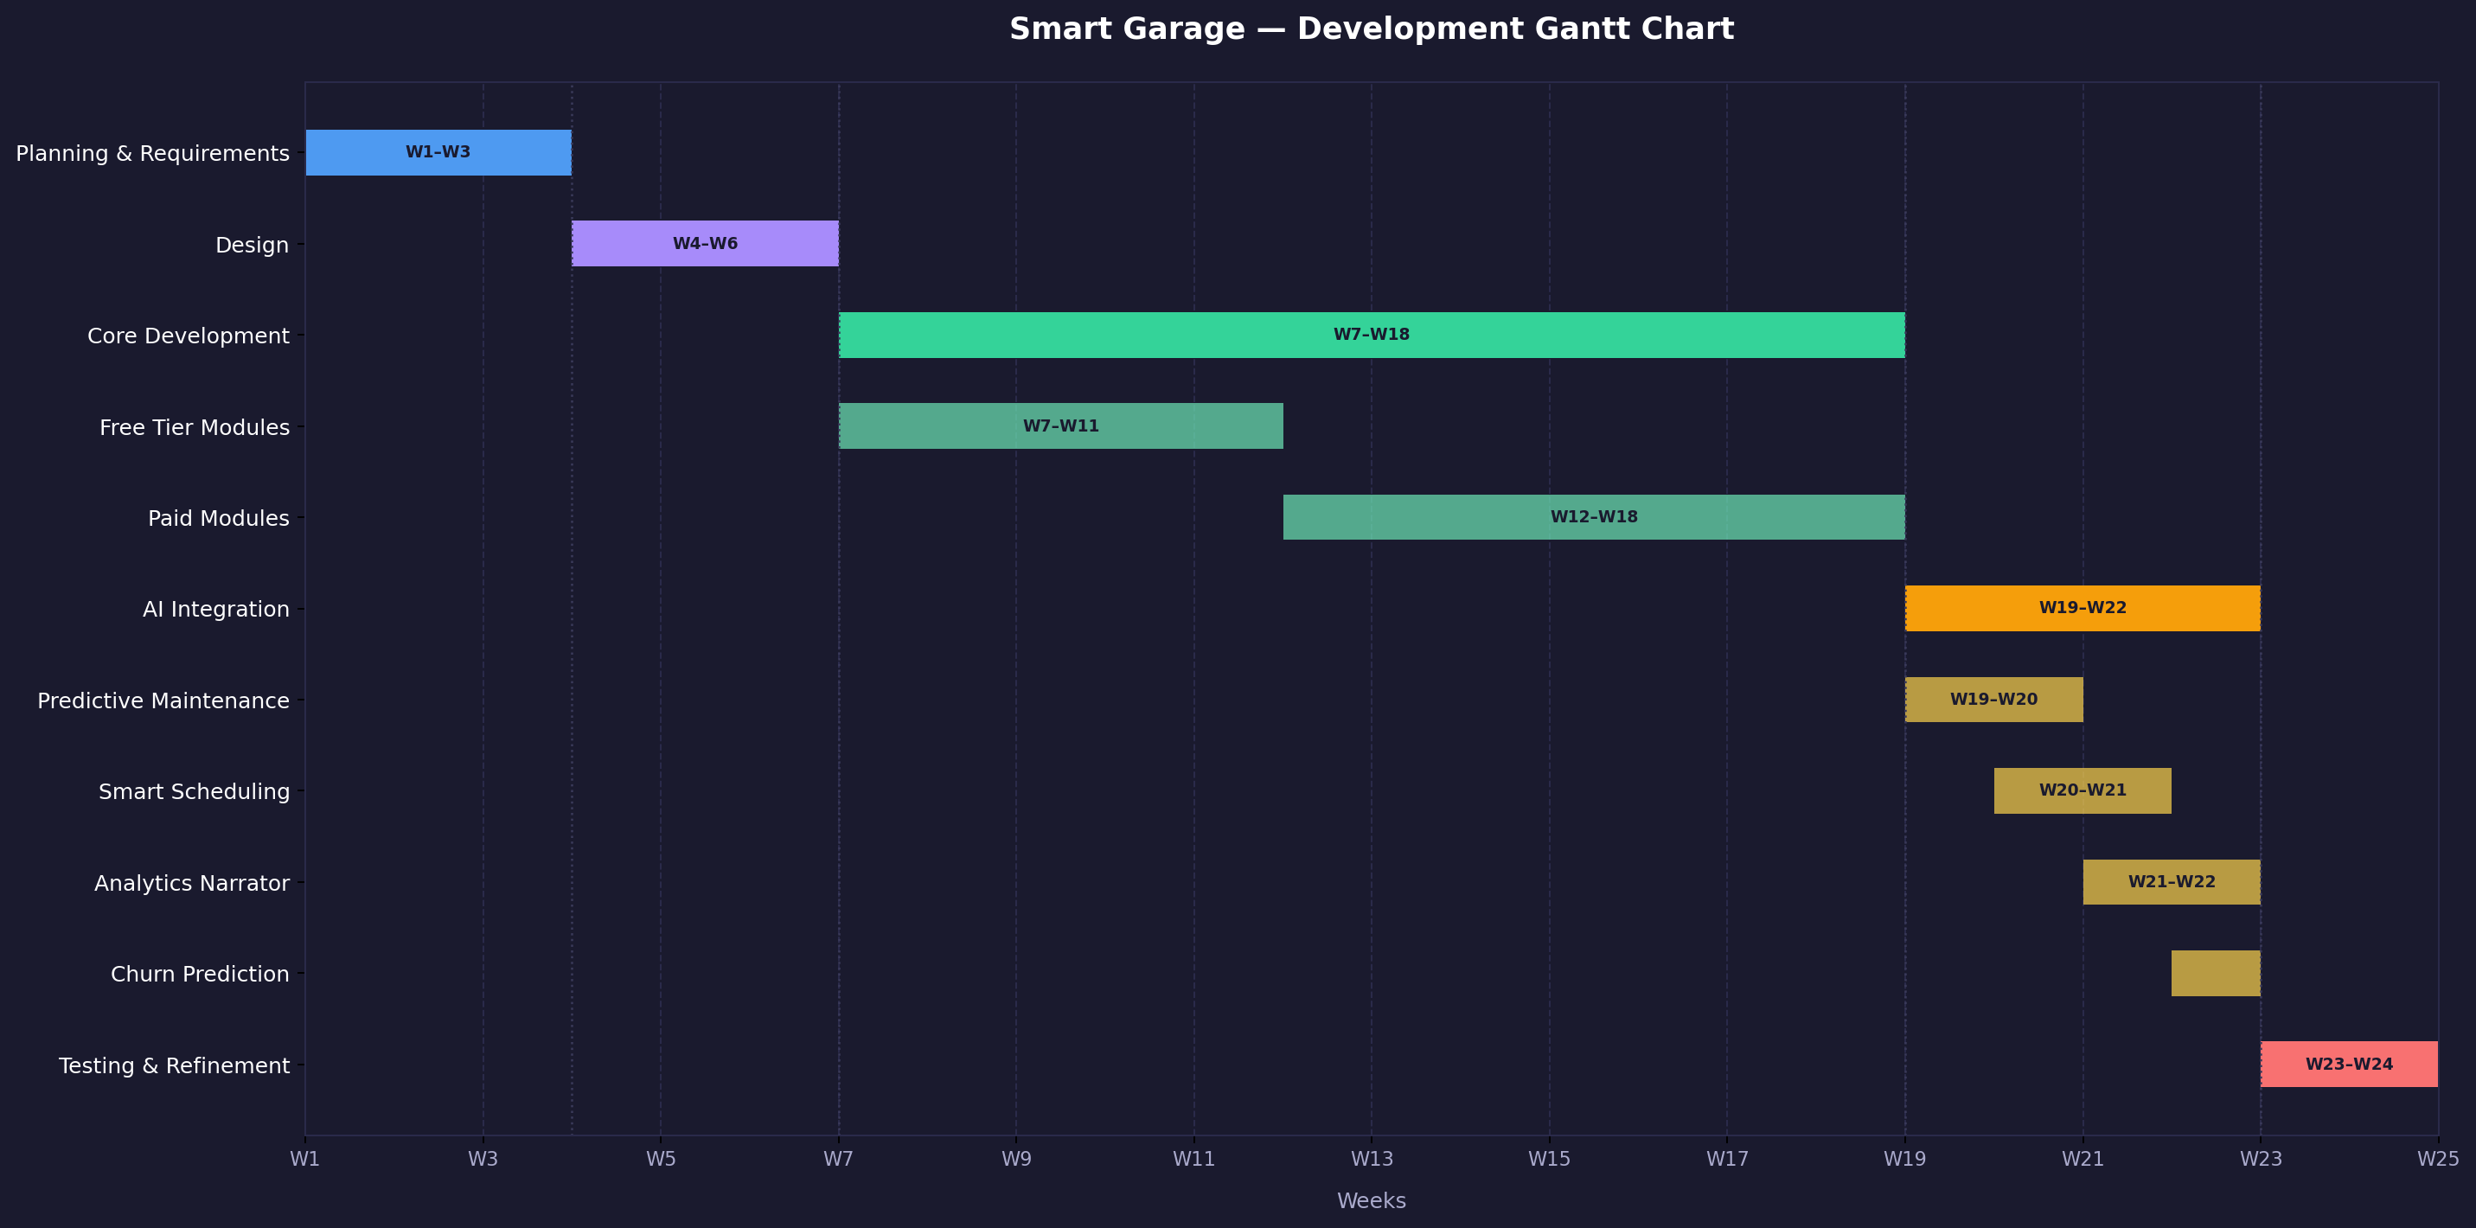
Figure 1 — Smart Garage Development Gantt Chart

Feature Backlog
The following table summarizes the full feature scope of Smart Garage, from the features delivered in the MVP to the short-term and long-term roadmap items planned for future releases.
Feature | Description | Complexity | Release
Customer Management | Register and manage customer profiles | Low | MVP
Vehicle Management | Track vehicles, mileage, and service history | Low | MVP
Appointment Scheduling | Create and manage appointments in list view | Low | MVP
Basic Dashboard | KPIs and daily activity overview | Low | MVP
Calendar Module | Visual month/week/day views with drag-and-drop | Medium | MVP
Maintenance Module | Job tracking with mechanic assignments and status workflows | Medium | MVP
Invoicing | Generate and manage invoices | Medium | MVP
Inventory Management | Parts tracking and stock visibility | Medium | MVP
Reporting & Analytics | Revenue, utilization, and job distribution insights | Medium | MVP
Predictive Maintenance | Estimate upcoming service needs from mileage and history | High | MVP
Smart Scheduling Optimizer | Balance mechanic workload and bay availability | High | MVP
Analytics Narrator | Natural-language summaries of dashboard data | Medium | MVP
Churn Prediction | Identify at-risk customers from visit patterns | High | MVP
AI Diagnostic Chatbot | Symptom-based diagnosis suggestions using LLM | High | Short-term
Intelligent Invoice Generation | AI-suggested line items and anomaly detection | Medium | Short-term
Work Order Copilot | AI suggestions when creating maintenance jobs | Medium | Short-term
VIN Auto-decoding | Automatic vehicle identification via VIN | Low | Short-term
WhatsApp & SMS Notifications | Real delivery via WhatsApp Business API | Medium | Short-term
RAG Knowledge Base | Natural language search over repair manuals and OEM docs | High | Long-term
Image-Based Damage Assessment | Computer vision for damage estimation from photos | High | Long-term
Demand Forecasting | Predict parts demand from appointments and seasonal trends | High | Long-term
Customer Portal | Self-service portal for service history and appointments | Medium | Long-term
Mobile App | Native mobile companion application | High | Long-term

