

ENSIA — Machine Learning Project · Spring 2025–2026
Forecasting and Identifying
Global Export Opportunities
for Algerian Exporters
Technical Report
End-to-End Machine Learning System for Export Diversification
Data Sources: BACI HS12 · World Bank · CEPII GeoDist · UNCTAD
ML Tasks: Clustering · Classification · Forecasting · Dashboard

Project Team
Guettaf Temam Selsabila | Bensabra Ala
Sekfali Lina | Chouimet Noussayba Om Salama

The National School of Artificial Intelligence (ENSIA) · Algeria · 2026

Abstract

Abstract

Algeria's economy remains heavily dependent on hydrocarbons, which accounted for approximately 92% of total export revenues in 2023, generating an estimated 50–55 billion USD. This structural concentration creates significant exposure to global energy price volatility and represents a strategic vulnerability that national economic policy has prioritized addressing.
Within this context, this report presents a complete end-to-end machine learning system designed to identify, analyze, and forecast international export opportunities for Algerian exporters across all non-hydrocarbon economic sectors.
The system integrates five publicly available international trade datasets — BACI HS12 bilateral trade data, CEPII GeoDist geographic and cultural variables, World Bank macroeconomic indicators, and UNCTAD export diversification indices — into a unified master panel dataset covering 14,153,904 observations across 12 years (2012–2023), 227 partner countries, and 5,196 HS6 product codes.

Dataset Size  14.15M  observations |  | Best Model  94.68%  LightGBM accuracy |  | Forecast Error  15.19%  WMAPE (Random Forest) |  | Priority Markets  20  countries ranked

Three machine learning tasks are implemented. Clustering groups partner countries, HS6 products, and HS2 sectors according to trade demand profiles, yielding a 20-country priority market ranking. Classification compares Logistic Regression, Random Forest, XGBoost, and LightGBM to assign each country-product pair a three-class export opportunity label; LightGBM is the best classifier with 94.68% accuracy and a macro F1-score of 0.9083. Forecasting uses baseline models and machine learning regressors to predict partner import demand for 500 non-hydrocarbon country-product series over 2024-2026; Random Forest is selected with a WMAPE of 15.19%. Results are exposed through a Grafana dashboard backed by SQLite, with a Streamlit + Plotly backup dashboard for live Python exploration.

Navigation

Table of Contents

Abstract 1
Table of Contents 1
Introduction 1
1.1 Context and Motivation 1
1.2 Algeria's Export Landscape and the Hydrocarbons Dependency Problem 1
1.3 Problem Statement 1
1.4 Project Objectives 1
1.5 Report Structure 1
Related Work and Background 1
2.1 Export Opportunity Identification in the Literature 1
2.2 Machine Learning for Trade Analysis 1
2.3 The Gravity Model and Trade Features 1
2.4 Positioning of This Project 1
Data Sources and Collection 1
3.1 Overview of the Multi-Source Integration Strategy 1
3.2 BACI International Trade Database 1
3.2.1 Structure and Content 1
3.2.2 Filtering and Scope 1
3.3 CEPII GeoDist Dataset 1
3.4 World Bank Macroeconomic Indicators 1
3.5 UNCTAD Diversification Indicators 1
3.6 Dataset Summary 1
Data Preparation and Integration 1
4.1 Master Dataset Architecture 1
4.1.1 Dataset Grain 1
4.1.2 Inclusion of Zero-Export Pairs 1
4.2 Data Cleaning 1
4.2.1 Duplicate Detection 1
4.2.2 Infinite Value Check 1
4.2.3 Missing Values and Imputation Strategy 1
4.3 Feature Engineering 1
4.4 Target Variable Definition 1
4.4.1 Binary Opportunity Label 1
4.4.2 Class Balance 1
4.5 Temporal Train / Validation / Test Split 1
Exploratory Data Analysis 1
5.1 Data Quality Report 1
5.2 Algeria's Export Value Over Time 1
5.3 Top Export Partners 1
5.4 Global Demand Analysis 1
5.5 Export Opportunity Distribution 1
Clustering 1
6.1 Objectives and Approach 1
6.2 Country Clustering 1
6.2.1 Feature Construction 1
6.2.2 Results 1
6.2.3 Cluster Interpretation 1
6.2.4 Priority Market Ranking — Top 10 1
6.3 Product Clustering 1
6.3.1 Product Cluster Interpretation 1
Classification 1
7.1 Problem Formulation 1
7.2 Model Selection Rationale 1
7.3 Results 1
7.3.1 LightGBM — Best Model 1
7.4 Feature Importance Analysis 1
Forecasting 1
8.1 Forecasting Objective 1
8.2 Non-Hydrocarbon Scope 1
8.3 Sample Selection Strategy 1
8.4 Results 1
8.5 Forecast Opportunity Scoring 1
Visualization Dashboard 1
9.1 Objectives and Target Users 1
9.2 Technology Choice: Streamlit and Plotly 1
9.3 Dashboard Architecture 1
9.4 Dashboard Pages and Modules 1
Results and Economic Interpretation 1
10.1 Summary of Key Findings 1
10.2 Top Export Opportunity Markets 1
10.3 High-Demand Non-Hydrocarbon Products for Algeria 1
10.4 Forecasted Demand Trends 2024–2026 1
Discussion 1
11.1 Limitations 1
11.1.1 Data Availability 1
11.1.2 Zero-Export Pair Assumptions 1
11.1.3 Forecasting Horizon Uncertainty 1
11.2 Ethical Considerations 1
11.3 Recommendations for Operational Use 1
11.4 Future Work 1
Conclusion 1
References 1
Full Feature List 1
Model Hyperparameter Configurations 1
Notebook Pipeline Summary 1

Chapter 1

Introduction

1.1 Context and Motivation
Algeria is one of Africa's largest economies and the continent's leading natural gas exporter. However, its integration into global trade remains dominated almost entirely by hydrocarbon products. In 2023, petroleum oils, natural gas, and related energy products constituted roughly 92% of total export revenues, leaving the non-hydrocarbon export sector — comprising agriculture, food products, pharmaceuticals, chemicals, manufactured goods, and services — largely underdeveloped relative to the country's productive capacity.
This dependence creates two interrelated risks. First, macroeconomic exposure to energy price cycles means that sharp downturns in global oil and gas markets translate directly into foreign exchange shortfalls, pressuring the national budget. Second, the narrow export base limits the accumulation of competitive capabilities in knowledge-intensive industries, reducing long-term economic resilience. These dynamics have been clearly visible: between 2012 and 2016, Algeria's total recorded exports in BACI fell from approximately 75.3 billion USD to 32.1 billion USD — a 57% decline driven almost entirely by the collapse in global energy prices.
In response, the government of President Abdelmadjid Tebboune has placed export diversification at the center of national economic strategy, with specific targets for growing non-hydrocarbon export revenues. The Algerian Chamber of Commerce and Industry (CACI) and the Ministry of External Commerce play central roles in operationalizing this agenda. Yet both institutions face a common challenge: identifying, with precision and at scale, which international markets offer the most credible and sustainable opportunities for Algerian exporters in which specific product categories.

1.2 Algeria's Export Landscape and the Hydrocarbons Dependency Problem
The BACI dataset records Algeria's export flows across all HS6 product categories. Analysis of these flows from 2012 to 2023 reveals a highly concentrated export basket. Non-hydrocarbon exports exist but are small in absolute terms and concentrated in a narrow set of destinations, primarily neighboring countries, France, and select Middle Eastern markets. Key non-hydrocarbon products with some export history include fertilizers (HS chapter 31), iron and steel products (chapter 72), food preparations, and dates (chapter 08). However, market penetration for most of these products remains extremely low relative to global demand volumes.
Algeria's Herfindahl-Hirschman Index (HHI) of export concentration, as recorded in the UNCTAD diversification dataset, confirms this structural imbalance. A value approaching 1.0 indicates a near-monopoly concentration of exports in a single product category. Algeria's recorded HHI in the dataset is approximately 0.54, reflecting severe concentration.

1.3 Problem Statement
Given the urgency of export diversification and the complexity of global trade markets, manual analysis of export opportunities is neither scalable nor sufficiently rigorous. A data-driven approach is required that can simultaneously process bilateral trade flows across thousands of product-market combinations, identify statistically meaningful opportunity signals, account for comparative advantage and market penetration, and produce forward-looking demand forecasts.
This project addresses the following core problem: how can machine learning methods — applied to large-scale international trade datasets — systematically identify and rank the most promising export opportunities for Algerian exporters across all non-hydrocarbon sectors, and how can the resulting insights be made actionable for institutional decision-makers?

1.4 Project Objectives
- Collect and integrate international trade data from at least two independent publicly available sources.
- Engineer economically meaningful trade and economic features from raw bilateral trade flows.
- Apply clustering techniques to segment countries, products, and sectors by demand profile.
- Build classification models to rank country-product pairs by export opportunity level.
- Develop forecasting models to predict future import demand trends for priority non-hydrocarbon markets.
- Design an interactive dashboard supporting stakeholder exploration of results.
- Validate all models rigorously on temporally held-out test data to prevent data leakage.

1.5 Report Structure
This report is organized as follows. Chapter 2 provides background on related work. Chapter 3 describes the data sources and collection methodology. Chapter 4 details data preparation, integration, and feature engineering. Chapter 5 presents the exploratory data analysis. Chapters 6, 7, and 8 document the clustering, classification, and forecasting models respectively, including methodology, configuration, and evaluation results. Chapter 9 describes the visualization dashboard. Chapter 10 synthesizes key results and their economic interpretation. Chapter 11 discusses limitations and future work. Chapter 12 concludes.

Chapter 2

Related Work and Background

2.1 Export Opportunity Identification in the Literature
The identification of export opportunities has a long tradition in international economics. Early approaches relied on static indicators such as Balassa's Revealed Comparative Advantage (RCA), which measures a country's export specialization in a product relative to the world average. RCA values above 1.0 indicate comparative advantage, and products with high RCA and growing global demand are natural candidates for export expansion. This project uses RCA as one of its engineered features.
More recent work in the export potential literature has moved toward data-driven approaches. The International Trade Centre's Export Potential Map uses a gravity-model-based framework to estimate the gap between current and potential exports for country-product pairs. The World Bank's WITS platform and the Observatory of Economic Complexity (OEC) provide visualization and analytical tools that identify product space opportunities based on economic complexity theory. This project draws conceptual inspiration from these frameworks while implementing them through machine learning methods applied to a large panel dataset.

2.2 Machine Learning for Trade Analysis
The application of machine learning to trade and economic policy problems has grown substantially in recent years. Supervised learning methods — in particular gradient boosting frameworks such as XGBoost and LightGBM — have demonstrated strong performance on tabular economic datasets, outperforming linear models in tasks with non-linear feature interactions. Random Forest classifiers have similarly been used in trade facilitation contexts due to their robustness to outliers and ability to handle missing values naturally.
In the forecasting domain, machine learning regressors using lag features have been shown to outperform classical time series models such as ARIMA on short, heterogeneous panels — precisely the scenario encountered when forecasting bilateral trade flows across hundreds of product-market pairs with limited time depth. This justification underpins the modeling choices in Chapter 8.

2.3 The Gravity Model and Trade Features
The gravity model of trade, which predicts bilateral trade flows as a function of economic mass (GDP) and geographic distance, provides the theoretical foundation for several features used in this project. Distance (dist_km), contiguity (contig), common language (comlang_off), and colonial ties (colony) — all drawn from the CEPII GeoDist dataset — are standard gravity model controls. Their inclusion allows the classification and clustering models to account for the well-documented role of geographic and cultural proximity in determining trade patterns.

2.4 Positioning of This Project
Unlike the ITC Export Potential Map, which uses country-level aggregates, this project operates at the bilateral HS6 product level — the most granular level of the Harmonized System classification — enabling highly specific opportunity identification. Unlike most academic trade ML studies that use pre-processed summary statistics, this project builds the entire data pipeline from raw BACI bilateral trade files, producing a fully reproducible and extensible dataset of 14.15 million observations. The multi-task architecture — combining clustering, classification, and forecasting — also goes beyond single-task trade analyses found in the literature.

Chapter 3

Data Sources and Collection

3.1 Overview of the Multi-Source Integration Strategy
The project follows a principled multi-source integration strategy: a primary bilateral trade dataset is supplemented by geographic, macroeconomic, and institutional datasets that each contribute distinct information layers. The integration is performed at the country-year level for macroeconomic variables and at the country-pair level for geographic variables. All sources are publicly available and require no proprietary access, ensuring full reproducibility.
Table 3.1 summarizes all data sources used, their role in the project, and their integration status.

Source | Role | Coverage | Status
BACI HS12 (CEPII) | Main bilateral trade flows by exporter, importer, HS6 product, year | 2012–2023, 200+ countries | Integrated
BACI Country Codes | Mapping from numeric BACI codes to ISO3 and country names | All BACI countries | Integrated
BACI Product Codes | HS6 product descriptions for all 5,196 products in scope | HS12 classification | Integrated
World Bank API | GDP, population, GDP per capita, trade openness, market size | Annual, per country | Integrated
CEPII GeoDist | Bilateral distance (km), contiguity, common language, colonial ties | All country pairs | 92.5% coverage
UNCTAD | Algeria-level HHI export concentration and diversification index | Annual, Algeria only | Integrated
CACI / Ministry | Official Algerian domestic export support data | N/A | Not available
Table 3.1 — Data source audit

3.2 BACI International Trade Database

3.2.1 Structure and Content
BACI (Base pour l'Analyse du Commerce International) is produced by CEPII and provides harmonized bilateral trade statistics at the 6-digit Harmonized System (HS) level. BACI reconciles the mirror discrepancies between importer and exporter declarations in the UN Comtrade database using a methodological procedure that accounts for CIF/FOB differences and reporting asymmetries, producing a single harmonized trade value for each bilateral flow.
For this project, the HS12 version (using the 2012 HS classification) is used, covering annual bilateral trade flows from 2012 to 2023. Trade values in BACI are expressed in thousands of USD. Each row in the raw BACI files represents one directed bilateral flow: a specific exporter country, importer country, HS6 product code, and year.

3.2.2 Filtering and Scope
To manage computational scale while preserving analytical value, only HS6 products whose peak annual world import value exceeds 1,000 thousand USD (i.e., 1 million USD) over the study period are retained. This threshold removes trivially small product-market combinations while preserving 5,196 HS6 products that together account for the overwhelming majority of world trade value.

3.3 CEPII GeoDist Dataset
GeoDist provides bilateral geographic and cultural variables for all country pairs. The variables used in this project are: distance in kilometers between capital cities (dist_km), population-weighted distance (distw_km), contiguity indicator (contig), official common language (comlang_off), ethno-linguistic common language (comlang_ethno), ever-colonial relationship (colony), common colonizer (comcol), and same country history (smctry). GeoDist coverage in the master dataset is 92.5%, with the remaining 7.5% not matched, primarily for very small or recently established states.

3.4 World Bank Macroeconomic Indicators
Macroeconomic indicators are retrieved from the World Bank Open Data API using the wbdata Python library. The following indicators are collected for each partner country and year: GDP in current USD, total population, trade as a percentage of GDP, and GDP per capita. A composite market size indicator is computed as the product of GDP and trade openness. These variables capture the economic gravity mass of partner markets and serve as both clustering features and classification predictors.

3.5 UNCTAD Diversification Indicators
UNCTAD provides Algeria-specific indicators of export concentration and diversification. The Herfindahl-Hirschman Index of export concentration (hhi_export) and a product diversification index are included in the dataset for Algeria at the year level. The diversification_index was found to be 100% missing in the dataset version available for this project and was excluded from all modeling features.

3.6 Dataset Summary
After integration, the final master dataset contains 14,153,904 rows and 50 columns. Each row represents one (year, partner country, HS6 product) observation. The dataset includes both rows where Algeria currently exports (non-zero values) and rows where Algeria exports nothing to that market (zero-export rows), which represent unexplored or missed opportunities. The temporal coverage is 2012–2023, spanning 227 partner countries and 5,196 HS6 products.

Chapter 4

Data Preparation and Integration

4.1 Master Dataset Architecture

4.1.1 Dataset Grain
The fundamental unit of analysis is the (year, partner country, HS6 product) triplet. This grain is chosen because it captures all three dimensions of trade opportunity simultaneously: the temporal dimension (is demand growing?), the geographic dimension (which market?), and the product dimension (which product?). A single country may be an excellent opportunity for product A but a poor prospect for product B — aggregation to the country level would mask this.

4.1.2 Inclusion of Zero-Export Pairs
A distinctive feature of the dataset construction is the explicit inclusion of zero-export observations — rows where Algeria's recorded export value to a given partner for a given product in a given year is zero. These rows are critical for the machine learning models. An opportunity detection system that only sees historical positive trade flows would learn to recognize existing trade patterns rather than identifying untapped markets. By including zero-export pairs, the models learn to distinguish between markets with genuine demand that Algeria could target versus markets with low or negligible import volumes.
The full opportunity grid generates approximately 14.15 million rows. Of these, 21.2% are labeled as export opportunities (label_opportunity = 1), while 78.8% are labeled as non-opportunities (label_opportunity = 0).

4.2 Data Cleaning

4.2.1 Duplicate Detection
A duplicate check on the grain key (year, partner country, HS6 product) confirmed zero duplicate rows in the master dataset, validating the correctness of the data integration pipeline.

4.2.2 Infinite Value Check
All numeric columns were inspected for infinite values, which can arise from division operations in feature engineering. No infinite values were found after clipping and log-transform operations were applied during feature computation.

4.2.3 Missing Values and Imputation Strategy
Missing values arise primarily from the external datasets: World Bank indicators are not available for all countries and years, GeoDist does not cover all bilateral pairs, and some trade features have missing values for product-market pairs with limited historical trade. The imputation strategy adopted is median imputation per feature, fitted exclusively on the training split (years 2012–2019) to prevent data leakage into the validation and test periods.

4.3 Feature Engineering
Feature engineering transforms raw trade flows into economically interpretable signals. Thirteen feature categories are computed, covering Algeria export growth rates, world demand growth, global demand indices, market penetration ratios, trade balance indicators, Revealed Comparative Advantage, number of export destinations, lag features, and geographic/macroeconomic variables from CEPII GeoDist and the World Bank.

4.4 Target Variable Definition

4.4.1 Binary Opportunity Label
The binary label label_opportunity is defined using a percentile-based threshold applied within each year. An observation is labeled as an opportunity (label = 1) if the partner country's total imports of that product in that year exceed the 80th percentile of the world import distribution for that product-year. This threshold captures the top quintile of global demand. The label is computed purely from demand-side signals and is independent of Algeria's current export presence, ensuring that zero-export pairs can correctly receive a positive opportunity label.

4.4.2 Class Balance
Under this labeling rule, 21.25% of all observations receive label = 1 (opportunity) and 78.75% receive label = 0 (no opportunity). This moderate imbalance was addressed through class weighting in all classification models. Precision, recall, and F1-score are used alongside accuracy for evaluation.

4.5 Temporal Train / Validation / Test Split
All models are evaluated using a strict temporal split that prevents any future information from leaking into training. The split boundaries are:

Split | Years | Rows | Share
Train | 2012–2019 | 9,435,936 | 66.7%
Validation | 2020–2021 | 2,358,984 | 16.7%
Test | 2022–2023 | 2,358,984 | 16.7%
Table 4.1 — Temporal split distribution
This design ensures that models are validated and tested on data from years they have never seen during training, producing honest performance estimates that reflect real-world deployment conditions. Hyperparameters were selected based on validation set performance; final reported metrics are from the test set exclusively.

Chapter 5

Exploratory Data Analysis

5.1 Data Quality Report
The data quality audit confirmed that the master dataset meets all quality requirements for machine learning. The grain check verified zero duplicate (year, partner, product) triplets. No infinite values were found in any numeric column. Data types were correct: integer columns for year, partner code, and labels; categorical columns for product code and ISO3; and float columns for all engineered features.

5.2 Algeria's Export Value Over Time
Analysis of Algeria's total recorded export value in BACI from 2012 to 2023 reveals a highly volatile trajectory driven almost entirely by global energy prices. In 2012, Algeria's total export value stood at approximately 75.3 billion USD. This declined sharply to 32.1 billion USD in 2016 following the 2014–2016 oil price crash — a drop of 57.4% in four years. A partial recovery occurred through 2018 before another contraction in 2019–2020 associated with COVID-19-related demand suppression.
This pattern confirms the central premise of the project: Algeria's export performance is primarily a function of hydrocarbon commodity price cycles rather than structural export capacity development. Non-hydrocarbon export trends, while positive in direction, remain orders of magnitude smaller than hydrocarbon revenues.

5.3 Top Export Partners
Algeria's top export destinations by recorded value over the study period are dominated by energy-importing nations. France, Italy, Spain, the United States, and the United Kingdom collectively account for the majority of export revenues, reflecting both geographic proximity and long-standing energy supply contracts. Within non-hydrocarbon exports, regional partners — Tunisia, Mauritania, and selected West African countries — feature more prominently, consistent with the gravity model prediction that trade costs favor nearby markets.

5.4 Global Demand Analysis
The top 15 products by total world import value over 2012–2023 are dominated by energy products and technology goods. Petroleum oils head the ranking. Among non-hydrocarbon products, gold (~4.01 trillion USD), medicaments (~3.59 trillion USD), cellular network telephones (~3.49 trillion USD), vehicles (~3.17 trillion USD), and electronic integrated circuits (~2.99 trillion USD) are the largest markets. These products feature prominently in the forecasting analysis in Chapter 8.

5.5 Export Opportunity Distribution
The EDA confirms that opportunities (label = 1) are widely distributed across partner countries and products, not concentrated in a small subset. The UK, USA, Germany, Netherlands, Spain, Italy, Poland, Belgium, France, and Canada each host more than 5,100 opportunity products — essentially the entire product catalog qualifies as an opportunity in at least one year for these major importing nations. The implication for Algerian exporters is that market access, logistics, and competitiveness — not the existence of demand — are the binding constraints.

Chapter 6

Clustering

6.1 Objectives and Approach
The clustering module segments countries, products, and sectors by trade demand profiles. Country clustering identifies market groups, product clustering identifies HS6 demand tiers, and sector clustering provides a broader HS2-level strategic view. K-Means is retained for interpretable labels and centroids, while Agglomerative Ward is reported as a robustness check using Silhouette, Davies-Bouldin, and ARI metrics.

6.2 Country Clustering

6.2.1 Feature Construction
Each of the 227 partner countries is represented by an 8-dimensional feature vector capturing market size, growth trajectory, Algeria's current presence, and economic development level, including log total partner import value, import growth slope, mean market penetration by Algeria, opportunity rate, log median GDP, and median GDP per capita.

6.2.2 Results
Algorithm | Silhouette Score | Davies-Bouldin | ARI vs K-Means
K-Means (k=3) | 0.7307 | 0.5038 | —
Agglomerative Ward (k=3) | 0.7403 | 0.4738 | 0.9567
Table 6.1 — Country clustering evaluation
The PCA projection below confirms that the country clusters are visually separable. Cluster 2 contains the largest and most attractive importing markets, while Cluster 0 captures a wider set of emerging growth markets.
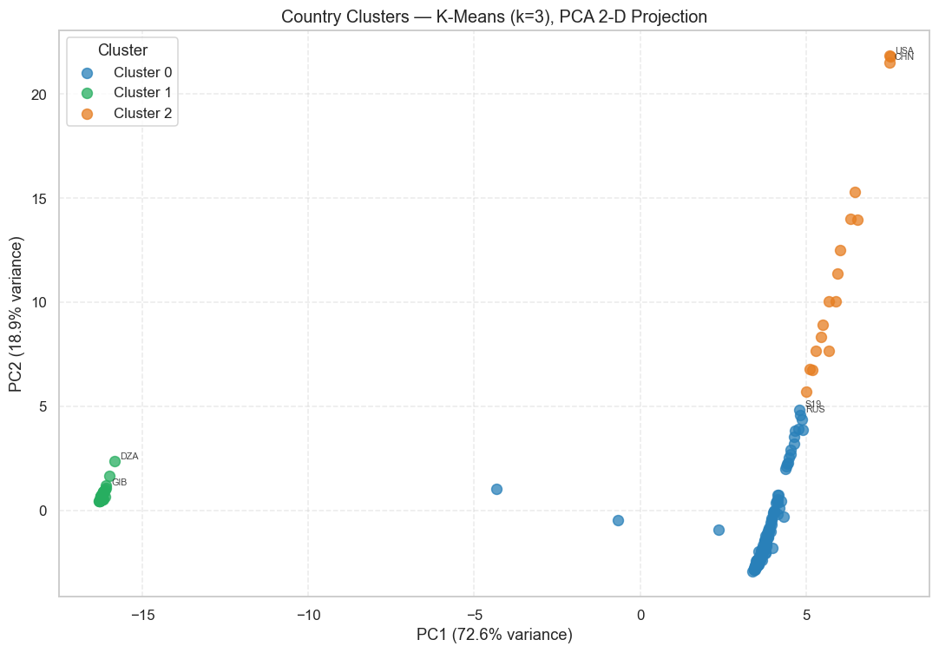
Figure 6.1 - Country clusters projected onto two principal components.

6.2.3 Cluster Interpretation
- Cluster 0 — Emerging Growth Markets (166 countries): Moderate import scale, positive import growth, moderate GDP per capita (~12,891 USD). Includes Vietnam, Poland, UAE, Thailand, and Russia.
- Cluster 1 — Niche and Restricted Markets (44 countries): Low import scale, very limited import growth (0.0019 slope), low opportunity rate (2.7%). Includes Gibraltar, Macao, and Turkmenistan.
- Cluster 2 — Priority Large Markets (17 countries): Very high import scale, highest GDP per capita (~39,406 USD), highest opportunity rate (86.75%). Contains the USA, China, Germany, Japan, UK, France, and India.

6.2.4 Priority Market Ranking — Top 10
Rank | Country | ISO3 | Cluster | Opportunity Rate | Priority Score
1 | Viet Nam | VNM | 0 | 72.2% | 0.888
2 | Poland | POL | 0 | 90.7% | 0.879
3 | USA | USA | 2 | 95.4% | 0.876
4 | India | IND | 2 | 71.7% | 0.867
5 | Germany | DEU | 2 | 95.7% | 0.865
6 | Mexico | MEX | 2 | 85.5% | 0.865
7 | China | CHN | 2 | 88.2% | 0.859
8 | Spain | ESP | 2 | 91.4% | 0.852
9 | United Kingdom | GBR | 2 | 95.3% | 0.845
10 | Czechia | CZE | 0 | 77.6% | 0.835
Table 6.2 — Top 10 priority export markets
The priority ranking translates cluster membership into action. Vietnam and Poland rank highly because they combine opportunity rate with import growth, while the USA, Germany, India, Mexico, and China remain important because of market scale.
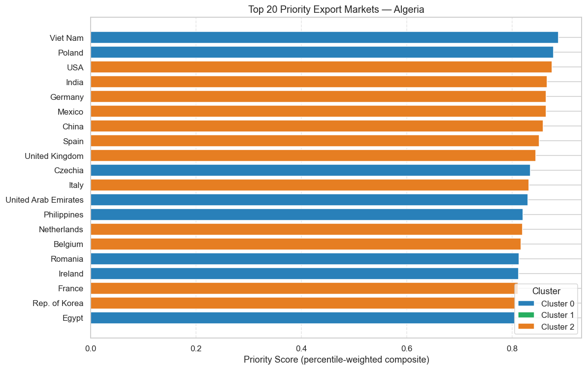
Figure 6.2 - Top priority markets from the clustering-based country ranking.

6.3 Product Clustering
Algorithm | Silhouette Score | Davies-Bouldin | ARI vs K-Means
K-Means (k=4) | 0.8685 | 0.3817 | —
Agglomerative Ward (k=4) | 0.8707 | 0.3182 | 0.8699
Table 6.3 — Product clustering evaluation

6.3.1 Product Cluster Interpretation
- Cluster 0 — Low-Demand Niche Products (4,716 products): Small global market, few buyer countries. Represents the long tail of international trade.
- Cluster 1 — Moderate-Demand Commodities (78 products): Broad geographic spread, stable but slow-growing demand.
- Cluster 2 — High-Demand Growth Products (309 products): Large and expanding global market, high opportunity rate. Contains electronics, pharmaceutical, and machinery products.
- Cluster 3 — Strategic Opportunity Products (93 products): Strong Algeria penetration potential, rising demand slope. Products where Algeria has some existing comparative advantage.
Cross-cluster analysis combines the country and product segmentations. The highest opportunity rates appear where large or high-growth country clusters intersect with high-demand product clusters, giving CACI a practical way to prioritize market-product campaigns.
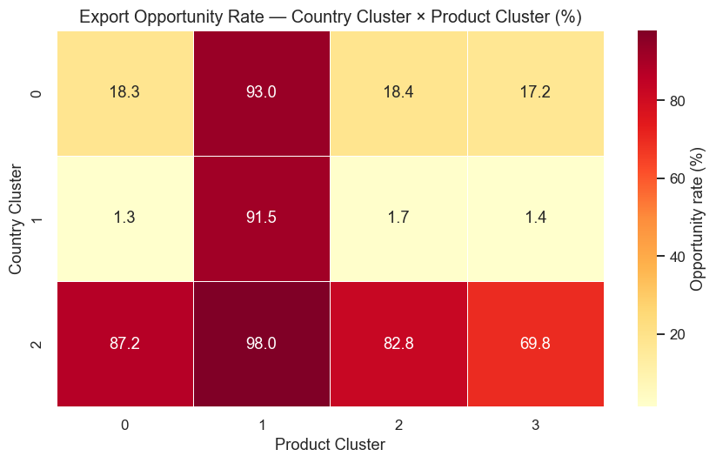
Figure 6.3 - Cross-cluster opportunity matrix for country and product segments.

Chapter 7

Classification

7.1 Problem Formulation
The binary label_opportunity variable from the master dataset is extended to a three-class label for more granular opportunity ranking. The three classes are: Class 0 (Low/No Opportunity) — low global demand and no existing Algerian export presence; Class 1 (Medium Opportunity) — moderate demand or some Algerian export history; Class 2 (High Opportunity) — high global demand, strong demand growth, and/or significant Algerian export potential based on RCA.

7.2 Model Selection Rationale
Four models are compared, representing a spectrum from interpretable linear learning to high-performing non-linear tree ensembles: Logistic Regression, Random Forest, XGBoost, and LightGBM. Logistic Regression provides the baseline, Random Forest provides robust non-linear behavior, and the boosting models test whether sequential tree learning improves classification of High, Medium, and Low opportunity cases.

7.3 Results
Model | Accuracy | Macro Precision | Macro Recall | Macro F1
Logistic Regression | 0.6524 | 0.5366 | 0.7384 | 0.5595
Random Forest | 0.9100 | 0.8074 | 0.9330 | 0.8591
XGBoost | 0.9062 | 0.7976 | 0.9305 | 0.8511
LightGBM ★ Best | 0.9468 | 0.9145 | 0.9029 | 0.9083
Table 7.1 — Classification model comparison on test set (2022–2023)
The model comparison shows a clear performance gap between the linear baseline and tree-based methods. LightGBM is selected because it gives the strongest balance of accuracy, precision, recall, and macro F1 on the 2022-2023 held-out test period.
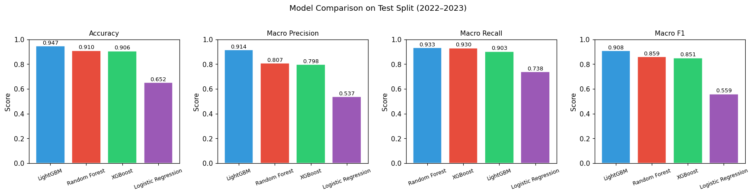
Figure 7.1 - Classification model comparison on the held-out test period.

7.3.1 LightGBM — Best Model
LightGBM achieves the best overall performance with 94.68% accuracy and a macro F1-score of 0.9083. The per-class breakdown shows strong performance across all three opportunity tiers:
Class | Precision | Recall | F1-Score | Support
Low/No Opportunity | 0.96 | 0.97 | 0.97 | 1,854,568
Medium Opportunity | 0.89 | 0.83 | 0.86 | 348,889
High Opportunity | 0.89 | 0.91 | 0.90 | 155,527
Table 7.2 — LightGBM per-class performance on test set

7.4 Feature Importance Analysis
Feature importance was computed for all three tree-based models and converted into a consensus ranking by averaging feature ranks. The most important variables are demand-side and market-access indicators: partner import value, global demand rank/log, market size, world import value, GDP, lagged import values, population, market penetration, RCA, and distance. This is economically coherent: high opportunity is driven by market size, demand strength, growth, low current Algerian penetration, and feasible trade conditions.
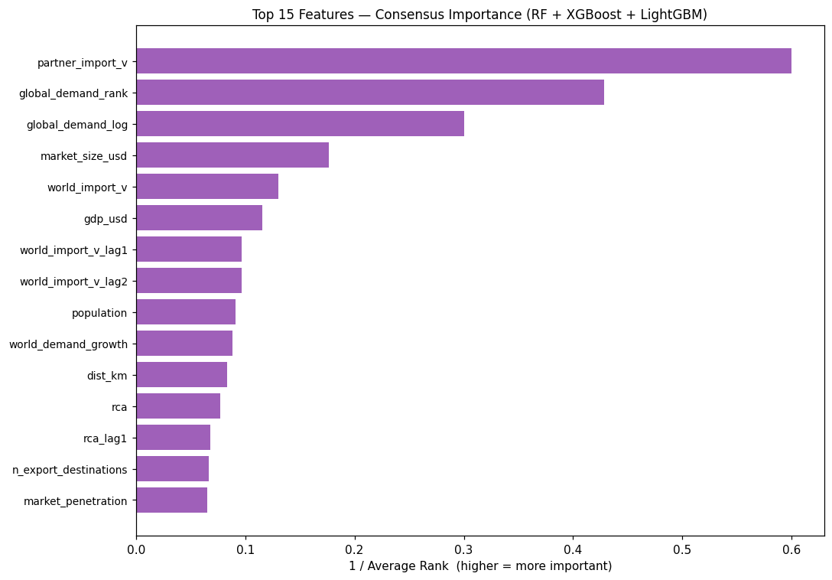
Figure 7.2 - Consensus feature-importance ranking across tree-based classifiers.
The ranked opportunity output then filters country-product pairs predicted as High Opportunity and orders them by market size, demand strength, growth, and low penetration. This provides the operational list used by the dashboard and report interpretation.
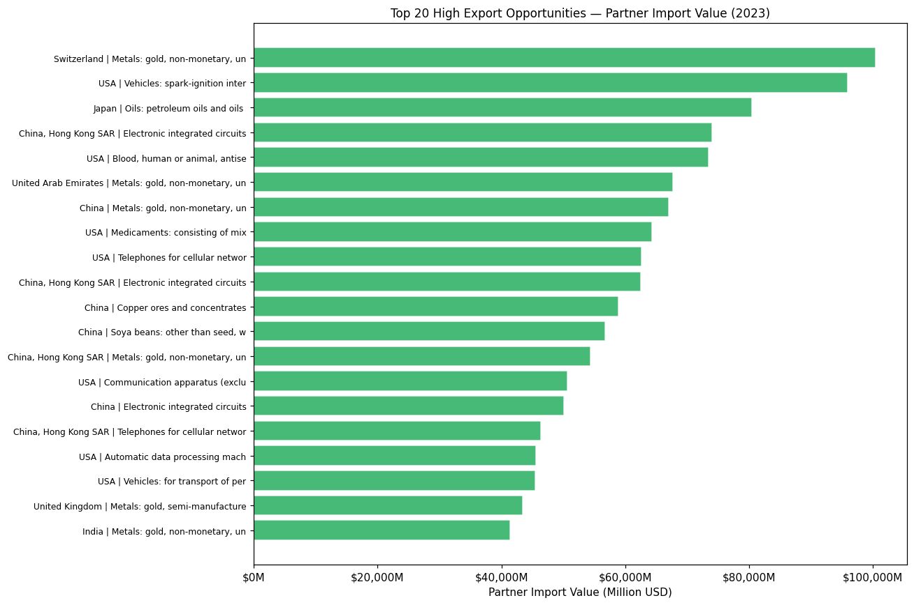
Figure 7.3 - Top classified export opportunities ranked by model output and market indicators.

Chapter 8

Forecasting

8.1 Forecasting Objective
The forecasting module predicts future import demand (partner_import_v) for selected country-product pairs over a three-year horizon (2024-2026). The target is the partner country's total imports of an HS6 product, not Algeria's current exports. This is intentional: partner import demand measures market opportunity, while Algeria's current exports may reflect supply constraints or underdeveloped market access.

8.2 Non-Hydrocarbon Scope
The default configuration excludes HS chapter 27 products and hydrocarbon-related descriptions such as petroleum, oils, gas, coal, and bituminous. This prevents the forecasting analysis from collapsing into a hydrocarbon price forecasting exercise and keeps the focus on export diversification. The INCLUDE_HYDROCARBONS flag remains available for a full all-products view.

8.3 Sample Selection Strategy
A balanced country-product sample is constructed to prevent one globally dominant product from controlling the forecast panel. The notebook selects the top 50 non-hydrocarbon products by world import value and then the top 10 importing countries for each product. This produces 500 country-product series covering 50 products and 49 partner countries.

8.4 Results
Metric | Value | Interpretation
MAE | 1,357,026 USD | Average absolute forecast error per series-year
RMSE | 2,928,567 USD | Root mean squared error — sensitive to large errors
MAPE | 39.11% | Mean absolute percentage error (unstable near zero)
sMAPE | 19.54% | Symmetric MAPE — more stable for near-zero values
WMAPE ★ | 15.19% | Weighted MAPE — recommended primary metric
Table 8.1 — Random Forest forecasting performance on test set (2022–2023)
The forecasting comparison includes both simple baselines and machine learning regressors. This is important because advanced models should only be trusted if they beat transparent rules such as naive last value or moving average.
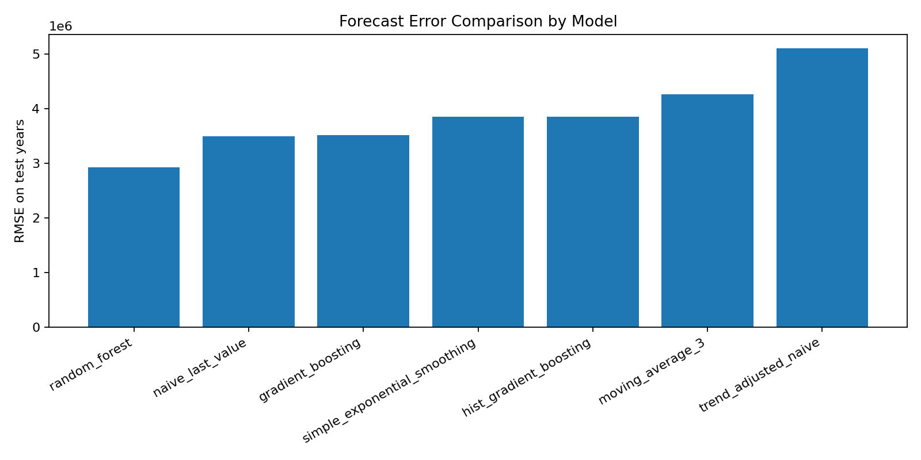
Figure 8.1 - Forecast error comparison across baselines and machine learning regressors.
Random Forest is selected as the final future-forecast model because it achieves the lowest RMSE on the time-based test set. Its WMAPE of 15.19% is competitive for bilateral HS6 trade forecasting given the short annual histories and volatile product-level trade flows. The model also outperforms the naive last-value baseline, which confirms that it adds value beyond simply repeating the previous year.
ARIMA is included as an optional comparator when statsmodels is installed, but it is not the main strategy because each annual country-product series has only about 12 observations. The panel machine-learning approach is more suitable because it learns shared patterns across many related series.
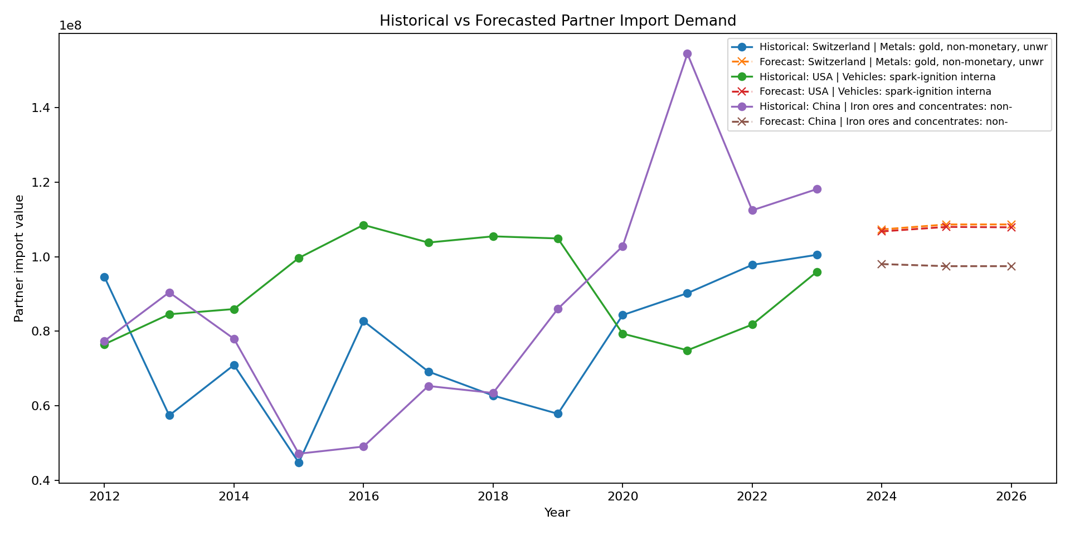
Figure 8.2 - Historical baseline and future forecasted partner import demand for representative high-value series.

8.5 Forecast Opportunity Scoring
A composite forecast opportunity score is computed using the following weighted formula: 40% normalized forecasted demand + 25% predicted growth rate + 20% global demand rank + 10% RCA + 5% low market penetration bonus. This weighting prioritizes demand volume and future growth while still accounting for product attractiveness, Algeria's competitiveness signal, and untapped market room.
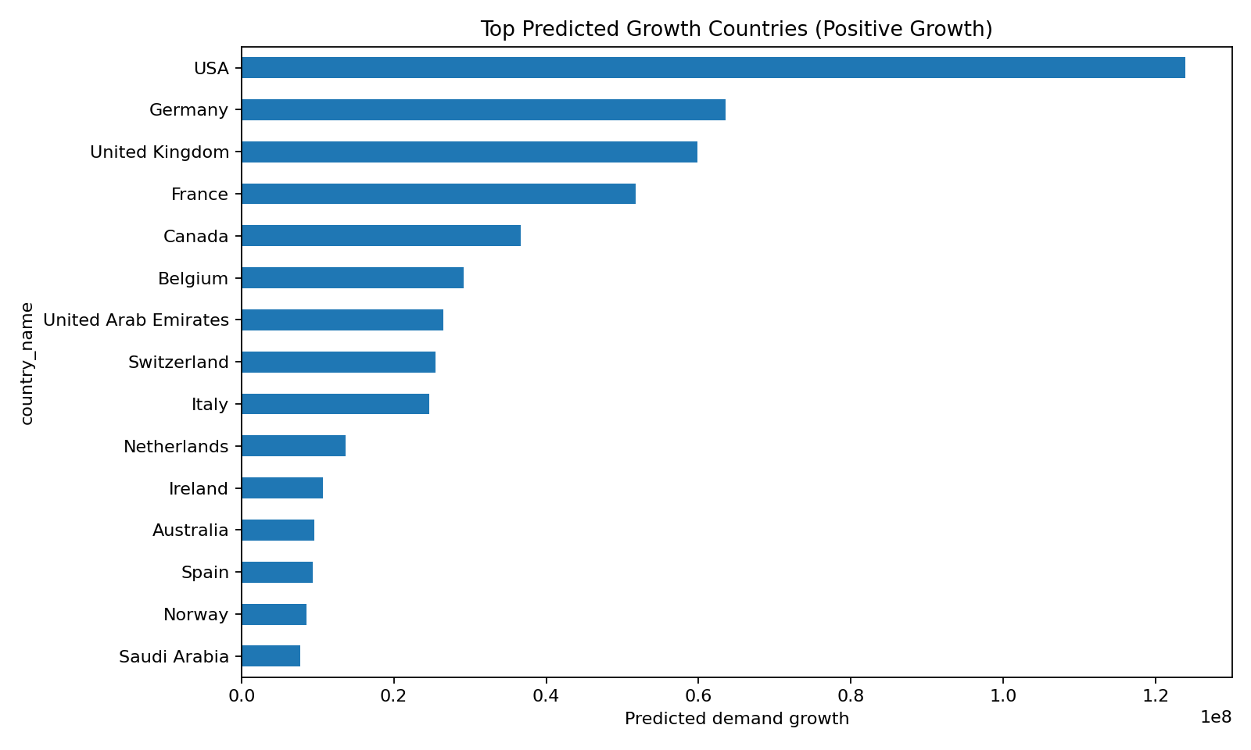
Figure 8.3 - Top countries by predicted forecast growth in the selected non-hydrocarbon panel.

Chapter 9

Visualization Dashboard

9.1 Objectives and Target Users
The dashboard is designed to translate the machine learning outputs into actionable insights for three categories of stakeholders: CACI experts who need country-level and sector-level market overviews; individual exporters who need product-specific opportunity and demand information; and policymakers who need aggregate trends and forecasted growth trajectories to inform export promotion strategy.

9.2 Technology Choice: Grafana, SQLite, Streamlit, and Plotly
The final professional dashboard layer is built around Grafana because the project brief requires a professional BI dashboard. Grafana reads a SQLite database generated by grafana/export_to_sqlite.py from the forecasting, clustering, and classification outputs. Streamlit + Plotly is kept as a backup/live Python dashboard because it can read the same CSV outputs directly and is useful for fast local validation during demonstrations.
Criterion | Grafana + SQLite | Streamlit + Plotly | Apache Superset
Professional BI requirement | Strong | Backup / live Python dashboard | Strong
Data integration | SQLite export from all model outputs | Direct CSV loading | Requires connector/API
Model output coverage | Forecasting, clustering, classification | Forecasting, clustering, classification, optional EDA | Depends on setup
Setup complexity | Medium/High (Docker + plugin) | Low (Python script) | High (server)
Production suitability | High | Medium | High
Academic demo suitability | High | High | Medium
Table 9.1 — Dashboard technology comparison

9.3 Dashboard Architecture
The dashboard layer is read-only: it presents saved model outputs rather than retraining models. Grafana reads data/grafana/export_opportunities.db, which contains 18 imported tables and 6 helper views covering forecast, clustering, and classification outputs. The Streamlit backup dashboard reads data/forecast_outputs/, data/clustering_outputs/, data/classification_outputs/, and optional data/eda_outputs/ directly.

9.4 Dashboard Pages and Modules
The Streamlit backup dashboard is structured as a single-page multi-section application with thirteen sections: Executive Summary, Opportunities Explorer, Priority Markets, Priority Products, Demand and Trade Flows, Growth and Potential, Historical vs. Forecasted, Forecast Model Performance, Historical EDA Context, Sector-Level Analysis, Clustering-Based Market Segmentation, Classification-Based Opportunity Ranking, and an Interpretation Guide. Grafana uses equivalent panels backed by SQLite tables and views.

Chapter 10

Results and Economic Interpretation

10.1 Summary of Key Findings
The end-to-end system produces coherent and economically interpretable findings across all three machine learning tasks. The clustering, classification, and forecasting results are mutually consistent: the priority markets identified by country clustering (USA, Germany, UK, China, India, Spain) are also the markets with the highest classification opportunity rates and the largest forecasted demand volumes. This triangulation across independent methods strengthens confidence in the overall conclusions.

10.2 Top Export Opportunity Markets
- Tier 1 — Large established importers: USA, Germany, China, UK, France, Italy, Spain, Japan, Netherlands, Belgium. Highest absolute demand volumes and broadest product range. Higher entry barriers but large revenue potential.
- Tier 2 — High-growth emerging importers: Vietnam, Poland, India, Mexico, UAE, Czechia, Philippines. Positive import growth trajectories with lower competitive intensity and, in some cases, geographic or historical proximity to Algeria.

10.3 High-Demand Non-Hydrocarbon Products for Algeria
The forecasting and classification results converge on a consistent set of high-priority non-hydrocarbon product categories: electronic integrated circuits (HS 854231, 854239), medicaments (HS 300490), cellular network devices (HS 851712), passenger vehicles (HS 870323), laptops (HS 847130), and biopharmaceuticals (HS 300210). For most of these products, Algeria's current market penetration is near zero.
Among products where Algeria does have some existing export presence and a measurable RCA, fertilizers (HS chapter 31), iron and steel articles (chapter 73), food preparations (chapter 21), and dates (chapter 08) stand out as natural expansion candidates.

10.4 Forecasted Demand Trends 2024–2026
The Random Forest forecasting model projects continued demand growth in electronics, pharmaceuticals, and precision machinery through 2026 across the top partner markets. The WMAPE of 15.19% on the 2022–2023 test period suggests the model's 2024–2026 projections are reliable indicators of demand direction, though absolute values carry uncertainty that grows with the forecast horizon.

Chapter 11

Discussion

11.1 Limitations

11.1.1 Data Availability
The most significant data limitation is the unavailability of official Algerian domestic export support data from CACI and the Ministry of External Commerce. Such data could provide ground-truth validation of the system's opportunity rankings and could supply additional features (export financing, trade agreements, non-tariff barrier information) that are known to influence market access.

11.1.2 Zero-Export Pair Assumptions
The labeling strategy assigns opportunity labels based purely on demand-side signals without conditioning on supply-side feasibility. A market can be labeled as a high opportunity for semiconductor chips, even though Algeria has no semiconductor manufacturing capacity. Future versions of the label could incorporate supply-side eligibility filters based on Algerian production statistics.

11.1.3 Forecasting Horizon Uncertainty
The three-year forecast horizon (2024–2026) is inherently uncertain, particularly for products in fast-evolving technology sectors. The system is best used as a directional decision-support tool rather than a precise revenue forecasting instrument.

11.2 Ethical Considerations
All data sources used in this project are publicly available and do not contain individual-level personal information. Trade data is reported at the country level (aggregate bilateral flows) and presents no privacy concerns. The system's outputs are intended to support institutional export promotion policy, not to disadvantage individual countries or firms. No discriminatory criteria are embedded in the labeling or modeling procedures; all countries and products are treated symmetrically in the data pipeline.

11.3 Recommendations for Operational Use
- Use the priority market ranking table to plan trade mission destinations, prioritizing Tier 2 high-growth markets (Vietnam, Poland, India, Mexico, UAE) for near-term outreach.
- Focus product promotion resources on the 309 products in the High-Demand Growth cluster (Cluster 2), particularly electronics, pharmaceutical, and machinery categories.
- For products where Algeria has an existing RCA above 1 (fertilizers, some base metals, food products), use the classification opportunity ranking to identify specific under-served market-country combinations.
- Monitor the forecast opportunity scores for the top 500 country-product series annually as new BACI data becomes available.

11.4 Future Work
- Automated dashboard refresh: schedule the forecasting, clustering, classification, and SQLite export steps so Grafana updates automatically when new BACI data becomes available.
- Supply-side feasibility filter: incorporating Algerian production statistics to screen out theoretically attractive markets that Algeria cannot realistically supply.
- Non-tariff barrier data integration: adding tariff rates, trade agreement coverage, and non-tariff barrier indicators from WTO or UNCTAD TRAINS.
- Annual retraining pipeline: automating the data collection, feature engineering, and model retraining workflow with each new BACI data release.
- Grafana provisioning and access control: package the Grafana dashboard configuration, data source, and panel definitions so the system can be deployed reproducibly with multi-user access at CACI.

Chapter 12

Conclusion

This report has presented a complete end-to-end machine learning system for identifying and forecasting international export opportunities for Algerian non-hydrocarbon exporters. The system integrates five publicly available datasets into a unified 14.15 million row panel dataset spanning 12 years, 227 partner countries, and 5,196 HS6 products.
Three machine learning tasks were implemented and rigorously evaluated on temporally held-out test data. Clustering identified three strategically distinct country segments and four product demand tiers, producing a 20-country priority market ranking. Classification selected LightGBM as the best performer, achieving 94.68% accuracy and a macro F1-score of 0.9083 on the 2022–2023 test set. Forecasting applied Random Forest regression to project import demand across 500 country-product series, achieving a WMAPE of 15.19% on the test period.
The system's results are mutually consistent and economically interpretable. The priority markets identified by clustering are also the markets with the highest classification opportunity rates and the largest forecasted demand volumes. The feature importance analysis confirms that the classification models learn patterns grounded in standard international trade theory: market size, demand growth, market penetration, and revealed comparative advantage are the primary drivers of opportunity classification.
With planned extensions to incorporate non-tariff barrier data, annual retraining workflows, automated dashboard refresh, and Grafana provisioning, this system could serve as a practical decision-support tool for the Algerian Chamber of Commerce and Industry and the Ministry of External Commerce.

References

References

Balassa, B. (1965). Trade Liberalisation and Revealed Comparative Advantage. The Manchester School, 33(2), 99–123.
CEPII. (2023). BACI: International Trade Database at the Product-Level. Centre d'Etudes Prospectives et d'Informations Internationales. http://www.cepii.fr/CEPII/en/bdd_modele/
CEPII. (2011). GeoDist: A Gravity Equation Database. http://www.cepii.fr/CEPII/en/bdd_modele/
Chen, T., & Guestrin, C. (2016). XGBoost: A Scalable Tree Boosting System. Proceedings of the 22nd ACM SIGKDD International Conference on Knowledge Discovery and Data Mining, 785–794.
Ke, G., et al. (2017). LightGBM: A Highly Efficient Gradient Boosting Decision Tree. Advances in Neural Information Processing Systems, 30.
Hidalgo, C. A., & Hausmann, R. (2009). The Building Blocks of Economic Complexity. Proceedings of the National Academy of Sciences, 106(26), 10570–10575.
International Trade Centre. (2023). Export Potential Map: Methodology. https://exportpotential.intracen.org/
Mayer, T., & Zignago, S. (2011). Notes on CEPII's Distances Measures: The GeoDist Database (CEPII Working Paper No. 2011-25). CEPII.
Pedregosa, F., et al. (2011). Scikit-learn: Machine Learning in Python. Journal of Machine Learning Research, 12, 2825–2830.
UNCTAD. (2023). Trade Structure and Diversification Statistics. https://unctadstat.unctad.org/
World Bank. (2023). World Development Indicators. https://data.worldbank.org/

Appendix A

Full Feature List

Feature | Source | Description
alg_export_v | BACI | Algeria's bilateral export value (thousand USD, log1p scale)
partner_import_v | BACI | Partner country's total imports of product k (thousand USD)
world_import_v | BACI | Total world imports of product k (thousand USD)
alg_export_growth | BACI | YoY growth rate of Algeria's exports (log scale)
world_demand_growth | BACI | YoY growth rate of world imports of product k
global_demand_log | BACI | Log-transformed total world import value for product k
global_demand_rank | BACI | Percentile rank of global demand (0–1)
market_penetration | BACI | Algeria's share of partner's imports of product k
trade_balance_bilateral | BACI | Algeria exports minus imports for each product-partner pair
rca | BACI | Revealed Comparative Advantage (Balassa index)
dist_km | CEPII | Distance between capital cities (km)
distw_km | CEPII | Population-weighted bilateral distance (km)
contig | CEPII | 1 if countries share a land border
comlang_off | CEPII | 1 if countries share an official language
colony | CEPII | 1 if colonial relationship ever existed
gdp_usd | World Bank | GDP in current USD
population | World Bank | Total population
trade_pct_gdp | World Bank | Trade as percentage of GDP
gdp_per_capita | World Bank | GDP per capita in current USD
hhi_export | UNCTAD | Herfindahl-Hirschman Index of Algeria's export concentration

Appendix B

Model Hyperparameter Configurations

Model | Key Hyperparameters
Logistic Regression | multi_class=ovr, solver=saga, C=0.1, class_weight=balanced, max_iter=300
Random Forest | n_estimators=200, max_depth=20, max_features=sqrt, class_weight=balanced, n_jobs=-1
XGBoost | n_estimators=300, max_depth=8, learning_rate=0.1, subsample=0.8, colsample_bytree=0.8, reg_alpha=0.1
LightGBM | n_estimators=400, max_depth=8, learning_rate=0.05, num_leaves=63, subsample=0.8, class_weight=balanced
Forecasting RF | n_estimators=180, min_samples_leaf=2, random_state=42, n_jobs=-1

Appendix C

Notebook Pipeline Summary

Notebook | Purpose | Key Output
01_build_master_dataset.ipynb | Data integration and feature engineering | master_df.parquet (14.15M rows × 50 cols)
02_data_cleaning_eda.ipynb | Data cleaning, EDA, preprocessing pipeline | modeling/ splits, eda_outputs/ CSVs
04_classification.ipynb | 3-class opportunity classification | classification_outputs/ (rankings, metrics, confusion matrices)
05_clustering.ipynb | Country, product, and sector clustering | clustering_outputs/ (cluster labels, priority rankings)
07_forecasting.ipynb | Self-contained demand forecasting and opportunity scoring | forecast_outputs/ (forecasts, metrics, ranked opportunities)
app.py | Streamlit backup/live dashboard | Reads forecast, clustering, classification, and optional EDA outputs
grafana/export_to_sqlite.py | Grafana SQLite export layer | data/grafana/export_opportunities.db with model-output tables and views

