ENSIA — Machine Learning Project
Spring 2025–2026
Forecasting and Identifying Global Export Opportunities for Algerian Exporters

Technical Report
End-to-End Machine Learning System for Export Diversification

Data Sources: BACI HS12 • World Bank • CEPII GeoDist • UNCTAD
ML Tasks: Clustering • Classification • Forecasting • Dashboard

Abstract
Algeria's economy remains heavily dependent on hydrocarbons, which accounted for approximately 92% of total export revenues in 2023, generating an estimated 50–55 billion USD. This structural concentration creates significant exposure to global energy price volatility and represents a strategic vulnerability that national economic policy has prioritized addressing. Within this context, this report presents a complete end-to-end machine learning system designed to identify, analyze, and forecast international export opportunities for Algerian exporters across all non-hydrocarbon economic sectors.
The system integrates five publicly available international trade datasets — BACI HS12 bilateral trade data, CEPII GeoDist geographic and cultural variables, World Bank macroeconomic indicators, and UNCTAD export diversification indices — into a unified master panel dataset covering 14,153,904 observations across 12 years (2012–2023), 227 partner countries, and 5,196 HS6 product codes.
Three machine learning tasks are implemented. Clustering groups partner countries, HS6 products, and HS2 sectors according to trade demand profiles, yielding a 20-country priority market ranking for Algerian non-hydrocarbon exporters. Classification trains four models ? Logistic Regression, Random Forest, XGBoost, and LightGBM ? to assign each country-product pair a three-class export opportunity label (High, Medium, or Low); LightGBM achieves the best performance with 94.68% accuracy and a macro F1-score of 0.9083 on the held-out test set. Forecasting applies baseline and machine learning regressors to predict future import demand for 500 country-product series across 50 non-hydrocarbon products and 49 partner countries; Random Forest delivers the best RMSE of 2,928,567 USD and a WMAPE of 15.19%. Results are exposed through a Grafana dashboard backed by a SQLite database generated from the model outputs, with a Streamlit + Plotly backup dashboard retained for live Python exploration.

1. Introduction

1.1 Context and Motivation
Algeria is one of Africa's largest economies and the continent's leading natural gas exporter. However, its integration into global trade remains dominated almost entirely by hydrocarbon products. In 2023, petroleum oils, natural gas, and related energy products constituted roughly 92% of total export revenues, leaving the non-hydrocarbon export sector — comprising agriculture, food products, pharmaceuticals, chemicals, manufactured goods, and services — largely underdeveloped relative to the country's productive capacity.
This dependence creates two interrelated risks. First, macroeconomic exposure to energy price cycles means that sharp downturns in global oil and gas markets translate directly into foreign exchange shortfalls, pressuring the national budget. Second, the narrow export base limits the accumulation of competitive capabilities in knowledge-intensive industries, reducing long-term economic resilience. These dynamics have been clearly visible: between 2012 and 2016, Algeria's total recorded exports in BACI fell from approximately 75.3 billion USD to 32.1 billion USD — a 57% decline driven almost entirely by the collapse in global energy prices.
In response, the government of President Abdelmadjid Tebboune has placed export diversification at the center of national economic strategy, with specific targets for growing non-hydrocarbon export revenues. The Algerian Chamber of Commerce and Industry (CACI) and the Ministry of External Commerce play central roles in operationalizing this agenda. Yet both institutions face a common challenge: identifying, with precision and at scale, which international markets offer the most credible and sustainable opportunities for Algerian exporters in which specific product categories.

1.2 Algeria's Export Landscape and the Hydrocarbons Dependency Problem
The BACI dataset records Algeria's export flows across all HS6 product categories. Analysis of these flows from 2012 to 2023 reveals a highly concentrated export basket. Non-hydrocarbon exports exist but are small in absolute terms and concentrated in a narrow set of destinations, primarily neighboring countries, France, and select Middle Eastern markets. Key non-hydrocarbon products with some export history include fertilizers (HS chapter 31), iron and steel products (chapter 72), food preparations, and dates (chapter 08). However, market penetration for most of these products remains extremely low relative to global demand volumes.
Algeria's Herfindahl-Hirschman Index (HHI) of export concentration, as recorded in the UNCTAD diversification dataset, confirms this structural imbalance. A value approaching 1.0 indicates a near-monopoly concentration of exports in a single product category. Algeria's recorded HHI in the dataset is approximately 0.54, reflecting severe concentration.

1.3 Problem Statement
Given the urgency of export diversification and the complexity of global trade markets, manual analysis of export opportunities is neither scalable nor sufficiently rigorous. A data-driven approach is required that can simultaneously process bilateral trade flows across thousands of product-market combinations, identify statistically meaningful opportunity signals, account for comparative advantage and market penetration, and produce forward-looking demand forecasts.
This project addresses the following core problem: how can machine learning methods — applied to large-scale international trade datasets — systematically identify and rank the most promising export opportunities for Algerian exporters across all non-hydrocarbon sectors, and how can the resulting insights be made actionable for institutional decision-makers?

1.4 Project Objectives
The system is designed to achieve the following objectives:
- Collect and integrate international trade data from at least two independent publicly available sources.
- Engineer economically meaningful trade and economic features from raw bilateral trade flows.
- Apply clustering techniques to segment countries, products, and sectors by demand profile.
- Build classification models to rank country-product pairs by export opportunity level.
- Develop forecasting models to predict future import demand trends for priority non-hydrocarbon markets.
- Design an interactive dashboard supporting stakeholder exploration of results.
- Validate all models rigorously on temporally held-out test data to prevent data leakage.

1.5 Report Structure
This report is organized as follows. Chapter 2 provides background on related work. Chapter 3 describes the data sources and collection methodology. Chapter 4 details data preparation, integration, and feature engineering. Chapter 5 presents the exploratory data analysis. Chapters 6, 7, and 8 document the clustering, classification, and forecasting models respectively, including methodology, configuration, and evaluation results. Chapter 9 describes the visualization dashboard. Chapter 10 synthesizes key results and their economic interpretation. Chapter 11 discusses limitations and future work. Chapter 12 concludes.

2. Related Work and Background

2.1 Export Opportunity Identification in the Literature
The identification of export opportunities has a long tradition in international economics. Early approaches relied on static indicators such as Balassa's Revealed Comparative Advantage (RCA), which measures a country's export specialization in a product relative to the world average. RCA values above 1.0 indicate comparative advantage, and products with high RCA and growing global demand are natural candidates for export expansion. This project uses RCA as one of its engineered features.
More recent work in the export potential literature has moved toward data-driven approaches. The International Trade Centre's Export Potential Map uses a gravity-model-based framework to estimate the gap between current and potential exports for country-product pairs. The World Bank's WITS platform and the Observatory of Economic Complexity (OEC) provide visualization and analytical tools that identify product space opportunities based on economic complexity theory. This project draws conceptual inspiration from these frameworks while implementing them through machine learning methods applied to a large panel dataset.

2.2 Machine Learning for Trade Analysis
The application of machine learning to trade and economic policy problems has grown substantially in recent years. Supervised learning methods — in particular gradient boosting frameworks such as XGBoost and LightGBM — have demonstrated strong performance on tabular economic datasets, outperforming linear models in tasks with non-linear feature interactions. Random Forest classifiers have similarly been used in trade facilitation contexts due to their robustness to outliers and ability to handle missing values naturally.
In the forecasting domain, machine learning regressors using lag features have been shown to outperform classical time series models such as ARIMA on short, heterogeneous panels — precisely the scenario encountered when forecasting bilateral trade flows across hundreds of product-market pairs with limited time depth. This justification underpins the modeling choices in Chapter 8.

2.3 The Gravity Model and Trade Features
The gravity model of trade, which predicts bilateral trade flows as a function of economic mass (GDP) and geographic distance, provides the theoretical foundation for several features used in this project. Distance (dist_km), contiguity (contig), common language (comlang_off), and colonial ties (colony) — all drawn from the CEPII GeoDist dataset — are standard gravity model controls. Their inclusion allows the classification and clustering models to account for the well-documented role of geographic and cultural proximity in determining trade patterns.

2.4 Positioning of This Project
Unlike the ITC Export Potential Map, which uses country-level aggregates, this project operates at the bilateral HS6 product level — the most granular level of the Harmonized System classification — enabling highly specific opportunity identification. Unlike most academic trade ML studies that use pre-processed summary statistics, this project builds the entire data pipeline from raw BACI bilateral trade files, producing a fully reproducible and extensible dataset of 14.15 million observations. The multi-task architecture — combining clustering, classification, and forecasting — also goes beyond single-task trade analyses found in the literature.

3. Data Sources and Collection

3.1 Overview of the Multi-Source Integration Strategy
The project follows a principled multi-source integration strategy: a primary bilateral trade dataset is supplemented by geographic, macroeconomic, and institutional datasets that each contribute distinct information layers. The integration is performed at the country-year level for macroeconomic variables and at the country-pair level for geographic variables. All sources are publicly available and require no proprietary access, ensuring full reproducibility.
Table 3.1 summarizes all data sources used, their role in the project, and their integration status.

Source | Role | Coverage | Status
BACI HS12 (CEPII) | Main bilateral trade flows by exporter, importer, HS6 product, year | 2012–2023, 200+ countries | Integrated
BACI Country Codes | Mapping from numeric BACI codes to ISO3 and country names | All BACI countries | Integrated
BACI Product Codes | HS6 product descriptions for all 5,196 products in scope | HS12 classification | Integrated
World Bank API | GDP, population, GDP per capita, trade openness (% of GDP), market size | Annual, per country | Integrated
CEPII GeoDist | Bilateral distance (km), weighted distance, contiguity, common language, colonial ties | All country pairs | Integrated — 92.5% coverage
UNCTAD | Algeria-level HHI export concentration and diversification index | Annual, Algeria only | Integrated
CACI / Ministry | Official Algerian domestic export support data | N/A | Not publicly available — excluded

Table 3.1 — Data source audit

3.2 BACI International Trade Database

3.2.1 Structure and Content
BACI (Base pour l'Analyse du Commerce International) is produced by CEPII (Centre d'Etudes Prospectives et d'Informations Internationales) and provides harmonized bilateral trade statistics at the 6-digit Harmonized System (HS) level. BACI reconciles the mirror discrepancies between importer and exporter declarations in the UN Comtrade database using a methodological procedure that accounts for CIF/FOB differences and reporting asymmetries, producing a single harmonized trade value for each bilateral flow.
For this project, the HS12 version (using the 2012 HS classification) is used, covering annual bilateral trade flows from 2012 to 2023. Trade values in BACI are expressed in thousands of USD. Each row in the raw BACI files represents one directed bilateral flow: a specific exporter country, importer country, HS6 product code, and year. The project version (202601) was used.

3.2.2 Filtering and Scope
To manage computational scale while preserving analytical value, only HS6 products whose peak annual world import value exceeds 1,000 thousand USD (i.e., 1 million USD) over the study period are retained. This threshold removes trivially small product-market combinations while preserving 5,196 HS6 products that together account for the overwhelming majority of world trade value.

3.3 CEPII GeoDist Dataset
GeoDist provides bilateral geographic and cultural variables for all country pairs. The variables used in this project are: distance in kilometers between capital cities (dist_km), population-weighted distance (distw_km), contiguity indicator (contig, equal to 1 if the two countries share a land border), official common language (comlang_off), ethno-linguistic common language (comlang_ethno), ever-colonial relationship (colony), common colonizer (comcol), and same country history (smctry). These variables constitute the geographic and cultural feature block in the master dataset. GeoDist coverage in the master dataset is 92.5%, with the remaining 7.5% of country pairs not matched, primarily for very small or recently established states.

3.4 World Bank Macroeconomic Indicators
Macroeconomic indicators are retrieved from the World Bank Open Data API using the wbdata Python library. The following indicators are collected for each partner country and year: GDP in current USD (NY.GDP.MKTP.CD), total population (SP.POP.TOTL), trade as a percentage of GDP (NE.TRD.GNFS.ZS), and GDP per capita in current USD (NY.GDP.PCAP.CD). A composite market size indicator is computed as the product of GDP and trade openness. These variables capture the economic gravity mass of partner markets and serve as both clustering features and classification predictors.

3.5 UNCTAD Diversification Indicators
UNCTAD provides Algeria-specific indicators of export concentration and diversification. The Herfindahl-Hirschman Index of export concentration (hhi_export) and a product diversification index (diversification_index) are included in the dataset for Algeria at the year level. The diversification_index was found to be 100% missing in the dataset version available for this project and was excluded from all modeling features. The HHI is complete and is included in the scale-sensitive feature set.

3.6 Dataset Summary
After integration, the final master dataset contains 14,153,904 rows and 50 columns. Each row represents one (year, partner country, HS6 product) observation — a unique point in the opportunity space. The dataset includes both rows where Algeria currently exports (non-zero alg_export_v) and rows where Algeria exports nothing to that market (zero-export rows), which represent unexplored or missed opportunities. The temporal coverage is 2012–2023, spanning 227 partner countries and 5,196 HS6 products.

4. Data Preparation and Integration

4.1 Master Dataset Architecture

4.1.1 Dataset Grain
The fundamental unit of analysis is the (year, partner country, HS6 product) triplet. This grain is chosen because it captures all three dimensions of trade opportunity simultaneously: the temporal dimension (is demand growing?), the geographic dimension (which market?), and the product dimension (which product?). A single country may be an excellent opportunity for product A but a poor prospect for product B — aggregation to the country level would mask this.

4.1.2 Inclusion of Zero-Export Pairs
A distinctive feature of the dataset construction is the explicit inclusion of zero-export observations — rows where Algeria's recorded export value to a given partner for a given product in a given year is zero. These rows are critical for the machine learning models. An opportunity detection system that only sees historical positive trade flows would learn to recognize existing trade patterns rather than identifying untapped markets. By including zero-export pairs, the models learn to distinguish between markets with genuine demand that Algeria could target versus markets with low or negligible import volumes.
The full opportunity grid — combining all years, all 227 partner countries, and all 5,196 HS6 products above the demand threshold — generates approximately 14.15 million rows. Of these, 21.2% are labeled as export opportunities (label_opportunity = 1), while 78.8% are labeled as non-opportunities (label_opportunity = 0).

4.2 Data Cleaning

4.2.1 Duplicate Detection
A duplicate check on the grain key (year, partner country, HS6 product) confirmed zero duplicate rows in the master dataset, validating the correctness of the data integration pipeline.

4.2.2 Infinite Value Check
All numeric columns were inspected for infinite values (positive or negative infinity), which can arise from division operations in feature engineering (e.g., computing growth rates from near-zero base values). No infinite values were found after clipping and log-transform operations were applied during feature computation.

4.2.3 Missing Values and Imputation Strategy
Missing values arise primarily from the external datasets: World Bank indicators are not available for all countries and years, GeoDist does not cover all bilateral pairs, and some trade features have missing values for product-market pairs with limited historical trade. The imputation strategy adopted is median imputation per feature, fitted exclusively on the training split (years 2012–2019) to prevent data leakage into the validation and test periods. The diversification_index variable was found to be 100% missing and was excluded from all models.

4.3 Feature Engineering
Feature engineering transforms raw trade flows into economically interpretable signals. Thirteen feature categories are computed:

4.3.1 Algeria Export Growth Rate
The year-over-year percentage change in Algeria's bilateral export value to each partner for each product, computed on a log scale to handle large absolute value differences. Log-scale growth rates are more stable and symmetric than raw percentage changes for skewed trade distributions.

4.3.2 World Demand Growth
The annual growth rate of total world imports for each HS6 product, capturing secular demand trends at the global level. A product with consistently positive world demand growth is structurally more attractive for new market entry.

4.3.3 Global Demand Index and Rank
The log-transformed total world import value for each product (global_demand_log) provides an absolute measure of market size. A percentile rank version (global_demand_rank, ranging from 0 to 1) normalizes this across all products for use in classification models.

4.3.4 Market Penetration Ratio
Algeria's share of each partner country's total imports of each product. A market penetration close to zero indicates a market that imports the product from other suppliers but not (yet) from Algeria — a potential entry point. High penetration combined with high world demand growth signals a product where Algeria already has presence in a growing market.

4.3.5 Trade Balance and Coverage Ratio
The bilateral trade balance (Algeria exports minus Algeria imports for each product-partner pair) and the trade coverage ratio (exports divided by imports) are computed to capture whether Algeria is a net exporter or importer of each product vis-a-vis each partner.

4.3.6 Revealed Comparative Advantage (RCA)
Balassa's RCA is computed as: RCA = (Algeria's share of product k in Algeria's total exports) / (world's share of product k in world total exports). Values above 1 indicate comparative advantage. RCA is a direct measure of Algeria's revealed export competitiveness and is one of the most economically interpretable features in the classification model.

4.3.7 Number of Export Destinations
The count of distinct partner countries to which Algeria exports a given product in a given year. Products with many destinations have demonstrated international marketability; products exported to very few countries may represent either niche specialization or unrealized diversification potential.

4.3.8 Lag Features
One- and two-year lags of the key trade features — Algeria export value, market penetration, world import value, and RCA — are computed on a log1p scale. Lag features are essential for forecasting and classification because they encode the historical trajectory of each series, enabling models to distinguish improving trends from declining ones.

4.3.9 Geographic and Cultural Features (CEPII GeoDist)
Eight bilateral variables from the CEPII GeoDist dataset are included: distance in kilometers, population-weighted distance, contiguity, official common language, ethno-linguistic common language, colonial relationship, common colonizer, and same country history. These features capture trade cost proxies and historical linkages that systematically influence bilateral trade volumes.

4.3.10 Macroeconomic Features (World Bank)
GDP in current USD, total population, trade openness as a percentage of GDP, GDP per capita, and a composite market size indicator (GDP multiplied by trade openness) are drawn from the World Bank API and merged at the country-year level.

4.4 Target Variable Definition

4.4.1 Binary Opportunity Label
The binary label label_opportunity is defined using a percentile-based threshold applied within each year. An observation is labeled as an opportunity (label = 1) if the partner country's total imports of that product in that year exceed the 80th percentile of the world import distribution for that product-year. This threshold captures the top quintile of global demand, identifying partner markets that are large enough to constitute meaningful export opportunities. The label is computed purely from demand-side signals and is independent of Algeria's current export presence, ensuring that zero-export pairs can correctly receive a positive opportunity label.

4.4.2 Class Balance
Under this labeling rule, 21.25% of all observations receive label = 1 (opportunity) and 78.75% receive label = 0 (no opportunity). This moderate imbalance is acceptable for supervised classification and was addressed through class weighting in all classification models. Precision, recall, and F1-score are used alongside accuracy for evaluation to account for the class imbalance.

4.5 Temporal Train / Validation / Test Split
All models are evaluated using a strict temporal split that prevents any future information from leaking into training. The split boundaries are:

Split | Years | Rows | Share
Train | 2012–2019 | 9,435,936 | 66.7%
Validation | 2020–2021 | 2,358,984 | 16.7%
Test | 2022–2023 | 2,358,984 | 16.7%

Table 4.1 — Temporal split distribution
This design ensures that models are validated and tested on data from years they have never seen during training, producing honest performance estimates that reflect real-world deployment conditions. Hyperparameters were selected based on validation set performance; final reported metrics are from the test set exclusively.

4.6 Final Dataset
The master dataset is saved in Apache Parquet format using fastparquet, which is the preferred format for this project due to its efficient columnar storage, fast loading, and type preservation. The final dataset contains 14,153,904 rows and 50 columns, with 227 partner countries, 5,196 HS6 products, and 12 years of annual data. Two feature tiers are defined: a simple tier (core BACI trade features only) and an advanced tier (all 50 features including GeoDist, World Bank, and UNCTAD variables).

5. Exploratory Data Analysis

5.1 Data Quality Report
The data quality audit conducted in Notebook 02 confirmed that the master dataset meets all quality requirements for machine learning. The grain check verified that there are zero duplicate (year, partner, product) triplets. No infinite values were found in any numeric column. Data types were correct: integer columns for year, partner code, and labels; categorical columns for product code, ISO3, and split; and float columns for all engineered features.
The source audit (Table 3.1) confirmed integration of five distinct public datasets. CACI and Ministry data were not publicly available and therefore could not be included. This represents a limitation discussed further in Chapter 11.

5.2 Algeria's Export Value Over Time
Analysis of Algeria's total recorded export value in BACI from 2012 to 2023 reveals a highly volatile trajectory driven almost entirely by global energy prices. In 2012, Algeria's total export value stood at approximately 75.3 billion USD. This declined sharply to 32.1 billion USD in 2016 following the 2014–2016 oil price crash — a drop of 57.4% in four years. A partial recovery occurred through 2018 (approximately 46.1 billion USD) before another contraction in 2019–2020 associated with COVID-19-related demand suppression. By 2022, exports recovered to near 2018 levels, driven by energy price increases following geopolitical disruptions.
This pattern confirms the central premise of the project: Algeria's export performance is primarily a function of hydrocarbon commodity price cycles rather than structural export capacity development. Non-hydrocarbon export trends, while positive in direction, remain orders of magnitude smaller than hydrocarbon revenues.

5.3 Top Export Partners
Algeria's top export destinations by recorded value over the study period are dominated by energy-importing nations. France, Italy, Spain, the United States, and the United Kingdom collectively account for the majority of export revenues, reflecting both geographic proximity and long-standing energy supply contracts. Within non-hydrocarbon exports, regional partners — Tunisia, Mauritania, and selected West African countries — feature more prominently, consistent with the gravity model prediction that trade costs favor nearby markets.

5.4 Global Demand Analysis
The top 15 products by total world import value over 2012–2023 are dominated by energy products and technology goods. Petroleum oils (HS 270900) head the ranking with approximately 14.25 trillion USD in cumulative world imports. Among non-hydrocarbon products, gold (HS 710812, ~4.01 trillion USD), medicaments (HS 300490, ~3.59 trillion USD), cellular network telephones (HS 851712, ~3.49 trillion USD), vehicles (HS 870323, ~3.17 trillion USD), and electronic integrated circuits (HS 854231, ~2.99 trillion USD) are the largest markets. These products feature prominently in the forecasting analysis in Chapter 8.

5.5 Sector Demand Analysis
Aggregating HS6 products to HS2 chapters and then to broader sector groups reveals the distribution of global import demand. Electronics, Machinery and Equipment, Energy (hydrocarbons), Pharmaceuticals, Chemicals, and Transport dominate global demand. For the purposes of this project's diversification focus, the non-hydrocarbon sectors — Electronics, Pharmaceuticals, Chemicals, Base Metals, and Machinery — are the most strategically relevant, as they represent large global markets where Algeria's current presence is negligible.

5.6 Export Opportunity Distribution
The EDA confirms that opportunities (label = 1) are widely distributed across partner countries and products, not concentrated in a small subset. The UK, USA, Germany, Netherlands, Spain, Italy, Poland, Belgium, France, and Canada each host more than 5,100 opportunity products — essentially the entire product catalog of 5,196 products qualifies as an opportunity in at least one year for these major importing nations. This reflects their status as large, diversified importing economies. The implication for Algerian exporters is that market access, logistics, and competitiveness — not the existence of demand — are the binding constraints.

5.7 Country-Product Heatmaps
Country-product demand heatmaps were produced at both raw and log-scale levels to visualize the distribution of import demand across partner country and product combinations. The log-scale heatmap reveals that global demand is highly right-skewed: a small number of product-country combinations account for a disproportionate share of total import value, while the large majority of combinations involve modest trade volumes. This heterogeneity motivates the use of log-transformed features throughout the modeling pipeline.

6. Clustering

6.1 Objectives and Approach
The clustering module addresses the project requirement to segment countries, products, and sectors by their trade demand profiles. Three independent clustering analyses are conducted: country clustering (to identify priority market segments for Algerian exporters), product clustering (to group HS6 products by global demand pattern and growth trajectory), and sector clustering (to understand structural differences across HS2-level industries). All analyses are performed on compact aggregated feature matrices derived from the master dataset, keeping peak memory well below 1 GB.
Each analysis applies two algorithms — K-Means and Agglomerative Hierarchical Clustering with Ward linkage — and evaluates results using the Silhouette Score and Davies-Bouldin Index. The Adjusted Rand Index (ARI) measures agreement between the two algorithms. This dual-algorithm approach provides robustness against initialization sensitivity in K-Means and allows verification that cluster structures are stable across methods.

6.2 Country Clustering

6.2.1 Feature Construction
Each of the 227 partner countries is represented by an 8-dimensional feature vector: log total partner import value, log world import share, import growth slope (from linear regression over 2012–2023), mean market penetration by Algeria, coefficient of variation of penetration across products, opportunity rate (share of product-year observations with label = 1), log median GDP, and median GDP per capita. These features collectively capture market size, growth trajectory, Algeria's current presence, and economic development level.

6.2.2 Results
Both K-Means and Agglomerative Ward clustering with k = 3 produce near-identical segmentations (ARI = 0.9567), confirming that the cluster structure is robust. K-Means was selected as the final model because its centroids provide interpretable average market profiles for institutional use.
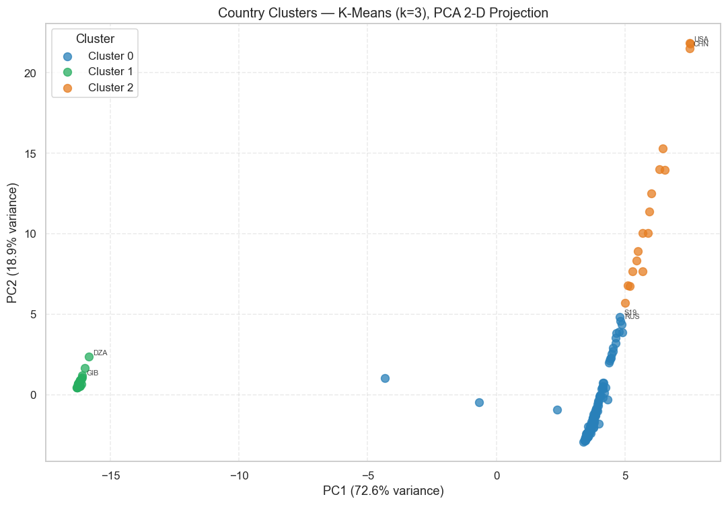
Figure 6.1 - Country clusters projected onto two principal components.

Algorithm | Silhouette Score | Davies-Bouldin | ARI vs K-Means
K-Means (k=3) | 0.7307 | 0.5038 | —
Agglomerative Ward (k=3) | 0.7403 | 0.4738 | 0.9567

Table 6.1 — Country clustering evaluation

6.2.3 Cluster Interpretation
Three strategically distinct market segments emerge from the country clustering:
- Cluster 0 — Emerging Growth Markets (166 countries): Moderate import scale, positive import growth slope (0.0233 average), moderate GDP per capita (~12,891 USD). Countries in this cluster include Vietnam, Poland, the UAE, Thailand, and Russia. These markets are growing and accessible; many have historical or geographic ties to Algeria.
- Cluster 1 — Niche and Restricted Markets (44 countries): Low import scale, very limited import growth (0.0019 slope), low opportunity rate (2.7%). Countries in this cluster include Algeria itself (appearing as an importer in the dataset), Gibraltar, Macao, and Turkmenistan. These markets offer limited expansion potential.
- Cluster 2 — Priority Large Markets (17 countries): Very high import scale (log 22.2), highest GDP per capita (~39,406 USD), highest opportunity rate (86.75%). This cluster contains the USA, China, Germany, Japan, UK, France, India, and other large OECD economies. These markets represent the highest absolute demand volumes globally.

6.2.4 Priority Market Ranking
A composite priority score combining import scale, opportunity rate, and import growth slope was computed for all 227 countries. The top 20 priority markets for Algerian non-hydrocarbon exporters, ranked by priority score, are:
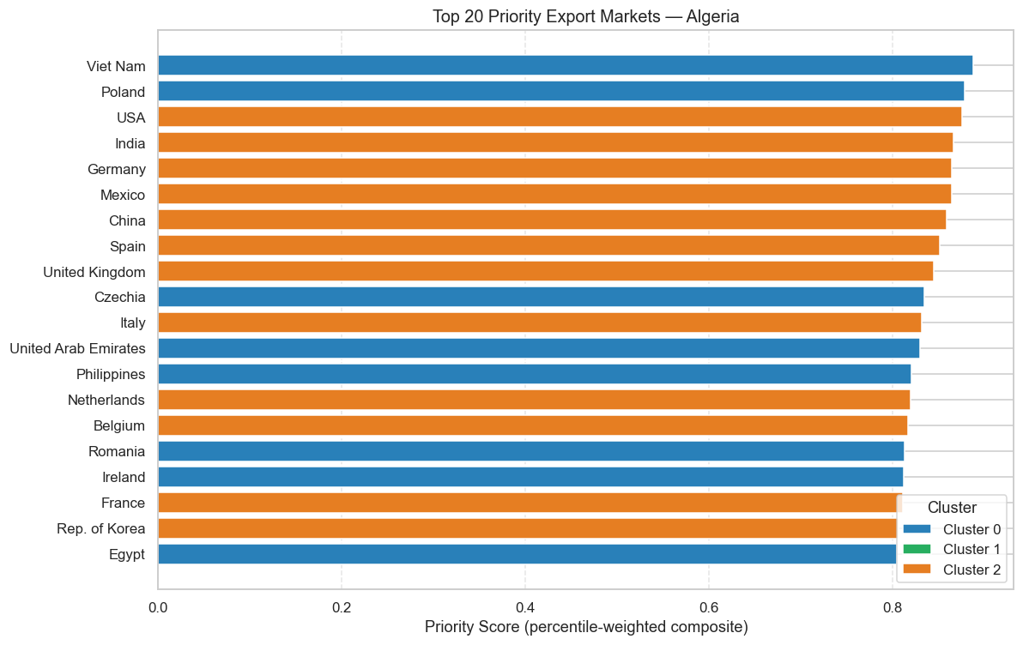
Figure 6.2 - Top priority markets from the clustering-based country ranking.

Rank | Country | ISO3 | Cluster | Opportunity Rate | Priority Score
1 | Viet Nam | VNM | 0 | 72.2% | 0.888
2 | Poland | POL | 0 | 90.7% | 0.879
3 | USA | USA | 2 | 95.4% | 0.876
4 | India | IND | 2 | 71.7% | 0.867
5 | Germany | DEU | 2 | 95.7% | 0.865
6 | Mexico | MEX | 2 | 85.5% | 0.865
7 | China | CHN | 2 | 88.2% | 0.859
8 | Spain | ESP | 2 | 91.4% | 0.852
9 | United Kingdom | GBR | 2 | 95.3% | 0.845
10 | Czechia | CZE | 0 | 77.6% | 0.835

Table 6.2 — Top 10 priority export markets (full ranking covers top 20)

6.3 Product Clustering

6.3.1 Results and Evaluation
Product clustering is performed on a 9-feature matrix representing each of the 5,196 HS6 products: log world import value, world import slope, median global demand log, demand volatility, log number of markets, market concentration, mean market penetration by Algeria, log maximum penetration, and opportunity rate. With k = 4, both algorithms achieve excellent separation scores:

Algorithm | Silhouette Score | Davies-Bouldin | ARI vs K-Means
K-Means (k=4) | 0.8685 | 0.3817 | —
Agglomerative Ward (k=4) | 0.8707 | 0.3182 | 0.8699

Table 6.3 — Product clustering evaluation

6.3.2 Product Cluster Interpretation
The four product clusters reveal a clear demand hierarchy:
- Cluster 0 — Low-Demand Niche Products (4,716 products): Small global market, few buyer countries. Represents the long tail of international trade — specialized goods with limited but sometimes stable demand.
- Cluster 1 — Moderate-Demand Commodities (78 products): Broad geographic spread, stable but slow-growing demand. Includes industrial materials and some agricultural commodities.
- Cluster 2 — High-Demand Growth Products (309 products): Large and expanding global market, high opportunity rate. This cluster contains electronics, pharmaceutical, and machinery products — the most strategically relevant for diversification.
- Cluster 3 — Strategic Opportunity Products (93 products): Strong Algeria penetration potential, rising demand slope. These are products where Algeria has some existing comparative advantage or trade presence and demand is growing.

6.4 Sector Clustering
Sector clustering at the HS2 level produces the highest quality scores of all three clustering analyses, with Silhouette Scores of 0.9265 (K-Means) and 0.9395 (Agglomerative), indicating highly compact and well-separated sector clusters. Three sector clusters are identified: a large dominant cluster of mainstream global trade sectors, a cluster of specialized high-value sectors (aircraft, industrial machinery, electronics), and a cluster of strategic commodity sectors. The ARI of 0.8891 confirms strong agreement between both algorithms.

6.5 Cross-Analysis
A cross-tabulation of opportunity rates by country cluster and product cluster reveals the highest opportunity density at the intersection of Cluster 2 countries (large markets) with Cluster 2 and 3 products (high-demand growth and strategic products). This cross-analysis provides actionable targeting guidance: Algerian exporters in priority product categories should prioritize outreach to Cluster 2 countries first, followed by high-growth Cluster 0 markets such as Vietnam and Poland.
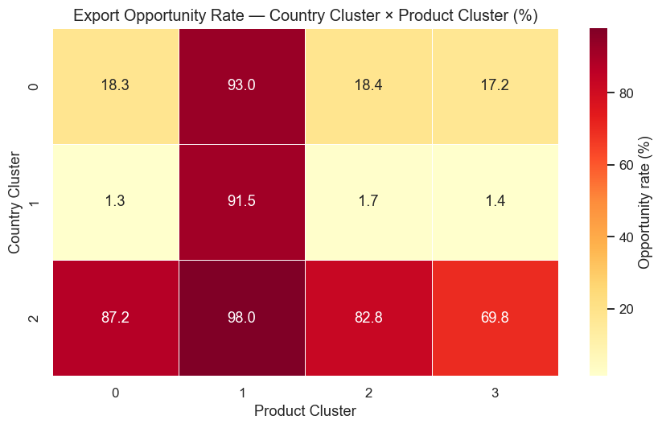
Figure 6.3 - Cross-cluster opportunity matrix showing priority country-product segment combinations.

7. Classification

7.1 Problem Formulation

7.1.1 Three-Class Opportunity Label
The binary label_opportunity variable from the master dataset is extended to a three-class label for more granular opportunity ranking. The three classes are: Class 0 (Low/No Opportunity) — low global demand and no existing Algerian export presence; Class 1 (Medium Opportunity) — moderate demand or some Algerian export history; Class 2 (High Opportunity) — high global demand, strong demand growth, and/or significant Algerian export potential based on RCA.
The class distribution is consistent across the three temporal splits, confirming that the labeling rule is stable over time. The training set contains approximately 9.4 million rows, with Class 0 comprising the majority (78–79%), followed by Class 1 (~15%) and Class 2 (~6%).

7.2 Feature Sets
Two feature tiers are defined for the classification task. The simple feature set uses 15 core BACI trade features available for all observations. The advanced feature set (ALL_FEATURES) uses all 36 engineered features including GeoDist geographic variables, World Bank macroeconomic indicators, lag features, and UNCTAD concentration measures. Tree-based models (Random Forest, XGBoost, LightGBM) use the advanced feature set directly from the Parquet splits. Logistic Regression uses a 31-feature scaled version produced by a median-impute + StandardScaler pipeline fitted on the training set.

7.3 Model Selection Rationale
Four models are compared, representing a spectrum from linear to highly non-linear:
- Logistic Regression (Baseline): a linear model with L2 regularization (C = 0.1) using the one-vs-rest strategy and the SAGA solver. It serves as a performance floor and interpretability reference.
- Random Forest: 200 trees with maximum depth 20 and sqrt feature sampling, trained with balanced class weights. Provides robust non-linear decision boundaries and natural feature importance.
- XGBoost: 300 trees with maximum depth 8, learning rate 0.1, L1 and L2 regularization, and histogram-based splits for computational efficiency on the large dataset. Class imbalance is addressed via sample weights.
- LightGBM: leaf-wise gradient boosting with 400 trees, maximum depth 8, learning rate 0.05, and class_weight='balanced'. LightGBM's leaf-wise strategy and efficient histogram implementation provide speed and accuracy advantages on large tabular datasets.

7.4 Results
Table 7.1 reports the test set performance for all four models on the held-out 2022–2023 data.
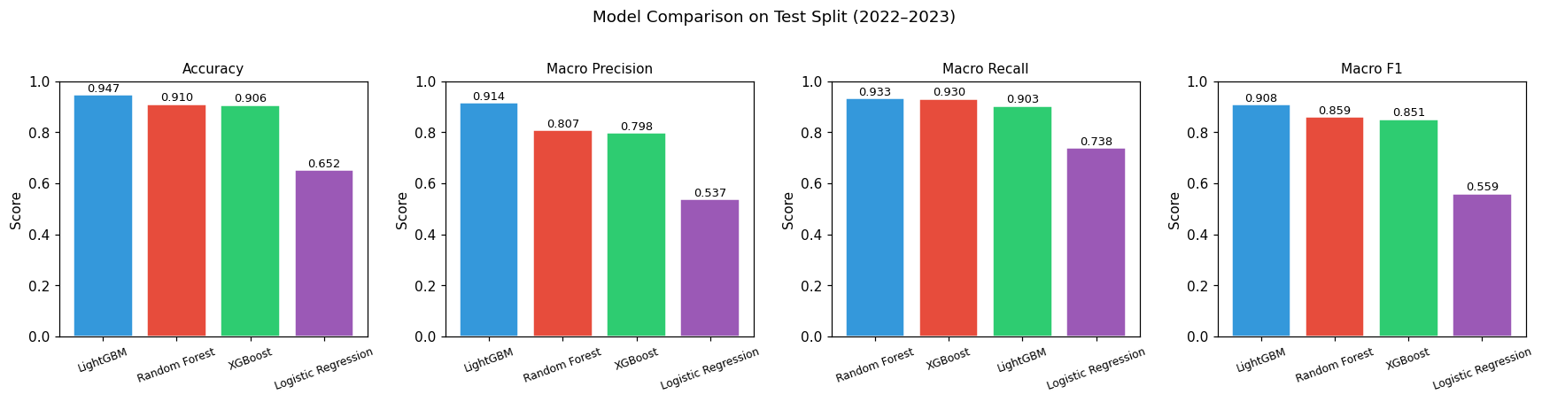
Figure 7.1 - Classification model comparison on the held-out test period.

Model | Accuracy | Macro Precision | Macro Recall | Macro F1
Logistic Regression | 0.6524 | 0.5366 | 0.7384 | 0.5595
Random Forest | 0.9100 | 0.8074 | 0.9330 | 0.8591
XGBoost | 0.9062 | 0.7976 | 0.9305 | 0.8511
LightGBM | 0.9468 | 0.9145 | 0.9029 | 0.9083

Table 7.1 — Classification model comparison on test set (2022–2023)

7.4.1 LightGBM — Best Model
LightGBM achieves the best overall performance with 94.68% accuracy and a macro F1-score of 0.9083. The per-class breakdown shows strong performance across all three opportunity tiers:

Class | Precision | Recall | F1-Score | Support
Low/No Opportunity | 0.96 | 0.97 | 0.97 | 1,854,568
Medium Opportunity | 0.89 | 0.83 | 0.86 | 348,889
High Opportunity | 0.89 | 0.91 | 0.90 | 155,527

Table 7.2 — LightGBM per-class performance on test set

7.4.2 Random Forest — Runner-up
Random Forest achieves 91.00% accuracy with a macro F1-score of 0.8591, demonstrating competitive performance. Its stronger recall (0.9330 macro) relative to LightGBM's (0.9029) means it captures more true opportunity cases at the cost of slightly lower precision — a trade-off that may be preferred in an exploratory opportunity identification setting where false negatives (missed opportunities) are more costly than false positives.

7.4.3 Logistic Regression — Baseline
Logistic Regression performs significantly below the tree-based models, achieving only 65.24% accuracy and a macro F1-score of 0.5595. While its recall is relatively high (0.7384), its precision is poor, particularly for the High Opportunity class (precision 0.27). This gap confirms that the export opportunity classification problem is inherently non-linear and cannot be adequately modeled with linear decision boundaries.

7.5 Feature Importance Analysis
Feature importance was computed for all three tree-based models and a consensus ranking was derived by averaging the rank each feature received across models (lower average rank = more important). The top features consistently ranked across Random Forest, XGBoost, and LightGBM are:
- global_demand_rank and global_demand_log: directly measure total world import demand for a product — the primary driver of opportunity classification.
- market_penetration: Algeria's current share of the target market — low penetration in a high-demand market signals untapped opportunity.
- world_demand_growth: growing markets provide more sustainable entry opportunities than stagnant ones.
- partner_import_v: the absolute size of the target market in the specific partner country.
- rca: Revealed Comparative Advantage — sectors where Algeria has RCA > 1 are better positioned for export.
- dist_km and gdp_per_capita: geographic proximity reduces trade costs; higher GDP per capita signals a market that imports higher-value goods.
- Lag features (alg_export_v_lag1, market_penetration_lag1): past trade trajectories are strong predictors of current classification.
These findings align with standard international trade theory (gravity model, comparative advantage, product complexity), confirming that the classification models are learning economically meaningful patterns rather than statistical artifacts.
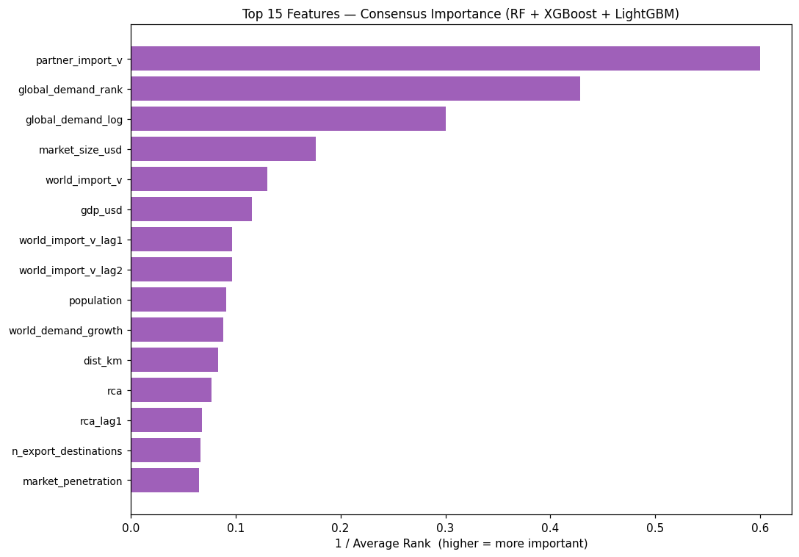
Figure 7.2 - Consensus feature-importance ranking across tree-based classifiers.

7.6 Export Opportunity Ranking Table
Using the best model (LightGBM), a ranked export opportunity table is generated from the test set (2022–2023). The table filters all test observations predicted as Class 2 (High Opportunity) and ranks them by a composite score combining the model's predicted probability, world demand rank, and RCA. This table, saved as classification_outputs/opportunity_rankings.csv, provides CACI and exporters with a directly actionable list of (country, product, sector) combinations ordered by estimated opportunity strength.

8. Forecasting

8.1 Forecasting Objective
The forecasting module predicts future import demand (partner_import_v) for selected country-product pairs over a three-year horizon (2024–2026). The target variable is the partner country's total imports of a specific HS6 product — a demand-side signal that captures how much of a given product a market absorbs, irrespective of Algeria's current export presence. This framing is deliberate: it identifies markets where demand is expected to grow even if Algeria does not yet export there.
Algeria's historical export value (alg_export_v) is retained as a contextual feature but is not the forecast target, as projecting Algeria's own exports would reflect historical supply constraints rather than true market opportunity.

8.2 Non-Hydrocarbon Scope
If the forecasting scope were defined purely by global import volume, petroleum oils (HS chapter 27) would dominate the analysis, transforming the project into a hydrocarbon price forecasting exercise — the opposite of the intended diversification focus. Accordingly, the default configuration excludes HS chapter 27 products and product descriptions containing terms such as petroleum, oils, gas, coal, or bituminous. The non-hydrocarbon scope is configurable; the INCLUDE_HYDROCARBONS flag can be set to True for a full all-products view when needed.

8.3 Sample Selection Strategy
A balanced country-product sample is constructed to prevent single products from dominating the forecasting panel. The selection algorithm first identifies the top 50 non-hydrocarbon products by total world import value over the study period, then selects the top 10 importing countries for each product. This produces a panel of 500 (product, country) time series covering 50 products and 49 distinct partner countries. Each series spans 12 years (2012–2023), giving a minimum of 8 training observations per series after the temporal split.
The top 10 selected products by total partner import value include: gold (HS 710812), electronic processors (HS 854231), other integrated circuits (HS 854239), passenger vehicles (HS 870323), medicaments (HS 300490), cellular telephones (HS 851712), memory circuits (HS 854232), iron ore concentrates (HS 260111), laptops (HS 847130), and blood fractions/antisera (HS 300210).

8.4 Forecasting Models

8.4.1 Baseline Models
Four baseline models and one optional statistical model are implemented to establish performance benchmarks: (1) Naive Baseline ? next period value equals last observed value; (2) Moving Average ? three-year trailing average; (3) Trend-Adjusted Naive ? last value adjusted by a clipped recent growth rate; (4) Simple Exponential Smoothing ? adaptive weighted average; and (5) ARIMA ? included when the statsmodels package is available. This design ensures that the selected model is compared against transparent, defensible alternatives rather than being evaluated in isolation.

8.4.2 Machine Learning Regressors
Three machine learning regressors are trained using lag features derived from the historical series: Random Forest (180 trees with min_samples_leaf=2), Gradient Boosting, and HistGradientBoosting (250 boosting iterations, learning rate 0.05, L2 regularization 0.01). Input features include target lags at t-1, t-2, and t-3; a three-year rolling mean; lagged growth rate; year; encoded series, country, and product identifiers; and available market indicators such as global demand rank, world demand growth, market penetration, and RCA. This lag-feature approach is appropriate for panel forecasting with limited temporal depth because it learns patterns across many country-product series rather than fitting a separate fragile model for each short annual series.

8.5 Time-Based Split and Evaluation
Forecasting uses the same temporal split as the classification task: training and validation periods (2012–2021) are used for model fitting, and the test period (2022–2023) is held out for final evaluation. This prevents the trivial leakage that would occur with random train-test splits in time series contexts.
Five evaluation metrics are reported: MAE (Mean Absolute Error), RMSE (Root Mean Squared Error), MAPE (Mean Absolute Percentage Error), sMAPE (Symmetric MAPE), and WMAPE (Weighted MAPE). MAPE is included for familiarity but is known to be unstable when actual trade values are near zero. WMAPE (which weights errors by actual values) and sMAPE (symmetric, bounded) are more reliable for heterogeneous trade data.

8.6 Results
Random Forest achieves the best performance by RMSE on the time-based test set. It is selected by the evaluation rule, not by preference: it outperforms the naive last-value baseline and the other implemented machine learning regressors on RMSE while remaining robust for short, noisy annual trade series.
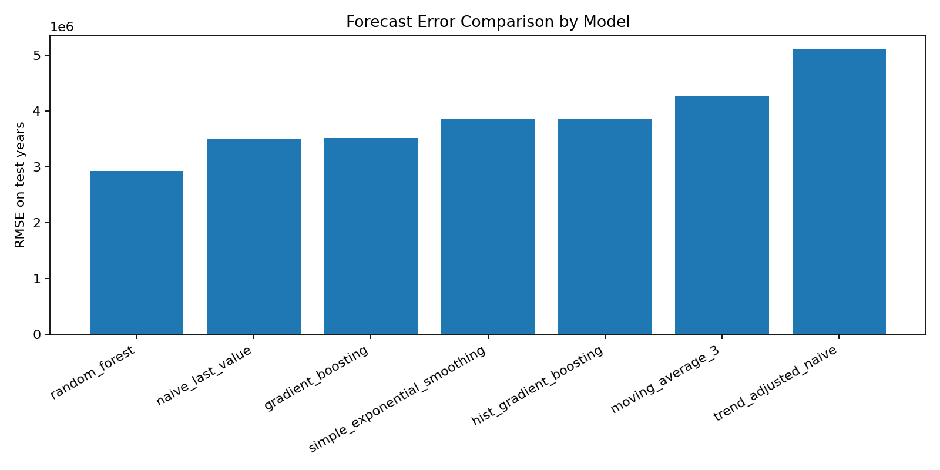
Figure 8.1 - Forecast error comparison across baselines and machine learning regressors.

Metric | Value | Interpretation
MAE | 1,357,026 USD | Average absolute forecast error per series-year
RMSE | 2,928,567 USD | Root mean squared error — sensitive to large errors
MAPE | 39.11% | Mean absolute percentage error (unstable near zero)
sMAPE | 19.54% | Symmetric MAPE — more stable for near-zero values
WMAPE | 15.19% | Weighted MAPE — recommended primary metric

Table 8.1 — Random Forest forecasting performance on test set (2022–2023)
The WMAPE of 15.19% is competitive for bilateral product-level trade forecasting, particularly given the relatively short time series (12 years) and the inherent volatility of bilateral trade flows at the HS6 level. Random Forest is selected as the final future-forecast model because it has the lowest RMSE in the current regenerated run. XGBoost is a valid extension candidate, but it usually requires more careful tuning of learning rate, tree depth, regularization, and early stopping; with short annual series, an aggressively tuned boosting model can overfit recent shocks. Any XGBoost replacement should therefore be judged against the same time-based test split and baseline models before being adopted.
The model comparison explicitly includes a naive last-value baseline and therefore answers the key validation question: the selected Random Forest model improves over simply repeating the previous year. ARIMA is also represented in the pipeline as arima_110_log; in the current regenerated environment it is skipped safely because statsmodels is not installed. Methodologically, ARIMA is less suitable as the main approach for this project because each annual country-product series has only about 12 observations, whereas the panel machine-learning approach can learn shared demand patterns across many series.
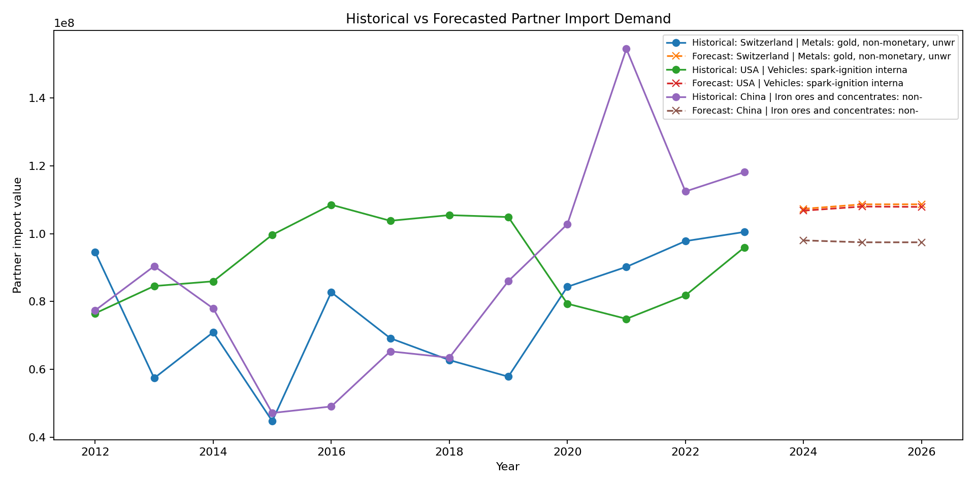
Figure 8.2 - Historical baseline and future forecasted partner import demand for representative high-value series.

8.7 Forecast Opportunity Scoring
A composite forecast opportunity score is computed for each of the 1,500 future forecast observations (500 series × 3 forecast years) using the following weighted formula:

score = 0.40 × normalized_forecasted_demand + 0.25 × normalized_predicted_growth_rate + 0.20 × normalized_global_demand_rank + 0.10 × normalized_rca + 0.05 × low_market_penetration_score
The weighting scheme prioritizes forecasted demand volume (40%) and predicted growth rate (25%) as the primary opportunity drivers, followed by global demand rank (20%) as a market quality indicator, RCA (10%) as a supply-side competitiveness signal, and low current market penetration (5%) as a bonus for untapped markets. This composite score enables ranking of the 1,500 forecast observations by overall opportunity attractiveness.

8.8 Top Forecasted Opportunities
The forecasting module produces three output tables: a ranked opportunity table (top 1,500 country-product-year combinations by forecast opportunity score), a priority country table (countries ranked by aggregated forecasted import demand), and a priority product table (products ranked by forecasted demand). These outputs are saved to data/forecast_outputs and constitute the primary forecasting inputs for both the Grafana dashboard database and the Streamlit backup dashboard.

9. Visualization Dashboard

9.1 Objectives and Target Users
The dashboard is designed to translate the machine learning outputs into actionable insights for three categories of stakeholders: CACI experts who need country-level and sector-level market overviews; individual exporters who need product-specific opportunity and demand information; and policymakers who need aggregate trends and forecasted growth trajectories to inform export promotion strategy.

9.2 Technology Choice: Grafana, SQLite, Streamlit, and Plotly
The project brief recommended Grafana or equivalent professional BI tools such as Apache Superset, Metabase, or Kibana. The final professional dashboard layer is therefore built around Grafana using a SQLite database generated from the model-output CSV files. Streamlit with Plotly is retained as a backup/live Python dashboard for rapid exploration, local validation, and demonstration if Docker, Grafana, or the SQLite plugin setup is unavailable.
- Professional BI compliance: Grafana satisfies the project requirement for a professional visualization platform and connects to the generated SQLite database through the SQLite data source plugin.
- Reproducible data layer: grafana/export_to_sqlite.py converts forecasting, clustering, and classification outputs into a single SQLite database, making the dashboard independent of notebook execution during presentation.
- Backup Python exploration: Streamlit's widget API enables quick interactive filtering by country, product, sector, year, forecast horizon, and model output, which is useful during development and examiner demonstrations.
- Low-friction fallback: Streamlit runs directly from dashboard/app.py and reads the same CSV outputs, reducing deployment risk if Grafana or Docker is unavailable on the presentation machine.
Table 9.1 compares the considered tools across key evaluation dimensions:

Criterion | Grafana + SQLite | Streamlit + Plotly | Apache Superset
Professional BI requirement | Strong | Backup/prototype | Strong
Python ML integration | Via SQLite export | Native | Via connector/API
Model output coverage | Forecasting, clustering, classification | Forecasting, clustering, classification, optional EDA | Depends on setup
Setup complexity | Medium/High (Docker + plugin) | Low (Python script) | High (server)
Interactive filtering | Dashboard panels | Python widgets/sidebar | Dashboard panels
Production suitability | High | Medium | High
Academic demo suitability | High | High | Medium

Table 9.1 — Dashboard technology comparison

9.3 Dashboard Architecture and Data Pipeline

9.3.1 Data Flow
The dashboard reads pre-computed CSV outputs from two directories: data/forecast_outputs/ (produced by Notebook 07) and data/eda_outputs/ (produced by Notebook 02). All heavy computation — model training, feature engineering, scoring — is performed offline in the notebooks. The dashboard is a read-only presentation layer that applies lightweight filtering and aggregation at display time.

9.3.2 Required Files
The six forecast output files are mandatory for the dashboard to launch: top_forecasted_opportunities.csv, priority_countries.csv, priority_products.csv, final_forecasts.csv, historical_forecast_comparison.csv, and forecast_model_metrics.csv. The nine EDA output files are optional — their panels are shown conditionally when the files exist. This graceful degradation design ensures the dashboard remains functional even if the EDA notebook has not been run.

9.3.3 Integration of Forecasting, Clustering, and Classification Outputs
The current dashboard data layer integrates all three model-output families. Forecasting outputs drive the ranked opportunity tables, growth charts, historical-vs-forecasted comparison, and forecast model performance panels. Clustering outputs provide cluster quality metrics, country/product/sector segment summaries, priority market rankings, and cross-cluster opportunity matrices. Classification outputs provide High/Medium/Low opportunity predictions, classifier comparison, feature importance, and top classified export opportunities. This resolves the earlier integration gap and makes the dashboard a unified presentation layer for the full machine learning workflow.

9.4 Dashboard Pages and Modules
The Streamlit backup dashboard is structured as a single-page multi-section application with thirteen sections accessible by scrolling, while the Grafana dashboard uses equivalent panels backed by SQLite tables and views:
- Section 1 — Executive Summary: key performance indicators (top opportunity score, forecasted demand volumes, best model WMAPE) and a high-level opportunity count by sector.
- Section 2 — Opportunities Explorer: filterable table of the top forecasted country-product opportunities, with sidebar controls for country, product, and sector selection.
- Section 3 — Priority Markets: bar chart of countries ranked by aggregate forecasted import demand.
- Section 4 — Priority Products: bar chart of products ranked by forecasted demand.
- Section 5 — Demand and Trade Flows: line chart of forecasted demand trajectories and volume comparisons.
- Section 6 — Growth and Potential: scatter or bar visualization of predicted growth rates by country or product.
- Section 7 — Historical vs. Forecasted: overlay of actual test-period values with model predictions for the best model.
- Section 8 — Forecast Model Performance: bar charts of RMSE and WMAPE by model, and the full metrics table.
- Section 9 — Historical EDA Context: partner demand by sector, opportunity counts by country and product, and the country-product demand heatmap.
- Section 10 — Sector-Level Analysis: aggregated forecasted value and average opportunity score by HS sector.
- Section 11 — Interpretation Guide: explanatory text for CACI experts, exporters, and policymakers on how to read and use the dashboard outputs.

9.5 HS Sector Mapping
The dashboard includes a hand-coded mapping from HS2 chapter codes to broad sector labels (Agriculture, Chemicals, Electronics, Pharmaceuticals, Transport, Base Metals, etc.), used throughout sector-level visualizations. This mapping is applied dynamically at display time by deriving the HS2 chapter from the first two digits of each HS6 product code.

10. Results and Economic Interpretation

10.1 Summary of Key Findings
The end-to-end system produces coherent and economically interpretable findings across all three machine learning tasks. The clustering, classification, and forecasting results are mutually consistent: the priority markets identified by country clustering (USA, Germany, UK, China, India, Spain) are also the markets with the highest classification opportunity rates and the largest forecasted demand volumes. This triangulation across independent methods strengthens confidence in the overall conclusions.

10.2 Top Export Opportunity Markets
The 20-country priority market ranking from clustering, corroborated by the classification and forecasting outputs, points to two distinct strategic market segments for Algerian non-hydrocarbon exporters:
Tier 1 — Large established importers: USA, Germany, China, UK, France, Italy, Spain, Japan, Netherlands, Belgium. These markets offer the highest absolute demand volumes and the broadest product range. Entry barriers (logistics, standards compliance, competition from established suppliers) are higher, but successful entry delivers large revenue potential.
Tier 2 — High-growth emerging importers: Vietnam, Poland, India, Mexico, UAE, Czechia, Philippines. These markets combine positive import growth trajectories with lower competitive intensity from established suppliers and, in some cases, geographic or historical proximity to Algeria. They represent more accessible near-term entry points.

10.3 High-Demand Non-Hydrocarbon Products for Algeria
The forecasting and classification results converge on a consistent set of high-priority non-hydrocarbon product categories. Electronic integrated circuits (HS 854231, 854239), medicaments (HS 300490), cellular network devices (HS 851712), passenger vehicles (HS 870323), laptops (HS 847130), and biopharmaceuticals (HS 300210) are among the top products by forecasted import demand. For most of these products, Algeria's current market penetration is near zero, reflecting the significant export capacity gap the system is designed to help close.
Among products where Algeria does have some existing export presence and a measurable RCA, fertilizers (HS chapter 31), iron and steel articles (chapter 73), food preparations (chapter 21), and dates (chapter 08) stand out as natural expansion candidates — markets where incremental growth builds on demonstrated competitiveness rather than requiring new entry from scratch.

10.4 Strategic Market Segments from Clustering
The sector clustering reveals that the highest-growth global demand is concentrated in Electronics (HS chapters 84–85), Pharmaceuticals (chapter 30), Transport (chapters 86–89), and Precision Instruments (chapter 90). Algeria's current RCA in these sectors is essentially zero, reflecting the structural challenge of the export diversification agenda. The high-demand sectors where Algeria has non-trivial trade presence — Chemicals, Minerals and Stone, and Base Metals — offer more immediate leverage for incremental diversification.

10.5 Forecasted Demand Trends 2024–2026
The Random Forest forecasting model projects continued demand growth in electronics, pharmaceuticals, and precision machinery through 2026 across the top partner markets. The WMAPE of 15.19% on the 2022–2023 test period suggests the model's 2024–2026 projections are reliable indicators of demand direction, though the absolute values carry uncertainty that grows with the forecast horizon.

10.6 Alignment with Algeria's Diversification Policy
The project's findings are directly actionable within the framework of Algeria's non-hydrocarbon export promotion policy. The priority market ranking, product opportunity scores, and sector-level demand projections provide a data-driven foundation for CACI and the Ministry of External Commerce to allocate promotional resources, prioritize trade mission destinations, identify product categories for quality certification investment, and monitor progress against diversification targets over time.

11. Discussion

11.1 Limitations

11.1.1 Data Availability
The most significant data limitation is the unavailability of official Algerian domestic export support data from CACI and the Ministry of External Commerce. Such data could provide ground-truth validation of the system's opportunity rankings against institutional knowledge and could supply additional features (export financing, trade agreements, non-tariff barrier information) that are known to influence market access. In the absence of this data, the system is built entirely on international trade flows and macroeconomic aggregates, which may miss sector-specific constraints on Algerian export capacity.
The UNCTAD diversification_index was 100% missing in the dataset version used and had to be excluded. This indicator would have provided a useful country-level complement to the HHI concentration measure. Future project iterations should investigate updated UNCTAD data releases.

11.1.2 Zero-Export Pair Assumptions
The labeling strategy assigns opportunity labels based purely on demand-side signals (partner import volumes) without conditioning on supply-side feasibility (whether Algeria actually produces a given product in exportable quantities). A market can be labeled as a high opportunity for, say, semiconductor chips, even though Algeria has no semiconductor manufacturing capacity. Future versions of the label could incorporate supply-side eligibility filters based on Algerian production statistics or HS chapter feasibility assessments.

11.1.3 Forecasting Horizon Uncertainty
The three-year forecast horizon (2024–2026) is inherently uncertain, particularly for products in fast-evolving technology sectors where demand trajectories can shift rapidly. The MAPE of 39% (unstable due to near-zero values) and WMAPE of 15.19% on the 2022–2023 test period provide a reasonable uncertainty estimate for the near term, but forecast reliability will decrease with the horizon. The system is best used as a directional decision-support tool rather than a precise revenue forecasting instrument.

11.1.4 Dashboard Deployment and Refresh Constraints
The current dashboard is connected to forecasting, clustering, and classification outputs, but deployment still depends on refreshing the saved CSV files and regenerating the SQLite database before presentation. In operational use, this refresh step should be automated so Grafana always reflects the latest model outputs without manual reruns.

11.2 Ethical Considerations
All data sources used in this project are publicly available and do not contain individual-level personal information. Trade data is reported at the country level (aggregate bilateral flows) and presents no privacy concerns. The system's outputs — opportunity rankings and market recommendations — are intended to support institutional export promotion policy, not to disadvantage individual countries or firms. No discriminatory criteria are embedded in the labeling or modeling procedures; all countries and products are treated symmetrically in the data pipeline.

11.3 Recommendations for Operational Use
For CACI and the Ministry of External Commerce, the following operational recommendations emerge from the system's outputs:
- Use the priority market ranking table (Chapter 6) to plan trade mission destinations, prioritizing Tier 2 high-growth markets (Vietnam, Poland, India, Mexico, UAE) for near-term outreach alongside continued engagement with Tier 1 large markets.
- Focus product promotion resources on the 309 products in the High-Demand Growth cluster (Cluster 2 from product clustering), particularly the electronics, pharmaceutical, and machinery categories where global demand growth is strongest.
- For products where Algeria has an existing RCA above 1 (fertilizers, some base metals, food products), use the classification opportunity ranking to identify specific under-served market-country combinations where penetration investment could yield near-term results.
- Monitor the forecast opportunity scores for the top 500 country-product series annually as new BACI data becomes available, updating the model with each additional year of observations.

11.4 Future Work
Several extensions would significantly enhance the system's value:
- Automated dashboard refresh: schedule the forecasting, clustering, classification, and SQLite export steps so Grafana updates automatically when new BACI data becomes available.
- Supply-side feasibility filter: incorporating Algerian production statistics or HS chapter feasibility scores to screen out theoretically attractive markets that Algeria cannot realistically supply.
- Non-tariff barrier data integration: adding tariff rates, trade agreement coverage, and non-tariff barrier indicators from the WTO or UNCTAD TRAINS database would improve the realism of opportunity assessments.
- Annual retraining pipeline: automating the data collection, feature engineering, and model retraining workflow with each new BACI data release to keep the system current.
- Grafana provisioning and access control: package the Grafana dashboard configuration, data source, and panel definitions so the system can be deployed reproducibly with multi-user access at CACI.

12. Conclusion
This report has presented a complete end-to-end machine learning system for identifying and forecasting international export opportunities for Algerian non-hydrocarbon exporters. The system integrates five publicly available datasets — BACI HS12 bilateral trade data, CEPII GeoDist, World Bank macroeconomic indicators, and UNCTAD diversification indices — into a unified 14.15 million row panel dataset spanning 12 years, 227 partner countries, and 5,196 HS6 products.
Three machine learning tasks were implemented and rigorously evaluated on temporally held-out test data. Clustering identified three strategically distinct country segments and four product demand tiers, producing a 20-country priority market ranking for Algerian non-hydrocarbon exporters. Classification trained four models and selected LightGBM as the best performer, achieving 94.68% accuracy and a macro F1-score of 0.9083 on the 2022–2023 test set — demonstrating that export opportunity classification at the bilateral HS6 product level is a tractable machine learning problem. Forecasting applied Random Forest regression to project import demand across 500 country-product series, achieving a WMAPE of 15.19% on the test period and generating 2024–2026 demand projections used for opportunity scoring.
The system's results are mutually consistent and economically interpretable. The priority markets identified by clustering — USA, Germany, UK, China, India, Spain, Vietnam, and Poland — are also the markets with the highest classification opportunity rates and the largest forecasted demand volumes. The feature importance analysis confirms that the classification models learn patterns grounded in standard international trade theory: market size, demand growth, market penetration, and revealed comparative advantage are the primary drivers of opportunity classification.
While limitations exist — notably the absence of supply-side feasibility filters and the incomplete integration of clustering and classification results into the dashboard — the system provides a solid, reproducible, and extensible foundation for data-driven export diversification support. With planned extensions to incorporate non-tariff barrier data, annual retraining workflows, and a production-grade dashboard, this system could serve as a practical decision-support tool for the Algerian Chamber of Commerce and Industry and the Ministry of External Commerce in their effort to expand and diversify Algeria's international trade footprint.

References
Balassa, B. (1965). Trade Liberalisation and Revealed Comparative Advantage. The Manchester School, 33(2), 99–123.

CEPII. (2023). BACI: International Trade Database at the Product-Level. Centre d'Etudes Prospectives et d'Informations Internationales. http://www.cepii.fr/CEPII/en/bdd_modele/bdd_modele_item.asp?id=37

CEPII. (2011). GeoDist: A Gravity Equation Database. http://www.cepii.fr/CEPII/en/bdd_modele/bdd_modele_item.asp?id=6

Chen, T., & Guestrin, C. (2016). XGBoost: A Scalable Tree Boosting System. Proceedings of the 22nd ACM SIGKDD International Conference on Knowledge Discovery and Data Mining, 785–794.

Ke, G., Meng, Q., Finley, T., Wang, T., Chen, W., Ma, W., ... & Liu, T. Y. (2017). LightGBM: A Highly Efficient Gradient Boosting Decision Tree. Advances in Neural Information Processing Systems, 30.

Hidalgo, C. A., & Hausmann, R. (2009). The Building Blocks of Economic Complexity. Proceedings of the National Academy of Sciences, 106(26), 10570–10575.

International Trade Centre. (2023). Export Potential Map: Methodology. https://exportpotential.intracen.org/

Mayer, T., & Zignago, S. (2011). Notes on CEPII's Distances Measures: The GeoDist Database (CEPII Working Paper No. 2011-25). CEPII.

Pedregosa, F., et al. (2011). Scikit-learn: Machine Learning in Python. Journal of Machine Learning Research, 12, 2825–2830.

UNCTAD. (2023). Trade Structure and Diversification Statistics. https://unctadstat.unctad.org/

World Bank. (2023). World Development Indicators. https://data.worldbank.org/

Appendices

Appendix A — Full Feature List

Feature | Source | Description
alg_export_v | BACI | Algeria's bilateral export value (thousand USD, log1p scale)
partner_import_v | BACI | Partner country's total imports of product k (thousand USD)
world_import_v | BACI | Total world imports of product k (thousand USD)
alg_export_growth | BACI | YoY growth rate of Algeria's exports (log scale)
world_demand_growth | BACI | YoY growth rate of world imports of product k
global_demand_log | BACI | Log-transformed total world import value for product k
global_demand_rank | BACI | Percentile rank of global demand (0–1)
market_penetration | BACI | Algeria's share of partner's imports of product k
trade_balance_bilateral | BACI | Algeria exports minus imports for each product-partner pair
trade_coverage_ratio | BACI | Algeria exports divided by imports (product-partner)
n_export_destinations | BACI | Number of distinct countries Algeria exports product k to
rca | BACI | Revealed Comparative Advantage (Balassa index)
alg_export_v_lag1/2 | BACI | Lagged Algeria export values at t-1 and t-2 (log1p)
market_penetration_lag1/2 | BACI | Lagged market penetration at t-1 and t-2
world_import_v_lag1/2 | BACI | Lagged world import value at t-1 and t-2
rca_lag1/2 | BACI | Lagged RCA values at t-1 and t-2
dist_km | CEPII | Distance between capital cities (km)
distw_km | CEPII | Population-weighted bilateral distance (km)
contig | CEPII | 1 if countries share a land border
comlang_off | CEPII | 1 if countries share an official language
comlang_ethno | CEPII | 1 if countries share a common ethno-linguistic group
colony | CEPII | 1 if colonial relationship ever existed
comcol | CEPII | 1 if countries share a common colonizer
smctry | CEPII | 1 if countries were once the same country
gdp_usd | World Bank | GDP in current USD
population | World Bank | Total population
trade_pct_gdp | World Bank | Trade as percentage of GDP
gdp_per_capita | World Bank | GDP per capita in current USD
market_size_usd | World Bank | Composite: GDP × trade openness
hhi_export | UNCTAD | Herfindahl-Hirschman Index of Algeria's export concentration

Appendix B — Model Hyperparameter Configurations

Model | Key Hyperparameters
Logistic Regression | multi_class=ovr, solver=saga, C=0.1, class_weight=balanced, max_iter=300
Random Forest | n_estimators=200, max_depth=20, max_features=sqrt, class_weight=balanced, n_jobs=-1
XGBoost | n_estimators=300, max_depth=8, learning_rate=0.1, subsample=0.8, colsample_bytree=0.8, reg_alpha=0.1, reg_lambda=1.0, tree_method=hist
LightGBM | n_estimators=400, max_depth=8, learning_rate=0.05, num_leaves=63, subsample=0.8, colsample_bytree=0.8, class_weight=balanced
Forecasting RF | n_estimators=100, random_state=42, n_jobs=-1

Appendix C — Notebook Pipeline Summary

Notebook | Purpose | Key Output
01_build_master_dataset.ipynb | Data integration and feature engineering | data/master_df.parquet (14.15M rows × 50 cols)
02_data_cleaning_eda.ipynb | Data cleaning, EDA, preprocessing pipeline | data/modeling/ splits, data/eda_outputs/ CSVs
04_classification.ipynb | 3-class opportunity classification | data/classification_outputs/ (rankings, metrics, confusion matrices)
05_clustering.ipynb | Country, product, and sector clustering | data/clustering_outputs/ (cluster labels, priority rankings)
07_forecasting.ipynb | Demand forecasting and opportunity scoring | data/forecast_outputs/ (forecasts, metrics, ranked opportunities)
app.py | Streamlit backup/live interactive dashboard | dashboard/app.py reading forecast, clustering, classification, and optional EDA outputs
grafana/export_to_sqlite.py | Grafana SQLite data export layer | data/grafana/export_opportunities.db with forecasting, clustering, and classification tables/views

