tabs-item  Type：2 | 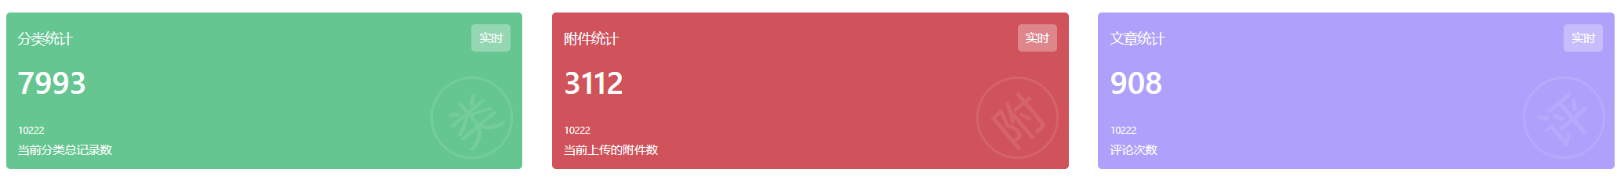  https://avuex.avue.top/#/doc/data1
mount-item
Type：4
amount-item
Type：3
general-item  type：5 | 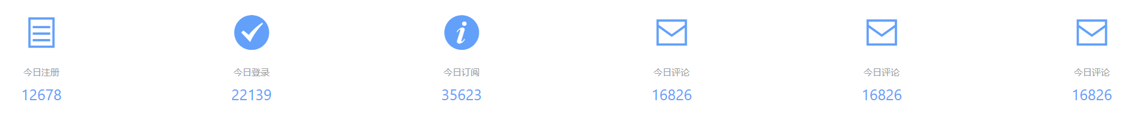
 | 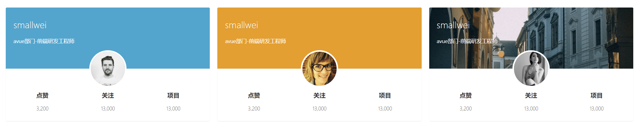
ratio-item
type：9
number-item  Type：1 | 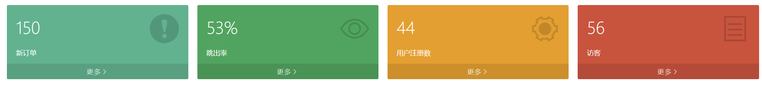
 | 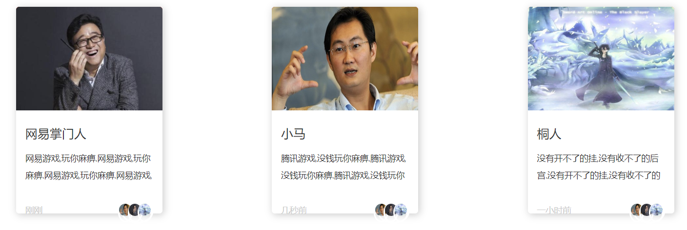
zk-data-option | 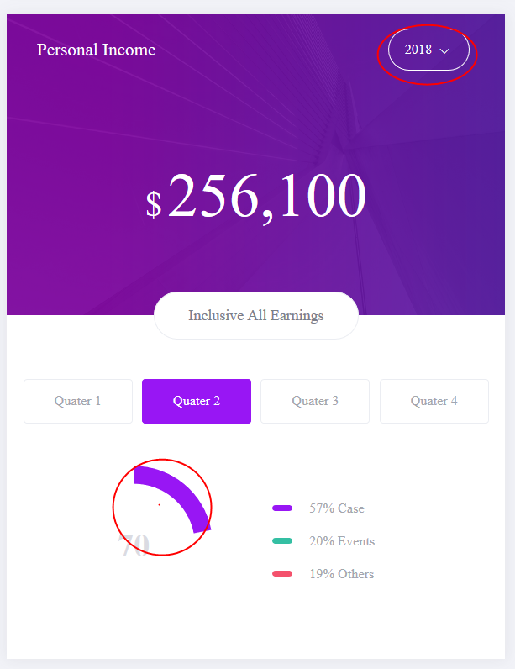
 | 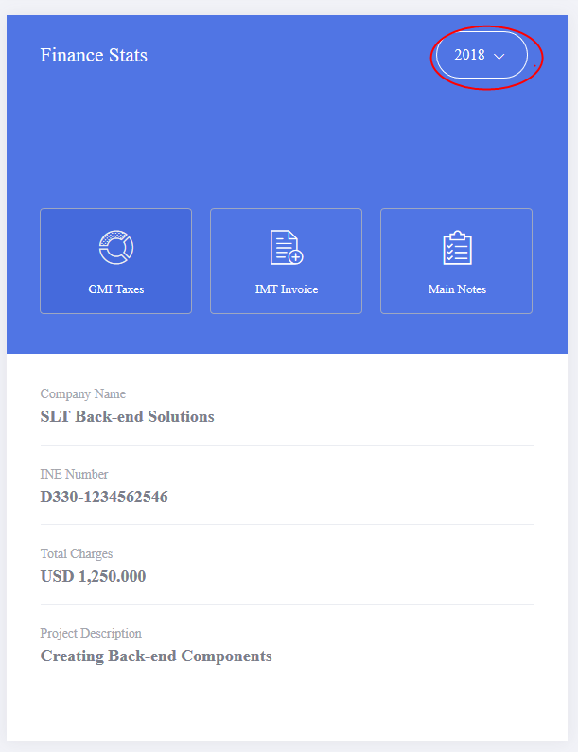
 | 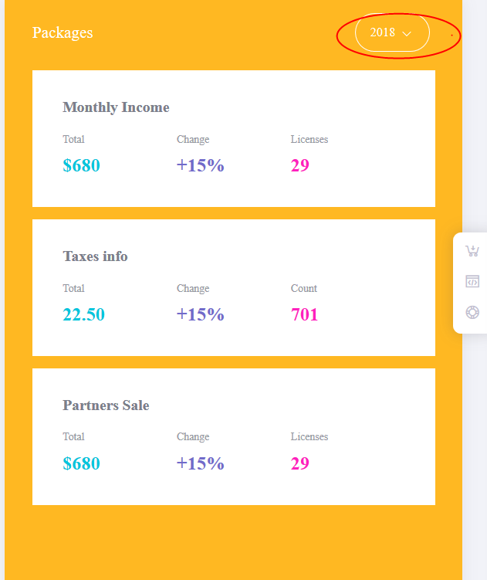
member-item  type：8 | 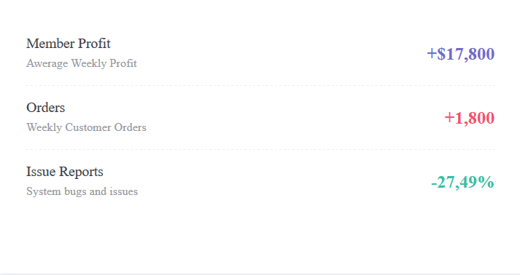  http://ui.5ug.com/metronic_v5.5.5/theme/default/dist/default/index.html
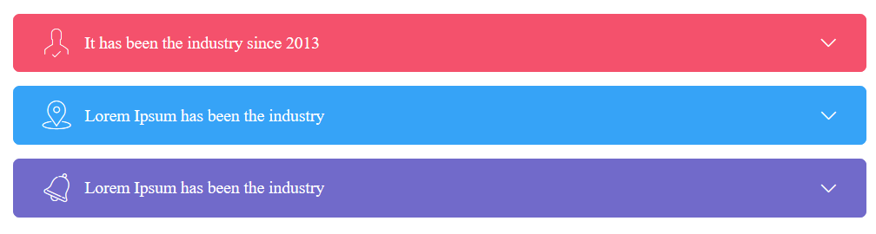
http://ui.5ug.com/metronic_v5.5.5/theme/default/dist/default/components/base/accordions.html
growing-item  type：6 | 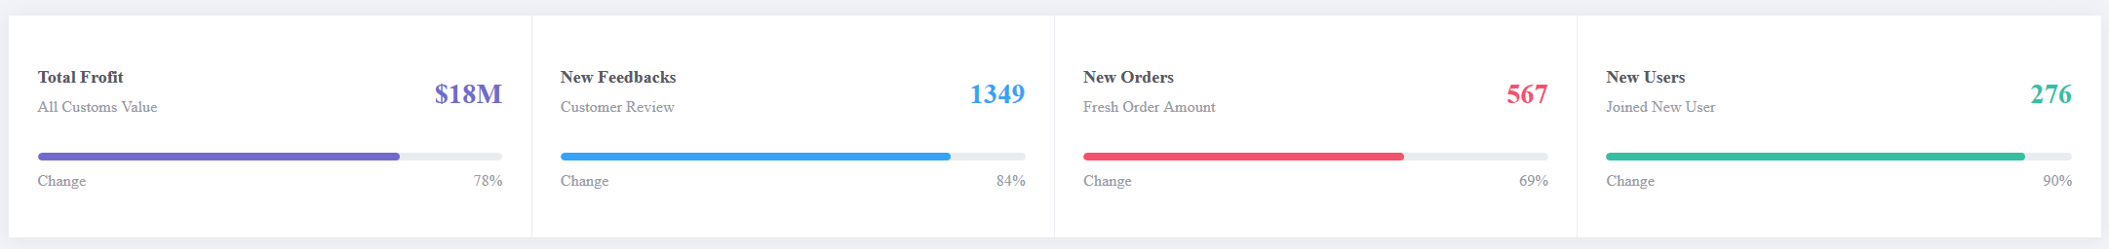  http://ui.5ug.com/metronic_v5.5.5/theme/default/dist/default/components/widgets/general.html
total-item  type：11 | 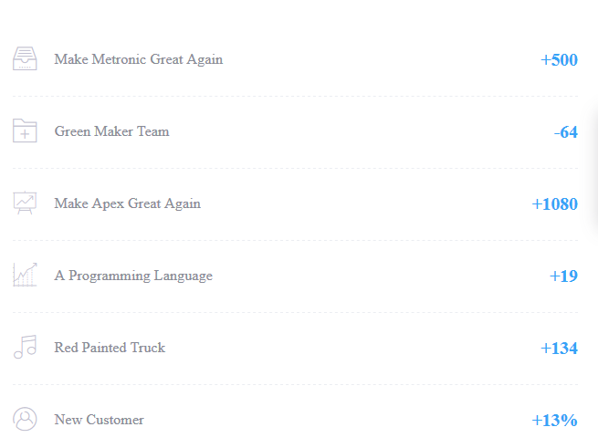
 | 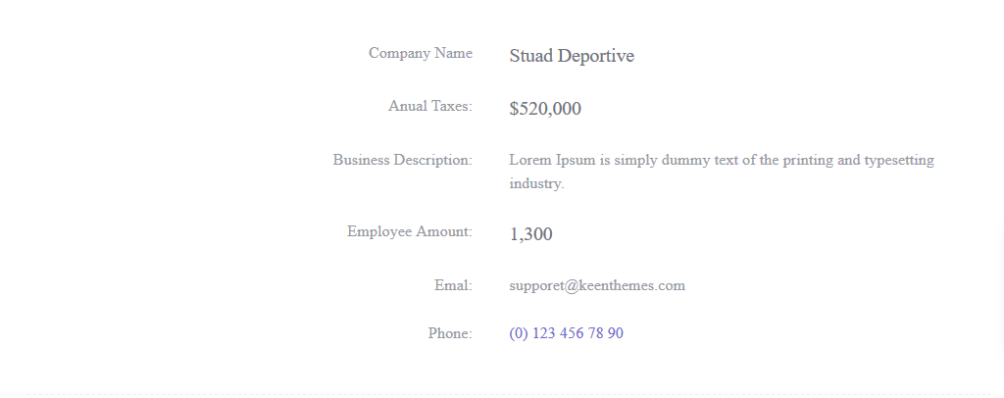
 | 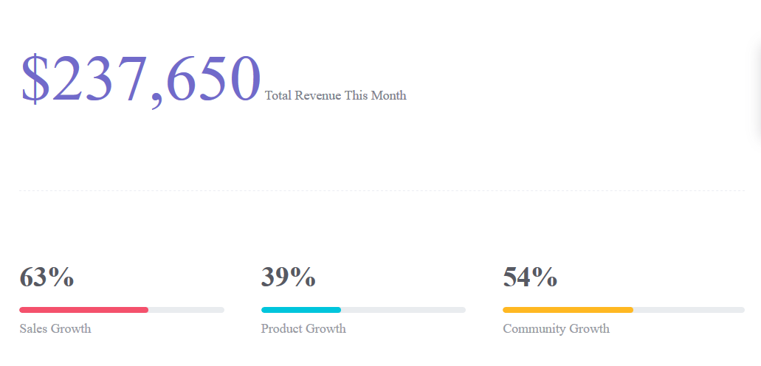
introduce-item  type：7 | 