Brand Research - SingleParentMeet.com
Current Brand 2
Problems/Opportunities 2
Brand Related Stats 2
Quantcast 2
Comscore 2
Demo Related Stats 3
US Census Data (on demo if available) 3
Wikipedia.com 3
Google “single parents” “single parent dating” 4
Organic 4
Paid 4
Blogs 4
Popular Media Consumed by Demo 6
Websites (comScore) 6
Movies 13
Magazines 13
Television Shows 16
Events Attended (optional) 16
Psychographics 17
New Beginnings 17
Family Thrifts: 19
Kids & Cul de Sacs: 21
Kid Country USA: 23
Additional Psychographic Findings 24
Earn Income Online 24
Life-Balancing Act 24
Key Findings 25
Demo 25
Consumer Tastes 25
Other 25
New Brand Features 26
Target - Single Parents 26
Mood 26
Adjectives 26
Photos 27
Colors 30
Font Styles 33
Visuals 33
Textures/Patterns 34
Attachments 39
Site Samples 39
More Research 40

Current Brand

Problems/Opportunities
- No branding
- Small, relatively inactive community

Brand Related Stats

Quantcast
- Gender: 55% male, 45% female
- Age: 9% 3-11,16% 12-17 ,18% 18-34,36% 35-49 ,21% 50+
- Race: 78% Caucasian, 10% Afr. Amer., 8% Hispanic, 1% Asian, 1% Other
- Children 6-17: 43% Have Children, 57% No Children
- Household Income: 22% 0-30K, 32% 30-60, 22% 60-100, 21% 100+
- Education: 50% No College, 40% College, 10% Graduate
- Traffic: 7,337,482 visits, 452,339 visitors

Comscore
NA

Demo Related Stats

US Census Data (on demo if available)
- Percentage of singleparent children living with single mother: 23% (with highest percentages Afr. Amer. and Hispanic)
- Percentage of singleparent children living with father: 5% (with highest percentages Afr. Amer. and Hispanic)
- Source: http://www.census.gov/prod/2003pubs/p20-547.pdf

Wikipedia.com
- http://en.wikipedia.org/wiki/Single_parents
- higher risk of poverty
- There are various websites available, offering discussion forums and helpful advice to those parents who find themselves alone. Other websites help by offering single parents to support each other while also providing highly useful links to various solicitors, counselors and financial advisers in any area of the UK. Only Dads and Only Mums are examples of such websites, with link SingleWithKids offering not only support and advice, but also a large range of activities and events exclusively for single parent families.
- Unexpected Friends is a 501(c)3, non-profit organization that reaches out to working single parents and their families.
- A choice parent is a parent who voluntarily becomes a single parent to a biologic child from the very beginning, rather than by a later separation from a partner. Sometimes, it also includes becoming a single parent by adoption

Google “single parents” “single parent dating”

Organic
- http://singleparents.about.com/
- http://www.singleparentsnetwork.com/
- http://www.singleparentsmingle.com/
- http://en.wikipedia.org/wiki/Single_parent
- http://kidshealth.org/kid/feeling/home_family/single_parents.html
- http://www.singleparentmeet.com/
- http://www.singleparents.org/
- http://www.parentswithoutpartners.org/
- http://www.parentsworld.com/
- http://www.singleparentmatch.com/

Paid
- http://www.singleparentmeet.com
- http://www.singleparentlove.com
- http://www.singlemomsanddads.com/
- http://www.onlinedaterprofile.com/
- http://www.eharmony.com
- http://www.match.com/
- http://www.mormon.org/mormonorg/eng/basic-beliefs/membership-in-christ-s-church/forever-families
- http://www.elitepersonalsearch.com
- http://www.happyhealthyhip.com/
- http://www.knowledgeocity.com/lifestyle.html
- http://www.grantkit.org/singlemothers.htm

Blogs
- http://single-parenting.families.com/blog/
- http://singleparentsunite.blogspot.com/
- http://smart-single-parents.blogspot.com/
- http://www.singleparentcenter.net/
- http://www.parenting-child-development.com/
- http://www.fathermag.com/
- http://mvparents.blogspot.com/

Popular Media Consumed by Demo

Websites (comScore)
- ?
- http://www.myfamily.com (social media) 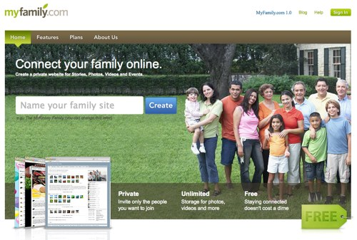
- http://www.loveandlogic.com/ 
- http://familyfun.go.com/ (Disney) 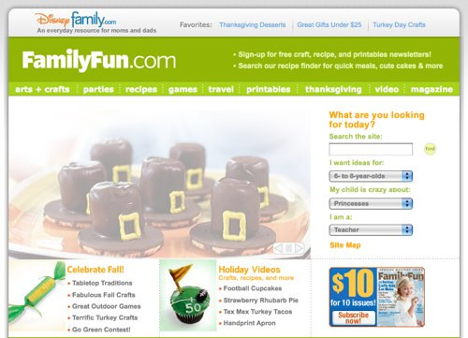
- http://www.crayola.com/ 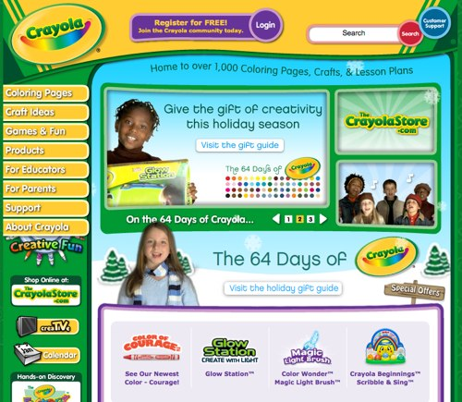
- http://pbskids.org/ 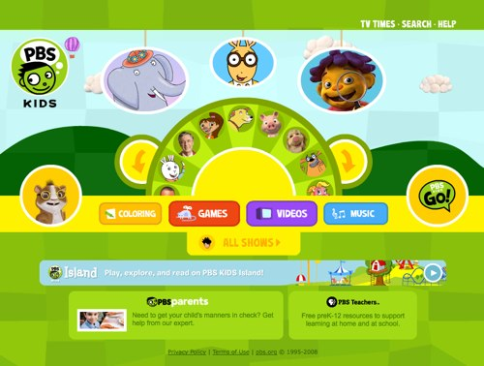
- http://www.families.com/ 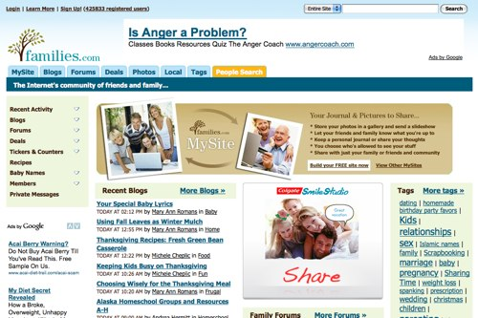
- http://www.familycorner.com/ 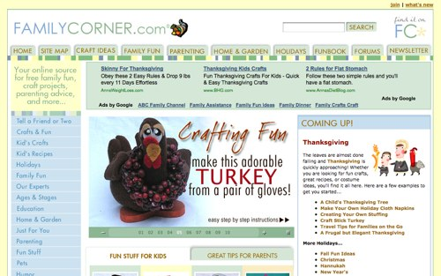
- http://www.parents-talk.com/
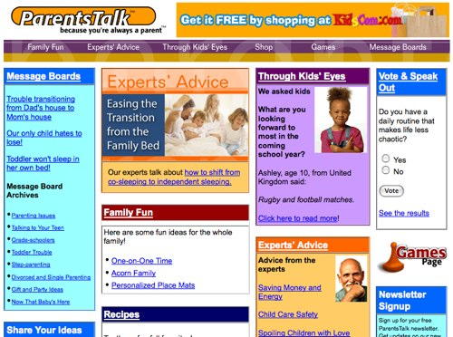

Movies
- Disney
- ?

Magazines
- http://www.parenting.com/ 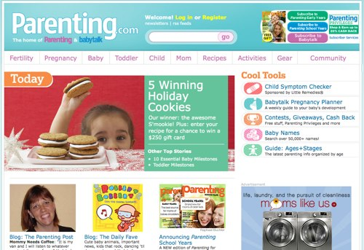
- http://www.parents.com 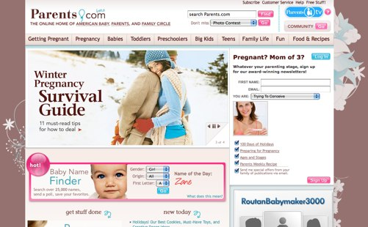
- http://www.workingmother.com 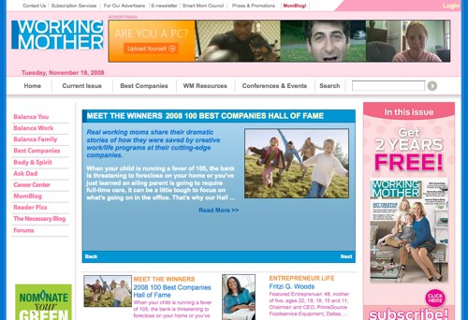
- http://www.spmagazine.net 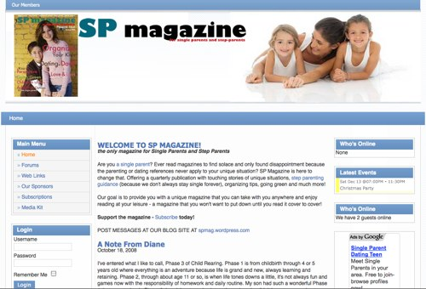
- http://www.parenting.com/Babytalk/ 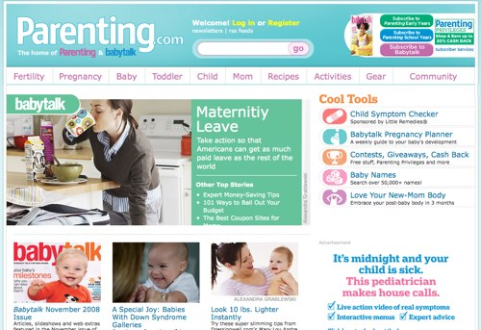
- http://www.familycircle.com/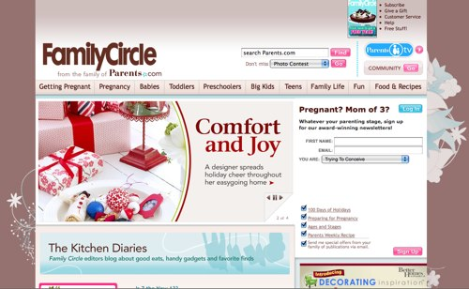

Television Shows
- Oprah
- Ellen
- Dancing With the Stars
- ??

Events Attended (optional)
- ??

Psychographics

New Beginnings
- http://www.claritas.com/MyBestSegments/Content/tabs/loadMenu.jsp?id2=44
- Downscale, Younger Mix
Filled with young, single adults, New Beginnings is a magnet for adults in transition. Many of its residents are twentysomething singles and couples just starting out on their career paths--or starting over after recent divorces or company transfers. Ethnically diverse--with more than half its residents Hispanic, Asian, or African-American--New Beginnings households tend to have the modest living standards typical of transient apartment dwellers.
- 2007 Statistics:
US Households: 1,703,233 (1.50%)
Median HH Income: $31,109
Lifestyle Traits
# Go to the movies 4+ times/month
# Read Jet
# WWE Magazine (wrestling)
# Jerry Springer TV
# Kia Spectra
- Demographics Traits:
Urbanicity: Suburban
Income: Downscale
Income Producing Assets: Low
Age Ranges: Age <35
Presence of Kids: Family Mix
Homeownership: Renters
Employment Levels: White Collar, Mix
Education Levels: Some College
Ethnic Diversity: White, Black, Asian, Hispanic
- Social Group: Inner Suburbs
  - The four segments in the Inner Suburbs social group are concentrated in the inner-ring suburbs of major metros-areas where residents tend to be high school educated, unmarried and lower-middle class. There's diversity in this group, with segments that are racially mixed, divided evenly between homeowners and renters and filled with households that are either young or aging in place. However, the consumer behavior of the S4 segments are dominated by older Americans who enjoy social activities at veterans clubs and fraternal orders, TV news and talk shows, and shopping at discount department stores.
  - 2007 Statistics:
US Households: 5,131,894
Median HH Income: $32,391
- Lifestage Group: Striving Singles
  - The seven segments in Striving Singles make up the most downscale of the Younger Years class. Centered in exurban towns and satellite cities, these twentysomething singles typically have low incomes-often under $25,000 a year-from service jobs or part-time work they take on while going to college. Housing for this group consists of a mix of cheap apartment complexes, dormitories and mobile homes. As consumers, the residents in these segments score high for outdoor sports, movies and music, fast food and inexpensive cars.
  - 2007 Statistics:
US Households: 12,154,827
Median HH Income: $33,350

Family Thrifts:
- http://www.claritas.com/MyBestSegments/Content/tabs/loadMenu.jsp?id2=63
- Lower-Mid, Younger w/ Kids
The small-city cousins of inner-city districts, Family Thrifts contain young, ethnically diverse parents who have lots of children and work entry-level service jobs. In these apartment-filled neighborhoods, visitors find the streets jam-packed with babies and toddlers, tricycles and basketball hoops, Daewoos and Hyundais.
- 2007 Statistics:
US Households: 1,895,774 (1.67%)
Median HH Income: $29,787
Lifestyle Traits
# Buy rap music
# Eat fast food
# Vibe magazine
# Toon Disney channel
# Kia Spectra
- Demographics Traits:
Urbanicity: Second City
Income: Lower-Mid
Income Producing Assets: Low
Age Ranges: Age 25-44
Presence of Kids: HH w/ Kids
Homeownership: Mix, Renters
Employment Levels: WC, Service, Mix
Education Levels: High School Grad
Ethnic Diversity: White, Black, Hispanic
- Social Group: Micro-City Blues
  - Micro-City Blues was created via the predominantly downscale residents living in the affordable housing found throughout the nation's smaller cities. A diverse social group, these five segments contain a mix of old and young, singles and widowers, whites, African-Americans and Hispanics. Most of the workers hold blue-collar jobs-hence the name-and their marketplace behavior reflect the segments' varied lifestyles. This is one of the few social groups where consumers have a high index for video games and bingo, aerobic exercise and fishing, BET and the Country Music Network.
  - 2007 Statistics:
US Households: 6,943,109
Median HH Income: $26,846
- Lifestage Group: Sustaining Families
  - Sustaining Families is the least affluent of Family Life groups, an assortment of segments that range from working-class to decidedly downscale. Ethnically mixed, with a high percentage of African American, Asian and Hispanic families, these segments also display geographic diversity-from inner cities to some of the most isolated communities in the nation. Most adults hold blue-collar and service jobs, earning wages that relegate their families to small, older apartments and mobile homes. And the lifestyles are similarly modest: Households here are into playing games and sports, shopping at discount chains and convenience stores, and tuning into nearly everything that airs on TV and radio.
  - 2007 Statistics:
US Households: 6,827,045
Median HH Income: $27,997

Kids & Cul de Sacs:
- http://www.claritas.com/MyBestSegments/Content/tabs/loadMenu.jsp?id2=18
- Upper-Mid, Younger w/ Kids
Upper-middle class, suburban, married couples with children--that's the skinny on Kids & Cul-de-Sacs, an enviable lifestyle of large families in recently built subdivisions. With a high rate of Hispanic and Asian Americans, this segment is a refuge for college-educated, white-collar professionals with administrative jobs and upper-middle-class incomes. Their nexus of education, affluence, and children translates into large outlays for child-centered products and services.
- 2007 Statistics:
US Households: 1,853,880 (1.63%)
Median HH Income: $70,490
Lifestyle Traits
# Shop at The Disney Store
# Go to Chuck E. Cheese
# Parenting magazines
# Nickelodeon TV
# Nissan Armada SUV
- Demographics Traits:
Urbanicity: Suburban
Income: Upper-Mid
Income Producing Assets: Moderate
Age Ranges: Age 25-44
Presence of Kids: HH w/ Kids
Homeownership: Mostly Owners
Employment Levels: White Collar, Mix
Education Levels: College Grad
Ethnic Diversity: White, Asian, Hispanic, Mix
- Social Group: The Affluentials
  - The six segments in The Affluentials are one socioeconomic rung down from the Elite Suburbs-with a 25 percent drop in median income-but their residents still enjoy comfortable, suburban lifestyles. The median income in S2 is nearly $60,000, the median home value is about $200,000, and the mostly couples in this social group tend to have college degrees and white-collar jobs. Asian Americans make up an important minority in these predominantly white segments. As consumers, The Affluentials are big fans of health foods, computer equipment, consumer electronics and the full range of big-box retailers.
  - 2007 Statistics:
US Households: 8,774,470
Median HH Income: $69,830
- Lifestage Group: Young Accumulators
  - Compared to the Accumulated Wealth group, the five segments in Young Accumulators are slightly younger and less affluent than their upscale peers. Ethnically diverse, these households include an above-average number of Hispanic and Asian Americans. Adults typically have college educations and work a mix of white-collar managerial and professional jobs. Found mostly in suburban and exurban areas, the large families in Young Accumulators have fashioned comfortable, upscale lifestyles in their mid-sized homes. They favor outdoor sports, kid-friendly technology and adult toys like campers, powerboats and motorcycles. Their media tastes lean towards cable networks targeted to children and teenagers.
  - 2007 Statistics:
US Households: 9,182,666
Median HH Income: $69,332

Kid Country USA:
- http://www.claritas.com/MyBestSegments/Content/tabs/loadMenu.jsp?id2=50
- Lower-Mid, Younger w/ Kids
Widely scattered throughout the nation's heartland, Kid Country, USA is a segment dominated by large families living in small towns. Predominantly white, with an above-average concentration of Hispanics, these young, working-class households include homeowners, renters, and military personnel living in base housing; about 20 percent of residents own mobile homes.
- 2007 Statistics:
US Households: 1,529,683 (1.35%)
Median HH Income: $42,353
Lifestyle Traits
# Buy kids' bicycles
# Buy swingsets
# Baby Talk magazine
# Toon Disney channel
# Mazda Pickup
- Demographics Traits:
Urbanicity: Town
Income: Lower-Mid
Income Producing Assets: Low
Age Ranges: Age 25-44
Presence of Kids: HH w/ Kids
Homeownership: Mix, Owners
Employment Levels: BC, Service, Mix
Education Levels: High School Grad
Ethnic Diversity: White, Black, Hispanic
- Social Group: Middle America
  - The six segments in Middle America are filled with middle-class homeowners living in small towns and remote exurbs. Typically found in scenic settings throughout the nation's heartland, Middle Americans tend to be white, high school educated, living as couples or larger families, and ranging in age from under 25 to over 65. Like many residents of remote communities, these conservative consumers tend to prefer traditional rural pursuits: fishing, hunting, making crafts, antique collecting, watching television and meeting at civic and veterans clubs for recreation and companionship. Friday nights are for celebrating high school sports.
  - 2007 Statistics:
US Households: 11,455,903
Median HH Income: $43,316
- Lifestage Group: Mainstream Families
  - Mainstream Families refers to a collection of seven segments of middle- and working-class child-filled households. While the age range of adults is broad-from 25 to 54-most families have at least one child under 18. And residents in this exurban group share similar consumption patterns, living in modestly priced homes-including mobile homes-and ranking high for owning three or more cars. As consumers, Mainstream Families maintain lifestyles befitting large families in the nation's small towns: lots of sports, electronic toys, groceries in bulk and televised media.
  - 2007 Statistics:
US Households: 13,600,364
Median HH Income: $46,252

Additional Psychographic Findings

Earn Income Online
- Single parents are turning to supplemental, second income sources via internet marketing at astounding rates and it’s no wonder. Most single parents are living below the poverty level, most are struggling just to have food in the house, let alone afford such luxuries as a good running vehicle, a vacation (away from the home), or even new outfit to wear to a job interview. http://www.associatedcontent.com/article/39108/supplemental_income_source_for_single.html?cat=31

Life-Balancing Act
- Struggling with Life-Balance Mix. Concerned about losing patience and eating well. Always looking for an edge in time management. Very efficient, multi-taskers. Finds it difficult to ask for help. http://www.singleparentcenter.net/facts-about-single-parenting.html

Key Findings

Demo
?

Consumer Tastes
?

Other
?

New Brand Features

Target - Single Parents

Mood

Adjectives
- Working
- Time-crunched
- Stressed
- Giving
- Caring
- Penny-saving
- Time-saving
- Multi-tasking
- Super-mom/Super-dad
- No BS
- DIY
- Survivor
- Fighter
- Lover

Photos









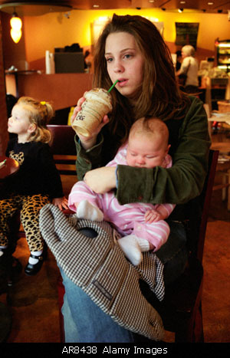





Colors
- Staccato rainbow - http://www.colourlovers.com/palette/612865/Staccato_rainbow 
- Patagonia - http://www.colourlovers.com/palette/40172/Patagonia

- Softys - http://www.colourlovers.com/palette/188578/Softys

- Panting for Insomnia - http://www.colourlovers.com/palette/394346/Panting_ForLinsomnia

- Cavity causing pants - http://www.colourlovers.com/palette/394341/cavity_causing_pants

- Grains de Bonheur - http://www.colourlovers.com/palette/407827/Graines_de_Bonheur

- Katamari - http://www.colourlovers.com/palette/407836/katamari

- Knit - http://www.colourlovers.com/palette/74203/knit


Font Styles
- Frankfurter - http://www.myfonts.com/fonts/efscangraphic/frankfurter-sh/

- Darling Nikki - http://www.myfonts.com/fonts/chank/darling-nikki/

- Up up and Away - http://www.myfonts.com/fonts/comicraft/up-up-and-away/

- Mati - http://www.myfonts.com/fonts/sudtipos/mati/

- Write Hand - http://www.myfonts.com/fonts/scholtz/write-hand/

- Tiresias InfoFont Z - http://www.myfonts.com/fonts/bitstream/tiresias/infofont-z/ 
- Horsham - http://www.myfonts.com/fonts/ef-typeshop/horsham/regular/

- Franklin Gothic - http://www.myfonts.com/fonts/urw/dtc-franklin-variants/dtc-franklin-gothic-m00/


Visuals
??

Textures/Patterns
- Kids on Sunday - http://www.colourlovers.com/pattern/50680/Kids_on_Sunday 
- Vector Grunge Floral - http://www.istockphoto.com/file_closeup/nature/flowers/2246820-vector-grunge-floral-background.php?id=2246820

- Floral Design Elements - http://www.istockphoto.com/file_closeup/arts-and-entertainment/arts-abstract/6427800-floral-design-elements.php?id=6427800

- Baroque Scroll - http://www.istockphoto.com/file_closeup/arts-and-entertainment/arts-symbols/4782137-baroque-scroll.php?id=4782137

- Wheat - http://www.istockphoto.com/file_closeup/nature/plants/3355670-wheat.php?id=3355670

- Yin Yang - http://www.istockphoto.com/file_closeup/nature/plants/6690303-green-yin-yang-click-scroll-down-4-more.php?id=6690303

- Father & Son / Mother & Daughter Cookie Cutter - http://www.istockphoto.com/file_closeup/lifestyle/families/4695836-father-and-son.php?id=4695836

http://www.istockphoto.com/file_closeup/lifestyle/families/4695844-mother-and-daughter.php?id=4695844


Attachments

Site Samples
- See above
- http://www.marthastewart.com 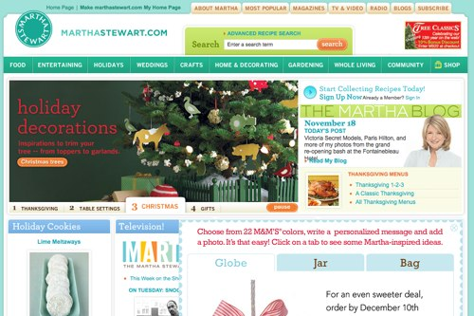
- http://www.oprah.com/ 

More Research
- http://parenting.alltop.com/
- http://www.facebook.com/
- http://www.myspace.com

