Brand Research



Introduction:

"Singleparentmeet.com is a top 5,000 site that reaches over 452K U.S. monthly people. The site appeals to a slightly more male than female audience. The typical visitor frequents Latino People Meet and visits amigos.com."
-quantcast

"According to the United States Bureau of the Census, the fastest-growing household type since the 1980s has been the single person."
-wikipedia

- Current Brand
  - Problems/Opportunities
    - Problem:
      - bland unexciting design – looks too much like a specialized site rather than a mainstream professional media presence
      - generic American color scheme of red, white and blue is limiting for international audience
      - lack of diversity of models in stock photography doesn’t reflect the audience makeup
    - Opportunity
      - Improve logo and design to better represent the tastes of the target
      - Use a diverse population in stock photography to better target the sizable ethnic audience
  - Brand Related Stats
      - Current Demo:
        - Mostly Male
        - Middle Aged and Teenagers
        - Mainly Caucasian but with above average African-American and Hispanic
        - 43% have children (much more than index)
        - Less Affluent (54% under $60K)
        - Some College Grads (50% No College)
- Demo-Related Stats
  - U.S. Census data
    - Most single parents are female, however the male-headed families are growing quickly.
    - Overall population of single parents has been holding steady for the last decade:
"The percentage of households headed by single parents showed little variation from 1994 through 2006, at about 9 percent, up from 5 percent in 1970, according to the latest data on America’s families and households released today by the U.S. Census Bureau.
According to Families and Living Arrangements: 2006, there were 12.9 million one-parent families in 2006 — 10.4 million single-mother families and 2.5 million single-father families."
    - Most single parents are female, however the male-headed families are growing quickly.
- Recommended Brand Features
  - Target
    - Income: <60K
    - Geography: International
    - Marital Status: Single
    - Children: yes
  - Mood
    - Adjectives
      - Active
      - Independent
      - Relaxed
    - What to Avoid
      - Stereotypes of overstressed parent
  - Possible color schemes
    - Purple/White – feminine
    - Earth tones – natural browns, green and other fall colors that imply health
  - Font Styles
    - Stick to mainly traditional sans-serifs (Arial/Verdana/Helvetica) to appeal to male audience
  - Privacy/Security
    - Make the audience feel comfortable giving their personal information, since many people visiting dating sites from work often use traffic-cloaking tools to hide their personal surfing. For example, “nntime” is highly ranked as a likely site for bbpeoplemeet on quantcast and is a one of the proxy servers for anonymizer, a privacy-securing service.
- Popular Media Consumed by Demo
  - TV Shows
    - Oprah
    - Ellen
    - Dancing With The Stars
  - Websites

- http://www.myfamily.com (social media) 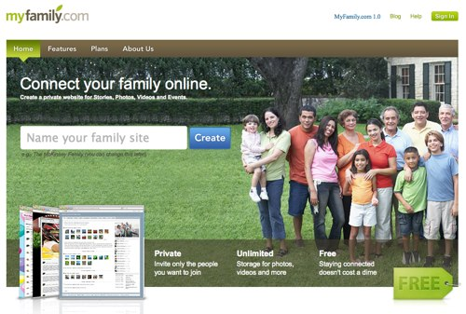
- http://www.loveandlogic.com/ 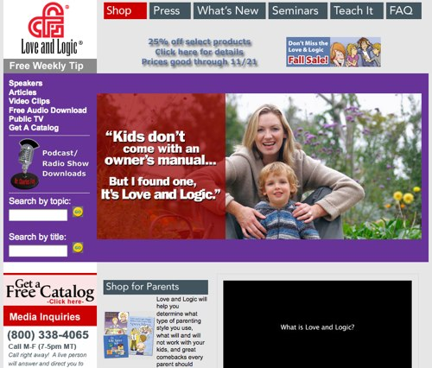
- http://familyfun.go.com/ (Disney) 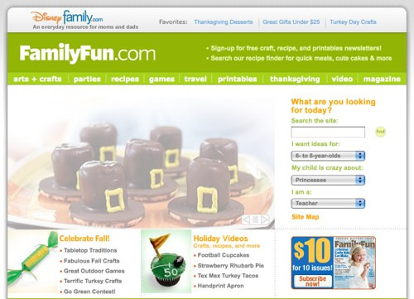
- http://www.crayola.com/ 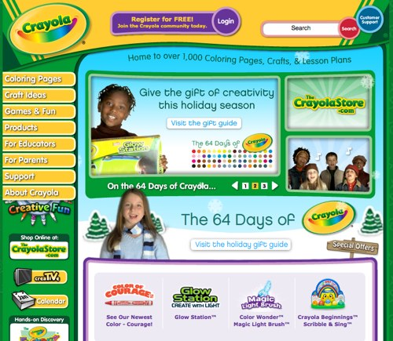
- http://pbskids.org/ 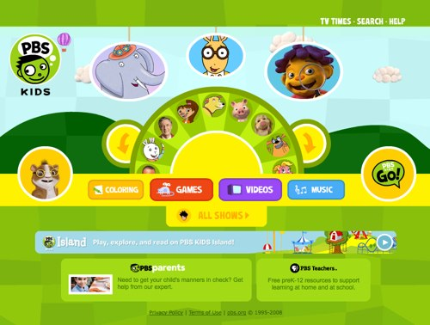
- http://www.families.com/ 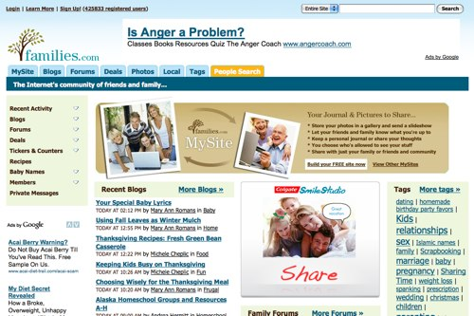
- http://www.familycorner.com/ 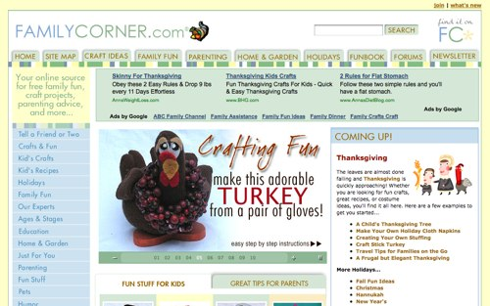
- http://www.parents-talk.com/
