Pharmacist responsibilities when selling complementary medicines

|  |  |
| --- | --- |
| Adam La Caze | Lecturer |
|  | School of Pharmacy |
|  | The University of Queensland |
|  | [a.lacaze@uq.edu.au](mailto:a.lacaze@uq.edu.au) |
| Amber Salman Popattia | PhD Candidate |
|  | School of Pharmacy |
|  | The University of Queensland |
|  | [amber.salmanpopattia@uqconnect.edu.au](mailto:amber.salmanpopattia@uqconnect.edu.au) |
| Laetitia Hattingh | Adjunct Associate Professor |
|  | School of Pharmacy and Pharmacology |
|  | Griffith University |
|  | [L.Hattingh@griffith.edu.au](mailto:L.Hattingh@griffith.edu.au) |

This is a draft report for the project *Evaluating the acceptability and feasibility of an ethical framework for the sale of complementary medicines in community pharmacy* funded by an APSA Research Grant 2019.

**Version**: [215f577](https://github.com/alacaze/cmethics_apsa) 03 February, 2020

# Executive Summary

There is a need for clearer guidance for pharmacists regarding their responsibilities when selling complementary medicines. This project introduces an ethical framework for the sale of complementary medicines in community pharmacy, and then evaluates the acceptability and feasibility of implementing the framework in practice.

The ethical framework was developed using principle-based ethics and consists in (i) a public health argument for having pharmacists involved in the sale of complementary medicines and (ii) the specific responsibilities that pharmacists need to meet to make a positive contribution to health outcomes by selling complementary medicines.

Seventeen community pharmacists participated in four focus groups and six individual interviews. There was good representation among participants in terms of gender, years of practice, pharmacy location and script volume. The majority of participants found the framework was acceptable for practice and was feasible for implementation with some targeted support. Participants tended to differ in how proactive they were in relation to selling and providing advice on complementary medicines, how they interpreted evidence in relation to complementary medicines, and how they navigated practice within the retail environment of community pharmacy.

Some participants expressed concern that the framework put the additional responsibilities and associated costs on pharmacists selling complementary medicines when compared to alternative outlets. However, the majority of participants felt that the additional responsibilities were appropriate and felt that pharmacies compete in terms of the services they provide in addition to cost. Participants identified two important areas for targeted support in implementing the framework: additional guidance and access to evidence-based information resources on complementary medicines and independent evidence-based education and training on complementary medicine for pharmacists and pharmacy support staff.

The *Framework for pharmacist responsibilities when selling complementary medicines* addresses an important gap in providing specific professional guidance to pharmacists when selling complementary medicines. The results of the study demonstrate that the framework will be acceptable to most pharmacists and is feasible to implement with targeted support.

# Introduction

This project seeks to contribute to pharmacy practice by developing clear guidance to pharmacists regarding their responsibilities when selling complementary medicines. Complementary medicines are a $4.9 billion dollar industry in Australia, 41% of which is sold through pharmacies (Complementary Medicines Australia, 2018). Consumers purchase complementary medicines from pharmacies due to a trust in the quality of the products and the availability of advice.[REF] There is clear recognition that pharmacists should (i) support consumer choice and (ii) provide advice that is informed by evidence (International Pharmaceutical Federation, 2014; The Pharmaceutical Society of Australia, 2017). There is, however, very little guidance on what to do when these two principles conflict. The conflict arises because many complementary medicines lack rigorous evidence of effectiveness and yet can cause harm through adverse effects, drug interactions and delayed treatment (Izzo & Ernst, 2009; Myers & Cheras, 2004). Recent reports suggest that pharmacists are failing to meet community expectations regarding the advice they provide on complementary medicines (Arnold, 2016; Bray, 2017;. King, 2017; Thompson et al., 2017)

Salman Popattia et al. (2018) identify several gaps in the literature examining the responsibilities of pharmacists selling complementary medicines. The most striking of these is the lack of specific guidance for pharmacists on the sale of complementary medicines. The expectations of pharmacists and consumers regarding the sale of complementary medicines are well described (Iyer et al., 2016; Kanjanarach et al., 2011; Tran et al., 2013). To the extent that ethical considerations are discussed in this literature, the conflict between supporting consumer choice, evidence-based practice and business considerations are frequently identified but never resolved. Part of the problem is the lack of an explicit ethical theory to guide decision-making. While the ‘four principles approach’ of bioethical principlism is implicit in many discussions, the version that is employed focuses on ‘ethics first-aid’: the *identification* of ethical conflicts rather than resolution of the conflict (Beauchamp & Childress, 2012; Pullman, 2005)

The problems associated with the lack of specific guidance for pharmacist responsibilities when selling complementary medicines is highlighted by the current *Code of ethics for pharmacists* (The Pharmaceutical Society of Australia, 2017). While the code provides the advice to support consumer choice and to practice in accordance with evidence, it also provides the directive that pharmacists will “only purchase, supply or promote any medicine, complementary medicine, herbal remedy or other healthcare product where there is credible evidence of efficacy and the benefit of use outweighs the risk”. This directive is in contrast with current practice in which complementary medicines that lack credible evidence of efficacy are frequently purchased and supplied. There is no attempt to reconcile this disparity in the professional or academic literature—no explicit argument for the directive provided in the code, nor a counter-argument defending the routine sale of complementary medicines that lack evidence of efficacy in community pharmacy.

Salmon Popattia and La Caze have developed an ethical framework that provides specific guidance to pharmacists regarding their responsibilities when selling complementary medicines. The framework seeks to identify the responsibilities pharmacists must meet in order to ensure the sale of complementary medicines in community pharmacy support good consumer health outcomes. An overview of the framework is provided below.

# A framework for pharmacist responsibilities when selling complementary medicines

There are three components to the framework: principle-based ethics provides the theoretical foundations, a *public health argument* provides *prima facie* support for the sale of complementary medicines in community pharmacy, and specific responsibilities are provided that ensure that pharmacists meet their obligations to the public when selling complementary medicines.

## Principle-based ethics

Principle-based ethics, and more specifically, the ‘four principles approach’ to bioethics advocated by Beauchamp & Childress (2012), is frequently employed in bioethics and professional ethics in health care. The four principles are *respect for autonomy*, *beneficience*, *non-maleficence*, and *justice*. The theory provides resources for further specifying these general principles when they conflict in particular contexts. The approach—using *reflective equilibrium* and *specification*—provides a framework for responding to ethical challenges by explicitly weighing up and resolving conflicts in general principles based on salient details within the context [REF].

The specific responsibilities provided by the framework were developed by weighing up mid-level principles such as the need for pharmacists to provide evidence-based care as well as to respect the health beliefs and preferences of consumers. These mid-level principles can be derived from more general guiding principles, such as ensuring positive health outcomes in consumers (beneficence and non-maleficence) and respecting autonomy. The framework seeks to resolve the conflicts that arise in these principles in relation to pharmacists selling complementary medicines.

## Public health argument

The second component of the framework is a public health argument for pharmacists selling complementary medicines. This argument is driven by two key points. First, complementary medicines are regulated in Australia (and most regions in the world) as being sufficiently safe for self-care. Most complementary medicines available in community pharmacy are *listed* on the Australian Register of Therapeutic Goods (**???**). This means that the complementary medicine contains items that are on a list of low-risk ingredients, is manufactured according to the principles of Good Manufacturing Practice, and the only claims made regarding therapeutic use relate to the maintenance and enhancement of health for non-serious, self-limiting conditions. Listed medicines are available from a wide range of outlets, including pharmacies, health food stores, and supermarkets. Many consumers choose to use complementary medicines and are likely to continue to do so even if they were not available in community pharmacies.

Second, pharmacists are a highly accessible health professional with the training and skills to provide guidance on the appropriate use of complementary medicines. In particular, pharmacists have excellent skills in being able to identify and resolve potential drug interactions and to provide guidance regarding actual or potential adverse reactions. Pharmacists tend to focus on this role in relation to complementary medicines and consumers frequently identify this support as one of the drivers for purchasing complementary medicines from community pharmacies (**???**; Kanjanarach et al., 2011).

The combination of these points provides a *prima facie* argument in support of the sale of complementary medicines in community pharmacy. However, some pharmacists are hesitant to discuss complementary medicines with consumers, and some provide inaccurate or misleading information regarding the likely benefits of complementary medicines (Arnold, 2016; Bray, 2017; Salman Popattia et al., 2018). The specific responsibilities of pharmacists when selling complementary medicines outlined below seek to address these issues. The framework identifies the responsibilities that pharmacists must meet in order to make a positive contribution to health outcomes by selling complementary medicines.

## Specific responsibilities

The key responsibilities outlined by the framework are provided in Table . The responsibilities overlap in some respects, but each articulates a specific responsibility for pharmacists working in a community pharmacy and managing staff in relation to complementary medicines. The framework makes a distinction between pharmacy staff making an *explicit recommendation* to take a complementary medicine, and selling complementary medicines without an explicit recommendation. The framework suggests that *recommendations* for a complementary medicine must be consistent with current best evidence, and all *sales* of a complementary medicine should be accompanied with an *offer* of advice from a pharmacist. If consumers take up that offer of advice, a pharmacist must be available to provide that advice and to provide sufficient information to the consumer such that they can make an informed decision with regard to the purchase of the complementary medicine. Since some consumers might refuse the offer of advice from a pharmacy, it is the responsibility of the pharmacist to have procedures in place to identify and act if a consumer is at significant risk of harm from complementary medicines. Further advice regarding the responsibilities outlined in the framework are available in Appendix A.

# Aim

The **specific aim** of this project was to evaluate the acceptability and feasibility of the proposed ethical framework for the sale of complementary medicines in community pharmacy. The project also sought to identify any barriers to the acceptance and/or implementation of the framework in community pharmacy.

# Methods

Australian community pharmacists were invited to participate in online workshops via a videoconferencing platform in September and October 2019. Pharmacists were be recruited using social media, professional organisations, and communication through the professional networks of key community pharmacy banner groups. If necessary, purposive sampling was to be employed to ensure that the age and gender distribution of participants reflects the workforce and that participants are recruited with different levels of experience and from different practice environments (small independent pharmacies, large chains, and discount-oriented pharmacies).

The workshops employed focus group methods to engage participants in discussion regarding the sale of complementary medicines in community pharmacies. Focus groups provide an opportunity to investigate complex behaviours and motivations, to learn more about the degree of consensus on a topic, and to gain feedback regarding new ideas (Basch, 1987; Knodel, 1993). They are especially helpful to understand group norms, meanings and processes (Barbour, 2011). Workshops were offered inside and outside of usual business hours using video-conferencing software, Zoom. Conducting focus groups via video-conference provided an opportunity to recruit participants from a large geographical area. A number of strategies were employed to support the success of conducting the focus group in an online environment, these included seeking to arrange groups of 4–6 participants (limiting larger groups), enabling video feeds and offering alternatives for those with lower internet speeds (Abrams & Gaiser, 2017).

Participants received information about the framework prior to the workshop and were asked to complete a short pre-workshop survey. The objectives of the workshops were (i) to examine the range of views community pharmacists have regarding their responsibilities when selling complementary medicines; (ii) to assess perceived appropriateness and feasibility of the developed ethical framework; (iii) to identify organisational, professional and personal barriers to the acceptance and/or implementation of the ethical framework, and (iv) to aid the development of specific guidance for pharmacists in applying the ethical framework. Discussion topics explored the context in which pharmacists provide advice on complementary medicines within community pharmacy, and the acceptability and feasibility of the proposed ethical framework. The semi-structured interviews conducted with participants unable to join a workshop followed the same structure.

All focus groups and interviews were conducted by AL. It was made clear from the start of each focus group and interview that the objective of the discussion was to understand the participants views and how they varied. Participants were encouraged to share diverging views and to debate topics in a respectful manner. The facilitator did not share views during the focus groups or interviews. ASP was an observer for most of the focus groups and interviews. AL and ASP debriefed immediately following each focus group and interview and prepared the summary that was sent to participants for comment.

The workshops and interviews were video and audio recorded. Focus groups and interviews were transcribed verbatim. The transcripts were analysed using the thematic analysis methods described by Braun and Clarke (2006). An inductive approach to coding was employed, and themes were developed with a focus on addressing the research questions in the study. Two investigators, AL and ASP, familiarized themselves with the data and developed an initial coding scheme. This was refined through discussion early in the analysis and then used to code the focus groups and interviews. AL and ASP then identified and refine themes individually first, and then as a group that included LH.

All three investigators have experience in pharmacy ethics. AL has experience in qualitative research, facilitation of online groups and research and teaching in ethical reasoning and decision-making in pharmacy practice. ASP has a background in nursing and bioethics and developed the ethical framework as part of her PhD. LH has experience in health law and ethics and qualitative research. LH was involved in development of the Pharmaceutical Society of Australia *Code of ethics for pharmacists*.

# Results

Seventeen community pharmacists participated in 4 workshops and 6 individual interviews. The workshops contained 2–4 participants and went from 29 to 68 minutes in duration (median duration 42.5 minutes). The duration of the interviews ranged from 17 to 34 minutes (median 21 minutes). Demographic features of the participants are provided in Table 2. Participants varied in terms of gender, years of practice and type of pharmacy and typical script volume. More than a third of participants worked in a regional or rural location.

The presurvey questions provide a snapshot of the participants views about complementary medicines in terms of their day-to-day practice. Most participants agreed with statements regarding providing advice to consumers about complementary medicines as being part of their role, and feeling positive about the advice they give to consumers regarding complementary medicines. Participants were less likely to agree with statements regarding their possession of the necessary knowledge and skills in relation to complementary medicines, and a statement regarding possessing the necessary time and resources to help consumers with complementary medicines.

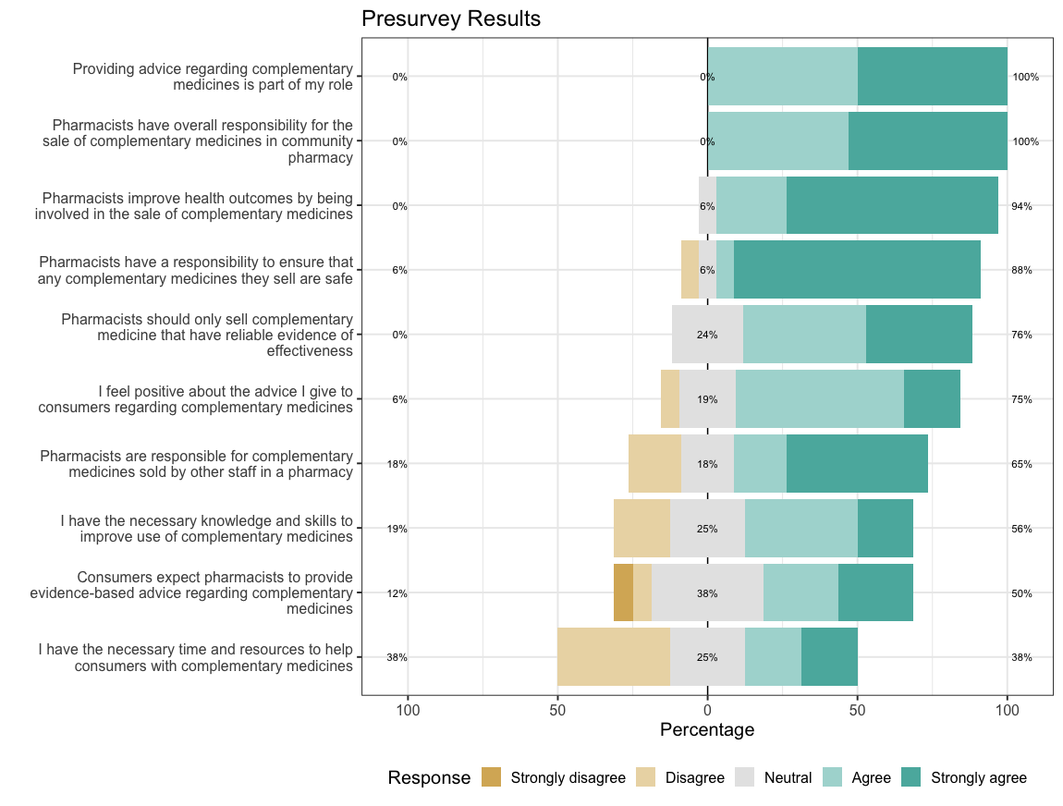

Results of the presurvey. Statements are ordered by the percentage of agreement of the participants. TODO: NEED TO WORK ON FIGURE

## Key themes

The focus groups provided rich information on how pharmacists approached their practice in relation to complementary medicines, their perceptions of the framework and their views regarding the facilitators and barriers to implementing the framework in practice. A number of themes were consistently discussed in the focus groups and interviews. Reviewing transcripts following the analysis, thematic saturation occurred after 3 focus groups and 4 interviews, additional focus groups and interviews helped to explore and confirm key findings. Three main themes emerged from the focus groups and interviews. These themes are summarised in Table 3. The first two themes represent spectra on which participants differed: *Approach to complementary medicines (proactive–reactive)* and *Approach to evidence*. The third theme, *Navigating practice in a retail environment*, represents the recognition from all participants that community pharmacy is in a retail environment and decisions regarding professional practice have resource and other financial implications.

The ways in which participants *approached complementary medicines*, *approached evidence*, and *navigated practice in a retail environment* inform how they viewed their responsibilities in relation to complementary medicines within the context of community pharmacy practice and their views on the acceptability and feasibility of the proposed framework. Each of these themes are briefly introduced below. Subsequent sections provide further discussion regarding how participant responses within these themes addresses the objectives of the project. Understanding these themes, and the ways in which participants varied within the themes provide insight into the *context* (Section ) of community pharmacy practice in relation to complementary medicines, and the *acceptability* and *feasibility* of the framework as perceived by the participants (Section and ).

### Approach to complementary medicines

A number of participants described their practice in terms of a proactive approach to complementary medicines. These participants tended to initiate discussion regarding complementary medicines with consumers and see an important role for pharmacists in being active in relation to complementary medicines.

Pharmacists are becoming more involved than before. People are trusting pharmacists more. They always check their complementary medicine. I think, from what I remember five years ago, people were just picking it up. They were thinking that, “That’s just a supplement,” but I think the awareness is more than before among people. So they always come and ask, “Oh, is this one safe?” or, “What should I take?” I think now, lots of pharmacists are always checking things for them. (D1P1)[1]

Some participants worked in community pharmacies set-up to provide specialist advice on complementary medicines, including the use of practitioner-lines.

I work in a small community pharmacy. I probably consider myself a integrated pharmacist. We have complementary medicines in three different areas similar to the rest of your medicines, like S2s, S3s. So we’ve got some out in the front shop, which I consider your [day-to-day] vitamins, like your supermarket lines. They’re more lines that are more for patients to choose and that sort of thing if they want to self-select. If they go for advice from a pharmacist or staff member, we’d probably go for something a bit better quality. So we’ve got some in the S2 section which are, I guess, better quality practitioner ranges. And then we’ve got your other ones in your S3 areas which are ranges that do require a consult or a prescription. So a lot of them are prescribed by some of our doctors as well. (D7P13)

By contrast, other participants adopted a reactive approach to complementary medicines. These participants indicated that they are less likely to initiate discussion of complementary medicines with consumers, and were more likely to express a lack of confidence in complementary medicines. Participants expressing these views tended to rely more heavily on support staff in this area.

I suppose it’s not as big a focus in my professional practice…. I think it’s probably because of lack of knowledge, to be honest, and confidence, where you feel a lot more secure at the back counter or in a dispensary than you do out in the vitamin section. (D5P8)

For some participants, a reactive role towards complementary medicines was seen as a consequence of the lack of evidence for the effectiveness of many of these medicines.

Yeah. I think at the moment, I don’t think we have much role to play in selling or providing any counselling for complementary medicine because first, working in community pharmacy, our main role is actually just dispensing. And then pharmacies, I think, we should follow more like evidence-based medicine practise…. All this supplementary of complementary medicine and all, they’re not evidence-based. (D5P6)

### Approach to evidence

Participants also varied in their approach to evidence. Most participants explicitly endorsed “evidence-based practice” in relation to complementary medicines, but what participants took this to mean and how it related to their day-to-day practice tended to differ.

Many participants described their practice in a way that is consistent with evidence-based practice while also recognising some of the challenges.

[W]e shouldn’t just be selling things because someone … says, “Oh, this turmeric is great for the sake of curing cancer.” I think there has to be some level of evidence… And it’s hard in certain conditions because you’re just never going to have the trials. (D4P5)

A number of participants felt there should be a greater emphasis on evidence-based practice in relation to complementary medicines.

If we, I think, perhaps as an industry, move towards more– well, what is the evidence? Do I feel that your needs will be met by what I’m recommending today? Is there evidence to support what it says on the label, or what it says in the marketing material? And if not, then maybe we, as an industry, could push the emphasis of companies bringing things to market, being more about actual evidence. More money going into these studies of N equals 50. (D5P9)

Some participants, however, expressed views inconsistent with evidence-based practice. These participants put significantly more weight into anecdotal reports and placebo effects as providing evidence for the effectiveness of complementary medicines. In response to the explicit PSA guidance to only sell complementary medicines that are efficacious, one participant felt that placebo effects were sufficient to meet this standard.

So how I would actually interpret [the PSA guidance], and this is where placebo effects comes in. So hey, if it’s not doing them any harm and they think it’s better for them and they’re going on in their life and happy days, you just let them go. (D5P7)

Other participants put a lot of value into anecdotal experience.

So I see a lot of people really—a lot of people want to use it. I’ve talked to a lot of customers, and they do feel the result. Every time they come back, I always ask, “Is this working for you?” And a lot of times, they say, “Yes, I know it’s working because when my bottle ran out, I started feeling it.” So then they came back to get a new bottle. So regarding your first question where you say, “What’s our perspective regarding purchase of natural medications?” I think they really work. I think they work depending what the situation is. There are some situations where you obviously need something more potent. But even in those situations, I think there’s always a place for natural medication, either as a stand-alone treatment or in combination. This is just based on what I’ve seen, not just what I think, what I’ve seen from what people say. (D9P16)

Participants tended to vary according to their approach to complementary medicines and approach to evidence independently. Different participants expressed each of the following views: “proactive and evidence-based”, “reactive and evidence-based”, “proactive and less evidence-based” and “reactive and less evidence-based” (see Figure ). Here, for example, is one of the participants suggesting that most pharmacists they knew were “reactive and evidence-based”

I would think in the most part people are very reactive. I don’t know that people would proactively engage in conversations a lot in my experience. But I think if they were asked, then they would provide evidence-based information to the best of their knowledge. (D6P10)

Where participants exist on these spectra informed their response to a variety of topics regarding the sale of complementary medicines in community pharmacy, including the role of naturopaths, the availability and confidence the participant had with regard to information resources, practitioner-only products and the proposed framework.

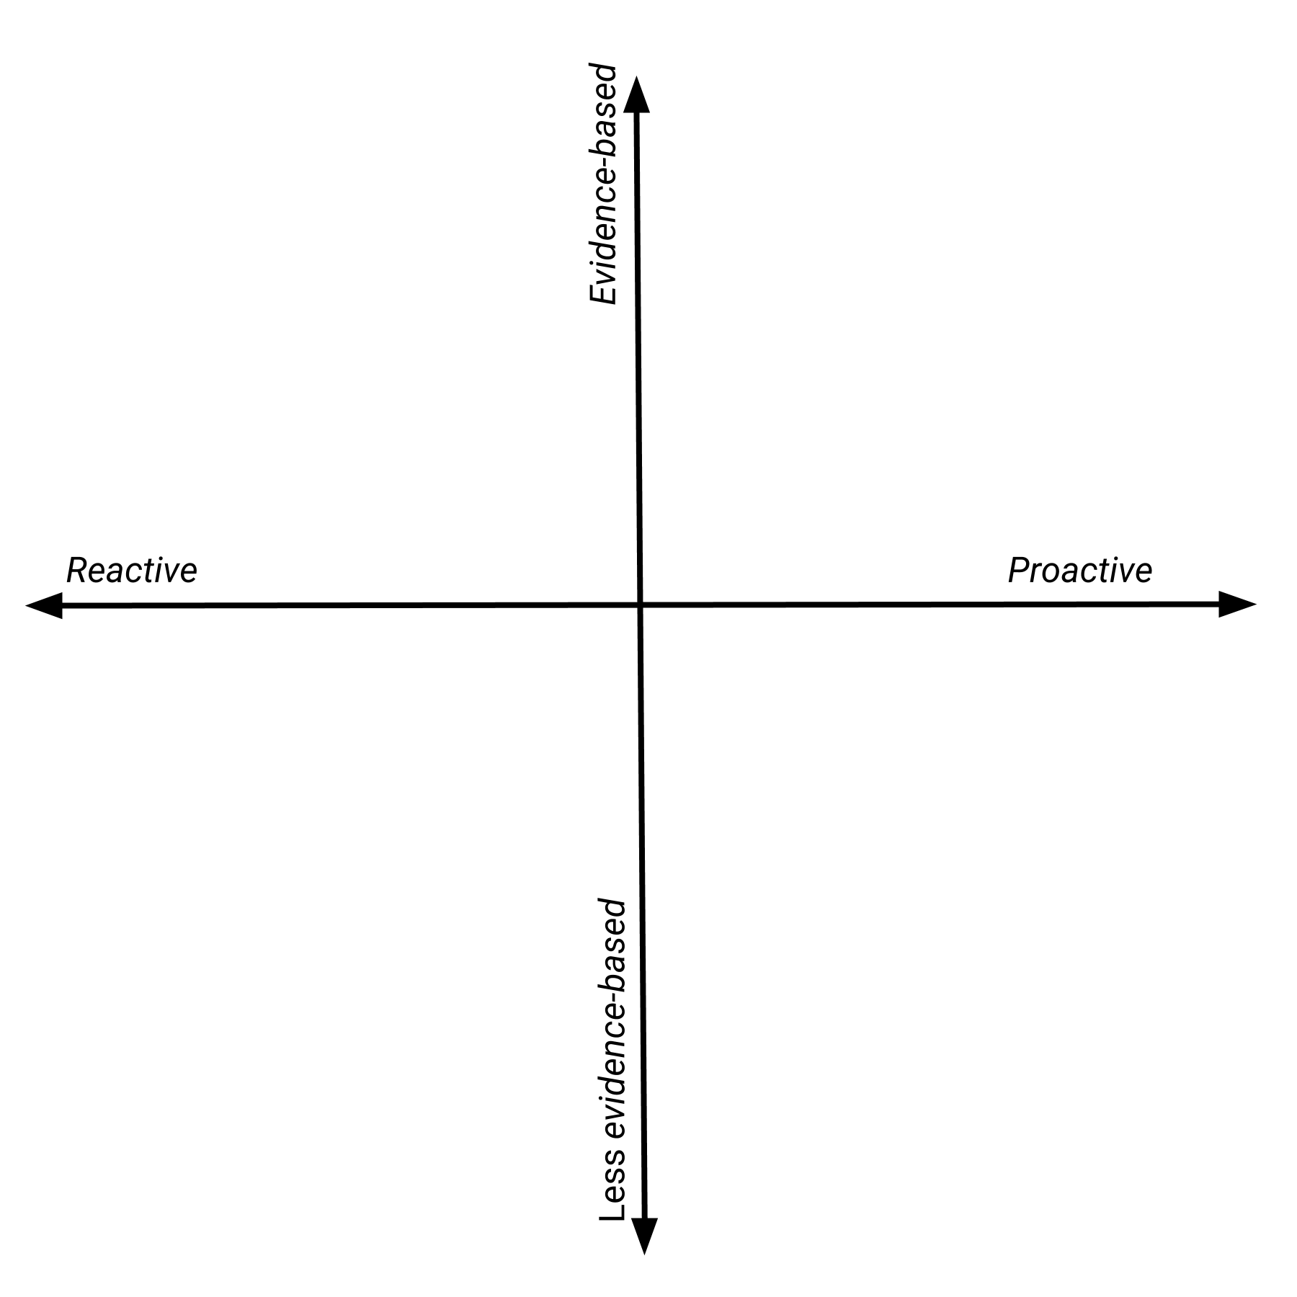

Participants tended to vary according to how they approached complementary medicines and how they approached evidence

### Navigating practice in a retail environment

All participants discussed implications of the retail environment within the context of fulfilling their professional obligations. Participants who were pharmacy owners, in particular, recognised the impact of complementary medicines on the financial bottom-line of the pharmacy.

I own a pharmacy … I still work in the shop on a daily basis. So I still come across on a daily basis having to chat to people about this. But then I am also going to come at it from the side [that complementary medicines] prop up half of the bank loan. So I guess we are going to go both ways on this a little bit. (D5P7)

Participants differed, however, in how they navigated practice in the retail environment. Most participants sought to prioritize professional obligations over financial considerations.

If a pharmacy’s going to lose money for the sake of a sale, that isn’t a good enough reason for the sake of giving something out. We should always be having a look at evidence-based treatments, … (D4P5)

These participants focused on ensuring appropriate practice within the confines of financial constraints. Because participants differed in how they viewed appropriate practice in the context of complementary medicines, they also differed on the financial impost they were willing to accept to fulfil the responsibilities outlined in the proposed framework. This topic is discussed in detail below in relation to the acceptability and feasibility of the framework.

## Context

Participants described how they approached complementary medicines in day-to-day interactions with consumers as well as how they thought pharmacists *should* approach such interactions. They also discussed what resources they had available to them to assist consumers with complementary medicines as well as any barriers they experienced when providing advice to consumers in relation to complementary medicines. Topics frequently raised by participants in focus groups and interviews were the role of naturopaths in community pharmacy, the availability of resources on complementary medicines and the increasing role of practitioner-only complementary medicine lines. Practitioner-only lines have typically been sold by naturopaths working in the pharmacy, but in recent years pharmacists have become more actively involved in these sales. Most of these complementary medicines are regulated in the same way as complementary medicines sold in the front shop, but are marketed such that only certain practitioners can sell the item (typically naturopaths and pharmacists). How participants approached these topics was informed by the approach they took to complementary medicines and their views regarding evidence. These views are summarised in Figure .

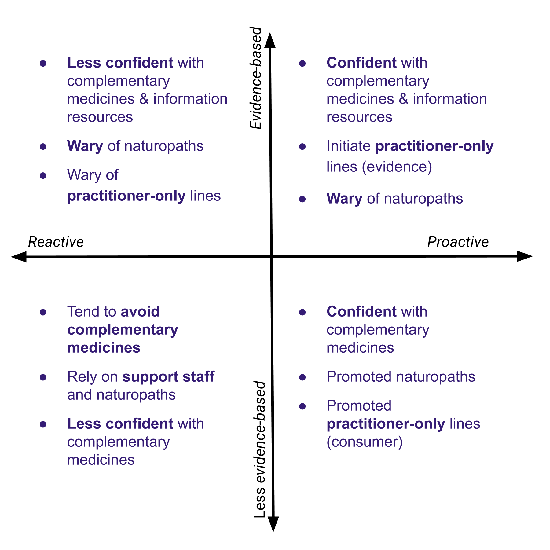

How participants varied in relation to how they viewed the context of providing advice on complementary medicines in community pharmacy

In brief, participants who were “proactive” and “evidence-based” tended to have access to and be confident users of information resources on complementary medicines, actively recommend practitioner-only lines and express concern regarding whether naturopaths provide evidence-based advice. Participants who described their practice as evidence-based, but took a more passive (reactive) approach to complementary medicines were also wary about naturopaths, but were less likely to recommend pracititioner-only lines and less likely to express confidence in relation to information resources on complementary medicines. Participants who were “proactive” and “less evidence-based” tended to express confidence in relation to their knowledge and practice in relation to complementary medicines as well as the knowledge and practice of naturopaths. These participants actively recommended practitioner-only lines. Participants who were “less evidence-based” and “reactive” in relation to complementary medicines tended to rely on support staff and naturopaths to provide advice to consumer and expressed a lack of confidence in relation to their knowledge and skills in relation to complementary medicines.

## Acceptability of the framework

Most participants felt the framework was acceptable: that it accurately captured the responsibilities of pharmacists when selling complementary medicines. Participants were more likely to express concern regarding the feasibility of the framework. Participant views on the acceptability and feasibility of the framework tended to be informed by how they approached complementary medicines and how they approached evidence. The other key determinant was how the participant navigated practice within a retail environment. Participant views regarding the acceptability and feasibility of the framework are summarised in Figure .

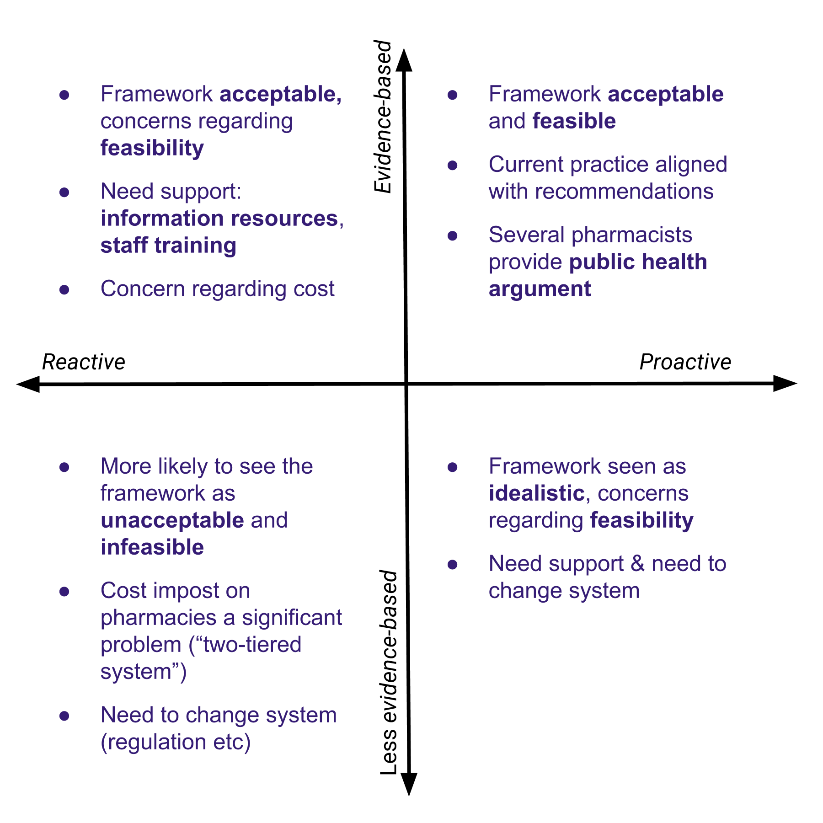

How participants views on the acceptability and feasibility of the framework different depending on how they approach complementary medicines and evidence

Participants who were “proactive” *and* “evidence-based” were most strongly in favour of the proposed ethical framework. These participants saw the framework as a being closely aligned with their practice and commended the clear guidance the framework provided regarding pharmacist responsibilities when selling complementary medicines.

I think generally pharmacists are time poor and stressed and overburdened, so anything that can make something more simplified and streamlined with clear-cut expectations is useful. (D7P12)

…

I would say [the framework is acceptable], particularly with, yeah, treating it along the lines of an S2 or an S3. So front-shop staff can talk to the patients about it. If there’s any further queries, the pharmacist can be involved, but they don’t automatically have to come down and talk to them if it’s not something that there’s any questions about. (D7P11)

Several participants provided an argument along the lines of the public health argument to support the sale of complementary medicines in community pharmacies.

I think the reason that pharmacies should sell their complementary medicine is not because there is a market. I think people, instead of going to the health food store to get their [comple?] medicine, they should come to the pharmacy because there is a better chance that the pharmacies can find out if there’s any interaction for people with some actual medications. But I know most of my customers. I know exactly what they are taking. If they come and someone on warfarin asks me for some complementary medication, I just quickly before going and checking their medical history, I know that that’s not the right thing to give to the person. But if that person goes to the health food store and buy it there, there is no way that they can figure it out. So I think they should be always at the pharmacy because people should think to go to pharmacy to get their complementary medicine because that way they are going to be protected and lots of trauma is going to be stopped. (D1P1)

Two threats to acceptability were identified in the focus groups and interviews. The primary perceived threat to the acceptability of the framework was that it permits a “two-tiered system” for the sale of complementary medicines. The framework identifies responsibilities for pharmacies selling complementary medicines that are not expected of other retailers. This point was raised in several focus groups and interviews. The following quotes illustrate the back-and-forth between a participant who argues the framework is not acceptable due to the differential cost it imposes on community pharmacies and a second participant who argues that part of being a pharmacist involves such obligations.

I would say consumers mostly view [complementary medicines] as an item of commerce. You buy them like you buy bread and milk, in some instances, for some of them. So you’ve now imposed this cost on us providing evidence, but in order to do that, we have to mark the product up more. Then you’ve got this two-tiered system. (D5P7)

I think that having the degree means that … people come for a higher level of service and understanding than what they can get in the supermarket. And that’s part of what differentiates us professionally. And that’s part of why it’s still called a pharmacy and not a supermarket. I’m comfortable that I would actually be probably more comfortable practising where the TGA just says, “Yes, that is safe to take.” And then the pharmacist makes the clinical judgement and says, “Well, this may not be the best product for you.” I think that that’s literally our goal. (D5P9)

The second threat to the acceptability of the framework is a consequence of the different approaches participants take to evidence-based practice. The proposed framework assumes a shared understanding of what is considered appropriate evidence for the efficacy of complementary medicines. Participants who expressed an approach to evidence in complementary medicines that was less evidence-based appear to hold a different view. Accepting placebo effects as sufficient evidence of the efficacy of complementary medicines and/or putting considerable weight into the anecdotal experiences of others are approaches to evidence that are incompatible with the framework. Similarly, for those who take the view that placebo effects and anecdotal reports are sufficient evidence for determining the efficacy of complementary medicine, the proposed framework will be viewed as unacceptable.

The importance of taking this into account is illustrated in the response some participants had to the guidance on complementary medicine provided in the current *Code of ethics for pharmacists*. For example, some participants suggested that there were practising in accordance with the guidance provided in the code of ethics on the basis of the purported placebo effects of complementary medicines (see, for example, the third quote in Section ). Determining appropriate evidence for assessing the effectiveness of complementary medicines is complex and somewhat controversial. Some of the considerations include the availability of well-conducted randomized trials and the lack of impetus for such trials given they are not a regulatory requirement. While it is not necessary (or feasible) to resolve all of these issues for the purposes of the proposed framework, it is necessary to identify some boundaries in relation to approaches to evidence and complementary medicines. The findings of this study suggest two such boundaries are the use of placebo effects and anecdotal reports (in other consumers) as a justification for recommending complementary medicines.

## Feasibility of the framework

Participants tended to be more concerned about the feasibility of the framework as opposed to its acceptability. The specific barriers that participants identified, and the kinds of things that would enable participants to overcome the barrier, depended on how participants approached complementary medicines and evidence.

Participants who were “evidence-based” and “proactive” tended to see the framework as both acceptable and feasible as presented. Participants who were “evidence based” and “reactive” expressed concerns about the feasibility of implementing the framework. These participants tended to identify local, practical barriers and to identify areas of support that would remedy these concerns. The two most consistently identified barriers were the availability of (and confidence with) evidence-based information resources on complementary medicines and staff training. Some example quotes highlighting the importance of information resources and training and some of the optimism participants expressed to addressing these barriers:

Oh. I think it’s a very nice framework in an ideal world, and if we are provided with tools and training and the resources to train the staff, I would be very happy to have that in the pharmacy. (D2P2)

I feel like it would be really helpful if there was a better database to look up interactions and all that type of thing because more often than not, I have to call either the company or look into it really far to make sure it doesn’t interact. So maybe extra training in that area like compulsory training, I guess. (D3P4)

So I think, honestly, I would just be keen to try it out in the shop and see how it actually works. But it’s sort of one of those questions. If you change the framework and require pharmacies to do something, some sort of fundamental change in how we provide advice, would that open up the space for a new database to actually provide some money so someone would actually make it? Would that then mean that companies looking to get their products into pharmacy would put more emphasis on evidence and therefore training? So pharmacists wouldn’t have to be doing these trainings. You’re going to get detailed by companies that are looking to get the best, most evidence-based product into your stores. (D5P9)

The absence of independent evidence-based training for pharmacy support staff was identified as a barrier to implementing the framework. The response to this is providing more opportunities for this kind of training.

I’ve got 30 staff, and the idea that there could be more specialised training for people that have that interest [in evidence-based complementary medicines] and that could be another avenue for non-pharmacists into pharmacy careers. Immediately, that’s more attractive than going to work at Woolies, where they just sell the stuff en mass for profit. How would that not be a good thing when we’ve copped a lot of bad press about some pharmacists? So yeah, definitely. I would be very interested to see if this framework allowed for more of that. (D5P9)

A number of participants identified an increased focus on practitioner-only lines as one way to differentiate pharmacy services in relation to complementary medicines while fulfilling the professional obligations outlined in the framework.

Well, I feel like there should be, I guess, a shift away from the front-shop selling. So just to distinguish pharmacy from the health food store, so other things that people just see on TV or things that people can buy without talking to a pharmacist or talking to someone that’s been trained in complementary medicines. So there’s the idea of what we’ve got, the pharmacy, with labelling it, even though it’s not necessarily a dangerous product, but just something that at least requires a consult from the first go. Not every time but just from the initial, first-selling to them so they know exactly why they’re taking it, rather than just they’ve been taking it for 10 years. And if we said, “Well, this is a better product, a better form of calcium or whatever it might be,” at least that way they can think of their complementary medicines along the same lines as their regular medications. So they still put some value on it, and they don’t just look for the cheapest option or the most convenient, necessarily, but something that they get more value out of. (D7P11)

Participants who described their practice in a way that was less evidence based tended to agree with the barriers and facilitators identified above as well as express additional concerns regarding the feasibility of implementing the framework. Participants who were “proactive” and “less evidence-based” tended to see the framework as acceptable though idealistic, and suggest that it could only be implemented if there were significant system changes made to support the framework. Participants who were “reactive” and “less evidence-based” were more likely to view the framework as both unacceptable and infeasible. These participants had significant concerns about cost implications. The system changes that each of these groups of participants suggested were similar. Suggestions included ensuring all pharmacies implemented the framework in a similar way (perhaps taking a regulatory approach to assessing compliance with the framework) and making changes to the way the complementary medicines were regulated such that there were tighter restrictions on the availability of complementary medicines.

…[G]etting all the pharmacies on the same page. If you’ve got pharmacies that are run by corporations and banner groups that are more for-profit versus small community pharmacies that are trying to provide a service. You’ve got to have these frameworks that are enforceable, maybe through QCPP or a PBS listing, and make sure that everyone does the same things and stocks the same products and doesn’t stock the same products based on evidence. (D7P12)

The next thing, I think, would be TGA. If they’re approving it, but then it’s not evidence based, then consumers will get confused because they would say, “Oh, but then it’s approved by TGA, so it must be all right or evidence based.” (D10P17)

Why should it be up to us as pharmacists? Why shouldn’t the TGA—when it goes to them in the first place to be approved, why is it even getting to us? Why are we required to make the decision? Why haven’t TGA done their job? (D5P7)

# Discussion & recommendations

The *Framework for pharmacist responsibilities when selling complementary medicines* provides specific guidance to pharmacists on fulfilling their responsibilities when selling complementary medicines. The framework seeks to address current gaps in the professional and academic literature with regard to the availability of specific professional guidance supported by an explicit theoretical approach. It balances pharmacist responsibilities for promoting positive health outcomes and respecting consumer health beliefs with recognition of the consumer practices in relation to complementary medicines, the regulation of these products and the roles that pharmacists play in providing advice on these products. The study findings suggest that the proposed framework will be acceptable to most pharmacists and is feasible to implement with some targeted support.

The strengths of the study include asking participants to respond to specific advice on the responsibilities of pharmacists when selling complementary medicines, the variation present in the demographic details of the participants, and the features of the qualitative methods that permit an in-depth examination of how the participants approached complementary medicines and the framework. Further work with a larger representative sample of pharmacists would be required to estimate the prevalence of different approaches to complementary medicines in Australian community pharmacy (e.g. “evidence-based”, “proactive”, etc). While the study did not include the perspectives of consumers or pharmacy support staff, the perspectives of these groups have been explored elsewhere (Iyer et al., 2016).

The acceptability of the framework to most participants is an important precondition on the successful implementation. Participants who are evidence-based and proactive towards complementary medicines are likely to act as champions for the framework. Equally important are the barriers identified by participants who felt the framework is acceptable but had concerns regarding feasibility. Appropriately addressing these barriers will help to shift pharmacists towards an evidence-based and proactive approach to complementary medicines. Specific activities that would support this shift include the development of support regarding evidence-based information resources, and evidence-based training on complementary medicines for aimed at both pharmacists and pharmacy support staff.

Several participants indicated that better access to and confidence with evidence-based information resources on complementary medicines would help Suitable information resources are available and used within community pharmacy (as indicated by other participants). This suggests that guidance on the availability, strengths and limitations of key evidence-based information resources available to community pharmacists could aid pharmacists unfamiliar with these resources. A second and related activity is the availability of training for pharmacists and pharmacy support staff. There is a lot of sponsor-provided training opportunities in community pharmacy for both pharmacists and pharmacy support staff. Participants in this study identified the need for independent evidence-based learning opportunities in complementary medicines for both pharmacists and pharmacy support staff. Similar needs have been identified in the literature (**???**; Iyer et al., 2016). Learning activities specifically targeting evidence-based health care and the role of pharmacists and pharmacy support staff in providing appropriate advice regarding complementary medicines would facilitate implementation of the framework. These learning activities could then feed into longer-term projects such as the development of a career pathway for pharmacy support staff with expertise in providing evidence-based advice regarding complementary medicines.

The initiatives outlined above are targeted at pharmacists who identify an evidence-based approach to complementary medicines but experience barriers to taking a more proactive approach to complementary medicines. This is likely the most effective and efficient strategy and can be implemented at the same time larger-scale regulatory actions regarding complementary medicines are considered. The framework in addition to training activities and further guidance on evidence-based information resources on complementary medicines has the benefit of providing clear guidance on the responsibilities of pharmacists when selling complementary medicines, and building the capacity of pharmacists and pharmacy support staff to deliver evidence-based advice and support to consumers using complementary medicines.

# Conclusion

The *Framework for pharmacist responsibilities when selling complementary medicines* addresses an important gap in providing specific professional guidance to pharmacists when selling complementary medicines. The results of the study demonstrate that the framework will be acceptable to most pharmacists and is feasible to implement with targeted support.

# References

Abrams, K. M., & Gaiser, T. J. (2017). Online Focus Groups. In *The sage handbook of online research methods* (pp. 435–449). SAGE Publications Ltd. <https://doi.org/10.4135/9781473957992.n25>

Arnold, A. (2016). *Should you trust your pharmacist?* [http://www.abc.net.au/radionational/programs/
backgroundbriefing/should-you-trust-your-pharmacist/7237496](http://www.abc.net.au/radionational/programs/                   backgroundbriefing/should-you-trust-your-pharmacist/7237496)

Barbour, R. (2011). Focus groups. In *Introducing qualitative research* (pp. 132–148). [https://books.google.co.uk/books/about/Focus{\_}Groups.html?
id=APtDBAAAQBAJ](https://books.google.co.uk/books/about/Focus{_}Groups.html?                   id=APtDBAAAQBAJ)

Basch, C. E. (1987). Focus Group Interview: An Underutilized Research Technique for Improving Theory and Practice in Health Education. *Health Education & Behavior*, *14*(4), 411–448. <https://doi.org/10.1177/109019818701400404>

Beauchamp, T. L., & Childress, J. F. (2012). *Principles of Biomedical Ethics* (7th ed.). Oxford University Press.

Braun, V., & Clarke, V. (2006). Using thematic analysis in psychology. *Qualitative Research in Psychology*, *3*(2), 77–101. <https://doi.org/10.1191/1478088706qp063oa>

Bray, K. (2017). *Is your pharmacist giving you the right advice?* [https://www.choice.com.au/health-and-body/health-
practitioners/doctors/articles/pharmacy-advice-for-stress](https://www.choice.com.au/health-and-body/health-                   practitioners/doctors/articles/pharmacy-advice-for-stress)

Complementary Medicines Australia. (2018). *Australia’s Complementary Medicines Industry Snapshot 2018*. [http://www.cmaustralia.org.au/resources/Documents/
Australian Complementary Medicines Industry snapshot
2018{\_}English.pdf](http://www.cmaustralia.org.au/resources/Documents/                       Australian Complementary Medicines Industry snapshot   2018{_}English.pdf)

International Pharmaceutical Federation. (2014). *Codes of ethics for pharmacists* (August; pp. 3–5). [http://fip.org/www/uploads/database{\_}file.php?id=351{\&
}table{\_}id=](http://fip.org/www/uploads/database{_}file.php?id=351{\&                   }table{_}id=)

Iyer, P., McFarland, R., & La Caze, A. (2016). Expectations and responsibilities regarding the sale of complementary medicines in pharmacies: perspectives of consumers and pharmacy support staff. *International Journal of Pharmacy Practice*, *epub ahead*. <https://doi.org/10.1111/ijpp.12315>

Izzo, A. A., & Ernst, E. (2009). Interactions between herbal medicines and prescribed drugs: An updated systematic review. *Drugs*, *69*(13), 1777–1798. <https://doi.org/10.2165/00003495-200161150-00002>

Kanjanarach, T., Krass, I., & Cumming, R. G. (2011). Australian community pharmacists’ practice in complementary medicines: A structural equation modeling approach. *Patient Education and Counseling*, *83*(3), 352–359. <https://doi.org/10.1016/j.pec.2011.05.003>

King, S. (2017). *Review of Pharmacy Renumeration and Regulation: Final Report*. [http://www.health.gov.au/internet/main/publishing.nsf/
content/review-pharmacy-remuneration-regulation](http://www.health.gov.au/internet/main/publishing.nsf/                   content/review-pharmacy-remuneration-regulation)

Knodel, J. (1993). The Design and Analysis of Focus Group Studies: A Practical Approach. In *Successful focus groups: Advancing the state of the art* (pp. 35–50). SAGE Publications, Inc. <https://doi.org/10.4135/9781483349008.n3>

Myers, S. P., & Cheras, P. A. (2004). The other side of the coin: Safety of complementary and alternative medicine. *Medical Journal of Australia*, *181*(4), 222–225. <https://doi.org/mye10108_fm [pii]>

Pullman, D. (2005). Ethics First Aid: Reframing the Role of“ Principlism” in Clinical Ethics Education and Practice. *Journal of Clinical Ethics*, *16*(3), 223–229.

Salman Popattia, A., Winch, S., & La Caze, A. (2018). Ethical responsibilities of pharmacists when selling complementary medicines: a systematic review. *International Journal of Pharmacy Practice*, *26*(2), 93–103. <https://doi.org/10.1111/ijpp.12425>

The Pharmaceutical Society of Australia. (2017). *Code of ethics for pharmacists* (p. 52). <https://www.psa.org.au/membership/ethics>

Thompson, G., Russell, A., & Fallon, M. (2017). *SWALLOWING IT*. [http://www.abc.net.au/4corners/stories/2017/02/13/
4616948.htm](http://www.abc.net.au/4corners/stories/2017/02/13/                   4616948.htm)

Tran, S., Calabretto, J.-P., & Sorich, M. (2013). Consumer-pharmacist interactions around complementary medicines: agreement between pharmacist and consumer expectations, satisfaction and pharmacist influence. *The International Journal of Pharmacy Practice*, *21*(6), 378–385. <https://doi.org/10.1111/ijpp.12027>

1. Workshops and interviews are labelled as “Discussions” and numbered in order. “Participants” are also allocated a number in order. “D1P1” refers to Discussion 1, Participant 1.