**CS340 Introduction to Databases Final Project: BattleMagick!**

Outline (5%)

Give me a paragraph or two explaining your database content. If it is about auto dealerships, tell me what goes on at the auto dealership and why it would be interesting to track that data.

The database we are designing for this project was originally inspired by and similar in nature to the universe created by Wizards of the Coasts in the popular trading card game, Magic the Gathering. In our implementation, we simplified the game and focused on the idea of wizards battling one another by drinking potions, casting spells, and befriending creatures which act on our bidding or even rally other creatures to assist the party as well, among other possibilities. The concept game is in its infancy, but when the database has been built, it can be used as the basis for a simple 2-dimensional video game. This has been a lot of fun to create, as well as very educational!

Database Outline in Words (5%)

Tell me how the data is supposed to work. This is similar to the description I gave for the question 3 of assignment 1. What constraints should be in place. What tables are related to what other tables. A lot of the grading will be based on if things match this description of your database so make sure it is complete. If you say a constraint exist and you don’t enforce it, that is incorrect. If you enforce a constraint you don’t describe, that is incorrect.

Entities:  
* Wizard – Each wizard has a name, special ability, life level, and magick level.  
* Spells – Each spell has a name, cost, effect and a rate at which they can be cast. Spells have various positive and negative effects on wizards and creatures alike.  
* Creatures – Each creature has a name, ability, attack, and defense. May aid a wizard in order to gain some traction in the BattleMagick Universe or, of course, vanquish enemy Wizards.  
* Potions – Each potion has a name and effect. Only Wizards can drink potions, but be warned… Consume with caution!

Relationships:  
* Wizards have potions and spells. These are many-to-many relationships, many wizards can have many potions and many spells. (2 relations described here)

* Each Wizard has one (and only one) Special Spell. Special Spells may be cast for free!ff  
* Wizards and creatures can be enchanted by potions and spells. These are also many to many relationships, many creatures can be enchanted by many spells. This is not the same as possessing a spell. (4 relations described here)

* Wizards can befriend creatures. This is a one-to-many relationship. One wizard can befriend many creatures, but a creature may only befriend one wizard.

* Wizards can form alliances with each other. This is a many-to-many relationship.

ER Diagram of Database (10%)

This diagram should capture, as best as possible, all of the constraints and components of your database outline.

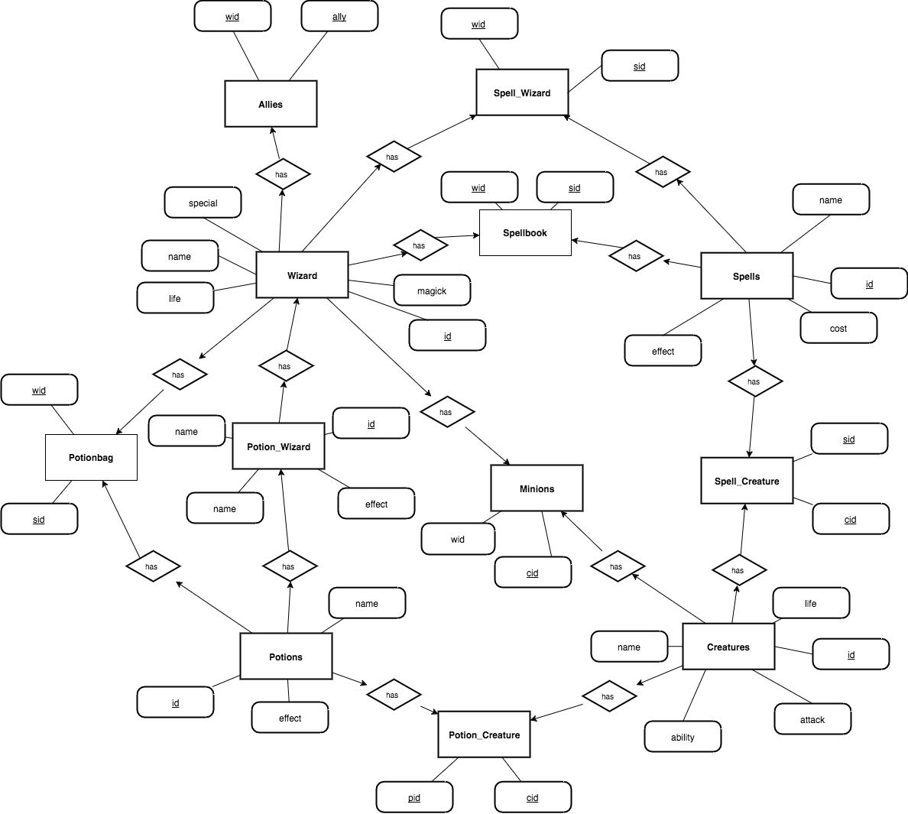

Database Schema (15%)

This should capture every attribute of every table. Additionally it should show every foreign key reference used in the database.

Table Creation Queries (15%)

I want to see the queries your ran to build your tables. These should not be in any of the website code because you should not be dynamically building or deleting tables.

General Use Queries (30%)

I want to see all of the queries that will be used to select, update, add or delete data. Because many of these will be based on user input, use square brackets to act as place holders for variables that will be user provided. For example, if I were going to query based on employee salaries, I might have a query like this:

SELECT salary FROM employee WHERE salary > [salaryInput ]; Another example INSERT INTO employee(name, age) VALUES ([user],[name]);

HTML (10%)

All of the needed forms and buttons should be present to allow me to perform all of actions required of the database. This is graded on if the functionality is there. Not if it looks pretty.

Style (10%)

This is a catchall for if you have bad coding style, don’t comment, have illegible diagrams etc.