Chapter1: INTRODUCTION

1.0Introduction

The term agronomy is derived from Greek words “AGRO” meaning field & “NOMO” meaning to manage. Agronomy is a branch of agriculture science that deals with methods which provide favourable environment to the crop for higher productively. It also deals with various physical and biological factors—including soil management, tillage, crop rotation, breeding, weed control, and climate—related to crop production. Agronomy commonly refers to field crops, e.g. wheat, rice, corn, sorghum, soybean, cotton, as well as pasture, sugar, and forage crops. Agronomy arose out of the practical activity of man, developing in close connection with growth of the productive forces of society and with change in socioeconomic relations and progress in natural science. Agronomy is the umbrella term for a number of technical research and teaching activities: soil science and weed management frequently are included in agronomy[1].

Soil science is the study of soil as a natural resource on the surface of the Earth including soil formation, classification and mapping; physical, chemical, biological, and fertility properties of soils; and these properties in relation to the use and management of soils.[1]

Weed management is the common methods used to manage weeds include prevention and cultural, mechanical, biological, and chemical means.

Agronomy is a dynamic discipline with the advancement of knowledge and better understanding of planet & environment, agricultural Practices and modified of new practices developed for high productively as follows:

* Proper methods of filling the lands.
* Suitable period for its cultivation.
* Availability of chemical fertilizers has necessitated the generation of knowledge on the method.
* Availability of herbicides for control of weeds has led to development for a vast knowledge about selectivity, time & method of its application.
* Water management practices.
* Intensive cropping.

Restoration of soil fertility, preparation of good seedbed, use of proper seed rates, correct dates of sowing for each improved Variety, proper methods of conservation & management of soil moisture & proper control weeds are agronomic practices to make our finite land water resources more productive.

* 1. Statement of the problem

Through careful and thorough analysis, certain problems were noted; the biggest problems facing agriculture are those due to increase in population. Most of these problems result to the following:

1. The difficulties encountered in accessing fertile soil suitable for a particular crop.
2. Poor crop yield due to pests and diseases.

1.2 Objectives

The aim and objectives of the project is to develop a website on agronomy. Specific objectives are:

1. To develop a reliable system that could be used in providing information on soil and climate requirement for crop growth.
2. To develop a piece of software that aid in providing an effective method of controlling pests and diseases.

1.3 Significance of the project

The system will solve problem associated with poor crop yield, attack on pests and diseases. This is done by using the website to check the requirement for any crop.

REFERENCE

1. Sovetov, A. V. *O sistemakh zemledeliia*. St. Petersburg, 1867.

CHAPTER 2: Literature Review

2.0 Introduction

The emphasis of agronomy is now more towards the scientific study of the behaviour of plant under the different environmental conditions like vary soils and climate, irrigation, fertilization etc. by conducting well laid out experiments in the fields, pots & laboratories. With the growth of other allied agricultural sciences, the present day agronomy not only embodies the act of soil management of crop production and obtaining maximum production at minimum cost but also establishing new facts and applying scientific knowledge to practical problems. It is also involves application of research in the field or forming suitable packages of practices under a given set of conditions. Literally, the science of field cropping. In the broad sense the term denotes the principles of agricultural production in general or the aggregate of knowledge in all branches of agriculture. With the development of the theory and practice of agricultural production, several areas of inquiry have become independent of agronomy: farm economics and organization, animal husbandry, the theory of agricultural machinery, the technology of processing agricultural products, and the like.

2.1 Theoretical Background

The need for a web-based agronomy became known when the desire to achieve a faster and more efficient means of producing crops is needed. There are quite some concepts and technologies that were put into use to achieve this work. The major technologies used in this project work are basically the web development technologies; html, php, css, ajax and relational database (mysql). The system’s site that is being developed is a collection of web documents i.e. files written in html using html tags. The web documents basically require a web browser and an internet access to view the website.

HTML: HTML stands for Hyper Text Markup Language. It is a markup language for describing web pages. A markup language can be described as a set of markup tags that describe document content. HTML documents, also called webpages, contain HTML tags and plain text. A web browser is used to read and display them as web pages. The browser does not display the HTML tags, but uses these tags to interpret the content of the page.

HTML tags are keywords surrounded by angle brackets like <html>. The tags normally come in pairs like <b> and </b>. The first tag in a pair is the start tag and the second tag is the end tag. They could also be called opening and closing tags respectively. Some tags in an HTML document determine the way certain text, such as titles, will be formatted. Other tags cue the computer to respond to the user's actions on the keyboard or mouse. For instance, the user might click on an icon (a picture that represents a specific command), and that action might call another piece of software to display a graphic, play a recording, or run a short movie. Another important tag is a link, which may contain the Uniform Resource Locator (URL) of another document. The URL can be compared to an address where a particular document resides. The document may be stored on the same computer as the parent document or on any computer connected to the World Wide Web. The user can navigate from document to document simply by clicking on these links. HTML also includes mark-ups for forms that let the user fill out information and electronically send, or e-mail, the data to the document author, initiate sophisticated searches of information on the Internet, or order goods and services.

Below is a visualization of an HTML page structure:

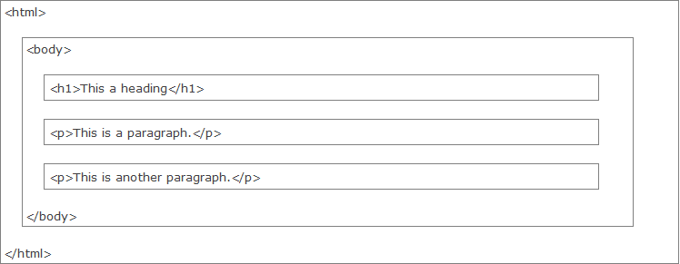

CSS: Css allows the planning, production, and maintenance of a website to be incredibly simpler than HTML alone ever could be. By using CSS to present your web documents, you curtail literally days of development time and planning.

The CSS syntax is made up of three parts: A SELECTOR, A PROPERTY and A VALUE.

Selector {property: value}. E.g. Body {color: black}

The selector is normally the HTML element/tag to be defined, the property is the attribute to be changed, and value is the change to be applied.

PHP: PHP acronym for PHP: Hypertext Preprocessor, is a scripting language designed specifically for use on the Web which is a tool for creating dynamic Web pages. PHP can also be called data mover because it moves data to the database.

How PHP works

PHP is an embedded scripting language when used in Web pages. This means that PHP code is embedded in HTML code. You use HTML tags to enclose the PHP language that you embed in your HTML file the same way that you would use other HTML tags. You create and edit Web pages containing PHP the same way that you create and edit regular HTML pages.

The PHP software works in conjunction with the Web server. The Web server is the software that delivers Web pages to the world*.* When you type a URL into your Web browser, you’re sending a message to the Web server at that URL, asking it to send you an HTML file. The Web server responds by sending the requested file. Your browser reads the HTML file and displays the Web page. You also request the Web server to send you a file when you click a link in a Web page. In addition, the Web server processes a file when you click a Web page button that submits a form.

When PHP language statements are processed, only the output is sent by the Web server to the Web browser. The PHP language statements are not included in the output sent to the browser, so the PHP code is secure and transparent to the user. For instance, in this simple PHP statement:

<?php echo “Hello World”; ?>

<?php is the PHP opening tag, and ?> is the closing tag. echo is a PHP instruction that tells PHP to output the upcoming text. The PHP software processes the PHP statement and outputs this: Hello World.

SQL: Sql is an acronym that stands for Structured Query Language, SQL supports a small but very powerful set of statements for manipulating, managing, and protecting data stored in a database. For example, SQL describes what data to retrieve, delete, or insert, rather than how to perform the operation.

A database is a collection of related files having minimum redundancy and high efficiency. Usually, when we talk about databases we refer to a collection of tables. The building block of a database is the record. A record is a collection of related data treated as a single entity. For example, a hockey trading card could be called a record: it brings together the name, photograph, team, and statistics of one player. Using database terms, each of these related pieces of information is called a field: each hockey card record has a name field, a photograph field, a team field, and various player statistics fields. A collection of records that share the same fields is called a table because this kind of information can easily be presented in table format: each column represents a field and each row represents a record. In fact, the word column is synonymous with the word field, and the word row is synonymous with the word record.

2.2 Review of Related Literature

Agronomy arose out of the practical activity of man, developing in close connection with growth of the productive forces of society and with change in socioeconomic relations and progress in natural science. The roots of agronomy lie deep in the past. Man has tilled the soil for many thousands of years. At the turn of the century other countries also faced the problem of transition to a more intensive system of agriculture.

With the development of capitalism and growth of the urban population came a rise in the demand for agricultural products. This brought with it an increase in the marketability of these products and the introduction of more intensive farming systems. In the second half of the 18th century, under the influence of A. Young, fallow farming in England was replaced by crop rotation. At the turn of the century other countries also faced the problem of transition to a more intensive system of agriculture. Great credit for the solution of this problem is due to the German scientist I. Schubart, who originated the practice of sowing clover on fallow ground and who did much to advance the cultivation of clover. It was A. Thaer of Germany who synthesized Western European achievements in agronomy. He categorized all crops as soil-depleting or soil-enriching and thereby confirmed the necessity of alternating the two in crop rotation. Thaer proceeded from the so-called humus theory of plant nutrition, which erroneously maintained that green plants draw carbon from the soil through their roots. Nevertheless, Thaer’s basic ideas of the significance of organic substance in the soil played a constructive role in the development of agronomy. During the 19th century both plant chemistry and plant physiology began to assume stature as independent sciences. A long step forward had been taken in the theory of plant nutrition. In 1840 the German scientist Liebig formulated the basic tenets of the theory of the mineral nutrition of plants, according to which it is only the inorganic world which supplies food to plants, humus playing only the indirect role of acting on the mineral component of the soil by means of the carbon dioxide formed as the humus decomposes. Liebig’s error lay in underestimating the importance of nitrogenous fertilizers.

The present-day tasks of agronomy derive from the necessity of satisfying the growing needs of the population for agricultural products. The agronomic sciences are called upon to develop methods which will steadily free agriculture from the effects of harmful natural factors, particularly drought. Here a very important role belongs to mechanization, agricultural engineering, use of chemistry, land development, and seed selection and growing. The successful execution of the tasks facing agronomy is possible only with a rise in the level of scientific research, further organization of the interrelated working out of the most important problems, and the most intimate bonds between agricultural theory and practice. We must observe strictly the methodology of conducting field experiments and perfect that methodology, and we must introduce into research work new and more precise methods of field and laboratory analysis, in particular the use of apparatus reflecting the latest advances in physics, electronics, chemistry, and mathematics.

REFERENCES

[1] A.Thear, “*Soil Science History Biblography*”.

[2] Justus von Liebig, “*Chemistry in its Applications to Agriculture and Physiology*”, 1855.

[3] J. Boussingault, “*Agricultural chemistry* ”. Paris: Gauthier-Vollar, 1864-1884.

[4] H. Helriegel, “Botanical Gazette”, vol. 39, No. 6(Jun., 1905), pp. 425-436.

[5] Burbank, “Sustainable Production:Global Case Studies”, pp 295-308.

CHAPTER 3: System Analysis and Design

1. INTRODUCTION

Systems are basically designed to tackle problems. In the system in the phase of system specification and design, an architectural analysis of the proposed system is being carried out to know what the system is expected to do, its procedures of doing it, in order to enable thorough understanding of the necessary aspects under consideration needed for the development of the system. It creates more problems to develop system/computer software without analysing the project requirement and developing a design that will efficiently satisfy them. When a system is analysed, it saves time by avoiding ill-planned system development approach that has to be abandoned half way through its implementation.

In this chapter, the analysis of the old method of manual agronomy will be discussed and some of the inherent problems identified, and then the proposed system will be analyzed in order to provide a comprehensive documentation of the system’s design.

3.0.1 SYSTEM DESIGN AND METHODOLOGY

Design methodology refers to the development of a system or method for a unique situation; it aims at identifying the software specification and specifying the pattern by which the software is being made. This system will be using object oriented analysis and design (OOAD) as its design methodology with unified modeling language (UML) as its design tool.

3.1 DESCRIPTION OF THE EXISTING SYSTEM

The existing system is a system that is been carried out in terms of manual operation, A system in which all the methods of storing data and searching is of a manual approach. This approach is such that the agronomist will record the crop requirements on a paper or register and kept it a file. Critical analysis of this system reveals that it is a system prone to a lot of errors and it is not effective. The system is in such a way that the office is full of files. This tends to make the office look untied. Also because of the inconsistency of the manual system, at times files are lost because of mismanagement.

* + 1. INHERENT PROBLEMS IN THE EXISTING SYSTEM

After the existing system has been carefully analyzed, the following problems were identified:

1. The difficulties encountered in keeping crop data.
2. Difficulties in updating the data.
3. Difficulties in accessing the crop data.
4. Time wasted in searching for a given crop data/information on packed files
5. Files got missed as a result of manual storage of data.
6. Large physical space consumption since there is manual form of data storage.
7. Inadequate communication link.

3.2 ANALYSIS OF THE PROPOSED SYSTEM

Having looked at the old way of taking population census, and identified the problems with this method, we now look at how the proposed system will work to meet up with the problems inherent in the existing system.

In a detailed analysis of the proposed system, it has proven to be more effective and efficient than the existing system considering the following features:

1. The collected crops requirements can then be stored in a centralized database.
2. A lot of time is being saved because taking in of data and computation takes little or no time.
3. It requires little or no energy to be expended during the process of enumeration
4. It needs not store data or make references because result is being produced immediately (online).
5. Immediate and accurate response is being provided.
   * 1. REQUIREMENT SPECIFICATIONS

Basically, the only requirements to view a website that is hosted in the internet are a web browser and an internet access. But for the testing of this system, I am going to need the local provision of those services provided in the host server, which includes the web server (provided by Apache web server), the database management system (provided by MySQL) and the PHP interpreter. These services are locally made available in my computer by installing the WAMP application which made my computer a website host – local host.

3.2.2 USE CASE DIAGRAM

A use case is a list of steps, typically defining interactions between a role and a system to achieve a goal. Use case diagrams are diagrams that demonstrate the basic functions of the system (what the user can do and how the system should respond to the user’s action). These interactions represent the external and function view of the system from the perspective of the user. A use case can contain several paths that a user can take while interacting with the system. Each path through the use case is referred to as a scenario. Fig 1 shows the use case diagram of the system.

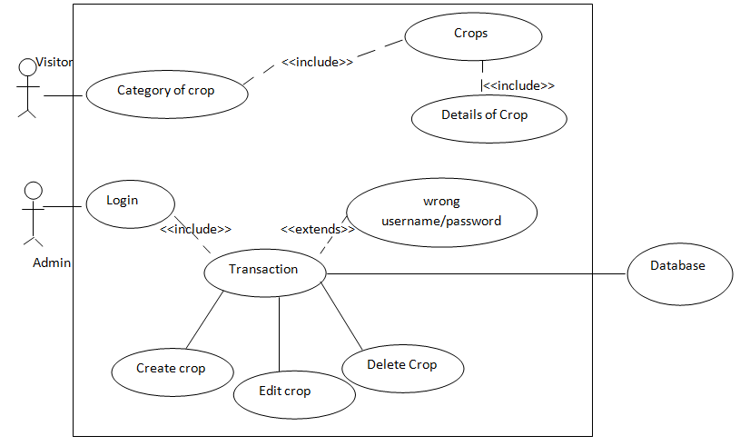FIG 3.1 USE CASE DIAGRAM

3.2.3 CLASS DIAGRAM

The class diagram is the most important entity in object-oriented analysis and design. It describes the types of objects that exists in the system and shows the static relationships among internal classes of the system.

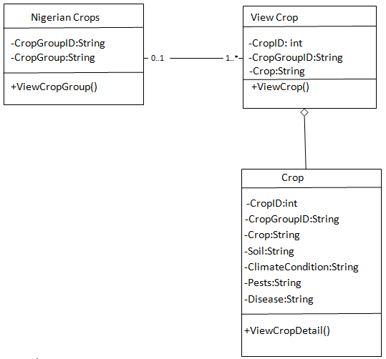

FIG 3.3 CLASS DIAGRAM

3.2.4 OBJECT DIAGRAM

Object Diagrams, sometimes referred to as Instance diagrams are very similar to class diagrams. Like class diagrams, they also show the relationship between objects but they use real world examples. They are used to show how a system will look like at a given time. Because there is data available in the objects, they are often used to explain complex relationships between objects.

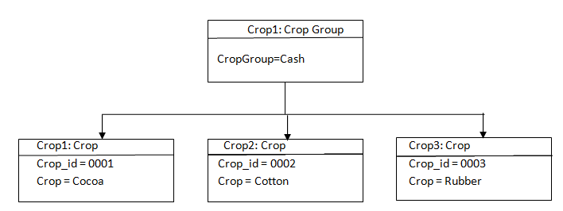

### Fig 3.4 OBJECT DIAGRAM

### 3.2.5 ACTIVITY DIAGRAM

Activity diagrams represent workflows in a graphical way. They can be used to describe business workflow or the operational workflow of any component in a system. Sometimes activity diagrams are used as an alternative to State machine diagrams.



Fig 3.5 ACTIVITY DIAGRAM

3.2.6 COMMUNICATION DIAGRAM

Communication diagram was called collaboration diagram in UML 1. It is similar to sequence diagrams, but the focus is on messages passed between objects. The same information can be represented using a sequence diagram and different objects.

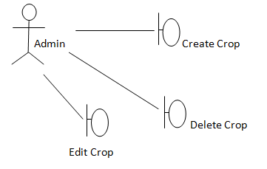

FIG 3.5 COMMUNICATION DIAGRAM

1. DESIGN OF THE PROPOSED SYSTEM

3.3.1 DATABASE DESIGN

Database design is about discovering and completely defining the application's data characteristics and processes. With a good database design, an application's data access is fast, easily maintained, and can gracefully accept future data enhancements. The process of database design includes identifying the data, defining specific data types and storage mechanisms, and ensuring data integrity by using business rules and other run-time enforcement mechanisms.

The following tables present the database design of my system:

Table 3.1: User table

| Column | Type | Null | Index | Comments |
| --- | --- | --- | --- | --- |
| crop_id | int(11) | No | Primary key |  |
| Name | varchar(200) | No | Unique |  |
| Image_name | Varchar(255) | No |  |  |
| Crop_group | Varchar(255) | No |  |  |
| Soil requirement | Text | No |  |  |
| Climate requirement | Text | No |  |  |
| Place grown | Text | No |  |  |
| Crop disease | Text | No |  |  |
| Crop pests | Text |  |  |  |
| Control | Text |  |  |  |

Table 3.2: faculty Table

3.3.2 DEPLOYMENT DIAGRAM

A deployment diagram in the unified modeling language models the physical deployment of artifacts on nodes. The UML provides a model to allow us to plan how our software is going to be deployed. Figure 3.6 showed the deployment of the system.

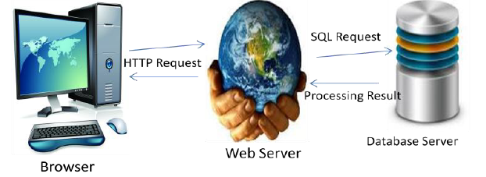

*Fig 3.6:.* A DEPLOYMENT DIAGRAM OF THE SYSTEM

3.3.3 SYSTEM ARCHITECTURE

The system has a 3-tier architecture which are; the presentation tier, the middle tier and the data tier. The presentation tier is the user interface of the software and it is designed using HTML and CSS. The middle tier (also called the business logic) is the part that connects the presentation tier and the data tier together. The middle tier is the back end PHP code that reads information from the database, logically processes it and present an output to the user through the web browser. The data tier is the part of the system that is responsible for the storing of data. This is also called the database. The database management system used for the development of this system is MySQL. The middle tier and the data tier operates in the server and present output to the web browser through the presentation tier. Figure 3.7 shows system architecture.

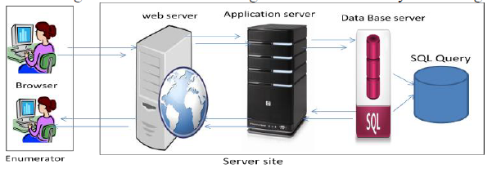

Fig 3.7: System Architecture