**Reports**

1. 167 users for 60 seconds Report

* Throughput – 2.4/sec

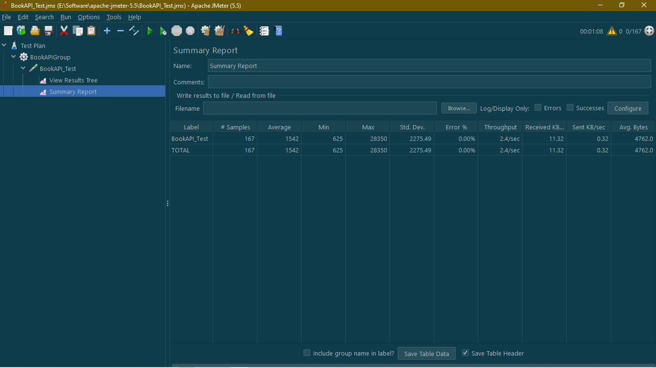

***Figure 1: First test for 60 seconds 167 users***

1. 833 users for 300 seconds Report

* Throughput – 2.8/sec

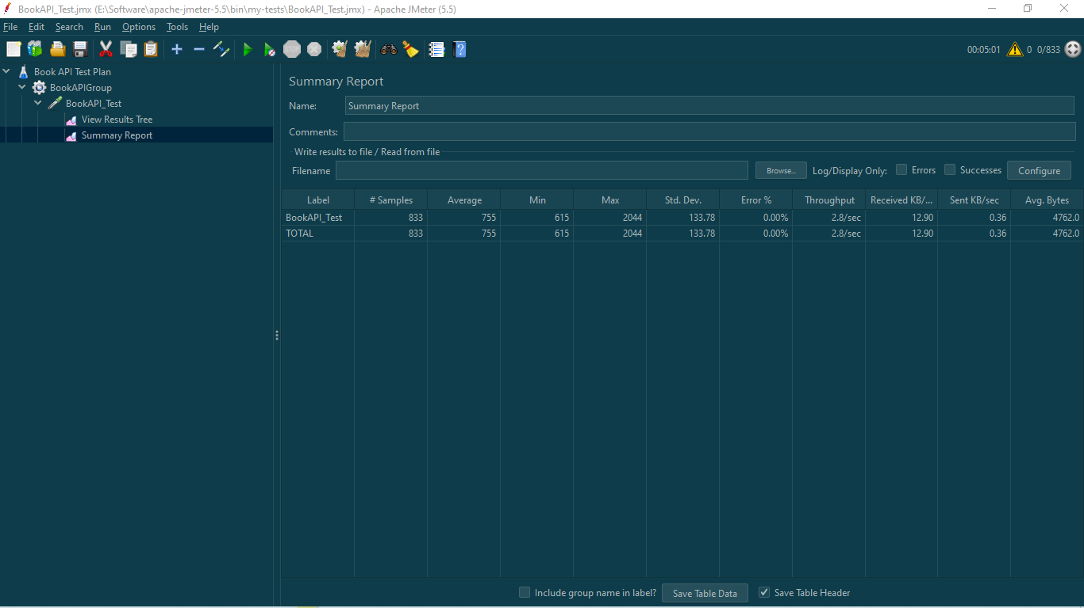

***Figure 2: Second test for 300 seconds 833 users***

1. 1667 users for 600 seconds Report

* Throughput – 2.8/sec
* Error – 0.06%

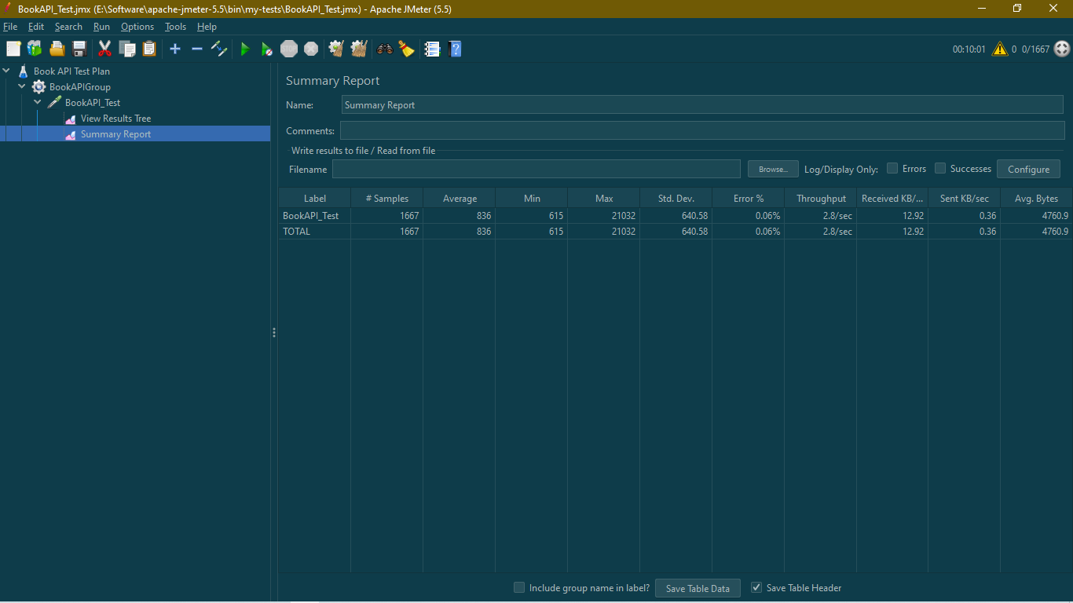

***Figure 3: Third test for 600 seconds 1667 users***

1. 1667 users for 650 seconds Report

* Throughput – 2.6/sec

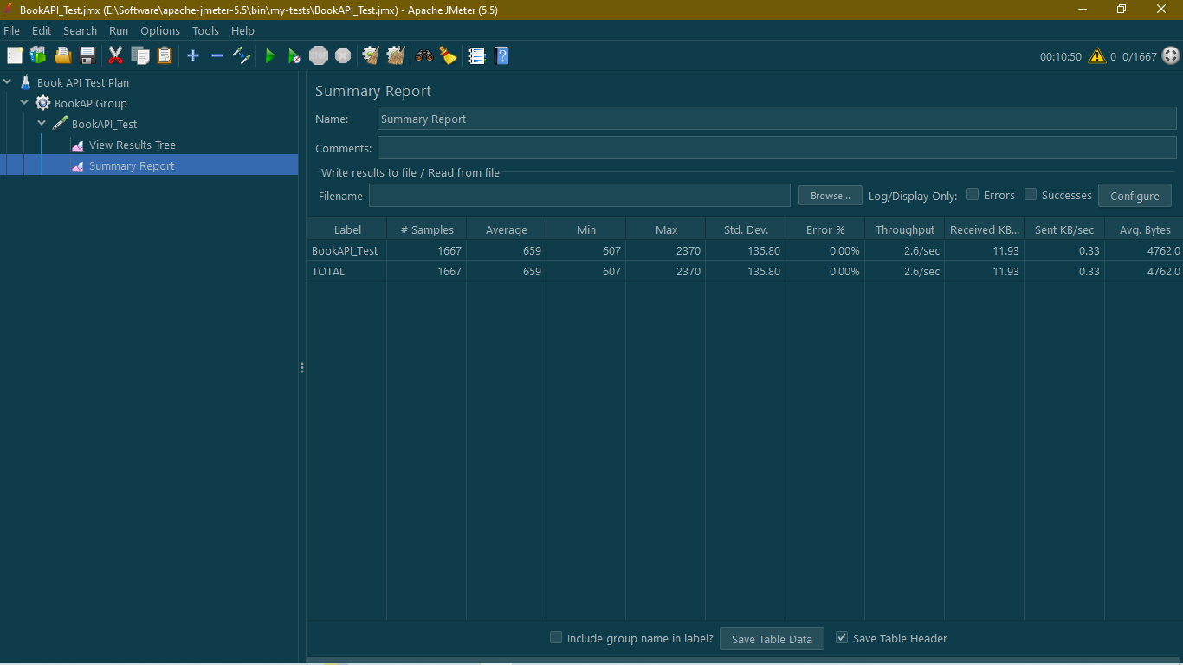

**Figure 4: Fourth test for 650 seconds 1667 users**

1. 2500 users for 900 seconds Report

* Throughput – 2.8/sec
* Error – 0.04%

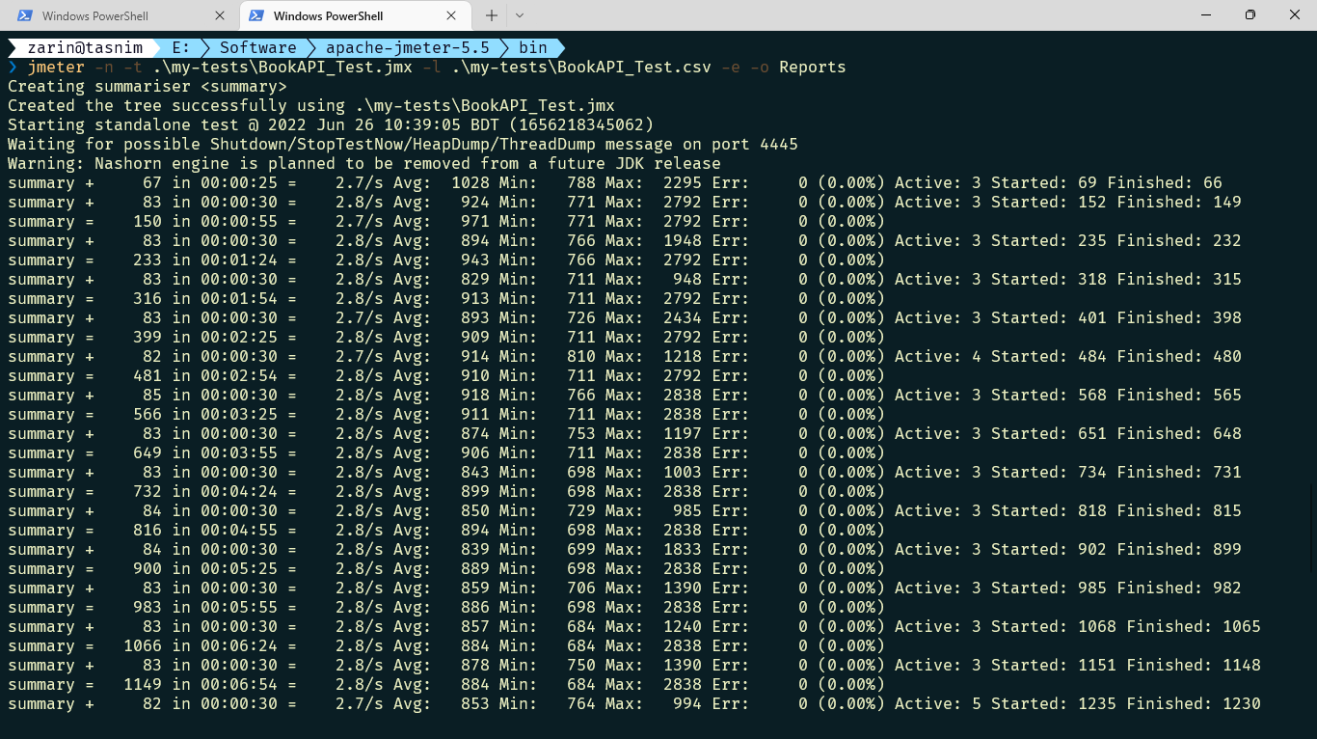

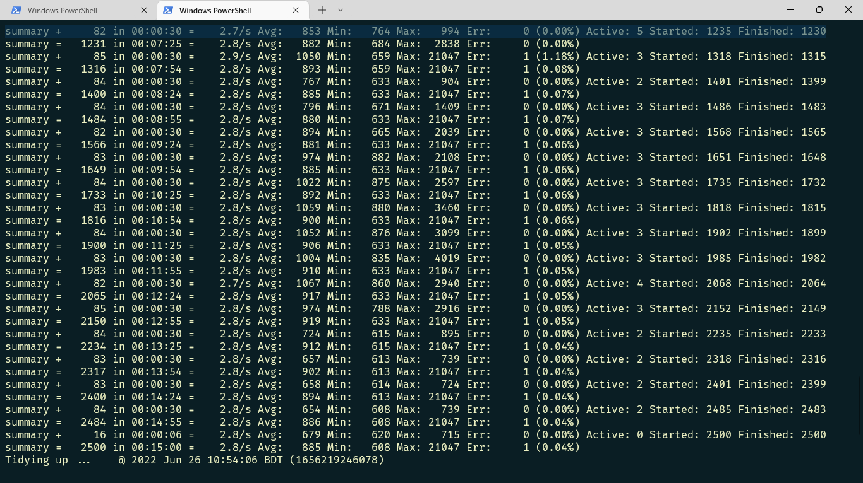

**Figure 5: Fifth test for 900 seconds 2500 users**

1. 2500 users for 950 seconds Report

* Throughput – 2.6/sec

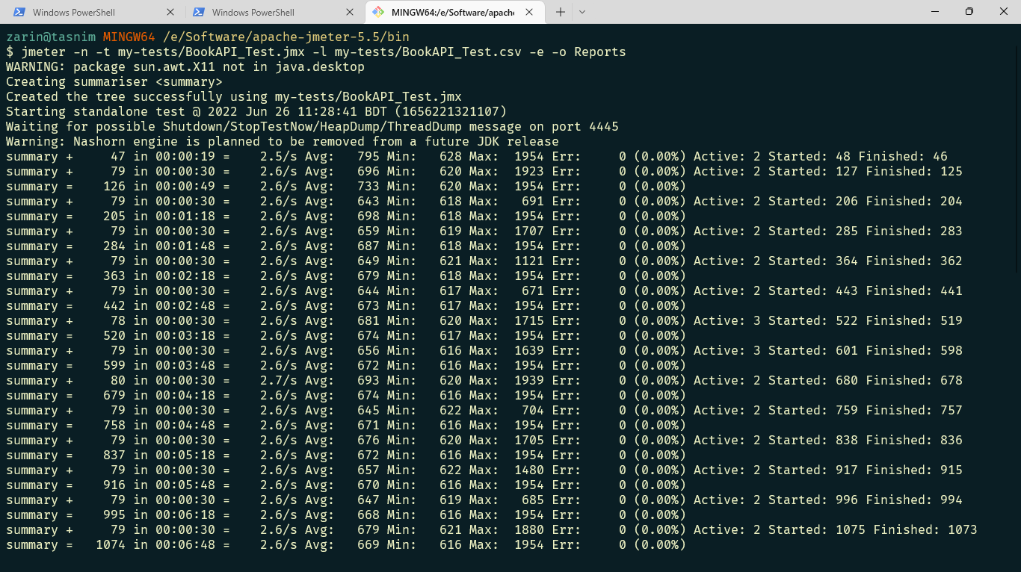

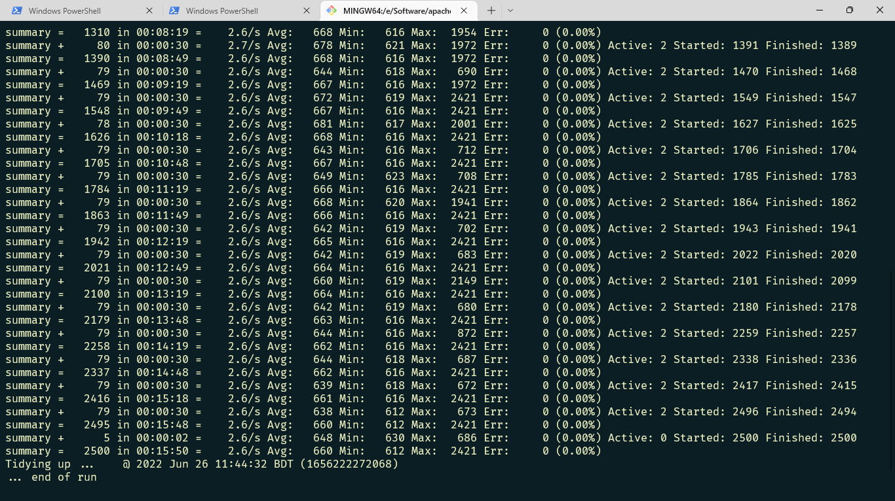

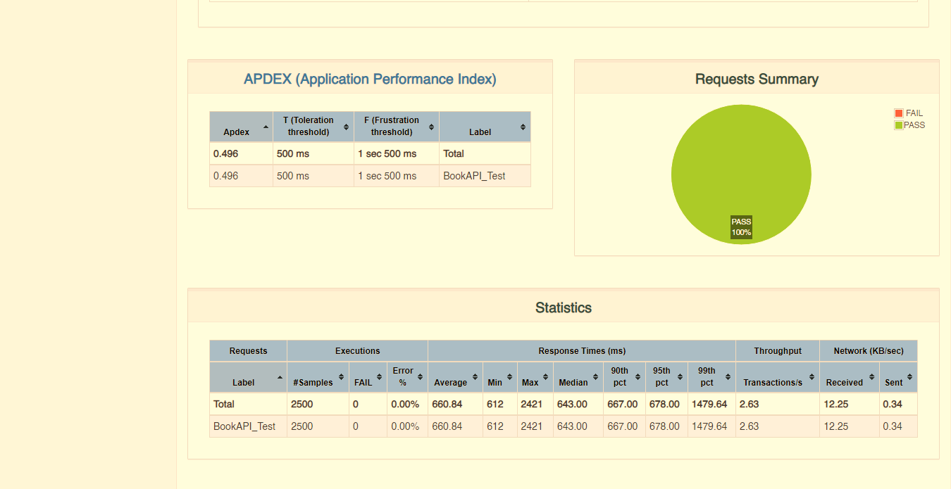

**Figure 6: Sixth test for 950 seconds 2500 users**