*In this kata you focus on the score of a tennis set*

***SPRINT1 : manage a tennis GAME within a set of a tennis match***

*User Story 1**(**see example bellow**):*

*As a tennis referee*

*I want to manage the score of a game of a set of a tennis match between 2 players with simple Game rules*

*In order to display the current Game score of each player*

*Rules details:*

-          *The game starts with a score of 0 point for each player*

-          *Each time a player win a point, the Game score changes as follow:*

*0 -> 15 -> 30 -> 40-> Win game*

*User Story 2 (**see example bellow**) :*

*As a tennis referee*

*I want to manage the specific of the rule DEUCE at the end of a Game*

*In order to display the current Game score of each player*

*Rules details:*

-          *If the 2 players reach the score 40, the DEUCE rule is activated*

-          *If the score is DEUCE , the player who  win the point take the ADVANTAGE*

-          *If the player who has the ADVANTAGE win the  point, he win the game*

-          *If the player who has the ADVANTAGE loose the point, the score is DEUCE*

***SPRINT2 : manage a Tennis SET within a tennis match***

*User Story 1 (**see example bellow**): :*

*As a tennis referee*

*I want to manage the score of a set of a tennis match between 2 players*

*In order to display the current Game & Set score of each player*

*Rules details:*

-          *The set starts with a score of 0 Game for each player*

-          *Each time a player win a Game, the Set score changes as follow:*

*1 -> 2 -> 3 -> 4 -> 5 -> 6 (-> 7)*

-          *If a player reach the Set score of 6 and the other player has a Set score of 4 or lower, the player win the Set*

-          *If a player win a Game and reach the Set score of 6 and the other player has a Set score of 5, a new Game must be played and the first player who reach the score of 7 wins the match*

*User Story 2  (see example bellow)::*

*As a tennis referee*

*I want to manage the specific of the rule of Tie-Break at the end of the Set*

*In order to display the current Game, Set score & Tie-Break score of each player*

*Rules details:*

-          *If the 2 players reach the score of 6 Games , the Tie-Break rule is activated*

-          *Each time a player win a point, the score changes as follow:*

*1 -> 2 -> 3 -> 4 -> 5 -> 6 (-> 7-> 8-> 9-> 10-> …)*

-          *The Tie-Break ends as soon as a player gets a least 6 points and gets 2 points more than his opponent*

-          *The player who wins the Tie-Break wins the Set and the match*

Prerequisite*:*

*Write a program that calculate the score of two tennis players*

*Players must be able to score points*

*The Set should be finished with y a winner*

*After a game is won, the winning player must be determined.*  
*We must be able to follow the score of each player at any time during the game.*

**Sprint 1 use case 1**

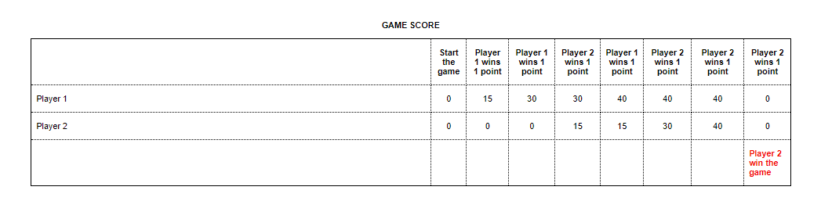

**Sprint 1 use case 2**

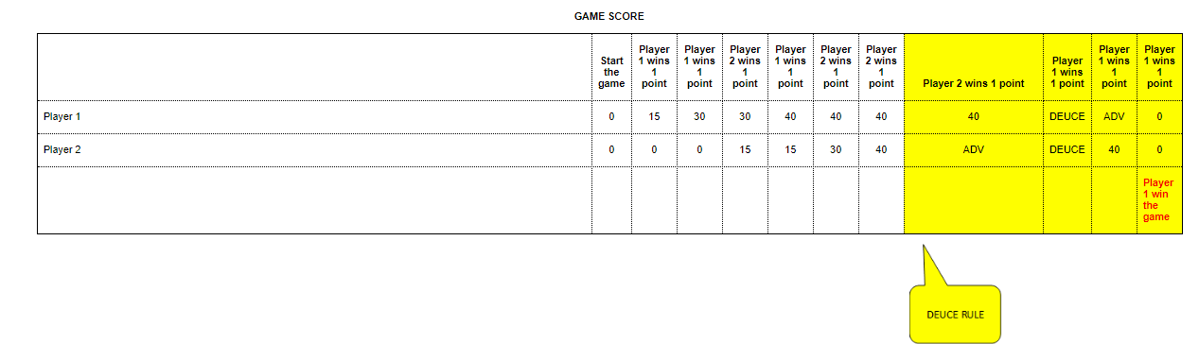

**Sprint 2 use case 1**



**Sprint 2 use case 2**

