**CS 428/528**

**Instructor: Anand Seetharam**

**Quiz 1**

1. Name the five layers of the protocol stack. (**2 points)**

**Application, Transport, Network, Link, Physical**

2. In this figure, 3 clients are simultaneously downloading a file from a server. The capacity of the bottleneck link is R. What is the throughput received by each client (assume Rc > R)? (**2 points)**

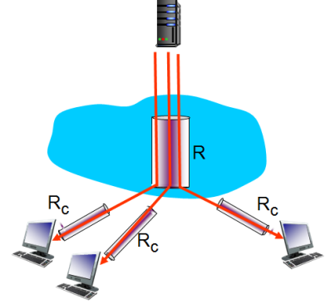

**Assuming a packet-switched network, each client C receives a throughput of Rc/3 Bps.**

3. Application and Transport layers of the Internet protocol stack are implemented in the end systems but not in the routers in the network core. True or False? **(1 point)**

**True**

4. Two hosts A and B are connected by a 100 Mbps link. A is sending a packet of size 1000 KBytes to B. What is transmission delay for the packet? (**2 points)**

**1e6/1e8 = 10-2s**

5. Write one important difference between circuit-switched and packet-switched networks. (**1 point)**

**Circuit-switched networks have an always-on dedicated end-to-end connection between each client pair, packet-switched networks do not have dedicated connections as they are created dynamically between each hop on the connection request.**

6. Two hosts A and B are connected by an optical fiber 3000 Km long. The speed of light is 3*108 m/sec. What is the propagation delay? (**2 points)**

**velocity/distance = 3e6/3e8 =10-2 sec**