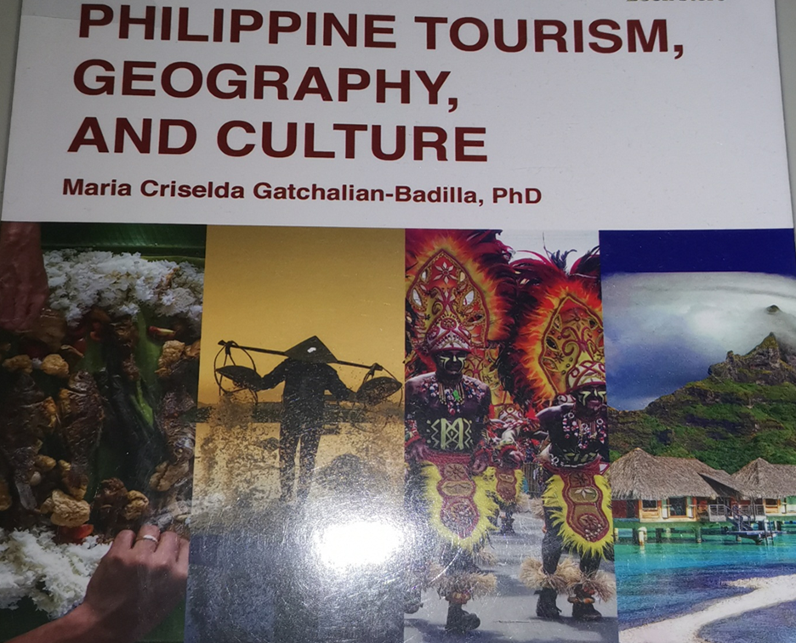

**PHILIPPINE TOURISM, GEOGRAPHY, AND CULTURE**

**Instructor/s:** **AUDITTE V. SOL**

**Course Title:** PHILIPPINE TOURISM, GEOGRAPHY, AND CULTURE

**Course Description:** This course shall have students analyse and familiarize themselves with specific world travel destinations, with emphasis on the exploration of geographic features, customs and traditions, population centers, visitor attractions, political, religious, language and other cultural differences as these relate to the hospitality and travel industry. Students will develop understanding as well as sense of responsiveness for cultural values and traditions that exist beyond their own culture. Students will be able to identify international travel patterns by locating various major cities, natural wonders, historic sites, and other tourism attractions, both man made and natural focusing as well with the major travel-generating and travel-receiving areas.

**Credit hours:** 3 hours

**Pre-Requisite:** No

**Module 3**

**Unit I. REGION 2- CAGAYAN VALLEY REGION**

1. **LEARNING OUTCOMES:**

At the end of the module, students be able to:

1. Identify the different major attractions, activities, accommodations, and cultural highlights in the provinces within the Cagayan Valley Regions;
2. Create different tour packages that carry different types of tourism activities and;
3. Assess the strengths, weaknesses, opportunities, and threats of the region in terms of the 4As of tourism

2. Geography Check

Identify which parts of the map are Isabela, Nueva Viscaya, Quirino, Batanes, Cagayan. The following are the assigned color, Batanes (blue), Cagayan (yellow), Isabela (green), Nueva Viscaya (red), Quirino (Purple).

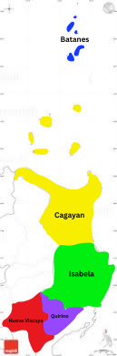

3. Regional and Provincial Slogans

Search the Internet for the current regional and provincial tourism slogans used by the different province within the region. What does each slogan highlight? Knowing the attractions of each province, is it the most appropriate tagline to use? If not, do you have another suggestion on the slogan/tagline to be used?

|  |  |
| --- | --- |
| **REGION/PROVINCE** | **CURRENT SLOGAN USED** |
| BATANES | Land of the True Insulars |
| CAGAYAN | A True Spelunker’s Paradise |
| ISABELA | Rice Granary of the North |
| NUEVA VISCAYA | Watershed Have of the North |
| QUIRINO | Forest Heartland of Cagayan |

**REFERENCES**

Maria Criselda Gatchalian-Badilla, PhD (2019). Philippine Tourism, Geography, and Culture, Rex Bookstore, 856 Nicanor Reyes Sr. St., Sampaloc Manila

Paul L. So (2012). Philippine Tourist Destination, Published by: Accumicro I.T. Solutions 1514-E Alcantara St., Sampaloc, Manila 1008

**RUBRICS**

|  |  |  |  |  |
| --- | --- | --- | --- | --- |
| **Features** | **5**  **Expert** | **4**  **Accomplished** | **3**  **Capable** | **2**  **Beginner** |
| **Quality of Writing** | Piece was written in an extraordinary style and voice  Very Informative and well organized | Piece was written in an interesting style and voice  Somewhat informative and organized | Piece had little style and voice  Gives some new information but poorly organized | Piece had no style or voice  Gives no new information and very poorly organized |
| **Grammar, Usage & Mechanics** | Virtually no spelling, punctuation or grammatical errors | Few spelling and punctuation errors, minor grammatical errors | A number of spelling, punctuation or grammatical errors | So many spelling, punctuation and grammatical errors that it interferes with the meaning |

END OF MODULE 1