Coding challenge to create a graphics viewer.

This coding challenge aims to assess your ability to create a graphics viewer from scratch. There are two aspects.

1. Create the graphics viewer.
2. Create a lean UI to hold the viewer.

Challenge: Create a graphics viewer that appears something like below

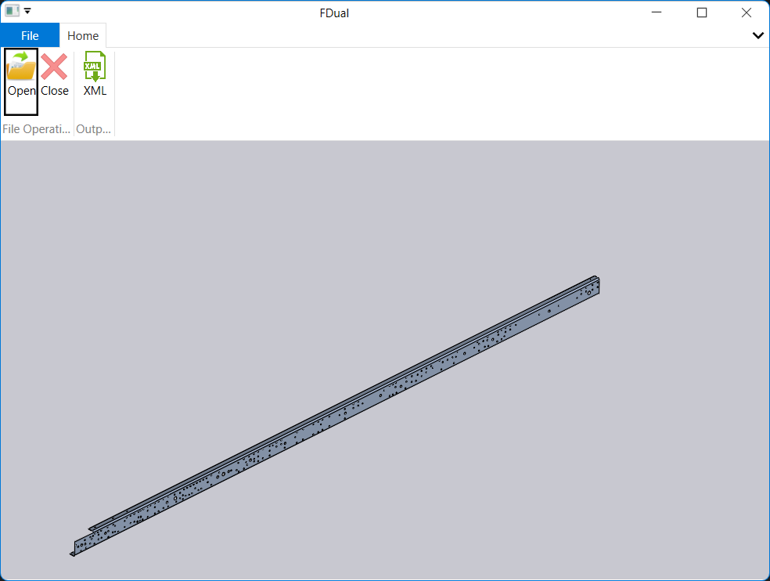

Features that it should have.

1. File-> Open an STL file. The STL files attached with this document are binary ones. It should open STL file and display like above
2. A basic vertex and fragment shaders would suffice.
3. Implement Zoom, Orbit, and PAN.
4. Support Perspective and Orthogonal projection systems with the help of toggle button on the top.
5. Implement Select and Unselect. When in select mode, there are two possible outcomes
   1. Either the triangle alone, which was selected, shall be highlighted in “YELLOW” color OR
   2. The entire STL part shall be highlighted in “YELLOW” color. Let the “F10” key toggle decide the highlight mode.
6. Implement a compass ( like CATIA)  at the world coordinate system. It should
   1. Be drag and droppable to any location on the STL. The compass should move and stick to the point. (Any orientation will do)
   2. If the compass is dragged and dropped at a location that is devoid of any part, the compass regains the world coordinate origin location again.

You are free to assume any other specs/features.

It would be beneficial if you added more features to the viewer.

Choice of technology:

1. *Preferably use OpenGL or Open Scene Graph.*
2. *Windows platform is preferred*.
3. I prefer WinForms or WPF.