**PHASE 2: INNOVATION**

**FLOOD MONITORING AND EARLY WARNING**

**SYSTEM**

Flood monitoring and early warning system is used for monitoring the river and water bodies for give the immediate warning to public and disaster management team when the water level increase above the normal level to reduce the damage.

For this solution components we using are

1.ESP32 development board (ESP32-WROOM-32)

2.water level sensor (float sensor)

3.Buzzer or speaker for alarm

4.ARDUINO IDE software

5.GSM module

6.LED display

**DESIGN**:

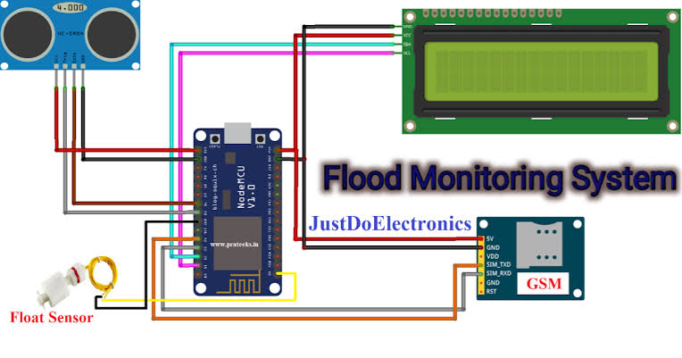

**ESP32:**

There are many different types of flood monitoring systems that may be constructed using the flexible and powerful ESP32 microcontroller. The ESP32 is a great option for IoT applications and applications that are cost-conscious because to its low cost, low power consumption, and built-in Wi-Fi connectivity.

**WATER LEVEL SENSOR**:

The area to be monitored normally has a network of water level sensors placed. The sensors periodically gather information on the water level and send it to a central monitoring station. After then, the information is examined to spot any potential flood threats. Float sensors are inexpensive, dependable devices that track changes in a float's position when the water level changes.

**BUZZER:**

Buzzers are often positioned in key positions all around the monitored area. The buzzers start to make a loud, continuous noise when a flood warning is issued. This noise will alert people to the possibility of flooding and allow them time to flee to safety.

**ADRUINO IDE SOFTWARE**:

One can create a flood monitoring and early warning system using the Arduino IDE software. For authoring and uploading programs to Arduino microcontrollers, there is a free and open-source software environment called the Arduino IDE. It has a debugger, a compiler, and a code editor.

**GSM MODULE:**

Text messages (SMS) or voice calls can be used in a flood monitoring and early warning system to notify individuals of a potential flood. GSM modules are compact, reasonably priced devices that may be plugged into a microcontroller, like an Arduino, to make and receive voice calls and SMS messages.

**LED DISPLAY:**

In flood monitoring and early warning systems, LED displays can be utilized to show the water level and flood risk visually. Information such as the following can be displayed on LED displays:

• The current water level

• The expected water level

• The level of flood danger

**USE CASE:**

This flood monitoring and early warning system is Operated by depend on water level detection. Water level sensor detect the water level, send it to the ESP32 by using ARDUINO IDE software set the threshold level of water, when water level increase above the threshold level it will alarm the buzzer to surrounding area. it will also send the message (via website and/ or SMS) that alerts concern rescue team and public for a potential flood event. furthermore, inquiry system is also included in this solution to become more interactive wherein public could inquire the actual Water level and status of desired area or location affected by flood through SMS keyword. This system aims in helping public to be prepared and knowledge whenever there is a flood. The innovation of work falls under utilization of the Arduino, water level sensors, LORA module, web-monitoring and SMS early warning system in helping public and government to control damages related to flood. This flood monitoring and early warning system is most essential and important as per needs for safety and welfare of the community.