**PHASE 2: INOVATION**

**FLOOD MONITORING AND EARLY WARNING**

**SYSTEM**

Flood monitoring and early warning system is used for monitoring the river and water bodies for give the immediate warning to public and disaster management team when the water level increase above the normal level to reduce the damage.

For this solution components we using are

1.ESP32 development board (ESP32-WROOM-32)

2.water level sensor

3.Buzzer or speaker for alarm

4.ARDUINO IDE software

5.LORA module or GSM module

6.LED display

**DESIGN**:

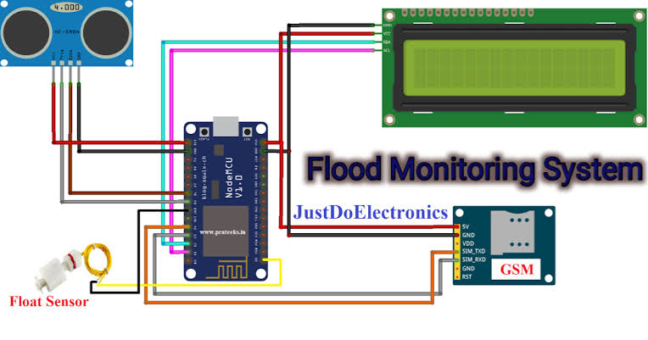**USE CASE:**

This flood monitoring and early warning system is Operated by depend on water level detection. Water level sensor detect the water level, send it to the ESP32 by using ARDUINO IDE software set the threshold level of water, when water level increase above the threshold level it will alarm the buzzer to surrounding area. it will also send the message (via website and/ or SMS) that alerts concern rescue team and public for a potential flood event. furthermore, inquiry system is also included in this solution to become more interactive wherein public could inquire the actual Water level and status of desired area or location affected by flood through SMS keyword. This system aims in helping public to be prepared and knowledge whenever there is a flood. The innovation of work falls under utilization of the Arduino, water level sensors, LORA module, web-monitoring and SMS early warning system in helping public and government to control damages related to flood. This flood monitoring and early warning system is most essential and important as per needs for safety and welfare of the community.