Problem statement 1 :

students = ["Arun", "Bala", "Kavin"]

new_student = "Ravi"

students.append(new_student)

print("Updated Student List:", students)

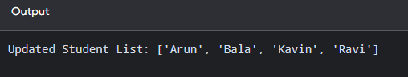

Problem statement 2 :

existing = ["Python", "Java"]

new = ["MySQL", "HTML", "CSS"]

existing.extend(new)

print("Updated Subject List:", existing)
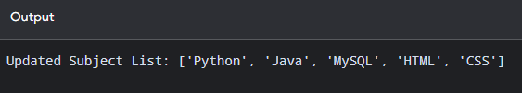

Problem statement 3 :

students = ["Arun", "Bala", "Kavin", "Ravi"]

new_student = "Mohan"
position = 2

students.insert(position, new_student)

print("Updated Student List:", students)

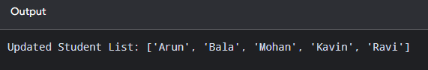

Problem statement 4 :

cart = ["Laptop", "Mouse", "Keyboard", "Monitor"]

remove = "Keyboard"

cart.remove(remove)

print("Updated Cart:", cart)

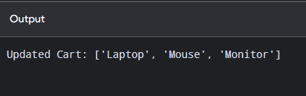

Problem statement 5 :

courses = ["Python", "Java", "SQL", "Spring"]

removed_course = courses.pop()

print("Removed Course:", removed_course)
print("Updated Course List:", courses)

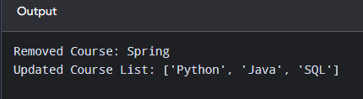

Problem statement 6 :

students = ["Arun", "Bala", "Kavin", "Ravi"]

search_student = "Kavin"

position = students.index(search_student)

print("Student:", search_student)
print("Position:", position)

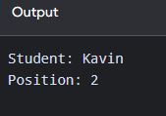

Problem statement 7 :

marks = [80, 75, 90, 80, 65, 80]

search_mark = 80

count = marks.count(search_mark)

print("Search Mark:", search_mark)
print("Number of Occurrences:", count)

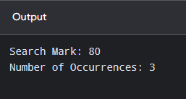

Problem statement 8 :

marks = [78, 92, 65, 88, 70]

print("Before Sorting:", marks)

marks.sort()

print("After Sorting:", marks)

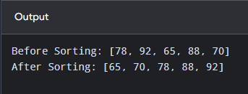

Problem statement 9 :

students = ["Arun", "Bala", "Kavin", "Ravi"]

print("Before Reversing:", students)

students.reverse()

print("After Reversing:", students)

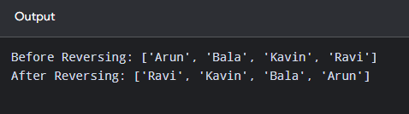

Problem statement 10 :

students = ["Arun", "Bala", "Kavin"]

backup = students.copy()

new_student = "Ravi"
backup.append(new_student)

print("Original List:", students)
print("Copied List:", backup)

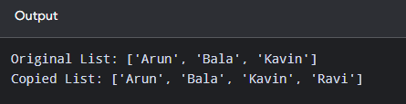

Problem statement 11:

cart = ["Laptop", "Mouse", "Keyboard"]

print("Before Clearing:", cart)

cart.clear()

print("After Clearing:", cart)

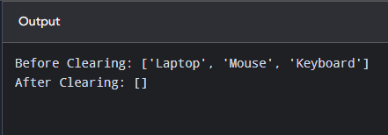

Problem statement 12 :

marks = [65, 78, 92, 56, 88]

total = sum(marks)
highest = max(marks)
lowest = min(marks)
number_of_students = len(marks)
average = sum(marks) / len(marks)

print("Total Marks:", total)
print("Highest Mark:", highest)
print("Lowest Mark:", lowest)
print("Number of Students:", number_of_students)
print("Average Mark:", average)

