**OUTPUT OF THE PROJECT**

**Adaptive Mail : A Flexible Email Client App**

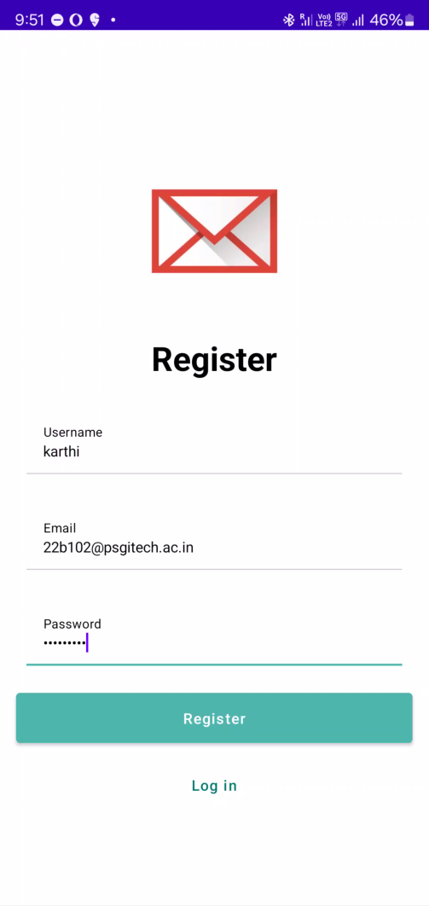

Fig 1: Register Page

Fig 2: Login Page

Fig 3: Home Page

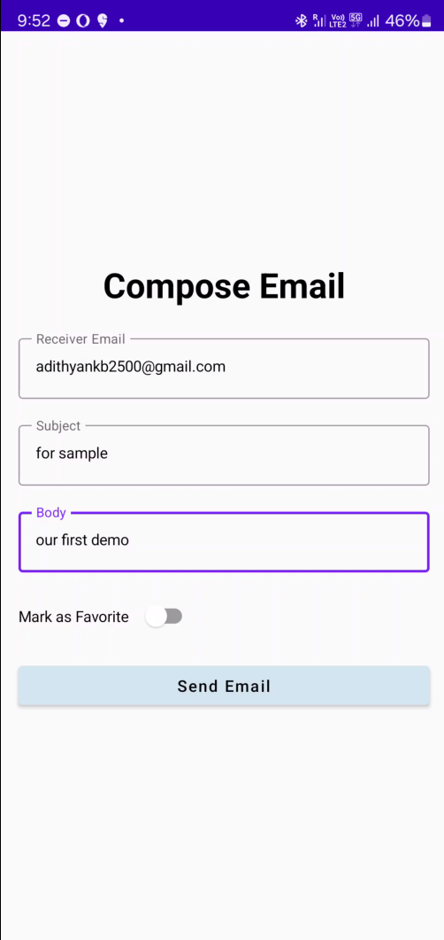

Fig 4: Send Mail Page

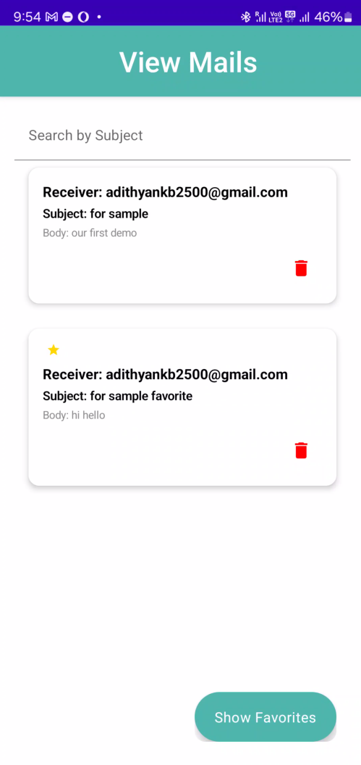

Fig 5: View Mail page