PROJECT REPORT
AUTO TICKET CLASSIFICATION USING FLOW DESIGNER

Submitted as part of the project work

Student Name: __________________________
Register Number: _______________________
Department: Computer Science and Engineering
Academic Year: _________________________

1. INTRODUCTION

1.1 Project Overview
The school IT helpdesk receives multiple incident requests every day from students and teachers. These requests may be related to Wi-Fi issues, projector failures, password or account problems, network connectivity, hardware failures, and slow system performance. In the existing process, IT staff manually review each request and assign a suitable category and subcategory.
The project 'Auto Ticket Classification using Flow Designer' automates this process using ServiceNow Flow Designer. The flow analyzes keywords and information in the incident description and automatically assigns the appropriate category and subcategory. It also supports automated notification and structured storage of ticket information.

1.2 Purpose
- Automatically classify incidents when they are created.
- Reduce manual effort for IT support staff.
- Improve ticket processing efficiency and consistency.
- Provide a no-code and easily maintainable solution.
- Support future expansion of classification rules.

2. IDEATION PHASE

2.1 Problem Statement
The school IT helpdesk receives a large number of support requests from students and teachers. Currently, IT staff manually read each ticket, identify the issue type, select the correct category and subcategory, and communicate the ticket creation to the caller. This manual process is time-consuming, error-prone, and difficult to scale when the number of requests increases.
Therefore, a simple automated solution is required to classify tickets based on their issue description and assign the appropriate category and subcategory without manual intervention.

2.2 Empathy Map Canvas
The main users are students, teachers, callers, and IT support staff.
Empathy Area | User Observation
Says | Users report issues such as Wi-Fi not working, password problems, projector failure, or slow computers.
Thinks | Users expect their issue to be registered and routed quickly.
Does | Users create support tickets and provide a short description of the problem.
Feels | Users may feel frustrated when a simple issue takes a long time to process.
Needs | Fast ticket creation, correct classification, and timely communication.
Pain Points | Manual classification, delays, inconsistent category selection, and increasing ticket volume.

2.3 Brainstorming
- Use ServiceNow Flow Designer to automate ticket classification.
- Analyze keywords in the incident short description and description fields.
- Assign category and subcategory automatically.
- Use dependent choice logic between category and subcategory.
- Send an automated email notification after ticket creation.
- Store ticket information in a structured and standardized format.
- Use Update Sets to package and move configuration changes.

3. REQUIREMENT ANALYSIS

3.1 Customer Journey Map
Stage | User Action | System Action | Expected Result
Issue Occurs | Student/teacher experiences an IT issue. | No system action yet. | Issue is identified by the user.
Ticket Creation | User submits an incident. | Incident record is created. | Ticket receives a unique number.
Classification | User provides issue description. | Flow Designer analyzes the ticket. | Category and subcategory are selected.
Notification | User waits for confirmation. | System sends email notification. | Caller receives confirmation.
Support | IT staff handles the ticket. | Ticket remains stored in structured form. | Faster and more consistent support.

3.2 Solution Requirement
The system must:
- Automatically classify IT tickets based on the issue description.
- Assign both Category and Subcategory without manual intervention.
- Support dependent choice logic between Category and Subcategory.
- Send an automated email notification to the caller upon ticket creation.
- Store ticket information in a structured and standardized format.
- Ensure easy maintenance and future scalability.

3.3 Data Flow Diagram
The overall data flow can be represented as follows:
Student / Teacher → Create Incident → ServiceNow Incident Record → Flow Designer → Keyword/Condition Check → Category & Subcategory Assignment → Email Notification → IT Support
Figure 1: Data Flow of the Auto Ticket Classification System
[Insert the project DFD diagram/screenshot here]

3.4 Technology Stack
Technology / Component | Purpose
ServiceNow | IT service management platform used to create and manage incidents.
Flow Designer | No-code automation used for ticket classification and actions.
Incident Table | Stores incident/ticket information in a structured format.
Update Set | Captures configuration changes for movement between instances.
Email Notification | Automatically informs the caller after ticket creation.

4. PROJECT DESIGN

4.1 Problem Solution Fit
The main problem is the manual classification of a large number of IT incidents. The proposed solution directly addresses this problem by using Flow Designer to automatically evaluate the issue description and assign the relevant category and subcategory. This reduces repetitive work for IT staff and provides a consistent classification process.

4.2 Proposed Solution
- An incident is created by a student, teacher, or other caller.
- The system reads the incident information and issue description.
- Flow Designer checks the defined keywords and conditions.
- The appropriate category is identified.
- A dependent subcategory is selected according to the category.
- The ticket information is stored in the incident record.
- An automated email notification is sent to the caller.
- The IT support team can continue with ticket resolution.

4.3 Solution Architecture
The solution follows a simple automation architecture:
User → ServiceNow Incident → Flow Designer Trigger → Classification Logic → Category/Subcategory → Notification → IT Support
Figure 2: Solution Architecture
[Insert the Flow Designer architecture screenshot/diagram here]

5. PROJECT PLANNING & SCHEDULING

5.1 Project Planning
Phase | Activity | Status
Phase 1 | Requirement Analysis and Planning | Completed
Phase 2 | Business Use Case Identification | Completed
Phase 3 | Creation of Update Set | Completed / Project dependent
Phase 4 | Flow Designer Configuration | Completed / Project dependent
Phase 5 | Ticket Classification Testing | Completed / Project dependent
Phase 6 | Notification and Output Verification | Completed / Project dependent
Phase 7 | Documentation and Final Report | Planned / Completed

6. FUNCTIONAL AND PERFORMANCE TESTING

6.1 Performance Testing
Testing is performed to verify that the flow correctly classifies incidents, assigns the required category and subcategory, and performs the configured notification action. The following test cases can be used for validation.
Test Case | Input / Issue | Expected Result | Actual Result | Status
TC01 | Wi-Fi / network connectivity issue | Correct network-related category and subcategory | ________ | Pass/Fail
TC02 | Projector failure | Correct hardware/projector category and subcategory | ________ | Pass/Fail
TC03 | Password or account access issue | Correct account/access category and subcategory | ________ | Pass/Fail
TC04 | Slow computer/system performance | Correct performance-related classification | ________ | Pass/Fail
TC05 | Valid incident with caller email | Ticket created and notification generated | ________ | Pass/Fail

7. RESULTS

7.1 Output Screenshots
The project output should demonstrate successful automated classification and notification.
Figure 3: Incident creation screen
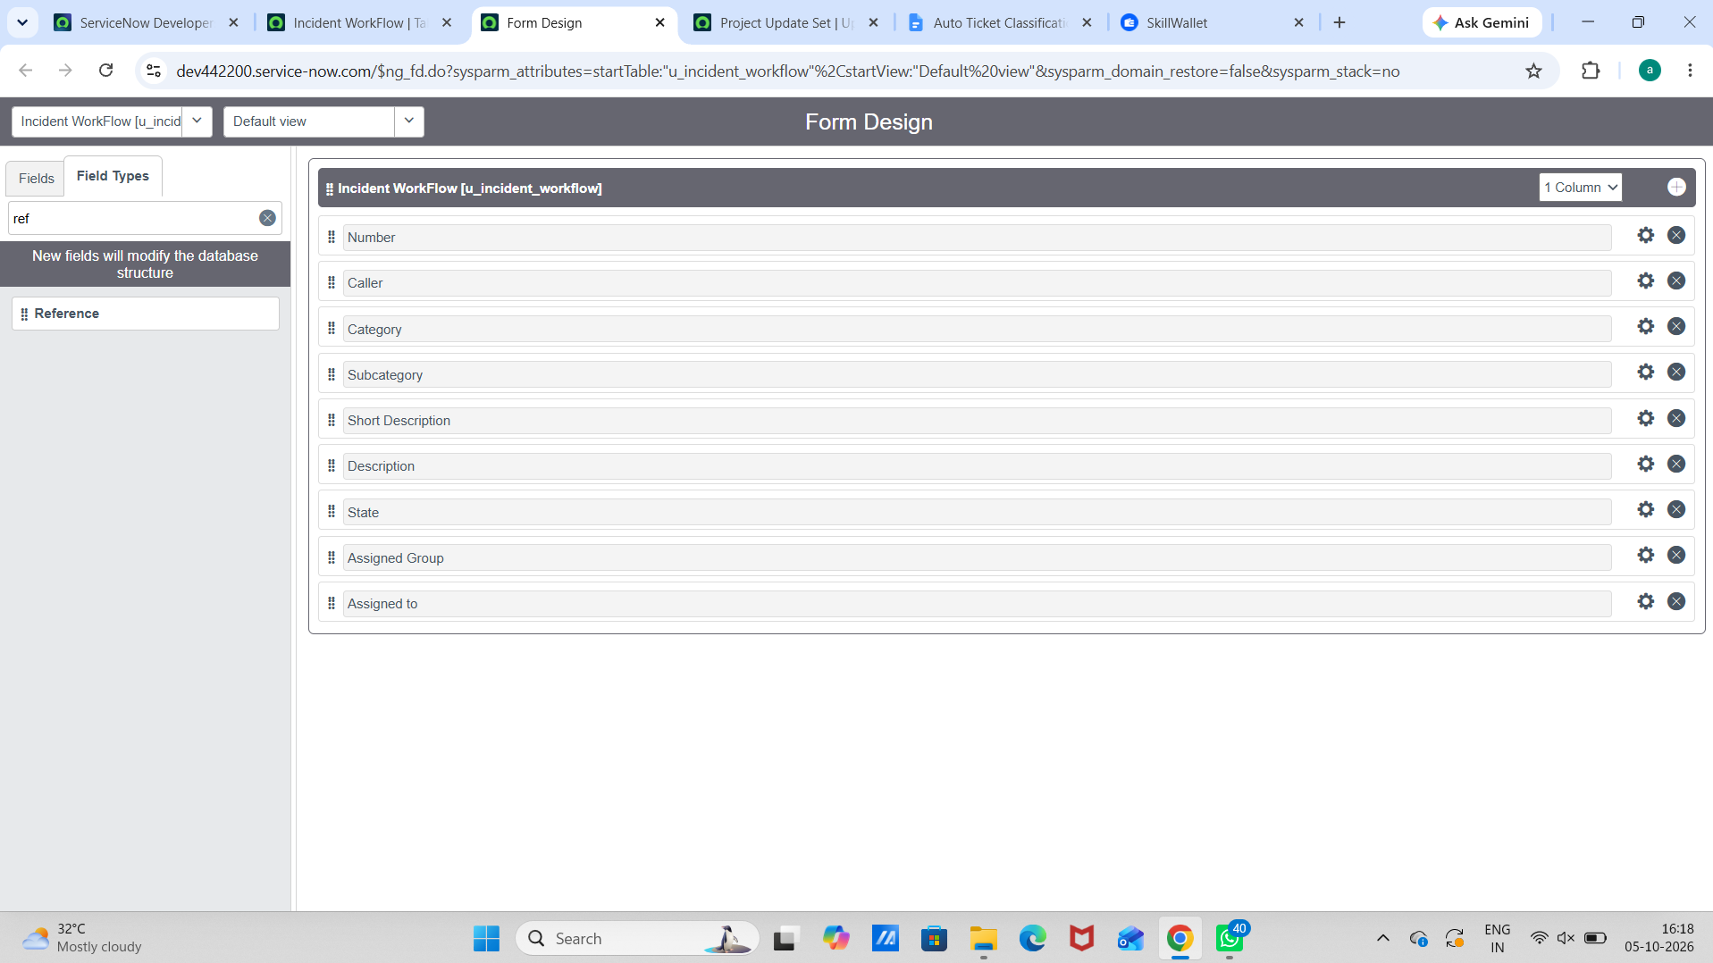
Figure 4: Flow Designer configuration
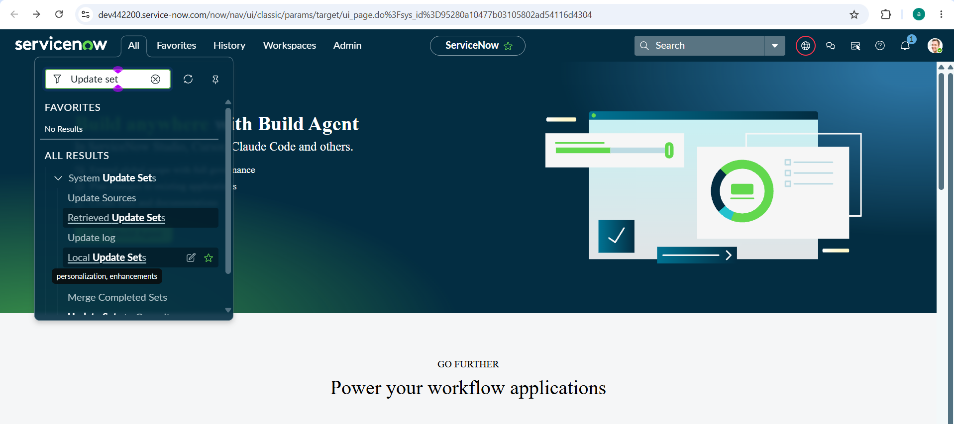
Figure 5: Automatically assigned Category and Subcategory
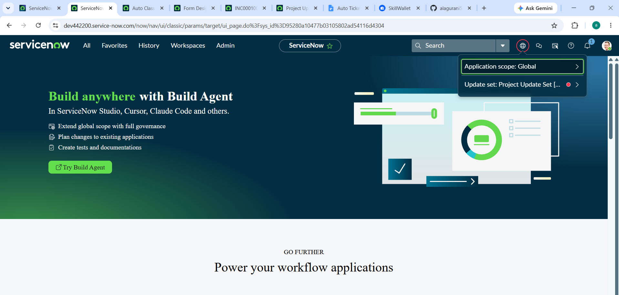
Figure 6: Email notification sent to the caller
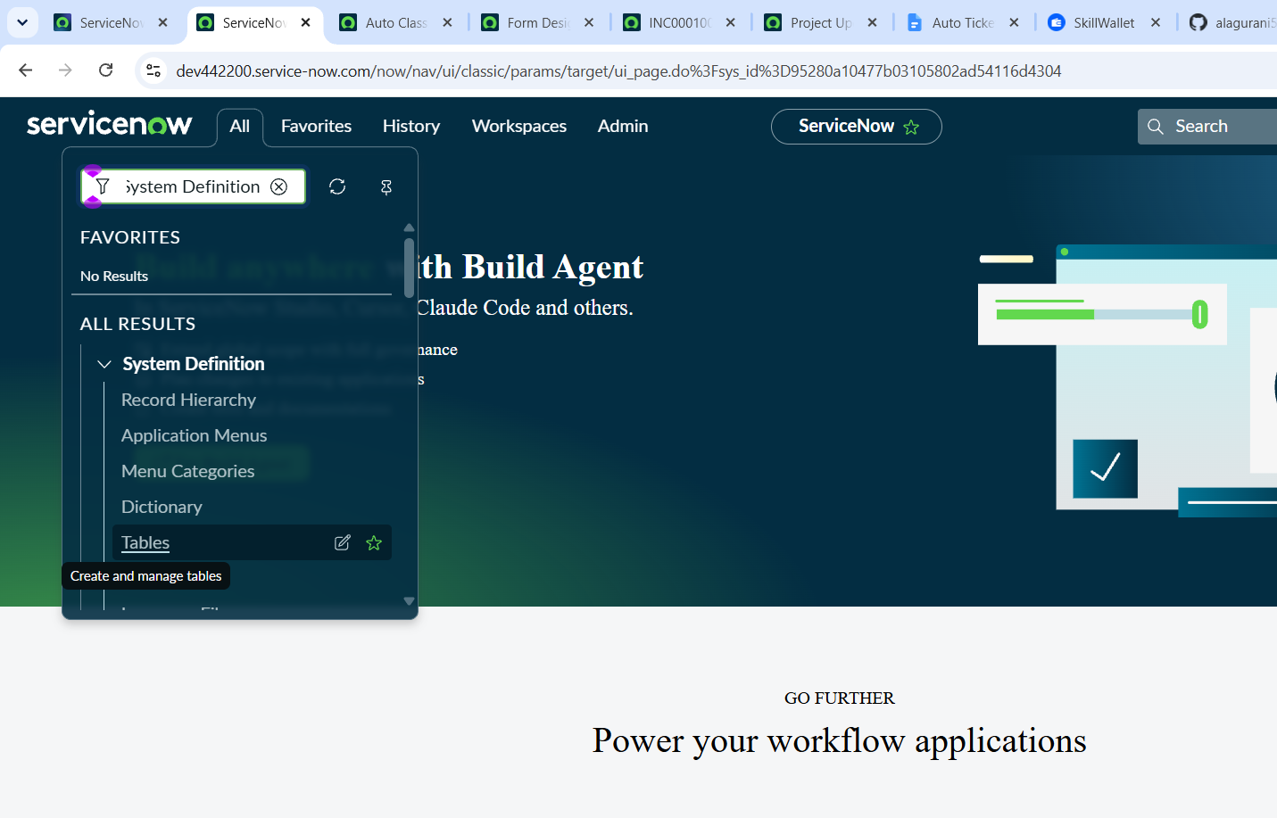
Figure 7: Final incident record
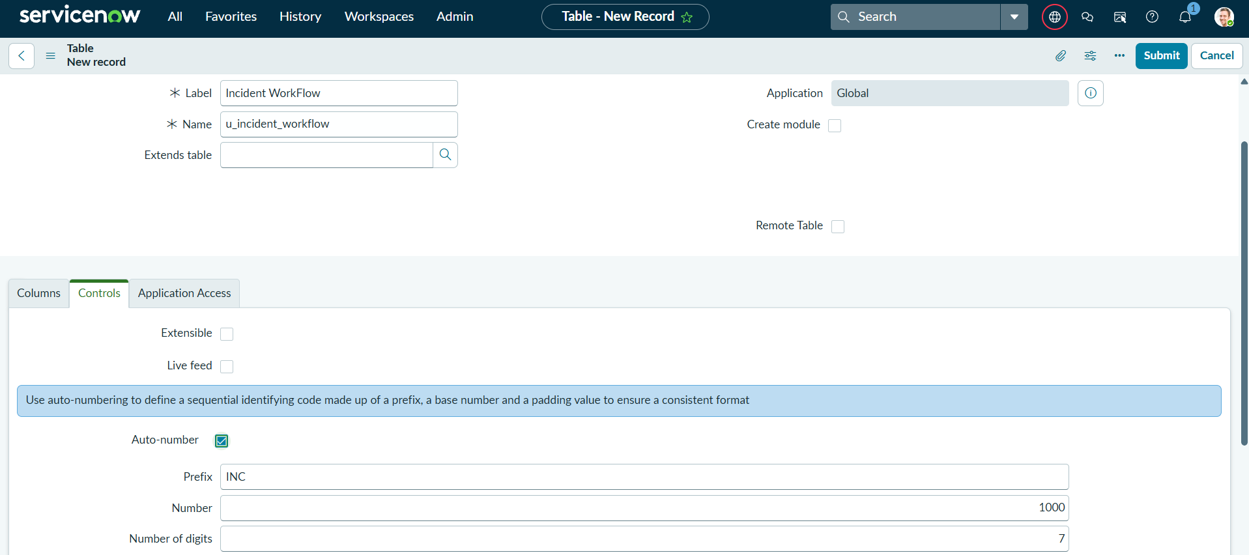

8. ADVANTAGES & DISADVANTAGES

Advantages
- Reduces manual classification work.
- Provides faster ticket processing.
- Improves consistency in category and subcategory selection.
- Reduces classification errors caused by manual work.
- Provides automated email communication.
- Uses a no-code Flow Designer approach.
- Can be maintained and expanded by modifying flow conditions.

Disadvantages
- Classification depends on the keywords and conditions defined in the flow.
- New issue types may require additional rules.
- Incorrect or incomplete descriptions can reduce classification accuracy.
- The solution depends on the ServiceNow environment and configuration.

9. CONCLUSION
The Auto Ticket Classification using Flow Designer project provides an automated approach for handling school IT support incidents. Instead of requiring IT staff to manually inspect every ticket and select its category, the system uses ServiceNow Flow Designer to analyze incident information and apply the appropriate classification. The solution also supports structured ticket storage and automated email notification. Overall, the project demonstrates how a no-code workflow can reduce repetitive work and create a more consistent incident management process.

10. FUTURE SCOPE
- Add more issue categories and subcategories.
- Support a larger set of keywords and phrases.
- Use advanced text classification or AI-based classification for complex descriptions.
- Support multiple languages for students and teachers.
- Add dashboards to monitor classification accuracy and ticket trends.
- Integrate with other communication channels such as chat or self-service portals.
- Continuously improve rules using historical incident data.

11. APPENDIX

Source Code / Configuration
The project is implemented mainly using ServiceNow Flow Designer configuration. Add exported configuration or relevant screenshots here if required.
[Insert source/configuration details here]

Dataset Link
Not applicable / Add the dataset or sample incident data link if used.
Dataset Link: ______________________________

GitHub & Project Demo Link
GitHub: ______________________________
Project Demo: ________________________

