# ACADEMIC TASK-4

**CSE121**

(ORIENTATION TO COMPUTING-II)

COMPUTER SCIENCE AND ENGINEERING

Submitted by: Name: Lakshyan Alahari

Registration number: 12305842

Roll No.: 63 Section: K23EP

Submitted to : Ashim Sharma



**LOVELY PROFESSIONAL UNIVERSITY**

# DECLARATION

I,Lakshyan, a student of Bachelor of Technology under CSE discipline at Lovely Professional University, Punjab, hereby declare that all the information furnished in this project report is based on my own work and is genuine

Your name : Lakshyan Alahari Registrartion Number: 12305842

**Detail of Career Profiles:**

1. Attach your the dream CV under the dream CV coloumn.
2. For video CV you can provide the link of your video recording. You can upload the video on google drive, youtube or any other shareable platform.
3. Thirdly you have to provide the three year career roadmap on Gantt Chart. You can create gantt chart using given link online <https://www.onlinegantt.com/> and provide us exported image in the following gantt chart coloumn.

## Dream CV:

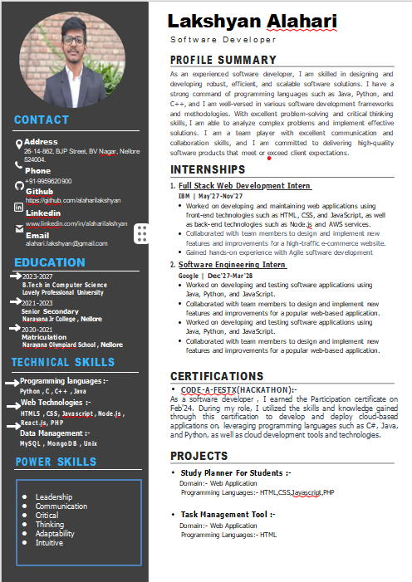

* 1. **Video CV Link: (Provide link of your video recording)**

Link: [https://drive.google.com/drive/folders/1kK3U91sFuXZnluj0SRuuqAHFxI](https://drive.google.com/drive/folders/1kK3U91sFuXZnluj0SRuuqAHFxIY4GCPj?usp=sharing) [Y4GCPj?usp=sharing](https://drive.google.com/drive/folders/1kK3U91sFuXZnluj0SRuuqAHFxIY4GCPj?usp=sharing)

## Three year career roadmap on Gantt Chart:

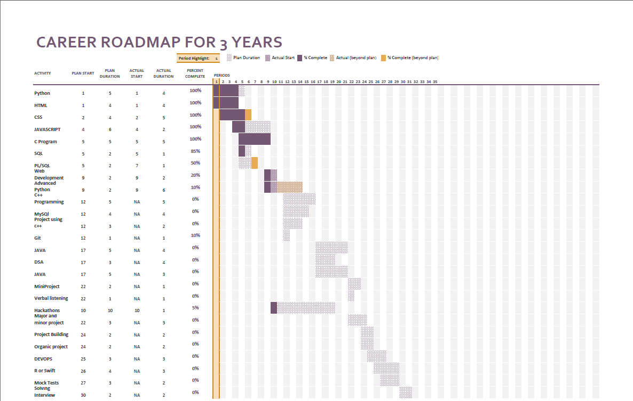

**PROFILE CREATION**

## Profile Creation: Full Stack Developer

|  |  |
| --- | --- |
| List the name of the companies for the profile of Full Stack Developer (At  least 5 company names are required) | |
| 1. | Facebook/Meta |
| 2. | Netflix |
| 3. | Airbnb |
| 4. | Uber |

|  |  |
| --- | --- |
| 5. | Twitter |

|  |  |
| --- | --- |
| List the Skills required the profile of Full Stack Developer (can add more  columns to list more skills) | |
| 1. | Versatility and Efficiency |
| 2. | End-to-End Development |
| 3. | Problem Solving and Innovation |
| 4. | Cost Effectiveness |
| 5. | Adaptability and Future proofing |

|  |  |  |  |
| --- | --- | --- | --- |
| Companies offering package up to 10 Lac | | | |
| Companies Names: IBM | | | |
| Designation: | Full stack developer on SCIS/EIS Suite | Required Industrial Certifications: | cloud-native technologies including Docker containers, Kubernetes orchestration, or OpenShift |
| Job Link (URL): | [https://www.naukri.com/job-listings-full-stack-developer-ibm-india-](https://www.naukri.com/job-listings-full-stack-developer-ibm-india-pvt-limited-bengaluru-5-to-10-years-260424909647?src=cluster&sid=17141451056334875_4&xp=1&px=1) [pvt-limited-bengaluru-5-to-10-years-](https://www.naukri.com/job-listings-full-stack-developer-ibm-india-pvt-limited-bengaluru-5-to-10-years-260424909647?src=cluster&sid=17141451056334875_4&xp=1&px=1) [260424909647?src=cluster&sid=17141451056334875_4&xp=1&px=1](https://www.naukri.com/job-listings-full-stack-developer-ibm-india-pvt-limited-bengaluru-5-to-10-years-260424909647?src=cluster&sid=17141451056334875_4&xp=1&px=1) | | |
|  |  |  |  |
| Companies offering package 10 to 20 Lac | | | |
| Companies Names: Cognizant | | | |
| Designation: | AEM Full Stack Developer | Required Industrial Certifications: | AEM components like Oak and Sling. Automated test execution and building tools such as Jenkins, Hudson, Selenium or Maven |
| Job Link (URL): | [https://www.naukri.com/job-listings-aem-full-stack-developer-](https://www.naukri.com/job-listings-aem-full-stack-developer-cognizant-hyderabad-bangalore-rural-chennai-3-to-8-years-310124005059?src=cluster&sid=17141451056334875_3&xp=1&px=1) [cognizant-hyderabad-bangalore-rural-chennai-3-to-8-years-](https://www.naukri.com/job-listings-aem-full-stack-developer-cognizant-hyderabad-bangalore-rural-chennai-3-to-8-years-310124005059?src=cluster&sid=17141451056334875_3&xp=1&px=1) [310124005059?src=cluster&sid=17141451056334875_3&xp=1&px=1](https://www.naukri.com/job-listings-aem-full-stack-developer-cognizant-hyderabad-bangalore-rural-chennai-3-to-8-years-310124005059?src=cluster&sid=17141451056334875_3&xp=1&px=1) | | |
|  |  |  |  |
| Companies offering package 20 to 30 Lac | | | |
| Companies Names: Airbnb | | | |
| Designation: | Senior Software Engineer, GraphQL | Required Industrial  Certifications: | GraphQL, Kotlin, etc. |
| Job Link (URL): | <https://careers.airbnb.com/positions/5926753/> | | |

|  |  |  |  |
| --- | --- | --- | --- |
|  |  | | |
|  |  |  |  |
| Companies offering package 30 Lac or more | | | |
| Companies Names: Netflix | | | |
| Designation: | Cloud Games Developer | Required Industrial  Certifications: | Certification in Electron Framework |
| Job Link (URL): | <https://jobs.netflix.com/jobs/319368353> | | |
|  |  |  |  |

*Can add more Job links for same job profile.

## Profile Creation: UI/UX Designer

|  |  |
| --- | --- |
| List the name of the companies for the profile of UI/UX Designer (At least 5  company names are required) | |
| 1. | Designit |
| 2. | IBM |
| 3. | Wilson Wings |
| 4. | Unified Infotech |
| 5. | Appening |

|  |  |
| --- | --- |
| List the Skills required the profile of UI/UX Designer (can add more columns  to list more skills) | |
| 1. | Information Architecture |
| 2. | Wireframing and Prototyping |
| 3. | UX Writing Skills |
| 4. | Visual Communication |
| 5. | Interaction Design Skills |

|  |  |  |  |
| --- | --- | --- | --- |
| Companies offering package up to 10 Lac | | | |
| Companies Names: Webchefz Infotech | | | |
| Design ation: | Word press Developer | Required Industrial Certifications: | HTML/HTML5, CSS3 &  JavaScript, JQuery & Responsive Web |

|  |  |  |  |
| --- | --- | --- | --- |
|  |  |  | Development |
| Job Link (URL): | [https://www.naukri.com/job-listings-wordpress-developer-](https://www.naukri.com/job-listings-wordpress-developer-webchefz-infotech-p-ltd-mohali-2-to-4-years-250424501696?src=jobsearchDesk&sid=17141467912538631&xp=3&px=1) [webchefz-infotech-p-ltd-mohali-2-to-4-years-](https://www.naukri.com/job-listings-wordpress-developer-webchefz-infotech-p-ltd-mohali-2-to-4-years-250424501696?src=jobsearchDesk&sid=17141467912538631&xp=3&px=1) [250424501696?src=jobsearchDesk&sid=17141467912538631&xp=3](https://www.naukri.com/job-listings-wordpress-developer-webchefz-infotech-p-ltd-mohali-2-to-4-years-250424501696?src=jobsearchDesk&sid=17141467912538631&xp=3&px=1) [&px=1](https://www.naukri.com/job-listings-wordpress-developer-webchefz-infotech-p-ltd-mohali-2-to-4-years-250424501696?src=jobsearchDesk&sid=17141467912538631&xp=3&px=1) | | |
|  |  |  |  |
| Companies offering package 10 to 20 Lac | | | |
| Companies Names: I[mpact Analytics](https://www.naukri.com/impact-analytics-jobs-careers-3833160?src=jddesktop) | | | |
| Design ation: | UI / UX Designer | Required Industrial Certifications: | Adobe XD, Figma, or similar tools |
| Job Link (URL): | [https://www.naukri.com/job-listings-ui-ux-designer-impact-analytics-](https://www.naukri.com/job-listings-ui-ux-designer-impact-analytics-kolkata-mumbai-new-delhi-hyderabad-pune-chennai-bengaluru-1-to-3-years-100424500136?src=jobsearchDesk&sid=17141469411332637&xp=10&px=1) [kolkata-mumbai-new-delhi-hyderabad-pune-chennai-bengaluru-1-to-](https://www.naukri.com/job-listings-ui-ux-designer-impact-analytics-kolkata-mumbai-new-delhi-hyderabad-pune-chennai-bengaluru-1-to-3-years-100424500136?src=jobsearchDesk&sid=17141469411332637&xp=10&px=1) [3-years-](https://www.naukri.com/job-listings-ui-ux-designer-impact-analytics-kolkata-mumbai-new-delhi-hyderabad-pune-chennai-bengaluru-1-to-3-years-100424500136?src=jobsearchDesk&sid=17141469411332637&xp=10&px=1) [100424500136?src=jobsearchDesk&sid=17141469411332637&xp=10](https://www.naukri.com/job-listings-ui-ux-designer-impact-analytics-kolkata-mumbai-new-delhi-hyderabad-pune-chennai-bengaluru-1-to-3-years-100424500136?src=jobsearchDesk&sid=17141469411332637&xp=10&px=1) [&px=1](https://www.naukri.com/job-listings-ui-ux-designer-impact-analytics-kolkata-mumbai-new-delhi-hyderabad-pune-chennai-bengaluru-1-to-3-years-100424500136?src=jobsearchDesk&sid=17141469411332637&xp=10&px=1) | | |
|  |  |  |  |
| Companies offering package 20 to 30 Lac | | | |
| Companies Names: [Innoviti Technologies Pvt. Ltd](https://www.naukri.com/innoviti-payment-solutions-jobs-careers-1567082?src=jddesktop) | | | |
| Design ation: | Manager or Lead - UI UX Designer | Required Industrial Certifications: | Adobe XD, Figma, or similar tools |
| Job Link (URL): | [https://www.naukri.com/job-listings-manager-or-lead-ui-ux-](https://www.naukri.com/job-listings-manager-or-lead-ui-ux-designer-innoviti-technologies-pvt-ltd-bengaluru-8-to-12-years-280324007258?src=cluster&sid=17141451056334875_11&xp=10&px=1&nignbevent_src=jobsearchDeskGNB) [designer-innoviti-technologies-pvt-ltd-bengaluru-8-to-12-years-](https://www.naukri.com/job-listings-manager-or-lead-ui-ux-designer-innoviti-technologies-pvt-ltd-bengaluru-8-to-12-years-280324007258?src=cluster&sid=17141451056334875_11&xp=10&px=1&nignbevent_src=jobsearchDeskGNB) [280324007258?src=cluster&sid=17141451056334875_11&xp=10&px](https://www.naukri.com/job-listings-manager-or-lead-ui-ux-designer-innoviti-technologies-pvt-ltd-bengaluru-8-to-12-years-280324007258?src=cluster&sid=17141451056334875_11&xp=10&px=1&nignbevent_src=jobsearchDeskGNB)  [=1&nignbevent_src=jobsearchDeskGNB](https://www.naukri.com/job-listings-manager-or-lead-ui-ux-designer-innoviti-technologies-pvt-ltd-bengaluru-8-to-12-years-280324007258?src=cluster&sid=17141451056334875_11&xp=10&px=1&nignbevent_src=jobsearchDeskGNB) | | |
|  |  |  |  |
| Companies offering package 30 Lac or more | | | |
| Companies Names: Graphics Specialist | | | |
| Design  ation: | IBM | Required Industrial  Certifications: | PowerPoint, Paint, Adobe Illustrator, and Photoshop. |
| Job Link  (URL): | [https://careers.ibm.com/job/20128132/graphics-specialist-ts-sci-w-](https://careers.ibm.com/job/20128132/graphics-specialist-ts-sci-w-ci-poly-washington-dc/?codes=WEB_SEARCH_NA) [ci-poly-washington-dc/?codes=WEB_SEARCH_NA](https://careers.ibm.com/job/20128132/graphics-specialist-ts-sci-w-ci-poly-washington-dc/?codes=WEB_SEARCH_NA) | | |
|  |  |  |  |

*Can add more Job links for same job profile.