
Department of CSE

B.Tech. CSE Trimester -5

2520030223
ALAHARI THAPASWI

Cloud Infrastructure and Services
25CS2206E

LAB RECORD
2026

Experiment -1

AIM: To create an AWS free tier account to provision the resources.

Description:
Amazon Web Services (AWS) is a cloud computing platform that provides on-demand services such as computing, storage, databases and networking. An AWS account is required to access the AWS Management Console and provision cloud resources. Account creation involves email and mobile verification, providing contact and billing information, and completing identity verification. For this experiment, the AWS account is created using the Free plan.

Steps:
1. Open a web browser and visit https://aws.amazon.com/free.
2. Click “Sign in to console”, then select “Create a new AWS account”.
3. Enter the email address, password and AWS account name.
4. Click “Verify email address” and enter the OTP received in the registered email.
5. Choose the Free plan by clicking “Choose Free plan”.
6. Enter the required contact information, including full name, phone number and address. Agree to the terms and continue.
7. Provide the requested billing information using an accepted payment method, such as a debit/credit card or UPI where supported.
8. Complete identity verification. Select Academic as the primary purpose and Individual as the ownership type. Provide an accepted identity document if requested.
9. Enter the mobile number, request the SMS verification code and submit the code.
10. Wait while AWS sets up the account.
11. Open https://console.aws.amazon.com and sign in using the registered root-user email and credentials.
12. Verify that the AWS Management Console dashboard is displayed and that the account name and Free Plan information are accessible.

Output:
The AWS account is successfully created and verified, and the AWS Management Console dashboard is accessed. The account name and Free Plan information are visible, and the available AWS services can be accessed according to the selected account plan.

Screenshots
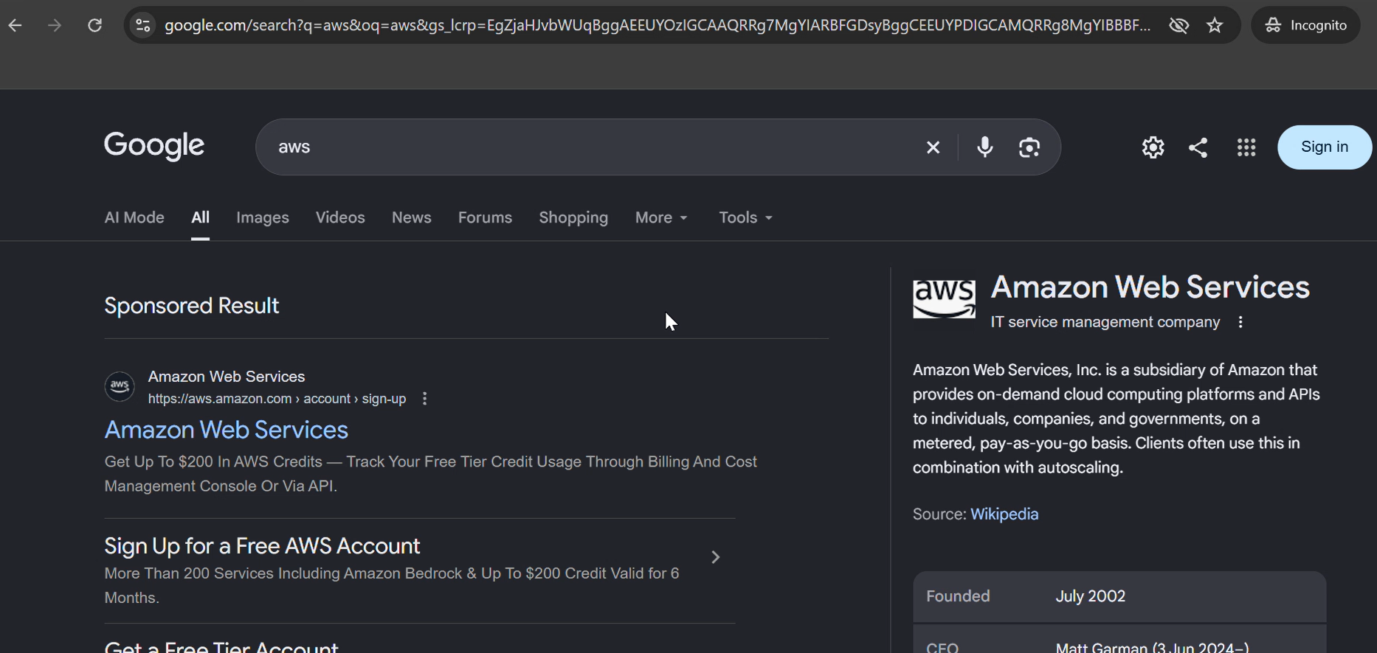
Figure 1: Searching for AWS using a web browser.
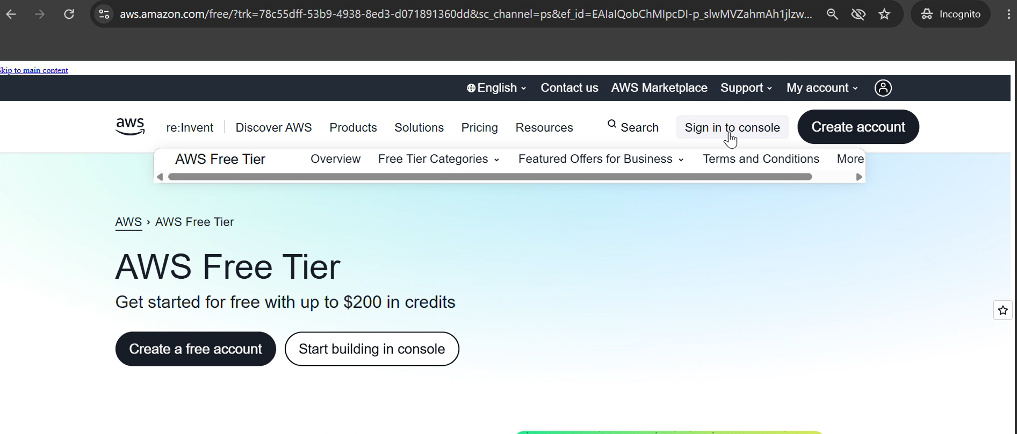
Figure 2: AWS Free Tier website and account creation option.
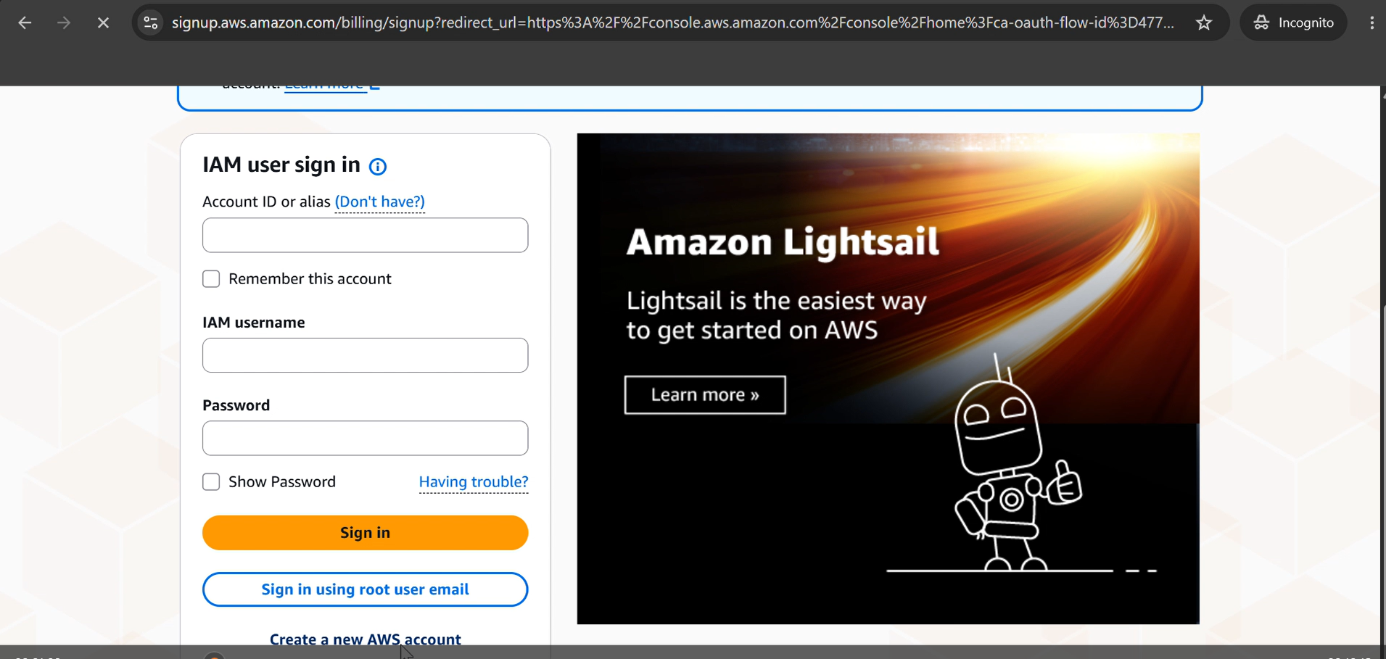
Figure 3: AWS sign-in page showing the option to create a new AWS account.
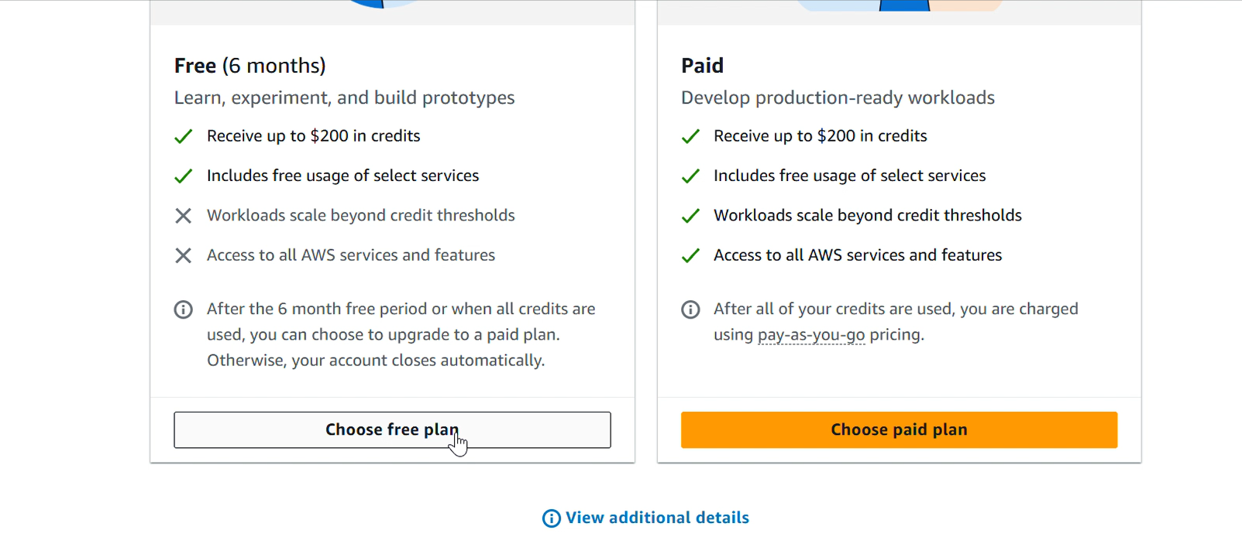
Figure 4: Selecting the Free plan during AWS account registration.
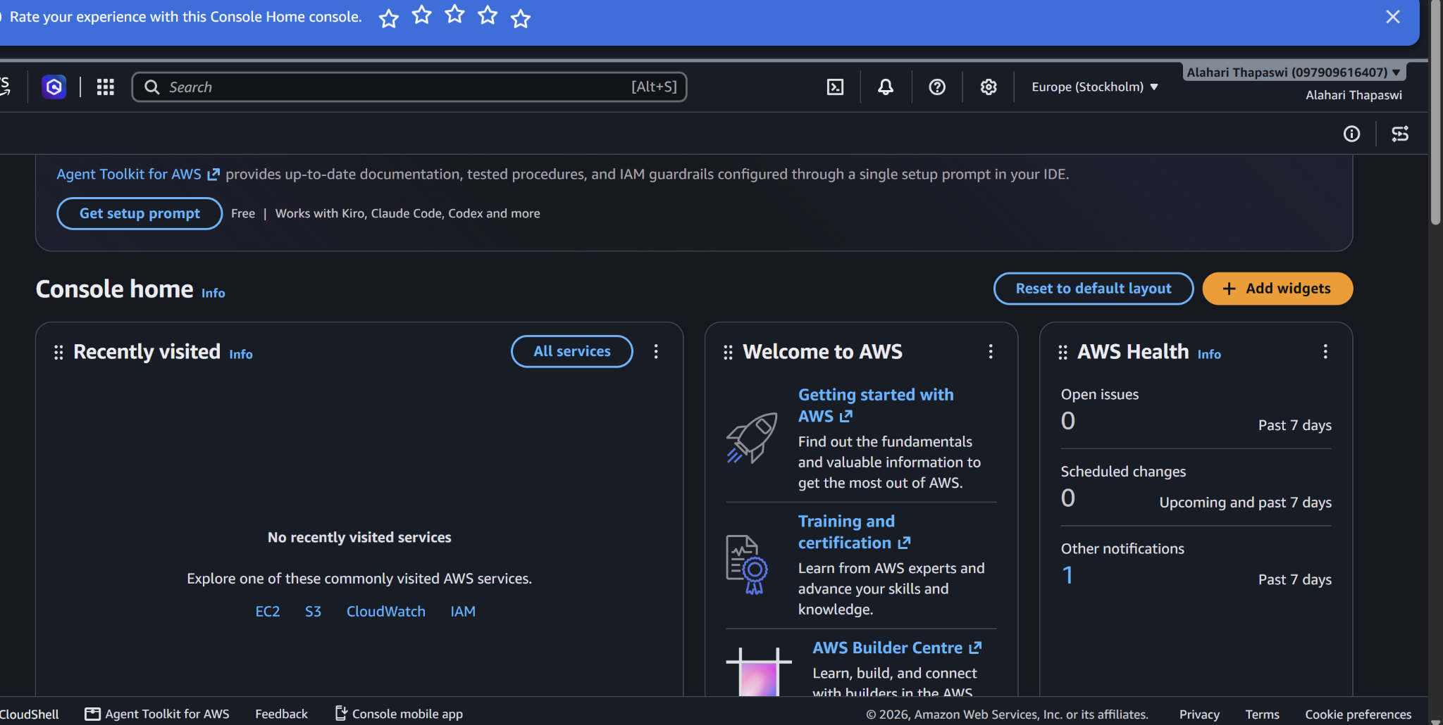
Figure 5: AWS Management Console Home dashboard after successful account sign-in.

