WaterWatch: A Spatial Water Intelligence Platform for Infrastructure, Consumption, Quality and Flood Monitoring in Port Harcourt
A FINAL YEAR PROJECT REPORT
Submitted to the Department of Computer Science, [INSTITUTION NAME], in partial fulfilment of the requirements for the award of Bachelor of Science (B.Sc.) in Computer Science.

BY
[STUDENT FULL NAME]
[MATRICULATION NUMBER]

SUPERVISOR: [SUPERVISOR NAME]
October 2026

DECLARATION
I, [STUDENT FULL NAME], hereby declare that this final-year project report titled "WaterWatch: A Spatial Water Intelligence Platform for Infrastructure, Consumption, Quality and Flood Monitoring in Port Harcourt" is my original work. It has not been submitted for the award of any other degree or diploma in this or any other institution. All sources of information and material used have been acknowledged in the references and in the body of the report. Any assistance received during the project has been documented and acknowledged.

Signature: ______________________________
Name: [STUDENT FULL NAME]
Matriculation number: [MATRICULATION NUMBER]
Date: October 2026

CERTIFICATION
This is to certify that this project report was carried out by [STUDENT FULL NAME] with matriculation number [MATRICULATION NUMBER] under my supervision. The report has been read and approved as meeting the requirements of the Department of Computer Science, [INSTITUTION NAME].

Supervisor: [SUPERVISOR NAME]
Signature: ______________________________
Date: ______________________________

ABSTRACT
WaterWatch is a spatial water-intelligence platform for Port Harcourt City LGA and Obio/Akpor LGA in Rivers State, Nigeria. It integrates infrastructure assets, consumption and NRW analysis, water quality, hydrology, flood exposure, groundwater, remote-sensing metadata, IoT telemetry, field operations, reporting and administration. The application is implemented as an ASP.NET Core 8 MVC modular monolith with PostgreSQL/PostGIS, EF Core, Leaflet and Chart.js. Source extracts from OCHA, OpenStreetMap and population data are imported with provenance metadata, while demonstration utility records are generated only when an explicit demo mode is enabled. Role-based identity, antiforgery protection, rate limiting, audit entries and sensitive-coordinate controls support the operational workflow. The report explains the domain problem, related systems, methodology, system design, implementation screenshots and evaluation. The project deliberately distinguishes observed, imported, estimated, modelled and synthetic data and does not present demonstration records as official utility facts.
Keywords: software engineering, web application, database, spatial data, security, human-computer interaction, WaterWatch

TABLE OF CONTENTS
CHAPTER ONE: INTRODUCTION 11
1.1 Background 11
1.2 Statement of the Problem 11
1.3 Aim and Objectives 12
1.3.1 Objectives 12
1.4 Research Questions 12
1.5 Scope of the Project 12
1.6 Significance of the Project 13
1.7 Limitations of the Project 13
1.8 Expected Contributions 13
1.9 Definition of Terms 13
1.10 Organisation of the Report 14
CHAPTER TWO: LITERATURE REVIEW 15
2.1 Introduction 15
2.2 Conceptual Review 15
2.2.1 Quality Attributes and User-Centred Design 15
2.3 Review of Related Systems 16
2.4 Technology Review 16
2.5 Research Gap 17
2.6 Summary 17
CHAPTER THREE: METHODOLOGY AND SYSTEM ANALYSIS 18
3.1 Introduction 18
3.2 Development Methodology 18
3.2.1 Requirements Elicitation 18
3.3 Requirements Analysis 19
3.3.1 Functional Requirements 19
3.3.2 Non-Functional Requirements 19
3.3.3 Constraints and Assumptions 19
3.4 System Architecture 19
3.4.1 Component Responsibilities 20
3.5 Database and Data Model 20
3.5.1 Data Integrity Rules 21
3.6 Use Case Analysis 22
3.7 Security Design 23
3.8 Ethical and Legal Considerations 23
3.9 Testing Strategy 23
3.10 Deployment and Operational Considerations 24
3.11 Summary 24
CHAPTER FOUR: SYSTEM IMPLEMENTATION AND RESULTS 25
4.1 Introduction 25
4.2 Development Environment 25
4.3 Implementation of Major Modules 25
4.3.1 Dashboard and GIS explorer 25
4.3.2 Infrastructure 25
4.3.3 Water resources 26
4.3.4 Monitoring and analytics 26
4.3.5 Operations and governance 26
4.4 Implementation Challenges and Resolutions 26
4.5 System Interface Screenshots 28
4.6 Testing Results 36
4.6.1 Acceptance Test Cases 36
4.7 Discussion of Results 37
4.8 Summary 37
CHAPTER FIVE: SUMMARY, CONCLUSION AND RECOMMENDATIONS 38
5.1 Summary 38
5.2 Conclusion 38
5.3 Evaluation Against Objectives 38
5.4 Contributions 39
5.5 Limitations of the Implementation 39
5.6 Recommendations 39
5.7 Suggestions for Future Work 39
5.8 Final Remarks 39
REFERENCES 41
APPENDIX A: DEMONSTRATION GUIDE 42
APPENDIX B: PRIMARY ROUTES AND ENDPOINTS 43

LIST OF FIGURES
Figure 3.1: System architecture
Figure 3.2: Simplified entity-relationship model
Figure 3.3: Use case overview
Figure 4.1: WaterWatch login page.
Figure 4.2: Water intelligence overview.
Figure 4.3: GIS explorer.
Figure 4.4: Infrastructure asset registry.
Figure 4.5: Consumption and demand analysis.
Figure 4.6: Water quality workspace.
Figure 4.7: Flood intelligence workspace.
Figure 4.8: Administration and audit.

LIST OF TABLES
Table 1.1: Definition of key terms
Table 2.1: Comparison of related systems
Table 2.2: Technologies used in the implementation
Table 3.1: Functional requirements
Table 3.2: Non-functional requirements
Table 3.3: Component responsibilities
Table 3.4: Principal data entities
Table 3.5: Summary of primary use cases
Table 4.1: Implementation environment
Table 4.2: Implementation challenges and resolutions
Table 4.3: Summary of test evidence
Table 4.4: Acceptance test cases
Table 5.1: Evaluation against objectives
Table B.1: Primary routes and endpoints

LIST OF ABBREVIATIONS
Abbreviation | Meaning
API | Application Programming Interface
DMA | District Metered Area
EF Core | Entity Framework Core
GIS | Geographic Information System
NRW | Non-Revenue Water
OCHA | United Nations Office for the Coordination of Humanitarian Affairs
PostGIS | Spatial extension for PostgreSQL
STAC | SpatioTemporal Asset Catalog

CHAPTER ONE: INTRODUCTION

1.1 Background
Water utilities need to coordinate infrastructure condition, consumption, water quality, hydrology and customer service. In rapidly growing cities such as Port Harcourt, these records are often held by different teams and in different formats, making it difficult to identify leakage hotspots, quality failures or flood-exposed assets. Spatial analysis can connect those records through a shared geography, but only if data provenance and uncertainty are made visible.
Open geospatial data has improved the availability of administrative boundaries, waterways and some infrastructure features. OCHA Common Operational Datasets provide official administrative boundaries, while OpenStreetMap contains volunteered water-related features whose completeness varies (Goodchild, 2007; Haklay & Weber, 2008). These sources are valuable for an academic prototype but are not a substitute for a surveyed utility asset register or a DMA boundary set.
WaterWatch was designed as a modular water-intelligence workspace that brings those layers together while preserving evidence. It supports operational views but clearly labels synthetic records, imported boundaries and modelled analytics so that a demonstration cannot be mistaken for an official operational system.

1.2 Statement of the Problem
Water-sector decisions require a joined view of assets, consumption, quality and environmental risk. Without a spatial information system, teams may duplicate data collection, miss cross-domain relationships and struggle to prioritise field work. A naive dashboard can make the problem worse if it mixes observed and synthetic data without labels or if it presents an estimated flood layer as an official warning.
The problem addressed by this project is the design of an integrated, evidence-aware spatial platform that supports water-resource and utility workflows for Port Harcourt while remaining transparent about data sources, assumptions and limitations.

1.3 Aim and Objectives
To design and implement a spatial water-intelligence platform that integrates infrastructure, consumption, quality, hydrology, flood, telemetry and operational records for Port Harcourt with explicit data provenance and role-based access.

1.3.1 Objectives
- Import and display Port Harcourt administrative boundaries and water-related spatial layers.
- Provide a GIS explorer and operational dashboard with source metadata.
- Manage infrastructure assets, network data, inspections and maintenance records.
- Analyse consumption, NRW, water quality, hydrology and groundwater records.
- Support flood exposure, remote-sensing metadata, telemetry and field work orders.
- Provide role-based administration, auditability, reports and honest availability states.

1.4 Research Questions
The objectives are translated into the following research questions. Each question is revisited in Chapters Three and Four, where the design and implementation evidence are discussed.
- How can a water-intelligence platform integrate infrastructure, consumption, quality and environmental records through a shared spatial model?
- How can data provenance and evidence classification be made visible in an operational interface?
- Which PostGIS and security mechanisms support spatial analysis without exposing sensitive infrastructure?
- How can the system support field operations and reporting while clearly separating demonstration data from official records?

1.5 Scope of the Project
The project covers the following functional and technical scope:
- Port Harcourt City LGA and Obio/Akpor LGA focus, with Rivers State context.
- Spatial layers, asset registry, consumption, quality, hydrology, flood, groundwater and NRW.
- IoT telemetry, field operations, reports and administration.
- OCHA, OSM, Open-Meteo, Nominatim and Earth Search integrations.
- Explicit demonstration mode for synthetic utility records.

1.6 Significance of the Project
- Demonstrates integrated spatial water management in a local government context.
- Shows how source and evidence classifications can be preserved in an operational UI.
- Provides a tested PostGIS and ASP.NET Core reference implementation.
- Creates a foundation for utility, environmental and flood-resilience analysis.

1.7 Limitations of the Project
The limitations below define the boundary of the academic deliverable. They are not hidden implementation gaps: they explain which capabilities are outside the approved project scope and why.
- The asset register and service/DMA zones are demonstration data, not official utility records.
- No official NIHSA flood warning feed or authoritative utility data feed is connected.
- Remote sensing depends on external STAC availability and caches metadata only.
- GeoTIFF import is metadata registration only; raster processing is not enabled.

1.8 Expected Contributions
- A provenance-aware spatial water-intelligence workspace for Port Harcourt.
- An integrated asset, consumption, quality, hydrology and flood workflow.
- Role-protected APIs, auditability and sensitive-coordinate controls.
- A reproducible demonstration environment that does not disguise synthetic records as official facts.

1.9 Definition of Terms
Table 1.1: Definition of key terms
Term | Definition
PostGIS | A spatial database extension used to store and analyse geometry.
DMA | District Metered Area, an operational subdivision used for water-balance analysis.
NRW | Non-revenue water, the difference between system input and billed authorised consumption.
Data classification | A label indicating whether a value is observed, imported, estimated, modelled or synthetic.
Flood exposure | The intersection of a flood layer with assets or administrative areas.
Telemetry | Automated readings transmitted from field devices.

1.10 Organisation of the Report
Chapter One introduces the water-management problem and the project objectives. Chapter Two reviews water information systems, spatial data sources and related platforms. Chapter Three describes the methodology, requirements, PostGIS architecture, data model and security design. Chapter Four presents the implemented water-intelligence workspaces with actual screenshots and test evidence. Chapter Five summarises the outcomes and recommends a path toward validated operational use.

CHAPTER TWO: LITERATURE REVIEW

2.1 Introduction
This chapter reviews the concepts, related systems and technologies relevant to the project. The review is organised around the problem domain, the capabilities of existing products and the technical choices used in the implementation. It ends by identifying the gap that the project addresses. The review draws on established software-engineering and domain literature as well as the official documentation of the frameworks used in the system.

2.2 Conceptual Review
WaterWatch is a multi-user information system rather than a single-user desktop tool. Its design therefore has to account for user identity, persistent records, validation, feedback and operational workflows. Software-engineering research emphasises that these concerns should be handled through explicit requirements, modular design and iterative evaluation (Sommerville, 2016; Pressman & Maxim, 2020). The design-science perspective adds that the resulting artefact should be evaluated against the problem it was created to solve rather than judged only by the number of implemented features (Hevner et al., 2004).
The project also reflects the broader shift from isolated records to connected digital services. Users expect immediate validation, clear status information and predictable navigation. At the same time, sensitive systems need security boundaries that are enforced on the server rather than only hidden in the interface. These principles informed the choice of layered architectures, role-aware endpoints and explicit error states.
For the WaterWatch domain, the important conceptual concerns are data ownership, consistency of state transitions and the relationship between a user action and a persistent record. The implementation therefore treats workflow state, authorization and source provenance as first-class parts of the design.

2.2.1 Quality Attributes and User-Centred Design
A functioning demonstration also has to satisfy quality attributes that are not visible in a feature list. Security, usability, maintainability and graceful failure are particularly important for a multi-user system. Usability heuristics emphasise visibility of system status, clear error messages, prevention of invalid input and consistent navigation (Nielsen, 1994). These ideas are reflected in loading indicators, validation messages, explicit empty states and role-specific navigation in the implemented interface.
Maintainability is addressed through feature-oriented source organisation, shared validation and a consistent data-access layer. Security is treated as a server-side concern: the interface may hide an action, but the endpoint must still verify identity and permission. This separation between presentation and enforcement is a recurring theme in secure web-application guidance (OWASP Foundation, 2021).

2.3 Review of Related Systems
Table 2.1: Comparison of related systems
System | Strengths | Limitations and relationship to this project
ArcGIS Dashboards | Configurable operational dashboards over GIS layers. | Strong visualisation, but proprietary and dependent on a full GIS platform.
Water utility GIS portals | Asset, network and customer mapping. | Often internally focused and not designed for an academic, provenance-aware prototype.
Open data water portals | Public water and environmental indicators. | Useful data publishing but limited operational workflows and field task integration.
OpenStreetMap-based dashboards | Community mapping and local features. | Open and flexible, but incomplete and not a utility asset register.

The comparison shows that existing products are generally stronger in scale, commercial integrations or specialised domain features. The opportunity for this project is not to reproduce a commercial platform, but to build a transparent, locally runnable system that demonstrates the core workflow with maintainable code, explicit limitations and test evidence.

2.4 Technology Review
Table 2.2: Technologies used in the implementation
Technology | Role in the system | Reason for selection
ASP.NET Core 8 MVC | Server-rendered application and JSON APIs | Provides a single deployable modular monolith with familiar security and middleware.
PostgreSQL and PostGIS | Spatial and relational system of record | Supports geometry, GiST indexes, spatial predicates and time-series tables.
Leaflet and Chart.js | Maps and charts | Provide interactive spatial and statistical visualisation without a heavy frontend build.
ASP.NET Core Identity | Users and roles | Supports cookie authentication and policy-based authorization.
EF Core and NetTopologySuite | Persistence and geometry mapping | Integrates spatial operations with the application model.
Open-Meteo, Nominatim and STAC | External data services | Provide rainfall, place search and satellite metadata with explicit failure states.

The technology stack was selected for reliability, documentation and suitability for a final-year project. The architecture separates transport, application logic, persistence and presentation concerns. Official documentation was used to confirm configuration and security behaviour rather than relying on assumptions about framework defaults.
The technology review also considered operational constraints. The project should be reproducible on a student workstation, avoid unnecessary infrastructure, preserve data through migrations and make optional external dependencies fail gracefully. These constraints influenced the choice of a modular monolith and the decision to keep provider-specific integrations behind service boundaries.

2.5 Research Gap
The reviewed systems demonstrate strong spatial visualisation or open data publishing, but a small self-hosted platform that joins water infrastructure, consumption, quality, flood risk and field operations while preserving data provenance is less common. WaterWatch fills that gap with an explicitly labelled demonstration environment and a transparent spatial architecture.

2.6 Summary
The review establishes that WaterWatch addresses a genuine workflow rather than a purely visual mock-up. The next chapter translates the reviewed requirements into a development methodology, system architecture, data model and testing plan.

CHAPTER THREE: METHODOLOGY AND SYSTEM ANALYSIS

3.1 Introduction
This chapter explains how the system was analysed, designed and tested. It presents the development approach, functional and non-functional requirements, architecture, data model, use cases, security design and verification strategy. The design aims to keep the implementation understandable while still meeting the needs of a multi-user application.

3.2 Development Methodology
The project followed an incremental, vertical-slice methodology. Spatial foundations and identity were established first, then infrastructure, consumption, quality, hydrology, flood, telemetry and operations were added as service-API-UI-test slices. Each slice was verified against its data classification and authorization rules. The process used iterative requirements and evaluation (Sommerville, 2016; Hevner et al., 2004).
The work used a requirements-driven, incremental approach. The problem domain and stakeholder actions were decomposed into vertical slices, and each slice was checked through code review, automated tests or browser inspection. The design-science cycle of problem identification, artefact construction and evaluation was used to keep the project focused on a usable result (Hevner et al., 2004).

3.2.1 Requirements Elicitation
Requirements were elicited from the problem statement, the implemented prototype, domain documentation and the practical workflows observed in each application area. The analysis did not assume that a feature should be built simply because it appeared in a related commercial product; each requirement was checked against the project aim and the available data.
- Review of water utility, GIS and environmental monitoring literature.
- Analysis of Port Harcourt spatial data sources and provenance.
- Operational requirements for assets, consumption, quality, hydrology, flood and field work.
- ASP.NET Core, PostGIS, OCHA and Open-Meteo documentation.

3.3 Requirements Analysis

3.3.1 Functional Requirements
Table 3.1: Functional requirements
ID | Requirement | Priority
FR-01 | Import and display Port Harcourt administrative and water-related spatial layers. | High
FR-02 | Manage infrastructure assets, inspections, maintenance and network records. | High
FR-03 | Import meter readings and analyse consumption, anomalies and NRW. | High
FR-04 | Record water-quality samples, standards and compliance states. | High
FR-05 | Record hydrology, groundwater and rainfall observations. | High
FR-06 | Analyse flood layers and asset exposure with classification metadata. | High
FR-07 | Ingest telemetry, trigger alerts and display device state. | High
FR-08 | Manage work orders, reports, users, roles and audit history. | High

3.3.2 Non-Functional Requirements
Table 3.2: Non-functional requirements
Area | Requirement
Evidence integrity | Every imported or synthetic record must retain source and data classification.
Security | Role policies, antiforgery, rate limiting, sensitive-coordinate controls and audit logging are required.
Spatial performance | Spatial filters and joins should use PostGIS indexes and avoid raw-degree metric calculations.
Availability | External provider failure must produce a clear unavailable state without fabricated values.
Usability | The shell and map must remain operable on desktop and smaller viewports.

3.3.3 Constraints and Assumptions
The design assumes a local or small-team deployment, a supported web browser and access to the configured database. Optional external services are treated as enhancements rather than preconditions for the core workflow. The project does not assume access to an official utility asset register, commercial imagery or a production identity provider unless those services are explicitly configured.

3.4 System Architecture
WaterWatch is a single ASP.NET Core MVC process. Razor pages provide the shell and Leaflet-based workspaces. JSON API controllers apply role policies and call domain services for consumption, quality, hydrology, flood, NRW, telemetry, forecasting and reports. EF Core and PostGIS persist spatial and time-series data. Optional external providers are isolated behind typed services.
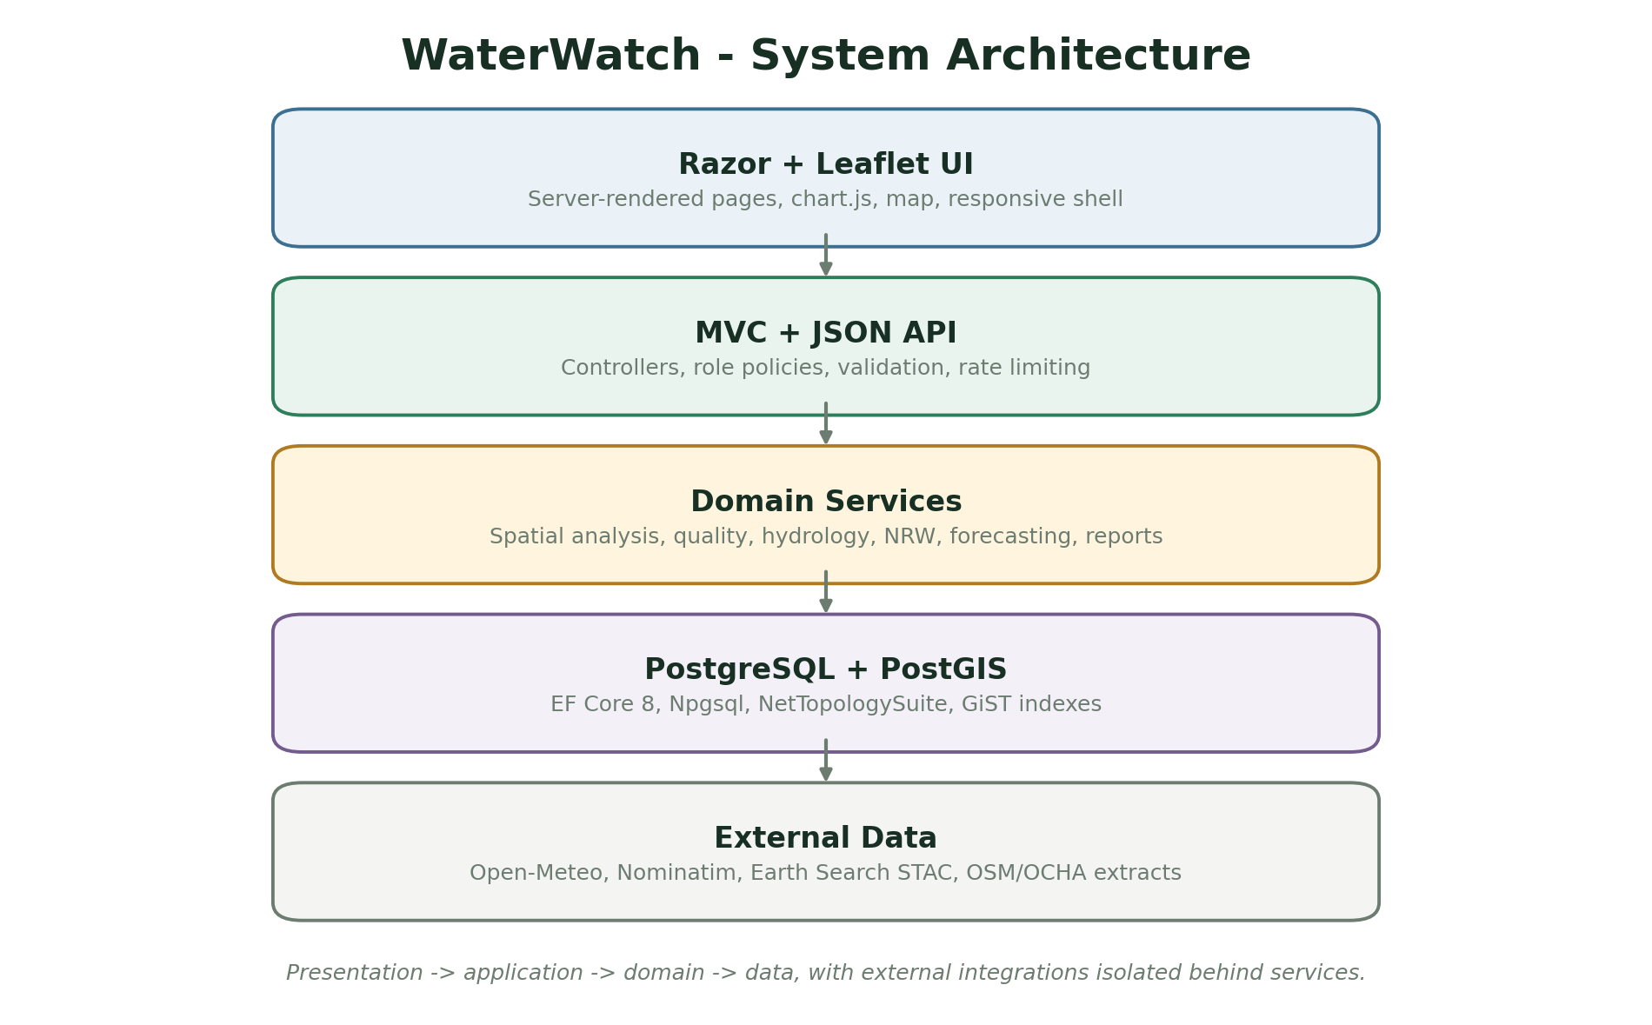
Figure 3.1: System architecture of WaterWatch. Source: Author design (2026).

3.4.1 Component Responsibilities
Table 3.3: Component responsibilities
Component | Responsibility | Implementation evidence
Razor + Leaflet UI | Provides the shell, dashboards, GIS explorer and module workspaces. | MVC views and bundled JavaScript
MVC and API controllers | Handle page requests, validation, policies and JSON responses. | WaterWatch.Controllers
Domain services | Encapsulate spatial analysis, quality, hydrology, NRW, forecasting and reports. | Services folder
PostgreSQL/PostGIS | Stores geometry, time-series data, provenance and audit records. | DatabaseContext and migrations
External integrations | Provide optional rainfall, geocoding, STAC and OSM data. | Typed HTTP clients and source imports

3.5 Database and Data Model
The data model is designed around the entities that carry the core business rules. Identifiers connect records, while status fields and timestamps preserve operational state. The simplified entity-relationship model below illustrates the principal relationships; the implementation contains additional attributes, indexes and join records.
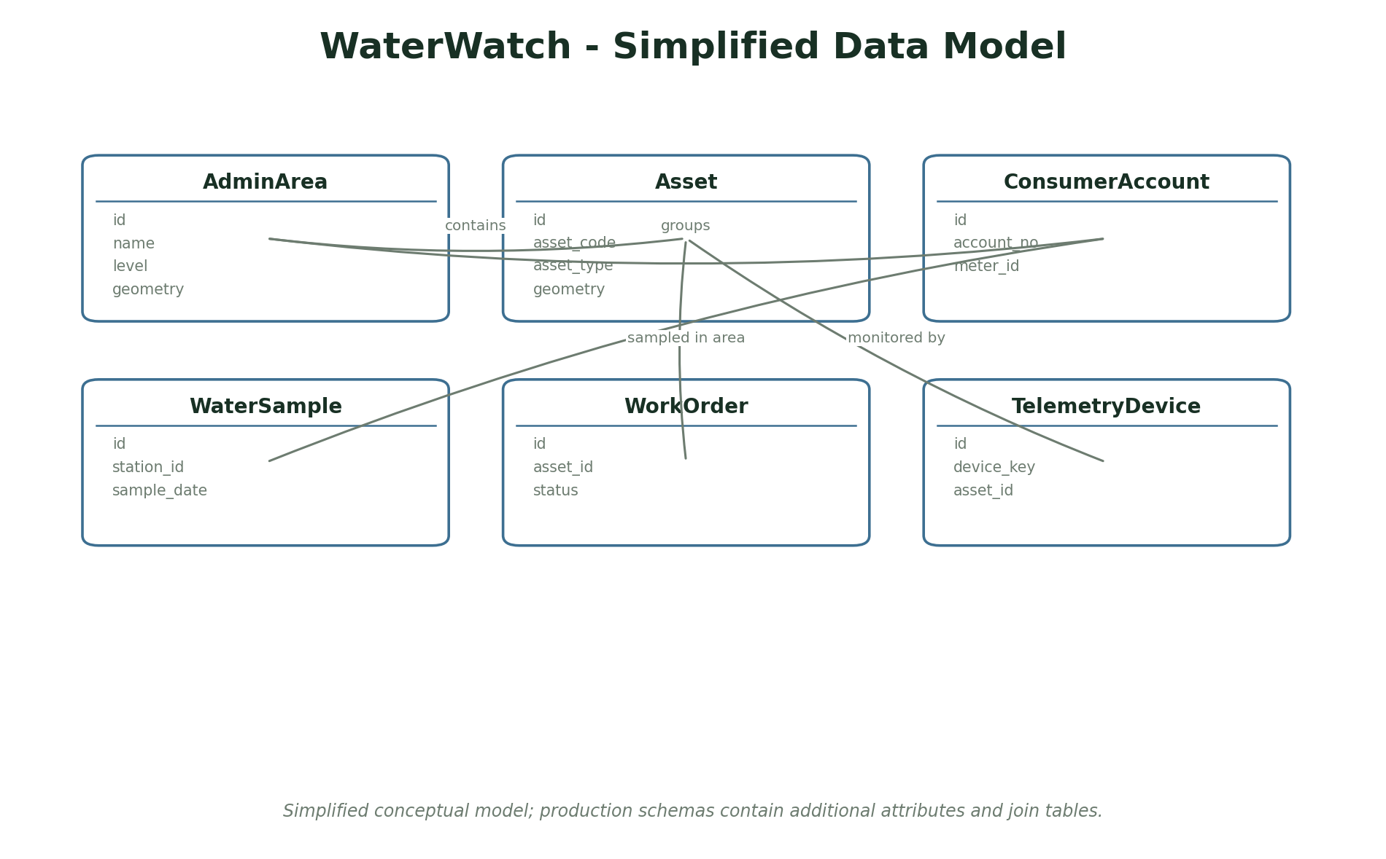
Figure 3.2: Simplified entity-relationship model for WaterWatch. Source: Author design (2026).
Table 3.4: Principal data entities
Entity | Key attributes and purpose
AdminArea | id, name, level, geometry, source
Asset | id, asset code, type, geometry, status
ConsumerAccount | id, account number, meter, service area
WaterSample | id, station, campaign, sample date, classification
WorkOrder | id, asset, status, assignment, due date
TelemetryDevice | id, device key, asset, last reading

3.5.1 Data Integrity Rules
The database is not treated as a passive storage container. Constraints, validation and transactional updates protect the relationships that the application relies on. The following rules are enforced in the domain or database layer rather than only in the browser form.
- Every spatial record retains a data source and classification where applicable.
- Sensitive assets are excluded from public layers and detail endpoints.
- Spatial operations use PostGIS or projected coordinates rather than raw-degree distances.
- Quality results are classified against a named standard and never assumed safe when evidence is missing.
- Demonstration records are generated only in demo mode and remain labelled synthetic.

3.6 Use Case Analysis
Use cases describe the observable actions available to each actor. They also provide a basis for the authorization matrix and the test cases. The overview below is deliberately simplified to emphasise the main workflow rather than every administrative action.
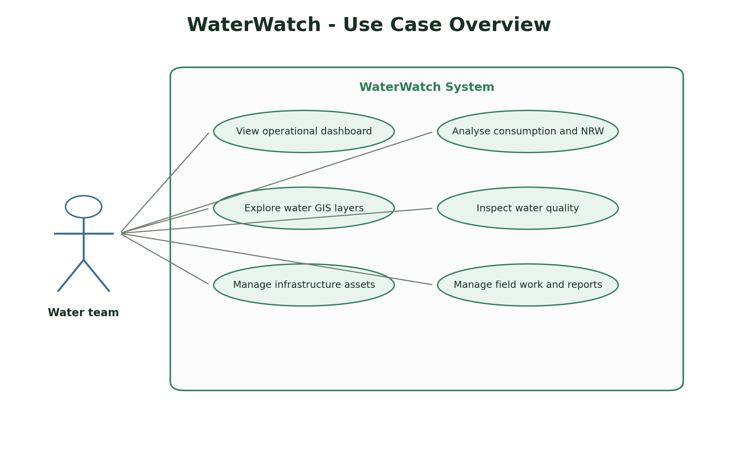
Figure 3.3: Use case overview for WaterWatch. Source: Author design (2026).
Table 3.5: Summary of primary use cases
Actor | Use case | Outcome
Water team | View operational dashboard | Inspect KPIs, map layers and data availability.
GIS analyst | Explore layers and assets | Filter, inspect and export spatial records.
Engineer | Analyse consumption and NRW | Review balances, trends, leaks and anomalies.
Environmental officer | Inspect water quality | Compare samples with standards and locate exceedances.
Field inspector | Complete work orders | Move operational tasks through the approved state model.

3.7 Security Design
Security is implemented at the server boundary. The design assumes that the browser cannot be trusted to enforce ownership, roles or workflow transitions. Every protected operation therefore checks the authenticated identity and the relevant domain relationship before changing data.
- ASP.NET Core Identity with eight application roles and policy-based authorization.
- Antiforgery validation for browser mutations and rate limiting for APIs.
- Audit entries for writes and imports, with source metadata retained.
- Sensitive asset coordinates excluded from public layers and detail endpoints.
- HSTS and security headers in production; database secrets supplied by environment configuration.

3.8 Ethical and Legal Considerations
A computer science project must consider the effect of the system beyond its functional requirements. The project avoids real personal, financial or health data and documents where demonstration data is synthetic. The following considerations guided the scope and interface.
- Water infrastructure locations can be sensitive; public access is restricted to approved layers.
- The project uses open datasets and synthetic utility records rather than real customer information.
- Flood and quality outputs are not official warnings and are labelled accordingly.
- Data sources, licences and limitations are visible so that users can judge fitness for purpose.

3.9 Testing Strategy
Testing uses several complementary levels. Unit tests check isolated rules, integration tests exercise APIs and persistence, and browser checks confirm that the main user journeys render and behave correctly. The tests are designed to verify negative cases such as invalid input, unauthorised access and inconsistent state, not only the happy path.
The test strategy follows the project requirements rather than the implementation structure. Each core workflow should have at least one positive verification and one rejected or restricted case. Test evidence is reported in Chapter Four, together with limitations of the current suite.

3.10 Deployment and Operational Considerations
The deployment model is intentionally simple so that the project can be reproduced and examined. Configuration is separated from source code where practical, migrations are applied through the framework and a local launcher is supplied for demonstration. A production deployment would require stronger secret management, monitoring, backups and an operational support process.
- The application runs as one ASP.NET Core process with a PostgreSQL/PostGIS database.
- database/setup.sql creates the application role, database and PostGIS extensions.
- Migrations and seeding run at startup; health checks report database and PostGIS status.

3.11 Summary
This chapter established the development approach, requirements, architecture, data model, security controls, ethical boundary and test strategy. Chapter Four describes how these designs were implemented and presents the resulting interface screens and test evidence.

CHAPTER FOUR: SYSTEM IMPLEMENTATION AND RESULTS

4.1 Introduction
This chapter presents the implemented system and the evidence used to evaluate it. It starts with the development environment, then describes the main modules, presents interface screenshots and reports the testing results. The screenshots were captured from the running application and therefore show the actual interface rather than a conceptual mock-up.

4.2 Development Environment
Table 4.1: Implementation environment
Item | Implementation
Operating system | Windows development workstation
Application type | ASP.NET Core MVC and PostGIS application
Backend stack | ASP.NET Core 8 MVC, EF Core 8, Npgsql, QuestPDF, ClosedXML
Frontend / interface | Razor, Leaflet, Chart.js, Bootstrap
Database | PostgreSQL + PostGIS (waterwatch database)
Testing tools | The NUnit suite covers domain and repository behaviour; the optional PostGIS test requires WATERWATCH_TEST_CONNECTION.
Browser verification | Headless Chromium screenshots and manual browser smoke checks

4.3 Implementation of Major Modules

4.3.1 Dashboard and GIS explorer
Operational KPIs, map layers, filters, asset inspection and layer catalogue.
The module was implemented as a vertical slice containing the necessary persistence, server-side validation and interface feedback. Loading, empty and error states were handled so that the interface remains understandable when data is absent or an external operation fails.

4.3.2 Infrastructure
Asset registry, inspection/maintenance records, network nodes and network tracing.
The module was implemented as a vertical slice containing the necessary persistence, server-side validation and interface feedback. Loading, empty and error states were handled so that the interface remains understandable when data is absent or an external operation fails.

4.3.3 Water resources
Consumption, NRW, water quality, hydrology, groundwater and flood exposure.
The module was implemented as a vertical slice containing the necessary persistence, server-side validation and interface feedback. Loading, empty and error states were handled so that the interface remains understandable when data is absent or an external operation fails.

4.3.4 Monitoring and analytics
Telemetry, remote-sensing metadata, spatial analytics and forecasting.
The module was implemented as a vertical slice containing the necessary persistence, server-side validation and interface feedback. Loading, empty and error states were handled so that the interface remains understandable when data is absent or an external operation fails.

4.3.5 Operations and governance
Field work orders, reports, administration, users, roles and audit.
The module was implemented as a vertical slice containing the necessary persistence, server-side validation and interface feedback. Loading, empty and error states were handled so that the interface remains understandable when data is absent or an external operation fails.

4.4 Implementation Challenges and Resolutions
Implementation did not follow a straight path from design to finished feature. The following issues were encountered while building and testing the system, together with the action taken and the lesson carried into the final implementation.
Table 4.2: Implementation challenges and resolutions
Challenge | Resolution | Lesson
Maintaining provenance | Imported boundaries, synthetic records and modelled outputs can look equally authoritative in a dashboard. | Every layer and record carries source and classification metadata that the UI displays.
Spatial correctness | Calculating distances or areas from raw longitude/latitude values can produce misleading results. | PostGIS geography/UTM operations and spatial indexes are used for metric analysis.
Handling incomplete utility data | A real utility asset register and DMA boundaries were not available. | The system supports imports and CRUD while keeping demonstration sectors explicitly labelled.
Protecting sensitive assets | Infrastructure coordinates may be sensitive even when the surrounding map is public. | Sensitive coordinates are filtered from public GeoJSON and detail responses.

4.5 System Interface Screenshots
The following screenshots show the principal user interface of the implemented system. Each figure is followed by an explanation of the workflow it demonstrates. The images retain the application layout but crop out the host browser chrome for clarity.
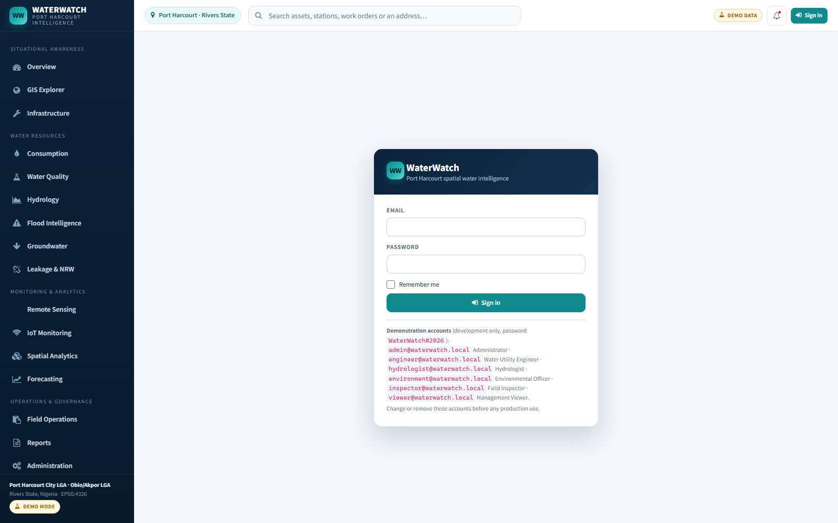
Figure 4.1: WaterWatch login page. Screenshot from the running system (2026).
The login page introduces the Port Harcourt water-intelligence workspace and the demonstration accounts.

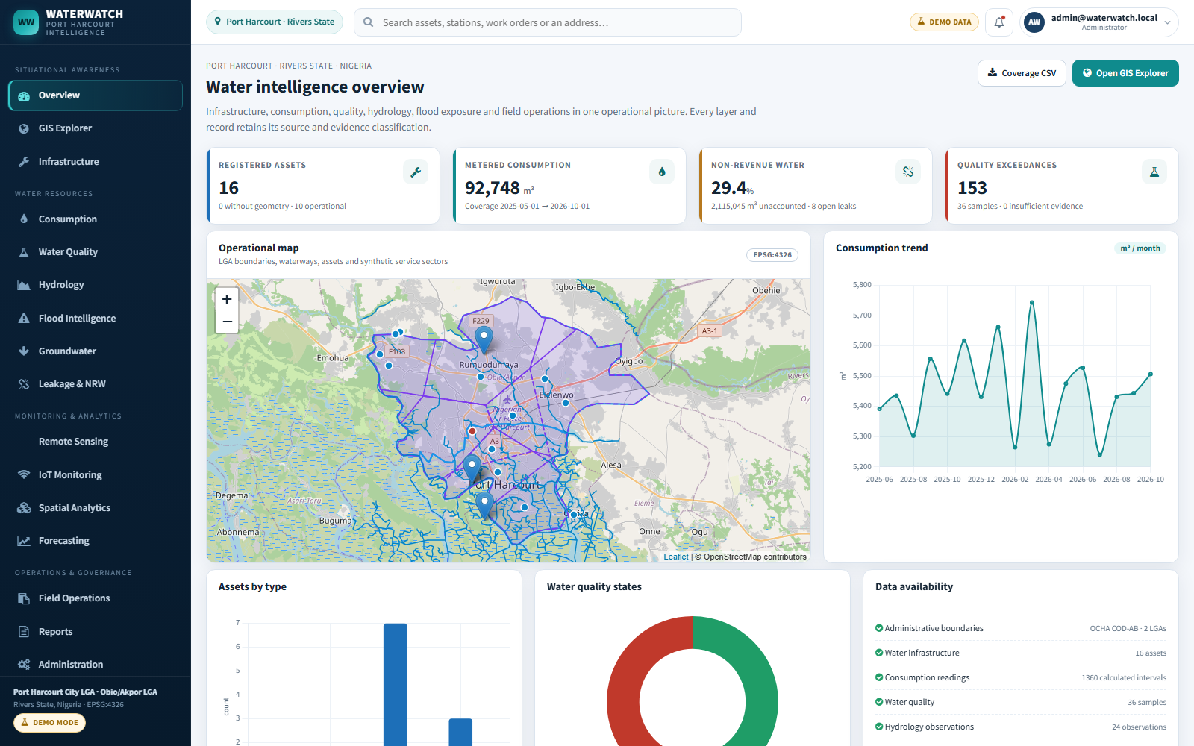
Figure 4.2: Water intelligence overview. Screenshot from the running system (2026).
The dashboard joins asset counts, metered consumption, NRW, quality exceedances, an operational map and availability states.

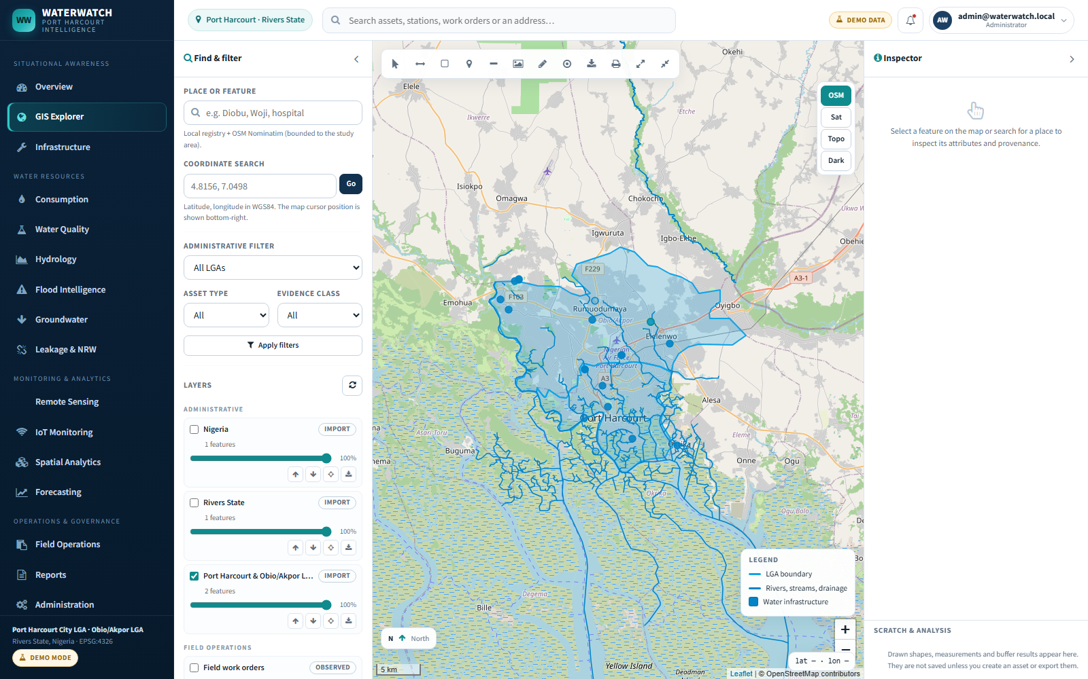
Figure 4.3: GIS explorer. Screenshot from the running system (2026).
The spatial workspace exposes layer categories, filters, asset inspection, basemaps and map tools.

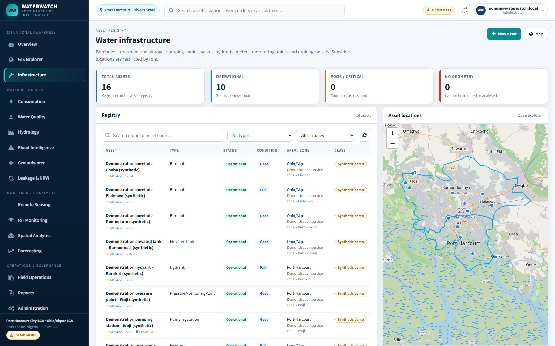
Figure 4.4: Infrastructure asset registry. Screenshot from the running system (2026).
Assets are presented with type, status, location, KPIs and links to operational details.

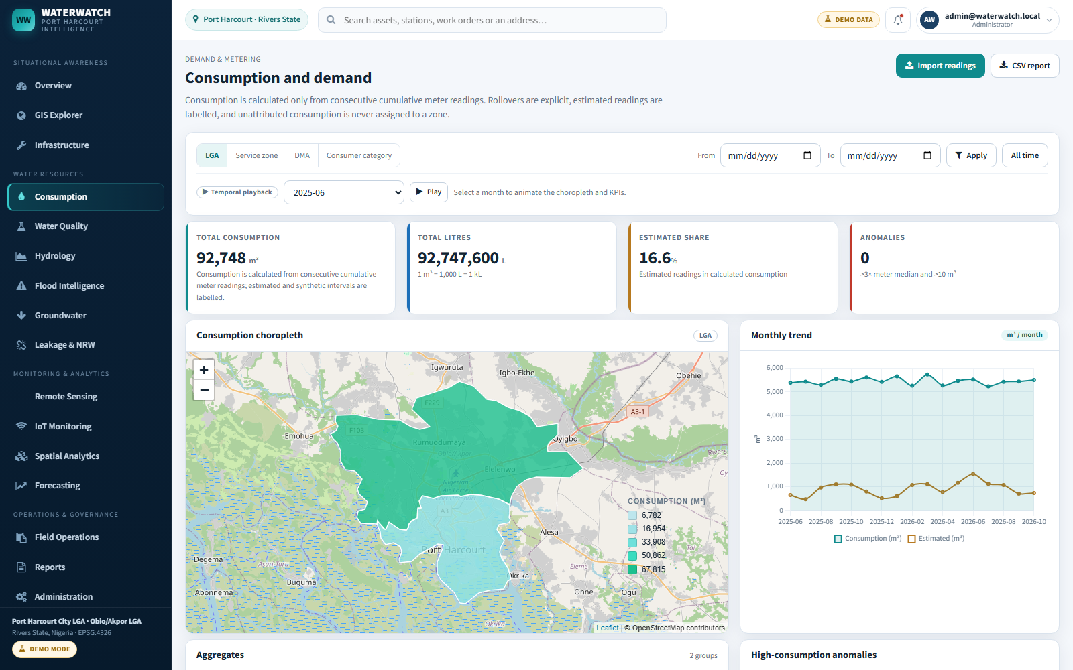
Figure 4.5: Consumption and demand analysis. Screenshot from the running system (2026).
The module combines spatial aggregates, monthly trends and high-consumption anomaly signals.

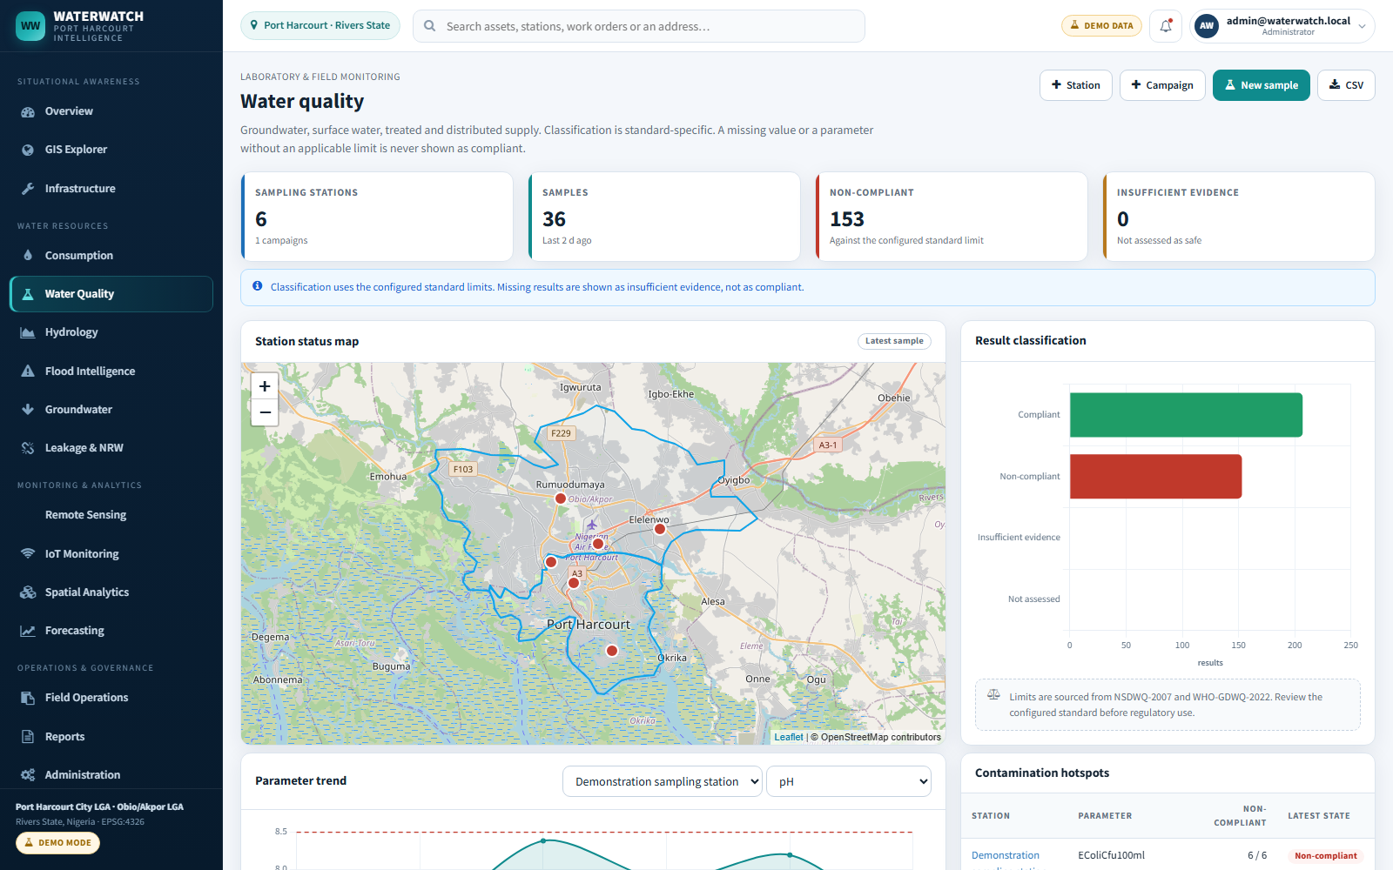
Figure 4.6: Water quality workspace. Screenshot from the running system (2026).
Station and sample data are classified against a selected standard with clear compliance states.

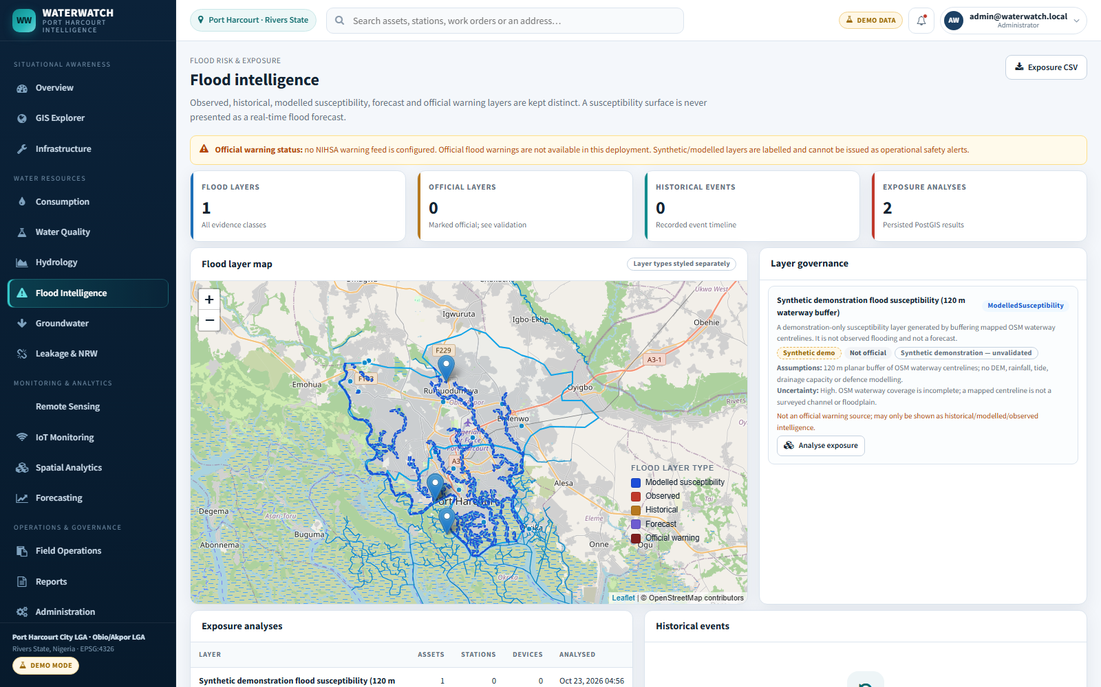
Figure 4.7: Flood intelligence workspace. Screenshot from the running system (2026).
Flood layers and exposure analysis are labelled by evidence type with explicit warnings about operational use.

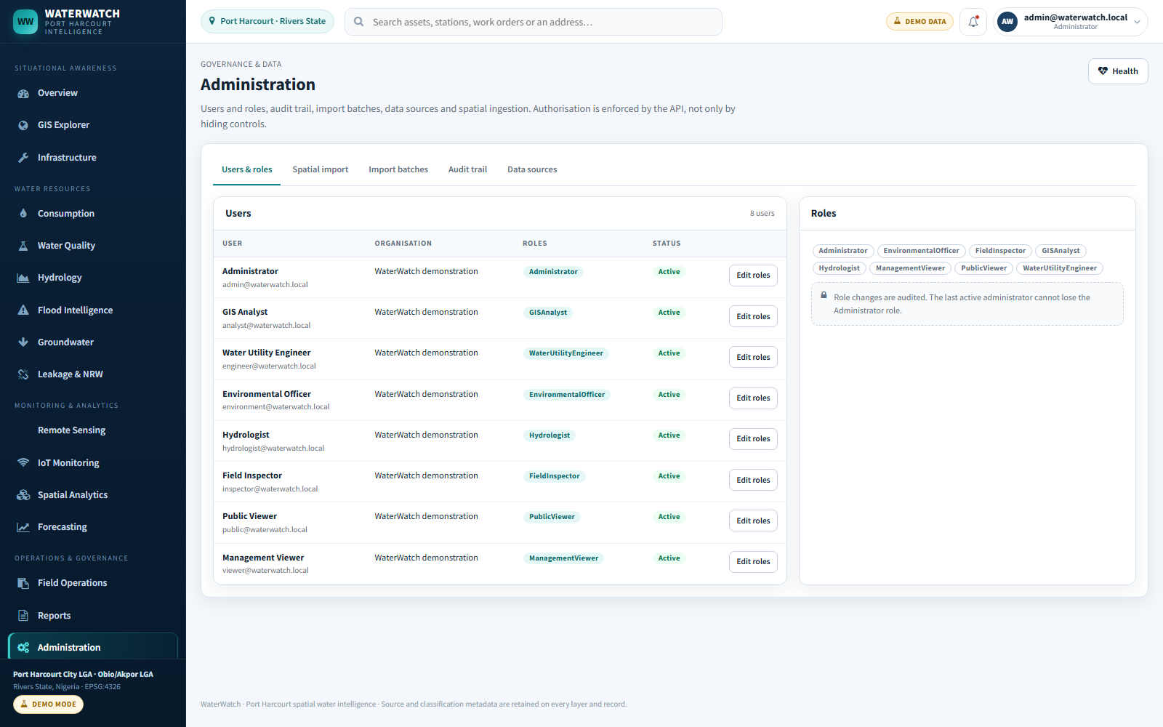
Figure 4.8: Administration and audit. Screenshot from the running system (2026).
User roles, audit entries, imports and system controls are available to authorised administrators.

4.6 Testing Results
The following table summarises the test evidence. The results are based on the repository test suites and browser checks performed during the implementation. Where an optional integration test requires an external database or service, that dependency is stated explicitly.
Table 4.3: Summary of test evidence
Area | Test approach | Evidence
Domain calculations | NUnit | Spatial/measurement, water-balance and quality classification rules.
Repository/import | NUnit and EF Core InMemory | Consumption import filtering, ordering and legacy repository behaviour.
PostGIS integration | NUnit and PostgreSQL | Optional geometry/index and spatial predicate test.
Browser smoke | Manual/Playwright-style review | Login, dashboard, GIS, infrastructure, consumption, quality, flood and admin pages.

Overall verification: The NUnit suite covers domain and repository behaviour; the optional PostGIS test requires WATERWATCH_TEST_CONNECTION.

4.6.1 Acceptance Test Cases
Acceptance cases connect the original requirements to observable evidence. The table below summarises the principal scenarios used to judge whether the workflow is complete.
Table 4.4: Acceptance test cases
ID | Scenario | Expected result | Evidence
AT-01 | An authorised user signs in. | The dashboard loads with role-appropriate navigation. | Verified in browser smoke test
AT-02 | GIS layers are selected and filtered. | The map and layer catalogue respond with matching features. | Verified in browser smoke test
AT-03 | Consumption aggregates are requested. | Monthly and spatial aggregates are returned with units. | Verified in service/API review
AT-04 | A quality sample is classified. | The result is marked compliant, non-compliant or insufficient evidence. | Covered in domain tests
AT-05 | Flood exposure is calculated. | Exposure records include assumptions, timestamp and layer type. | Covered in service/API review
AT-06 | An unauthorised user attempts an administrative action. | The policy rejects the request. | Covered in authorization design

4.7 Discussion of Results
WaterWatch demonstrates that a local water-intelligence platform can join several operational domains without hiding the quality of its data. The most important design decision is the classification model: imported boundaries, observed samples, modelled forecasts and synthetic utility records are visually distinct. The main limitations are the lack of an official utility feed and the fact that only metadata-level remote-sensing support is currently deployed.
The evidence supports the conclusion that the main workflows are implemented rather than merely described. The combination of API tests, browser screenshots and explicit acceptance scenarios also exposes the boundary of the work: features that depend on an external provider, real institutional data or a more advanced analytical model are identified as future work rather than presented as completed.

4.8 Summary
The implemented system demonstrates the design described in Chapter Three and provides a working interface for the main user journeys. The screenshots, acceptance scenarios and tests show that data can be created, read, updated and controlled through the application. Chapter Five reflects on the project as a whole and identifies the most useful next steps.

CHAPTER FIVE: SUMMARY, CONCLUSION AND RECOMMENDATIONS

5.1 Summary
This project set out to design and implement WaterWatch as a working final-year computer science artefact. The report reviewed the problem domain, related systems and technologies, then described an incremental methodology, a layered architecture, a relational and spatial data model, role-aware security and a practical testing strategy. The resulting application was demonstrated through actual interface screenshots and test evidence.

5.2 Conclusion
WaterWatch achieves its aim of providing a spatially integrated water-intelligence platform for Port Harcourt. It combines infrastructure, consumption, quality, hydrology, flood, telemetry and field operations in a tested modular monolith, while explicitly distinguishing evidence types. It is a credible foundation for further work with a utility partner, official flood data and satellite analytics.

5.3 Evaluation Against Objectives
The table below maps the original objectives to the implementation and evidence presented in Chapter Four. The purpose is to make the evaluation traceable rather than relying on a general claim that the system is complete.
Table 5.1: Evaluation against objectives
ID | Objective | Evaluation
OBJ-01 | Import and display Port Harcourt administrative boundaries and water-related spatial layers. | Addressed - see Chapter Four implementation and test evidence
OBJ-02 | Provide a GIS explorer and operational dashboard with source metadata. | Addressed - see Chapter Four implementation and test evidence
OBJ-03 | Manage infrastructure assets, network data, inspections and maintenance records. | Addressed - see Chapter Four implementation and test evidence
OBJ-04 | Analyse consumption, NRW, water quality, hydrology and groundwater records. | Addressed - see Chapter Four implementation and test evidence
OBJ-05 | Support flood exposure, remote-sensing metadata, telemetry and field work orders. | Addressed - see Chapter Four implementation and test evidence
OBJ-06 | Provide role-based administration, auditability, reports and honest availability states. | Addressed - see Chapter Four implementation and test evidence

5.4 Contributions
- A provenance-aware spatial water dashboard for Port Harcourt.
- An integrated asset, consumption, quality, hydrology and flood workflow.
- Role-based APIs with audit, security and sensitive-coordinate controls.
- A demonstration mode that keeps synthetic data clearly labelled.

5.5 Limitations of the Implementation
- No official utility asset register, DMA boundary set or customer billing integration.
- No official NIHSA flood warning feed.
- Remote sensing provides STAC metadata and change-layer catalogue rather than live raster processing.
- The project is not a production SCADA or emergency warning system.

5.6 Recommendations
- Partner with a utility to validate the asset and DMA data model with real records.
- Connect an authorised flood-warning source and document warning permissions.
- Enable raster processing and imagery indices through a controlled provider.
- Add backup, deployment, monitoring and staff training procedures.

5.7 Suggestions for Future Work
- Add real-time hydraulic and pressure network analysis.
- Integrate billing and customer-service records with privacy controls.
- Build mobile field capture with offline operation.
- Add scenario modelling for drought, leakage and flood resilience.

5.8 Final Remarks
The project provides a coherent, tested foundation for WaterWatch. Its value is not only in the number of screens, but in the way the problem was decomposed into requirements, data, security and evidence. The documented limitations should be treated as a research and deployment agenda rather than hidden defects. With the recommended validation and operational work, the prototype can support further study or a supervised pilot in its intended domain.

REFERENCES
Goodchild, M. F. (2007). Citizens as sensors: The world of volunteered geography. GeoJournal, 69(4), 211-221.
Haklay, M., & Weber, P. (2008). OpenStreetMap: User-generated street maps. IEEE Pervasive Computing, 7(4), 12-18.
Hevner, A. R., March, S. T., Park, J., & Ram, S. (2004). Design science in information systems research. MIS Quarterly, 28(1), 75-105.
Microsoft. (n.d.). ASP.NET Core documentation. https://learn.microsoft.com/aspnet/core/
OCHA. (n.d.). Nigeria common operational datasets. https://data.humdata.org/dataset/cod-ab-nga
Open-Meteo. (n.d.). Open-Meteo documentation. https://open-meteo.com/en/docs
PostGIS Project. (n.d.). PostGIS documentation. https://postgis.net/documentation/
PostgreSQL Global Development Group. (n.d.). PostgreSQL documentation. https://www.postgresql.org/docs/
Sommerville, I. (2016). Software engineering (10th ed.). Pearson.
World Health Organization & UNICEF. (2021). Progress on household drinking water, sanitation and hygiene 2000-2020. https://washdata.org/
Nielsen, J. (1994). Usability engineering. Morgan Kaufmann.

APPENDIX A: DEMONSTRATION GUIDE
The following steps provide a repeatable demonstration of the implemented system. The sequence uses the development configuration and the demonstration accounts described in the project README.
- Create the waterwatch database with database/setup.sql.
- Copy .env.example to .env and confirm demo mode and the local connection string.
- Start the application with run.cmd.
- Sign in as admin@waterwatch.local.
- Open the dashboard, GIS explorer and infrastructure modules.
- Review consumption, water quality, flood intelligence and administration.
During the demonstration, inspect the loading, empty, success and validation states rather than only the populated screen. The screenshots in Chapter Four can be used as a visual checklist.

APPENDIX B: PRIMARY ROUTES AND ENDPOINTS
The routes below identify the principal user-facing pages or API areas used in the demonstration. The repository README contains the fuller endpoint catalogue and deployment notes.
Table B.1: Primary routes and endpoints
Route or endpoint | Purpose
/ | Water intelligence dashboard
/Gis | GIS explorer and layer catalogue
/Infrastructure | Asset registry and network data
/Consumption | Consumption and demand analytics
/WaterQuality | Quality stations, samples and standards
/Flood | Flood layers and exposure analysis
/Administration | Users, roles, audit and imports

Access to protected routes is subject to the role and ownership rules described in Chapter Three. A successful HTTP response does not by itself prove authorization; the negative tests and acceptance scenarios are the relevant evidence.

