Alo Exchange: A Web-Based Barter Marketplace with Recommendation and Offer Management
A FINAL YEAR PROJECT REPORT
Submitted to the Department of Computer Science, [INSTITUTION NAME], in partial fulfilment of the requirements for the award of Bachelor of Science (B.Sc.) in Computer Science.

BY
[STUDENT FULL NAME]
[MATRICULATION NUMBER]

SUPERVISOR: [SUPERVISOR NAME]
October 2026

DECLARATION
I, [STUDENT FULL NAME], hereby declare that this final-year project report titled "Alo Exchange: A Web-Based Barter Marketplace with Recommendation and Offer Management" is my original work. It has not been submitted for the award of any other degree or diploma in this or any other institution. All sources of information and material used have been acknowledged in the references and in the body of the report. Any assistance received during the project has been documented and acknowledged.

Signature: ______________________________
Name: [STUDENT FULL NAME]
Matriculation number: [MATRICULATION NUMBER]
Date: October 2026

CERTIFICATION
This is to certify that this project report was carried out by [STUDENT FULL NAME] with matriculation number [MATRICULATION NUMBER] under my supervision. The report has been read and approved as meeting the requirements of the Department of Computer Science, [INSTITUTION NAME].

Supervisor: [SUPERVISOR NAME]
Signature: ______________________________
Date: ______________________________

ABSTRACT
Alo Exchange is a self-hosted barter marketplace that enables members to publish items, discover listings, receive simple recommendations and negotiate exchanges without using money. The project addresses the difficulty students and community members face when trying to exchange unused items through informal noticeboards or cash-oriented marketplaces. It was implemented as a Java Servlet/JSP application running on Jetty, with PostgreSQL for persistence and a layered Servlet-DAO architecture. Security features include BCrypt password hashing, session-based authentication, CSRF synchronizer tokens and owner-only offer decisions. The system supports listing creation and editing, category filtering, Weka-based recommendations, offer creation, offer review and transactional acceptance or rejection. The report describes the background, literature, methodology, implementation and evaluation of the system. Seven JUnit tests cover the principal workflows, and the interface was verified through browser screenshots of the login, catalogue, listing, offer and personal-list pages.
Keywords: software engineering, web application, database, spatial data, security, human-computer interaction, Alo Exchange

TABLE OF CONTENTS
CHAPTER ONE: INTRODUCTION 11
1.1 Background 11
1.2 Statement of the Problem 11
1.3 Aim and Objectives 12
1.3.1 Objectives 12
1.4 Research Questions 12
1.5 Scope of the Project 12
1.6 Significance of the Project 13
1.7 Limitations of the Project 13
1.8 Expected Contributions 13
1.9 Definition of Terms 14
1.10 Organisation of the Report 14
CHAPTER TWO: LITERATURE REVIEW 15
2.1 Introduction 15
2.2 Conceptual Review 15
2.2.1 Quality Attributes and User-Centred Design 15
2.3 Review of Related Systems 16
2.4 Technology Review 16
2.5 Research Gap 17
2.6 Summary 17
CHAPTER THREE: METHODOLOGY AND SYSTEM ANALYSIS 18
3.1 Introduction 18
3.2 Development Methodology 18
3.2.1 Requirements Elicitation 18
3.3 Requirements Analysis 19
3.3.1 Functional Requirements 19
3.3.2 Non-Functional Requirements 19
3.3.3 Constraints and Assumptions 19
3.4 System Architecture 19
3.4.1 Component Responsibilities 20
3.5 Database and Data Model 20
3.5.1 Data Integrity Rules 21
3.6 Use Case Analysis 22
3.7 Security Design 22
3.8 Ethical and Legal Considerations 23
3.9 Testing Strategy 23
3.10 Deployment and Operational Considerations 23
3.11 Summary 24
CHAPTER FOUR: SYSTEM IMPLEMENTATION AND RESULTS 25
4.1 Introduction 25
4.2 Development Environment 25
4.3 Implementation of Major Modules 25
4.3.1 Authentication and access control 25
4.3.2 Listing catalogue 25
4.3.3 Recommendation 26
4.3.4 Listing management 26
4.3.5 Offer lifecycle 26
4.4 Implementation Challenges and Resolutions 26
4.5 System Interface Screenshots 28
4.6 Testing Results 34
4.6.1 Acceptance Test Cases 34
4.7 Discussion of Results 35
4.8 Summary 35
CHAPTER FIVE: SUMMARY, CONCLUSION AND RECOMMENDATIONS 36
5.1 Summary 36
5.2 Conclusion 36
5.3 Evaluation Against Objectives 36
5.4 Contributions 37
5.5 Limitations of the Implementation 37
5.6 Recommendations 37
5.7 Suggestions for Future Work 37
5.8 Final Remarks 37
REFERENCES 39
APPENDIX A: DEMONSTRATION GUIDE 40
APPENDIX B: PRIMARY ROUTES AND ENDPOINTS 41

LIST OF FIGURES
Figure 3.1: System architecture
Figure 3.2: Simplified entity-relationship model
Figure 3.3: Use case overview
Figure 4.1: Login page for Alo Exchange.
Figure 4.2: Listing catalogue and recommendation area.
Figure 4.3: Listing detail and offer entry point.
Figure 4.4: Create-listing form.
Figure 4.5: Personal listing management.
Figure 4.6: Offer review page.

LIST OF TABLES
Table 1.1: Definition of key terms
Table 2.1: Comparison of related systems
Table 2.2: Technologies used in the implementation
Table 3.1: Functional requirements
Table 3.2: Non-functional requirements
Table 3.3: Component responsibilities
Table 3.4: Principal data entities
Table 3.5: Summary of primary use cases
Table 4.1: Implementation environment
Table 4.2: Implementation challenges and resolutions
Table 4.3: Summary of test evidence
Table 4.4: Acceptance test cases
Table 5.1: Evaluation against objectives
Table B.1: Primary routes and endpoints

LIST OF ABBREVIATIONS
Abbreviation | Meaning
DAO | Data Access Object
CSRF | Cross-Site Request Forgery
JSP | JavaServer Pages
JSTL | JavaServer Pages Standard Tag Library
WAR | Web Application Archive
SQL | Structured Query Language
BCrypt | Password hashing algorithm based on the Blowfish cipher
OWASP | Open Worldwide Application Security Project

CHAPTER ONE: INTRODUCTION

1.1 Background
The growth of collaborative consumption has changed how people obtain and exchange everyday goods. Instead of purchasing every item new, communities increasingly reuse, swap and redistribute products through digital platforms (Belk, 2014). This is particularly relevant in student and community settings where budgets are limited and useful items often remain unused after a short period. A barter marketplace provides a structured way for members to turn those items into things they actually need.
Many existing online marketplaces are designed around cash transactions, advertising or large-scale retail. Their workflows are not always suitable for small, trust-based exchanges between local users. Users may also lack a clear record of who offered what, which listing was involved and whether an offer was accepted or rejected. A dedicated barter system can model these interactions explicitly and preserve an auditable offer history.
This project demonstrates those ideas using server-rendered Java web technologies. It combines session authentication, relational data storage, a recommendation component and a complete listing-to-offer lifecycle in one application. The result is an academic prototype that is small enough to run locally but complete enough to demonstrate multi-user marketplace behaviour.

1.2 Statement of the Problem
Informal exchange channels such as noticeboards, messaging groups and spreadsheets do not provide a reliable marketplace workflow. Listings can be duplicated or lost, ownership is not enforced, and there is no consistent way to make, review and close an exchange offer. Cash-oriented platforms solve some discovery problems but introduce payment, advertising and delivery concerns that are outside the scope of a community barter exchange.
The problem addressed by this project is therefore the absence of a simple, secure and self-hosted platform that supports the full lifecycle of a barter transaction: registration, listing, discovery, recommendation, offer creation and owner-controlled acceptance or rejection, while protecting account and form data.

1.3 Aim and Objectives
To design and implement a secure, server-rendered barter marketplace that supports multi-user listing and offer workflows, and to evaluate whether the resulting system meets the functional and security requirements of a small community exchange.

1.3.1 Objectives
- Provide account registration, login and logout with server-side session management.
- Allow authenticated members to create, edit, view and remove their own listings.
- Allow members to browse visible listings, filter by category and see recommended items.
- Implement an offer workflow that records the listing, offered item, requested item and quantities.
- Allow only the listing owner to accept or reject pending offers, with transactional closure of both listings.
- Apply password hashing, CSRF protection, ownership checks and input validation to the main workflows.

1.4 Research Questions
The objectives are translated into the following research questions. Each question is revisited in Chapters Three and Four, where the design and implementation evidence are discussed.
- How can a small community marketplace support the complete lifecycle of a barter offer rather than only listing items?
- Which server-side controls are needed to protect listing ownership, account sessions and offer decisions?
- How can a recommendation component be included without turning the project into a commercial recommendation system?
- What evidence demonstrates that the implemented offer workflow is consistent under duplicate or competing offers?

1.5 Scope of the Project
The project covers the following functional and technical scope:
- Account registration and session-based authentication for community members.
- Listing catalogue, category filtering, search and a Weka-based recommendation block.
- Owner-managed listing creation, editing, viewing and soft deletion.
- Offer creation, offer review and owner-only acceptance or rejection.
- A demonstration database containing sample users, categories and listings.

1.6 Significance of the Project
- The system demonstrates how a non-cash exchange can be modelled with a clear offer lifecycle rather than informal messages.
- It gives students a practical example of layered Java web development with servlets, JSP, JDBC and PostgreSQL.
- It demonstrates security controls that are often missing from small academic CRUD projects.
- It provides a foundation for community reuse and sustainable consumption initiatives.

1.7 Limitations of the Project
The limitations below define the boundary of the academic deliverable. They are not hidden implementation gaps: they explain which capabilities are outside the approved project scope and why.
- The system is intended for local demonstration and does not include payment, delivery or dispute resolution.
- Recommendations use a small Weka model and demonstrate the concept rather than production-scale personalisation.
- Notifications are limited to in-application views; there is no email or push notification service.
- The map of listings is not a geographic feature; listings are organised by category and text metadata.

1.8 Expected Contributions
- A reproducible reference implementation of a multi-user barter workflow.
- A clear separation between listing ownership, offer ownership and administrative action.
- A practical demonstration of BCrypt, session authentication, CSRF protection and transactional offer acceptance.
- A tested teaching artefact that can be extended with messaging, ratings or deployment automation.

1.9 Definition of Terms
Table 1.1: Definition of key terms
Term | Definition
Barter | The direct exchange of goods or services without using money.
Listing | An item published by a member for possible exchange.
Offer or Interest | A record showing that one member wants to exchange an item with another member.
CSRF token | A synchronizer token used to confirm that a state-changing request originated from the application.
DAO | Data Access Object, the layer responsible for issuing SQL queries and mapping database rows.
Recommendation | A suggested listing generated from the user's category interests and available items.

1.10 Organisation of the Report
Chapter One introduces the problem, aim, objectives, scope and significance of the project. Chapter Two reviews the relevant concepts, related platforms and technologies. Chapter Three presents the methodology, requirements, architecture and testing strategy. Chapter Four documents the implementation and includes screenshots of the running system. Chapter Five summarises the work, states the conclusions and recommends further improvements.

CHAPTER TWO: LITERATURE REVIEW

2.1 Introduction
This chapter reviews the concepts, related systems and technologies relevant to the project. The review is organised around the problem domain, the capabilities of existing products and the technical choices used in the implementation. It ends by identifying the gap that the project addresses. The review draws on established software-engineering and domain literature as well as the official documentation of the frameworks used in the system.

2.2 Conceptual Review
Alo Exchange is a multi-user information system rather than a single-user desktop tool. Its design therefore has to account for user identity, persistent records, validation, feedback and operational workflows. Software-engineering research emphasises that these concerns should be handled through explicit requirements, modular design and iterative evaluation (Sommerville, 2016; Pressman & Maxim, 2020). The design-science perspective adds that the resulting artefact should be evaluated against the problem it was created to solve rather than judged only by the number of implemented features (Hevner et al., 2004).
The project also reflects the broader shift from isolated records to connected digital services. Users expect immediate validation, clear status information and predictable navigation. At the same time, sensitive systems need security boundaries that are enforced on the server rather than only hidden in the interface. These principles informed the choice of layered architectures, role-aware endpoints and explicit error states.
For the Alo Exchange domain, the important conceptual concerns are data ownership, consistency of state transitions and the relationship between a user action and a persistent record. The implementation therefore treats workflow state, authorization and source provenance as first-class parts of the design.

2.2.1 Quality Attributes and User-Centred Design
A functioning demonstration also has to satisfy quality attributes that are not visible in a feature list. Security, usability, maintainability and graceful failure are particularly important for a multi-user system. Usability heuristics emphasise visibility of system status, clear error messages, prevention of invalid input and consistent navigation (Nielsen, 1994). These ideas are reflected in loading indicators, validation messages, explicit empty states and role-specific navigation in the implemented interface.
Maintainability is addressed through feature-oriented source organisation, shared validation and a consistent data-access layer. Security is treated as a server-side concern: the interface may hide an action, but the endpoint must still verify identity and permission. This separation between presentation and enforcement is a recurring theme in secure web-application guidance (OWASP Foundation, 2021).

2.3 Review of Related Systems
Table 2.1: Comparison of related systems
System | Strengths | Limitations and relationship to this project
OLX and Facebook Marketplace | Large classifieds platforms with broad reach and search. | Primarily cash or advertising oriented; no built-in reciprocal barter offer lifecycle.
Freecycle | Community reuse network that supports giving items away. | Gifting rather than a two-sided exchange; no structured offer negotiation.
BarterQuest and similar swap sites | Explicitly support item-for-item exchange. | General-purpose services may require external accounts, commercial hosting and opaque matching logic.
University noticeboards and chat groups | Low setup cost and familiar to students. | No ownership enforcement, expiry, audit trail or consistent offer status.

The comparison shows that existing products are generally stronger in scale, commercial integrations or specialised domain features. The opportunity for this project is not to reproduce a commercial platform, but to build a transparent, locally runnable system that demonstrates the core workflow with maintainable code, explicit limitations and test evidence.

2.4 Technology Review
Table 2.2: Technologies used in the implementation
Technology | Role in the system | Reason for selection
Java Servlet and JSP | Server-side request handling and dynamic page rendering | Directly demonstrates the request-response and session model used in the module.
Jetty Maven plugin | Local web container and repeatable run configuration | Allows the WAR application to run without a separate application server.
PostgreSQL | Relational persistence | Provides transactional integrity for listing and offer updates.
JDBC DAO layer | SQL access and row mapping | Makes persistence explicit and testable without a large ORM.
BCrypt | Password hashing | Adds a deliberately slow salted hash for stored credentials.
Weka | Recommendation model | Demonstrates a simple data-mining component in a Java application.

The technology stack was selected for reliability, documentation and suitability for a final-year project. The architecture separates transport, application logic, persistence and presentation concerns. Official documentation was used to confirm configuration and security behaviour rather than relying on assumptions about framework defaults.
The technology review also considered operational constraints. The project should be reproducible on a student workstation, avoid unnecessary infrastructure, preserve data through migrations and make optional external dependencies fail gracefully. These constraints influenced the choice of a modular monolith and the decision to keep provider-specific integrations behind service boundaries.

2.5 Research Gap
The reviewed platforms demonstrate discovery, reuse and exchange, but they do not combine a small, self-hosted barter workflow with explicit offer ownership, transactional acceptance and academic security controls. This project fills that gap by building the workflow as a transparent teaching artefact rather than as a commercial marketplace.

2.6 Summary
The review establishes that Alo Exchange addresses a genuine workflow rather than a purely visual mock-up. The next chapter translates the reviewed requirements into a development methodology, system architecture, data model and testing plan.

CHAPTER THREE: METHODOLOGY AND SYSTEM ANALYSIS

3.1 Introduction
This chapter explains how the system was analysed, designed and tested. It presents the development approach, functional and non-functional requirements, architecture, data model, use cases, security design and verification strategy. The design aims to keep the implementation understandable while still meeting the needs of a multi-user application.

3.2 Development Methodology
The project followed an incremental software development process. Requirements were identified from the barter scenario, and the system was built in slices: authentication, listing management, recommendation, offer creation and offer decision. Each slice was tested before the next was added. This approach follows the iterative delivery and validation principles described by Sommerville (2016) and Pressman and Maxim (2020).
The work used a requirements-driven, incremental approach. The problem domain and stakeholder actions were decomposed into vertical slices, and each slice was checked through code review, automated tests or browser inspection. The design-science cycle of problem identification, artefact construction and evaluation was used to keep the project focused on a usable result (Hevner et al., 2004).

3.2.1 Requirements Elicitation
Requirements were elicited from the problem statement, the implemented prototype, domain documentation and the practical workflows observed in each application area. The analysis did not assume that a feature should be built simply because it appeared in a related commercial product; each requirement was checked against the project aim and the available data.
- Review of barter and classified-marketplace workflows.
- Analysis of the original listing and offer requirements.
- Security guidance from OWASP and the Java Servlet session model.
- Inspection of the demonstration database and sample user scenarios.

3.3 Requirements Analysis

3.3.1 Functional Requirements
Table 3.1: Functional requirements
ID | Requirement | Priority
FR-01 | Register a new member account and validate email and password rules. | High
FR-02 | Log in, maintain a session and log out securely. | High
FR-03 | Create a listing with title, category, description, quantity and optional image. | High
FR-04 | Edit, view and soft-delete owned listings. | High
FR-05 | Browse visible listings and filter them by category. | High
FR-06 | Show recommended listings based on the member's interests. | Medium
FR-07 | Create an offer that records offered and requested items. | High
FR-08 | Review received and sent offers and accept or reject them as the owner. | High

3.3.2 Non-Functional Requirements
Table 3.2: Non-functional requirements
Area | Requirement
Security | Passwords must be hashed; CSRF tokens must protect POST forms; ownership checks must run on the server.
Usability | A member should be able to find a listing and submit an offer without training.
Reliability | Offer acceptance must be transactional so that both listings and competing offers remain consistent.
Maintainability | Servlets, DAOs and JSP views should remain separated by responsibility.
Portability | The application should run locally with JDK, Maven, Jetty and PostgreSQL.

3.3.3 Constraints and Assumptions
The design assumes a local or small-team deployment, a supported web browser and access to the configured database. Optional external services are treated as enhancements rather than preconditions for the core workflow. The project does not assume access to an official utility asset register, commercial imagery or a production identity provider unless those services are explicitly configured.

3.4 System Architecture
The application uses a layered architecture. JSP pages provide the browser interface, servlets handle requests and session state, DAO classes perform SQL operations, and PostgreSQL stores users, categories, listings and interests. Weka is isolated behind a recommendation service.
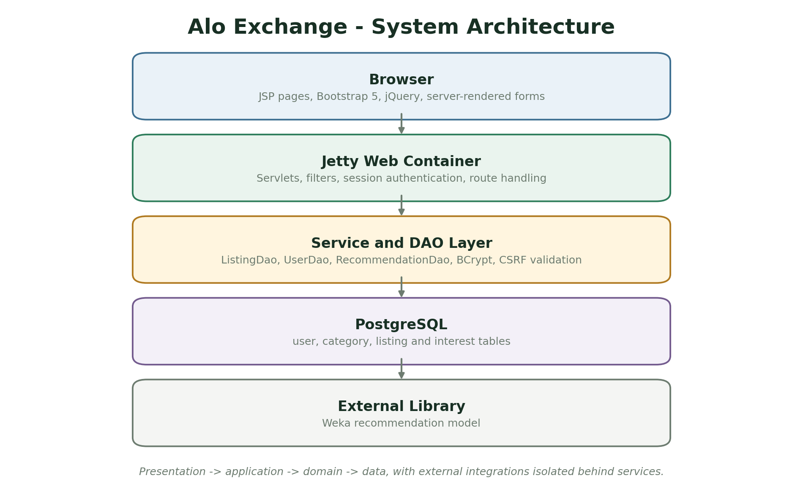
Figure 3.1: System architecture of Alo Exchange. Source: Author design (2026).

3.4.1 Component Responsibilities
Table 3.3: Component responsibilities
Component | Responsibility | Implementation evidence
Browser interface | Renders JSP pages, forms, listing cards and offer views with Bootstrap and jQuery. | JSP views and navigation fragments
Servlet layer | Accepts requests, manages sessions, applies authentication filters and coordinates workflows. | Home, Login, Register, Listing and Offer servlets
DAO layer | Executes SQL and maps rows into application objects. | UserDao, ListingDao and RecommendationDao
Recommendation service | Produces suggested listings from category behaviour. | Weka-based component
PostgreSQL | Stores accounts, categories, listings and offer records with transactional updates. | exchange database and script.sql

3.5 Database and Data Model
The data model is designed around the entities that carry the core business rules. Identifiers connect records, while status fields and timestamps preserve operational state. The simplified entity-relationship model below illustrates the principal relationships; the implementation contains additional attributes, indexes and join records.
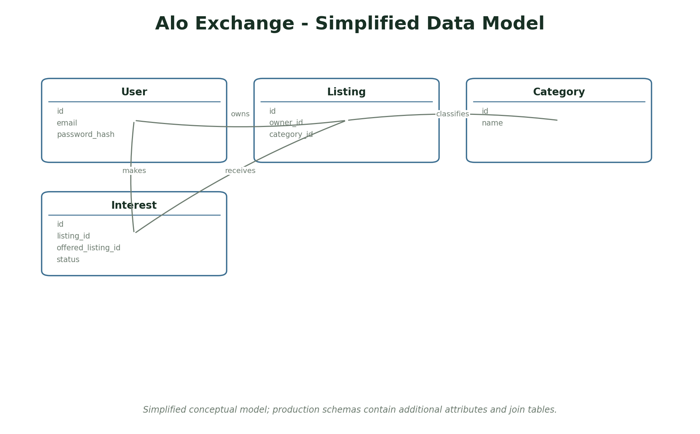
Figure 3.2: Simplified entity-relationship model for Alo Exchange. Source: Author design (2026).
Table 3.4: Principal data entities
Entity | Key attributes and purpose
User | id, email, password hash, display name
Listing | id, owner id, category id, title, description, quantity, status
Category | id, name
Interest | id, requesting user, target listing, offered listing, quantity, status

3.5.1 Data Integrity Rules
The database is not treated as a passive storage container. Constraints, validation and transactional updates protect the relationships that the application relies on. The following rules are enforced in the domain or database layer rather than only in the browser form.
- A listing must have an owner and a valid category.
- An offer must reference an existing target listing and an offered listing.
- Only the owner of the target listing may accept or reject an offer.
- Acceptance must reject competing pending offers and close both listings in one transaction.
- Duplicate pending offers from the same user for the same listing should be rejected.

3.6 Use Case Analysis
Use cases describe the observable actions available to each actor. They also provide a basis for the authorization matrix and the test cases. The overview below is deliberately simplified to emphasise the main workflow rather than every administrative action.
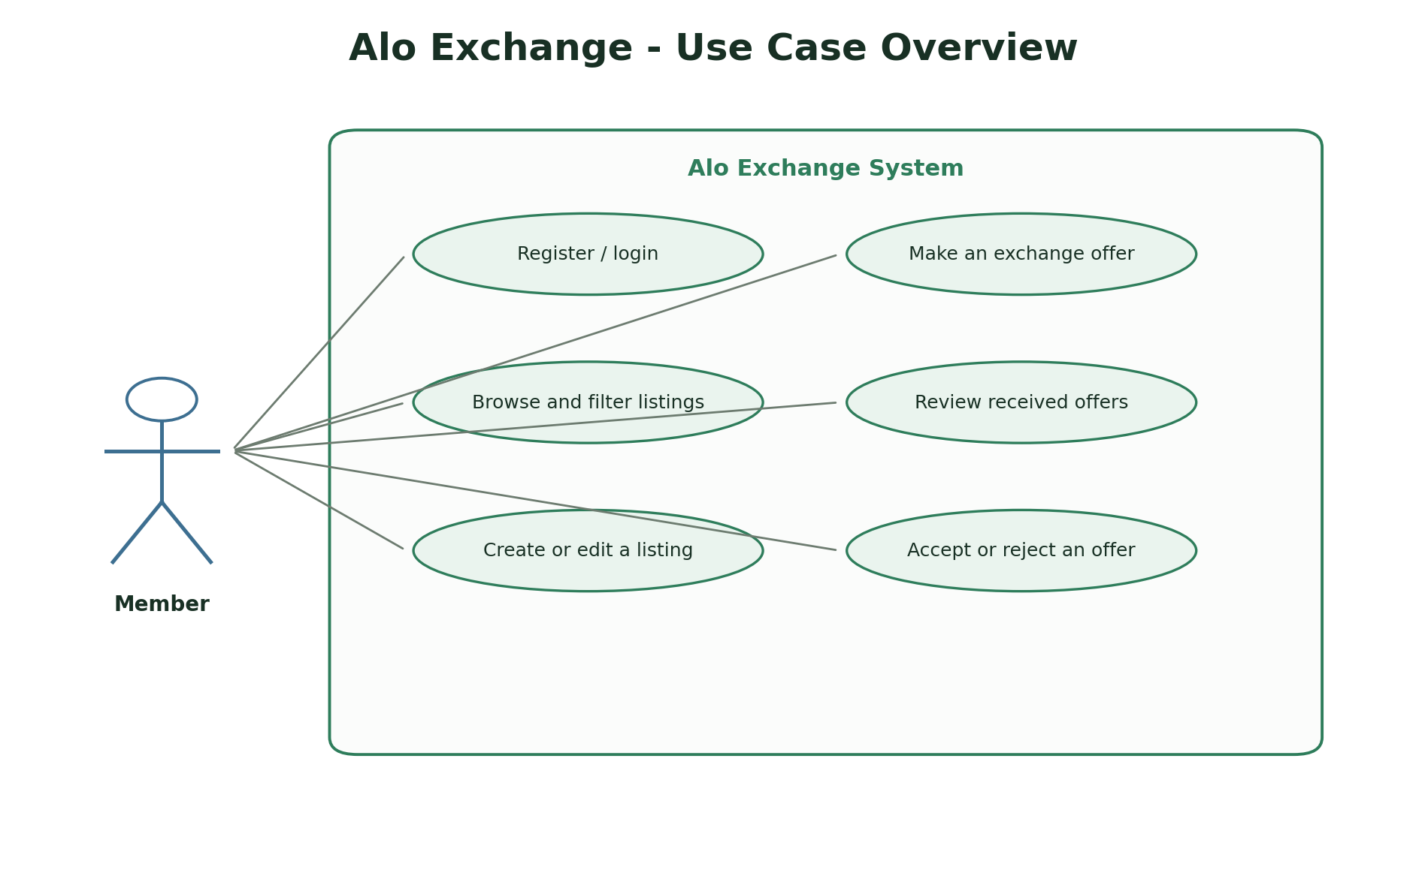
Figure 3.3: Use case overview for Alo Exchange. Source: Author design (2026).
Table 3.5: Summary of primary use cases
Actor | Use case | Outcome
Member | Browse and filter listings | Discover items available for exchange.
Member | Make an offer | Record an intended exchange against another listing.
Listing owner | Accept or reject offer | Close the exchange decision and update both listings.
Administrator/demonstrator | Seed and inspect data | Run the demonstration database and support evaluation.

3.7 Security Design
Security is implemented at the server boundary. The design assumes that the browser cannot be trusted to enforce ownership, roles or workflow transitions. Every protected operation therefore checks the authenticated identity and the relevant domain relationship before changing data.
- BCrypt hashes are used for stored passwords; plaintext passwords are never returned in models.
- Every state-changing POST includes a CSRF synchronizer token.
- The authentication filter protects user, listing, offer and personal-list routes.
- Offer acceptance checks that the current user owns the listing being offered on.
- Offer acceptance runs transactionally and rejects competing pending offers.

3.8 Ethical and Legal Considerations
A computer science project must consider the effect of the system beyond its functional requirements. The project avoids real personal, financial or health data and documents where demonstration data is synthetic. The following considerations guided the scope and interface.
- Only demonstration accounts and sample listings are used; no real personal or payment data is required.
- Passwords are hashed and never displayed in application output.
- Members can only modify their own listings and decisions, reducing the risk of impersonation.
- The project does not facilitate money transfers, and users should still apply normal community safety practices.

3.9 Testing Strategy
Testing uses several complementary levels. Unit tests check isolated rules, integration tests exercise APIs and persistence, and browser checks confirm that the main user journeys render and behave correctly. The tests are designed to verify negative cases such as invalid input, unauthorised access and inconsistent state, not only the happy path.
The test strategy follows the project requirements rather than the implementation structure. Each core workflow should have at least one positive verification and one rejected or restricted case. Test evidence is reported in Chapter Four, together with limitations of the current suite.

3.10 Deployment and Operational Considerations
The deployment model is intentionally simple so that the project can be reproduced and examined. Configuration is separated from source code where practical, migrations are applied through the framework and a local launcher is supplied for demonstration. A production deployment would require stronger secret management, monitoring, backups and an operational support process.
- The application is packaged as a WAR and can run through the Jetty Maven plugin with a local PostgreSQL database.
- The database schema and demonstration data are loaded separately so that data setup is explicit.
- For a shared deployment, the default credentials, development keys and database password must be replaced.

3.11 Summary
This chapter established the development approach, requirements, architecture, data model, security controls, ethical boundary and test strategy. Chapter Four describes how these designs were implemented and presents the resulting interface screens and test evidence.

CHAPTER FOUR: SYSTEM IMPLEMENTATION AND RESULTS

4.1 Introduction
This chapter presents the implemented system and the evidence used to evaluate it. It starts with the development environment, then describes the main modules, presents interface screenshots and reports the testing results. The screenshots were captured from the running application and therefore show the actual interface rather than a conceptual mock-up.

4.2 Development Environment
Table 4.1: Implementation environment
Item | Implementation
Operating system | Windows development workstation
Application type | Java Servlet/JSP web application
Backend stack | Java 21, Servlet 4, JSP, JDBC, BCrypt, Weka
Frontend / interface | JSP, Bootstrap 5, jQuery
Database | PostgreSQL (exchange database)
Testing tools | Seven JUnit tests and browser smoke testing of the main pages.
Browser verification | Headless Chromium screenshots and manual browser smoke checks

4.3 Implementation of Major Modules

4.3.1 Authentication and access control
Registration, login, logout, session handling, authentication filtering and CSRF validation.
The module was implemented as a vertical slice containing the necessary persistence, server-side validation and interface feedback. Loading, empty and error states were handled so that the interface remains understandable when data is absent or an external operation fails.

4.3.2 Listing catalogue
Visible item cards, category filters, search and item detail views.
The module was implemented as a vertical slice containing the necessary persistence, server-side validation and interface feedback. Loading, empty and error states were handled so that the interface remains understandable when data is absent or an external operation fails.

4.3.3 Recommendation
A Weka-based component recommends listings based on the member's category interest.
The module was implemented as a vertical slice containing the necessary persistence, server-side validation and interface feedback. Loading, empty and error states were handled so that the interface remains understandable when data is absent or an external operation fails.

4.3.4 Listing management
Owners create, edit, view and remove listings while other members only see permitted actions.
The module was implemented as a vertical slice containing the necessary persistence, server-side validation and interface feedback. Loading, empty and error states were handled so that the interface remains understandable when data is absent or an external operation fails.

4.3.5 Offer lifecycle
Members make offers, owners review them and acceptance closes both listings.
The module was implemented as a vertical slice containing the necessary persistence, server-side validation and interface feedback. Loading, empty and error states were handled so that the interface remains understandable when data is absent or an external operation fails.

4.4 Implementation Challenges and Resolutions
Implementation did not follow a straight path from design to finished feature. The following issues were encountered while building and testing the system, together with the action taken and the lesson carried into the final implementation.
Table 4.2: Implementation challenges and resolutions
Challenge | Resolution | Lesson
Keeping offer acceptance consistent | A member could accept an offer while another offer for the same listing was still pending. | Acceptance is performed in a transaction that updates the chosen offer, rejects competing offers and closes both listings.
Preventing forged POST requests | Ordinary session cookies alone do not prove that a form was generated by the application. | A synchronizer token is included in every state-changing form and checked before processing.
Enforcing ownership outside the UI | Hiding buttons in JSP is not sufficient because a user can still send a request directly. | The server checks ownership of the current listing before accepting, rejecting, editing or deleting.
Balancing recommendation simplicity | A large machine-learning pipeline would be disproportionate for the project. | A small Weka model demonstrates the recommendation concept while the main evaluation focuses on the marketplace workflow.

4.5 System Interface Screenshots
The following screenshots show the principal user interface of the implemented system. Each figure is followed by an explanation of the workflow it demonstrates. The images retain the application layout but crop out the host browser chrome for clarity.
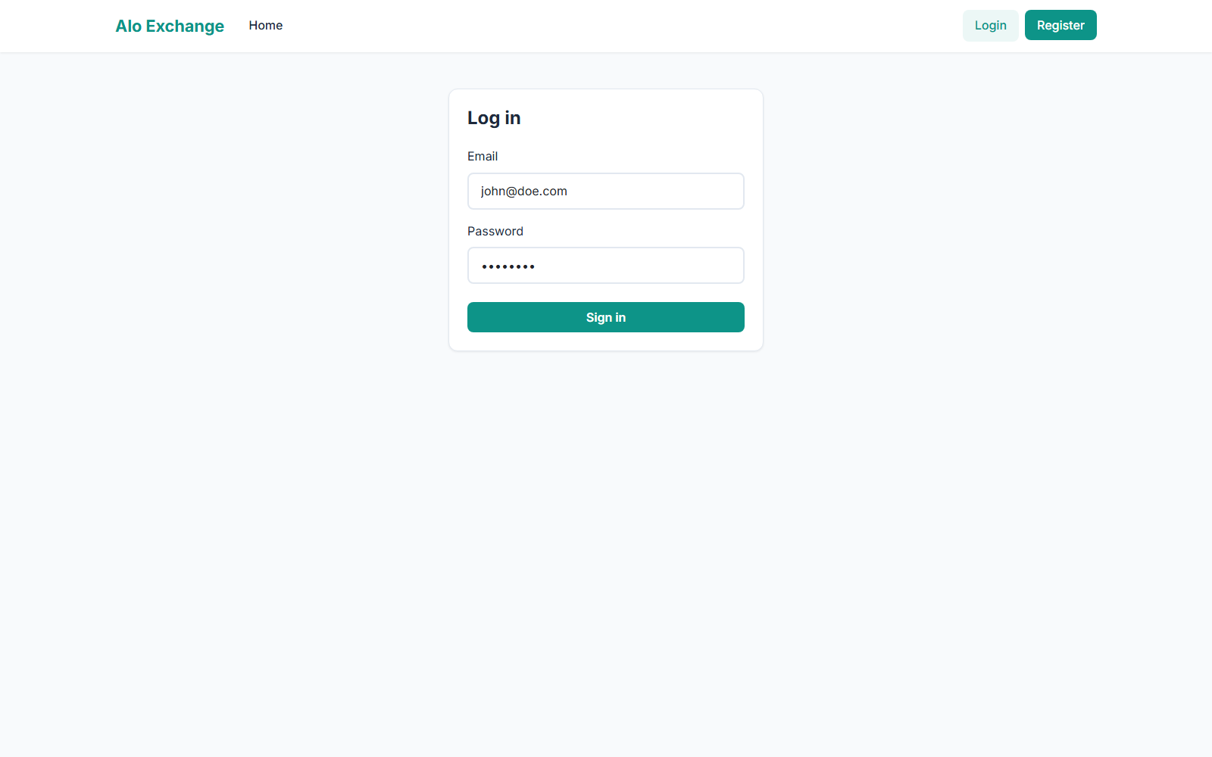
Figure 4.1: Login page for Alo Exchange. Screenshot from the running system (2026).
The login form demonstrates server-side validation, CSRF token submission and a clear single-purpose authentication screen.

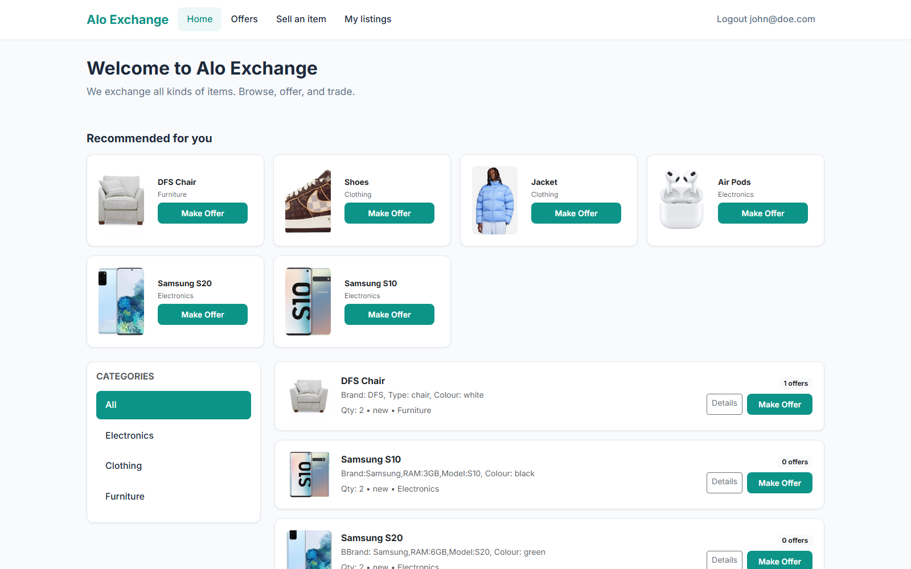
Figure 4.2: Listing catalogue and recommendation area. Screenshot from the running system (2026).
The home page combines recommended listings, categories and the visible item catalogue for the signed-in member.

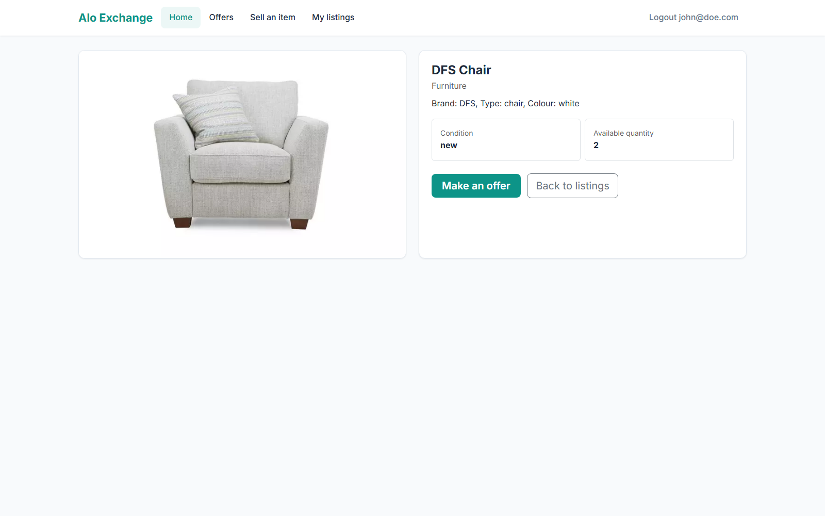
Figure 4.3: Listing detail and offer entry point. Screenshot from the running system (2026).
The detail view presents the item, its owner and the action required to start an exchange.

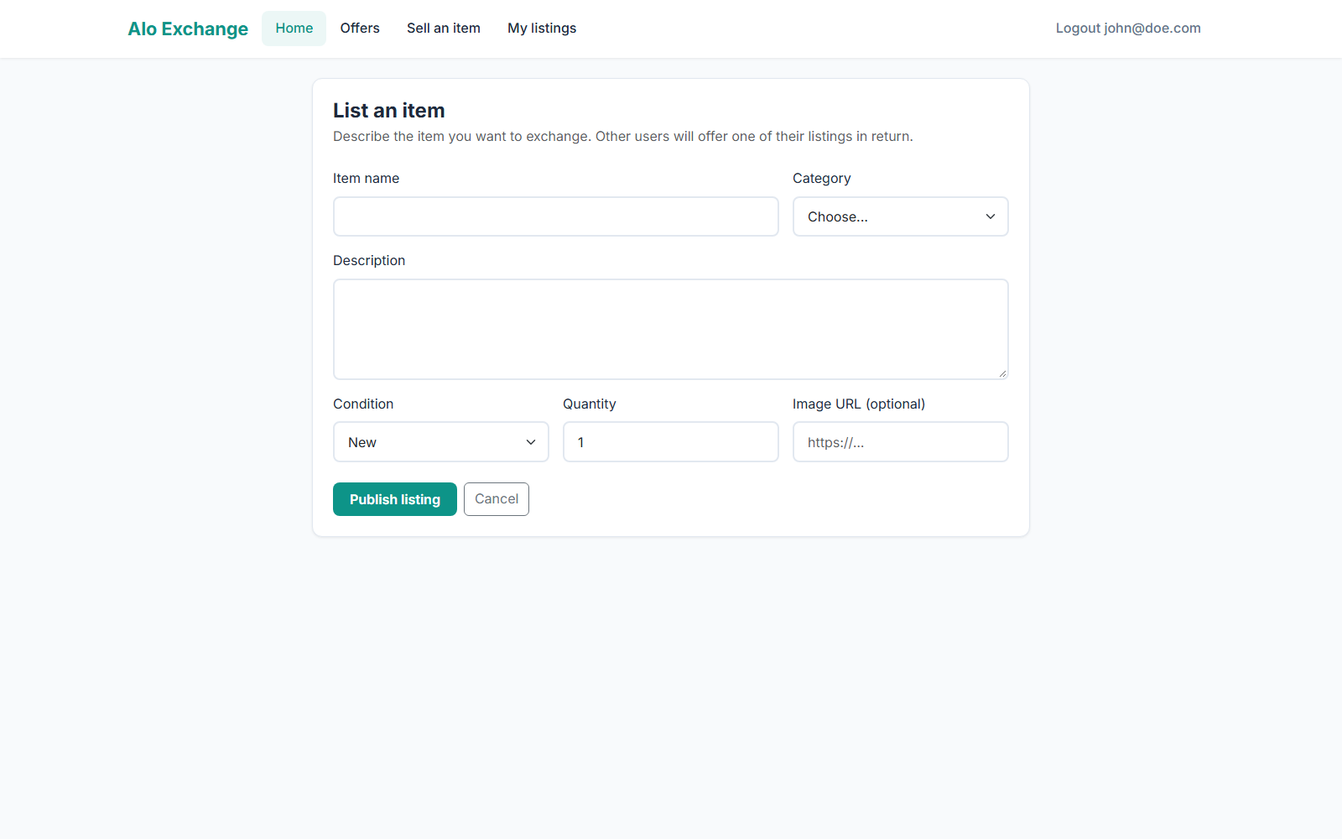
Figure 4.4: Create-listing form. Screenshot from the running system (2026).
The form captures title, category, description, quantity, condition and optional image information.

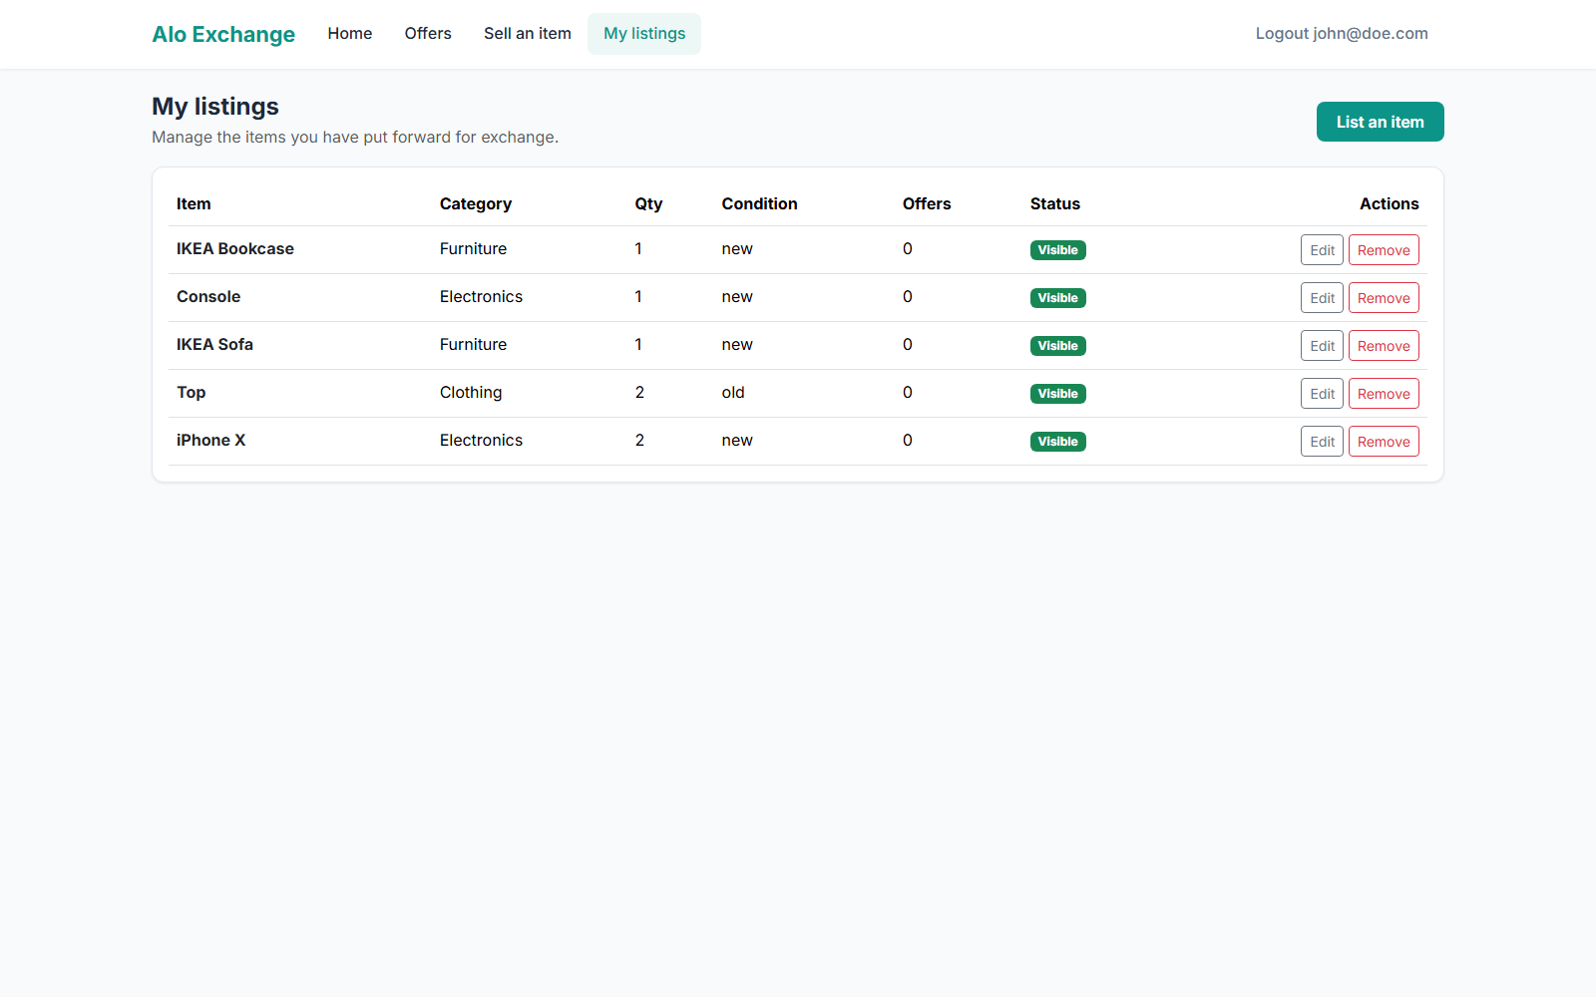
Figure 4.5: Personal listing management. Screenshot from the running system (2026).
Members can see their own listings, statuses and available edit, view and delete actions.

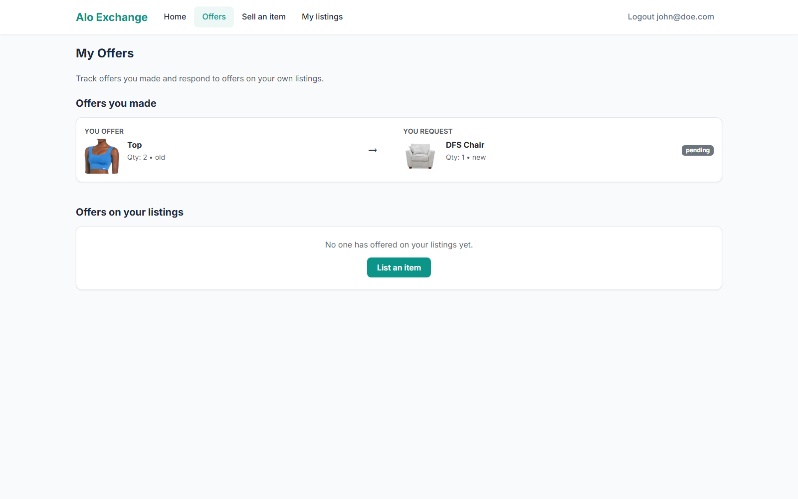
Figure 4.6: Offer review page. Screenshot from the running system (2026).
The offers page separates offers made by the member from offers received on their own listings.

4.6 Testing Results
The following table summarises the test evidence. The results are based on the repository test suites and browser checks performed during the implementation. Where an optional integration test requires an external database or service, that dependency is stated explicitly.
Table 4.3: Summary of test evidence
Area | Test approach | Evidence
Authentication | JUnit integration test | Valid login, rejection of invalid password and session protection.
Listing CRUD | JUnit DAO workflow test | Create, edit, view and remove owned listings.
Ownership | JUnit security test | A different user cannot modify another member's listing.
Offer lifecycle | JUnit workflow test | Offer creation, duplicate protection, owner decision and competing-offer rejection.
Password security | JUnit security test | BCrypt verification and legacy plaintext migration.
CSRF | JUnit security test | Missing or mismatched tokens are rejected.

Overall verification: Seven JUnit tests and browser smoke testing of the main pages.

4.6.1 Acceptance Test Cases
Acceptance cases connect the original requirements to observable evidence. The table below summarises the principal scenarios used to judge whether the workflow is complete.
Table 4.4: Acceptance test cases
ID | Scenario | Expected result | Evidence
AT-01 | A registered member signs in with a valid password. | A session is created and the member sees the home page. | Passed in JUnit login test
AT-02 | A member creates a listing with required fields. | The listing is persisted and appears in My Listings. | Passed in JUnit listing workflow test
AT-03 | A second member submits an offer. | An interest record is created with a pending state. | Passed in JUnit offer test
AT-04 | The listing owner accepts an offer. | Both listings close and competing offers are rejected. | Passed in JUnit transactional test
AT-05 | A different member attempts to modify a listing. | The request is rejected and ownership remains intact. | Passed in ownership test
AT-06 | A POST request omits the CSRF token. | The request is rejected with HTTP 403. | Passed in CSRF security test

4.7 Discussion of Results
The implementation shows that a relatively small Java web application can support a meaningful multi-user workflow when ownership, state and security are modelled explicitly. The strongest part of the design is the offer lifecycle: the system records the relationship between an offer, its target listing and the offered item, then applies owner-only decisions transactionally. The main limitations are the narrow recommendation model and the absence of asynchronous notifications.
The evidence supports the conclusion that the main workflows are implemented rather than merely described. The combination of API tests, browser screenshots and explicit acceptance scenarios also exposes the boundary of the work: features that depend on an external provider, real institutional data or a more advanced analytical model are identified as future work rather than presented as completed.

4.8 Summary
The implemented system demonstrates the design described in Chapter Three and provides a working interface for the main user journeys. The screenshots, acceptance scenarios and tests show that data can be created, read, updated and controlled through the application. Chapter Five reflects on the project as a whole and identifies the most useful next steps.

CHAPTER FIVE: SUMMARY, CONCLUSION AND RECOMMENDATIONS

5.1 Summary
This project set out to design and implement Alo Exchange as a working final-year computer science artefact. The report reviewed the problem domain, related systems and technologies, then described an incremental methodology, a layered architecture, a relational and spatial data model, role-aware security and a practical testing strategy. The resulting application was demonstrated through actual interface screenshots and test evidence.

5.2 Conclusion
Alo Exchange meets its aim of providing a secure, self-hosted barter workflow. It demonstrates registration and login, listing management, category discovery, recommendations and owner-controlled offer decisions. The project is a useful foundation for a community reuse service or for further work on trust, messaging and recommendation quality.

5.3 Evaluation Against Objectives
The table below maps the original objectives to the implementation and evidence presented in Chapter Four. The purpose is to make the evaluation traceable rather than relying on a general claim that the system is complete.
Table 5.1: Evaluation against objectives
ID | Objective | Evaluation
OBJ-01 | Provide account registration, login and logout with server-side session management. | Addressed - see Chapter Four implementation and test evidence
OBJ-02 | Allow authenticated members to create, edit, view and remove their own listings. | Addressed - see Chapter Four implementation and test evidence
OBJ-03 | Allow members to browse visible listings, filter by category and see recommended items. | Addressed - see Chapter Four implementation and test evidence
OBJ-04 | Implement an offer workflow that records the listing, offered item, requested item and quantities. | Addressed - see Chapter Four implementation and test evidence
OBJ-05 | Allow only the listing owner to accept or reject pending offers, with transactional closure of both listings. | Addressed - see Chapter Four implementation and test evidence
OBJ-06 | Apply password hashing, CSRF protection, ownership checks and input validation to the main workflows. | Addressed - see Chapter Four implementation and test evidence

5.4 Contributions
- A complete listing-to-offer workflow for a non-cash marketplace.
- A layered Java Servlet/JSP implementation with explicit DAO persistence.
- Practical security controls for passwords, sessions, CSRF and ownership.
- A reproducible demonstration with a seeded database and automated tests.

5.5 Limitations of the Implementation
- No payment, delivery, dispute resolution or rating workflow.
- Recommendations are demonstrative and not personalised from long-term behaviour.
- Email and push notifications are not implemented.
- The interface is designed for desktop and tablet use rather than a dedicated mobile application.

5.6 Recommendations
- Add email or in-app notifications for offer status changes.
- Introduce a richer recommendation model and explain recommendations to users.
- Add member ratings, item condition evidence and moderation tools.
- Provide deployment documentation for a managed PostgreSQL instance and HTTPS hosting.

5.7 Suggestions for Future Work
- Add image uploads with content validation and thumbnail generation.
- Implement saved searches, watchlists and offer messaging.
- Support multi-item offers and partial exchanges.
- Add an administrator dashboard for categories, reports and abuse handling.

5.8 Final Remarks
The project provides a coherent, tested foundation for Alo Exchange. Its value is not only in the number of screens, but in the way the problem was decomposed into requirements, data, security and evidence. The documented limitations should be treated as a research and deployment agenda rather than hidden defects. With the recommended validation and operational work, the prototype can support further study or a supervised pilot in its intended domain.

REFERENCES
Belk, R. (2014). You are what you can access: Sharing and collaborative consumption online. Journal of Business Research, 67(8), 1595-1600.
Fielding, R. T. (2000). Architectural styles and the design of network-based software architectures [Doctoral dissertation, University of California, Irvine].
Hall, M., Frank, E., Holmes, G., Pfahringer, B., Reutemann, P., & Witten, I. H. (2009). The WEKA data mining software: An update. ACM SIGKDD Explorations Newsletter, 11(1), 10-18.
Hevner, A. R., March, S. T., Park, J., & Ram, S. (2004). Design science in information systems research. MIS Quarterly, 28(1), 75-105.
OWASP Foundation. (2021). OWASP Top 10:2021. https://owasp.org/Top10/
Pressman, R. S., & Maxim, B. R. (2020). Software engineering: A practitioner's approach (9th ed.). McGraw-Hill.
Sommerville, I. (2016). Software engineering (10th ed.). Pearson.
Oracle. (n.d.). Jakarta Servlet specification. https://jakarta.ee/specifications/servlet/
PostgreSQL Global Development Group. (n.d.). PostgreSQL documentation. https://www.postgresql.org/docs/
Nielsen, J. (1994). Usability engineering. Morgan Kaufmann.

APPENDIX A: DEMONSTRATION GUIDE
The following steps provide a repeatable demonstration of the implemented system. The sequence uses the development configuration and the demonstration accounts described in the project README.
- Start PostgreSQL and load script.sql into the exchange database.
- Start the application with run.cmd or mvn jetty:run.
- Open http://localhost:9999/exchange/ and sign in as john@doe.com.
- Create a listing from Sell an item and inspect it in My listings.
- Use a second demo account to make an offer against that listing.
- Return to the first account, open Offers and accept or reject the pending offer.
During the demonstration, inspect the loading, empty, success and validation states rather than only the populated screen. The screenshots in Chapter Four can be used as a visual checklist.

APPENDIX B: PRIMARY ROUTES AND ENDPOINTS
The routes below identify the principal user-facing pages or API areas used in the demonstration. The repository README contains the fuller endpoint catalogue and deployment notes.
Table B.1: Primary routes and endpoints
Route or endpoint | Purpose
/exchange/login | Login form and session entry point
/exchange/home | Listing catalogue and recommendations
/exchange/listing/view?id=... | Listing details and offer entry point
/exchange/listing/create | Create a new listing
/exchange/listing/mine | Personal listings and status actions
/exchange/my-offers | Received and sent offers

Access to protected routes is subject to the role and ownership rules described in Chapter Three. A successful HTTP response does not by itself prove authorization; the negative tests and acceptance scenarios are the relevant evidence.

