GeoFarmland: An Enterprise GIS Platform for Integrated Farm and Agricultural Operations Management
A FINAL YEAR PROJECT REPORT
Submitted to the Department of Computer Science, [INSTITUTION NAME], in partial fulfilment of the requirements for the award of Bachelor of Science (B.Sc.) in Computer Science.

BY
[STUDENT FULL NAME]
[MATRICULATION NUMBER]

SUPERVISOR: [SUPERVISOR NAME]
October 2026

DECLARATION
I, [STUDENT FULL NAME], hereby declare that this final-year project report titled "GeoFarmland: An Enterprise GIS Platform for Integrated Farm and Agricultural Operations Management" is my original work. It has not been submitted for the award of any other degree or diploma in this or any other institution. All sources of information and material used have been acknowledged in the references and in the body of the report. Any assistance received during the project has been documented and acknowledged.

Signature: ______________________________
Name: [STUDENT FULL NAME]
Matriculation number: [MATRICULATION NUMBER]
Date: October 2026

CERTIFICATION
This is to certify that this project report was carried out by [STUDENT FULL NAME] with matriculation number [MATRICULATION NUMBER] under my supervision. The report has been read and approved as meeting the requirements of the Department of Computer Science, [INSTITUTION NAME].

Supervisor: [SUPERVISOR NAME]
Signature: ______________________________
Date: ______________________________

ABSTRACT
GeoFarmland is an organisation-scoped agricultural management platform that combines PostGIS land records with production, monitoring, operations and business workflows. The project addresses the fragmentation of farm information across maps, notebooks, spreadsheets and separate sensor tools. It was implemented with an ASP.NET Core 9/FastEndpoints backend, a Vue 3/TypeScript frontend, PostgreSQL/PostGIS and SignalR. The enterprise foundation includes organisations, memberships, roles, farms and land parcels with validated polygon geometry and automatic hectare calculation. Operational modules cover crops and harvests, livestock, aquaculture, greenhouses, soil and irrigation, IoT devices, weather, field tasks, inventory, finance, analytics and administration. A legacy field-map editor is retained for compatibility. The report presents the system background, literature, methodology, architecture, implementation screenshots and evaluation. Verification includes 21 backend integration tests and 11 frontend unit tests, together with browser smoke testing of the enterprise routes.
Keywords: software engineering, web application, database, spatial data, security, human-computer interaction, GeoFarmland

TABLE OF CONTENTS
CHAPTER ONE: INTRODUCTION 11
1.1 Background 11
1.2 Statement of the Problem 11
1.3 Aim and Objectives 12
1.3.1 Objectives 12
1.4 Research Questions 12
1.5 Scope of the Project 12
1.6 Significance of the Project 13
1.7 Limitations of the Project 13
1.8 Expected Contributions 13
1.9 Definition of Terms 13
1.10 Organisation of the Report 14
CHAPTER TWO: LITERATURE REVIEW 15
2.1 Introduction 15
2.2 Conceptual Review 15
2.2.1 Quality Attributes and User-Centred Design 15
2.3 Review of Related Systems 16
2.4 Technology Review 16
2.5 Research Gap 17
2.6 Summary 17
CHAPTER THREE: METHODOLOGY AND SYSTEM ANALYSIS 18
3.1 Introduction 18
3.2 Development Methodology 18
3.2.1 Requirements Elicitation 18
3.3 Requirements Analysis 19
3.3.1 Functional Requirements 19
3.3.2 Non-Functional Requirements 19
3.3.3 Constraints and Assumptions 19
3.4 System Architecture 19
3.4.1 Component Responsibilities 20
3.5 Database and Data Model 20
3.5.1 Data Integrity Rules 21
3.6 Use Case Analysis 22
3.7 Security Design 22
3.8 Ethical and Legal Considerations 23
3.9 Testing Strategy 23
3.10 Deployment and Operational Considerations 23
3.11 Summary 24
CHAPTER FOUR: SYSTEM IMPLEMENTATION AND RESULTS 25
4.1 Introduction 25
4.2 Development Environment 25
4.3 Implementation of Major Modules 25
4.3.1 Enterprise shell and dashboard 25
4.3.2 Farms and land parcels 25
4.3.3 Production modules 26
4.3.4 Monitoring and analytics 26
4.3.5 Operations and business modules 26
4.4 Implementation Challenges and Resolutions 26
4.5 System Interface Screenshots 28
4.6 Testing Results 37
4.6.1 Acceptance Test Cases 37
4.7 Discussion of Results 38
4.8 Summary 38
CHAPTER FIVE: SUMMARY, CONCLUSION AND RECOMMENDATIONS 39
5.1 Summary 39
5.2 Conclusion 39
5.3 Evaluation Against Objectives 39
5.4 Contributions 40
5.5 Limitations of the Implementation 40
5.6 Recommendations 40
5.7 Suggestions for Future Work 40
5.8 Final Remarks 40
REFERENCES 42
APPENDIX A: DEMONSTRATION GUIDE 43
APPENDIX B: PRIMARY ROUTES AND ENDPOINTS 44

LIST OF FIGURES
Figure 3.1: System architecture
Figure 3.2: Simplified entity-relationship model
Figure 3.3: Use case overview
Figure 4.1: GeoFarmland login page.
Figure 4.2: Enterprise operations dashboard.
Figure 4.3: GIS land parcel explorer.
Figure 4.4: Farms and land parcel register.
Figure 4.5: Crop and planting module.
Figure 4.6: Livestock and pasture module.
Figure 4.7: Analytics and forecasting module.
Figure 4.8: IoT device monitoring.
Figure 4.9: Platform administration.

LIST OF TABLES
Table 1.1: Definition of key terms
Table 2.1: Comparison of related systems
Table 2.2: Technologies used in the implementation
Table 3.1: Functional requirements
Table 3.2: Non-functional requirements
Table 3.3: Component responsibilities
Table 3.4: Principal data entities
Table 3.5: Summary of primary use cases
Table 4.1: Implementation environment
Table 4.2: Implementation challenges and resolutions
Table 4.3: Summary of test evidence
Table 4.4: Acceptance test cases
Table 5.1: Evaluation against objectives
Table B.1: Primary routes and endpoints

LIST OF ABBREVIATIONS
Abbreviation | Meaning
API | Application Programming Interface
EF Core | Entity Framework Core
GIS | Geographic Information System
GiST | Generalized Search Tree spatial index
JWT | JSON Web Token
PostGIS | Spatial extension for PostgreSQL
RBAC | Role-Based Access Control
SRID | Spatial Reference Identifier
SPA | Single-Page Application

CHAPTER ONE: INTRODUCTION

1.1 Background
Agricultural decision-making depends on relationships between land, production, equipment, people and environmental conditions. A farm manager may know a parcel boundary, the crop planted on it, the livestock grazing nearby, the sensor monitoring soil moisture and the worker assigned to an inspection, but these facts are often stored in different systems. This separation makes it difficult to answer operational questions quickly and to preserve a reliable history of what happened on each piece of land.
Geographic information systems provide a natural organising structure for farm records because most agricultural activities occur at a location. PostGIS extends PostgreSQL with spatial types, indexes and queries, making it possible to store parcel polygons and reason about area, overlap and land use. A spatial register becomes much more useful when it is connected to crop cycles, livestock groups, IoT readings and field tasks rather than used only as a drawing surface.
GeoFarmland applies that idea to a simulated enterprise setting. It preserves a simple field-map workflow while adding organisation-level access control and modules for the records a mixed farm needs. The project therefore demonstrates both geospatial engineering and the design of a modular operational information system.

1.2 Statement of the Problem
Small and medium farms often adopt separate tools for mapping, production records, weather, sensors and finance. The resulting records are incomplete, difficult to compare and tied to individual users rather than an organisation. Without a shared spatial identifier, reports may not agree about which field is being described. Manual spreadsheets also make it hard to enforce consistent validation or role-based access.
The project addresses the need for a single platform in which land parcels are the anchor for production, monitoring and operational records, and in which access is limited to the right organisation and role. The system must remain usable when external services such as weather or remote sensing are unavailable, and it must not fabricate missing observations.

1.3 Aim and Objectives
To design and implement an organisation-scoped geospatial farm-management platform that integrates land parcels, production records, monitoring, field operations and business information in one usable enterprise system.

1.3.1 Objectives
- Model organisations, memberships, roles, farms and land parcels with spatial data.
- Migrate existing owner-scoped plots into the enterprise land parcel register.
- Provide a dashboard, GIS explorer, farm/parcel register and role-aware navigation.
- Implement crop, livestock, aquaculture, greenhouse, soil and irrigation records.
- Integrate IoT telemetry, weather, analytics and field tasks into the operational view.
- Provide inventory, finance, reporting and administration surfaces with tested APIs.

1.4 Research Questions
The objectives are translated into the following research questions. Each question is revisited in Chapters Three and Four, where the design and implementation evidence are discussed.
- How can PostGIS parcel geometry act as the shared spatial key for production, monitoring and operational records?
- How can organisation membership and role policies prevent cross-tenant disclosure in a farm-management platform?
- Which agricultural modules can be integrated without compromising the maintainability of a modular monolith?
- How can the system preserve existing plot data while introducing an enterprise land-parcel register?

1.5 Scope of the Project
The project covers the following functional and technical scope:
- Organisation, membership and role-based access control.
- PostGIS farm and land parcel management with geometry validation and overlap detection.
- Crop, livestock, aquaculture, greenhouse, soil and irrigation production records.
- Weather, IoT device, telemetry and field operations views.
- Inventory, finance, analytics and platform administration.

1.6 Significance of the Project
- Demonstrates how spatial data can serve as the organising layer for operational farm records.
- Shows a practical modular monolith design for an agricultural information system.
- Provides evidence of secure organisation scoping and role-aware APIs.
- Creates a foundation for further work in precision agriculture and remote sensing.

1.7 Limitations of the Project
The limitations below define the boundary of the academic deliverable. They are not hidden implementation gaps: they explain which capabilities are outside the approved project scope and why.
- Remote sensing currently provides an integration-readiness view rather than live satellite processing.
- Aquaculture keeps current pond stock rather than a full stocking and health-event history.
- Finance is a ledger-level overview rather than a statutory accounting package.
- External weather and imagery providers require configuration and network access.

1.8 Expected Contributions
- An organisation-scoped spatial farm and land-parcel register.
- A tested enterprise shell and operational dashboard across multiple farm modules.
- A migration path that preserves legacy plots while exposing a richer land-parcel model.
- A practical reference for combining FastEndpoints, EF Core, PostGIS and Vue 3.

1.9 Definition of Terms
Table 1.1: Definition of key terms
Term | Definition
Organisation | A tenant that owns farms, parcels and members.
Land parcel | A spatially defined unit of land with use, tenure and status attributes.
PostGIS | A spatial extension for PostgreSQL that stores and queries geometry.
RBAC | Role-based access control, where permissions depend on assigned roles.
Telemetry | Readings sent from field devices such as soil-moisture sensors.
Crop season | A production cycle that links a crop to a parcel and harvest window.

1.10 Organisation of the Report
Chapter One explains the agricultural information problem and the project objectives. Chapter Two reviews farm-management systems, geospatial concepts and the selected technologies. Chapter Three describes the methodology, requirements, spatial architecture, data model and test plan. Chapter Four presents the implemented enterprise modules with screenshots and test evidence. Chapter Five summarises the outcomes and recommends further work.

CHAPTER TWO: LITERATURE REVIEW

2.1 Introduction
This chapter reviews the concepts, related systems and technologies relevant to the project. The review is organised around the problem domain, the capabilities of existing products and the technical choices used in the implementation. It ends by identifying the gap that the project addresses. The review draws on established software-engineering and domain literature as well as the official documentation of the frameworks used in the system.

2.2 Conceptual Review
GeoFarmland is a multi-user information system rather than a single-user desktop tool. Its design therefore has to account for user identity, persistent records, validation, feedback and operational workflows. Software-engineering research emphasises that these concerns should be handled through explicit requirements, modular design and iterative evaluation (Sommerville, 2016; Pressman & Maxim, 2020). The design-science perspective adds that the resulting artefact should be evaluated against the problem it was created to solve rather than judged only by the number of implemented features (Hevner et al., 2004).
The project also reflects the broader shift from isolated records to connected digital services. Users expect immediate validation, clear status information and predictable navigation. At the same time, sensitive systems need security boundaries that are enforced on the server rather than only hidden in the interface. These principles informed the choice of layered architectures, role-aware endpoints and explicit error states.
For the GeoFarmland domain, the important conceptual concerns are data ownership, consistency of state transitions and the relationship between a user action and a persistent record. The implementation therefore treats workflow state, authorization and source provenance as first-class parts of the design.

2.2.1 Quality Attributes and User-Centred Design
A functioning demonstration also has to satisfy quality attributes that are not visible in a feature list. Security, usability, maintainability and graceful failure are particularly important for a multi-user system. Usability heuristics emphasise visibility of system status, clear error messages, prevention of invalid input and consistent navigation (Nielsen, 1994). These ideas are reflected in loading indicators, validation messages, explicit empty states and role-specific navigation in the implemented interface.
Maintainability is addressed through feature-oriented source organisation, shared validation and a consistent data-access layer. Security is treated as a server-side concern: the interface may hide an action, but the endpoint must still verify identity and permission. This separation between presentation and enforcement is a recurring theme in secure web-application guidance (OWASP Foundation, 2021).

2.3 Review of Related Systems
Table 2.1: Comparison of related systems
System | Strengths | Limitations and relationship to this project
FarmOS | Open-source farm planning and record keeping. | Strong record model; less emphasis on an integrated enterprise dashboard and PostGIS parcel analytics.
Climate FieldView | Commercial field monitoring and agronomic insights. | Powerful sensing and analytics, but proprietary and not self-hosted.
Trimble Ag Software | Farm management and precision agriculture tools. | Broad commercial capability; heavier and less transparent for an academic build.
Generic GIS dashboards | Flexible spatial visualisation. | Usually lack agricultural production and operational workflows.

The comparison shows that existing products are generally stronger in scale, commercial integrations or specialised domain features. The opportunity for this project is not to reproduce a commercial platform, but to build a transparent, locally runnable system that demonstrates the core workflow with maintainable code, explicit limitations and test evidence.

2.4 Technology Review
Table 2.2: Technologies used in the implementation
Technology | Role in the system | Reason for selection
ASP.NET Core 9 and FastEndpoints | Backend API and request validation | Provides a typed, modular endpoint model with JWT support.
Vue 3 and TypeScript | Interactive enterprise UI | Supports reusable components and a responsive map-driven interface.
PostgreSQL and PostGIS | Spatial and relational persistence | Supports geometry validation, area measurement and parcel queries.
Entity Framework Core and NetTopologySuite | Data access and geometry mapping | Integrates spatial objects with the application model.
SignalR | Realtime device updates | Demonstrates authenticated server-push telemetry.
Leaflet | Interactive maps | Provides map tiles, polygons and selection behaviour in the GIS explorer.

The technology stack was selected for reliability, documentation and suitability for a final-year project. The architecture separates transport, application logic, persistence and presentation concerns. Official documentation was used to confirm configuration and security behaviour rather than relying on assumptions about framework defaults.
The technology review also considered operational constraints. The project should be reproducible on a student workstation, avoid unnecessary infrastructure, preserve data through migrations and make optional external dependencies fail gracefully. These constraints influenced the choice of a modular monolith and the decision to keep provider-specific integrations behind service boundaries.

2.5 Research Gap
Existing products either concentrate on agronomic advice, commercial farm accounting or generic GIS. The reviewed gaps are an integrated, self-hosted and explainable system that treats land parcels as the anchor for production, monitoring and operations while keeping data organisation-scoped. GeoFarmland addresses that combination at a scale suitable for a final-year engineering project.

2.6 Summary
The review establishes that GeoFarmland addresses a genuine workflow rather than a purely visual mock-up. The next chapter translates the reviewed requirements into a development methodology, system architecture, data model and testing plan.

CHAPTER THREE: METHODOLOGY AND SYSTEM ANALYSIS

3.1 Introduction
This chapter explains how the system was analysed, designed and tested. It presents the development approach, functional and non-functional requirements, architecture, data model, use cases, security design and verification strategy. The design aims to keep the implementation understandable while still meeting the needs of a multi-user application.

3.2 Development Methodology
The work followed an incremental, design-science approach. Requirements were translated into vertical slices containing a domain model, database migration, API endpoints, a Vue page and tests. Each slice was built on the previous one, beginning with organisations and land parcels and then adding production, monitoring and business modules. The approach follows the build-and-evaluate cycle described by Hevner et al. (2004) and the iterative delivery guidance in Sommerville (2016).
The work used a requirements-driven, incremental approach. The problem domain and stakeholder actions were decomposed into vertical slices, and each slice was checked through code review, automated tests or browser inspection. The design-science cycle of problem identification, artefact construction and evaluation was used to keep the project focused on a usable result (Hevner et al., 2004).

3.2.1 Requirements Elicitation
Requirements were elicited from the problem statement, the implemented prototype, domain documentation and the practical workflows observed in each application area. The analysis did not assume that a feature should be built simply because it appeared in a related commercial product; each requirement was checked against the project aim and the available data.
- Review of farm-management information systems and precision agriculture literature.
- Analysis of the original plot-mapping prototype and its owner-scoped API.
- Enterprise requirements for organisations, roles, farms, parcels and operational records.
- PostGIS and ASP.NET Core documentation for spatial and security constraints.

3.3 Requirements Analysis

3.3.1 Functional Requirements
Table 3.1: Functional requirements
ID | Requirement | Priority
FR-01 | Manage organisations, memberships and organisation roles. | High
FR-02 | Create, edit and delete farms within an organisation. | High
FR-03 | Register land parcels with validated polygon geometry and land-use attributes. | High
FR-04 | Prevent overlapping parcels within the same farm and calculate hectares. | High
FR-05 | Record crop seasons, harvests, livestock groups, ponds and greenhouse units. | High
FR-06 | Record soil samples, irrigation events, devices and telemetry readings. | High
FR-07 | Provide a dashboard, GIS explorer, farm register and module navigation. | High
FR-08 | Provide analytics, field tasks, inventory, finance and administration views. | Medium

3.3.2 Non-Functional Requirements
Table 3.2: Non-functional requirements
Area | Requirement
Security | All enterprise data must be scoped by organisation and role; passwords must be hashed.
Spatial integrity | Parcels must use SRID 4326, pass geometry checks and reject invalid overlaps.
Usability | Navigation and data-entry forms must remain usable on desktop and smaller screens.
Reliability | Migrations must preserve existing records and the system must handle provider outages gracefully.
Maintainability | Modules should remain separated by feature, with tests around key API workflows.

3.3.3 Constraints and Assumptions
The design assumes a local or small-team deployment, a supported web browser and access to the configured database. Optional external services are treated as enhancements rather than preconditions for the core workflow. The project does not assume access to an official utility asset register, commercial imagery or a production identity provider unless those services are explicitly configured.

3.4 System Architecture
The system is a modular monolith. The Vue SPA communicates with FastEndpoints over HTTP and SignalR. Endpoints resolve the active organisation and enforce role permissions before calling EF Core. PostgreSQL/PostGIS stores both relational and spatial records. External weather, imagery and IoT services are isolated behind service boundaries so that failure does not corrupt local records.
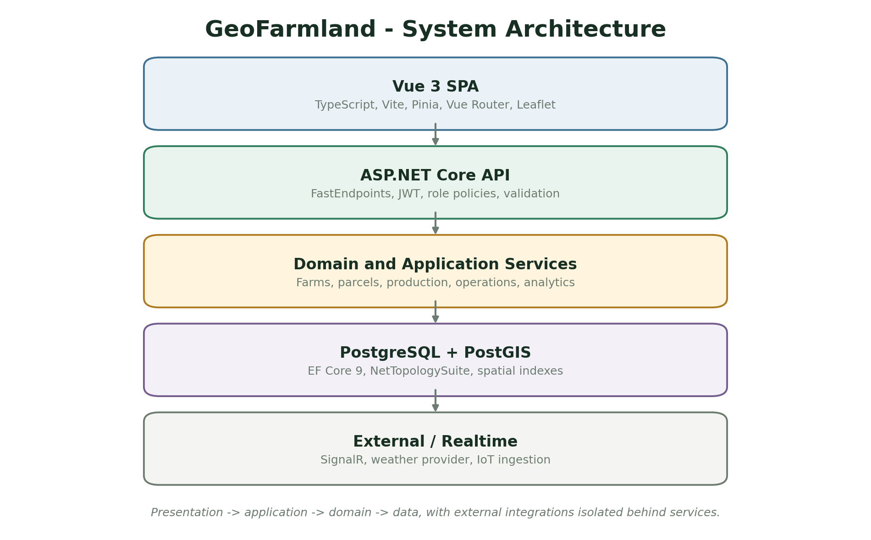
Figure 3.1: System architecture of GeoFarmland. Source: Author design (2026).

3.4.1 Component Responsibilities
Table 3.3: Component responsibilities
Component | Responsibility | Implementation evidence
Vue SPA | Provides authentication, dashboard, GIS explorer and module workspaces. | Vue views and Pinia stores
FastEndpoints API | Handles authentication, validation, organisation resolution and role policies. | Feature endpoint classes
Domain services | Enforce parcel, production, telemetry and finance rules. | EF Core queries and validation helpers
PostgreSQL/PostGIS | Stores relational and spatial records with SRID checks and GiST indexes. | LandParcels and related tables
SignalR and external services | Deliver realtime telemetry and optional weather data. | SignalHub and weather service

3.5 Database and Data Model
The data model is designed around the entities that carry the core business rules. Identifiers connect records, while status fields and timestamps preserve operational state. The simplified entity-relationship model below illustrates the principal relationships; the implementation contains additional attributes, indexes and join records.
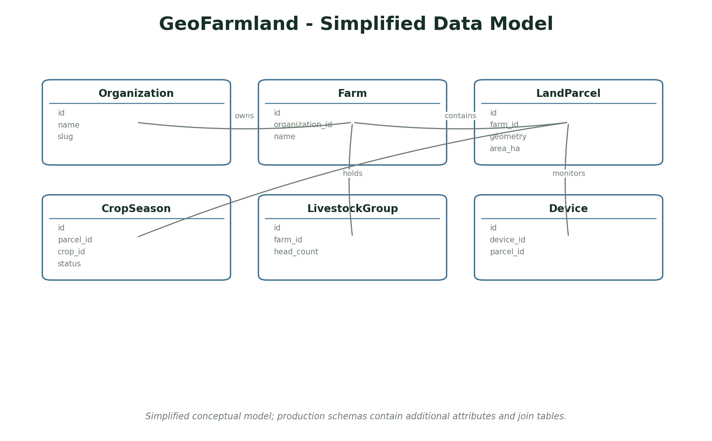
Figure 3.2: Simplified entity-relationship model for GeoFarmland. Source: Author design (2026).
Table 3.4: Principal data entities
Entity | Key attributes and purpose
Organisation | id, name, slug, country, currency
Farm | id, organisation id, name, code, region
LandParcel | id, farm id, name, geometry, land use, hectares
CropSeason | id, parcel id, crop id, planting date, expected yield
LivestockGroup | id, farm id, species, head count, grazing parcel
Device | id, owner, device id, parcel link, telemetry

3.5.1 Data Integrity Rules
The database is not treated as a passive storage container. Constraints, validation and transactional updates protect the relationships that the application relies on. The following rules are enforced in the domain or database layer rather than only in the browser form.
- A land parcel must belong to a farm in the same organisation.
- Parcel geometry must use SRID 4326, be valid and have a positive area.
- New parcels cannot overlap an existing parcel on the same farm.
- A crop season must reference a crop and parcel in the same organisation.
- Role checks must be applied before any write, regardless of how the UI is rendered.

3.6 Use Case Analysis
Use cases describe the observable actions available to each actor. They also provide a basis for the authorization matrix and the test cases. The overview below is deliberately simplified to emphasise the main workflow rather than every administrative action.
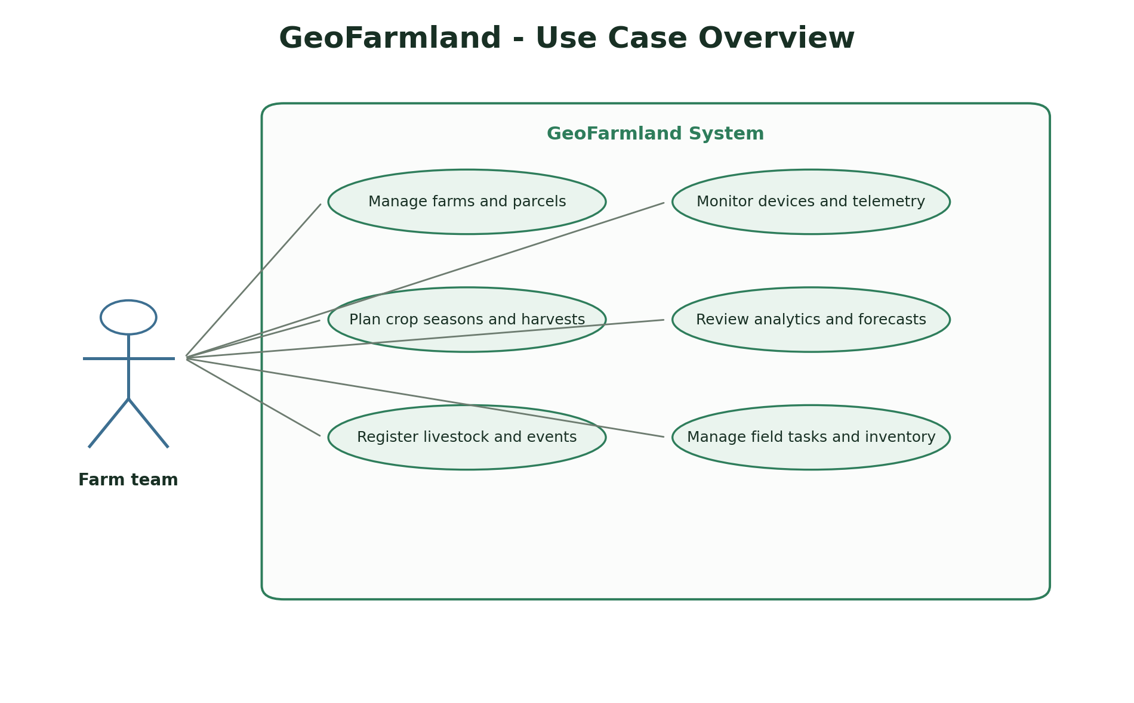
Figure 3.3: Use case overview for GeoFarmland. Source: Author design (2026).
Table 3.5: Summary of primary use cases
Actor | Use case | Outcome
Farm manager | Manage farms and parcels | Create the spatial land register and maintain land use.
Agronomist | Plan crop seasons and harvests | Record production cycles and expected or actual output.
Field officer | Record field data | Submit livestock, soil, irrigation and device records.
Organisation administrator | Review analytics and access | Monitor estate performance and manage users.

3.7 Security Design
Security is implemented at the server boundary. The design assumes that the browser cannot be trusted to enforce ownership, roles or workflow transitions. Every protected operation therefore checks the authenticated identity and the relevant domain relationship before changing data.
- JWT bearer tokens protect API endpoints and support refresh-token rotation.
- Organisation membership determines which farms, parcels and records a user can see.
- Organisation roles determine whether a user can read, manage or administer enterprise data.
- Polygon validation rejects invalid or self-intersecting geometries before persistence.
- External API keys are configuration values, not hard-coded source secrets.

3.8 Ethical and Legal Considerations
A computer science project must consider the effect of the system beyond its functional requirements. The project avoids real personal, financial or health data and documents where demonstration data is synthetic. The following considerations guided the scope and interface.
- Farm and parcel locations can be commercially sensitive, so access is restricted by organisation and role.
- No real farmer, worker or customer personal data is required for the demonstration.
- Synthetic records are visibly separated from user-created records.
- External imagery and weather services are optional and do not replace local evidence.

3.9 Testing Strategy
Testing uses several complementary levels. Unit tests check isolated rules, integration tests exercise APIs and persistence, and browser checks confirm that the main user journeys render and behave correctly. The tests are designed to verify negative cases such as invalid input, unauthorised access and inconsistent state, not only the happy path.
The test strategy follows the project requirements rather than the implementation structure. Each core workflow should have at least one positive verification and one rejected or restricted case. Test evidence is reported in Chapter Four, together with limitations of the current suite.

3.10 Deployment and Operational Considerations
The deployment model is intentionally simple so that the project can be reproduced and examined. Configuration is separated from source code where practical, migrations are applied through the framework and a local launcher is supplied for demonstration. A production deployment would require stronger secret management, monitoring, backups and an operational support process.
- The API and built Vue client can run from one ASP.NET Core process on port 58036.
- PostgreSQL must have the PostGIS extension and the schema is applied through EF migrations.
- The development launcher runs the API and Vite frontend separately for faster UI iteration.

3.11 Summary
This chapter established the development approach, requirements, architecture, data model, security controls, ethical boundary and test strategy. Chapter Four describes how these designs were implemented and presents the resulting interface screens and test evidence.

CHAPTER FOUR: SYSTEM IMPLEMENTATION AND RESULTS

4.1 Introduction
This chapter presents the implemented system and the evidence used to evaluate it. It starts with the development environment, then describes the main modules, presents interface screenshots and reports the testing results. The screenshots were captured from the running application and therefore show the actual interface rather than a conceptual mock-up.

4.2 Development Environment
Table 4.1: Implementation environment
Item | Implementation
Operating system | Windows development workstation
Application type | ASP.NET Core and Vue enterprise web application
Backend stack | ASP.NET Core 9, FastEndpoints, EF Core 9, JWT
Frontend / interface | Vue 3, TypeScript, Vite, Pinia, Leaflet
Database | PostgreSQL + PostGIS
Testing tools | 21 backend integration tests and 11 frontend unit tests passed, with browser smoke testing across the enterprise routes.
Browser verification | Headless Chromium screenshots and manual browser smoke checks

4.3 Implementation of Major Modules

4.3.1 Enterprise shell and dashboard
A responsive navigation shell and live operational overview across farms, parcels and telemetry.
The module was implemented as a vertical slice containing the necessary persistence, server-side validation and interface feedback. Loading, empty and error states were handled so that the interface remains understandable when data is absent or an external operation fails.

4.3.2 Farms and land parcels
Farm registration, parcel drawing and validation, land use, tenure and hectare calculations.
The module was implemented as a vertical slice containing the necessary persistence, server-side validation and interface feedback. Loading, empty and error states were handled so that the interface remains understandable when data is absent or an external operation fails.

4.3.3 Production modules
Crop seasons and harvests, livestock groups and events, aquaculture ponds, greenhouse units and soil records.
The module was implemented as a vertical slice containing the necessary persistence, server-side validation and interface feedback. Loading, empty and error states were handled so that the interface remains understandable when data is absent or an external operation fails.

4.3.4 Monitoring and analytics
IoT fleet view, weather observations, harvest trends, yield attainment and forecasts.
The module was implemented as a vertical slice containing the necessary persistence, server-side validation and interface feedback. Loading, empty and error states were handled so that the interface remains understandable when data is absent or an external operation fails.

4.3.5 Operations and business modules
Field task board, inventory register, finance ledger and administration.
The module was implemented as a vertical slice containing the necessary persistence, server-side validation and interface feedback. Loading, empty and error states were handled so that the interface remains understandable when data is absent or an external operation fails.

4.4 Implementation Challenges and Resolutions
Implementation did not follow a straight path from design to finished feature. The following issues were encountered while building and testing the system, together with the action taken and the lesson carried into the final implementation.
Table 4.2: Implementation challenges and resolutions
Challenge | Resolution | Lesson
Preserving legacy plot data | The original system stored owner-scoped polygons that could not be discarded. | Existing plots are backfilled into land parcels at startup while the legacy endpoints remain available.
Validating spatial overlap | Simple coordinate validation does not prevent overlapping parcels. | The system uses PostGIS/NTS geometry operations to reject overlap on the same farm.
Supporting several production modules | Each module could have grown into a separate service and increased operational complexity. | A feature-sliced modular monolith keeps modules isolated in code while deploying as one application.
Handling optional providers | Weather and remote-sensing providers may be unavailable. | The UI reports an explicit unavailable state and never substitutes fabricated readings.

4.5 System Interface Screenshots
The following screenshots show the principal user interface of the implemented system. Each figure is followed by an explanation of the workflow it demonstrates. The images retain the application layout but crop out the host browser chrome for clarity.
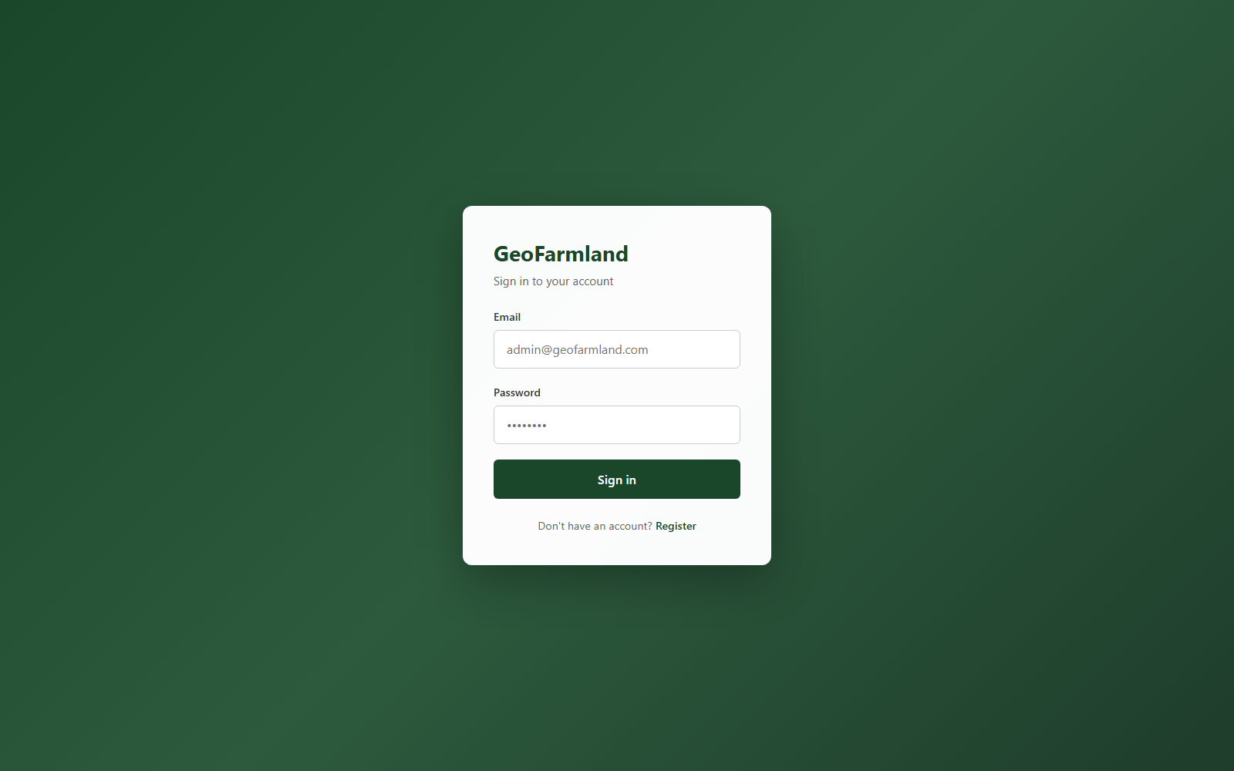
Figure 4.1: GeoFarmland login page. Screenshot from the running system (2026).
The authentication screen introduces the platform and provides a tested login path for administrators and field users.

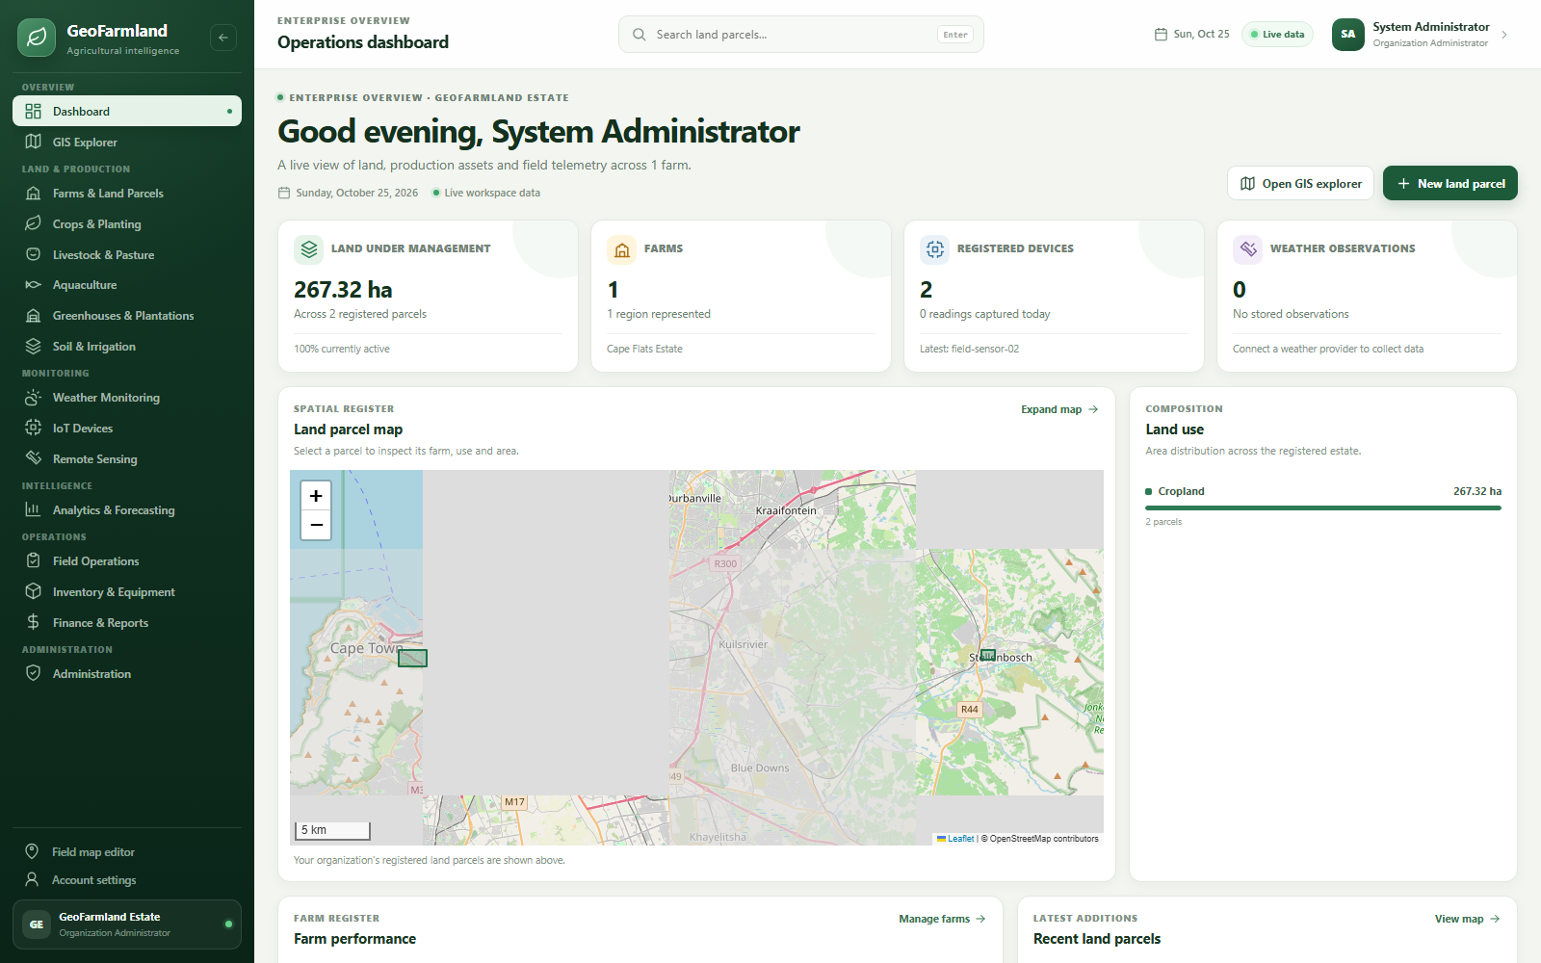
Figure 4.2: Enterprise operations dashboard. Screenshot from the running system (2026).
The dashboard combines total land, parcels, farms, devices, weather and recent production information.

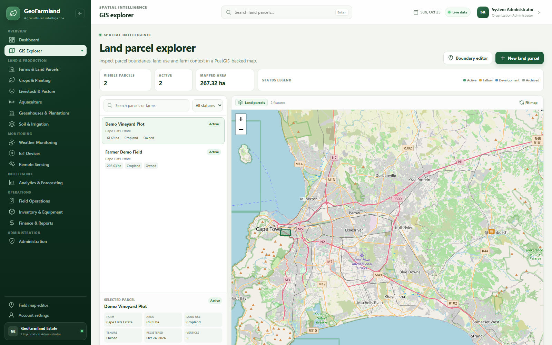
Figure 4.3: GIS land parcel explorer. Screenshot from the running system (2026).
The map renders PostGIS parcels, supports selection and presents parcel details beside the map.

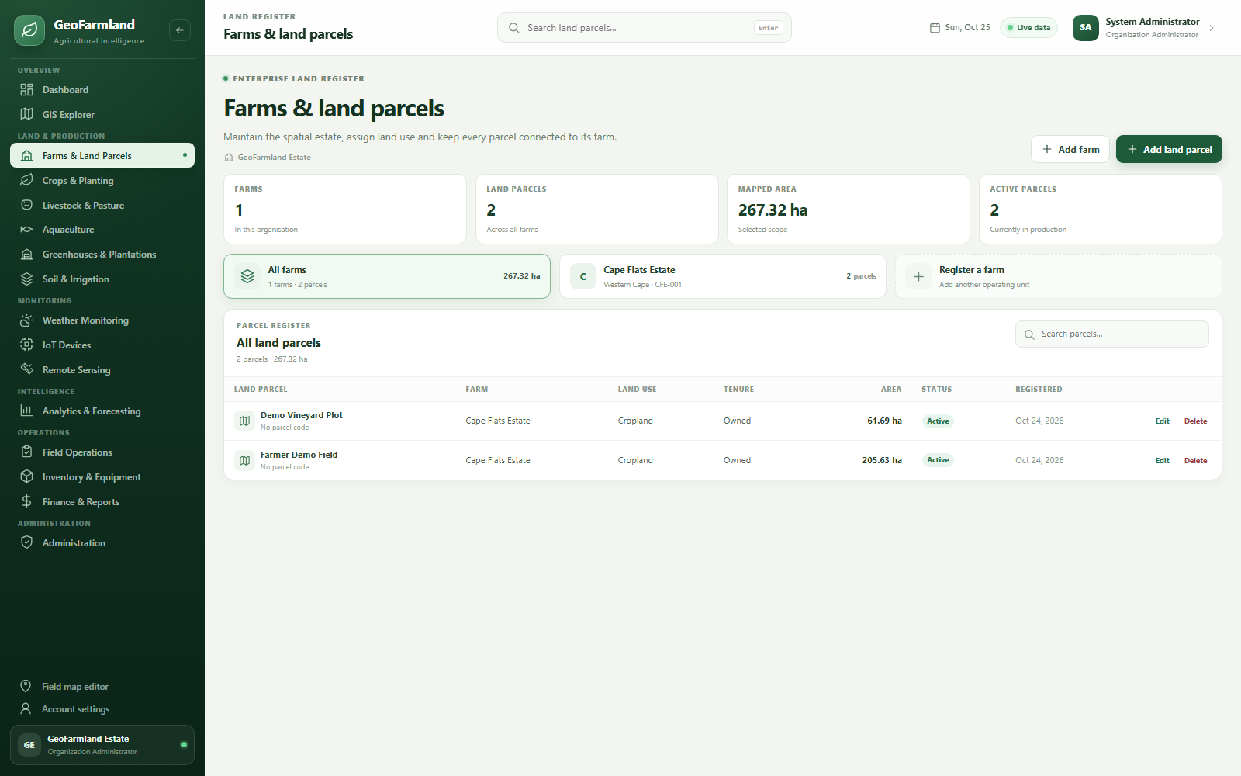
Figure 4.4: Farms and land parcel register. Screenshot from the running system (2026).
The register groups farms and parcels, allowing users to inspect land use, tenure, area and actions.

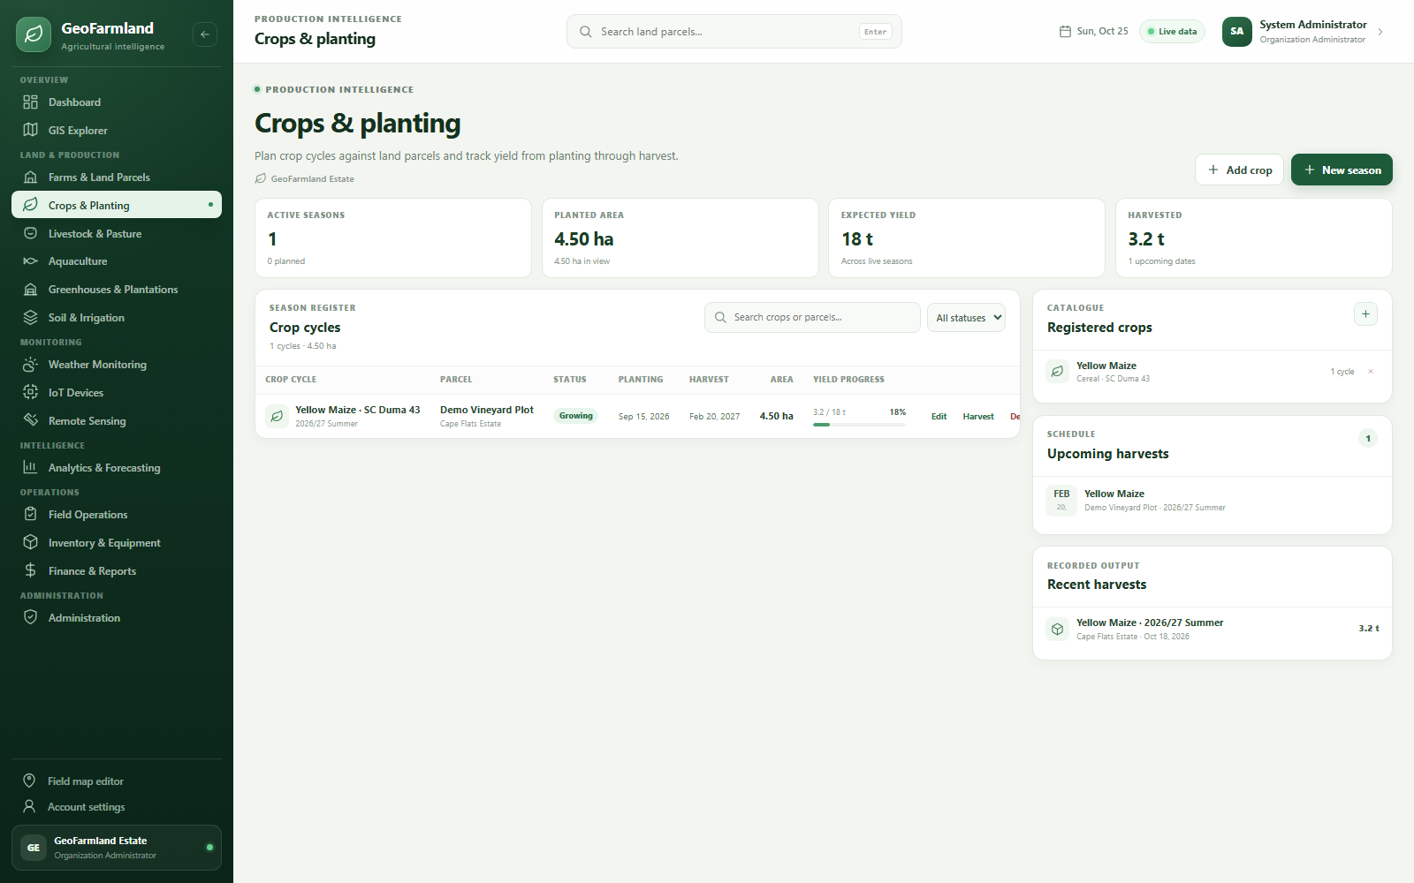
Figure 4.5: Crop and planting module. Screenshot from the running system (2026).
Crop cycles show planting dates, season status, farm/parcel context and yield progress.

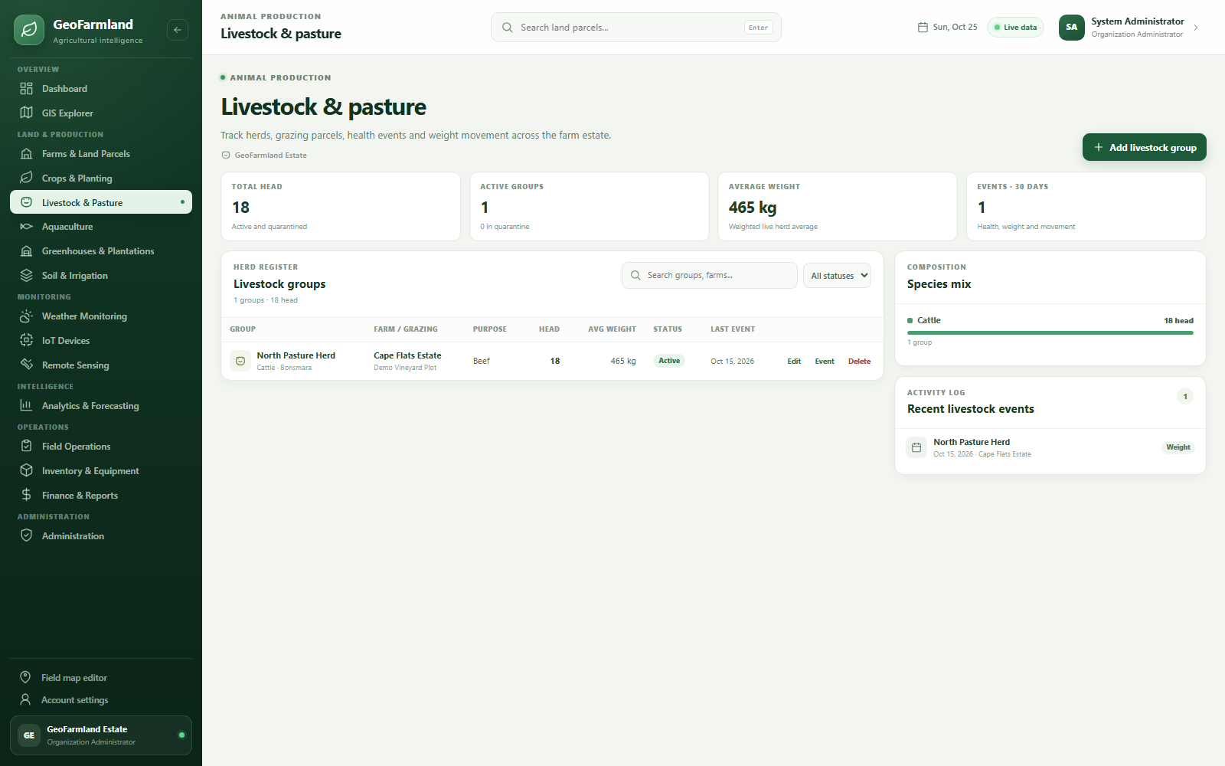
Figure 4.6: Livestock and pasture module. Screenshot from the running system (2026).
Livestock groups show species, purpose, head count, grazing parcel and recent events.

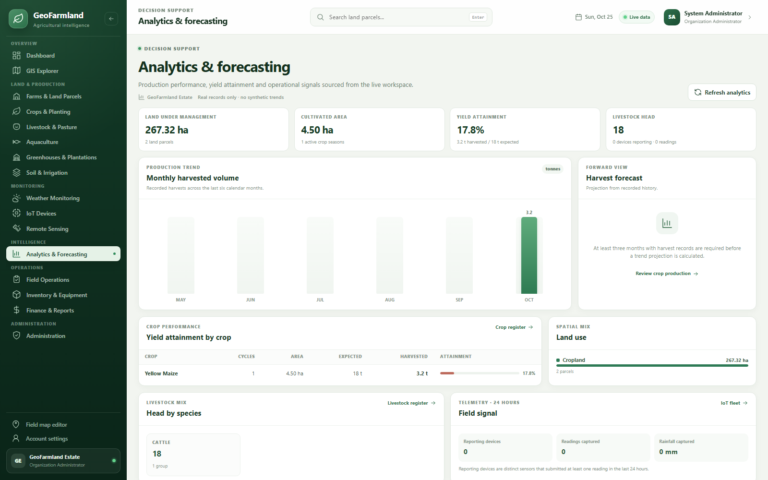
Figure 4.7: Analytics and forecasting module. Screenshot from the running system (2026).
The analytics page presents harvest performance, land use, livestock mix and telemetry-derived signals.

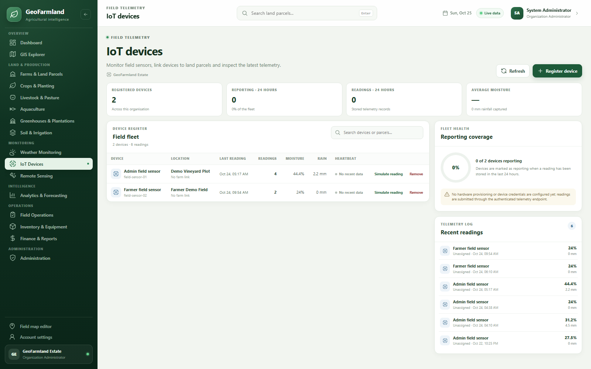
Figure 4.8: IoT device monitoring. Screenshot from the running system (2026).
The fleet view shows parcel-linked devices, heartbeat state, latest moisture and rainfall readings.

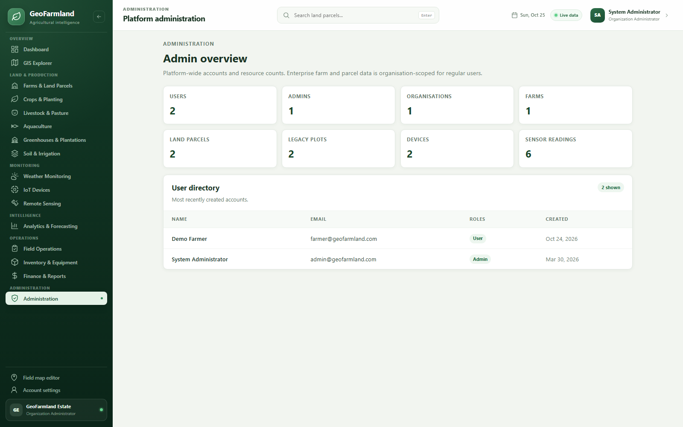
Figure 4.9: Platform administration. Screenshot from the running system (2026).
The administrator view summarises accounts and enterprise resource counts for platform oversight.

4.6 Testing Results
The following table summarises the test evidence. The results are based on the repository test suites and browser checks performed during the implementation. Where an optional integration test requires an external database or service, that dependency is stated explicitly.
Table 4.3: Summary of test evidence
Area | Test approach | Evidence
Authentication and ownership | NUnit integration test | Login, refresh-token rotation, owner scope and role restrictions.
Spatial parcels | NUnit integration test | Polygon validation, SRID preservation, hectares and overlap rejection.
Production records | NUnit integration test | Crop seasons, harvest totals and livestock head/weight updates.
Device telemetry | NUnit integration test | Parcel-linked devices, IoT overview and reporting state.
Operations and finance | NUnit integration test | Task overdue/completion, soil metrics, inventory and finance calculations.
Frontend utilities | Vitest | Formatting, area calculations, status mappings and Account/Admin components.

Overall verification: 21 backend integration tests and 11 frontend unit tests passed, with browser smoke testing across the enterprise routes.

4.6.1 Acceptance Test Cases
Acceptance cases connect the original requirements to observable evidence. The table below summarises the principal scenarios used to judge whether the workflow is complete.
Table 4.4: Acceptance test cases
ID | Scenario | Expected result | Evidence
AT-01 | An organisation administrator views the dashboard. | Only records from the active organisation are summarised. | Passed in enterprise API test
AT-02 | A parcel is drawn with an invalid self-intersection. | The API rejects the geometry with a validation error. | Passed in plot/parcel test
AT-03 | A crop season is created and harvested. | Harvest totals update the season and analytics. | Passed in crop workflow test
AT-04 | A livestock mortality event is recorded. | Head count decreases and the event history is stored. | Passed in livestock workflow test
AT-05 | A device is linked to a parcel and submits a reading. | IoT overview shows the parcel and reporting state. | Passed in IoT test
AT-06 | A non-manager attempts to add a farm. | The API returns a forbidden response. | Passed in role test

4.7 Discussion of Results
The major contribution of GeoFarmland is the integration of a spatial land register with the surrounding operational records. The parcel becomes the stable identifier that links production, monitoring and analytics, while organisation membership provides the access boundary. The module structure demonstrates that a relatively small team can build a coherent monolith without splitting into microservices. The main limitation is the depth of each specialist module: remote sensing and accounting are intentionally shallow compared with dedicated commercial products.
The evidence supports the conclusion that the main workflows are implemented rather than merely described. The combination of API tests, browser screenshots and explicit acceptance scenarios also exposes the boundary of the work: features that depend on an external provider, real institutional data or a more advanced analytical model are identified as future work rather than presented as completed.

4.8 Summary
The implemented system demonstrates the design described in Chapter Three and provides a working interface for the main user journeys. The screenshots, acceptance scenarios and tests show that data can be created, read, updated and controlled through the application. Chapter Five reflects on the project as a whole and identifies the most useful next steps.

CHAPTER FIVE: SUMMARY, CONCLUSION AND RECOMMENDATIONS

5.1 Summary
This project set out to design and implement GeoFarmland as a working final-year computer science artefact. The report reviewed the problem domain, related systems and technologies, then described an incremental methodology, a layered architecture, a relational and spatial data model, role-aware security and a practical testing strategy. The resulting application was demonstrated through actual interface screenshots and test evidence.

5.2 Conclusion
GeoFarmland achieves its aim of providing an enterprise-style agricultural management platform with PostGIS land records, role-aware access and integrated operational modules. It preserves the original field-mapping capability while adding a usable dashboard and tested APIs. The project is a credible foundation for further work in precision agriculture, imagery analysis and production planning.

5.3 Evaluation Against Objectives
The table below maps the original objectives to the implementation and evidence presented in Chapter Four. The purpose is to make the evaluation traceable rather than relying on a general claim that the system is complete.
Table 5.1: Evaluation against objectives
ID | Objective | Evaluation
OBJ-01 | Model organisations, memberships, roles, farms and land parcels with spatial data. | Addressed - see Chapter Four implementation and test evidence
OBJ-02 | Migrate existing owner-scoped plots into the enterprise land parcel register. | Addressed - see Chapter Four implementation and test evidence
OBJ-03 | Provide a dashboard, GIS explorer, farm/parcel register and role-aware navigation. | Addressed - see Chapter Four implementation and test evidence
OBJ-04 | Implement crop, livestock, aquaculture, greenhouse, soil and irrigation records. | Addressed - see Chapter Four implementation and test evidence
OBJ-05 | Integrate IoT telemetry, weather, analytics and field tasks into the operational view. | Addressed - see Chapter Four implementation and test evidence
OBJ-06 | Provide inventory, finance, reporting and administration surfaces with tested APIs. | Addressed - see Chapter Four implementation and test evidence

5.4 Contributions
- An organisation-scoped spatial farm and parcel model.
- A modular enterprise shell and operational dashboard.
- Production, monitoring, operations and finance modules with working APIs.
- A tested migration path from legacy plots to land parcels.

5.5 Limitations of the Implementation
- Remote sensing does not yet process live imagery or vegetation indices.
- Forecasting uses simple historical baselines rather than machine-learning models.
- The finance ledger does not apply tax, bank reconciliation or accounting periods.
- Weather and imagery features depend on external provider credentials.

5.6 Recommendations
- Connect a satellite imagery provider and add NDVI/NDMI history.
- Expand aquaculture and livestock modules with full event histories.
- Add equipment maintenance scheduling and inventory issue workflows.
- Introduce automated deployment, backups and production monitoring.

5.7 Suggestions for Future Work
- Add crop-specific agronomic recommendations and yield forecasting.
- Integrate accounting exports and financial reporting periods.
- Add offline field capture with later synchronisation.
- Add organisation switching and cross-farm benchmarking.

5.8 Final Remarks
The project provides a coherent, tested foundation for GeoFarmland. Its value is not only in the number of screens, but in the way the problem was decomposed into requirements, data, security and evidence. The documented limitations should be treated as a research and deployment agenda rather than hidden defects. With the recommended validation and operational work, the prototype can support further study or a supervised pilot in its intended domain.

REFERENCES
Fountas, S., Carli, G., Sorensen, C. G., Tsiropoulos, Z., Cavalaris, C., Vatsanidou, A., Liakos, B., Canavari, M., Wiebensohn, J., & Tchamitchian, M. (2015). Farm management information systems: Current situation and future perspectives. Computers and Electronics in Agriculture, 115, 40-50.
Goodchild, M. F. (2007). Citizens as sensors: The world of volunteered geography. GeoJournal, 69(4), 211-221.
Hevner, A. R., March, S. T., Park, J., & Ram, S. (2004). Design science in information systems research. MIS Quarterly, 28(1), 75-105.
Microsoft. (n.d.). ASP.NET Core documentation. https://learn.microsoft.com/aspnet/core/
PostGIS Project. (n.d.). PostGIS documentation. https://postgis.net/documentation/
PostgreSQL Global Development Group. (n.d.). PostgreSQL documentation. https://www.postgresql.org/docs/
Pressman, R. S., & Maxim, B. R. (2020). Software engineering: A practitioner's approach (9th ed.). McGraw-Hill.
Sommerville, I. (2016). Software engineering (10th ed.). Pearson.
Vue.js. (n.d.). Vue.js guide. https://vuejs.org/guide/
Nielsen, J. (1994). Usability engineering. Morgan Kaufmann.

APPENDIX A: DEMONSTRATION GUIDE
The following steps provide a repeatable demonstration of the implemented system. The sequence uses the development configuration and the demonstration accounts described in the project README.
- Start PostgreSQL with PostGIS and the geofarmland database.
- Start the application with run.cmd; the backend and Vite frontend open.
- Sign in as admin@geofarmland.com.
- Open the dashboard and GIS explorer to inspect the seeded estate.
- Review Farms and Land Parcels, then open Crops, Livestock and Analytics.
- Open IoT Devices to inspect readings and device heartbeat state.
During the demonstration, inspect the loading, empty, success and validation states rather than only the populated screen. The screenshots in Chapter Four can be used as a visual checklist.

APPENDIX B: PRIMARY ROUTES AND ENDPOINTS
The routes below identify the principal user-facing pages or API areas used in the demonstration. The repository README contains the fuller endpoint catalogue and deployment notes.
Table B.1: Primary routes and endpoints
Route or endpoint | Purpose
/ | Operations dashboard
/gis | GIS land parcel explorer
/farms | Farm and land-parcel register
/modules/crops | Crop catalogue, seasons and harvests
/modules/livestock | Livestock groups and events
/modules/analytics | Production analytics
/modules/iot | IoT fleet and telemetry
/admin | Platform administration

Access to protected routes is subject to the role and ownership rules described in Chapter Three. A successful HTTP response does not by itself prove authorization; the negative tests and acceptance scenarios are the relevant evidence.

