GIS PhotoShare: A Location-Aware Photograph Sharing and Spatial Exploration Platform
A FINAL YEAR PROJECT REPORT
Submitted to the Department of Computer Science, [INSTITUTION NAME], in partial fulfilment of the requirements for the award of Bachelor of Science (B.Sc.) in Computer Science.

BY
[STUDENT FULL NAME]
[MATRICULATION NUMBER]

SUPERVISOR: [SUPERVISOR NAME]
October 2026

DECLARATION
I, [STUDENT FULL NAME], hereby declare that this final-year project report titled "GIS PhotoShare: A Location-Aware Photograph Sharing and Spatial Exploration Platform" is my original work. It has not been submitted for the award of any other degree or diploma in this or any other institution. All sources of information and material used have been acknowledged in the references and in the body of the report. Any assistance received during the project has been documented and acknowledged.

Signature: ______________________________
Name: [STUDENT FULL NAME]
Matriculation number: [MATRICULATION NUMBER]
Date: October 2026

CERTIFICATION
This is to certify that this project report was carried out by [STUDENT FULL NAME] with matriculation number [MATRICULATION NUMBER] under my supervision. The report has been read and approved as meeting the requirements of the Department of Computer Science, [INSTITUTION NAME].

Supervisor: [SUPERVISOR NAME]
Signature: ______________________________
Date: ______________________________

ABSTRACT
GIS PhotoShare is a location-aware photograph sharing platform centred on Port Harcourt, Rivers State, Nigeria. It allows authenticated users to upload photographs with coordinates, explore public and private photographs on an interactive Leaflet map and manage a personal gallery. The project addresses the loss of geographic context in ordinary photo galleries and demonstrates secure handling of image uploads and visibility. The backend is implemented with ASP.NET Core 8, MediatR, EF Core and ASP.NET Core Identity, while the frontend uses Vue 2, Vue Router, Vuex and Leaflet. SQLite is the default database, with SQL Server and in-memory configurations available. Security features include JWT authentication, owner-only modification, private-media authorisation and server-side image validation. The report documents the system background, related work, methodology, architecture, implementation screenshots and evaluation. Verification includes domain, application and integration tests, Vue unit tests and Playwright end-to-end tests.
Keywords: software engineering, web application, database, spatial data, security, human-computer interaction, GIS PhotoShare

TABLE OF CONTENTS
CHAPTER ONE: INTRODUCTION 11
1.1 Background 11
1.2 Statement of the Problem 11
1.3 Aim and Objectives 11
1.3.1 Objectives 12
1.4 Research Questions 12
1.5 Scope of the Project 12
1.6 Significance of the Project 12
1.7 Limitations of the Project 13
1.8 Expected Contributions 13
1.9 Definition of Terms 13
1.10 Organisation of the Report 13
CHAPTER TWO: LITERATURE REVIEW 15
2.1 Introduction 15
2.2 Conceptual Review 15
2.2.1 Quality Attributes and User-Centred Design 15
2.3 Review of Related Systems 16
2.4 Technology Review 16
2.5 Research Gap 17
2.6 Summary 17
CHAPTER THREE: METHODOLOGY AND SYSTEM ANALYSIS 18
3.1 Introduction 18
3.2 Development Methodology 18
3.2.1 Requirements Elicitation 18
3.3 Requirements Analysis 19
3.3.1 Functional Requirements 19
3.3.2 Non-Functional Requirements 19
3.3.3 Constraints and Assumptions 19
3.4 System Architecture 19
3.4.1 Component Responsibilities 20
3.5 Database and Data Model 20
3.5.1 Data Integrity Rules 21
3.6 Use Case Analysis 22
3.7 Security Design 22
3.8 Ethical and Legal Considerations 23
3.9 Testing Strategy 23
3.10 Deployment and Operational Considerations 23
3.11 Summary 24
CHAPTER FOUR: SYSTEM IMPLEMENTATION AND RESULTS 25
4.1 Introduction 25
4.2 Development Environment 25
4.3 Implementation of Major Modules 25
4.3.1 Authentication and account area 25
4.3.2 Map explorer 25
4.3.3 Upload workflow 26
4.3.4 Gallery 26
4.3.5 Photo detail and editing 26
4.4 Implementation Challenges and Resolutions 26
4.5 System Interface Screenshots 28
4.6 Testing Results 34
4.6.1 Acceptance Test Cases 34
4.7 Discussion of Results 35
4.8 Summary 35
CHAPTER FIVE: SUMMARY, CONCLUSION AND RECOMMENDATIONS 36
5.1 Summary 36
5.2 Conclusion 36
5.3 Evaluation Against Objectives 36
5.4 Contributions 37
5.5 Limitations of the Implementation 37
5.6 Recommendations 37
5.7 Suggestions for Future Work 37
5.8 Final Remarks 37
REFERENCES 39
APPENDIX A: DEMONSTRATION GUIDE 40
APPENDIX B: PRIMARY ROUTES AND ENDPOINTS 41

LIST OF FIGURES
Figure 3.1: System architecture
Figure 3.2: Simplified entity-relationship model
Figure 3.3: Use case overview
Figure 4.1: GIS PhotoShare login page.
Figure 4.2: Public home page.
Figure 4.3: Interactive photograph map.
Figure 4.4: Photograph upload page.
Figure 4.5: Personal photograph gallery.
Figure 4.6: Photograph detail and map.

LIST OF TABLES
Table 1.1: Definition of key terms
Table 2.1: Comparison of related systems
Table 2.2: Technologies used in the implementation
Table 3.1: Functional requirements
Table 3.2: Non-functional requirements
Table 3.3: Component responsibilities
Table 3.4: Principal data entities
Table 3.5: Summary of primary use cases
Table 4.1: Implementation environment
Table 4.2: Implementation challenges and resolutions
Table 4.3: Summary of test evidence
Table 4.4: Acceptance test cases
Table 5.1: Evaluation against objectives
Table B.1: Primary routes and endpoints

LIST OF ABBREVIATIONS
Abbreviation | Meaning
API | Application Programming Interface
EXIF | Exchangeable Image File Format
GeoJSON | Geographic JavaScript Object Notation
JWT | JSON Web Token
SPA | Single-Page Application
SQL | Structured Query Language
UI | User Interface
UX | User Experience

CHAPTER ONE: INTRODUCTION

1.1 Background
Photographs are increasingly treated as geographic evidence rather than only visual memories. A photograph of a road, building, market or environmental feature has more value when its location is known and can be explored on a map. Volunteered geographic information research shows that citizens can contribute useful spatial observations when tools make the process straightforward (Goodchild, 2007; Haklay & Weber, 2008).
Conventional photo galleries organise images by date, album or person. They do not naturally answer questions such as what a neighbourhood looks like, where a landmark is located or which photos were taken within a particular area. A map-first gallery can provide that context while retaining the familiar workflows of uploading, describing and managing personal images.
GIS PhotoShare applies these ideas to Port Harcourt. It combines a default local map extent, marker clustering, layer switching, coordinate selection and secure uploads. The project also recognises that location data can be sensitive, so public and private visibility are modelled explicitly.

1.2 Statement of the Problem
Existing photo-sharing services are often global, generic and disconnected from a local spatial purpose. Users may not be able to browse photographs by area, and private images can be exposed through insecure storage or unauthorised API access. Uploaded files may contain EXIF metadata, oversized dimensions or malformed content that must be processed safely.
The problem addressed by this project is the design of a local, map-centred photo platform that makes geographic context first-class while enforcing ownership, visibility and safe media handling on the server.

1.3 Aim and Objectives
To design and implement a secure location-aware photograph sharing platform that supports map-based exploration, personal gallery management and controlled visibility.

1.3.1 Objectives
- Provide account registration, login and authenticated photo-management workflows.
- Capture and validate location using multiple coordinate-entry methods.
- Render public photographs on an interactive map with clustering and filters.
- Validate, resize, strip metadata and thumbnail uploaded images on the server.
- Enforce owner-only edit/delete actions and public/private visibility.
- Support search, viewport filtering, GeoJSON export and responsive gallery use.

1.4 Research Questions
The objectives are translated into the following research questions. Each question is revisited in Chapters Three and Four, where the design and implementation evidence are discussed.
- How can a photograph gallery make location a primary way of exploring images rather than an optional metadata field?
- Which server-side controls are required to protect private photographs and owner-only actions?
- How can EXIF, map selection and manual coordinate entry be combined into a usable upload workflow?
- What evidence shows that map clustering and filtering remain usable as the number of photographs grows?

1.5 Scope of the Project
The project covers the following functional and technical scope:
- Authentication and ownership-aware photograph management.
- Map exploration centred on Port Harcourt.
- Uploads with geolocation, EXIF detection, validation and thumbnail generation.
- Personal gallery, photo detail and visibility controls.
- GeoJSON export, optional reverse geocoding and responsive web interface.

1.6 Significance of the Project
- Demonstrates a map-first alternative to conventional photo galleries.
- Shows secure server-side handling of user-supplied media.
- Provides a local spatial storytelling tool for Port Harcourt.
- Illustrates integration of a modern Vue client with a layered ASP.NET Core backend.

1.7 Limitations of the Project
The limitations below define the boundary of the academic deliverable. They are not hidden implementation gaps: they explain which capabilities are outside the approved project scope and why.
- The default SQLite database is suitable for demonstration and small deployments.
- Map and geocoding features depend on external tile and Nominatim services.
- The application does not provide social networking, comments or public user profiles.
- Large-scale image processing and media delivery require additional infrastructure.

1.8 Expected Contributions
- A map-first photo gallery focused on Port Harcourt.
- A secure upload pipeline with orientation correction, metadata stripping and thumbnails.
- A clean separation between public and private media access.
- A tested full-stack reference for Vue 2, ASP.NET Core 8 and Leaflet.

1.9 Definition of Terms
Table 1.1: Definition of key terms
Term | Definition
Geotag | A latitude and longitude associated with a photograph.
EXIF | Metadata embedded in image files, often including camera and GPS information.
Marker clustering | A map technique that groups nearby markers at low zoom levels.
GeoJSON | A JSON format for encoding geographic features and coordinates.
Owner scope | A rule that allows only the uploader to modify or delete a photograph.
Private media | An image that is stored and served only after an authorisation check.

1.10 Organisation of the Report
Chapter One introduces the need for spatial context in photo collections. Chapter Two reviews related photo platforms, volunteered geographic information and image-security concerns. Chapter Three presents the methodology, requirements, architecture and test design. Chapter Four shows the implemented map, upload, gallery and detail screens. Chapter Five reflects on the results and future opportunities.

CHAPTER TWO: LITERATURE REVIEW

2.1 Introduction
This chapter reviews the concepts, related systems and technologies relevant to the project. The review is organised around the problem domain, the capabilities of existing products and the technical choices used in the implementation. It ends by identifying the gap that the project addresses. The review draws on established software-engineering and domain literature as well as the official documentation of the frameworks used in the system.

2.2 Conceptual Review
GIS PhotoShare is a multi-user information system rather than a single-user desktop tool. Its design therefore has to account for user identity, persistent records, validation, feedback and operational workflows. Software-engineering research emphasises that these concerns should be handled through explicit requirements, modular design and iterative evaluation (Sommerville, 2016; Pressman & Maxim, 2020). The design-science perspective adds that the resulting artefact should be evaluated against the problem it was created to solve rather than judged only by the number of implemented features (Hevner et al., 2004).
The project also reflects the broader shift from isolated records to connected digital services. Users expect immediate validation, clear status information and predictable navigation. At the same time, sensitive systems need security boundaries that are enforced on the server rather than only hidden in the interface. These principles informed the choice of layered architectures, role-aware endpoints and explicit error states.
For the GIS PhotoShare domain, the important conceptual concerns are data ownership, consistency of state transitions and the relationship between a user action and a persistent record. The implementation therefore treats workflow state, authorization and source provenance as first-class parts of the design.

2.2.1 Quality Attributes and User-Centred Design
A functioning demonstration also has to satisfy quality attributes that are not visible in a feature list. Security, usability, maintainability and graceful failure are particularly important for a multi-user system. Usability heuristics emphasise visibility of system status, clear error messages, prevention of invalid input and consistent navigation (Nielsen, 1994). These ideas are reflected in loading indicators, validation messages, explicit empty states and role-specific navigation in the implemented interface.
Maintainability is addressed through feature-oriented source organisation, shared validation and a consistent data-access layer. Security is treated as a server-side concern: the interface may hide an action, but the endpoint must still verify identity and permission. This separation between presentation and enforcement is a recurring theme in secure web-application guidance (OWASP Foundation, 2021).

2.3 Review of Related Systems
Table 2.1: Comparison of related systems
System | Strengths | Limitations and relationship to this project
Flickr | Large photo community with map and album features. | Broad social platform; not focused on a local academic deployment or custom visibility workflow.
Mapillary | Street-level imagery collected by contributors. | Strong map contribution model but oriented to street-level sequences rather than personal galleries.
Google Photos | Consumer gallery with location and search. | Convenient but proprietary and not designed as a self-hosted spatial teaching platform.
OpenStreetCam/OpenStreetView | Open street imagery initiatives. | Useful geographic contributions but not a general photo-sharing application for local landmarks.

The comparison shows that existing products are generally stronger in scale, commercial integrations or specialised domain features. The opportunity for this project is not to reproduce a commercial platform, but to build a transparent, locally runnable system that demonstrates the core workflow with maintainable code, explicit limitations and test evidence.

2.4 Technology Review
Table 2.2: Technologies used in the implementation
Technology | Role in the system | Reason for selection
ASP.NET Core 8 | Backend web host | Provides controllers, middleware, authentication and a stable deployment model.
Vue 2 and Vue Router | Single-page interface | Supports map, gallery, upload and detail views with a familiar component model.
Leaflet and MarkerCluster | Interactive maps | Provides tiles, markers, clustering, layers and map controls.
Entity Framework Core | Data access | Handles photo metadata, users, visibility and provider differences.
ImageSharp | Safe image processing | Decodes and re-encodes images, corrects orientation and generates thumbnails.
ASP.NET Core Identity and JWT | Authentication | Provides password hashing, lockout, tokens and role-aware endpoints.

The technology stack was selected for reliability, documentation and suitability for a final-year project. The architecture separates transport, application logic, persistence and presentation concerns. Official documentation was used to confirm configuration and security behaviour rather than relying on assumptions about framework defaults.
The technology review also considered operational constraints. The project should be reproducible on a student workstation, avoid unnecessary infrastructure, preserve data through migrations and make optional external dependencies fail gracefully. These constraints influenced the choice of a modular monolith and the decision to keep provider-specific integrations behind service boundaries.

2.5 Research Gap
The reviewed platforms provide strong photo experiences or strong geographic contribution tools, but they do not combine a small self-hosted gallery, explicit public/private media handling and a local map-first experience. This project fills that gap with a transparent implementation that can be inspected and extended by students.

2.6 Summary
The review establishes that GIS PhotoShare addresses a genuine workflow rather than a purely visual mock-up. The next chapter translates the reviewed requirements into a development methodology, system architecture, data model and testing plan.

CHAPTER THREE: METHODOLOGY AND SYSTEM ANALYSIS

3.1 Introduction
This chapter explains how the system was analysed, designed and tested. It presents the development approach, functional and non-functional requirements, architecture, data model, use cases, security design and verification strategy. The design aims to keep the implementation understandable while still meeting the needs of a multi-user application.

3.2 Development Methodology
An incremental development approach was used. Authentication and persistence were established first, followed by photo upload, map rendering, gallery management, visibility and search. Each increment was validated with unit, integration or browser tests. The approach reflects iterative requirements management and continuous validation (Sommerville, 2016; Pressman & Maxim, 2020).
The work used a requirements-driven, incremental approach. The problem domain and stakeholder actions were decomposed into vertical slices, and each slice was checked through code review, automated tests or browser inspection. The design-science cycle of problem identification, artefact construction and evaluation was used to keep the project focused on a usable result (Hevner et al., 2004).

3.2.1 Requirements Elicitation
Requirements were elicited from the problem statement, the implemented prototype, domain documentation and the practical workflows observed in each application area. The analysis did not assume that a feature should be built simply because it appeared in a related commercial product; each requirement was checked against the project aim and the available data.
- Review of location-aware photography and volunteered geographic information research.
- Analysis of the original photo gallery and its enhancement requirements.
- Image-security and privacy risks associated with EXIF metadata.
- Leaflet, ImageSharp and ASP.NET Core documentation.

3.3 Requirements Analysis

3.3.1 Functional Requirements
Table 3.1: Functional requirements
ID | Requirement | Priority
FR-01 | Register and authenticate users with secure password storage. | High
FR-02 | Upload a photograph with a title, category and coordinates. | High
FR-03 | Detect EXIF GPS metadata and allow manual or map-based coordinate entry. | High
FR-04 | Validate, re-encode and thumbnail uploaded images safely. | High
FR-05 | Display public photographs on an interactive map with clustering and layers. | High
FR-06 | Show personal gallery records and allow owner-only editing or deletion. | High
FR-07 | Support public/private visibility and authorised private media access. | High
FR-08 | Provide search, filters, viewport results and GeoJSON export. | Medium

3.3.2 Non-Functional Requirements
Table 3.2: Non-functional requirements
Area | Requirement
Security | Uploads must be validated, private media protected and ownership enforced on the server.
Usability | The map and gallery must provide clear feedback on loading, errors and empty states.
Performance | Images must be resized and thumbnailed; map results must be paginated or clustered.
Portability | SQLite must work by default with SQL Server and in-memory alternatives for tests.
Maintainability | Domain, application, infrastructure and WebUI responsibilities must remain separated.

3.3.3 Constraints and Assumptions
The design assumes a local or small-team deployment, a supported web browser and access to the configured database. Optional external services are treated as enhancements rather than preconditions for the core workflow. The project does not assume access to an official utility asset register, commercial imagery or a production identity provider unless those services are explicitly configured.

3.4 System Architecture
The Vue client calls ASP.NET Core WebUI endpoints for authentication, gallery queries, uploads and geocoding. Controllers delegate application work to MediatR handlers. Infrastructure contains EF Core, Identity, ImageSharp and storage implementations. Public media is served from wwwroot, while private media is served only through an authorised endpoint.
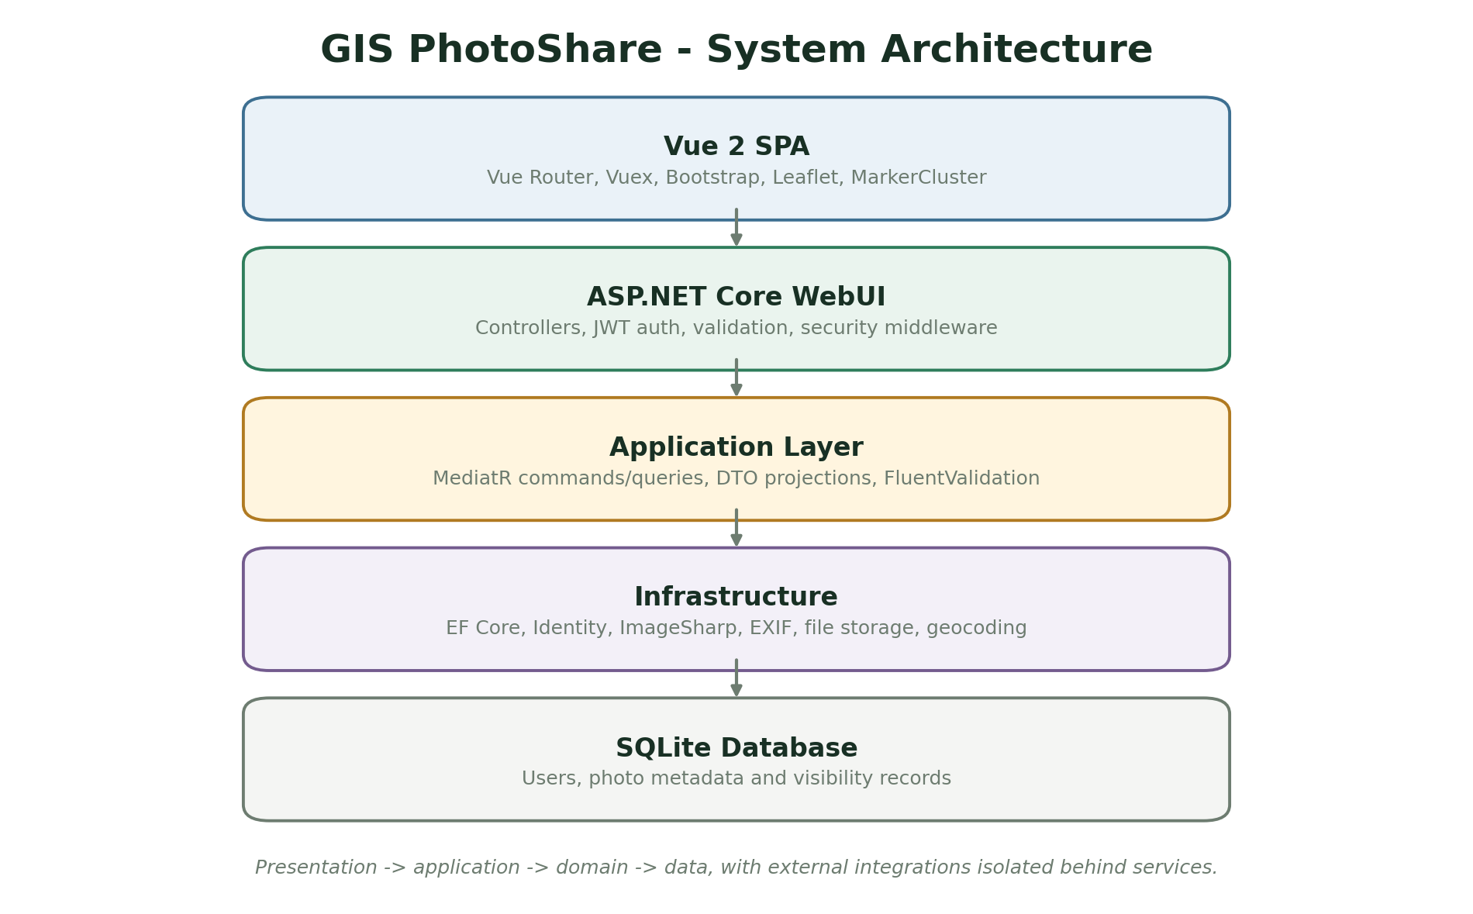
Figure 3.1: System architecture of GIS PhotoShare. Source: Author design (2026).

3.4.1 Component Responsibilities
Table 3.3: Component responsibilities
Component | Responsibility | Implementation evidence
Vue 2 client | Renders the home, map, upload, gallery and detail experiences. | Vue views and Vuex store
WebUI controllers | Expose auth, photo, upload, settings and geocoding endpoints. | ASP.NET Core controllers
Application layer | Coordinates commands and queries and applies validation. | MediatR handlers and DTO projections
Infrastructure | Handles EF Core, Identity, ImageSharp, EXIF and media storage. | Entity mappings and storage services
SQLite database | Stores user, photo, category and upload metadata for local operation. | Default development database

3.5 Database and Data Model
The data model is designed around the entities that carry the core business rules. Identifiers connect records, while status fields and timestamps preserve operational state. The simplified entity-relationship model below illustrates the principal relationships; the implementation contains additional attributes, indexes and join records.
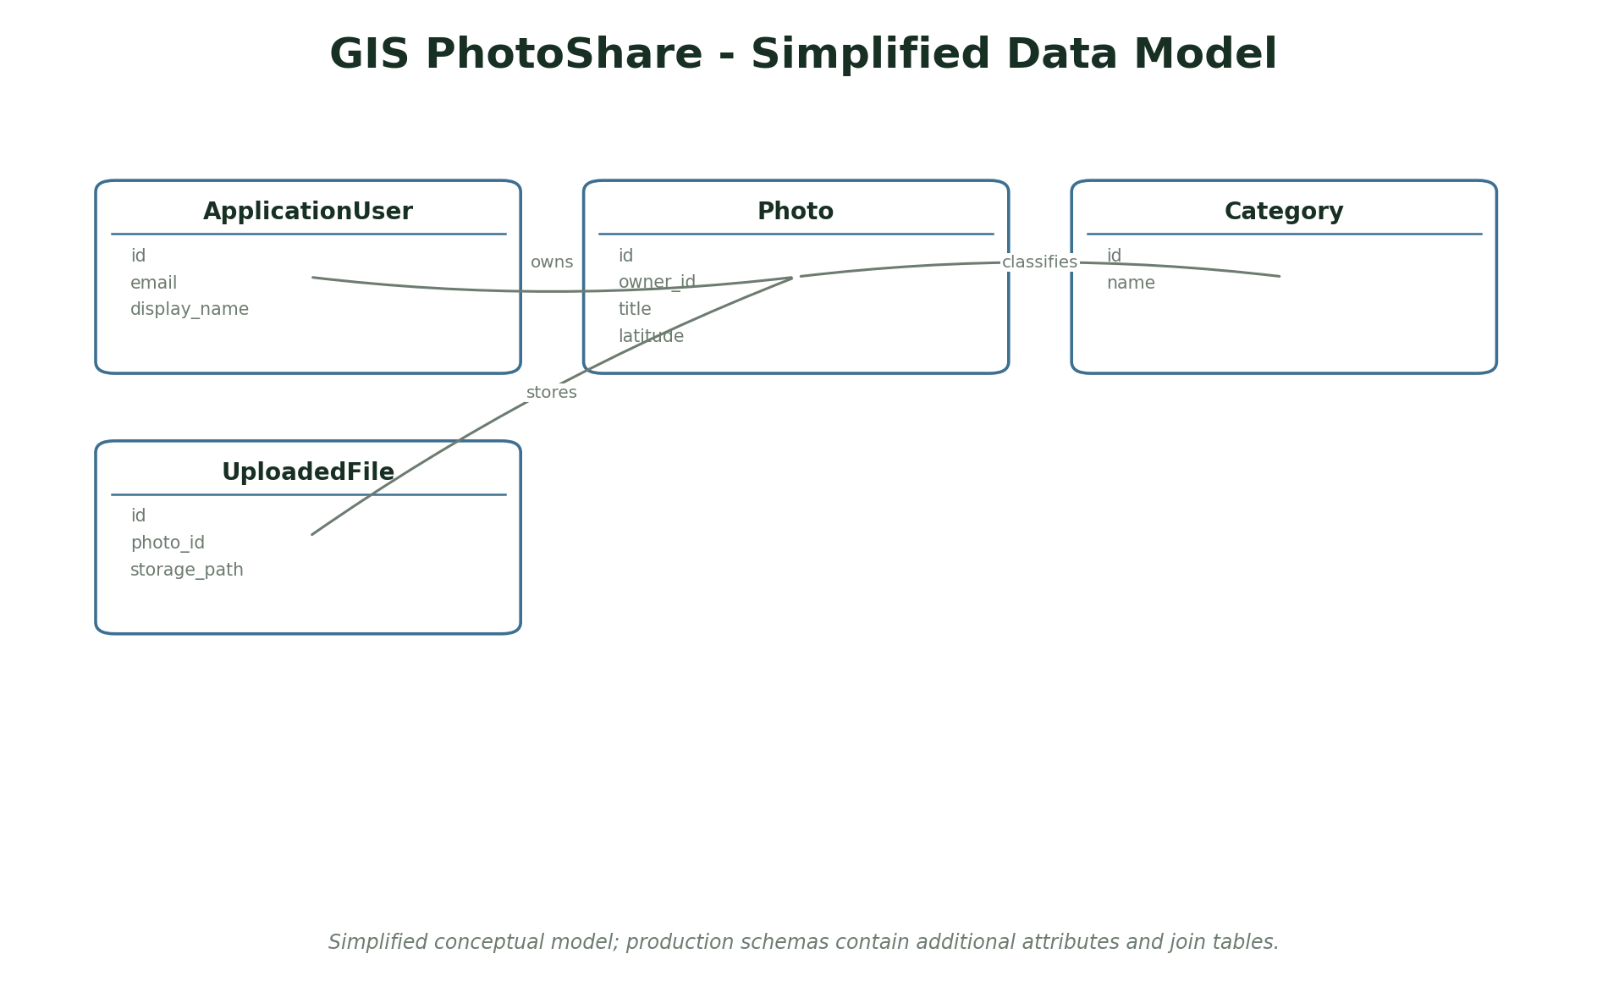
Figure 3.2: Simplified entity-relationship model for GIS PhotoShare. Source: Author design (2026).
Table 3.4: Principal data entities
Entity | Key attributes and purpose
ApplicationUser | id, email, display name, password hash
Photo | id, owner id, title, description, coordinates, visibility
Category | id, name
UploadedFile | id, photo id, storage path, thumbnail path

3.5.1 Data Integrity Rules
The database is not treated as a passive storage container. Constraints, validation and transactional updates protect the relationships that the application relies on. The following rules are enforced in the domain or database layer rather than only in the browser form.
- A photograph must have an owner and a valid title.
- Coordinates must be within latitude and longitude limits.
- Private media may not be returned without an authorised request.
- Only the owner can edit or delete a photograph.
- Uploaded files must pass content, dimension and size validation before storage.

3.6 Use Case Analysis
Use cases describe the observable actions available to each actor. They also provide a basis for the authorization matrix and the test cases. The overview below is deliberately simplified to emphasise the main workflow rather than every administrative action.
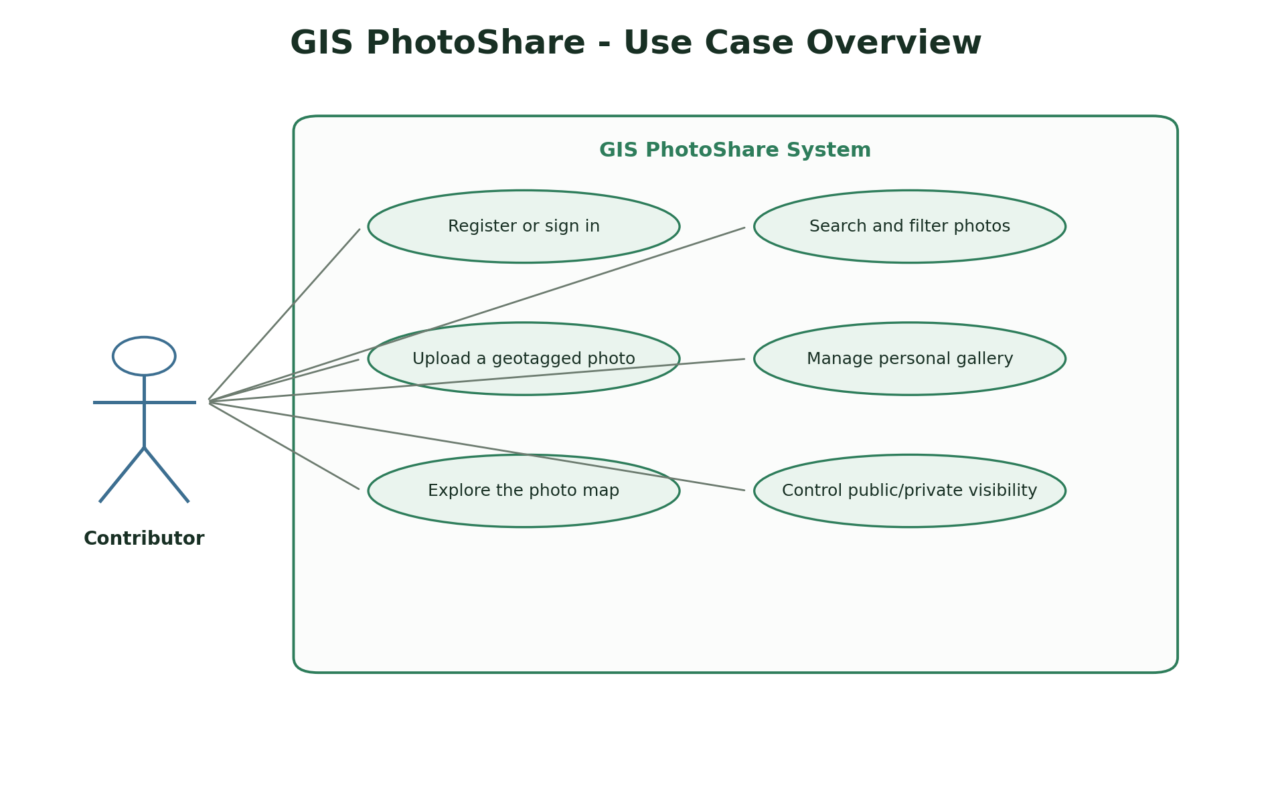
Figure 3.3: Use case overview for GIS PhotoShare. Source: Author design (2026).
Table 3.5: Summary of primary use cases
Actor | Use case | Outcome
Contributor | Upload a geotagged photo | Add title, category, location and image.
Visitor | Explore the map | Search, filter, inspect markers and open photo details.
Owner | Manage gallery | Edit metadata, change visibility or delete an owned photo.
Administrator | Inspect and maintain | Use the seeded environment and support data checks.

3.7 Security Design
Security is implemented at the server boundary. The design assumes that the browser cannot be trusted to enforce ownership, roles or workflow transitions. Every protected operation therefore checks the authenticated identity and the relevant domain relationship before changing data.
- JWT authentication and ASP.NET Core Identity enforce account access.
- Owner checks prevent editing or deleting another user's photograph.
- Private images are excluded from public feeds and served only after authorisation.
- Uploads are decoded and validated server-side, then re-encoded and thumbnailed.
- Login rate limiting, account lockout, security headers and production key validation are enabled.

3.8 Ethical and Legal Considerations
A computer science project must consider the effect of the system beyond its functional requirements. The project avoids real personal, financial or health data and documents where demonstration data is synthetic. The following considerations guided the scope and interface.
- Photographs can reveal homes, people or sensitive locations; private visibility is therefore explicit.
- EXIF metadata is stripped from stored public media to reduce unintended location leakage.
- The project uses sample photographs and a demonstration account rather than personal uploads.
- Contributors should have consent before photographing identifiable people or private property.

3.9 Testing Strategy
Testing uses several complementary levels. Unit tests check isolated rules, integration tests exercise APIs and persistence, and browser checks confirm that the main user journeys render and behave correctly. The tests are designed to verify negative cases such as invalid input, unauthorised access and inconsistent state, not only the happy path.
The test strategy follows the project requirements rather than the implementation structure. Each core workflow should have at least one positive verification and one rejected or restricted case. Test evidence is reported in Chapter Four, together with limitations of the current suite.

3.10 Deployment and Operational Considerations
The deployment model is intentionally simple so that the project can be reproduced and examined. Configuration is separated from source code where practical, migrations are applied through the framework and a local launcher is supplied for demonstration. A production deployment would require stronger secret management, monitoring, backups and an operational support process.
- SQLite is the default database and requires no external service for a local demonstration.
- The WebUI project builds the Vue client and serves the resulting static files from one process.
- Public uploads are stored under wwwroot; private uploads are stored outside the web root and served through an authorised endpoint.

3.11 Summary
This chapter established the development approach, requirements, architecture, data model, security controls, ethical boundary and test strategy. Chapter Four describes how these designs were implemented and presents the resulting interface screens and test evidence.

CHAPTER FOUR: SYSTEM IMPLEMENTATION AND RESULTS

4.1 Introduction
This chapter presents the implemented system and the evidence used to evaluate it. It starts with the development environment, then describes the main modules, presents interface screenshots and reports the testing results. The screenshots were captured from the running application and therefore show the actual interface rather than a conceptual mock-up.

4.2 Development Environment
Table 4.1: Implementation environment
Item | Implementation
Operating system | Windows development workstation
Application type | ASP.NET Core and Vue 2 web application
Backend stack | ASP.NET Core 8, MediatR, EF Core 8, ImageSharp
Frontend / interface | Vue 2, Vue Router, Vuex, Leaflet
Database | SQLite (default), SQL Server optional
Testing tools | Verified counts: 5 domain, 34 application, 30 integration, 8 Vue unit and 10 Playwright tests.
Browser verification | Headless Chromium screenshots and manual browser smoke checks

4.3 Implementation of Major Modules

4.3.1 Authentication and account area
Registration, login, session persistence and secure profile flows.
The module was implemented as a vertical slice containing the necessary persistence, server-side validation and interface feedback. Loading, empty and error states were handled so that the interface remains understandable when data is absent or an external operation fails.

4.3.2 Map explorer
Leaflet map, marker clustering, filters, search, layers, viewport results and exports.
The module was implemented as a vertical slice containing the necessary persistence, server-side validation and interface feedback. Loading, empty and error states were handled so that the interface remains understandable when data is absent or an external operation fails.

4.3.3 Upload workflow
Coordinate capture, EXIF detection, image validation and preview.
The module was implemented as a vertical slice containing the necessary persistence, server-side validation and interface feedback. Loading, empty and error states were handled so that the interface remains understandable when data is absent or an external operation fails.

4.3.4 Gallery
Paginated personal photographs with metadata and visibility indicators.
The module was implemented as a vertical slice containing the necessary persistence, server-side validation and interface feedback. Loading, empty and error states were handled so that the interface remains understandable when data is absent or an external operation fails.

4.3.5 Photo detail and editing
Owner-only metadata and coordinate updates with detail maps.
The module was implemented as a vertical slice containing the necessary persistence, server-side validation and interface feedback. Loading, empty and error states were handled so that the interface remains understandable when data is absent or an external operation fails.

4.4 Implementation Challenges and Resolutions
Implementation did not follow a straight path from design to finished feature. The following issues were encountered while building and testing the system, together with the action taken and the lesson carried into the final implementation.
Table 4.2: Implementation challenges and resolutions
Challenge | Resolution | Lesson
Safe image handling | User images may be malformed, oversized or contain unexpected metadata. | The server decodes and validates the image, corrects orientation, strips metadata and creates a thumbnail.
Private media access | A predictable static URL would expose private photographs. | Private media is stored outside the public root and served through an authorization check.
Map performance | Thousands of markers can make a map unusable. | Marker clustering and result pagination reduce visual congestion and query cost.
Coordinate entry variety | Users may have GPS metadata, a map point or only manual coordinates. | The upload workflow supports all four entry methods and validates them uniformly.

4.5 System Interface Screenshots
The following screenshots show the principal user interface of the implemented system. Each figure is followed by an explanation of the workflow it demonstrates. The images retain the application layout but crop out the host browser chrome for clarity.
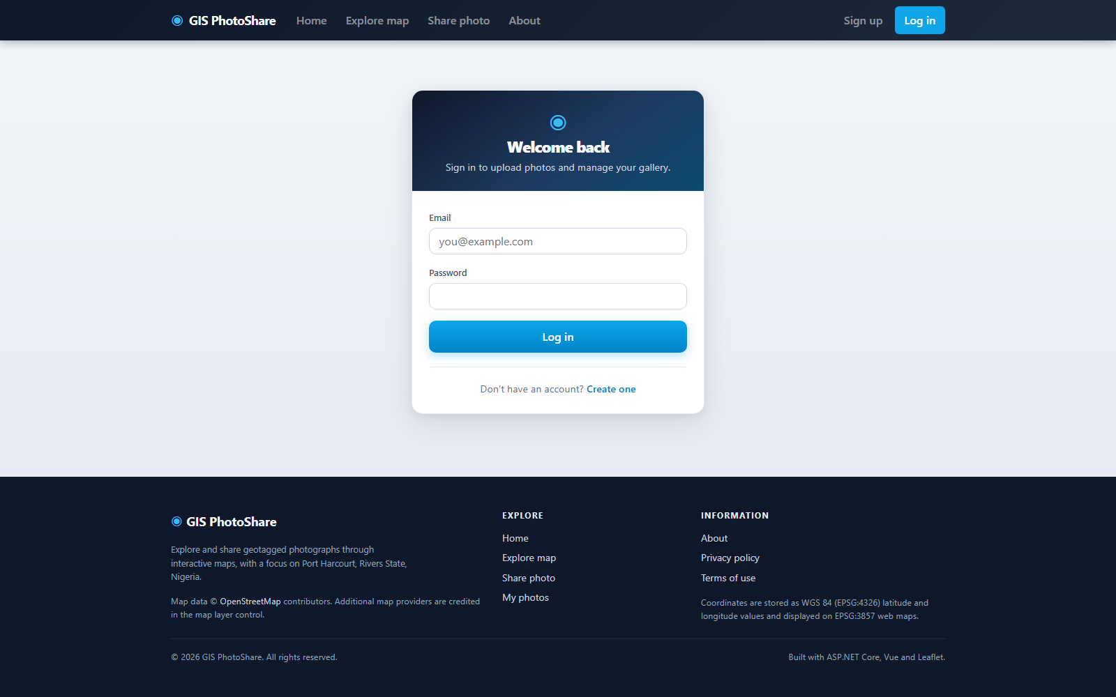
Figure 4.1: GIS PhotoShare login page. Screenshot from the running system (2026).
The login page uses the same visual language as the public site and provides account access for uploads and gallery management.

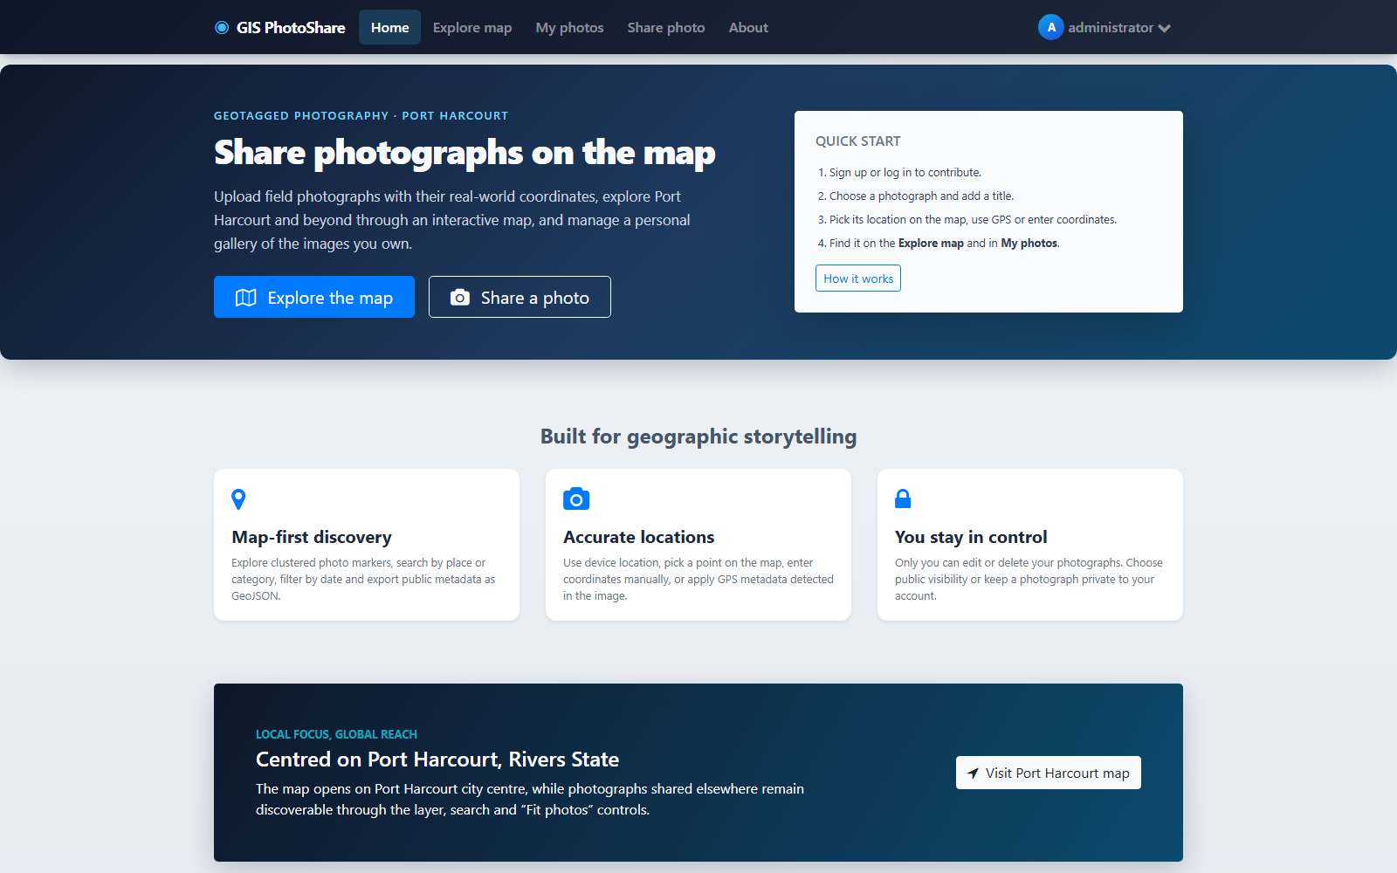
Figure 4.2: Public home page. Screenshot from the running system (2026).
The home page explains the map-first concept and directs users to explore or share photographs.

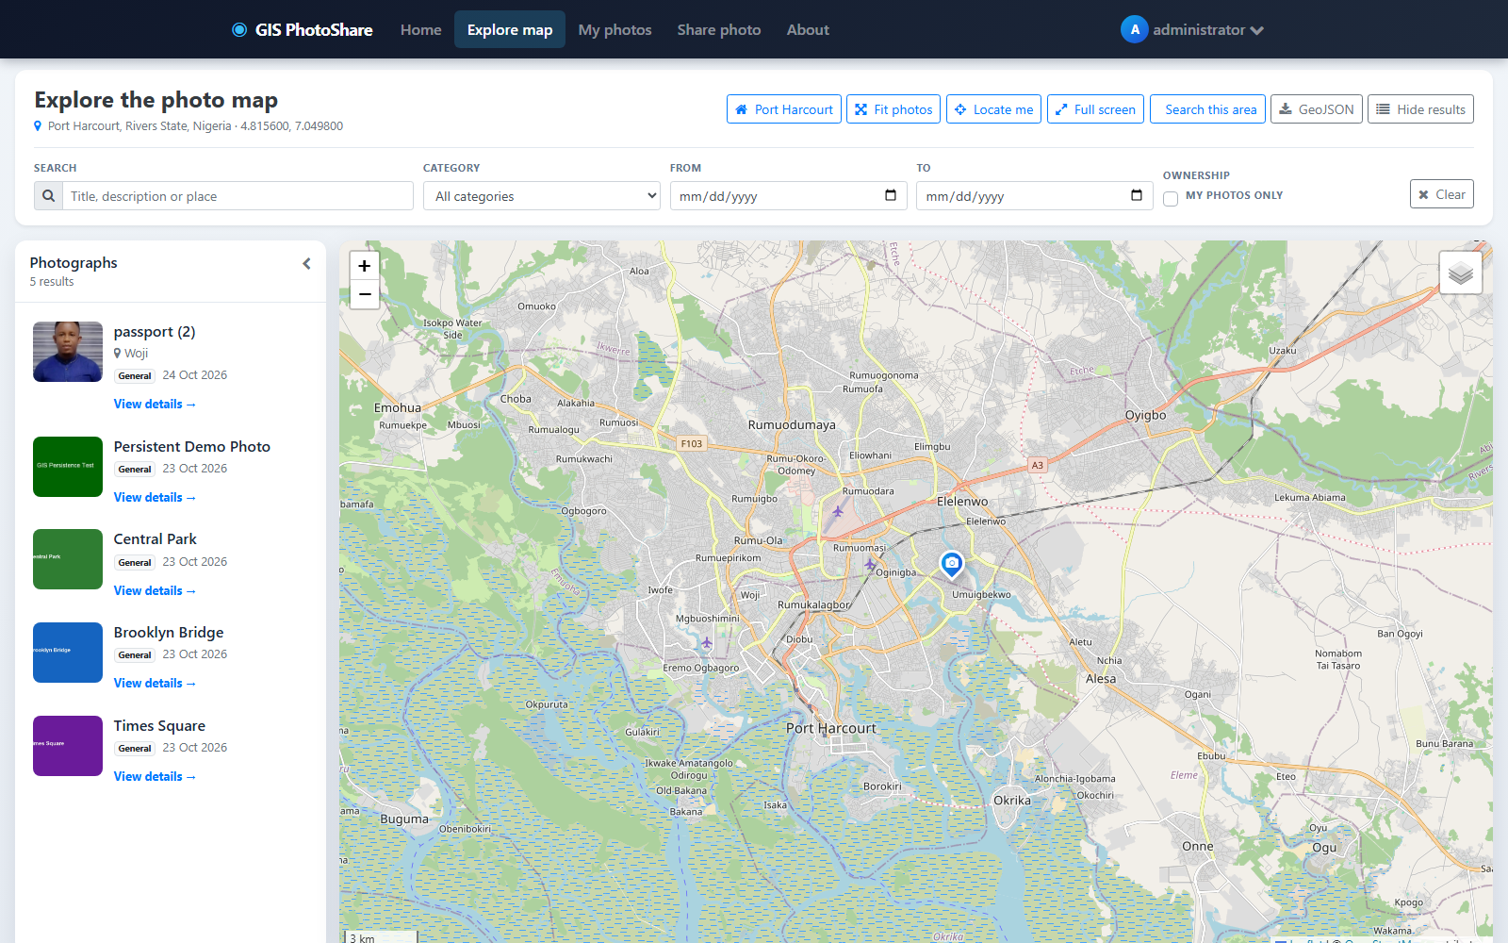
Figure 4.3: Interactive photograph map. Screenshot from the running system (2026).
Markers, filtering, layer selection and a results panel make geographic discovery the central interaction.

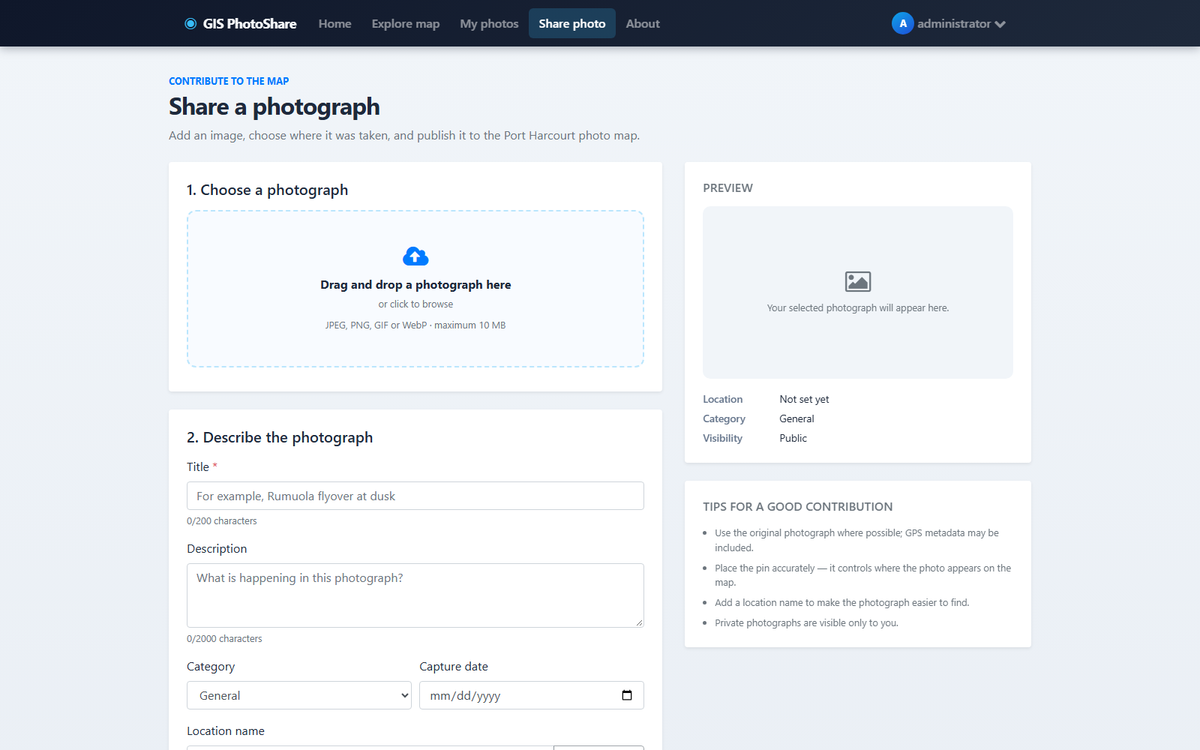
Figure 4.4: Photograph upload page. Screenshot from the running system (2026).
The upload form combines image selection, title, description, category, coordinate entry and a live preview.

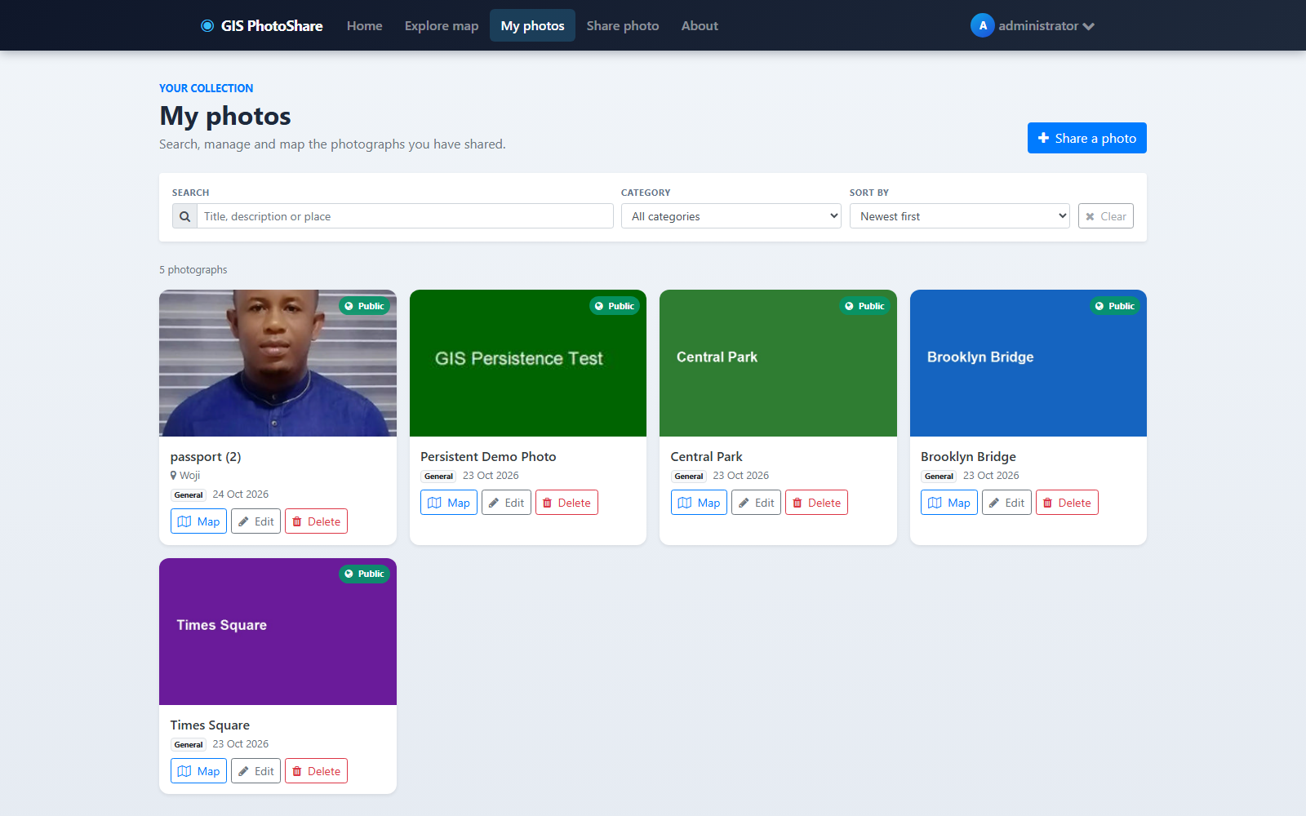
Figure 4.5: Personal photograph gallery. Screenshot from the running system (2026).
The gallery shows owned images with visibility and category metadata plus actions for viewing and editing.

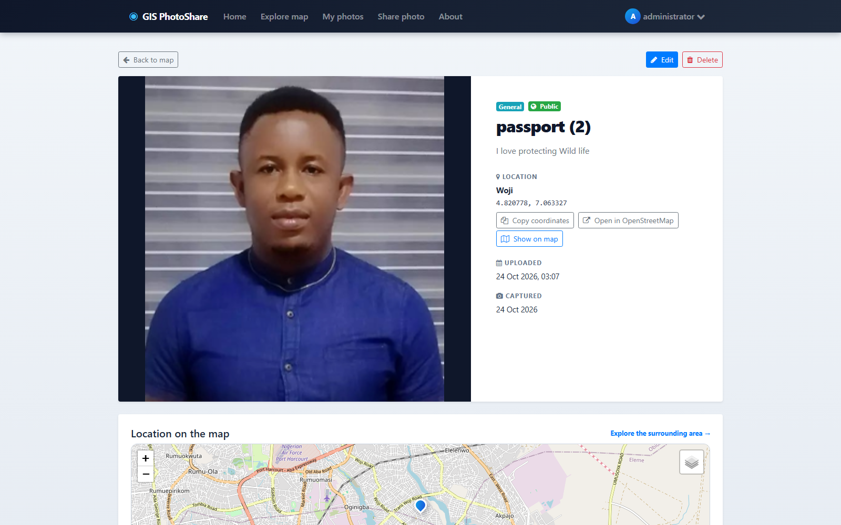
Figure 4.6: Photograph detail and map. Screenshot from the running system (2026).
The detail page presents the image, metadata, visibility and its exact location on a supporting map.

4.6 Testing Results
The following table summarises the test evidence. The results are based on the repository test suites and browser checks performed during the implementation. Where an optional integration test requires an external database or service, that dependency is stated explicitly.
Table 4.3: Summary of test evidence
Area | Test approach | Evidence
Domain tests | NUnit | Five domain tests for photo and visibility rules.
Application tests | NUnit | Thirty-four query, command, validation and media-token tests.
Integration tests | NUnit and EF Core | Thirty API and persistence compatibility tests.
Frontend utilities | Mocha/Chai | Eight coordinate and helper tests.
Browser workflows | Playwright | Ten map, upload, gallery and visibility scenarios.

Overall verification: Verified counts: 5 domain, 34 application, 30 integration, 8 Vue unit and 10 Playwright tests.

4.6.1 Acceptance Test Cases
Acceptance cases connect the original requirements to observable evidence. The table below summarises the principal scenarios used to judge whether the workflow is complete.
Table 4.4: Acceptance test cases
ID | Scenario | Expected result | Evidence
AT-01 | A user signs in and opens My Photos. | Only the user's photographs are listed. | Passed in integration tests
AT-02 | A valid image is uploaded with coordinates. | The image is re-encoded, thumbnailed and appears in the gallery. | Passed in Playwright workflow
AT-03 | A private photograph is requested without authorisation. | The media request is rejected. | Passed in media-authorisation test
AT-04 | A non-owner edits another user's photo. | The request is rejected. | Passed in ownership test
AT-05 | The map is filtered by category and viewport. | The result panel returns matching photographs. | Verified in browser workflow
AT-06 | GeoJSON export is requested. | Public photographs are returned in longitude/latitude order. | Passed in application test

4.7 Discussion of Results
The project demonstrates that geographic context can be integrated into a personal media application without sacrificing security. The strongest technical elements are the separation between public and private media and the upload hardening pipeline. The map experience is useful for discovery, while the gallery keeps ownership and editing tasks familiar. The main limitations are the absence of social features and the operational overhead of large-scale media storage.
The evidence supports the conclusion that the main workflows are implemented rather than merely described. The combination of API tests, browser screenshots and explicit acceptance scenarios also exposes the boundary of the work: features that depend on an external provider, real institutional data or a more advanced analytical model are identified as future work rather than presented as completed.

4.8 Summary
The implemented system demonstrates the design described in Chapter Three and provides a working interface for the main user journeys. The screenshots, acceptance scenarios and tests show that data can be created, read, updated and controlled through the application. Chapter Five reflects on the project as a whole and identifies the most useful next steps.

CHAPTER FIVE: SUMMARY, CONCLUSION AND RECOMMENDATIONS

5.1 Summary
This project set out to design and implement GIS PhotoShare as a working final-year computer science artefact. The report reviewed the problem domain, related systems and technologies, then described an incremental methodology, a layered architecture, a relational and spatial data model, role-aware security and a practical testing strategy. The resulting application was demonstrated through actual interface screenshots and test evidence.

5.2 Conclusion
GIS PhotoShare meets its objective of providing a secure, location-aware photograph platform for Port Harcourt. It combines map exploration, coordinate capture, gallery management and visibility controls in one tested application. The project is suitable as a foundation for community mapping, local heritage documentation and further work on media discovery.

5.3 Evaluation Against Objectives
The table below maps the original objectives to the implementation and evidence presented in Chapter Four. The purpose is to make the evaluation traceable rather than relying on a general claim that the system is complete.
Table 5.1: Evaluation against objectives
ID | Objective | Evaluation
OBJ-01 | Provide account registration, login and authenticated photo-management workflows. | Addressed - see Chapter Four implementation and test evidence
OBJ-02 | Capture and validate location using multiple coordinate-entry methods. | Addressed - see Chapter Four implementation and test evidence
OBJ-03 | Render public photographs on an interactive map with clustering and filters. | Addressed - see Chapter Four implementation and test evidence
OBJ-04 | Validate, resize, strip metadata and thumbnail uploaded images on the server. | Addressed - see Chapter Four implementation and test evidence
OBJ-05 | Enforce owner-only edit/delete actions and public/private visibility. | Addressed - see Chapter Four implementation and test evidence
OBJ-06 | Support search, viewport filtering, GeoJSON export and responsive gallery use. | Addressed - see Chapter Four implementation and test evidence

5.4 Contributions
- A map-first photograph gallery with local spatial context.
- Secure server-side upload, re-encoding and thumbnail generation.
- Explicit public/private media authorisation.
- A layered ASP.NET Core and Vue implementation with broad test coverage.

5.5 Limitations of the Implementation
- No comments, follows or social graph.
- External tile and geocoding services are required for the full experience.
- SQLite is intended for local demonstration rather than high-volume production.
- There is no dedicated moderation console.

5.6 Recommendations
- Add moderation tools and user reporting for public photographs.
- Introduce albums, collections and richer text search.
- Move media to object storage with signed URLs for production.
- Add a mobile capture workflow with offline coordinates and later upload.

5.7 Suggestions for Future Work
- Integrate additional map layers such as terrain and historical imagery.
- Add duplicate-image and location-cluster detection.
- Provide public contributor profiles and consent-aware attribution.
- Add accessibility audits and multi-language support.

5.8 Final Remarks
The project provides a coherent, tested foundation for GIS PhotoShare. Its value is not only in the number of screens, but in the way the problem was decomposed into requirements, data, security and evidence. The documented limitations should be treated as a research and deployment agenda rather than hidden defects. With the recommended validation and operational work, the prototype can support further study or a supervised pilot in its intended domain.

REFERENCES
Goodchild, M. F. (2007). Citizens as sensors: The world of volunteered geography. GeoJournal, 69(4), 211-221.
Haklay, M., & Weber, P. (2008). OpenStreetMap: User-generated street maps. IEEE Pervasive Computing, 7(4), 12-18.
Hevner, A. R., March, S. T., Park, J., & Ram, S. (2004). Design science in information systems research. MIS Quarterly, 28(1), 75-105.
Leaflet. (n.d.). Leaflet documentation. https://leafletjs.com/reference.html
Microsoft. (n.d.). ASP.NET Core documentation. https://learn.microsoft.com/aspnet/core/
OWASP Foundation. (2021). OWASP Top 10:2021. https://owasp.org/Top10/
Pressman, R. S., & Maxim, B. R. (2020). Software engineering: A practitioner's approach (9th ed.). McGraw-Hill.
Six Labors. (n.d.). ImageSharp documentation. https://docs.sixlabors.com/
Sommerville, I. (2016). Software engineering (10th ed.). Pearson.
Nielsen, J. (1994). Usability engineering. Morgan Kaufmann.

APPENDIX A: DEMONSTRATION GUIDE
The following steps provide a repeatable demonstration of the implemented system. The sequence uses the development configuration and the demonstration accounts described in the project README.
- Start the WebUI application with run.cmd.
- Sign in as administrator@localhost.
- Open Explore Map and select a cluster or marker.
- Open Share a Photo, choose a file and place the location on the map.
- Save the photo and inspect it in My Photos and the map results.
- Open the detail page and review its metadata and visibility.
During the demonstration, inspect the loading, empty, success and validation states rather than only the populated screen. The screenshots in Chapter Four can be used as a visual checklist.

APPENDIX B: PRIMARY ROUTES AND ENDPOINTS
The routes below identify the principal user-facing pages or API areas used in the demonstration. The repository README contains the fuller endpoint catalogue and deployment notes.
Table B.1: Primary routes and endpoints
Route or endpoint | Purpose
/ | Public home page
/MapRenderer | Interactive photograph map
/PhotoUpload | Authenticated upload workflow
/MyPhotos | Personal gallery
/photos/{id} | Photo detail and location
/SignUp | Account registration

Access to protected routes is subject to the role and ownership rules described in Chapter Three. A successful HTTP response does not by itself prove authorization; the negative tests and acceptance scenarios are the relevant evidence.

