Telemedicine Platform: A Role-Based System for Appointment Coordination and Secure Patient-Physician Communication
A FINAL YEAR PROJECT REPORT
Submitted to the Department of Computer Science, [INSTITUTION NAME], in partial fulfilment of the requirements for the award of Bachelor of Science (B.Sc.) in Computer Science.

BY
[STUDENT FULL NAME]
[MATRICULATION NUMBER]

SUPERVISOR: [SUPERVISOR NAME]
October 2026

DECLARATION
I, [STUDENT FULL NAME], hereby declare that this final-year project report titled "Telemedicine Platform: A Role-Based System for Appointment Coordination and Secure Patient-Physician Communication" is my original work. It has not been submitted for the award of any other degree or diploma in this or any other institution. All sources of information and material used have been acknowledged in the references and in the body of the report. Any assistance received during the project has been documented and acknowledged.

Signature: ______________________________
Name: [STUDENT FULL NAME]
Matriculation number: [MATRICULATION NUMBER]
Date: October 2026

CERTIFICATION
This is to certify that this project report was carried out by [STUDENT FULL NAME] with matriculation number [MATRICULATION NUMBER] under my supervision. The report has been read and approved as meeting the requirements of the Department of Computer Science, [INSTITUTION NAME].

Supervisor: [SUPERVISOR NAME]
Signature: ______________________________
Date: ______________________________

ABSTRACT
The Telemedicine Platform is a synthetic demonstration system for managing patient and physician onboarding, availability, appointment booking, appointment decisions, secure chat and limited EMR access. It was built to show how role-based and record-level authorization can be applied to a sensitive healthcare workflow while keeping the system clearly separated from clinical use. The backend uses ASP.NET Core 10, MediatR, FluentValidation, EF Core 10, PostgreSQL and SignalR. The frontend is a Vue 3 application with Vuex, Vue Router, Tailwind, PrimeVue and ApexCharts. The report describes the system problem, related work, methodology, architecture, implementation screenshots and evaluation. The platform includes patient and physician dashboards, doctor discovery, service booking, appointment management and authenticated chat. Release 1 deliberately excludes WebRTC video consultation. The report evaluates the system using 44 backend tests and 7 Playwright workflows.
Keywords: software engineering, web application, database, spatial data, security, human-computer interaction, Telemedicine Platform

TABLE OF CONTENTS
CHAPTER ONE: INTRODUCTION 11
1.1 Background 11
1.2 Statement of the Problem 11
1.3 Aim and Objectives 12
1.3.1 Objectives 12
1.4 Research Questions 12
1.5 Scope of the Project 12
1.6 Significance of the Project 13
1.7 Limitations of the Project 13
1.8 Expected Contributions 13
1.9 Definition of Terms 13
1.10 Organisation of the Report 14
CHAPTER TWO: LITERATURE REVIEW 15
2.1 Introduction 15
2.2 Conceptual Review 15
2.2.1 Quality Attributes and User-Centred Design 15
2.3 Review of Related Systems 16
2.4 Technology Review 16
2.5 Research Gap 17
2.6 Summary 17
CHAPTER THREE: METHODOLOGY AND SYSTEM ANALYSIS 18
3.1 Introduction 18
3.2 Development Methodology 18
3.2.1 Requirements Elicitation 18
3.3 Requirements Analysis 19
3.3.1 Functional Requirements 19
3.3.2 Non-Functional Requirements 19
3.3.3 Constraints and Assumptions 19
3.4 System Architecture 19
3.4.1 Component Responsibilities 20
3.5 Database and Data Model 20
3.5.1 Data Integrity Rules 21
3.6 Use Case Analysis 22
3.7 Security Design 22
3.8 Ethical and Legal Considerations 23
3.9 Testing Strategy 23
3.10 Deployment and Operational Considerations 23
3.11 Summary 24
CHAPTER FOUR: SYSTEM IMPLEMENTATION AND RESULTS 25
4.1 Introduction 25
4.2 Development Environment 25
4.3 Implementation of Major Modules 25
4.3.1 Identity and profiles 25
4.3.2 Availability and booking 25
4.3.3 Appointment lifecycle 26
4.3.4 Secure communication 26
4.3.5 Physician workspace 26
4.4 Implementation Challenges and Resolutions 26
4.5 System Interface Screenshots 28
4.6 Testing Results 37
4.6.1 Acceptance Test Cases 37
4.7 Discussion of Results 38
4.8 Summary 38
CHAPTER FIVE: SUMMARY, CONCLUSION AND RECOMMENDATIONS 39
5.1 Summary 39
5.2 Conclusion 39
5.3 Evaluation Against Objectives 39
5.4 Contributions 40
5.5 Limitations of the Implementation 40
5.6 Recommendations 40
5.7 Suggestions for Future Work 40
5.8 Final Remarks 40
REFERENCES 42
APPENDIX A: DEMONSTRATION GUIDE 43
APPENDIX B: PRIMARY ROUTES AND ENDPOINTS 44

LIST OF FIGURES
Figure 3.1: System architecture
Figure 3.2: Simplified entity-relationship model
Figure 3.3: Use case overview
Figure 4.1: Telemedicine login page.
Figure 4.2: Patient dashboard.
Figure 4.3: Doctor directory.
Figure 4.4: Appointment booking.
Figure 4.5: Patient appointment management.
Figure 4.6: Secure patient-physician chat.
Figure 4.7: Physician sign-in.
Figure 4.8: Physician dashboard.
Figure 4.9: Physician appointment queue.

LIST OF TABLES
Table 1.1: Definition of key terms
Table 2.1: Comparison of related systems
Table 2.2: Technologies used in the implementation
Table 3.1: Functional requirements
Table 3.2: Non-functional requirements
Table 3.3: Component responsibilities
Table 3.4: Principal data entities
Table 3.5: Summary of primary use cases
Table 4.1: Implementation environment
Table 4.2: Implementation challenges and resolutions
Table 4.3: Summary of test evidence
Table 4.4: Acceptance test cases
Table 5.1: Evaluation against objectives
Table B.1: Primary routes and endpoints

LIST OF ABBREVIATIONS
Abbreviation | Meaning
API | Application Programming Interface
EMR | Electronic Medical Record
JWT | JSON Web Token
MediatR | In-process mediator library for commands and queries
RBAC | Role-Based Access Control
SPA | Single-Page Application
UTC | Coordinated Universal Time
WHO | World Health Organization

CHAPTER ONE: INTRODUCTION

1.1 Background
Telemedicine uses information and communication technologies to support healthcare at a distance. Even when video consultation is not available, digital appointment coordination, availability management and secure messaging can reduce administrative friction between patients and physicians (World Health Organization, 2010). These workflows are especially important where travel or scheduling constraints make in-person coordination difficult.
Healthcare applications also raise the stakes for access control. A patient should not be able to read another patient's record, a physician should only see patients connected to their work, and administrative actions must be separated from clinical actions. A realistic final-year project therefore needs role-aware endpoints and record-level checks rather than a single shared login.
This project implements a controlled, synthetic telemedicine environment. It demonstrates onboarding, physician availability, appointment states, secure chat and an authorised EMR read. It explicitly excludes real patient data and clinical care, allowing the student to examine the software-engineering and security design without making medical claims.

1.2 Statement of the Problem
Appointment coordination is often handled through phone calls, messages and disconnected calendars. Patients may not know which physicians are available, physicians may receive incomplete booking information and neither side has a reliable history of rescheduling, acceptance or decline. In a teaching system, these problems must be solved together with a clear authorization model and a safe separation between patient, physician and administrator views.
The problem addressed by the project is the design of a role-based telemedicine workflow that coordinates profiles, availability and appointments while protecting private records and providing a credible demonstration of secure patient-physician interaction.

1.3 Aim and Objectives
To design and implement a secure, role-based telemedicine platform that demonstrates patient and physician onboarding, appointment coordination, availability management, secure chat and authorised record access.

1.3.1 Objectives
- Provide identity onboarding for patients, physicians and administrators.
- Model patient and physician profiles with role-specific information.
- Allow physicians to publish availability and generate bookable slots.
- Support booking, rescheduling, cancellation, acceptance and decline of appointments.
- Provide authenticated patient-physician chat and a constrained EMR read.
- Enforce role and record-level authorization and verify workflows with automated tests.

1.4 Research Questions
The objectives are translated into the following research questions. Each question is revisited in Chapters Three and Four, where the design and implementation evidence are discussed.
- How can patient and physician workflows be separated while sharing a common identity and appointment model?
- Which role and record-level checks are necessary to prevent unauthorised access to appointments and EMR data?
- How can availability rules be converted into valid bookable slots without creating overlapping appointments?
- What is an appropriate scope for a telemedicine demonstration that does not make clinical claims or require video consultation?

1.5 Scope of the Project
The project covers the following functional and technical scope:
- Synthetic patient, physician and administrator accounts.
- Patient and physician dashboards with appointment views.
- Weekly availability, booking, rescheduling, cancellation and physician decisions.
- Authenticated REST and SignalR chat surfaces.
- Bounded EMR read for authorised roles and documented Release 1 exclusions.

1.6 Significance of the Project
- Demonstrates how healthcare workflows can be modelled with explicit role boundaries.
- Shows an appointment state model backed by database constraints.
- Provides a realistic full-stack example of a sensitive multi-user application.
- Creates a foundation for future work in consent, audit and video consultation.

1.7 Limitations of the Project
The limitations below define the boundary of the academic deliverable. They are not hidden implementation gaps: they explain which capabilities are outside the approved project scope and why.
- The project is a synthetic demonstration and must not be used for clinical care.
- WebRTC video consultation is deliberately excluded from Release 1.
- Chat history and conversation persistence are not fully implemented.
- Invoices, receipts, email verification and full administrative operations are out of scope.

1.8 Expected Contributions
- A role-based patient and physician onboarding model.
- A tested appointment lifecycle with availability and state transitions.
- Authenticated patient-physician chat and constrained EMR access.
- A documented boundary between a synthetic demonstration and a clinical system.

1.9 Definition of Terms
Table 1.1: Definition of key terms
Term | Definition
Telemedicine | The delivery of healthcare services at a distance using information and communication technology.
Availability | A physician's published working periods from which bookable slots are generated.
Appointment | A scheduled interaction between a patient and a physician for a service.
EMR | Electronic medical record data made available through a controlled read endpoint.
Role policy | A server-side rule that limits an action to selected user roles.
Record-level authorization | A check that the specific record belongs to or is accessible to the current user.

1.10 Organisation of the Report
Chapter One explains the telemedicine coordination problem and the project scope. Chapter Two reviews digital-health literature, related platforms and security considerations. Chapter Three presents the methodology, requirements, architecture, appointment state model and testing plan. Chapter Four shows the patient and physician interfaces and reports test evidence. Chapter Five summarises the work and identifies responsible future work.

CHAPTER TWO: LITERATURE REVIEW

2.1 Introduction
This chapter reviews the concepts, related systems and technologies relevant to the project. The review is organised around the problem domain, the capabilities of existing products and the technical choices used in the implementation. It ends by identifying the gap that the project addresses. The review draws on established software-engineering and domain literature as well as the official documentation of the frameworks used in the system.

2.2 Conceptual Review
Telemedicine Platform is a multi-user information system rather than a single-user desktop tool. Its design therefore has to account for user identity, persistent records, validation, feedback and operational workflows. Software-engineering research emphasises that these concerns should be handled through explicit requirements, modular design and iterative evaluation (Sommerville, 2016; Pressman & Maxim, 2020). The design-science perspective adds that the resulting artefact should be evaluated against the problem it was created to solve rather than judged only by the number of implemented features (Hevner et al., 2004).
The project also reflects the broader shift from isolated records to connected digital services. Users expect immediate validation, clear status information and predictable navigation. At the same time, sensitive systems need security boundaries that are enforced on the server rather than only hidden in the interface. These principles informed the choice of layered architectures, role-aware endpoints and explicit error states.
For the Telemedicine Platform domain, the important conceptual concerns are data ownership, consistency of state transitions and the relationship between a user action and a persistent record. The implementation therefore treats workflow state, authorization and source provenance as first-class parts of the design.

2.2.1 Quality Attributes and User-Centred Design
A functioning demonstration also has to satisfy quality attributes that are not visible in a feature list. Security, usability, maintainability and graceful failure are particularly important for a multi-user system. Usability heuristics emphasise visibility of system status, clear error messages, prevention of invalid input and consistent navigation (Nielsen, 1994). These ideas are reflected in loading indicators, validation messages, explicit empty states and role-specific navigation in the implemented interface.
Maintainability is addressed through feature-oriented source organisation, shared validation and a consistent data-access layer. Security is treated as a server-side concern: the interface may hide an action, but the endpoint must still verify identity and permission. This separation between presentation and enforcement is a recurring theme in secure web-application guidance (OWASP Foundation, 2021).

2.3 Review of Related Systems
Table 2.1: Comparison of related systems
System | Strengths | Limitations and relationship to this project
Teladoc | Commercial telehealth and virtual care platform. | Mature clinical and video capability; not self-hosted and far beyond a student demonstration.
Amwell | Virtual care platform with scheduling and consultation. | Strong enterprise integrations and video, but proprietary and operationally complex.
Doxy.me | Browser-based telemedicine rooms. | Simple video access but limited academic transparency and broader administrative workflow.
Practo | Healthcare discovery and appointment service. | Broad consumer platform; not designed as a small role-isolated demonstration system.

The comparison shows that existing products are generally stronger in scale, commercial integrations or specialised domain features. The opportunity for this project is not to reproduce a commercial platform, but to build a transparent, locally runnable system that demonstrates the core workflow with maintainable code, explicit limitations and test evidence.

2.4 Technology Review
Table 2.2: Technologies used in the implementation
Technology | Role in the system | Reason for selection
ASP.NET Core 10 API | Backend service | Provides controllers, middleware, authentication and health checks.
MediatR and FluentValidation | Application workflow | Separates commands/queries from transport and validates requests.
EF Core 10 and PostgreSQL | Persistence | Supports relational integrity, migrations and exclusion constraints.
ASP.NET Core Identity and JWT | Authentication and roles | Provides password hashing, role claims and permission policies.
Vue 3 and Vuex | Patient and physician UI | Supports two role-specific dashboards and stateful appointment flows.
SignalR | Chat transport | Supports authenticated patient-physician messaging without arbitrary broadcast groups.

The technology stack was selected for reliability, documentation and suitability for a final-year project. The architecture separates transport, application logic, persistence and presentation concerns. Official documentation was used to confirm configuration and security behaviour rather than relying on assumptions about framework defaults.
The technology review also considered operational constraints. The project should be reproducible on a student workstation, avoid unnecessary infrastructure, preserve data through migrations and make optional external dependencies fail gracefully. These constraints influenced the choice of a modular monolith and the decision to keep provider-specific integrations behind service boundaries.

2.5 Research Gap
Commercial telemedicine systems provide broad clinical capability, but a final-year project needs a transparent and safe subset that demonstrates identity, availability, appointment decisions, secure chat and record-level access without pretending to be a clinical product. This project fills that gap with a clearly labelled synthetic system and explicit exclusions.

2.6 Summary
The review establishes that Telemedicine Platform addresses a genuine workflow rather than a purely visual mock-up. The next chapter translates the reviewed requirements into a development methodology, system architecture, data model and testing plan.

CHAPTER THREE: METHODOLOGY AND SYSTEM ANALYSIS

3.1 Introduction
This chapter explains how the system was analysed, designed and tested. It presents the development approach, functional and non-functional requirements, architecture, data model, use cases, security design and verification strategy. The design aims to keep the implementation understandable while still meeting the needs of a multi-user application.

3.2 Development Methodology
The system was developed incrementally around role-specific slices. Identity and profiles were implemented first, followed by availability, appointment booking and physician decisions. Chat and EMR access were added after the authorization model was established. Each slice was evaluated with unit, integration or Playwright tests. The process follows iterative delivery and design-science evaluation (Sommerville, 2016; Hevner et al., 2004).
The work used a requirements-driven, incremental approach. The problem domain and stakeholder actions were decomposed into vertical slices, and each slice was checked through code review, automated tests or browser inspection. The design-science cycle of problem identification, artefact construction and evaluation was used to keep the project focused on a usable result (Hevner et al., 2004).

3.2.1 Requirements Elicitation
Requirements were elicited from the problem statement, the implemented prototype, domain documentation and the practical workflows observed in each application area. The analysis did not assume that a feature should be built simply because it appeared in a related commercial product; each requirement was checked against the project aim and the available data.
- Review of telemedicine and electronic appointment literature.
- Role analysis of patient, physician and administrator journeys.
- Security requirements for health information and record-level access.
- ASP.NET Core Identity, EF Core and SignalR documentation.

3.3 Requirements Analysis

3.3.1 Functional Requirements
Table 3.1: Functional requirements
ID | Requirement | Priority
FR-01 | Register and authenticate patients, physicians and administrators. | High
FR-02 | Maintain patient and physician profiles with role-specific data. | High
FR-03 | Allow physicians to create and update weekly availability. | High
FR-04 | Generate bookable UTC slots from availability. | High
FR-05 | Book, reschedule, cancel, accept and decline appointments. | High
FR-06 | Provide patient and physician dashboards with live appointment data. | High
FR-07 | Provide authenticated chat and an authorised EMR read. | Medium
FR-08 | Enforce role and record-level authorization on all protected actions. | High

3.3.2 Non-Functional Requirements
Table 3.2: Non-functional requirements
Area | Requirement
Security and privacy | Synthetic data only; role policies and record ownership must be enforced.
Integrity | Appointment transitions must be consistent and overlapping active slots prevented.
Usability | Patients and physicians must have clear role-specific navigation and feedback.
Traceability | Protected clinical reads and appointment actions should be auditable.
Maintainability | Domain, application, infrastructure and API layers must remain separated.

3.3.3 Constraints and Assumptions
The design assumes a local or small-team deployment, a supported web browser and access to the configured database. Optional external services are treated as enhancements rather than preconditions for the core workflow. The project does not assume access to an official utility asset register, commercial imagery or a production identity provider unless those services are explicitly configured.

3.4 System Architecture
The Vue SPA calls an ASP.NET Core API through a Vite development proxy. Controllers dispatch commands and queries through MediatR. Domain rules validate appointment state and role permissions, while Infrastructure provides EF Core, Identity, JWT and SignalR. PostgreSQL stores profiles, availability, appointments, chat and EMR records.
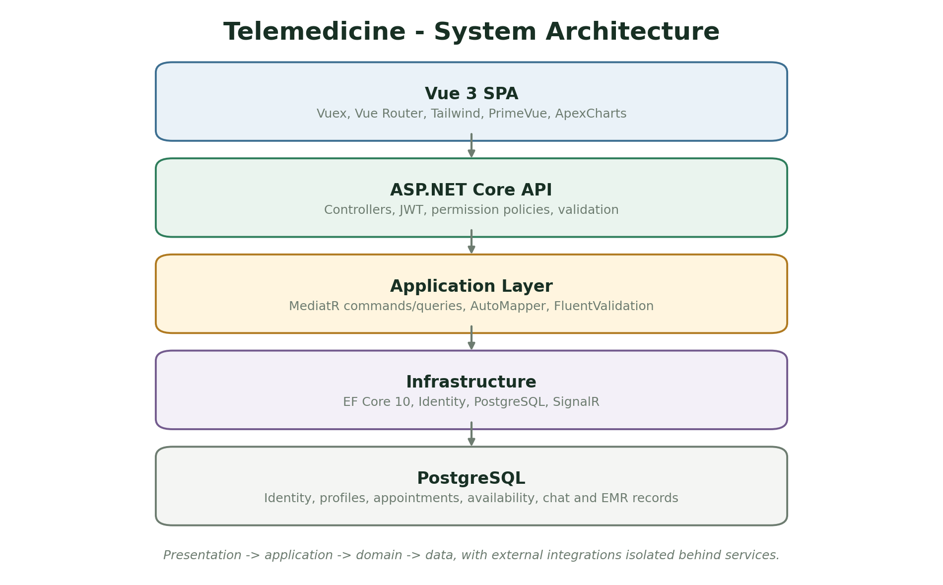
Figure 3.1: System architecture of Telemedicine Platform. Source: Author design (2026).

3.4.1 Component Responsibilities
Table 3.3: Component responsibilities
Component | Responsibility | Implementation evidence
Vue SPA | Provides public pages and separate patient, physician and administrator workspaces. | Vue views, Vuex store and router guards
ASP.NET Core API | Authenticates users, applies policy permissions and exposes health endpoints. | Controllers and permission policies
Application layer | Executes appointment, profile, availability and chat commands or queries. | MediatR handlers and validators
Infrastructure | Persists Identity, appointments, availability, chat and EMR records. | EF Core and PostgreSQL
SignalR | Delivers authenticated messaging events. | Chat hub and notification surfaces

3.5 Database and Data Model
The data model is designed around the entities that carry the core business rules. Identifiers connect records, while status fields and timestamps preserve operational state. The simplified entity-relationship model below illustrates the principal relationships; the implementation contains additional attributes, indexes and join records.
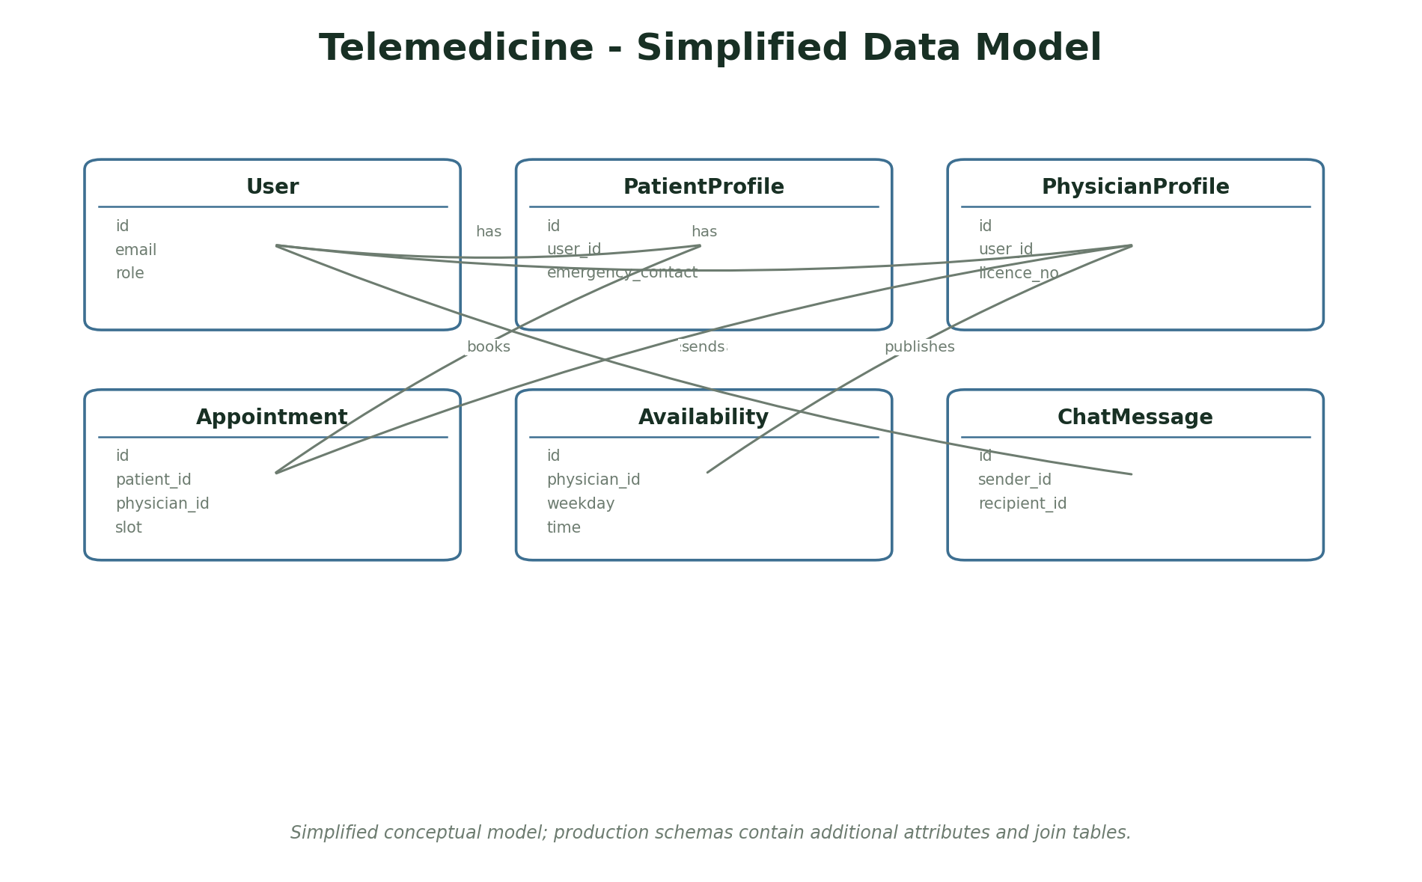
Figure 3.2: Simplified entity-relationship model for Telemedicine Platform. Source: Author design (2026).
Table 3.4: Principal data entities
Entity | Key attributes and purpose
ApplicationUser | id, email, role, password hash
PatientProfile | id, user id, contact and emergency information
PhysicianProfile | id, user id, licence, speciality, bio
Appointment | id, patient, physician, service, slot, status
Availability | id, physician, weekday, start/end time
ChatMessage | id, sender, recipient, content timestamp

3.5.1 Data Integrity Rules
The database is not treated as a passive storage container. Constraints, validation and transactional updates protect the relationships that the application relies on. The following rules are enforced in the domain or database layer rather than only in the browser form.
- An appointment must reference a valid patient, physician, service and slot.
- A physician can only manage availability and appointments associated with their profile.
- Active appointments must not overlap for the same physician.
- A patient cannot access another patient's appointment, chat or EMR record.
- Role policy checks must run on the server before any protected action.

3.6 Use Case Analysis
Use cases describe the observable actions available to each actor. They also provide a basis for the authorization matrix and the test cases. The overview below is deliberately simplified to emphasise the main workflow rather than every administrative action.
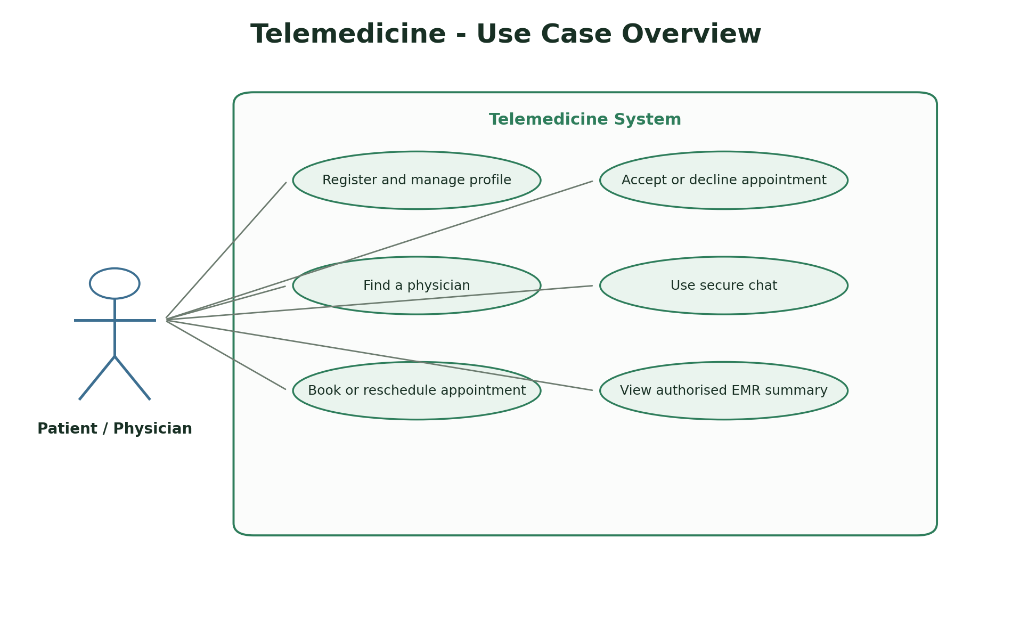
Figure 3.3: Use case overview for Telemedicine Platform. Source: Author design (2026).
Table 3.5: Summary of primary use cases
Actor | Use case | Outcome
Patient | Find and book a physician | Select a service, view slots and create an appointment.
Patient | Manage appointment | Reschedule or cancel a future appointment.
Physician | Publish availability | Create the slots from which patients book.
Physician | Accept or decline appointment | Move a request through the approved state model.
Authorised user | Use chat or read EMR | Interact only with records permitted by role and relationship.

3.7 Security Design
Security is implemented at the server boundary. The design assumes that the browser cannot be trusted to enforce ownership, roles or workflow transitions. Every protected operation therefore checks the authenticated identity and the relevant domain relationship before changing data.
- JWT tokens carry identity and role claims; permission policies guard API endpoints.
- Patient and physician resources enforce record-level ownership and appointment relationships.
- Passwords are handled by ASP.NET Core Identity; demonstration accounts use synthetic data.
- PostgreSQL constraints prevent overlapping active appointments.
- Chat does not permit arbitrary groups or unapproved broadcasts.

3.8 Ethical and Legal Considerations
A computer science project must consider the effect of the system beyond its functional requirements. The project avoids real personal, financial or health data and documents where demonstration data is synthetic. The following considerations guided the scope and interface.
- The system uses synthetic demo data only and must never be used for clinical care.
- No real health information is required, stored or transmitted during the demonstration.
- Physician profiles, appointments and chat are controlled by role-aware policies.
- Video consultation, prescriptions and clinical decision support are deliberately excluded from Release 1.

3.9 Testing Strategy
Testing uses several complementary levels. Unit tests check isolated rules, integration tests exercise APIs and persistence, and browser checks confirm that the main user journeys render and behave correctly. The tests are designed to verify negative cases such as invalid input, unauthorised access and inconsistent state, not only the happy path.
The test strategy follows the project requirements rather than the implementation structure. Each core workflow should have at least one positive verification and one rejected or restricted case. Test evidence is reported in Chapter Four, together with limitations of the current suite.

3.10 Deployment and Operational Considerations
The deployment model is intentionally simple so that the project can be reproduced and examined. Configuration is separated from source code where practical, migrations are applied through the framework and a local launcher is supplied for demonstration. A production deployment would require stronger secret management, monitoring, backups and an operational support process.
- The API and SPA run as separate development processes, with Vite proxying API and chat requests.
- PostgreSQL stores the identity and appointment model; Development can apply migrations and seed demo data.
- For real deployment, HTTPS, secrets management, audit review, consent and clinical governance would be mandatory.

3.11 Summary
This chapter established the development approach, requirements, architecture, data model, security controls, ethical boundary and test strategy. Chapter Four describes how these designs were implemented and presents the resulting interface screens and test evidence.

CHAPTER FOUR: SYSTEM IMPLEMENTATION AND RESULTS

4.1 Introduction
This chapter presents the implemented system and the evidence used to evaluate it. It starts with the development environment, then describes the main modules, presents interface screenshots and reports the testing results. The screenshots were captured from the running application and therefore show the actual interface rather than a conceptual mock-up.

4.2 Development Environment
Table 4.1: Implementation environment
Item | Implementation
Operating system | Windows development workstation
Application type | ASP.NET Core API and Vue 3 single-page application
Backend stack | ASP.NET Core 10, MediatR, EF Core 10, SignalR
Frontend / interface | Vue 3, Vuex, Vite, Tailwind, PrimeVue
Database | PostgreSQL (telemedicine database)
Testing tools | Release 1 evidence: 44 backend tests and 7 Playwright workflows pass.
Browser verification | Headless Chromium screenshots and manual browser smoke checks

4.3 Implementation of Major Modules

4.3.1 Identity and profiles
Registration, login, patient profiles, physician credentials and role-aware dashboards.
The module was implemented as a vertical slice containing the necessary persistence, server-side validation and interface feedback. Loading, empty and error states were handled so that the interface remains understandable when data is absent or an external operation fails.

4.3.2 Availability and booking
Weekly availability, slot generation, service selection and appointment creation.
The module was implemented as a vertical slice containing the necessary persistence, server-side validation and interface feedback. Loading, empty and error states were handled so that the interface remains understandable when data is absent or an external operation fails.

4.3.3 Appointment lifecycle
Rescheduling, cancellation, physician acceptance/decline and status display.
The module was implemented as a vertical slice containing the necessary persistence, server-side validation and interface feedback. Loading, empty and error states were handled so that the interface remains understandable when data is absent or an external operation fails.

4.3.4 Secure communication
Authenticated chat REST and SignalR surfaces with relationship checks.
The module was implemented as a vertical slice containing the necessary persistence, server-side validation and interface feedback. Loading, empty and error states were handled so that the interface remains understandable when data is absent or an external operation fails.

4.3.5 Physician workspace
Appointment queue, patient list, availability editor and profile management.
The module was implemented as a vertical slice containing the necessary persistence, server-side validation and interface feedback. Loading, empty and error states were handled so that the interface remains understandable when data is absent or an external operation fails.

4.4 Implementation Challenges and Resolutions
Implementation did not follow a straight path from design to finished feature. The following issues were encountered while building and testing the system, together with the action taken and the lesson carried into the final implementation.
Table 4.2: Implementation challenges and resolutions
Challenge | Resolution | Lesson
Preventing overlapping appointments | Two patients could attempt to reserve the same physician slot. | A PostgreSQL exclusion constraint and server-side state checks protect the booking boundary.
Separating patient and physician views | Both roles share the same account model but require different navigation and permissions. | Role-aware route guards and API policies redirect users to the correct workspace.
Protecting EMR reads | Constraining the interface alone would not protect the endpoint. | The API verifies the current user's role and relationship to the patient record.
Scoping a safe demonstration | Video and clinical features would create a misleading impression of readiness. | Release 1 explicitly excludes video and clinical functions and labels all data as synthetic.

4.5 System Interface Screenshots
The following screenshots show the principal user interface of the implemented system. Each figure is followed by an explanation of the workflow it demonstrates. The images retain the application layout but crop out the host browser chrome for clarity.
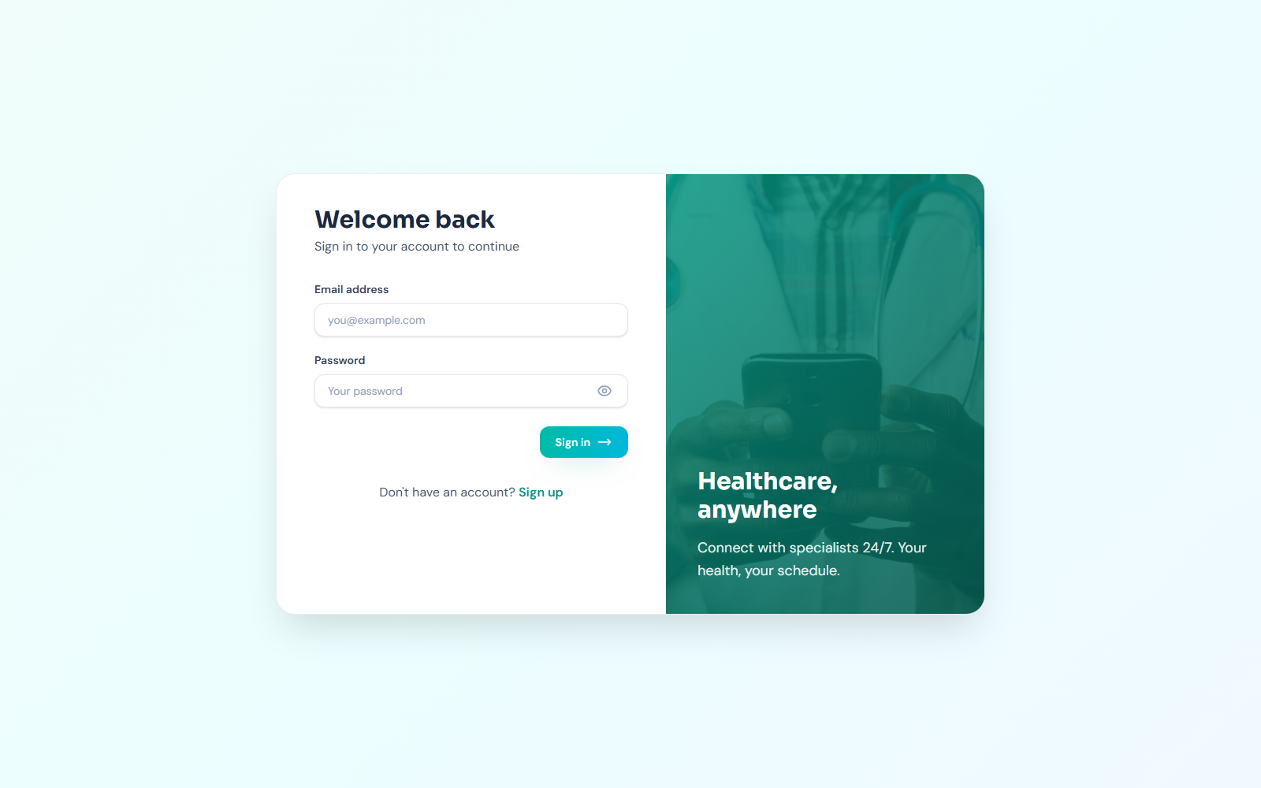
Figure 4.1: Telemedicine login page. Screenshot from the running system (2026).
The login screen provides a clear entry point for patient, physician and administrator accounts.

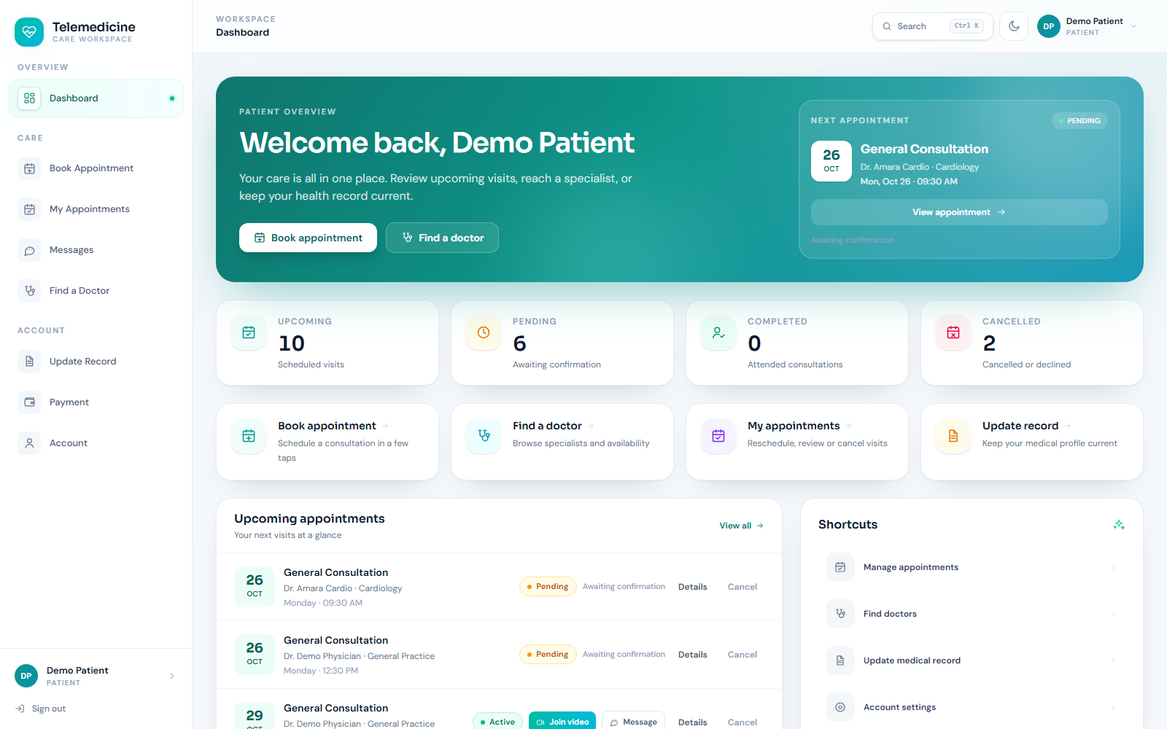
Figure 4.2: Patient dashboard. Screenshot from the running system (2026).
The patient view summarises upcoming appointments, services and shortcuts to booking and records.

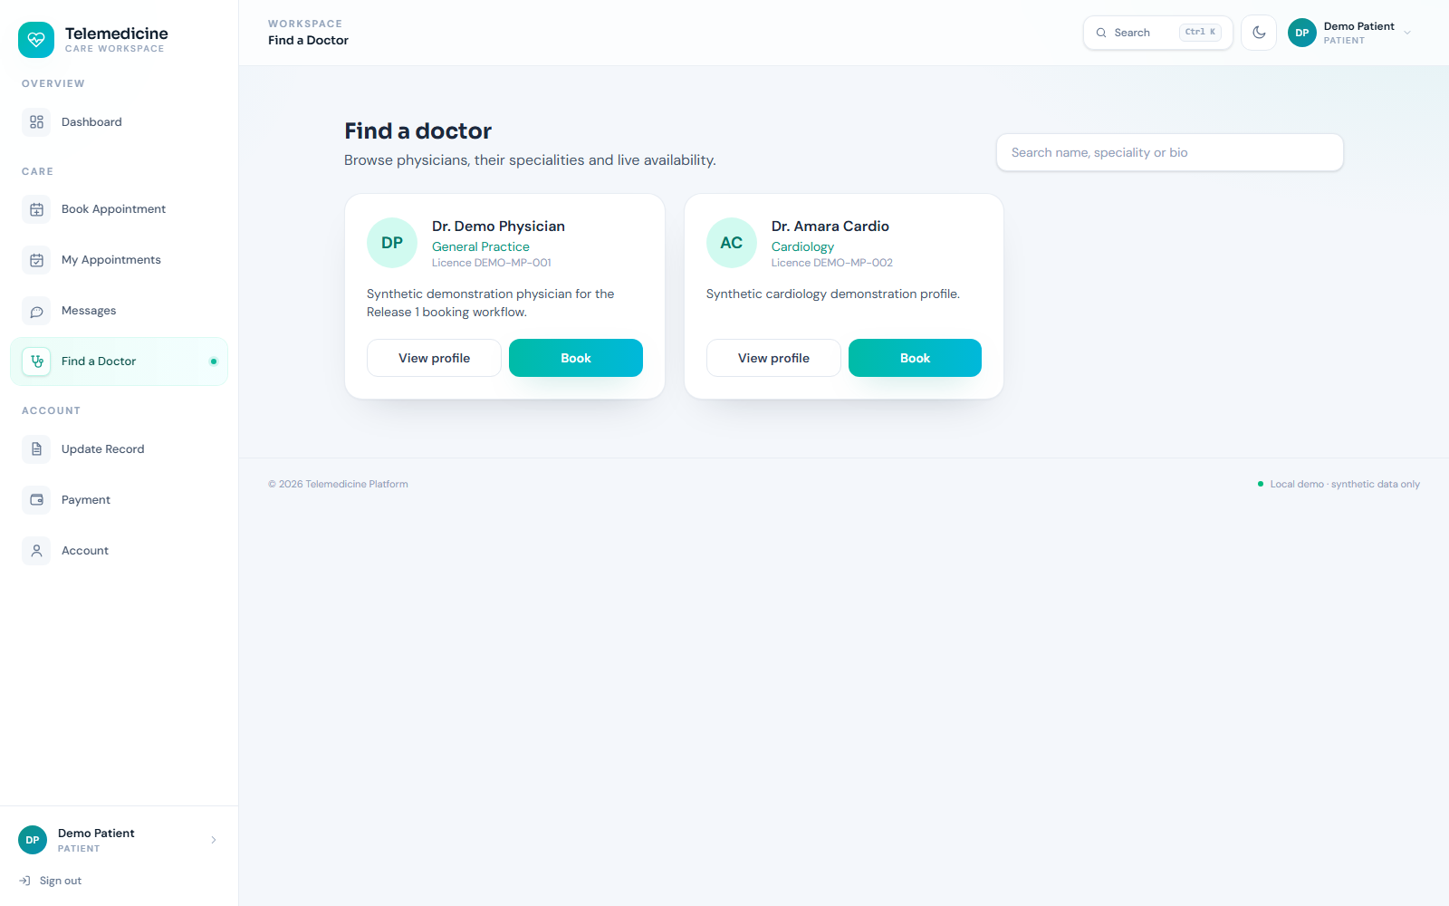
Figure 4.3: Doctor directory. Screenshot from the running system (2026).
Patients can compare physicians by speciality, experience, fee and availability.

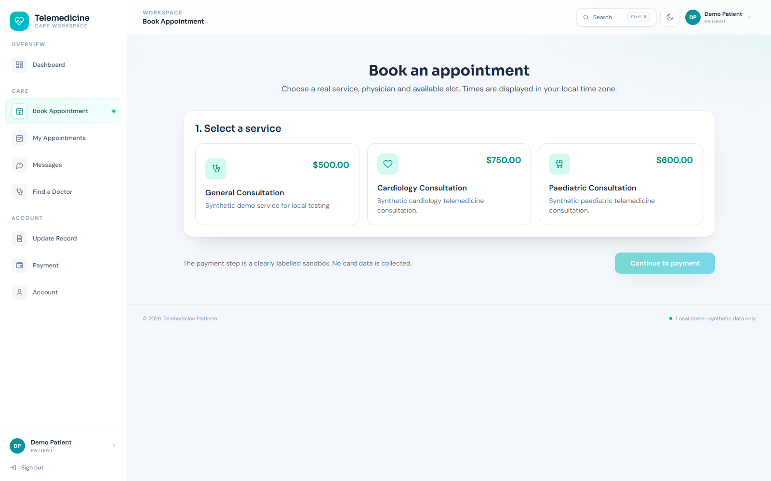
Figure 4.4: Appointment booking. Screenshot from the running system (2026).
The booking workflow selects a service before presenting available slots and payment context.

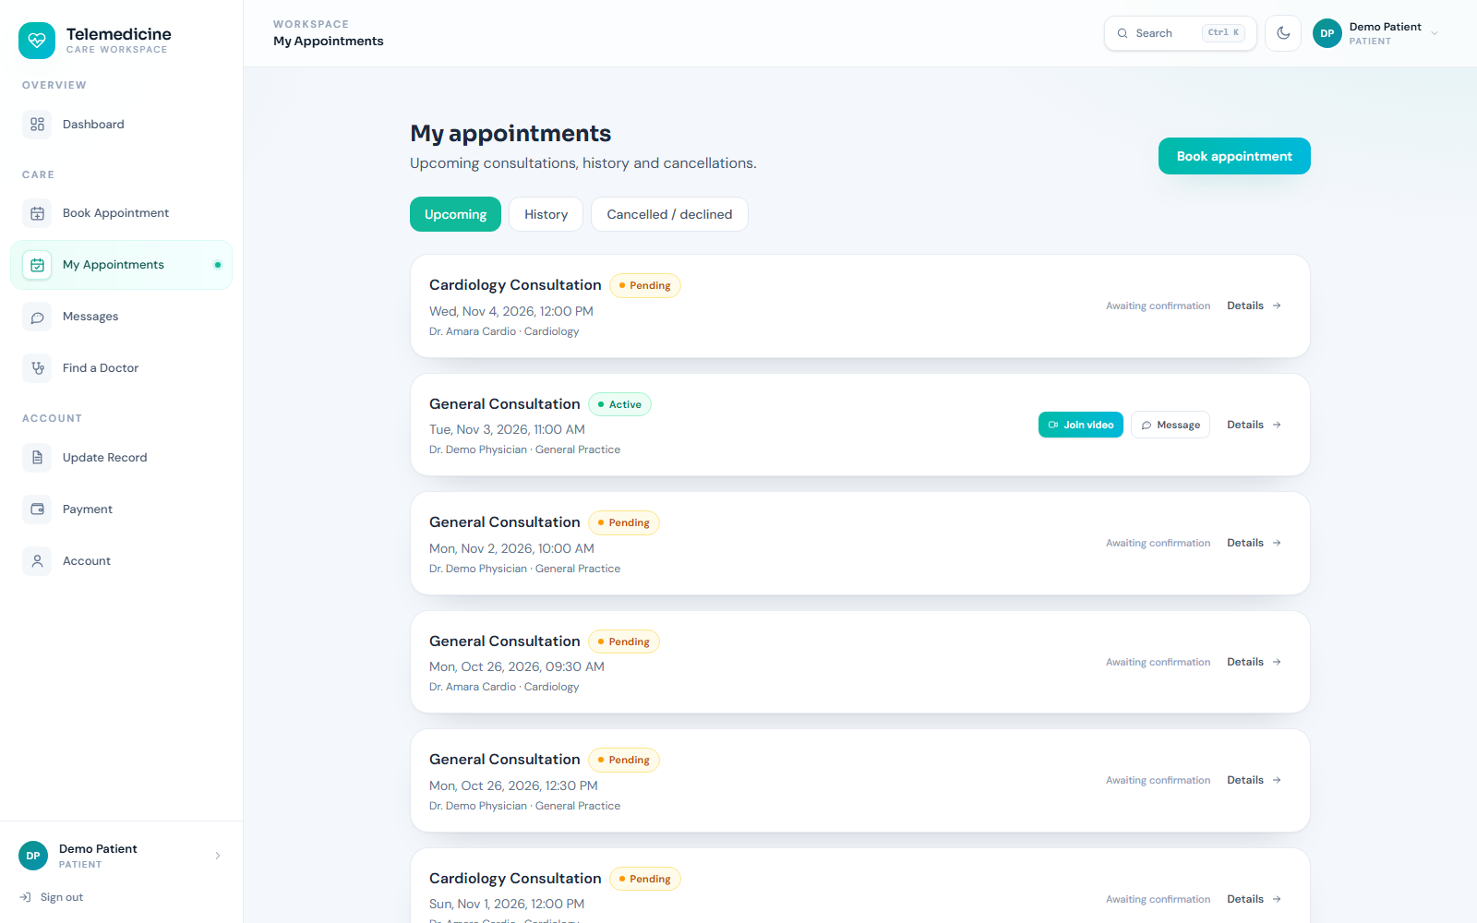
Figure 4.5: Patient appointment management. Screenshot from the running system (2026).
Appointments are separated into upcoming and historical views with reschedule and cancellation actions.

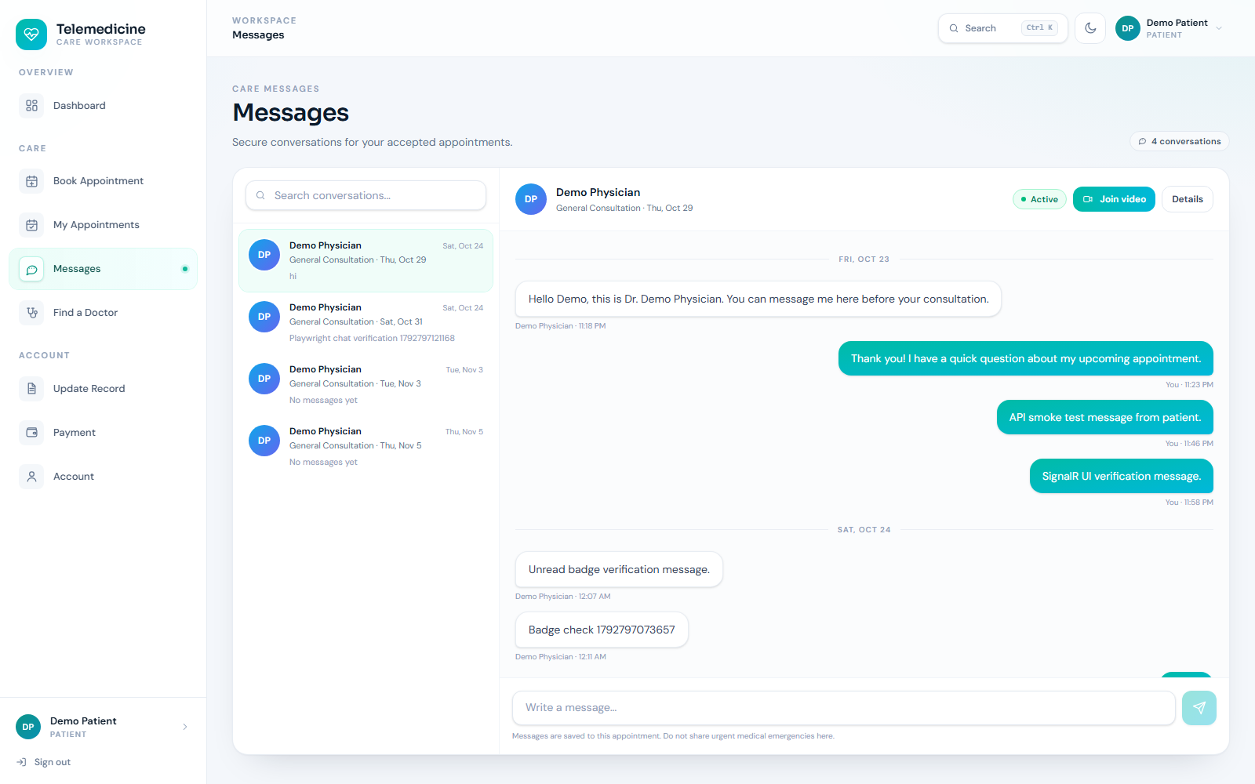
Figure 4.6: Secure patient-physician chat. Screenshot from the running system (2026).
The chat view demonstrates authenticated messaging attached to a consultation relationship.

Figure 4.7: Physician sign-in. Screenshot from the running system (2026).
The same authentication surface redirects a physician to the dedicated clinical workspace.

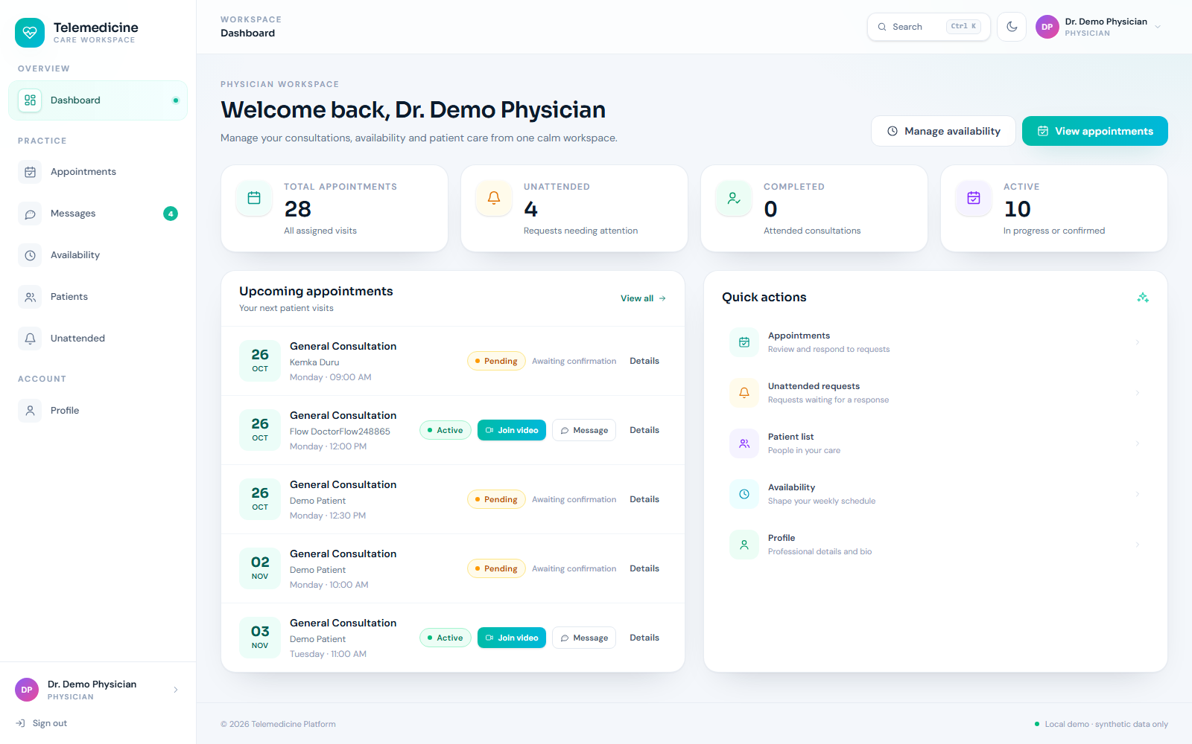
Figure 4.8: Physician dashboard. Screenshot from the running system (2026).
The physician dashboard presents workload, upcoming appointments and quick actions.

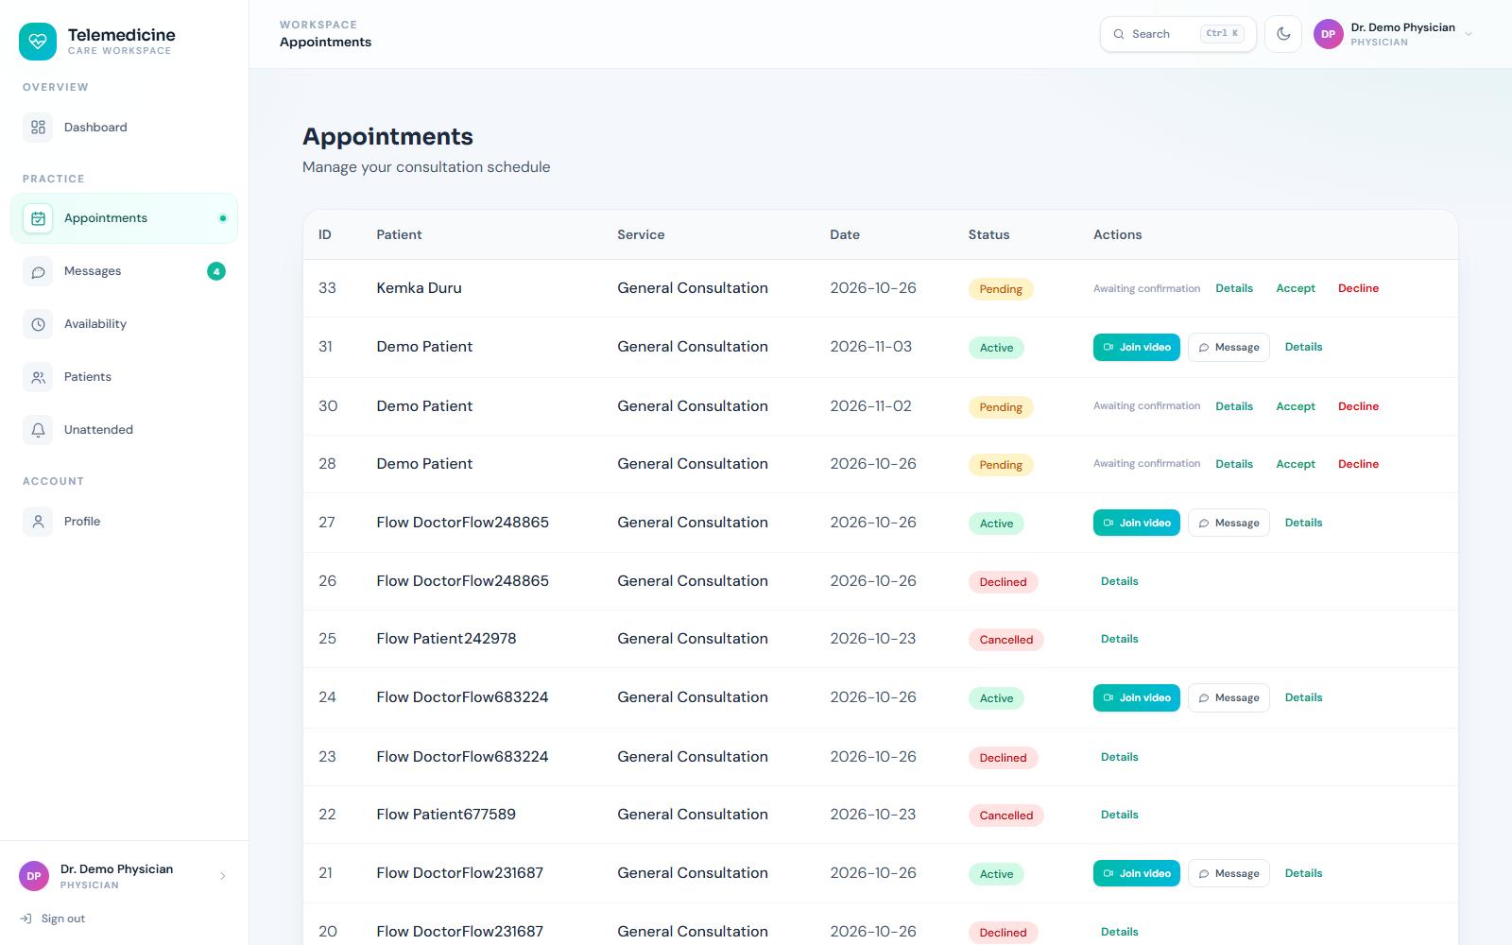
Figure 4.9: Physician appointment queue. Screenshot from the running system (2026).
Physicians can review requests and accept, decline, reschedule or message patients.

4.6 Testing Results
The following table summarises the test evidence. The results are based on the repository test suites and browser checks performed during the implementation. Where an optional integration test requires an external database or service, that dependency is stated explicitly.
Table 4.3: Summary of test evidence
Area | Test approach | Evidence
Domain rules | NUnit | Profile, availability and appointment invariants.
Application handlers | NUnit | Commands, queries and validation behaviour.
API integration | NUnit and PostgreSQL | Authentication, authorization, appointment states and record access.
Browser workflows | Playwright | Patient and physician login, booking, appointment and chat surfaces.

Overall verification: Release 1 evidence: 44 backend tests and 7 Playwright workflows pass.

4.6.1 Acceptance Test Cases
Acceptance cases connect the original requirements to observable evidence. The table below summarises the principal scenarios used to judge whether the workflow is complete.
Table 4.4: Acceptance test cases
ID | Scenario | Expected result | Evidence
AT-01 | A patient signs in with a valid account. | The patient dashboard is displayed. | Passed in Playwright workflow
AT-02 | A patient books an available slot. | An appointment is created with a pending/confirmed state. | Passed in integration test
AT-03 | A physician accepts an appointment. | The appointment state changes and the patient sees the update. | Passed in integration test
AT-04 | A patient requests another patient's record. | The API returns a forbidden response. | Passed in authorization test
AT-05 | A patient reschedules or cancels. | The valid state transition is applied and displayed. | Passed in workflow test
AT-06 | An authenticated patient sends a chat message. | The recipient receives the message through the approved surface. | Verified in browser workflow

4.7 Discussion of Results
The platform demonstrates that a role-based healthcare workflow can be represented without exposing clinical data or claiming to be a clinical product. The appointment state model and the separation between patient and physician workspaces are the strongest design elements. The absence of video, persistent chat history and comprehensive audit reporting are deliberate Release 1 boundaries rather than hidden functionality.
The evidence supports the conclusion that the main workflows are implemented rather than merely described. The combination of API tests, browser screenshots and explicit acceptance scenarios also exposes the boundary of the work: features that depend on an external provider, real institutional data or a more advanced analytical model are identified as future work rather than presented as completed.

4.8 Summary
The implemented system demonstrates the design described in Chapter Three and provides a working interface for the main user journeys. The screenshots, acceptance scenarios and tests show that data can be created, read, updated and controlled through the application. Chapter Five reflects on the project as a whole and identifies the most useful next steps.

CHAPTER FIVE: SUMMARY, CONCLUSION AND RECOMMENDATIONS

5.1 Summary
This project set out to design and implement Telemedicine Platform as a working final-year computer science artefact. The report reviewed the problem domain, related systems and technologies, then described an incremental methodology, a layered architecture, a relational and spatial data model, role-aware security and a practical testing strategy. The resulting application was demonstrated through actual interface screenshots and test evidence.

5.2 Conclusion
The Telemedicine Platform achieves its aim of demonstrating secure appointment coordination, availability management and patient-physician communication in a synthetic environment. It provides a useful foundation for later work on consent, messaging persistence, video consultation and audit, while remaining clearly separated from real clinical use.

5.3 Evaluation Against Objectives
The table below maps the original objectives to the implementation and evidence presented in Chapter Four. The purpose is to make the evaluation traceable rather than relying on a general claim that the system is complete.
Table 5.1: Evaluation against objectives
ID | Objective | Evaluation
OBJ-01 | Provide identity onboarding for patients, physicians and administrators. | Addressed - see Chapter Four implementation and test evidence
OBJ-02 | Model patient and physician profiles with role-specific information. | Addressed - see Chapter Four implementation and test evidence
OBJ-03 | Allow physicians to publish availability and generate bookable slots. | Addressed - see Chapter Four implementation and test evidence
OBJ-04 | Support booking, rescheduling, cancellation, acceptance and decline of appointments. | Addressed - see Chapter Four implementation and test evidence
OBJ-05 | Provide authenticated patient-physician chat and a constrained EMR read. | Addressed - see Chapter Four implementation and test evidence
OBJ-06 | Enforce role and record-level authorization and verify workflows with automated tests. | Addressed - see Chapter Four implementation and test evidence

5.4 Contributions
- A role-aware patient and physician onboarding workflow.
- A tested appointment state model with availability and booking.
- Authenticated chat and constrained EMR access.
- Clear documentation of clinical safety and scope boundaries.

5.5 Limitations of the Implementation
- No WebRTC video consultation or recording.
- Limited chat persistence and no full conversation history.
- No prescriptions, invoices, consent trail or clinical audit redesign.
- The system uses synthetic data and must not be used for actual care.

5.6 Recommendations
- Add a consent and audit model before any real deployment.
- Persist conversation history with retention controls.
- Add structured clinical records and prescription workflows only after approval.
- Introduce email verification, password reset and stronger session controls.

5.7 Suggestions for Future Work
- Evaluate a consented WebRTC consultation workflow.
- Add asynchronous messaging notifications and read receipts.
- Implement audit dashboards for administrators and compliance officers.
- Integrate standards-based health information exchange.

5.8 Final Remarks
The project provides a coherent, tested foundation for Telemedicine Platform. Its value is not only in the number of screens, but in the way the problem was decomposed into requirements, data, security and evidence. The documented limitations should be treated as a research and deployment agenda rather than hidden defects. With the recommended validation and operational work, the prototype can support further study or a supervised pilot in its intended domain.

REFERENCES
Hevner, A. R., March, S. T., Park, J., & Ram, S. (2004). Design science in information systems research. MIS Quarterly, 28(1), 75-105.
Microsoft. (n.d.). ASP.NET Core documentation. https://learn.microsoft.com/aspnet/core/
OWASP Foundation. (2021). OWASP Top 10:2021. https://owasp.org/Top10/
Pressman, R. S., & Maxim, B. R. (2020). Software engineering: A practitioner's approach (9th ed.). McGraw-Hill.
Sommerville, I. (2016). Software engineering (10th ed.). Pearson.
World Health Organization. (2010). Telemedicine: Opportunities and developments in Member States. https://www.who.int/publications/i/item/9789241564144
Nielsen, J. (1994). Usability engineering. Morgan Kaufmann.

APPENDIX A: DEMONSTRATION GUIDE
The following steps provide a repeatable demonstration of the implemented system. The sequence uses the development configuration and the demonstration accounts described in the project README.
- Start PostgreSQL and the API and SPA with run.cmd.
- Sign in as patient@demo.local to inspect the patient journey.
- Open Find a Doctor and Book Appointment to view available services.
- Review the appointments and chat screens.
- Sign in as physician@demo.local and open the physician dashboard.
- Review the appointment queue, availability and profile screens.
During the demonstration, inspect the loading, empty, success and validation states rather than only the populated screen. The screenshots in Chapter Four can be used as a visual checklist.

APPENDIX B: PRIMARY ROUTES AND ENDPOINTS
The routes below identify the principal user-facing pages or API areas used in the demonstration. The repository README contains the fuller endpoint catalogue and deployment notes.
Table B.1: Primary routes and endpoints
Route or endpoint | Purpose
/login | Shared login page
/dashboard | Patient dashboard
/dashboard/doctors | Doctor directory
/dashboard/book-service | Appointment booking
/dashboard/appointments | Patient appointments
/dashboard/chat | Patient chat
/physician | Physician dashboard
/physician/appointments | Physician appointment queue

Access to protected routes is subject to the role and ownership rules described in Chapter Three. A successful HTTP response does not by itself prove authorization; the negative tests and acceptance scenarios are the relevant evidence.

