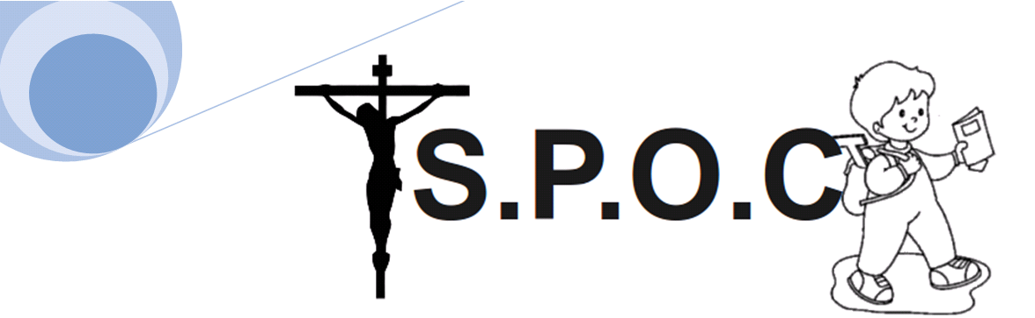

Margarette De Charach de Mombron
S.P.O.C 's Secretary
7 Rue de la bigotte
06000 NICE

Professor Igor Schwartzenberg
Auf der Driesch
Cologne

Dear Professor Schwartzenberg,

Our association is called «Save and Protect Our Children». We have been fighting since 1961 for the protection of children againt violence and perversity.
Indeed, thanks to new technologies such as the internet, cellphones and above all video games, our young boys and girls are more exposed than
ever to these dangers. That is why we are performing our awareness campaign.

Your internationally respected reputation on the dangers of video games is well known in France too. All the members of SPOC love your latest best seller «Video game are the first step on the path to Hell». We believe think you would be ideal as the key speaker for our third conference
on this subject « The video games' threat »

It would be a honour for us if you were to accept our invitation to Nice and share your thoughts with us. We will finalise the final date so as to suit your existing commitments and would therefore like to enquire as to your availability between the 15th and the 30th of june .

Yours Sincerly ,

Margarette De Charach de Mombron

