**Soapui uber Jenkins starten**

* Step 1: Open Soapui and goto the test Case
* Step 2: Right click and select Launch Test Runner
* Step 3: Run from Test Runner and copy the Commands
* Step 4: get Jenkins on your system
* Step 5: Optional->> Run Jenkins - java -jar jenkins.war --httpPort = xxxx
* Step 6: Create a new job and add details
* Step 7 : Build Environement klicken and Build -> add build step -> Execute Windows batch command or Execute Shell

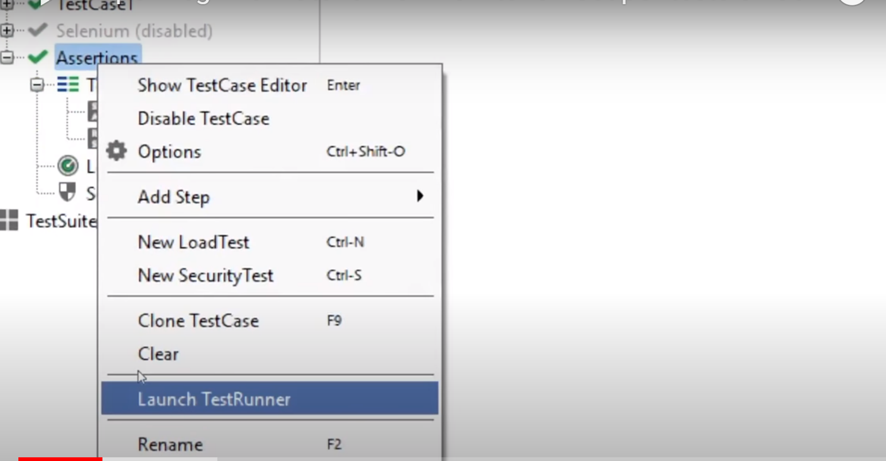

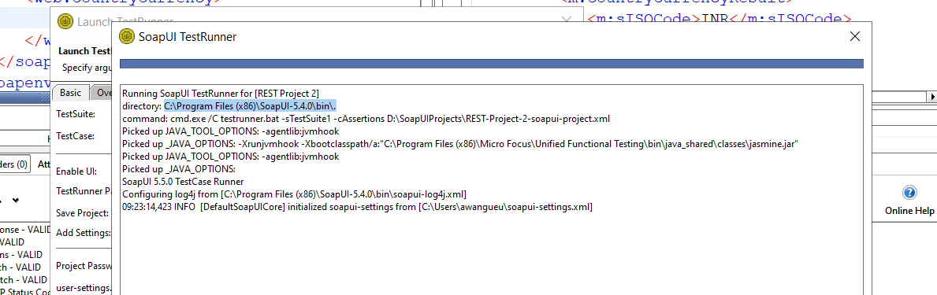

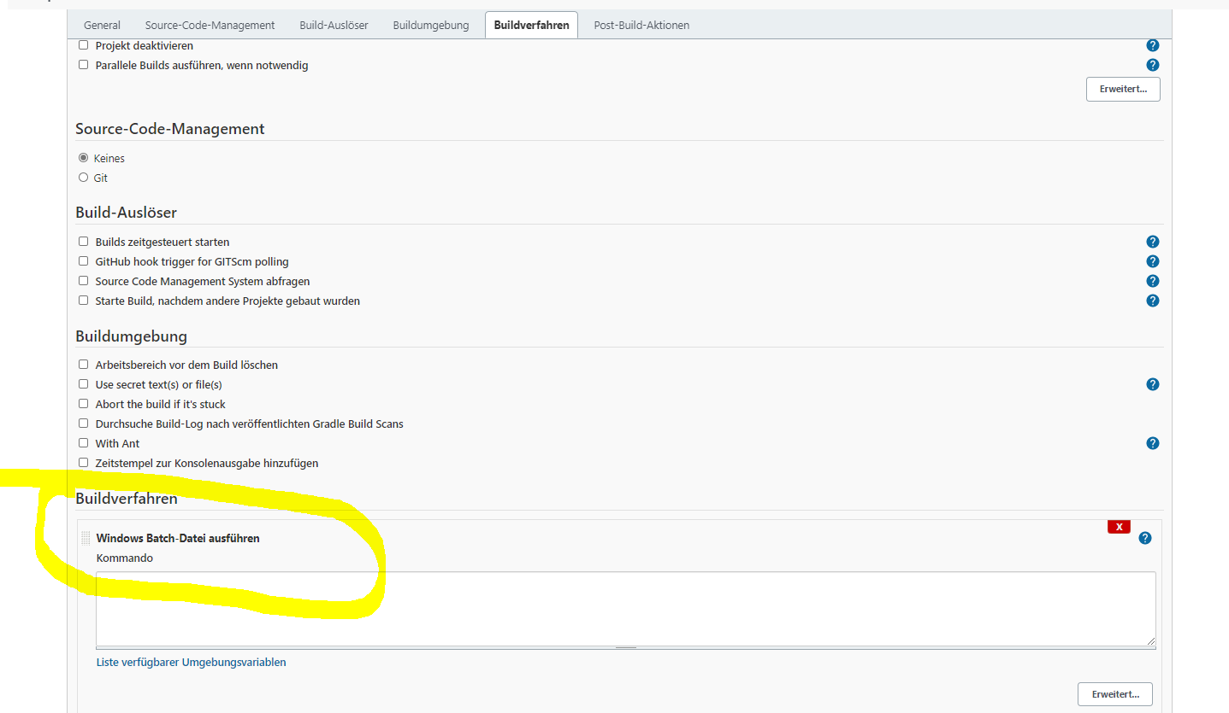

**How To setup API Monitors**

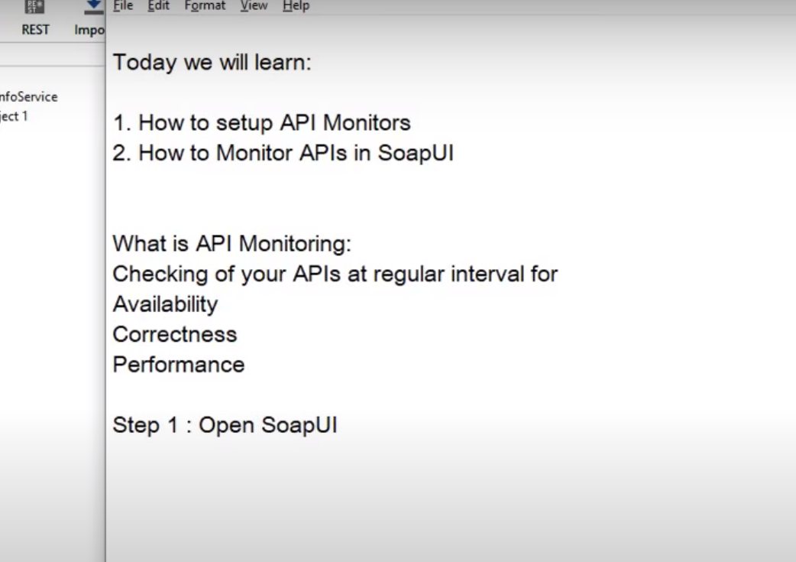

* Step 1: Open SoaPUI -> Right click on Project an Select - Montor APIS
* Step2 : Connect to AlertSite (SignUp | SignIn)
* Step 3: Add Monitor
* Step 4: API Status click and wait
* 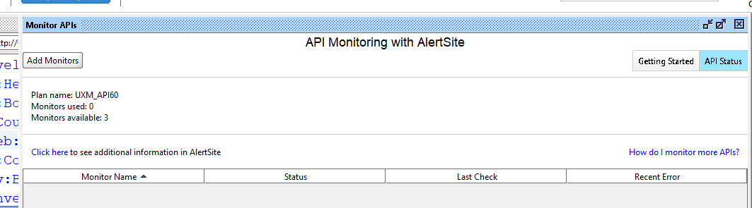

**How To add Soapui Project to Git**

* Step 1: Download and install Git
* Create GitHub account
* Add Soapui Project to Git