**Sprint 3 Retrospective**

|  |  |
| --- | --- |
| Group | 5 |

Members:

|  |  |  |  |  |
| --- | --- | --- | --- | --- |
|  | Alaina Johnson |  |  | Ryan Trull |
|  | Justin Young |  |  |  |

* **Bring a printed, stapled copy of your *Sprint 3 Retrospective* to the demo.**
* **Place a copy of your *Sprint 3 Retrospective* (and images) in the root folder of your master branch on GitHub.**
* **Make sure there is a README.md file in your repository as specified in the Sprint 3 Plan, Requirement 3.**

**Sprint 3 Plan Summary**

1. Provide a list of methods that have not been developed:

|  |  |
| --- | --- |
| **Class** | **Method** |
| Comments.java | Entire class. Meant to display comments on people’s answers |
| Likes.java | Entire class. Utilizes the points system to upvote/like comments and answers |
| GroupSearch.java | Entire class. Utilizes search group methods to locate a specific group or groups |
| Persistence.java | Entire class. Uses the persistence manager developed in Sprint 2 to save user information |

1. Provide a list of methods that are buggy and/or not fully tested:

|  |  |  |
| --- | --- | --- |
| **Class** | **Method** | **Comments** |
| N/A | N/A | From what we’ve tested, we haven’t found bugs with the core mechanisms |
|  |  |  |

1. Didn’t use website.
2. Display your Gui design below. Use a whole page if needed. Place your image in the root folder of your master branch on GitHub.

Mock-up design:

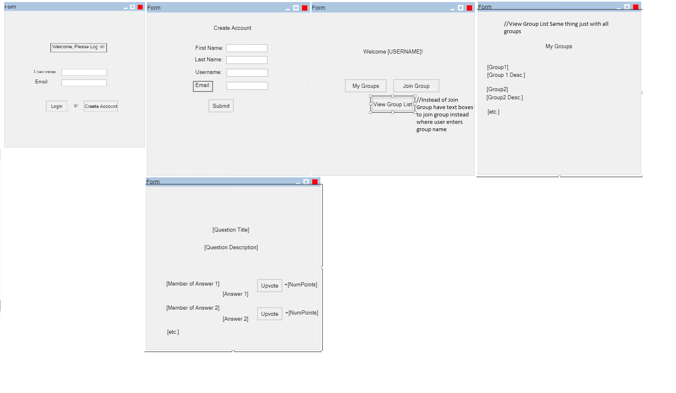

Actual GUI:

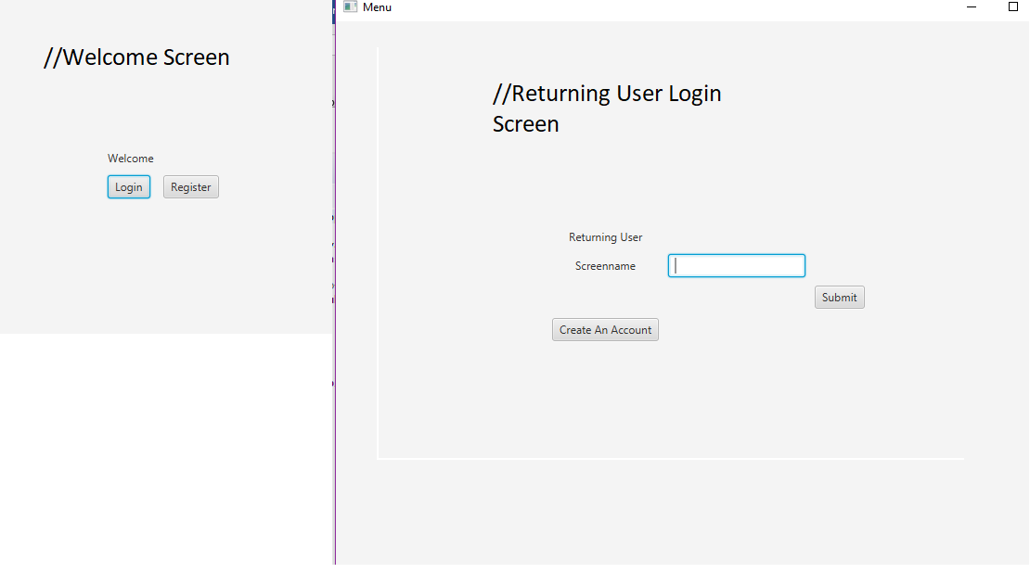

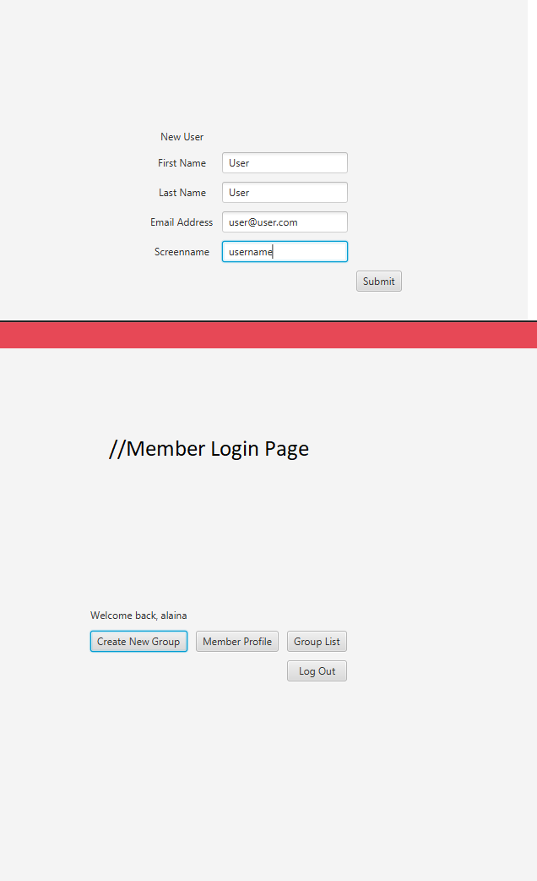

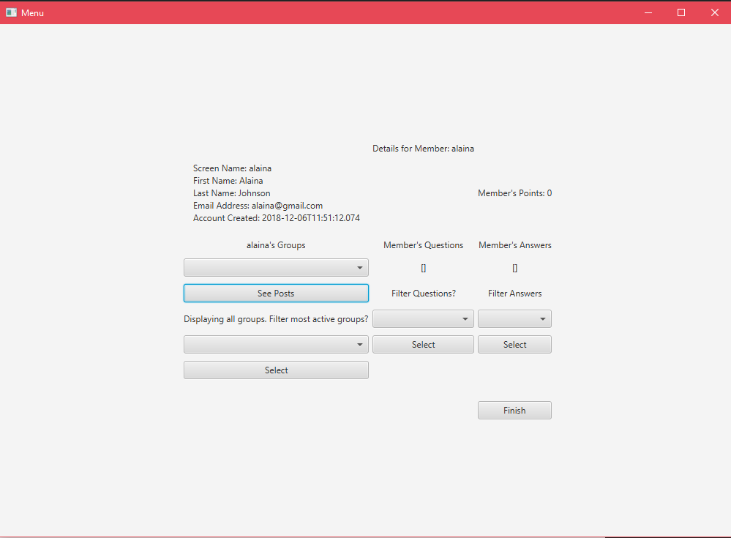

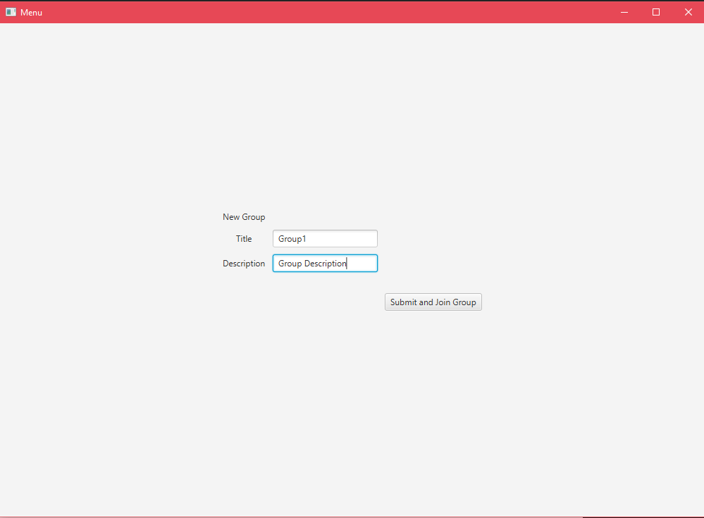

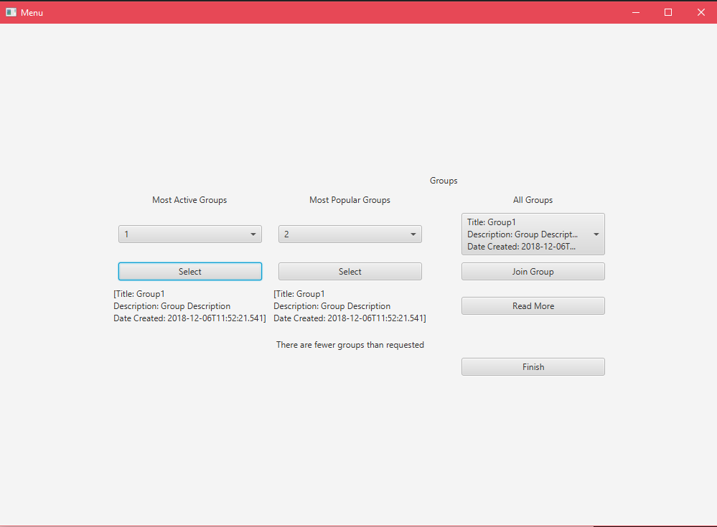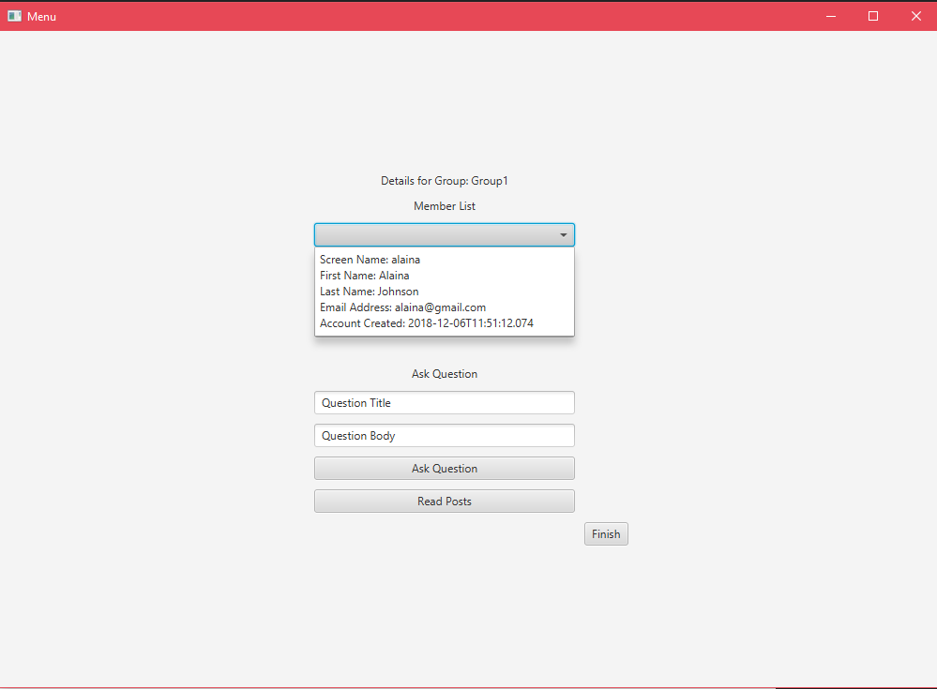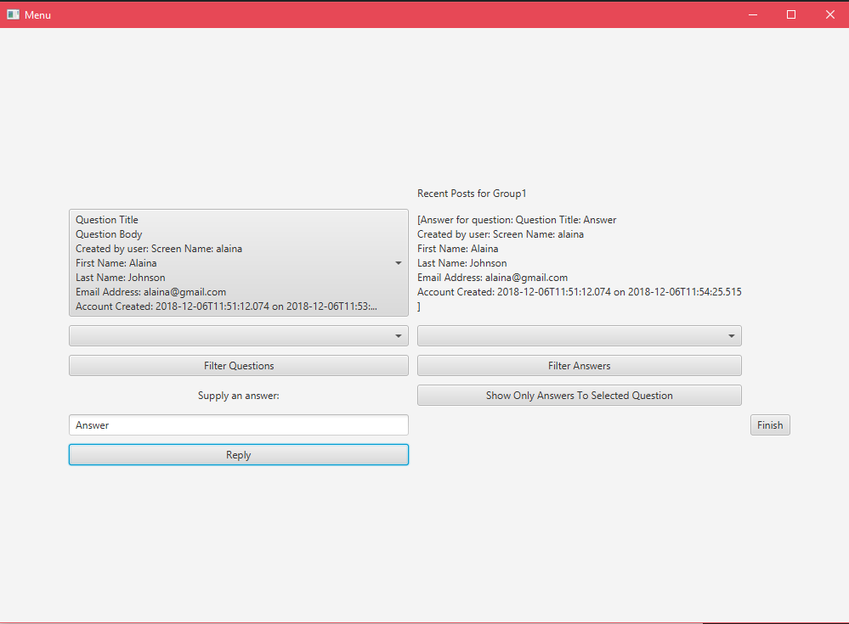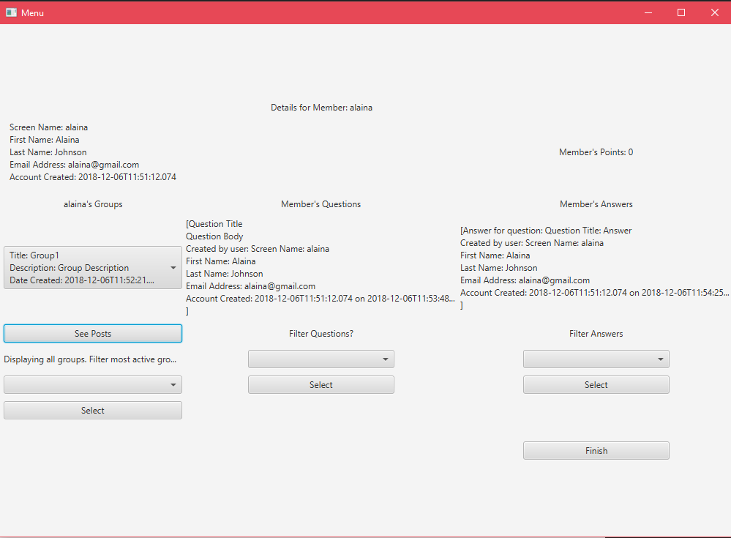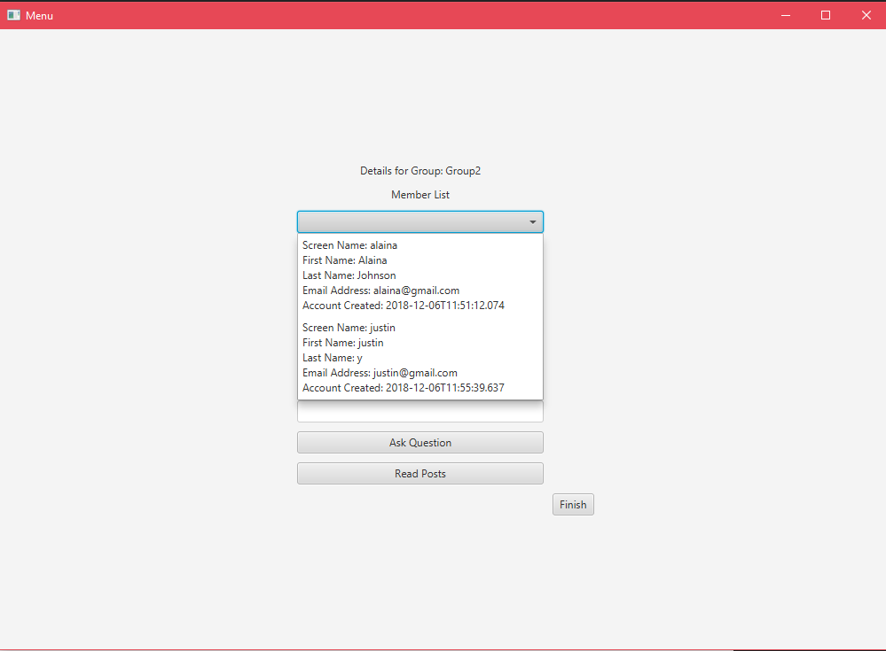

**Sprint 3 Retrospective**

Meet as a group and discuss the three questions below. Provide a thorough written response to each question below:

|  |  |
| --- | --- |
| **Question** | **Answer** |
| Discuss ways that your group’s ability to work as a team evolved over the 3 sprints. | We met repeadetly during the semester to discuss and plan out what we wanted to do with the project. Sometimes, we would work on it there and other times we would assign work to be done individually. We evolved by getting better at communicating and breaking up the work. |
| Discuss what you are most proud about your project. | We are proud that we were able to overcome the difficulties of Sprint 1 and catch up for Sprint 2. When we finished Sprint 1, we had a lot of broken and poorly implemented classes and we did extra research into fixing them in time for the next Sprint. |
| Regardless of the effectiveness of your team, discuss ways you could improve your team work. | We could do better when it comes to communication and updating Github. For communication, many times our schedules didn’t fit to talk or work on the project and it resulted in a lot of solo work. This semester has been busy for all of us and we could definitely improve on communication. As for updating Github, we need to improve by updating whenever we make any sort of change and assign issues and manage them on a regular basis. |