Translation Evaluations – How to Display Your New Feedback

1. Put the evaluation.json file you received into your Translation Evaluations folder.  
   A screenshot of a computer

   AI-generated content may be incorrect.
2. Open your Translation Evaluations folder in [Visual Studio Code](https://code.visualstudio.com)  
   A screenshot of a computer

   AI-generated content may be incorrect.
3. Open the config.json file pictured below. Notice the following patterns: In .json format, data is organized into *objects* and *lists* following a nesting structure. The data collected into objects and lists are presented within key-value pairs. For example:

|  |  |
| --- | --- |
| **Key** | **Value** |
| translator | Translator’s Name |
| evaluator | Alaina Brandt |
| identifier | TR18 |
| … and so on |  |

The text constituting the key (field) and the value must be surrounded in straight quotes not curly quotes ["translator", not “translator”]. There can be no spaces in the key, so people use camelCase (starting each word after the first word with a capital letter) to make the key easier to read. The key and the value must be separated by a colon : with no space before the colon.   
  
Note: The evaluation_files key is where we set what evaluations we’d like to display on the Translation Evaluations webpage (translation-evaluations.html). The evaluations_files object has for its value a list of key-value pairs. In the list, the key is the name of the evaluation.json we’ve received, and the value is the pretty title for this file that will be displayed in the dropdown menu on the webpage.   
  
Notice how the other key-value pairs are displayed on the webpage pictured on the next page:  
- We can fill out a name for Translator's Name and that displays on the page.  
- The identifier value displays as part of the title in the page header and in the footer contents  
- The organization and period values display as part of the footer contents.  
- The evaluation_files values are used to establish a pretty title for the file for the dropdown menu. They are also how the system knows which evaluation.json file contents to load onto the Translation Evaluations webpage when the pretty title is selected.  
  
1. Give editing the config.json a try. Make these edits to the config.json file:
   * You can start by adding a comma after the first list item. The comma tells the system that the next list item follows. A comma is not needed after the last (or only) item in a list.
   * Add the following key-value pair to the list on the next line, updating the key to the file name including the .json extension and the value to the pretty title you’d like to give to the text, and keeping the indentation consistent with the previous line:  
     "new-translation-evaluation.json": "New Translation Evaluation"  
       
     A screenshot of a computer code

     AI-generated content may be incorrect.  
       
     **Remember!** The quotes that you use in the file should be straight not curly ["translator", not “translator”]. Some programs auto-correct straight quotes to curly quotes (like MS Word), so when copying text into the .json file, be aware of this common source of issues.
2. Right click on the translation-evaluations.html file and click Open with Live Server  
   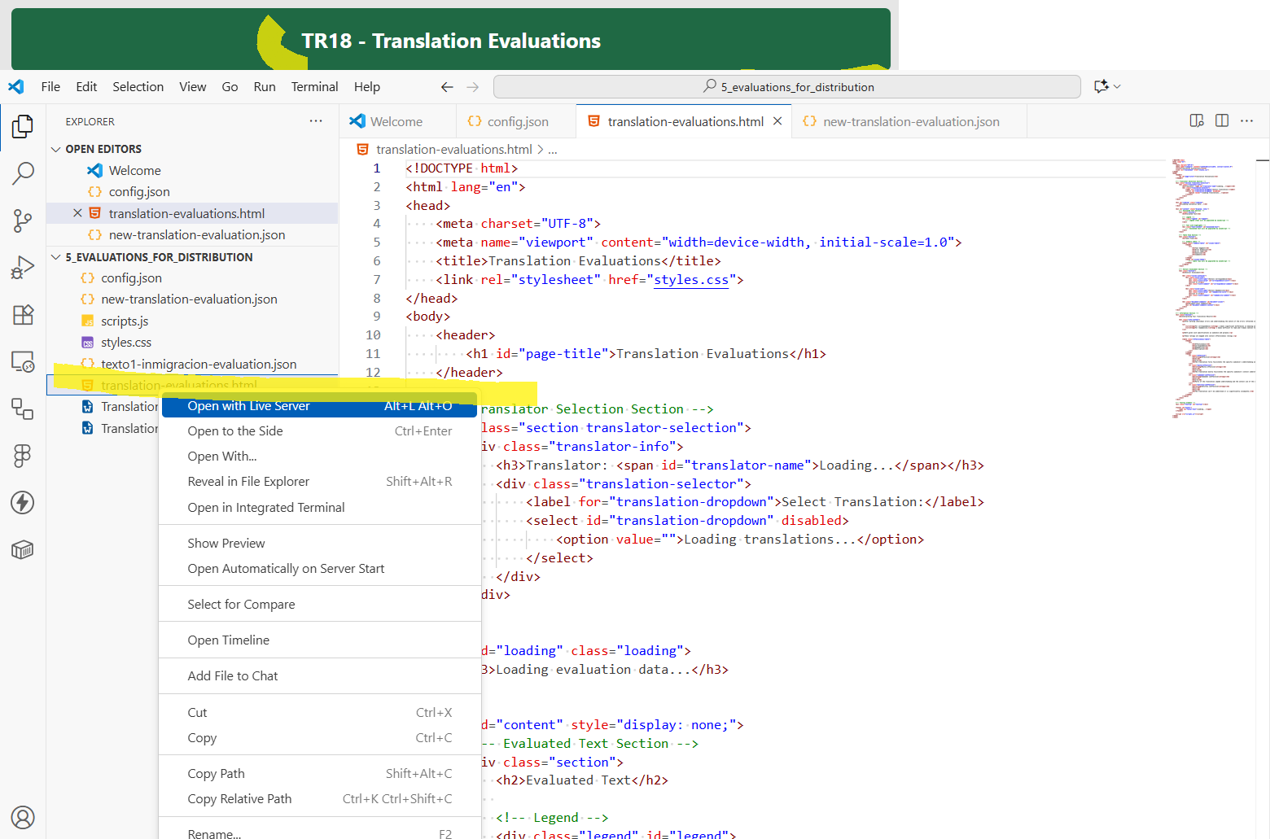
3. View your results on the local webpage that opened. The key-value pair you added should now be functioning on your webpage. The pretty title you gave the evaluation.json file now displays in the dropdown menu. When you select the pretty title, the data from the evaluation.json will be displayed on your page.  
     
   A screenshot of a computer

   AI-generated content may be incorrect.
4. Please let me know of any display issues that you encounter so that I can troubleshoot the code as necessary!