R markdown notes

2022-03-22

Table of Contents

## above here is the metadata…in the .Rmd file

pound sign defines a header

## settings for the file

by changing inclue to false it will hide this code

knitr::opts_chunk$set(  
 echo = FALSE,  
 warning = FALSE,  
 message = FALSE,  
 comment = NA)

# big header

## smaller header

### even smaller header

text in here is just text in the body of your document

you can set the output to basically anything from a pdf to a ppt, you just define these in the output settings

# making a list

dash before text makes a list

* tile = title,
* author = defines aithors with affiliations and a url for the author,
* date = date,
* output = the output options that you will knit to
  + toc = table of contents,
  + toc float = where the table of contents will go,
  + theme = how the file will look,
  + distill::distill_article: = specific formatting for html files, bookdown is just a dif way of formatting
    - the further you tab over
      * means you can make
        + sub

points

#libraries  
library(tidyverse)

# making a figure caption

# here is an example of some code you can put in (hotkey: cmd+option+i)

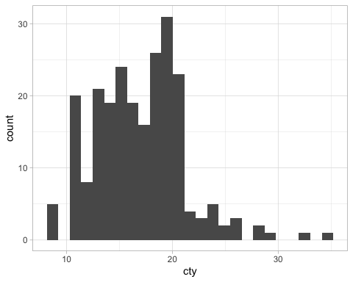

caption

Figure @ref(fig:name) !!!

# GRAPHICS

some graphics setting