Effects of indirect facilitation on functional diversity, dominance and niche differentiation in tropical alpine communities

Alain Danet, Fabien Anthelme, Nicolas Gross & Sonia Kéfi
Danet, A. (Corresponding author, alain.danet@umontpellier.fr)^{1,2}
Anthelme, F. (fabien.anthelme@ird.fr)^{2,3,4}
Gross, N. (nicolas.gross@cebc.cnrs.fr)^{5,6,7}
Kéfi, S. (sonia.kefi@umontpellier.fr)¹
¹ ISEM, CNRS, Université de Montpellier, IRD, EPHE, Montpellier, France;
² AMAP, Université de Montpellier, IRD, CIRAD, CNRS, INRA, Montpellier, France;
³ Museo Nacional de Historia Natural, Herbario Nacional de Bolivia, Cota Cota, La Paz, Bolivia;
⁴ Instituto de Ecologìa, Univ. Mayor San Andrès, Cota Cota, La Paz, Bolivia;
⁵ Departamento de Biologìa y Geologìa, Fìsica y Quìmica Inorgànica, Escuela Superior de Ciencias Experimentales y Tecnologìa, Universidad Rey Juan Carlos, C/ Tulipàn s/n, 28933 Mòstoles, Spain;
⁶ INRA, USC1339 Chizé (CEBC), F-79360 Villiers en Bois, France;
⁷ Centre d’étude biologique de Chizé, CNRS - Université La Rochelle (UMR 7372), F-79360 Villiers en Bois, France.
Printed journal page estimate: 5950 words (6 pages), figure 2 pages, total 8 pages.
Keywords: indirect facilitation; grazing; functional diversity; niche; coexistence; functional traits; trait distribution; permutation; tropical alpine peatlands
Nomenclature: Meneses, Beck, & Anthelme (2015)
Abbreviations: LDMC: Leaf Dry Matter Content
Running head: Effect of indirect facilitation on functional diversity of alpine plant communities

Introduction
Interactions between organisms are fundamental drivers of community composition, which in turn determines ecosystem properties such as productivity and resilience. Abiotic constraints (i.e. stress and disturbance) and negative interactions (i.e. competition and predation) have traditionally been considered to be the main processes structuring ecological communities (Vellend, 2010), although numerous studies have also outlaid the importance of facilitative interactions (Bertness & Callaway, 1994; Callaway, 2007; Cardinale, Palmer, & Collins, 2002; Wright, Wardle, Callaway, & Gaxiola, 2017). Direct facilitation from a facilitator to an associated species arises from the improvement of the surrounding abiotic environment, such as water retention, decrease in evapotranspiration and shading (Filazzola & Lortie, 2014). Indirect facilitation between two species occurs via a third species most commonly arising from intransitivity (Levine, Bascompte, Adler, & Allesina, 2017), shared competitors (Wootton, 1994) or grazing (Danet, Kéfi, Meneses, & Anthelme, 2017; Milchunas & Noy-Meir, 2002). For example, an unpalatable plant (hereafter referred to as a ‘nurse’) can reduce the feeding rate of a grazer on palatable plants growing in the neighborhood of the nurse (the so-called ‘associated community’), resulting in indirect facilitation from the nurse to the associated community.
Empirical and theoretical studies have shown that direct and indirect facilitation could contribute to locally increase species richness, productivity and biomass (Callaway, 2007; Graff, Aguiar, & Chaneton, 2007; Michalet et al., 2006, 2015). Those previous studies have, however, rarely investigated the associated changes in functional traits (Butterfield & Callaway, 2013), except for a few pioneering studies (Gross et al., 2013, 2009; Schöb, Armas, Guler, Prieto, & Pugnaire, 2013; Schöb, Butterfield, & Pugnaire, 2012; Soliveres et al., 2014). Investigating the variations in plant morphological traits is one way to better understand the underlying processes leading to facilitation (Pawar, 2015; Violle et al., 2007). For instance, the leaf dry matter content (LDMC) is closely related to a plant’s relative growth rate (Garnier, Navas, & Grigulis, 2016) and to the species susceptibility to herbivory (Gross, Liancourt, Butters, Duncan, & Hulme, 2015). In a context of grazing, it is predicted that low LDMC species will benefit more from the shelter of a nurse than less palatable, high LDMC species (Liancourt, Callaway, & Michalet, 2005). Schöb et al. (2012) also showed that the plant communities associated to alpine cushions had different trait value ranges from those found in open areas. While previous studies have shown that using a trait-based approach may help to understand the outcomes of competitive and facilitative interactions between species, very few have examined how direct and indirect facilitative interactions impact the community structure as a whole (Gross et al., 2009). How facilitation shapes plant functional diversity and community structure constitutes a substantial research gap in community ecology (Enquist et al., 2015; Violle et al., 2012).
Facilitation has been hypothesized to increase functional diversity (Butterfield & Callaway, 2013; Gross et al., 2009; Schöb et al., 2012). However, there are multiple ways by which facilitation may impact community structure (Gross et al., 2009). (i) Previous studies have suggested that facilitation is especially beneficial for maladapted species that can persist at low abundance under the shelter of nurse species (Bruno, Stachowicz, & Bertness, 2003; Liancourt et al., 2005; Soliveres et al., 2015a). By maintaining rare species with contrasted trait syndromes compared to the well-adapted nurse plant species, facilitation may therefore increase functional diversity by increasing the phenotypic space occupied by species in a community (phenotypic space hypothesis, H1). (ii) Studies have also shown that facilitation could benefit dominant species in some cases. Schöb et al. (2012) notably showed that, in response to increasing elevation, alpine cushions could either move, relax environmental pressures on associated communities or both, resulting in changes in the trait distributions observed in the associated communities. By modifying the environmental pressures, facilitation may impact the dominant status of species in communities and thus modify the trait abundance distribution of the whole community, possibly leading to flat or even bimodal trait distributions (Gross et al., 2017 trait abundance distribution hypothesis, H2, 2009). (iii) Moreover, facilitated species often co-occur under nurse species with other beneficiaries. Bulleri, Bruno, Silliman, & Stachowicz (2016) proposed that the facilitation of co-occurring beneficiaries could lead to a decrease in niche difference between beneficiaries via niche expansion of each beneficiary and thus to an increase in competition between them. In such a case, facilitation should result in more niche overlap between the species of associated communities. An alternative hypothesis could be that facilitation, by decreasing environmental pressure, enables beneficiary species to develop a larger range of traits and thus lead to an increase of the niche differences between beneficiaries (the niche differentiation hypothesis, H3). We tested these three alternative hypotheses (i-iii) about the role of indirect facilitation on the functional structure of plant communities.
Our study took place in tropical alpine peatland ecosystems of the Cordillera Real, in Bolivia. Like in most alpine environments (e.g. Callaway et al., 2002), plant communities of tropical alpine environments are strongly driven by positive interactions among plants (Hupp, Llambí, Ramírez, & Callaway, 2017; Malatesta, Tardella, Piermarteri, & Catorci, 2016), but the mechanisms underlying those interactions are different (reviewed in Anthelme & Dangles, 2012).
In our study sites, cushion species are a source of direct facilitation and host specific plant communities that are not found outside the cushions (Loza Herrera, Meneses, & Anthelme, 2015; Ruthsatz, 2012). These ecosystems are used as rangelands (Buttolph & Coppock, 2004). Two cushion-forming species dominate the ecosystems: Distichia muscoides Nees & Meyen and Oxychloe andina Phil. (Loza Herrera et al., 2015; Raevel, Anthelme, Meneses, & Munoz, 2018). D. muscoides forms a compact cushion which decreases the possibilities for a grazer to harvest their leaves. O. andina develops very sharp and long leaves which repel grazers. The two cushion species differ by other characteristics such as their compaction and their height (see also Loza Herrera et al., 2015 for more details). Previous studies showed that D. muscoides is among the preferred food for camelid livestock (López López, 2004; Reiner & Bryant, 1986) but that O. andina is also consumed (Meneses et al., 2015). As far as we know, there is no evidence for other types of protection against herbivores, such as chemical compounds, in both cushion species. Two recent studies suggested that the protection of O. andina against grazing extends to its associated community (indirect facilitation), whereas the one of D. muscoides does not (Danet et al., 2017; Raevel et al., 2018). We performed a grazing exclusion experiment and evaluated the response of the functional diversity of the associated communities in the two dominant nurse plants. Differences in the traits of the associated plant communities found in D. muscoides with and without grazing was expected to reveal the direct effects of grazing on the associated plant communities in the absence of indirect facilitation. In turn, the comparison of the traits of the associated plant communities observed in O. andina with and without grazing was expected to reveal both direct and indirect effects. Accordingly, comparing the effects exerted by the two nurse plants was expected to reveal the effect of indirect facilitation on the traits of the associated plant communities.

Methods

Study site
Our study took place in the tropical alpine peatlands of the Palcoco Valley (16°08’50"S, 68°17’08"W) at an elevation of 4500 m a.s.l in the north of La Paz in Bolivia (Figure [fig:wetland] and [fig:expe]). The site has a dry tropical climate characterized by a short humid season (December to march, rainfall reaches 410 mm and average temperature is 6.4 °C) and a long dry season (rest of the year, rainfall reaches 184 mm and average temperature is 4.5 °C, Loza Herrera et al., 2015). Those peatlands, dominated by the two cushion species D. muscoides and O. andina, generate a specific wetland plant community that is absent outside the cushions (Loza Herrera et al., 2015; Ruthsatz, 2012). The cushion species are thus considered obligate nurses through direct facilitation for a number of associated species.
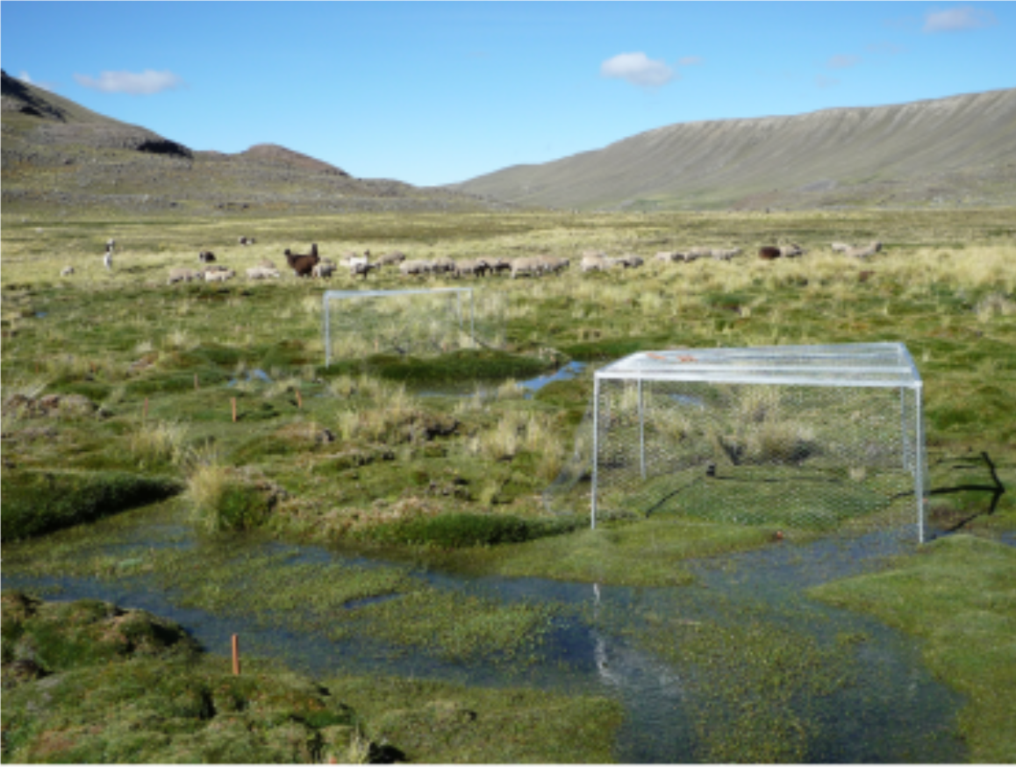
A peatland of the Palcoco valley with two plots at the forefront, one exclusion cage and one control (visible thanks to the wooden post). The structuring vegetation is composed of two cushion-forming plants: Oxychloe andina and Distichia muscoides. In the background, the cushions are increasingly colonized by the tussock grass Festuca dolichophylla spreading from the borders of the peatland.

Experimental design
We set up a grazing exclusion experiment in two peatlands of the Palcoco valley 1.5 km distant from each other and taken as repetitions. Those peatlands are extensively grazed by a domestic herd of about 300 individuals containing mainly llama (Llama glama L.), alpaca (Llama pacos L.) and a few sheeps (Ovis aries L.). The metal fences (1.5 x 1.5 x 0.5 m, Fig. [fig:wetland]) excluding grazers were etablished in February 2014 over D. muscoides and O. andina cushions. The fences were covered with chicken wire to also exclude medium to large herbivores naturally present, such as viscacha (Lagidium sp). The studied plots had an area of 1 square meter, letting a 25 cm thick border on each side inside the cage to avoid side effects. The fenced plots displaying unexpected signs of grazing were excluded from the analysis. Note that the fences were not made to exclude small grazers such as caterpillars, and it would be an interesting follow-up to estimate the importance of the effects of other grazers, such as caterpillars which can also have an important effect on functional community structure (Deraison, Badenhausser, Loeuille, Scherber, & Gross, 2015). However, there is no reason to think that smaller grazers could create confounding effects. The control plots were paired to the fenced plots (1-2 m away) to increase the statistical power of the analysis of grazing effects. We sampled 40 plots in total: 10 ungrazed over O. andina, 10 ungrazed over D. muscoides, 10 control plots over O. andina and 10 control plots over D. muscoides. See Danet et al. (2017) for a more extensive description of the experimental design.

Data collection
Plot sampling occurred 22 months after the start of the grazing exclusion, in December 2015. We collected relative cover, maximum height and leaves of all the associated species present in each of the plots. To assess the response of the associated plant communities to grazing, we measured three functional traits relevant in a context of grazing, which represent different dimensions of plant strategies (see Danet et al., 2017; Raevel et al., 2018 for details about the variations of those traits in the same system under different grazing conditions). LDMC characterizes plant resource acquisition strategies and is negatively correlated with maximum relative growth rate, because of a trade-off between resource acquisition speed and nutrient conservation (Westoby, Falster, Moles, Vesk, & Wright, 2002). LDMC has also been linked to palatability (Louault, Pillar, Aufrere, Garnier, & Soussana, 2005), high values of LDMC being correlated with low palatability. Together, those covariations reflect the growth-defense trade-off (Lind et al., 2013). There is also strong evidence that leaf mechanical properties play a role in deterring herbivores (Read & Stokes, 2006), notably the toughness (Ibanez, Lavorel, Puijalon, & Moretti, 2013). The physical resistance of the leaves is largely linked to their thickness (Pérez-Harguindeguy et al., 2013). Leaf thickness was thus used to assess the variations in the physical resistance of the leaves. Although often measured as a major trait accounting for aboveground competition (Westoby, 1998), we also considered maximum height as the closest proxy for grazing effects (see Díaz, Noy-Meir, & Cabido, 2001) and as an indicator of aboveground biomass (Catchpole & Wheeler, 1992).
In each plot and for each species, we sampled three leaves on four individuals and measured the maximum height of those individuals. For species with tiny leaves, we collected the whole individual (Danet et al., 2017). The trait collection followed standardized guidelines (Pérez-Harguindeguy et al., 2013). In total, 357 individuals were sampled for the 30 associated species found in the whole data set.

Data analysis
The trait measurements were averaged to have a single observation per species and per plot for each functional trait. Trait values were standardized (i.e. centered and scaled) across the whole data set to make their variations comparable, in particular for the comparisons of the phenotypic space.
Since the plots contained only a few data points and since the species abundances were highly variables because of the extreme environmental conditions, we pooled all the replicates (plots) of a given treatment combination for the subsequent analysis; this means that we had one community per treatment combination, i.e. four different communities in total (see Figure [fig:hypervolume]).
Statistical inference was obtained by permutations and resampling methods. In simple terms, we randomized trait values in the communities and compared the observed communities to the randomized ones. This method is common to the analysis of the phenotypic space and of the species niche differentiation; the details of null community computation are given in the following parts. The null communities provided a null distribution of parameters from which Standardized Effect Sizes (SES) were derived as the difference between the observed value of a parameter (x_{obs}) and the mean value of the null parameter distribution ($\overline{\hbox{x}}\m@th$_{null}), divided by the standard deviation of the null parameter distribution (s_{null}) (Eq. [eq:ses]).

We used the null distributions to define the confidence intervals with = 0.05, by reporting the positions of the quantiles at 0.025 and 0.975. We derived P-values by computing the proportion of the N null communities (x_{i, null}) showing an absolute difference superior or equal to the observed one (Eq. [eq:p_value]). We considered the difference as significant when this proportion was below 5%.

Hypothesis
In the absence of plant communities outside the cushion species (see Study site), the comparison between the two cushion species in both grazed and ungrazed conditions is the only way to assess the effect of indirect facilitation on the associated plant communities. For a given variable, (1) if the ungrazed plots are not different from the grazed plots in both cushions, that would suggest that grazing had no significant effect; (2) if grazed and ungrazed plots are different for both cushion species, it would be difficult to conclude about indirect facilitation; (3) if there are differences between ungrazed and grazed plots in D. muscoides and not in O. andina, that would suggest that O. andina protects its associated communities against grazing, an evidence of indirect facilitation; finally, (4) if the ungrazed plots are different from the control plots only in O. andina, that would contradict our expectation that the protection against grazing provided by O. andina was better than the one of D. muscoides. The comparison between the grazed and ungrazed treatments in each of the cushion species allows to isolate the effect of large mammal herbivores from potential differences of facilitation mechanisms between the two cushion species. Previous studies have documented the difference of protection between D. muscoides and O. andina, and shown that the protection of O. andina against grazing extends to its associated community, whereas the one of D. muscoides does not (Danet et al., 2017; Raevel et al., 2018), suggesting that our design is well suited to evaluate the effects of indirect facilitation on associated communities.

H1: Phenotypic space
To characterize the amount of distinct trait combinations found in the associated communities, we evaluated functional diversity by computing the phenotypic space occupied by the associated communities, which is the multidimensional space occupied by all trait combinations. It measures the range of life strategies present in a given community. The phenotypic space is a representation of the functional richness; a lower volume has been suggested to lead to a lower productivity, a lower resistance to invasions and a lower buffering of environmental conditions (Mason, Mouillot, Lee, & Wilson, 2005).

Hypervolume computation
The phenotypic space was obtained by computing a hypervolume containing all the trait combinations of the associated communities. Here, the hypervolume was restricted to a volume since only three traits were considered (maximum height, leaf thickness and LDMC). The unit of the volume is expressed in numbers of standard deviations of the centered and scaled trait values (sd³). Hypervolumes were computed with the R package hypervolume (Blonder, Lamanna, Violle, & Enquist, 2014) with the recommended parameters of the package. The hypervolume is computed with a multidimentional kernel density estimation. More details on the methods can be found in Blonder et al. (2014) and some of their applications can be found in the literature (Loranger et al., 2016). Other approaches to analyze functional diversity in a multidimentional phenotypic space have been proposed (Carmona, Bello, Mason, & Lepš, 2016), but have, as far as we know, not been implemented yet. Each of the traits had a different contribution to the phenotypic space but the hypervolume building was not highly unbalanced towards one variable (Table [tab:var_imp_hv]), suggesting that the trait combinations were not driven by one variable.

Null model
To test if the volume of the phenotypic space occupied by the associated communities was different from that of a random mix of individuals coming from all the dataset, we computed a null phenotypic space. Therefore, we simulated 5000 null communities for each of the observed communities. Each null community was built by sampling individuals in the regional pool (the whole dataset) assuming that it has the same number of individuals as the observed one. Indeed, keeping the number of individuals identical in the observed communities and in their null counterparts is important since the size of the phenotypic space is expected to increase with the number of individuals (Blonder et al., 2014).

Hypothesis testing
To test if the differences in phenotypic space between treatments were significant, we compared the observed differences to the expected differences drawn from the null communities simulated as described above (Eq. [eq:p_value]).

H2: Abundance trait distribution
To characterize the distribution of abundances of traits values, we computed their kurtosis and skewness, two parameters describing the shape of a distribution (respectively the "tailedness" and asymmetry of a distribution). High values of kurtosis mean that the distribution is peaked and that the abundance of traits are unevenly distributed, indicating the dominance of a few trait values. On the contrary, low values of kurtosis mean that the distribution of traits is flat and that the abundance of traits are evenly distributed, indicating low dominance (Enquist et al., 2015; Le Bagousse-Pinguet et al., 2017). High values of skewness mean that the distribution is asymmetric and that the abundance of traits is biased toward one direction (low or high trait values), indicating the presence of extreme trait values (Enquist et al., 2015; Le Bagousse-Pinguet et al., 2017).

Subsampling
To estimate the community trait distributions, we subsampled individuals (i.e. observations) in species trait distributions (Enquist et al., 2015). We assumed that the distribution X_{ijk} of the trait i of species j in a particular community k follows a normal distribution of mean _{ijk} and standard deviation _{ijk} (Eq. [eq:distri]).

Based on the values of _{ijk} and _{ijk} estimated from the data in each community, trait values were sampled in this distribution for n individuals per species, where the number of individuals was determined by the total number of individuals observed in the community (N) weighted by the relative cover of the species in the community. The advantages of this approach are that it allows to get more realistic trait distributions by using most of the information contained in the trait measurements and it takes into account intraspecific trait variations (Enquist et al., 2015).
We only kept species which had at least 5 measurements for a given trait in a community to compute relevant estimations of standard deviations. The relative biomass of each species was approximated using their cover. The total cover of each species in the community was determined by summing their cover values across the plots. The relative cover of each species in the community was obtained by scaling the sum of their cover to 1. Since there was an average of 6.5 species in each community, considering an average of 10 individuals per species and plot (based on observation), we proposed N = 650 as a realistic number of individuals in each community.

Parameter estimation
We computed the skewness and kurtosis of the simulated trait distributions $\overline{\hbox{X}}\m@th$_{ijk}. Since we did not have community replicates per treatment, we used the jackknife method to evaluate the standard error of our parameter estimation (Chernick & LaBudde, 2011). The jackknife computes parameters by removing one data point at a time and repeating the procedure as many times as the number of data points in the data set. To see if the parameters of the trait distributions were sensitive to one particular species, we computed the trait distribution parameters with one species of the community removed, as many times as the number of species present in the community. To decrease the variability due to the subsampling procedure, we ran three simulations for each species removal. We then averaged the parameter outputs of those three simulations.

Hypothesis testing
We used the variability created by the jackknife procedure to compute 95% confidence intervals of the parameters and to compare the treatments with each other. We performed Mann-Whitney rank tests to compare the treatments, and we used the Benjamini & Hochberg (1995) correction method to control for the inflation of the type I error due to multiple comparisons.
As skewness and kurtosis are mathematically linked (Gross et al., 2017), we also tested if the link between kurtosis and skewness changed across treatments. Details of the analysis and of the results can be found in the Appendix (Fig. [fig:dist_ks_bw] and [fig:relationship_k_sksq_bw]), we did not find differences in the link between kurtosis and skewness, meaning that the variations of skewness and kurtosis were constrained by their mathematical relationship, thus could not be interpreted independently.

H3: Species niche differentiation

Niche differentiation
Niche differentiation is defined as the degree of separation between the traits of the species in a community. Niche theory predicts that the more the species traits overlap with each other, the more those species compete with each other because they harvest the same resources. A corollary is that species which have a perfect niche overlap should not be able to coexist (HilleRisLambers, Adler, Harpole, Levine, & Mayfield, 2012; Macarthur & Levins, 1967). We tested here how grazing and indirect facilitation affected the niche overlap between species.
To determine the niche differentiation of the species in the communities, we used the T $% \frac{\,\text{IP}}{\mkern-\thinmuskip\text{IC}}%$ , which is part of the T-statistics developed in Violle et al. (2012). The T $% \frac{\,\text{IP}}{\mkern-\thinmuskip\text{IC}}%$ is the mean intra-population variance relative to the intra-community variance; it is computed as follows:

with ²_{IP,i} the trait variance of the species i, ²_{IC} the trait variance of the community and N the number of species.
If the distributions of traits of the populations in a community completely overlap with each other, T $% \frac{\,\text{IP}}{\mkern-\thinmuskip\text{IC}}%$ is equal to 1. In contrast, if species traits are perfectly separated inside the community, T $% \frac{\,\text{IP}}{\mkern-\thinmuskip\text{IC}}%$ tends towards 0. The index was computed with the R package cati (Taudiere & Violle, 2016). We obtained one value per community and per trait.
We used a permutation procedure to determine if the differences between communities were significant. We compared the differences between treatments observed in the data to those expected under the null hypothesis. The null hypothesis assumed that the species traits are derived from a random sample of the community traits, meaning that the traits are shuffled between species. We simulated 5000 null communities per treatment and per trait. We then computed the P-values as defined in equation [eq:p_value].

Results

H1: Phenotypic space
Grazing did not significantly decrease the phenotypic space of the associated communities in both cushion species (Fig. [fig:hypervolume]; O. andina: -34.7 sd³, P = 0.22; D. muscoides: -10.8 sd³, P = 0.64; Table [tab:hypervolume]).
The cushion type, however, significantly affected the phenotypic space of the associated communities, which was overall greater in O. andina than in D. muscoides, independently of the grazing status (Fig. [fig:hypervolume] left panel; grazed: 71.5 sd³, P = 0.008; ungrazed: 95.4 sd³, P = 0.002). This suggests that the panel of life strategies developed by the associated communities was larger in O. andina than in D. muscoides.
The trait contribution to the hypervolume (Table [tab:var_imp_hv]) showed that in O. andina, maximum height contributed the most to the hypervolume in ungrazed plots while leaf thickness was the largest contributor in grazed plots (Table [tab:var_imp_hv], contribution to the hypervolume; thickness: 4.21, height: 3.39, LDMC: 3.08). In D. muscoides, however, maximum height contributed relatively less to the hypervolume than the other traits (contribution of maximum height to the hypervolume: 1.07 in grazed communities and 1.41 in ungrazed communities).
Main panel: hypervolume of the associated communities (N: number of individuals). Bottom-left panel: Standardized Effect Sizes (SES) of phenotypic space of the associated communities inside the nurse cushion species for control (i.e. grazed; in dark grey) and grazing exclusion (light grey). The error bars represent the limits at 95% of the distribution of the sizes of the null hypervolumes. Different letters represent the significantly different groups according to post-hoc contrasts (Table [tab:hypervolume]).

H2: The abundance trait distribution
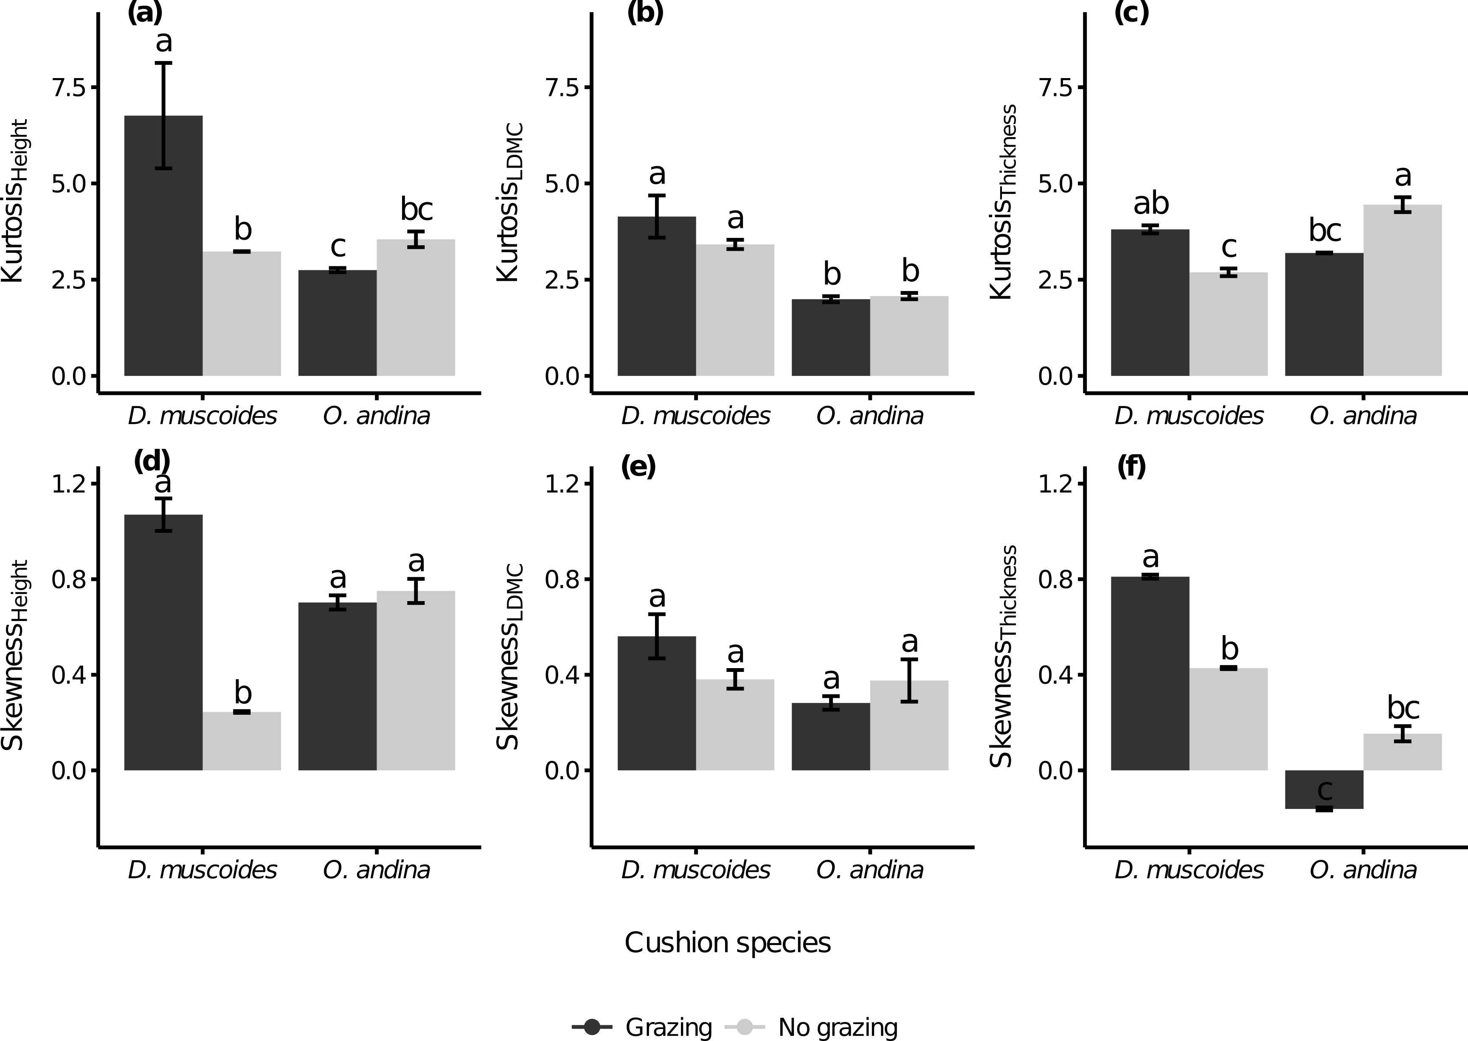
Kurtosis and skewness of the trait distributions of the associated communities inside the nurse cushion species for control (i.e. grazed; dark grey) and grazing exclusion (light grey). Error bars represent the 95 % confidence interval built from the jackknife. Different letters represent the significantly different groups according to post-hoc contrasts (Table [tab:moments]).
The shape of the trait distributions was clearly more affected by grazing in D. muscoides than in O. andina cushions (Fig. [fig:moments]), which is consistent with previous findings that the protection provided by O. andina extends to its associated community (Danet et al., 2017). In D. muscoides cushions, grazing significantly increased the kurtosis of the maximum height and leaf thickness distributions (height: -2.98, t₆ = -4.02, P = 0.02; thickness: -1.12, t₆ = -3.20, P = 0.02; Fig. [fig:moments]a and [fig:moments]c) as well as their skewness (height: -0.71, t₆ =-3.79, P = 0.04; thickness: -0.35, t₆ =-3.57, P = 0.01; Fig. [fig:moments]d and [fig:moments]f). The kurtosis and skewness of LDMC distributions were, however, not affected by grazing in D. muscoides cushions (kurtosis: -0.41, t₆ =-0.72, P = 0.58; skewness: -0.18, t₆ =-0.72, P = 0.88; Fig. [fig:moments]b and [fig:moments]e).
In contrast, grazing did not affect the trait distributions of the associated communities in O. andina (Fig. [fig:moments]; Table [tab:moments]), except for the kurtosis of the leaf thickness distribution, which significantly increased in grazing exclusion plots (1.36, t₆ = 4.04, P = 0.02).
The associated communities were also compared across cushions, to see if and how cushion type affected the associated communities. Overall, the trait distributions of the associated communities situated in O. andina cushions were similar or significantly less skewed and peaked than those in D. muscoides (Table [tab:moments]; 10 comparisons over 12), expect for the kurtosis of leaf thickness and the skewness of maximum height in ungrazed conditions, which were greater (respectively: 1.83, t₆ = 4.90, P = 0.01; 0.48, t₆ = 2.68, P = 0.08).

H3: Species niche differentiation
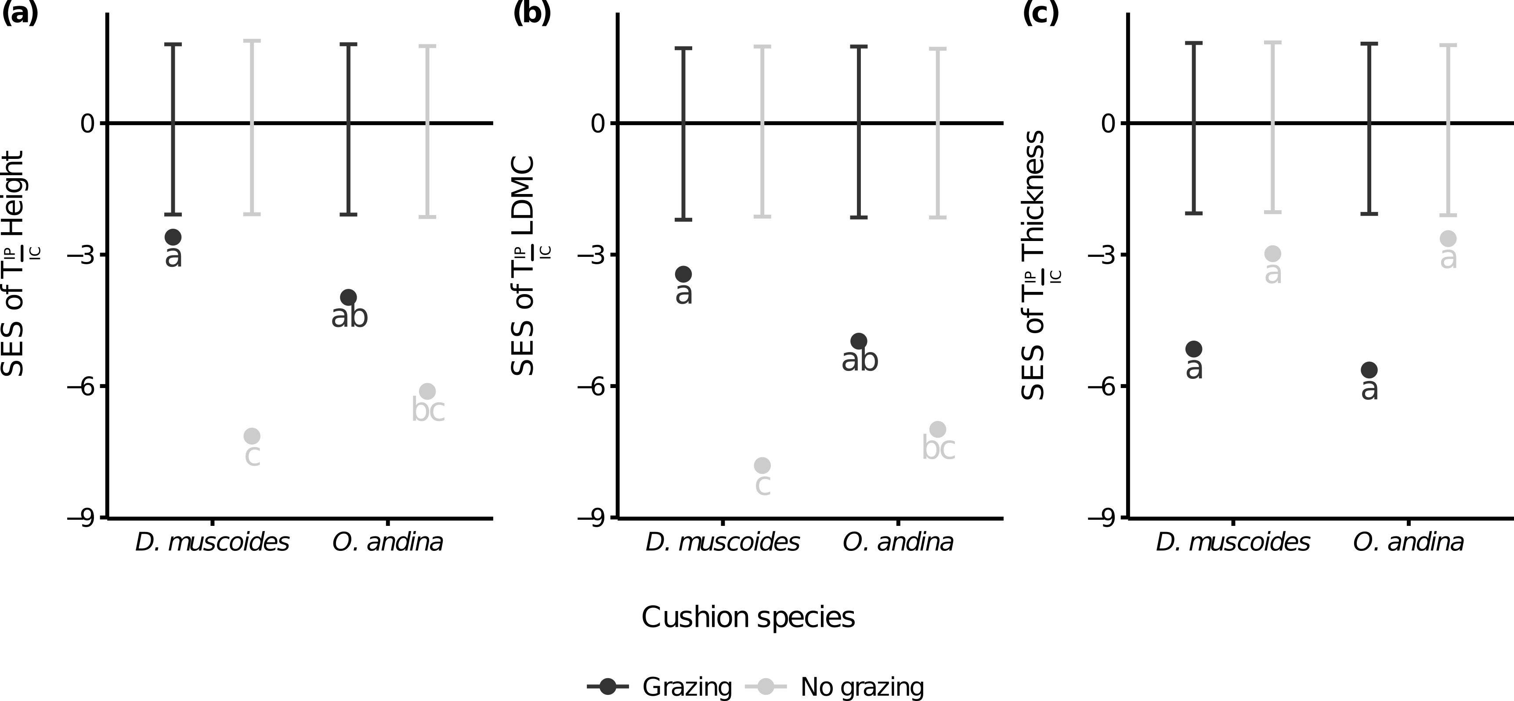
Standardized Effect Sizes (SES) of the T-statistic T $% \frac{\,\text{IP}}{\mkern-\thinmuskip\text{IC}}%$ (intra-population variance relative to intra-community variance) of the plant communities associated to the nurse cushion species for control (dark grey) and grazing exclusion (light grey). Different letters represent the significantly different groups according to post-hoc contrasts (Table [tab:tstat_contrast]). The lower is the value, the lower is the species overlap.
The interspecific niche differentiation was more affected by grazing in D. muscoides than in O. andina (Fig. [fig:tstat]). Yet, it was not significantly affected by the grazing status in neither of the two cushion species for the leaf thickness (Table [tab:tstat_contrast]).
Grazing exclusion significantly decreased the mean species trait overlap (T $% \frac{\,\text{IP}}{\mkern-\thinmuskip\text{IC}}%$ ) of maximum height and LDMC in D. muscoides cushions (height: -0.51, P < 0.05; LDMC: -0.44, P < 0.05), indicating that grazing increased species niche overlap in the associated community.
In O. andina cushions, however, grazing exclusion did not significantly affect the T $% \frac{\,\text{IP}}{\mkern-\thinmuskip\text{IC}}%$ of the associated communities (height: 0.36, P = 0.07; LDMC: 0.31, P = 0.07), indicating that indirect facilitation in O. andina was able to promote niche differentiation between associated species when grazing was present.
However, when comparing the cushions within the same grazing treatment, the niche overlap of the associated species were not significantly different between the associated communities situated in O. andina or in D. muscoides cushions, for each of the traits considered (Fig. [fig:tstat], Table [tab:tstat_contrast]).

Discussion
We investigated the effects of indirect facilitation on contrasted facets of functional diversity in Bolivian tropical alpine peatlands using a grazing exclusion experiment. We did not find a significant effect of grazing exclusion on the phenotypic space of the community (H1). This suggests that grazing does not influence the presence of the trait syndromes in those communities. However, our results also show that, in grazed conditions, indirect facilitation can maintain a higher evenness in the trait abundance distribution (H2) and a higher niche differentiation between beneficiary species (H3) than in the absence of indirect facilitation. Therefore, indirect facilitation can favor the coexistence of contrasted functional strategies and species in cushion plant species.
Previous studies have suggested that facilitation could allow maladapted phenotypes to be maintained in unfavorable environments (Bruno et al., 2003; Soliveres et al., 2015b). Such an effect of facilitation should translate into higher phenotypic space by the maintenance of contrasted trait syndromes. We found no significant effect of grazing on the phenotypic space in the control cushion species (i.e. D. muscoides). Therefore we could not conclude about the effect of indirect facilitation through grazing on the amount of distinct trait combinations (H1). This is congruent with previous work of Rota, Manzano, Carmona, Malo, & Peco (2017) suggesting that grazing affected more functional redundancy than functional originality (i.e. redundancy of trait combinations found in the associated communities), meaning that grazing did not lead to trait exclusions.
In agreement with our hypothesis H2, we found that indirect facilitation impacted the abundance structure of the trait distributions in the associated communities, thereby affecting the dominance status in the community (see similar evidence for facilitation in Gross et al., 2009, 2015). In D. muscoides, we found that the trait distributions of the associated communities in the grazed treatment were significantly more peaked and skewed for maximum height and more skewed for leaf thickness than in the ungrazed treatment. It was not the case in the spiny O. andina, suggesting that indirect facilitation had an effect on the maintenance of lower trait dominance in the associated plant communities (H2) for maximum height and leaf thickness. We did not find any effect of grazing exclusion on the kurtosis and skewness of the LDMC distribution in the associated communities. This result is quite surprising because grazing is known to affect LDMC (Cruz et al., 2010; Danet et al., 2017; Louault et al., 2005; Peco, Pablos, Traba, & Levassor, 2005). Overall our results show that indirect facilitation can modify trait abundance distribution (H2) but not the presence of contrasted trait combinations (H1).
An important result of our study was to show that the beneficiary species had a lower niche overlap (i.e. a greater niche differentiation) than expected by chance, and that the level of this overlap was mediated by indirect facilitation.
We found that, in D. muscoides (where there is no protection against grazing, grazing), the T $% \frac{\,\text{IP}}{\mkern-\thinmuskip\text{IC}}%$ of the associated communities was significantly lower in the grazed than in the ungrazed treatment for maximum height and LDMC, indicating more trait overlap and therefore more competition between beneficiaries in the grazed compared to the ungrazed treatment. Liancourt et al. (2005) proposed that when considering pairwise interactions, the species that better tolerate competitive interactions benefit also more of being facilitated by a nurse. Our study extents their proposition to the case of multiple co-occurring beneficiary species. The fact that, in O. andina (in which there is protection against grazing), the T $% \frac{\,\text{IP}}{\mkern-\thinmuskip\text{IC}}%$ of the associated communities was not significantly different in the grazed compared to the ungrazed treatment for maximum height and LDMC indicates that indirect facilitation maintained the niche differentiation between species of the associated communities for maximum height and LDMC (H3), meaning weaker competition between beneficiary species. Thus, indirect facilitation could increase the benefit of direct facilitation of the cushions toward the beneficiary species by maintaining weaker competition between the beneficiary species.
Niche differentiation between species has been shown to be a key mechanism promoting stable coexistence between species pairs in experiments (HilleRisLambers et al., 2012; Levine et al., 2017). Our work on niche differentiation complements the approaches developed by Bruno et al. (2003) and Bulleri et al. (2016). Bulleri et al. (2016) focused on the consequences of the broadening of the niche of all beneficiary species caused by facilitation. They hypothesized that the consequences of the broadening of all beneficiary species niche could lead to a dramatic decrease in niche differentiation resulting in a loss of stable coexistence between species. In contrast, we showed that indirect facilitation could maintain species coexistence in the communities benefiting from this facilitation. One interpretation is that indirect facilitation through grazing, stemming from the decrease in the negative effect of grazing on the associated communities, relaxes the selective pressure imposed by grazing, reducing trait convergence and thereby allowing populations of different species to develop different sets of traits through niche differentiation processes (Violle et al., 2012).
As argued in a previous study (Danet et al., 2017), comparing the associated communities living under two different cushion species to infer indirect facilitation is less definitive than a cushion/no cushion treatment, but this approach was constrained by the ecosystem in which we set up the experiment, where almost no plant species is found to grow outside the cushions.
Our study opens stimulating perspectives regarding the understanding of coexistence between facilitated species. It does not conclude about whether the observed niche convergence of the associated species found in D. muscoides is due to changes in species composition or due to intraspecific variations of the same species. At the community level, is the positive effect received by the facilitated species from the nurses strengthened by a concomitant decrease in negative interactions with other facilitated species? Addressing this question would extend the results of Liancourt et al. (2005) which suggest that the most facilitated species are also the ones that have the highest competitive-response ability ones, indicating that they increase the benefit of the environment improvement by the nurse.

Conclusion
There have been numerous calls in the literature about the need to introduce facilitative interactions in ecological theory (e.g. Bruno et al., 2003; Bulleri et al., 2016; Michalet et al., 2006; Wright et al., 2017). Indeed, facilitative interactions have been shown to affect community composition (e.g. Callaway, 2007) and ecosystem functioning (Cardinale et al., 2002). We tested how indirect facilitation may simultaneously impact contrasted facets of plant functional diversity in harsh tropical alpine environments, where the constraints generating positive plant interactions are distinct from other environments (low seasonality, absence of snow cover, long history of livestock grazing, different interacting life forms; (Michalet et al., 2016)). Our results suggest that indirect facilitation can release the selective pressures of grazing on associated plant communities by maintaining a lower dominance and the niche differences between the beneficiary species, but that indirect facilitation does not alter the functional strategies able to persist. the harsh condition. Our study hence implies that positive interactions can alter the predictions about the effect of an selective pressure on the structure of communities by maintaining low dominance and strong niche differentiation between species.

Acknowledgements
We thank Rosa Isela Meneses for the warm welcome received in the lab, the set up of the experimental design and for the assistance during species identification. We are grateful to Mary Carolina GarcÃa Lino, Ariel Lliully, Arthur Sanguet, Marine Segond and Pierre Vincent for their invaluable help in the field work and we thank Marine Segond for her help in the leaf analysis. We are grateful to Étienne Baron, Griégoire Freschet and Cyrille Violle for their useful advices about the measurements of functional traits. Finally, we thank Miguel Berdugo and two anonymous reviewers for their comments which have substantially increased the quality of the manuscript. This work was funded by the Fond Français pour l’Environnement Mondial (FFEM) and the Fondation pour la Recherche sur la Biodiversité (FRB). NG was supported by funding from the EU’s Seventh Framework Programme under grant agreement # FP7-609398 (AgreenSkills+ contract). The authors declare no conflict of interest.

Author contributions
SK, FA, NG and AD designed the study; FA set up the experimental design; AD collected the data and performed the analysis; AD wrote the first draft of the manuscript. All authors contributed critically to the drafts and gave final approval for publication.

Anthelme, F., & Dangles, O. (2012). Plant–plant interactions in tropical alpine environments. Perspectives in Plant Ecology, Evolution and Systematics, 14(5), 363–372.
Benjamini, Y., & Hochberg, Y. (1995). Controlling the False Discovery Rate: A Practical and Powerful Approach to Multiple Testing. Journal of the Royal Statistical Society. Series B (Methodological), 57(1), 289–300.
Bertness, M. D., & Callaway, R. (1994). Positive interactions in communities. Trends in Ecology & Evolution, 9(5), 191–193.
Blonder, B., Lamanna, C., Violle, C., & Enquist, B. J. (2014). The n -dimensional hypervolume: The n-dimensional hypervolume. Global Ecology and Biogeography, 23(5), 595–609.
Bruno, J. F., Stachowicz, J. J., & Bertness, M. D. (2003). Inclusion of facilitation into ecological theory. Trends in Ecology & Evolution, 18(3), 119–125.
Bulleri, F., Bruno, J. F., Silliman, B. R., & Stachowicz, J. J. (2016). Facilitation and the niche: Implications for coexistence, range shifts and ecosystem functioning. Functional Ecology, 30(1), 70–78.
Butterfield, B. J., & Callaway, R. M. (2013). A functional comparative approach to facilitation and its context dependence. Functional Ecology, 27(4), 907–917.
Buttolph, L. P., & Coppock, D. L. (2004). Influence of deferred grazing on vegetation dynamics and livestock productivity in an Andean pastoral system. Journal of Applied Ecology, 41(4), 664–674.
Callaway, R. M. (2007). Positive interactions and interdependence in plant communities. Dordrecht: Springer.
Callaway, R. M., Brooker, R. W., Choler, P., Kikvidze, Z., Lortie, C. J., Michalet, R., … Cook, B. J. (2002). Positive interactions among alpine plants increase with stress. Nature, 417(6891), 844–848.
Cardinale, B. J., Palmer, M. A., & Collins, S. L. (2002). Species diversity enhances ecosystem functioning through interspecific facilitation. Nature, 415(6870), 426–429.
Carmona, C. P., Bello, F. de, Mason, N. W., & Lepš, J. (2016). Traits Without Borders: Integrating Functional Diversity Across Scales. Trends in Ecology & Evolution, 31(5), 382–394.
Catchpole, W. R., & Wheeler, C. J. (1992). Estimating plant biomass: A review of techniques. Australian Journal of Ecology, 17(2), 121–131.
Chernick, M. R., & LaBudde, R. A. (2011). An introduction to bootstrap methods with applications to R. Hoboken, N.J: Wiley.
Cruz, P., De Quadros, F. L. F., Theau, J. P., Frizzo, A., Jouany, C., Duru, M., & Carvalho, P. C. F. (2010). Leaf Traits as Functional Descriptors of the Intensity of Continuous Grazing in Native Grasslands in the South of Brazil. Rangeland Ecology & Management, 63(3), 350–358.
Danet, A., Kéfi, S., Meneses, R. I., & Anthelme, F. (2017). Nurse species and indirect facilitation through grazing drive plant community functional traits in tropical alpine peatlands. Ecology and Evolution, 7(24), 11265–11276.
Deraison, H., Badenhausser, I., Loeuille, N., Scherber, C., & Gross, N. (2015). Functional trait diversity across trophic levels determines herbivore impact on plant community biomass. Ecology Letters, 18(12), 1346–1355.
Díaz, S., Noy-Meir, I., & Cabido, M. (2001). Can grazing response of herbaceous plants be predicted from simple vegetative traits? Journal of Applied Ecology, 38(3), 497–508.
Enquist, B. J., Norberg, J., Bonser, S. P., Violle, C., Webb, C. T., Henderson, A., … Savage, V. M. (2015). Scaling from Traits to Ecosystems. In Advances in Ecological Research (Vol. 52, pp. 249–318). Elsevier.
Filazzola, A., & Lortie, C. J. (2014). A systematic review and conceptual framework for the mechanistic pathways of nurse plants: A systematic review of nurse-plant mechanisms. Global Ecology and Biogeography, 23(12), 1335–1345.
Garnier, E., Navas, M., & Grigulis, K. (2016). Plant Functional Diversity: Organism Traits, Community Structure, and Ecosystem Properties. Oxford University Press.
Graff, P., Aguiar, M. R., & Chaneton, E. J. (2007). Shifts in positive and negative plant interactions along a grazing intensity gradient. Ecology, 88(1), 188–199.
Gross, N., Bagousse-Pinguet, Y. L., Liancourt, P., Berdugo, M., Gotelli, N. J., & Maestre, F. T. (2017). Functional trait diversity maximizes ecosystem multifunctionality. Nature Ecology & Evolution, 1(5), 0132.
Gross, N., Börger, L., Soriano-Morales, S. I., Le Bagousse-Pinguet, Y., Quero, J. L., García-Gómez, M., … Maestre, F. T. (2013). Uncovering multiscale effects of aridity and biotic interactions on the functional structure of Mediterranean shrublands. Journal of Ecology, 101(3), 637–649.
Gross, N., Kunstler, G., Liancourt, P., De Bello, F., Suding, K. N., & Lavorel, S. (2009). Linking individual response to biotic interactions with community structure: A trait-based framework: Biotic interactions and community structure. Functional Ecology, 23(6), 1167–1178.
Gross, N., Liancourt, P., Butters, R., Duncan, R. P., & Hulme, P. E. (2015). Functional equivalence, competitive hierarchy and facilitation determine species coexistence in highly invaded grasslands. New Phytologist, 206(1), 175–186.
HilleRisLambers, J., Adler, P., Harpole, W., Levine, J., & Mayfield, M. (2012). Rethinking Community Assembly through the Lens of Coexistence Theory. Annual Review of Ecology, Evolution, and Systematics, 43(1), 227–248.
Hupp, N., Llambí, L. D., Ramírez, L., & Callaway, R. M. (2017). Alpine cushion plants have species–specific effects on microhabitat and community structure in the tropical Andes. Journal of Vegetation Science, 28(5), 928–938.
Ibanez, S., Lavorel, S., Puijalon, S., & Moretti, M. (2013). Herbivory mediated by coupling between biomechanical traits of plants and grasshoppers. Functional Ecology, 27(2), 479–489.
Le Bagousse-Pinguet, Y., Gross, N., Maestre, F. T., Maire, V., Bello, F. de, Fonseca, C. R., … Liancourt, P. (2017). Testing the environmental filtering concept in global drylands. Journal of Ecology, 105(4), 1058–1069.
Levine, J. M., Bascompte, J., Adler, P. B., & Allesina, S. (2017). Beyond pairwise mechanisms of species coexistence in complex communities. Nature, 546(7656), 56–64.
Liancourt, P., Callaway, R. M., & Michalet, R. (2005). Stress tolerance and competitive-response ability determine the outcome of biotic interactions. Ecology, 86(6), 1611–1618.
Lind, E. M., Borer, E., Seabloom, E., Adler, P., Bakker, J. D., Blumenthal, D. M., … Wragg, P. D. (2013). Life-history constraints in grassland plant species: A growth-defence trade-off is the norm. Ecology Letters, 16(4), 513–521.
López López, L. C. (2004). Botanical and chemical composition of diets selected by alpacas (Lama pacos) pastured in the Ulla Ulla wetlands (Thesis (Ing.)). Universidad Catolica Boliviana "San Pablo", Bolivia.
Loranger, J., Blonder, B., Garnier, E., Shipley, B., Vile, D., & Violle, C. (2016). Occupancy and overlap in trait space along a successional gradient in Mediterranean old fields. American Journal of Botany, 103(6), 1050–1060.
Louault, F., Pillar, V. D., Aufrere, J., Garnier, E., & Soussana, J.-F. (2005). Plant traits and functional types in response to reduced disturbance in a semi-natural grassland. Journal of Vegetation Science, 16(2), 151–160.
Loza Herrera, S., Meneses, R., & Anthelme, F. (2015). Comunidades vegetales de los bofedales de la Cordillera Real (Bolivia) bajo el calentamiento global. Ecología En Bolivia, 50(1), 39–56.
Macarthur, R., & Levins, R. (1967). The limiting similarity, convergence, and divergence of coexisting species. The American Naturalist, 101(921), 377–385.
Malatesta, L., Tardella, F. M., Piermarteri, K., & Catorci, A. (2016). Evidence of Facilitation Cascade Processes as Drivers of Successional Patterns of Ecosystem Engineers at the Upper Altitudinal Limit of the Dry Puna. PLOS ONE, 11(11), e0167265.
Mason, N. W., Mouillot, D., Lee, W. G., & Wilson, J. B. (2005). Functional richness, functional evenness and functional divergence: The primary components of functional diversity. Oikos, 111(1), 112–118.
Meneses, R. I., Beck, S., & Anthelme, F. (2015). La Cordillera Real y sus plantas. IRD et Herbario Nacional de Bolivia.
Michalet, R., Brooker, R. W., Cavieres, L. A., Kikvidze, Z., Lortie, C. J., Pugnaire, F. I., … Callaway, R. M. (2006). Do biotic interactions shape both sides of the humped-back model of species richness in plant communities? Ecology Letters, 9(7), 767–773.
Michalet, R., Chen, S.-y., An, L.-z., Wang, X.-t., Wang, Y.-x., Guo, P., … Xiao, S. (2015). Communities: Are they groups of hidden interactions? Journal of Vegetation Science, 26(2), 207–218.
Michalet, R., Schöb, C., Xiao, S., Zhao, L., Chen, T., An, L.-z., & Callaway, R. M. (2016). Beneficiary feedback effects on alpine cushion benefactors become more negative with increasing cover of graminoids and in dry conditions. Functional Ecology, 30(1), 79–87.
Milchunas, D. G., & Noy-Meir, I. (2002). Grazing refuges, external avoidance of herbivory and plant diversity. Oikos, 99(1), 113–130.
Pawar, S. (Ed.). (2015). Trait-based ecology: From structure to function (1. ed). Amsterdam: Elsevier, AP.
Peco, B., Pablos, I. de, Traba, J., & Levassor, C. (2005). The effect of grazing abandonment on species composition and functional traits: The case of dehesa grasslands. Basic and Applied Ecology, 6(2), 175–183.
Pérez-Harguindeguy, N., Díaz, S., Garnier, E., Lavorel, S., Poorter, H., Jaureguiberry, P., … Cornelissen, J. H. C. (2013). New handbook for standardised measurement of plant functional traits worldwide. Australian Journal of Botany, 61(3), 167–234.
Raevel, V., Anthelme, F., Meneses, R. I., & Munoz, F. (2018). Cushion-plant protection determines guild-dependent plant strategies in high-elevation peatlands of the Cordillera Real, Bolivian Andes. Perspectives in Plant Ecology, Evolution and Systematics, 30, 103–114.
Read, J., & Stokes, A. (2006). Plant biomechanics in an ecological context. American Journal of Botany, 93(10), 1546–1565.
Reiner, R. J., & Bryant, F. C. (1986). Botanical composition and nutritional quality of alpaca diets in two Andean rangeland communities. Journal of Range Management, 39(5), 424–427.
Rota, C., Manzano, P., Carmona, C. P., Malo, J. E., & Peco, B. (2017). Plant community assembly in Mediterranean grasslands: Understanding the interplay between grazing and spatio-temporal water availability. Journal of Vegetation Science, 28(1), 149–159.
Ruthsatz, B. (2012). Vegetation and ecology of the high Andean peatlands of Bolivia. Phytocoenologia, 42(3), 133–179.
Schöb, C., Armas, C., Guler, M., Prieto, I., & Pugnaire, F. I. (2013). Variability in functional traits mediates plant interactions along stress gradients. Journal of Ecology, 101(3), 753–762.
Schöb, C., Butterfield, B. J., & Pugnaire, F. I. (2012). Foundation species influence trait-based community assembly. New Phytologist, 196(3), 824–834.
Soliveres, S., Maestre, F. T., Berdugo, M., & Allan, E. (2015a). A missing link between facilitation and plant species coexistence: Nurses benefit generally rare species more than common ones. Journal of Ecology, 103(5), 1183–1189.
Soliveres, S., Maestre, F. T., Bowker, M. A., Torices, R., Quero, J. L., García-Gómez, M., … Noumi, Z. (2014). Functional traits determine plant co-occurrence more than environment or evolutionary relatedness in global drylands. Perspectives in Plant Ecology, Evolution and Systematics, 16(4), 164–173.
Soliveres, S., Smit, C., & Maestre, F. T. (2015b). Moving forward on facilitation research: Response to changing environments and effects on the diversity, functioning and evolution of plant communities: Facilitation, community dynamics and functioning. Biological Reviews, 90(1), 297–313.
Taudiere, A., & Violle, C. (2016). Cati: An R package using functional traits to detect and quantify multi-level community assembly processes. Ecography, 39(7), 699–708.
Vellend, M. (2010). Conceptual synthesis in community ecology. The Quarterly Review of Biology, 85(2), 183–206.
Violle, C., Enquist, B. J., McGill, B. J., Jiang, L., Albert, C. H., Hulshof, C., … Messier, J. (2012). The return of the variance: Intraspecific variability in community ecology. Trends in Ecology & Evolution, 27(4), 244–252.
Violle, C., Navas, M.-L., Vile, D., Kazakou, E., Fortunel, C., Hummel, I., & Garnier, E. (2007). Let the concept of trait be functional! Oikos, 116(5), 882–892.
Westoby, M. (1998). A leaf-height-seed (LHS) plant ecology strategy scheme. Plant and Soil, 199(2), 213–227.
Westoby, M., Falster, D. S., Moles, A. T., Vesk, P. A., & Wright, I. J. (2002). Plant Ecological Strategies: Some Leading Dimensions of Variation Between Species. Annual Review of Ecology and Systematics, 33(1), 125–159.
Wootton, J. T. (1994). The Nature and Consequences of Indirect Effects in Ecological Communities. Annual Review of Ecology and Systematics, 25, 443–466.
Wright, A. J., Wardle, D. A., Callaway, R., & Gaxiola, A. (2017). The Overlooked Role of Facilitation in Biodiversity Experiments. Trends in Ecology & Evolution, 32(5), 383–390.

