Configuration for using markdown in subl

Alain Muls

# Installation Markdown / Pandoc for Sublime Text

## Github local repository

Make sure you have following software installed:

* pandoc: install using sudo apt install pandoc
* texlive-full: install using sudo apt install texlive-full
* sublime text 3: : install using sudo apt install sublime-text

The installation is done on Linux Mint 19.1 with Cinnamon v4.10.0 but any Ubuntu installation should have equivalent settings.

Download and install the github repository ammarkdown in a directory (I installed under ${HOME}/.config) using the command:

git clone https://github.com/alainmuls/ammarkdown.git

The obtained directory structure is represented in figure 1.

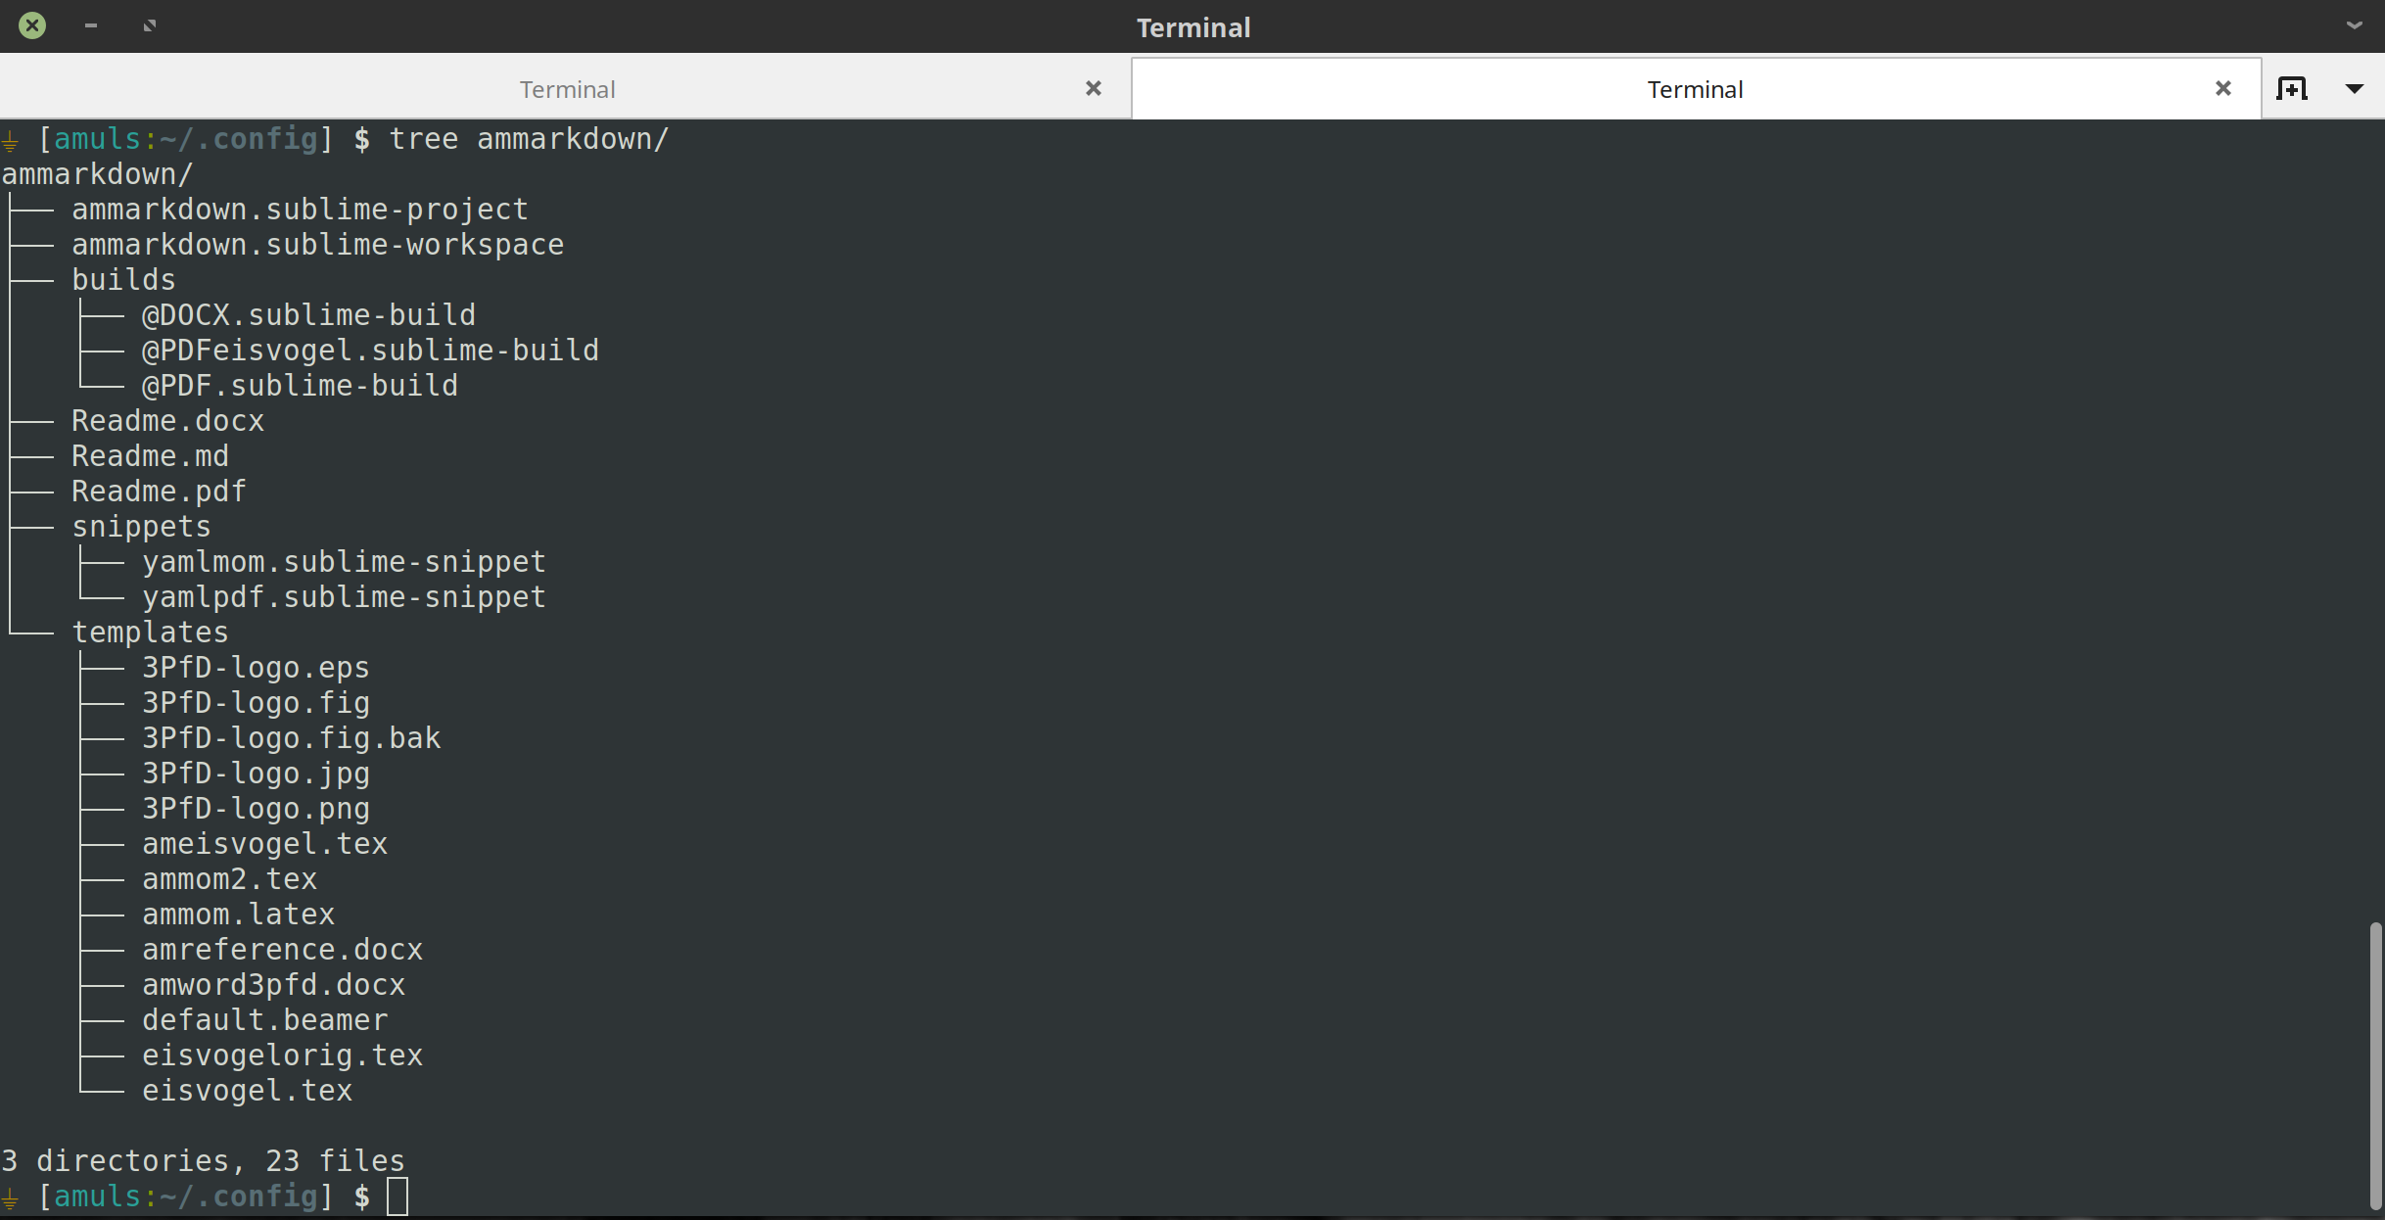

Figure 1: Directory structure of ammarkdown

## Linking from sublime-text-3

Next we need to create the appropriate links.

1. Go to directory ${HOME}/.config/sublime-text-3/Packages/User/snippets/ and create soft links:

* ln -sf ~/.config/ammarkdown/snippets/* .

1. Go to directory ${HOME}/.config/sublime-text-3/Packages/User/ and create soft links:

* ln -sf ~/.config/ammarkdown/builds/@* .

1. Go to directory ${HOME}/.pandoc/templates/ and create soft links:

* ln -sf ~/.config/ammarkdown/templates/* .

## Using the snippets and builds scripts

From sublime-text-3, or short subl, open a new file and save it with the extension .md in a directory of your project. As an example do:

mkdir ~/project

cd ~/project

subl

Ctrl-n> # creates a new unnamed file

Ctrl-s> # opens the file dialog for saving

(type) scenario-1.md # and save the file

We can now use the snippets to start working creating the markdown structure of the document. The following snippets are available (yaml stand for *Yet Another Markup Language*):

1. yamlmom used for creating the MoM of a meeting
2. yamlpdf used for creating a PDF document

Type either yamlpdf or yamlmom followed by <tab>, you get the following inserted (for yamlpdf) (Figure 2). By pressing <tab> one goes through different highlighted fields in the yaml header which you can easily adapt for the current task.

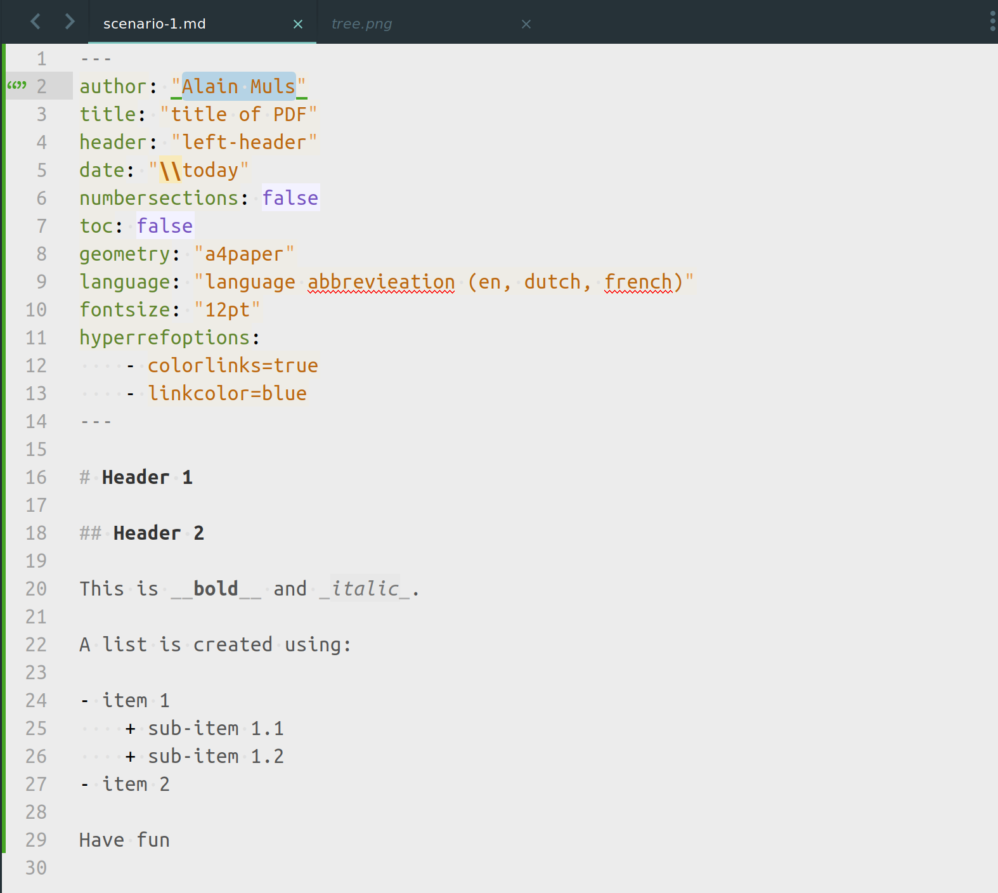

Figure 2: Markdown obtained by yamlpdf

Once the yaml header is finished, you can start editing the document.

For compiling and getting the output you go to Tools - Build System and select either @PDF or @DOCX. Press <Ctrl-b> and the corresponding PDF or DOCX file will be created (Figure @fig:pdf-outpu).

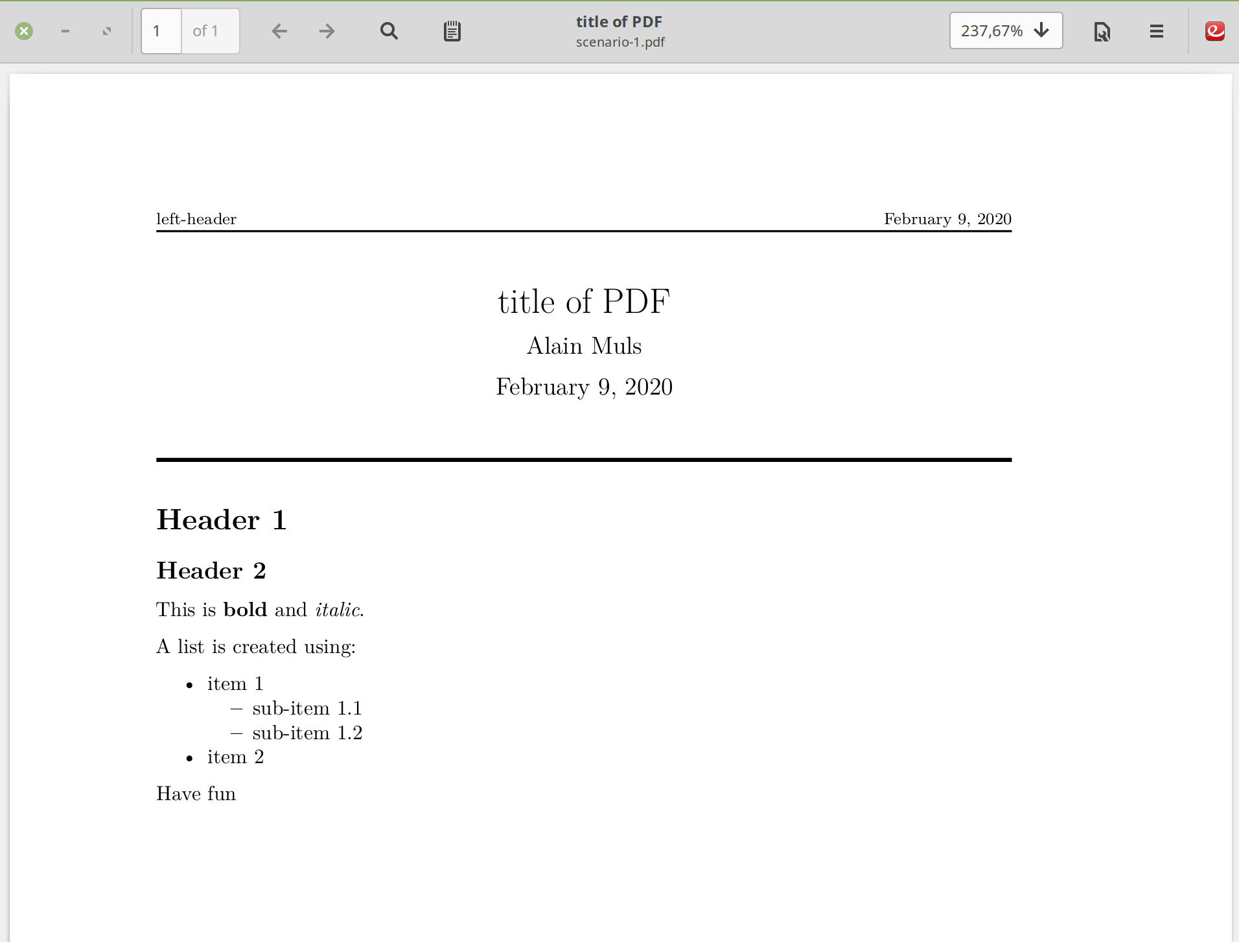

PDF output