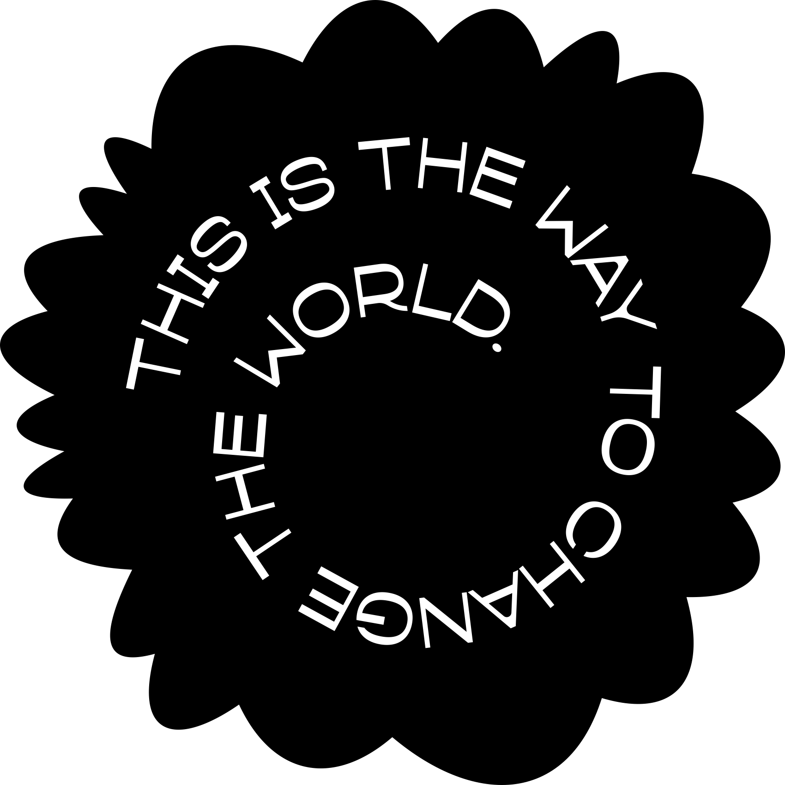


º
Project report – Bachelor's Degree
Technology, Communication and Transport

MOVIX
Group 5

AUTHOR/S Alain Ordoñez Alvaro
Iraitz Maritxalar Egilegor
Miguel Sabroso Sanz
Clara Soria Tazón
SAVONIA UNIVERSITY OF APPLIED SCIENCES THESIS
Abstract
Field of Study
Technology, Communication and Transport
Degree Programme
Degree Programme in Incormation Technology, Internet of Things
Author
Alain Ordoñez Alvaro, Iraitz Maritxalar Egilegor, Miguel Sabroso Sanz, Clara Soria Tazón
Title of Thesis
Muvix
Date | 05/12/2025 | Pages/Appendices | 5
Client Organisation /Partners
Keywords

CONTENTS
1 INTRODUCTION 4
2 GUIDELINES FOR USING THE REPORTING TEMPLATE 5
2.1 Use of heading styles 5
2.2 Hyphenation and section breaks 5
2.3 Table of contents 5
2.4 Including a figure and a list of figures 6
2.5 Including a table and a list of tables 7
2.6 Using the equation editor in reporting 8
2.7 Inserting and editing bibliography (list of references) in Word 8
3 REPORT APPENDICES 10
3.1 Examples of different types of appendices 10
3.2 Appending a figure 10
4 DISCUSSION 11
REFERENCES 12
Appendix 1: CREATIVE COMMONS LICENCES – IMAGE COPYRIGHT 13

INTRODUCTION
The idea of doing an app like Netflix was because is one of the applications everyone uses almost daily, is something we all are familiar with and there are many options to get inspiration from. It’s something we find very interesting to design a user-friendly app, some platforms in the market are sometimes confusing or not really useful so we decided that it will be an interesting challenge to improve that.
Our app is call Muvix, it is a video streaming app focused mostly on films. Most of app now a days are mainly series focused so it is a breath of fresh air the change to focus to films.
Our goal was to make an easy to understand and pleasing to the eyes app Desing. That makes thing easy for the user by implementing a clear Log in page, or an interesting home page.
The target audience of this project are all audiences, everyone will find something for their taste, kids will have some age-appropriate films, there will be action, romance, sci-fi, fantasy… all genres of films.

2 UI Design Approach
We have opted for a bi-chromatic color system it gives a professional and minimalistic atmosphere to the app. Our two main colors are black and bright green, black serves as a background color so it makes the films posters pop, and the bright green is our accent color it’s the color in our logo and is on our log in and sing up buttons making them be much more flashy for the eyes, so your focus goes to them.

