Introduction

Welcome to the Fibonacci API documentation. The Fib API is built on HTTP. This project provides a RESTful web service. The web service accepts a number, n, as input and returns the first n Fibonacci numbers, starting from 0. I.e. given n = 5, appropriate output would represent the sequence [0, 1, 1, 2, 3].   Given a negative number, it will respond with an appropriate error.

* Uses predictable, resource-oriented URLs.
* Uses built-in HTTP capabilities for passing parameters and authentication.
* Responds with standard HTTP response codes to indicate errors.
* Returns [JSON](http://en.wikipedia.org/wiki/Jsonobjects).

**Endpoints**

All API URLs referenced in this documentation start with the following base part:

/fib/:id

| **Method** | **Description** |
| --- | --- |
| GET | Return Fibonacci series for :id |

/fib/

| **Method** | **Description** |
| --- | --- |
| GET | Return a message to specify a value |

**Example Use**t

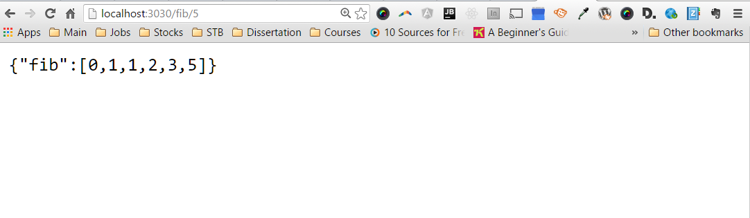

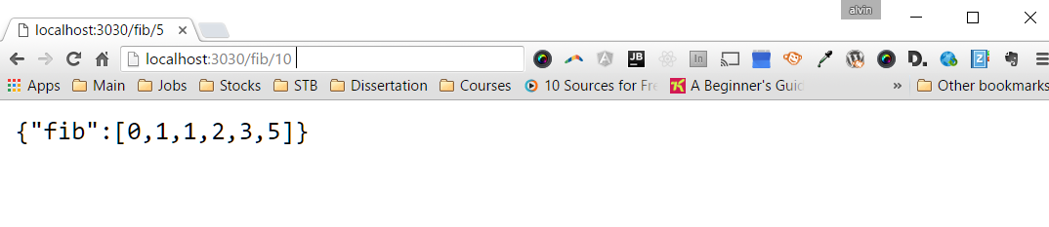

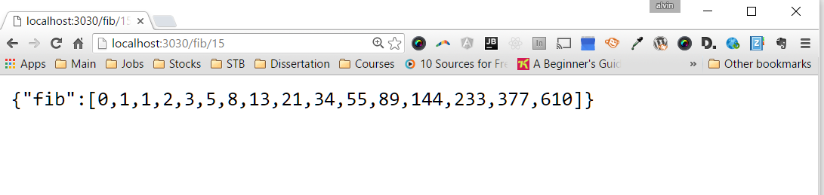

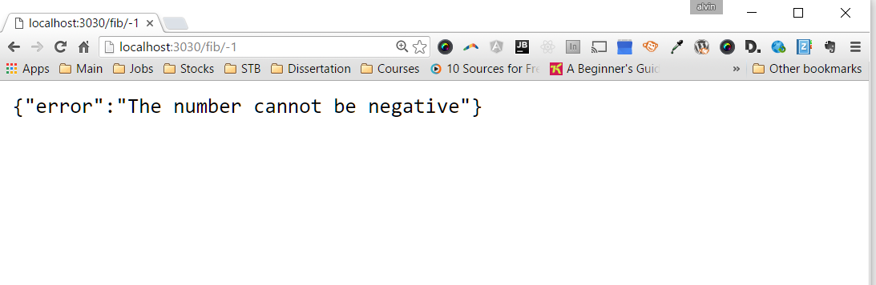

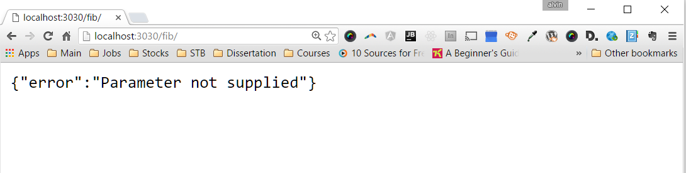

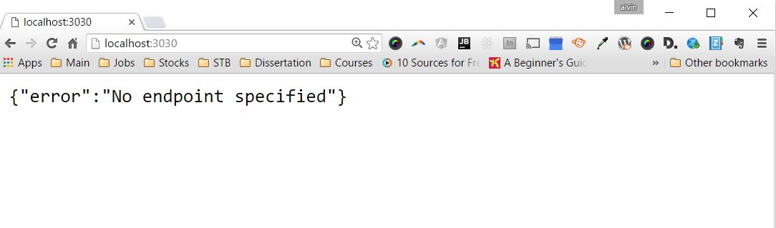

**Output Format**

Fib returns JSON for all API calls.

**HTTP Response Codes**

Fib returns standard HTTP response codes.

| Code | Description |
| --- | --- |
| 200 | Everything worked as expected, returns the Fibonacci series. |
| 400 | No valid endpoint specified |
| 401 | The parameter cannot be negative |
| 403 | Parameter not supplied |
| 500 | Problem with the server |

**Installation Instructions**

The installation guide for downloading and installing the API and starting the application.

1. $ mkdir fib
2. $ cd fib
3. $ https://github.com/alaj6625/virtustream.git
4. $ npm install
5. $ edit config.js

Update port and url.

1. $ node app.js