Graphical abstract

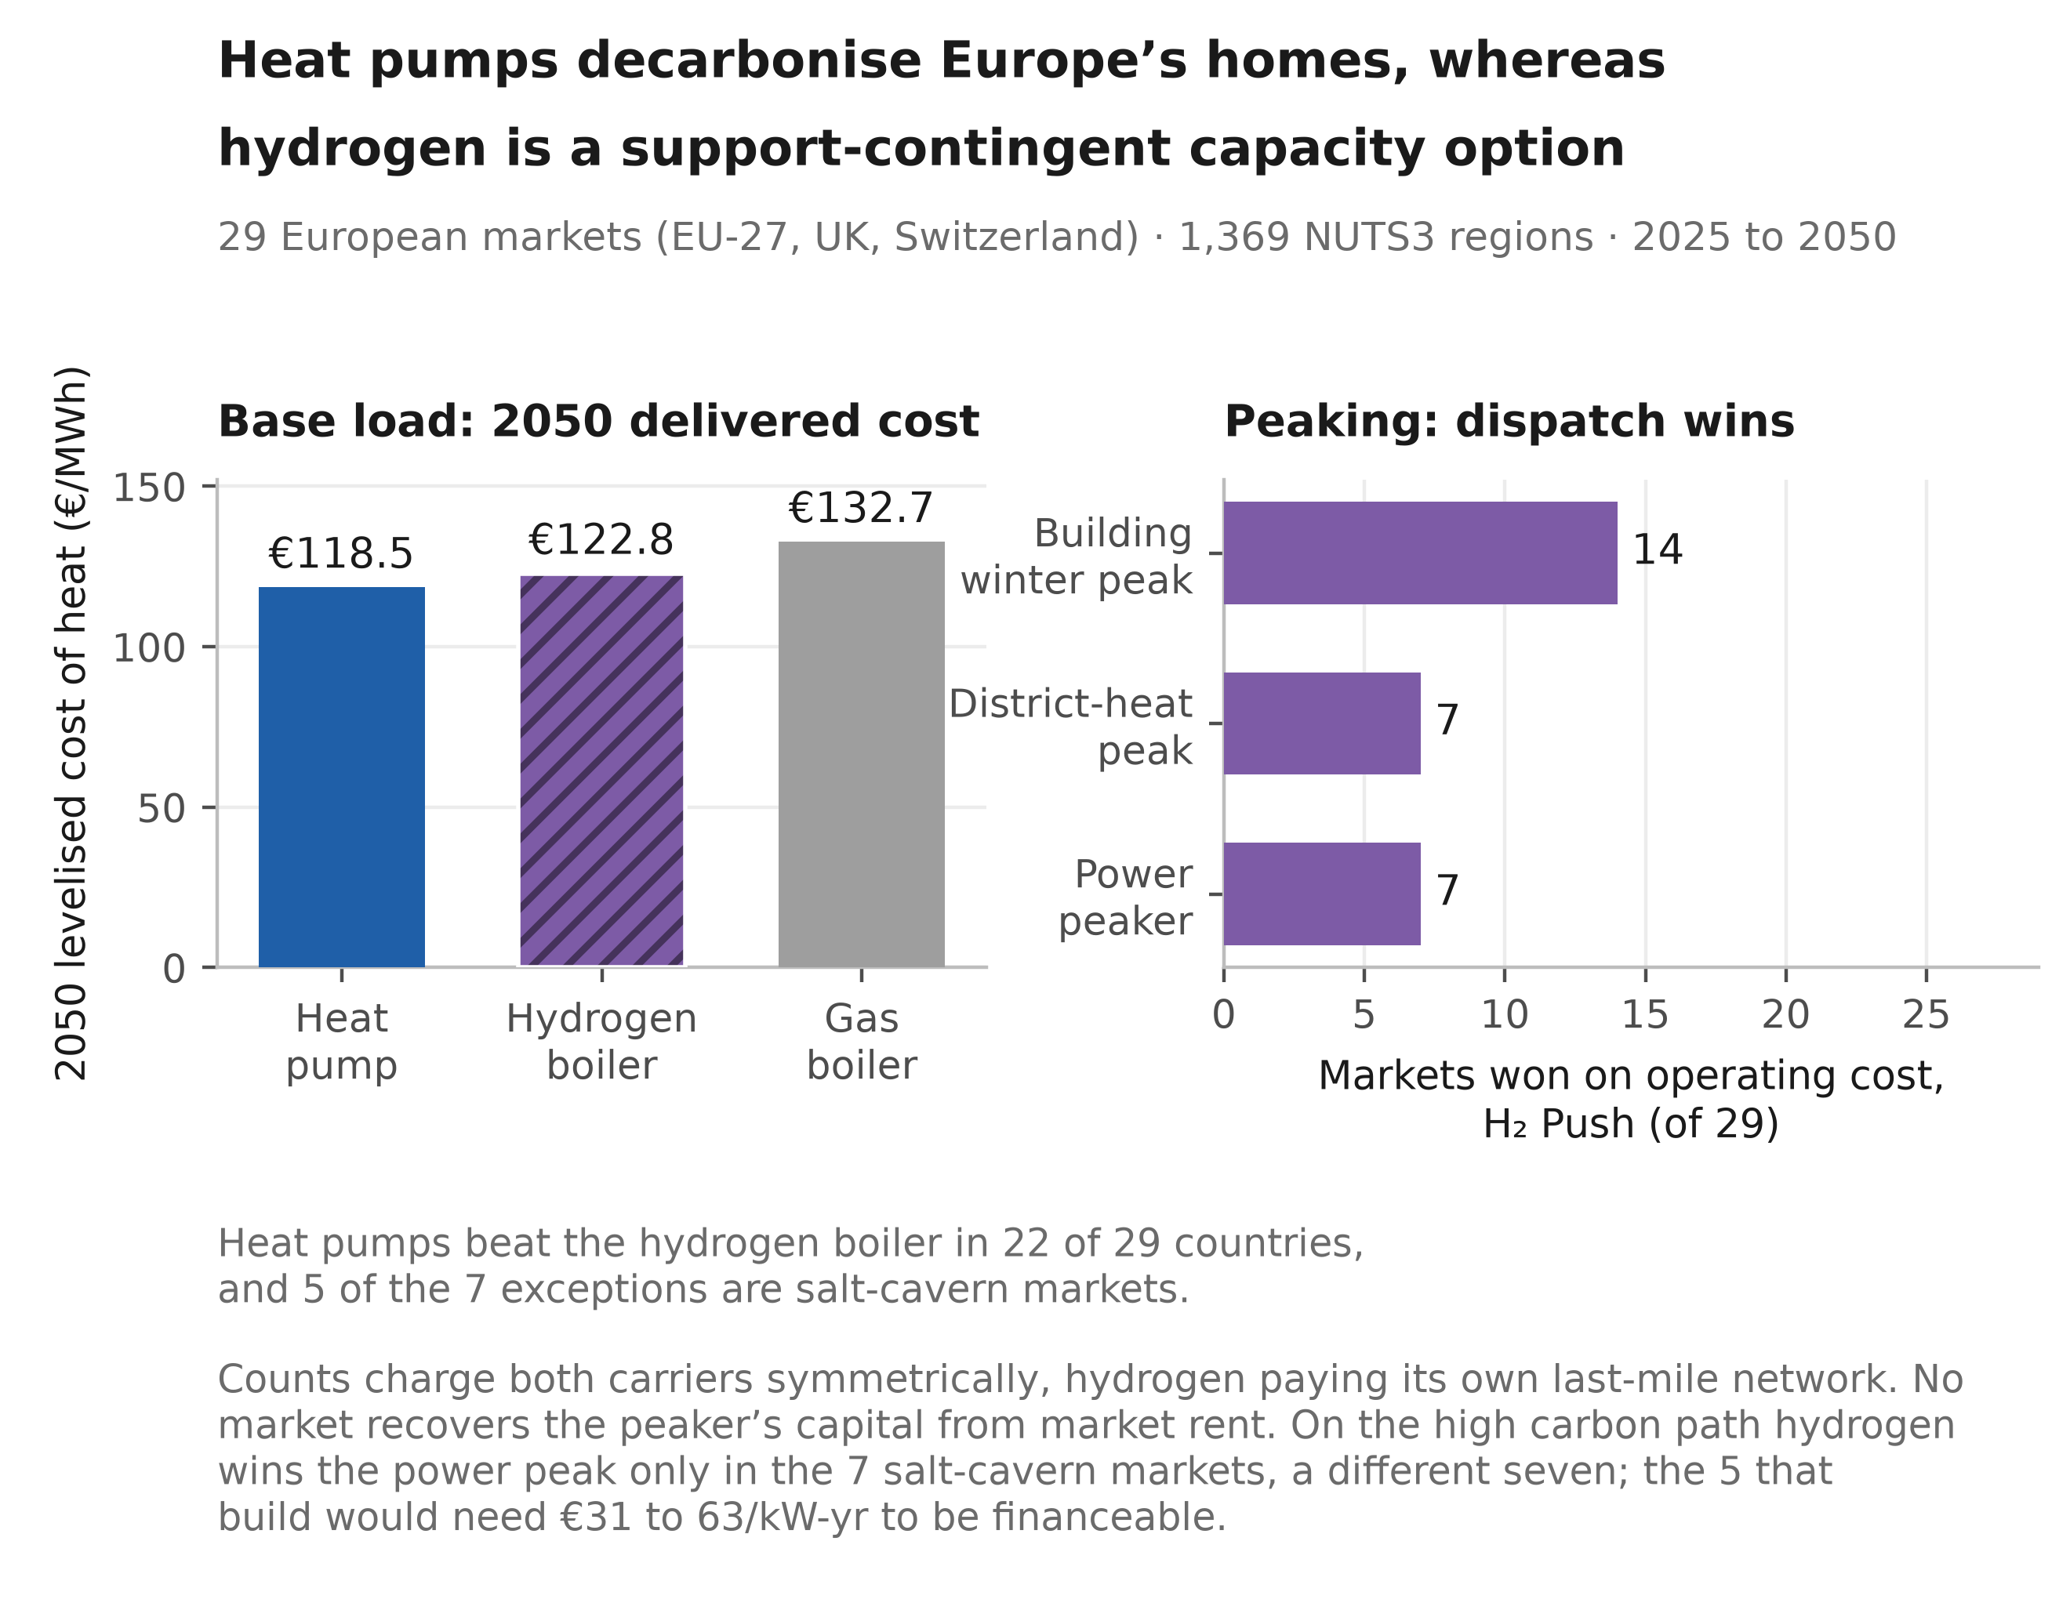

Highlights

• At central parameters heat pumps beat hydrogen on 2050 heat in 22 of 29 markets
• Hydrogen wins the high-carbon power peak in seven cavern markets at equal efficiency
• No market recovers peaker capital from energy-only rents, 9% in the central case
• At €600/kW a technology-neutral capacity payment procures gas, not hydrogen
• Scenario ambition moves 2050 heating emissions by 342 MtCO₂/yr

Hydrogen in residential heating and the power system: a merit-order and capital-recovery assessment for 29 European markets

Abdurahman Alsulaiman1, Ali Alajwad2,3
1 Oxford Institute for Energy Studies, Oxford, UK
2 RENEW Lab, Johns Hopkins University, Baltimore, MD, USA
3 Cornell University, Ithaca, NY, USA

Corresponding author: Abdurahman Alsulaiman

Abstract
Continental models report hydrogen's role in building heat at national resolution, whereas building-stock assessments fix its share exogenously. Neither gives a peaker's standalone capital-recovery position market by market. We bound that share from the winter-peak dispatch, cap each scenario at or below it, screen it across district heat and power, and charge each carrier its last mile on levelised cost. A bottom-up model covers 29 markets over 200 Monte Carlo draws. Three findings follow. On 2050 levelised cost the best heat pump delivers €118.5/MWh against €122.8 for a hydrogen boiler and €132.7 for gas, beating hydrogen in 22 of 29 markets. That count is the least robust result here, spanning 13 to 29 across the hydrogen price paths, and two assumptions favour hydrogen throughout: taxed retail electricity near €209/MWh against €50/MWh delivered, and a green price where the blue route costs €81/MWh. On short-run marginal cost hydrogen wins the winter power peak on the high carbon path in a different seven, all salt-cavern markets on a binary geology screen. No market recovers that peaker's capital from energy-only rents, about 9% in the central case, so at €600/kW a technology-neutral payment procures gas and selecting hydrogen needs an emissions-conditioned payment, about €172/tCO₂ in the central case. Residential-heating emissions in 2050 span 10 to 352 MtCO₂ from 644. The power-sector results rest on one constructed weather year and are a screening exercise, not an adequacy assessment.

Keywords: Heat pumps; Hydrogen; Building heat decarbonisation; Seasonal hydrogen storage; Missing money

Nomenclature
$c_{c}^{gas}, c_{c}^{H_{2}}, c_{c}^{HP}$ – Short-run marginal cost of delivered heat from the gas boiler, hydrogen boiler and heat pump in country $c$ (€/MWh-heat)
${COP}_{c}^{cold}$ – Cold-snap heat-pump coefficient of performance in country $c$
${CRF}_{c}$ – Capital-recovery factor at country discount rate $r_{c}$ over the asset life (25 yr for the peaking turbine)
$D_{c}(t)$ – National useful heat demand in country $c$, year $t$ (TWh/yr)
$D_{c}^{0}$ – National base-year (2025) useful heat demand in country $c$ (TWh/yr)
$D^{pk}$ – System peak electricity demand (GW)
$D^{tot}$ – Total electricity demand (TWh/yr)
$(Dw/Pop)_{c,t}$ – Dwellings per capita in country $c$, year $t$
$e_{g}$ – Natural-gas emission factor (=0.202 tCO₂/MWh)
$E_{c}^{pk}$ – Annual energy generated by the firm peaking fleet in country $c$ (TWh)
$f$ – Fixed operating-cost rate on peaking-turbine capital (=2.5 %/yr)
${FLH}_{c}$ – Full-load hours of the hydrogen peaker in country $c$ (h/yr)
$H_{c}$ – Equivalent full-load hours of the peak slice in country $c$ (≈518 h/yr, over a 2,000 h window)
$H_{c}^{2015}$ – Hotmaps 2015 benchmark demand for country $c$ (TWh)
$K^{T}$ – Hydrogen-ready peaking-turbine overnight capital cost (= €600/kW; conventional open-cycle gas = €450/kW). Eq. (2) turns it into an annual charge by applying ${CRF}_{c}+f$; this is the €600/kW of the abstract and of Section 3.4
$K_{c}^{pk}$ – Firm peaking-fleet capacity in country $c$ (GW)
$N$ – Monte Carlo / Saltelli sample size
$p_{c}^{gas}$ – Retail gas price in country $c$ (€/MWh)
$p^{gas,w}$ – Winter (backbone) gas price (€/MWh)
$p_{c}^{H_{2}}$ – Delivered hydrogen price in country $c$ (€/MWh)
$p_{c}^{H_{2},bb}$ – Backbone hydrogen price in country $c$ (€/MWh)
${Pop}_{c,t}$ – Projected population of country $c$, year $t$
$r_{c,s}$ – Per-country, per-scenario envelope-renovation rate (%/yr)
$r_{c}$ – Country weighted-average cost of capital (WACC)
$R_{c}$ – Capital recovery of the hydrogen peaker in country $c$, its scarcity rent over its annualised capital-and-fixed-operating charge (dimensionless; Eq. (2))
${SCOP}_{c}$ – Seasonal coefficient of performance of the heat pump in country $c$
$S_{T}$ – Sobol total-order sensitivity index
$t, t_{0}$ – Projection year; base year ($t_{0}=2025$)
$z_{c}, z_{EU}, z_{c}^{idio}$ – Standard-normal shocks (common and idiosyncratic) for sampling renovation rates
$φ_{y}$ – Carbon price (ETS2) in year $y$ (€/tCO₂)
$η_{g}, η_{h}$ – Gas-boiler (0.92) and hydrogen-boiler (0.90) efficiencies
$η_{OCGT}, η_{T}$ – Open-cycle gas turbine and hydrogen turbine electrical efficiencies. The winter-peak merit order that sets the win counts holds both at 0.40, so that comparison is even-handed. The capital-recovery layer instead lets them evolve, the gas turbine to 0.42 by 2050 and the hydrogen turbine to 0.44, or 0.48 under H2 Push, which assumes an advanced simple-cycle machine; there the hydrogen unit is deliberately given the better turbine
$μ_{c,s}, σ_{c,s}$ – Mean and standard deviation of the sampled renovation rate $r_{c,s}$
$π_{c}^{peak}$ – Derived scarcity (peak) electricity price in country $c$ (€/MWh-e)
$π^{s}$ – Scarcity premium (low/central/high {30,60,120} €/MWh; the sensitivity grid adds 90)
ρ – Cross-country shock correlation: renovation rate (=0.5), fuel prices (=0.75); all other sampled parameters are EU-wide scalars, i.e. ρ=1 implicitly
$σ_{c}$ – Seasonal hydrogen-storage adder, heat side (≈€50 to 100/MWh-heat)
$σ_{c}^{e}$ – Seasonal hydrogen-storage adder, electricity side (€/MWh-e)
$Δ_{c}^{VM}$ – Vintage-matched deviation of the bottom-up backcast from the Hotmaps 2015 benchmark in country $c$
$Φ_{cap}, Φ_{en}$ – Firm dispatchable peaking fleet’s share of system peak capacity and of generated energy
$c$ – Country (region) index
$s$ – Scenario index
$t, t_{0}, y$ – Year; base year; carbon-price year
$gas, H_{2}, HP$ – Gas-boiler, hydrogen-boiler and heat-pump branches
$pk, peak, cold$ – Peaker; system-peak/scarcity; cold-snap conditions

1 Introduction
Buildings take roughly 40 per cent of final energy in the European Union, most of it burned for space heating and hot water, which places them at the centre of European climate policy [1], [2]. Hundreds of billions of euros of that heating plant will be replaced by 2050, and whether that capital electrifies the heat or reuses the gas network for hydrogen is a choice slow to unwind. A clean option exists, but the difficulty lies in delivery, because heat reaches hundreds of millions of dwellings of differing vintage and fabric whose appliances are replaced only as they fail [3], [4].
European policy has converged on heat pumps as the principal route, and the case is strong. A coefficient of performance of two to four draws less final energy than any combustion appliance, and the machine decarbonises as the grid does [5], [6]. However, deployment is slowed by frictions that fall unevenly across the stock, among them retrofitting poorly insulated dwellings, distribution-grid reinforcement in dense areas, and performance that degrades in the coldest weather [7], [8]. We price that reinforcement inside the levelised cost of delivered heat, and the same frictions open pockets for a gas-based alternative.
Hydrogen is the alternative most often advanced, and the most contested, because a low-carbon gas could in principle reuse the existing distribution network and the appliance habit of a gas-heated home [9], [10]. REPowerEU raised the EU’s 2030 ambition to 20 Mt of renewable and imported supply, with buildings among the candidate demand centres [11], [12], and the 2022 gas crisis sharpened the appetite for a storable domestic fuel [13]. However, a substantial sceptical literature answers that hydrogen for space heating wastes primary energy, competes for scarce electrolytic supply, and understates the cost of network conversion [14], [15], [16], [17], [18].
The quantitative basis for settling the dispute is thinner than the debate implies, and the gaps fall into three groups. The first is spatial resolution. The continental assessments resolve the building stock in detail but at national resolution, so they cannot see the within-country demand gradient or the storage geology that decide where hydrogen might compete [19], [20]. Sub-national European work exists for the hydrogen network itself [21], [22], spatially explicit studies are mostly single-country [23], [24], [25], and the pan-European mapping resolves heat demand without a dispatch test [26], [27]. The second is the share itself, which studies commonly fix by assumption [28], [29] and price on annual levelised cost, which misstates how a dispatchable fuel competes [30], [31]. The third is a severed link between heat and power, and coupled system studies do model it [32], [33]. However, they report a system optimum rather than the standalone capital-recovery position of a hydrogen peaker market by market, which is the quantity a private investor and a capacity mechanism both need.
Against those strands, this paper adds a quantity each leaves out. The review literature concludes against hydrogen for domestic heat [14], [15] without reporting where the conclusion is close, so we reproduce the ordering in 22 of 29 markets, at an all-29 median of €15.4/MWh in the heat pump’s favour, and price the seven exceptions individually. The sub-national work returns a network plan rather than a plant’s balance sheet [21], [22], so we return a peaker’s standalone capital recovery market by market. The firm-capacity literature establishes that low-carbon systems need clean firm capacity [34], [35] without pricing it when the load is building heat, so we put that at €31 to 63/kW-yr.
The advance behind those three is twofold. First, where other work imposes a hydrogen share and stops, we impose transparent adoption pathways and then test them against an independent dispatch screen, market by market, exposing the cost and geology regimes a continental average would bury. Second, we recast the question from an energy-share contest into one about capacity and capital, screening the linked arenas on one dispatch basis and testing capital recovery on the plant that wins the power peak. To deliver both we assemble a bottom-up techno-economic model of residential heating across the EU-27, the United Kingdom and Switzerland from 2025 to 2050, reconstructing useful heat demand from NUTS3 building stock and aggregating it to the country before any cost test, benchmarking it to within −0.8 per cent against an independent regional database, and propagating it through eight technologies and four scenarios in a 200-draw Monte Carlo [36], [37].
The accounting is where our numbers part company with published comparisons. On the levelised comparison we price the two carriers on a symmetric distribution basis, charging the heat pump for the low- and medium-voltage reinforcement its winter peak requires and the hydrogen boiler for its own last-mile network and seasonal store, and we size equipment capital to peak heat demand, which does not shrink because a machine is efficient. Published comparisons differ in which of these they charge, so we sweep each; adopting them narrows the heat pump’s margin without reversing the median ordering, and corners of the sweep do turn it.
On that accounting the best 2050 heat pump undercuts the gas boiler in 24 of 29 countries and the hydrogen boiler in 22. Cheap storage sets how wide the remaining seven are, about €12/MWh with salt caverns against a median €24 without [38], but does not select them, since repriced at the non-cavern rate five still hold on retail electricity taxation alone. Repriced on the short-run marginal cost a system operator uses, hydrogen wins the cold-snap peak in a minority of markets that grows with policy ambition, and no market recovers that peaker’s capital, about 9 per cent in the central case, the classic missing-money problem.
These findings answer one research question: under what conditions, and where, is decarbonised hydrogen competitive against heat-pump electrification in the buildings of the EU-27, the United Kingdom and Switzerland by 2050? Switzerland, a high-cost, hydro-rich and cavern-poor system reliant on imports, provides a compact standalone case [39], [40].
The remainder is organised as follows. Section 2 sets out the model and its weather series, Section 3 the three tests and two cross-checks, and Section 4 the conclusions and policy implications.

2 Materials and methods
We assess where decarbonised hydrogen can compete with heat-pump electrification for European building heat using a spatially resolved, bottom-up techno-economic model coupled to a merit-order representation of the power sector. It is a chained simulation rather than a system-wide optimisation, reconstructing useful heat demand region by region, splitting it across eight technologies, pricing each on a levelised basis and then putting hydrogen against its rivals in operating-cost dispatch tests, so hydrogen’s share is set exogenously and then tested, never co-optimised (Supplementary Section S1.1). Coverage spans the EU-27, the United Kingdom and Switzerland, and demand resolves to the third level of the Nomenclature of Territorial Units for Statistics (NUTS3), 1,369 regions, aggregating to the country before the economic tests apply. The model runs on the milestone years 2025, 2030, 2040 and 2050, with 2025 the common anchor for demand, technology-share and cost trajectories alike (Fig. 1).
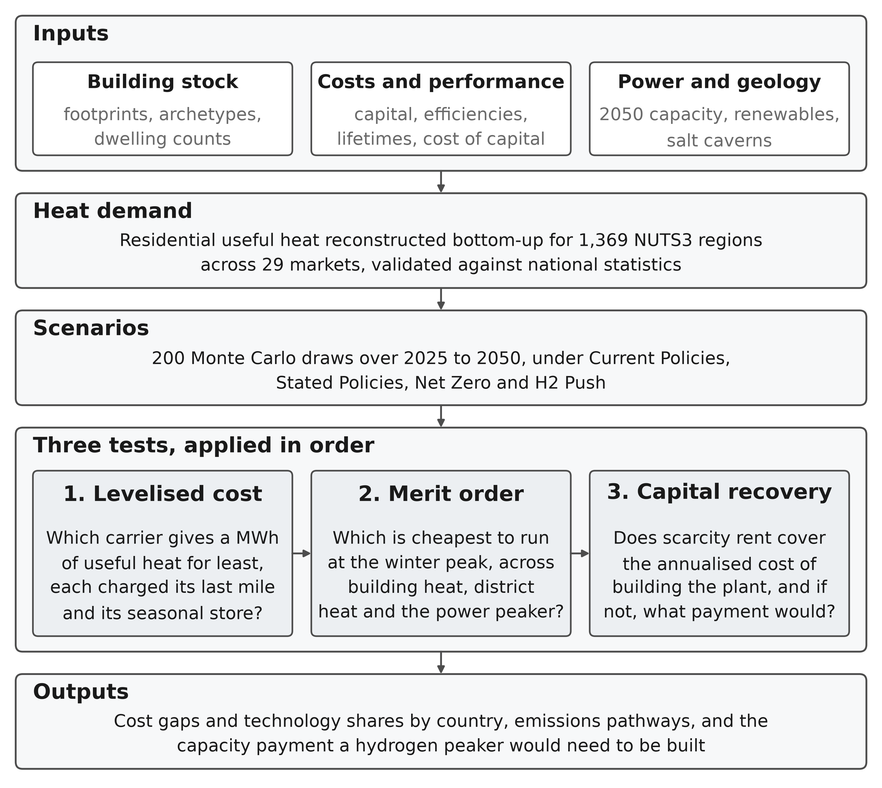
Figure 1: Model architecture. Inputs, the demand reconstruction and the scenario draws feed three tests applied in order.
Note: a technology that fails an earlier test is not rescued by a later one. The first two tests are cost comparisons at different time scales, annual and peak-hour, whereas the third asks whether the plant that wins the peak can be financed at all. The text below and the Supplementary Information give the data sources, the price paths, the adder bounds and the parameter ranges the boxes summarise.
The demand layer is built before the technology layer. A bottom-up strand reconstructs residential heat from open building footprints and a harmonised archetype typology, while an independent top-down baseline from the Hotmaps regional database [41], with census-derived building-type shares [42], [43], benchmarks it. The two agree to −0.8 per cent across the aggregate and to within ±25 per cent in 28 of the 29 countries. Section 3.1 gives the stricter vintage-matched comparison (Supplementary Section S1.2). National demand is then projected forward from 2025 on a multi-driver ratio identity, with population growth and falling household size adding demand and envelope renovation removing it. Boundary and terrain typologies come from the Eurostat GISCO service [44], and Fig. 2 shows the demand field, whose steep within-border gradient a country-resolution model averages away.
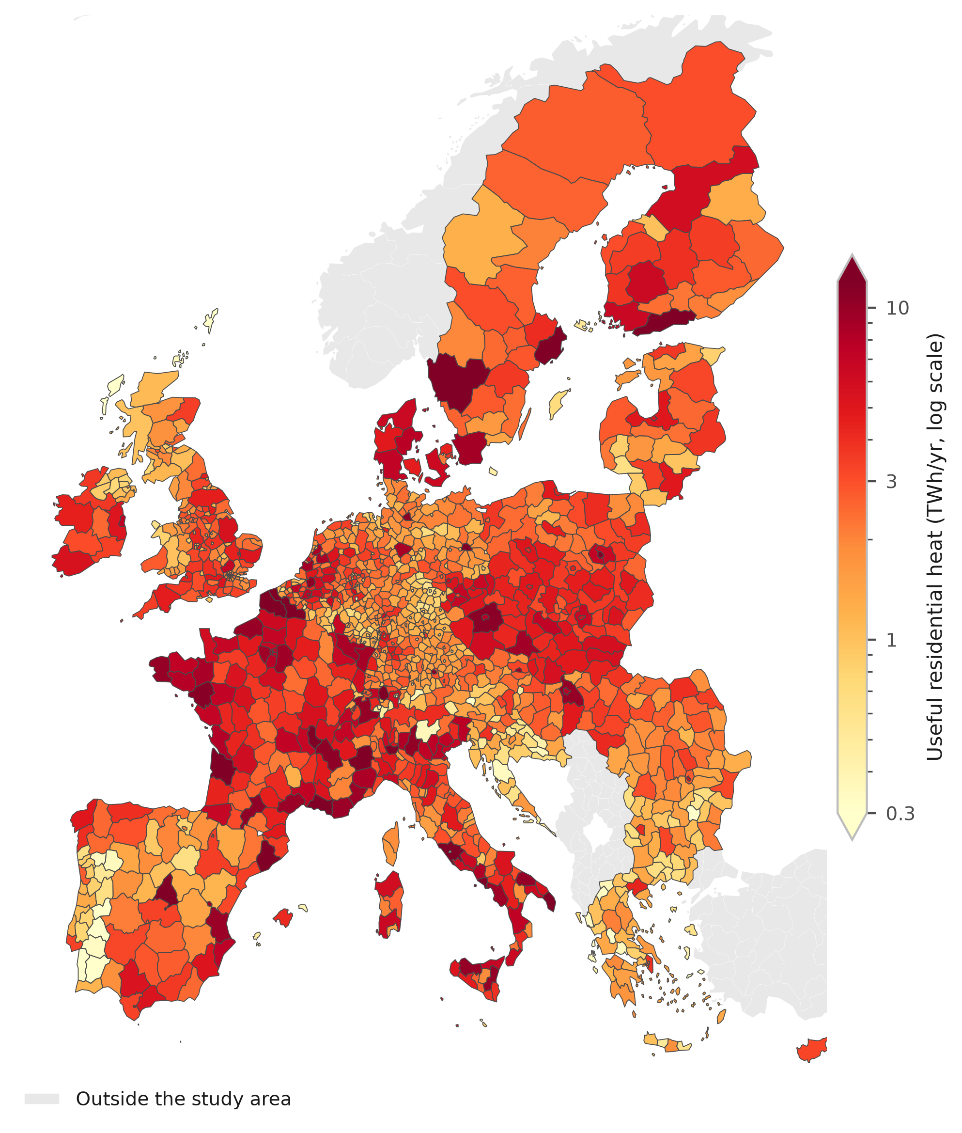
Figure 2: Useful residential heat demand by NUTS3 region, 2025. From the bottom-up build. The regional resolution sets the demand surface and the demand weights carried through the study (Section 2). The colour scale is logarithmic over 0.3 to 12 TWh/yr, close to the 2nd and 98th percentiles of the mapped values, and the colourbar arrowheads mark the regions outside that range.
Each of the eight technologies, comprising gas, oil and biomass boilers, a resistance heater, air-source and ground-source heat pumps, district heat and a hydrogen boiler, is priced on a levelised cost of heat that annualises capital at the country weighted-average cost of capital and adds fuel, fixed and variable operating costs, in real EUR₂₀₂₄ throughout (Supplementary Section S1.3). Equipment capital is sized to peak heat demand and not divided a second time by the machine’s efficiency, the accounting choice that moves the base-load count furthest. Techno-economic parameters are anchored to the Danish Energy Agency Technology Catalogue [45] and cross-checked against JRC, IEA and IRENA cost data [5], [46], [47]. Fossil fuels carry the second emissions trading system for buildings and road transport (ETS2) from its 2027 launch [48], green hydrogen follows the European Hydrogen Observatory central delivered-cost trajectory [49], and retail gas and electricity prices are Eurostat first-half-2025 figures [50], [51].
A scope-1 inventory runs alongside the cost layer on the same technology split, charging gas and oil fixed combustion factors [52], biomass and hydrogen zero on the European renewable-fuel convention, and electricity and district heat country-by-year intensities that each scenario’s grid lever scales [53], [54]. Those paths are calibrated trajectories rather than published projections, so the emissions levels inherit that calibration whereas the scenario ranking does not (Supplementary Section S1.4). Furthermore, two last-mile network charges apply by default, one to each carrier, so that neither is priced as though its delivery were free. The hydrogen boiler carries a coverage-weighted blend of conversion and new build, a median €13.4/MWh, and the heat pump a low- and medium-voltage reinforcement adder, a median €4.9/MWh.
Levelised cost compares technologies as base-load suppliers, an arena the review literature treats as settled in the heat pump’s favour [14], [15], [19]. Hydrogen’s narrower case is as a peaker serving the cold-snap slice, modelled as a merit-order dispatch among quick-start options whose short-run marginal costs per MWh of useful heat are
$$c_{c}^{gas}=\frac{p_{c}^{gas}+φ_{y} e_{g}}{η_{g}}, c_{c}^{H_{2}}=\frac{p_{c}^{H_{2}}}{η_{h}}+σ_{c}, c_{c}^{HP}=\frac{π_{c}^{peak}}{{COP}_{c}^{cold}},$$ | (1)
where $φ_{y}$ is the carbon price, η the conversion efficiencies and $σ_{c}$ the seasonal-storage adder, about €50/MWh-heat with domestic salt caverns and €100 without. Cold-snap heat-pump performance is derated from the seasonal figure, ${COP}_{c}^{cold}=max(0.60 {SCOP}_{c},1.8)$ following the low-temperature field measurements [8], which gives 1.80 to 2.84 across the 29 markets at a median of 2.04 in 2050. The scarcity electricity price $π_{c}^{peak}$ that prices the heat-pump branch is taken from the power sector’s own merit order, set by the marginal winter unit. A country counts as a hydrogen win where its hydrogen-ready turbine undercuts the gas turbine on short-run marginal cost, both machines held at the same efficiency. Winning the dispatch is necessary but not sufficient, because an investor must recover the peaker’s capital from the few hundred hours a year it runs (Eq. (2)). The question therefore shifts from an energy share to one of firm capacity, screened consistently across the building winter peak, district heat and the power sector. Symbols are listed in the nomenclature above.
Four multi-lever scenarios bracket the plausible range of European buildings decarbonisation to 2050. Current Policies freezes today’s implemented measures; Stated Policies delivers announced policy, broadly consistent with the European Commission long-term strategy [55]; Net Zero matches the IEA Net Zero scenario [56]; and H2 Push is a deliberately hydrogen-favourable world along the lines of REPowerEU [11]. Each sets six levers (Table 1), the hydrogen adoption setting among them. That setting is exogenous; the dispatch screen tests it rather than sets it.
Table 1: Scenario lever settings, 2050. Six exogenous levers per scenario, with the independently derived dispatch-supported potential beneath them.
Lever | Current | Stated | Net Zero | H2 Push
 | Policies | Policies
Envelope rate (vs announced)ª | ×0.70 | ×1.00 | ×2.73 | ×1.64
Carbon-price path | Low | Central | High | High
Hydrogen-price path | Stranded | Central | Central | Rapid
Grid-decarbonisation speedª | ×1.15 | ×1.00 | ×0.70 | ×1.00
Fossil share 2050 (ambition)^{c} | 40% | 27% | 5% | 15%
H₂ adoption setting 2050^{b,c} | 0% | 5% | 3% | 8%
Derived independently, not a lever
Dispatch-supported potential^{d} | 0% | 0.6% | 7.5% | 9.0%
ª Multipliers on the announced-policy (Stated Policies) central case.
^{b} An exogenous adoption pathway, not an output of the dispatch screen.
^{c} Share settings are Monte Carlo means rather than hard caps, and the realised medians sit a little above them for the reason given in the text. Supplementary Table S4 repeats the levers.
^{d} The demand-weighted peak slice the symmetric screen supports, at the central scarcity premium and derate. Stated Policies sets adoption above it, which Section 3.3 reports as a finding. The earlier asymmetric accounting gives 0, 5.1, 7.9 and 9.3 per cent (Supplementary Sections S1.3 and S1.6).
Source: Authors’ contribution.
The weather the power layer runs on, and what it costs the result
The weather series is the strongest assumption in the paper and every power-sector number descends from it, so we state it here rather than leaving it to the Supplementary Information. The power layer runs on synthetic hourly series, not reanalysis or metered data, and on one realisation of a single year. Hourly heat demand is a seasonal profile times a fixed daily shape, amplified over one six-day cold snap in mid-January; onshore wind is an AR(1) process forced down to a lull over those same six days in all 29 countries at once; solar and the non-heat baseline load are deterministic. That construction makes the event perfectly correlated across the study area, and the sizing rule, which takes the fourth-highest residual hour of the year and so admits three hours of lost load, is an order statistic on that one year rather than a loss-of-load expectation over a distribution of weather years.
The firm-fleet requirement carries a band of about ±9 per cent from the assumed event length alone, and a reader should treat it, the full-load hours and the cumulative shortfall as conditional on this constructed year, and not as an adequacy assessment.
Three extensions strengthen the power-sector coupling. An explicit unit commitment cross-checks the reduced-form peak-capacity cap, respecting minimum stable output, ramp limits, minimum up and down times and an operating-reserve margin; a myopic rolling-horizon test relaxes perfect foresight in the least-cost linear program; and an endogenous Switzerland treatment couples incremental Swiss heat-pump load back to the EU winter electricity price and credits the Swiss reservoir fleet as firm winter capacity. Parametric uncertainty is characterised with 200 Monte Carlo draws per scenario, sampling the envelope-renovation rate, fuel and hydrogen prices, equipment costs and heat-pump performance under a cross-country shock correlation of 0.5 on renovation and 0.75 on fuel prices, and reported at the 10th, 50th and 90th percentiles. A Sobol screen ranks the four demand drivers, and rank-regression coefficients the cost-side ones. Each extension’s formulation, the sampling distributions and the validation gates are in the Supplementary Information.
The model, the scenario configurations and the analysis code are released in a public repository under an MIT licence, with retrieval scripts for the source datasets, so every test reported below reproduces from the committed intermediate data; rebuilding the regional demand layer from raw building footprints additionally requires the object store named in the data-availability statement.

3 Results and discussion
Three tests organise what follows, applied in order, and a technology that fails an earlier one is not rescued by a later one. They are annual levelised cost against the heat pump and the gas boiler, where the headline count sits, then the peak hour on operating cost across three arenas, then whether a plant that wins the peak can be financed. Section 3.1 sets the demand, technology-mix and emissions spine those tests run on, and the last two sections are cross-checks, a heat-pump and district-heat cost program and the standalone Switzerland case. The 200-sample Monte Carlo carries the demand, technology-mix and emissions spine as medians with percentile bands, whereas the cost, dispatch and capital-recovery tests are evaluated at central parameters, because what decides each is a small set of prices and charges we sweep directly and never sample. Running medians settle inside a ±1 per cent tube by draw 139 and the deciles only by 188, so we read medians as converged and deciles as indicative.

3.1 Heat demand, technology mix and emissions
Useful-heat demand across the 29-country study area falls only slightly to 2050, because envelope renovation outpaces the growth of the building stock by a narrow margin. We estimate the 2025 base year at about 3,827 TWh, a bottom-up reconstruction reproducing the Hotmaps 2015 regional total to within about 0.8 per cent in aggregate (Section 2). Across the 29 countries the mean absolute deviation is 11.6 per cent, demand-weighted 9.8, root-mean-square 14.4 points and median 8.5. Backcasting to the benchmark’s 2015 vintage widens the aggregate to −8.3 per cent. The NUTS3 layer sets the demand field and the weights every later statistic carries (Fig. 2). Everything after it runs on country parameters, so no cost ordering is resolved beneath the country.
Under Stated Policies median demand declines to 3,483 TWh by 2050, a fall of about 9 per cent, with an 80 per cent Monte Carlo interval of 3,367 to 3,589 TWh. The four scenarios span a 5 per cent fall under Current Policies (3,651 TWh) to 31 per cent under Net Zero (2,660 TWh), and only the deep-renovation pathway reaches the IEA range of a 30 to 55 per cent reduction [56]. Demand is held at the 1991 to 2020 climate normal throughout, and overlaying the projected decline in heating degree days deepens the 2050 Stated Policies fall to 13, 15 or 19 per cent on a low, RCP4.5 or RCP8.5 warming path, so the frozen-climate path is conservative.
The scenario lever moves the technology mix; stock variation does not. All four start from the same reconstructed 2025 composition, heat pumps at 8 per cent of useful heat, gas 44, oil 14, biomass 17, district heat 11 and resistance 6. By 2050 the heat-pump share climbs from 29 per cent under Current Policies through 37 per cent under Stated Policies to 49 per cent under Net Zero, and district heat reaches 31 per cent in the deep pathway. Residual fossil falls to zero at the median under Net Zero, below that scenario’s own 5 per cent ambition, though it survives in 49 of its 200 draws. Fig. 3 shows the mixes. Even in the deliberately hydrogen-favourable H2 Push world hydrogen reaches only 8.5 per cent of useful heat at the realised median against an 8 per cent lever setting, the overshoot coming from the sampling of that lever. These settings are adoption pathways that the dispatch screen tests rather than sets. That screen supports 0, 0.6, 7.5 and 9.0 per cent by demand (Section 3.3), so three of the four sit under it and Stated Policies does not: 5 per cent of announced adoption against 0.6 of operating-cost support. Net Zero sits well under its own because electrification displaces hydrogen for reasons the peak dispatch does not price.
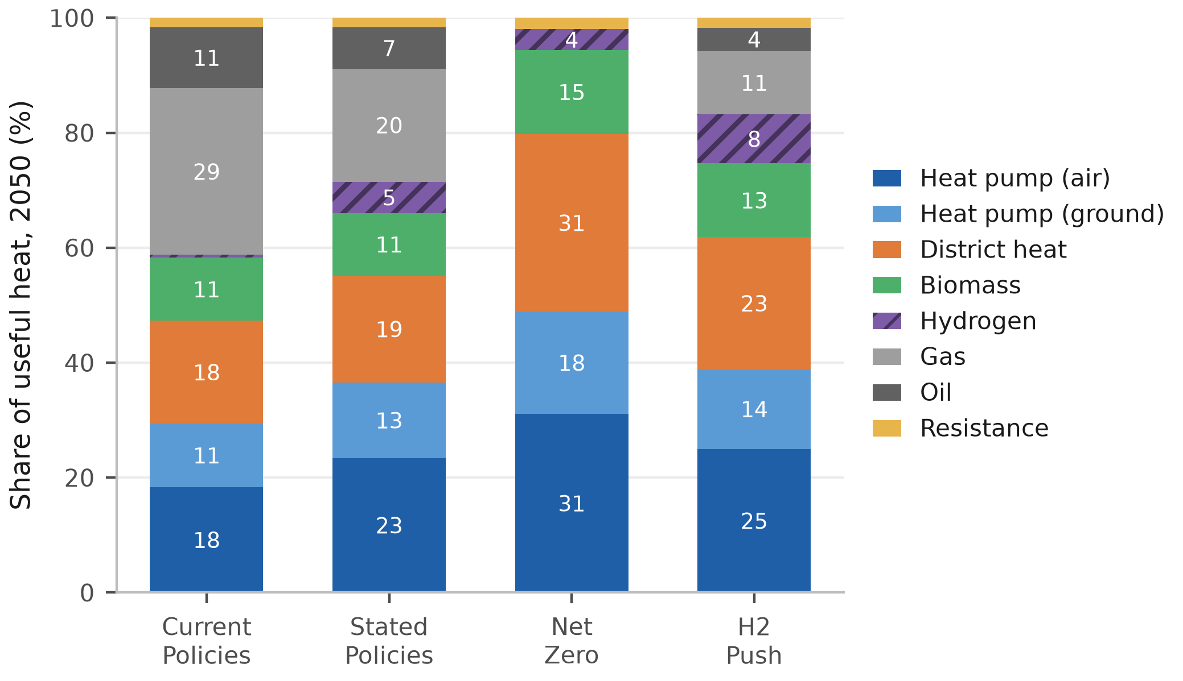
Figure 3: 2050 heating-technology mix by scenario. EU-27, UK and Switzerland, useful-heat basis. Segments below 2 per cent are unlabelled.
Note: bars are per-technology medians across draws with absent technologies counted as zero, renormalised to 100 per cent from raw sums of 97.5 to 100.1. Labelled segments are rounded to the nearest point and carry the renormalised shares, so hydrogen’s 8.5 per cent under H2 Push prints as 8, Net Zero’s 3.5 prints as 4, and the two Stated Policies heat-pump segments sum to 36 against the 37 in the text.
Demand moves little across the pathways; emissions move a great deal. All four start from the same reconstructed 2025 baseline of about 644 MtCO₂ and fan out to roughly 352, 231, 10 and 123 MtCO₂ by 2050. The Net Zero spread is a two-branch mixture that no tail describes, with 151 draws near 10 MtCO₂ and 49 near 70, so its decile band should be read as two outcomes and their probabilities. The same technology set is available in every scenario, so ambition alone separates the outcomes, and the roughly 342 MtCO₂/yr Current Policies to Net Zero gap at 2050 is the value of closing the implementation gap in residential heat, a spread the fossil-phaseout lever leads. Its ranking and sign are invariant to the shared 2025 anchor while the levels scale with it.

3.2 Levelised cost of heat
The base-load ordering is close at the median and wide across the 29 countries. Air-source heat pumps and gas boilers reach parity in 2025 at about €156/MWh each, on the Eurostat EU average gas price of €114/MWh including taxes [51] against existing-fleet seasonal coefficients of performance of 2.8 to 4.1 [57], and behind it the best heat pump per country already undercuts gas in 16 of the 29. Fig. 4 presents the component build-up. By 2050 the median best heat pump sits at €118.5/MWh against €132.7/MWh for gas, winning in 24 of the 29. Only the gas boiler pays a carbon price at 2050, so that count runs from 19 markets to 29 across the carbon paths. Each €50/tCO₂ of ETS2 adds about €11/MWh to the gas boiler against a median €0.7/MWh on the heat pump at 2030, because electricity carries only the increment above its 2025 carbon cost, which reaches zero by 2050. The ordering matches in direction a European household comparison built on a different accounting [18].
District heat undercuts both at about €96.5/MWh, though not on the same basis, since it pays no last-mile connection charge here. Charging it the €5,000 per connection our infrastructure bill assigns adds a median €21.0/MWh and takes it from cheaper than the best heat pump in 26 of 29 countries to 7. The hydrogen boiler closes most of the distance without closing it, falling from about €299/MWh in 2025 to €122.8/MWh by 2050. Fuel is the largest component of all three, the heat pump carries the largest capital charge at about 28 per cent because its equipment is sized to peak heat demand, and the hydrogen boiler’s network-and-storage charge at about 27 per cent matches its capital and fixed operating charges combined.
With each carrier charged the last-mile network it needs and hydrogen the seasonal store its winter-weighted load requires, hydrogen holds 7 and heat pumps the remaining 22. Across all 29 the median country gap is +€15.4/MWh, and the mean weighted by each country’s 2025 heat demand is +€1.4/MWh, since hydrogen still competes in the large north-western markets (Supplementary Table S6 and Section S2.2). The seasonal store sets how wide those margins are and decides the peaking arena. Space heating draws about three-quarters of its annual energy between October and March while electrolytic production is far flatter, so the mismatch is held between seasons at an assumed €1.5/kg with salt caverns and €3.0/kg without, rates consistent in order with the bulk-storage literature [58], [59], [60]. Spread over the annual load, that is about €12/MWh with caverns and €24 without; and charged to the peak slice alone it is the €50 and €100/MWh-heat the dispatch tests use. Cheap geology widens the five cavern margins without selecting the set, since at the non-cavern rate five still hold, though not the same five.
Two accounting corrections separate these numbers from a working-paper version of this analysis that circulated publicly with different headlines. Sizing equipment capital to peak heat demand rather than dividing it again by the machine’s efficiency, together with the last-mile charges, moves the base-load count from 28 of 29 markets to 12, and charging the seasonal store consistently across the three arenas moves it back to 22 (Supplementary Section S2.7).
Three caveats bear on the base-load case, the second of which closes the seven on its own. The first is fiscal. The comparison sets a household’s taxed retail electricity price, a 2050 study-area median of about €209/MWh, against hydrogen at roughly €50/MWh delivered and untaxed, a factor of four that a coefficient of performance near 3.5 does not quite close where electricity is dearest. The difference is levies, network charges and taxes, so it records a policy choice about which carrier bears the system’s cost.
The second is provenance. A detailed assessment of the German heating case concludes the hydrogen realistically supplied to heat would be blue, at about €81/MWh on the blue route we price [61], [62], a €31/MWh wedge over the green figure it replaces and wider than the €30/MWh by which hydrogen leads in Denmark, its widest win. Read flat across Europe, the reading we quote, that removes hydrogen’s advantage in all seven; read as a ratio on each market’s own price Denmark alone holds.
The third runs against our own accounting and we apply it only as a bound, since electrified heat is charged distribution reinforcement but not the firm generating capacity the same winter evenings call on, which Section 3.4 costs at €51 to 66/kW-yr annualised. Charging heating pro rata to its 9.2 per cent share of power demand costs €1.0 to 1.3/MWh over the 1,273 TWh of heat-pump heat and leaves the count at 22; charging the whole fleet to that load is €11.2 to 14.5/MWh and takes it to 17 and then 15. Between them sits the basis cost causation asks for, since a peaking asset is built for a peak. Removing the heat-pump load drops the fleet from 278 to 57 GW, so 79.6 per cent of it exists because heat is electrified, far above heating’s 9.2 per cent of electricity demand, because the cold snap collapses the coefficient of performance just as demand peaks. Charging on that share is €8.9 to 11.5/MWh and takes the count to 19 and then 17, so the 22 holds on the pro-rata bound alone.
The last-mile treatment moves the comparison as much. Sweeping it from free reuse of the gas grid to a dedicated new build takes the count at or below parity for hydrogen from 12 to 3, whereas loading the heat pump at the top of the reinforcement band and charging hydrogen nothing leaves heat pumps cheapest in only 10. The ordering is therefore robust to how dear electricity distribution proves, and fragile to whether hydrogen is charged for distribution at all. The four pathways carry network bills of €249 to 506 bn cumulated to 2050, and H2 Push’s hydrogen network does not displace the electricity reinforcement it still requires (Supplementary Table S12). The fiscal treatment of electricity is therefore a first-order buildings-policy question.
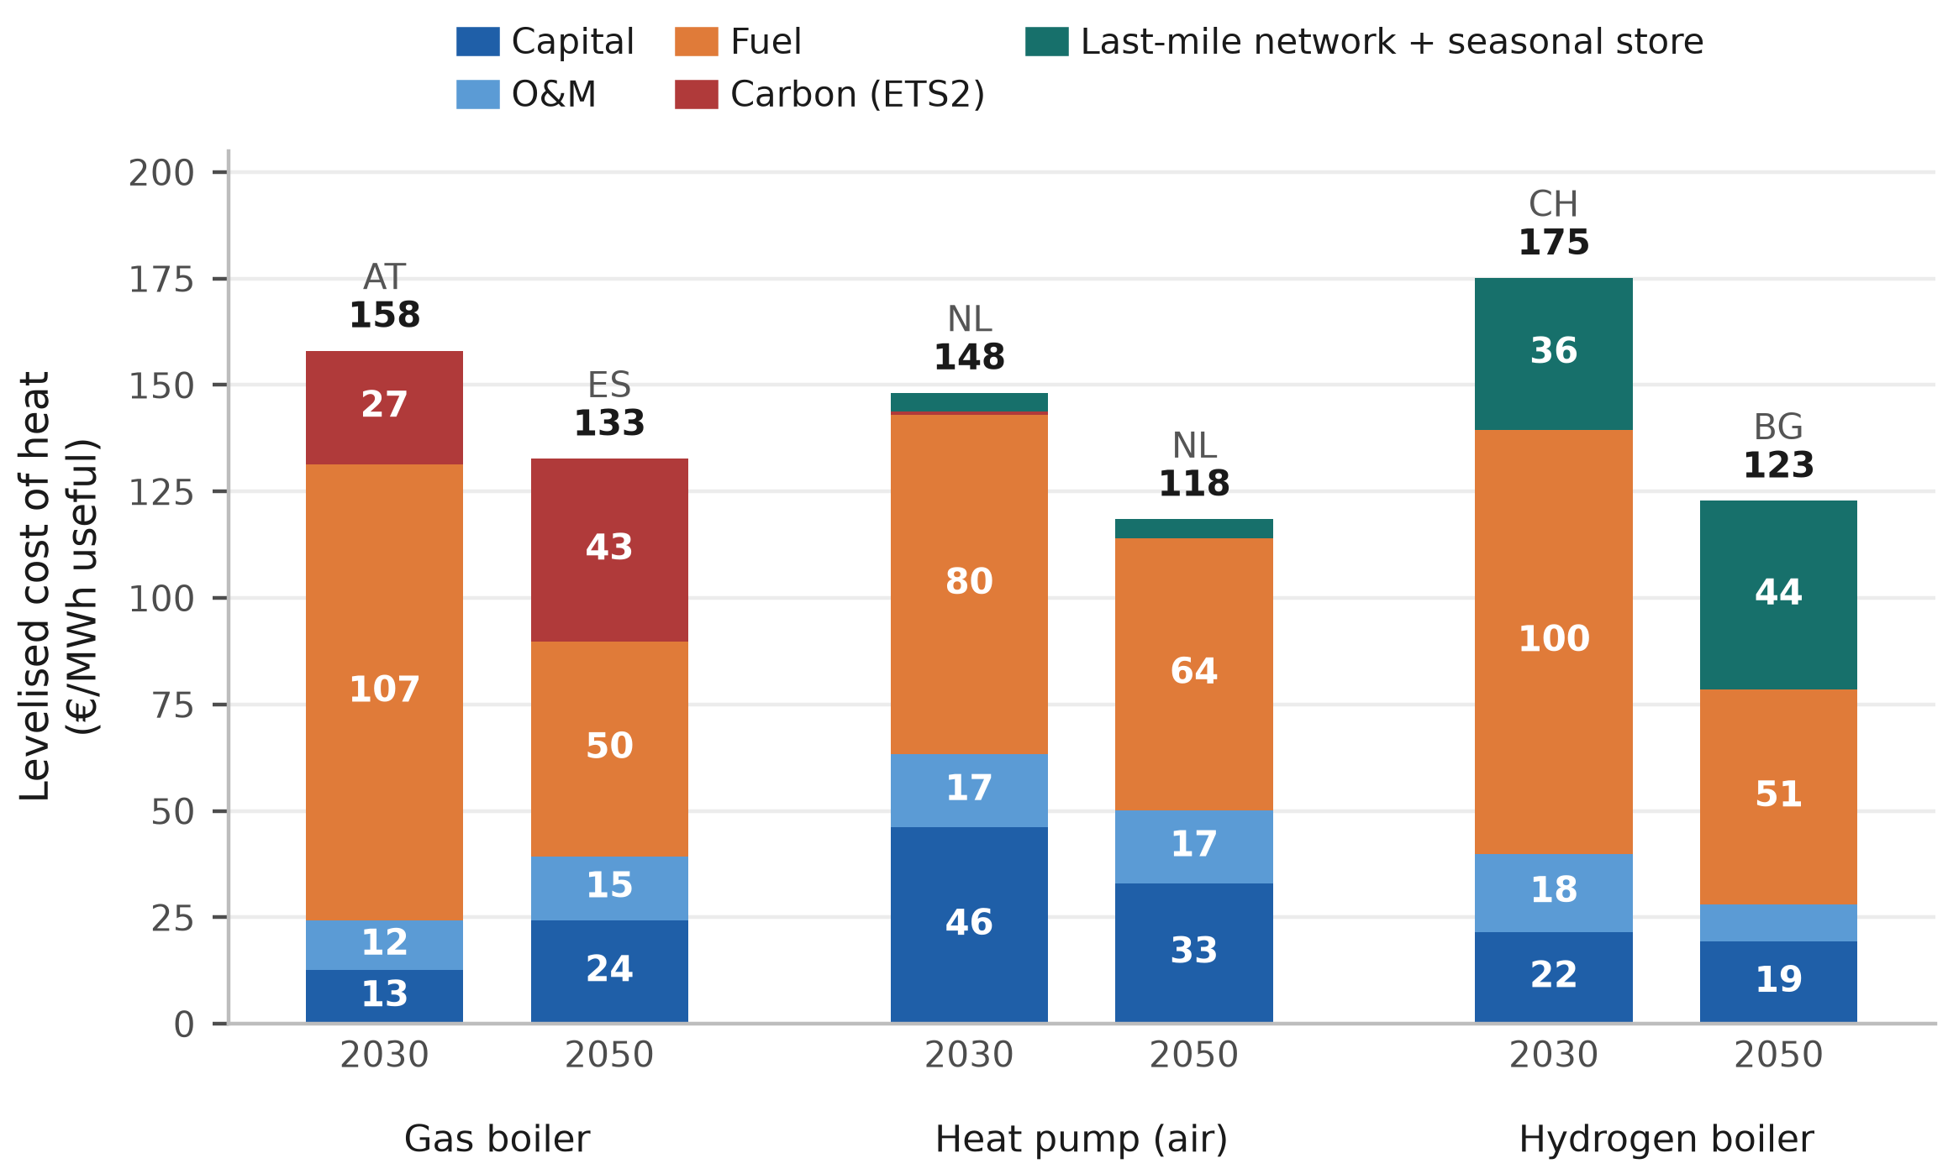
Figure 4: Levelised cost of heat by component, 2030 and 2050. The market at the study median for each technology and year, named above its bar. Air-source heat pump.
Note: the median of 29 markets falls on a market, so each 2050 stack sums to the median quoted in the text. The bars are different markets, so neither the pair nor the distance between two is a trajectory or the study’s median gap, which is the median of the 29 per-country differences. The last band is last-mile network and seasonal store for hydrogen, network reinforcement for the heat pump, nothing for gas. Segments below €11/MWh are unlabelled.

3.3 Power-sector merit order and the cavern markets
The levelised-cost test prices hydrogen as a base-load supplier, whereas its advocates cast it as a peaker serving only the cold-snap tip, when the air-source coefficient of performance collapses. We therefore reprice it on short-run marginal cost across the building, district-heat and power-sector peaks. The scarcity electricity price the building peak is judged against comes from the power sector’s merit order, averaging €215 to 307/MWh, because a high carbon price loads the gas unit that sets it.
On the symmetric accounting used throughout, hydrogen’s win count rises with carbon-pricing ambition in every arena, to 14 of 29 countries at the building winter peak, seven in district heating and seven in the power sector under H2 Push (Table 2); on the earlier draft’s basis the first two read 16 and 20. Two levers drive that ordering. Across the first three scenarios the carbon price on the competing gas plant opens the niche, ETS2 at the building peak and ETS1 elsewhere [63]. H2 Push then shares Net Zero’s carbon path and adds only a faster decline in the hydrogen price, so the fuel lever alone drives that rise, whereas the power arena holds at seven because the two turbines face the same carbon price. Hydrogen’s position is therefore set as much by its rival’s fortunes as by its own.
Waste heat sits at the bottom of the district-heat merit order at about €10/MWh, so a gas combined-heat-and-power plant is marginal on a cold day in 20 of the 29 networks, which caps the arena at 20. Hydrogen undercuts it in seven of those. Charging both alike means gas enters at the €30/MWh wholesale hub price the district-heat operator actually pays and hydrogen carries its own €13.4/MWh median last-mile adder at the building peak. The earlier draft charged gas the Eurostat residential retail tariff and hydrogen no last-mile network, which flatters hydrogen. The slice is thin either way, the top 12 to 18 per cent of the load over 2,000 hours at about 518 equivalent full-load hours, so sweeping all 20 is about 3 per cent of residential heat (Supplementary Section S2.3). Weighting each country’s building-peak slice by its heat demand puts the symmetric counts at 0, 0.6, 7.5 and 9.0 per cent of study-area residential heat, the bound each scenario ceiling is set at or below; the earlier draft’s accounting gives 0, 5.1, 7.9 and 9.3.
The model prices the dispatchable tip and holds the rungs below it at literature short-run costs. The figures are H2 Push, and Net Zero holds the same ordering with a narrower cavern advantage. On the equal-efficiency series that sets the win counts the hydrogen turbine’s cross-country median is about €286/MWh-e, some €30/MWh-e above the carbon-priced gas peaker at €256/MWh-e, so the typical market does not undercut gas at all (Eq. (1); Fig. 5). Both run the high carbon path, which lifts the gas peaker to that €256/MWh-e; on the central path it sits near €181 and the cavern advantage narrows to a few euros, so this count is conditional on the carbon path, whereas the base-load ordering is not (Supplementary Section S1.3). On the evolving-efficiency series the medians close to €238 against €239/MWh-e and the undercut count rises to 15, or 8 without the backbone discount, no longer confined to cavern geology. We count wins on the equal-efficiency series, which declines to hand hydrogen the better machine, and price recovery on the evolving one, so the seven and the 15 answer different questions. In the seven the turbine falls to €168 to 184/MWh-e, €72 to 89 below the gas peaker, and across the 22 non-cavern markets sits about €36 above.
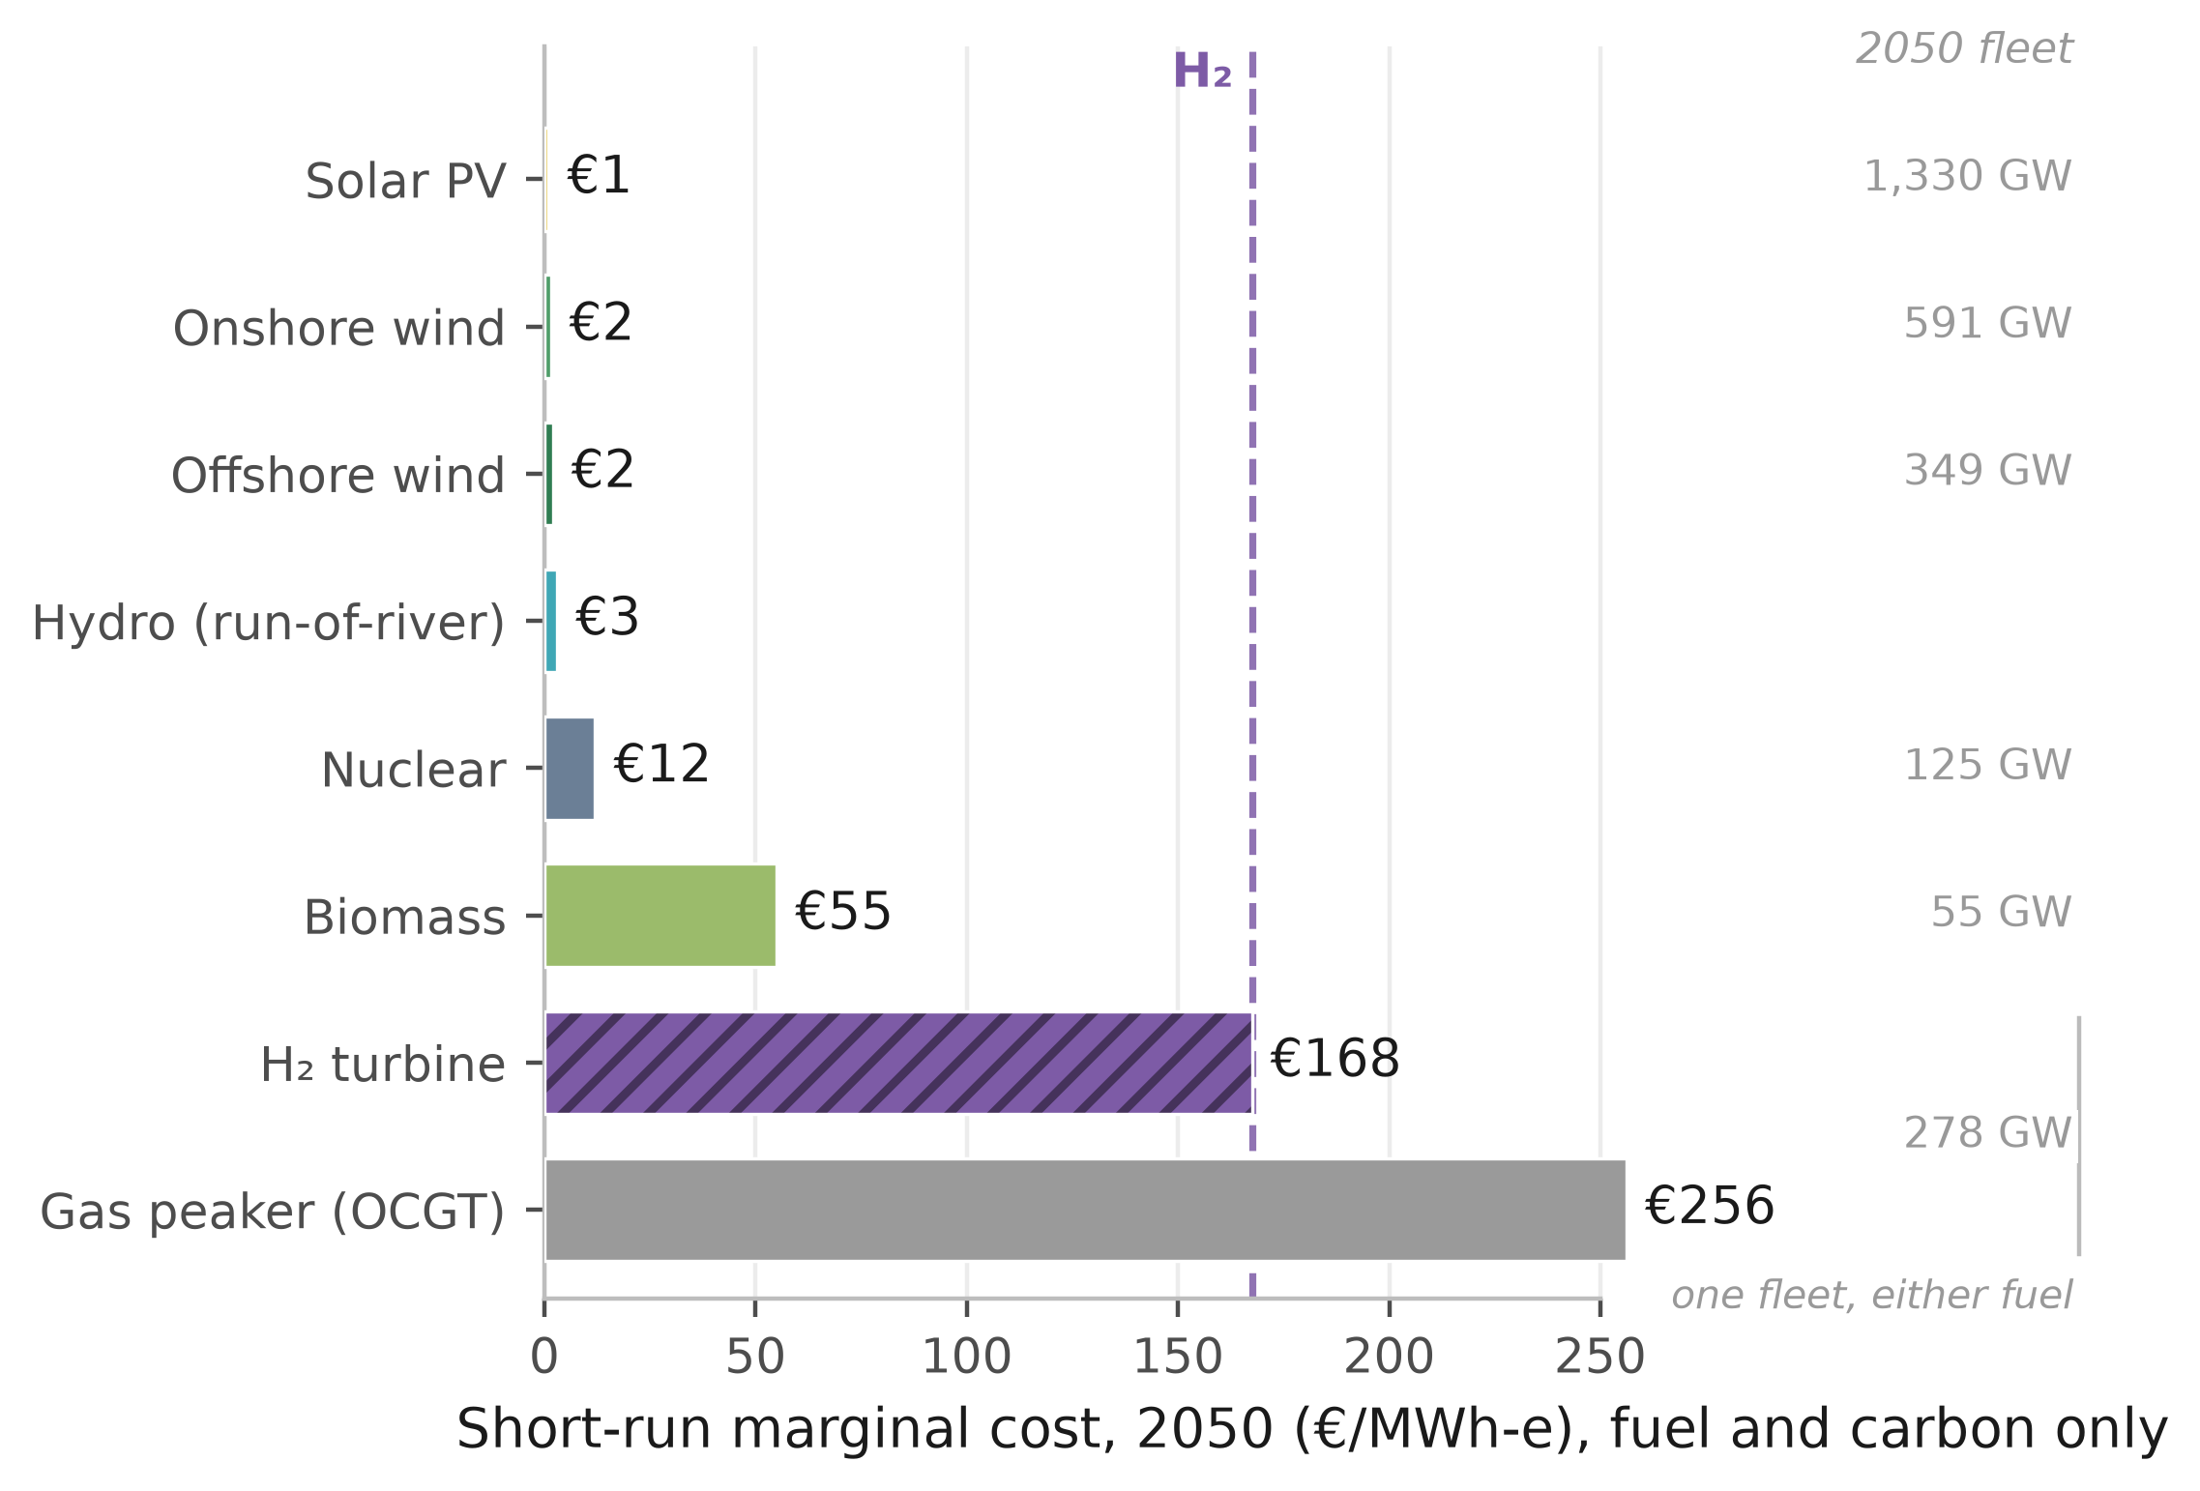
Figure 5: 2050 power merit order in Denmark, under H2 Push. A salt-cavern market. Short-run marginal cost, fuel and carbon only, capital excluded, on the equal-efficiency series.
Note: costs are Denmark’s, the capacity column the study-area 2050 fleet. The evolving series puts the two machines at €142 and €241/MWh-e, a different comparison from the medians above. Hydro carries no capacity figure because we hold only a whole-fleet series. Omitted from the rungs are 3 GW of coal, 421 GW of batteries and 195 GW of combined cycle. Batteries dispatch hourly with a carrying state of charge, so they shave the daily peak and deplete over a multi-day event; only the combined cycle counts as sustained firm capacity (Supplementary Section S2.4). Dispatchable rungs are model output.
The seven winning markets are the salt-cavern countries, in descending advantage Denmark, the United Kingdom, the Netherlands, Romania, Poland, and France and Germany tied (Fig. 6), and are not the seven hydrogen holds on base load. The two share five. Belgium and Ireland hold base load without the power peak and France and Romania the reverse, because retail prices decide part of the base-load set and geology alone the peaking one. The mechanism is the seasonal-storage adder of Section 2 [38]. Of the two exogenous adders only storage moves the count, since the premium cancels between the turbines. The count holds at seven across about €50 to 75/MWh-heat of storage, reaching every market only at €38 and under. The winning set is that two-value geology classification exactly, so the seven is conditional on it. Alternative readings move it, since including Iberia gives nine and restricting France to its northern basins six. Provenance moves it further. At the €81/MWh blue figure read flat across Europe the turbine reaches €289/MWh-e and all seven reverse, while on a green-to-blue ratio they hold at €30 to 57/MWh-e (Supplementary Section S1.3).
Both the base-load and the peaking verdicts turn on the cost of storing the molecule between seasons, the peaking one on endowment and the base-load one partly on tax incidence. However, even the peaking win does not pay for the plant.
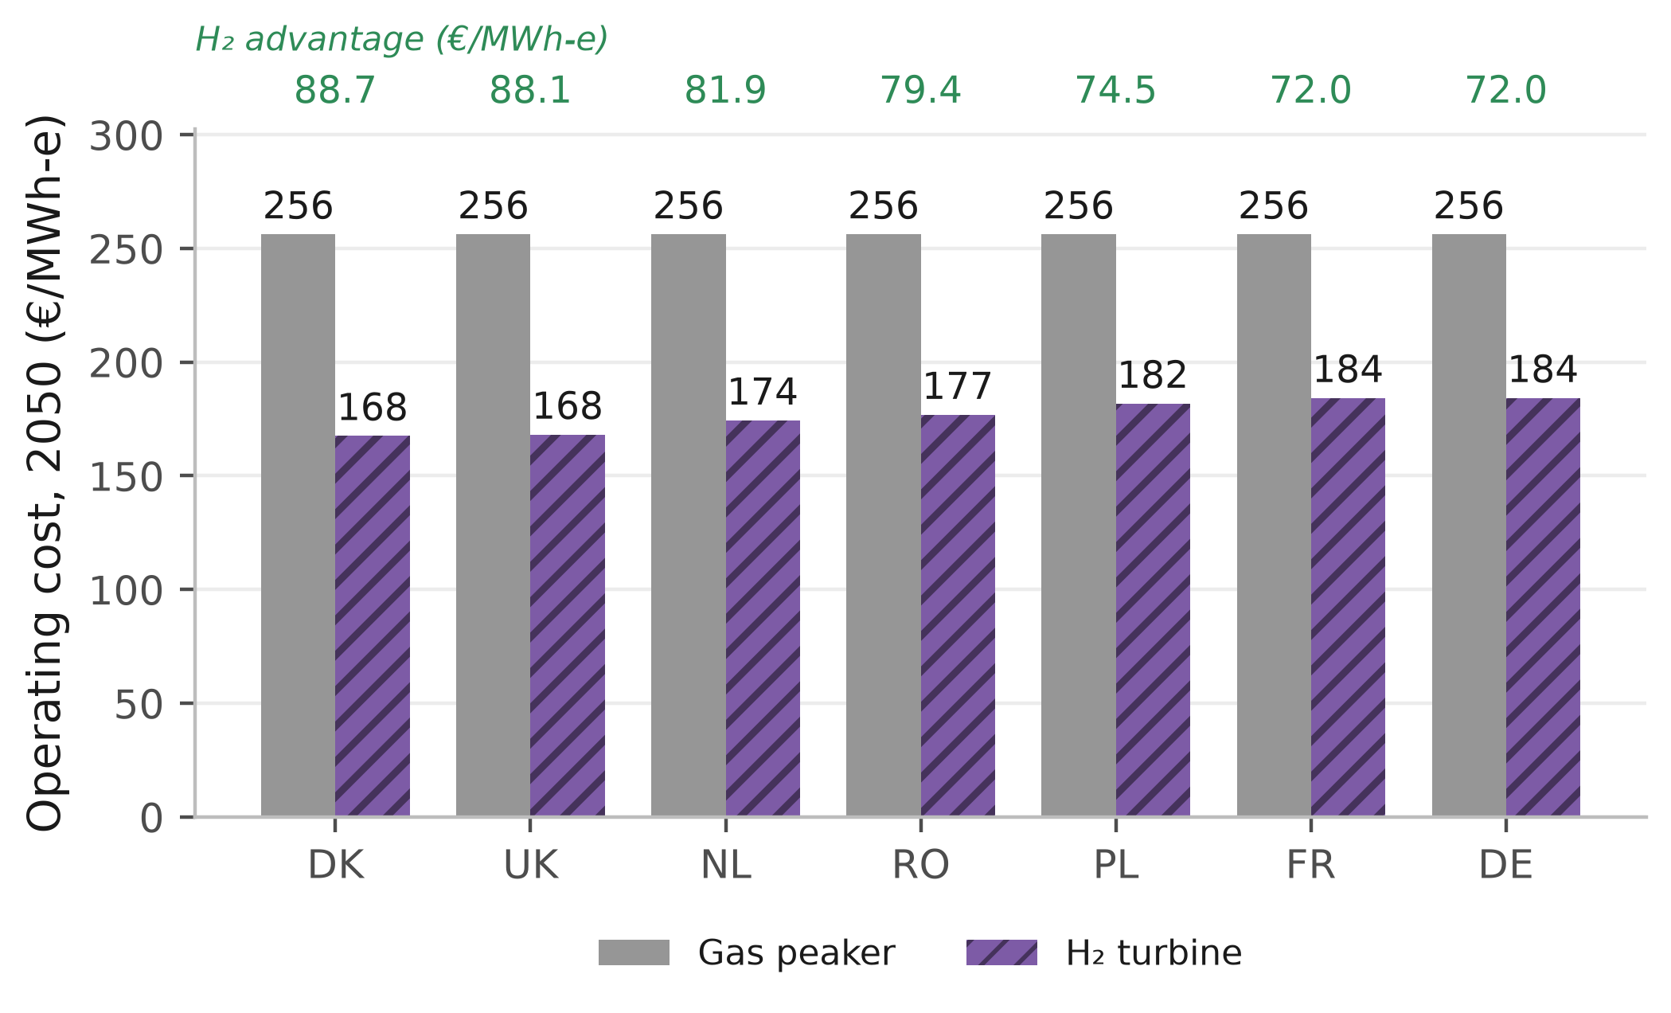
Figure 6: Where hydrogen undercuts the gas peaker, H2 Push 2050. The seven salt-cavern markets, on the equal-efficiency series. The green row above the frame is the advantage, gas minus hydrogen, in €/MWh-e.
Note: gas is €256/MWh-e in all seven on that series, since they share a carbon price and a gas cost, so the spread within them is the delivered hydrogen price alone. The other 22 markets do not undercut.

3.4 Capital recovery of the hydrogen peaker
An investor must also recover the peaker’s capital from the few hours it runs. Wherever hydrogen is the cheaper firm unit it sets the clearing price at its own short-run cost plus the scarcity premium $π^{s}$, so its rent is that premium and recovery is
$$R_{c}=\frac{π^{s} {FLH}_{c}}{({CRF}_{c}+f) K^{T}},$$ | (2)
with $FLH$ the peaker’s full-load hours, $K^{T}$ the turbine capital cost, $CRF$ the country’s capital-recovery factor over 25 years and $f=2.5$ per cent a year the fixed operating charge. On an energy-only market at the assumed $π^{s}$ of €60/MWh, $R_{c}<1$ in every country and scenario, so no hydrogen peaker is privately financeable even where its operating cost wins the cold snap. That failure, rather than its size, is the robust result: it holds at every scarcity premium tested and under every weather variant in Supplementary Section S2.9. The five that build average 80 full-load hours weighted by capacity, against 139 for the whole fleet, so their rent covers about 9 per cent of an annualised charge of €51 to 66/kW-yr in the central case, 4.4 to 17.4 per cent across the scarcity grid below.
Recovery is a single-year ratio of rent to that year’s capital charge, and the spread tracks utilisation, since Eq. (2) is linear in run hours at a common margin. Five of the seven cavern markets build a peaker in 2050, over run windows from 48 hours in Germany to 343 in Denmark and recoveries from Poland’s 5.1 per cent to Denmark’s 40.0 (Supplementary Section S2.4). None reaches the 100 per cent private finance requires, the classic missing-money problem [30], [64]. Cumulated undiscounted over the 25 years to 2050 the H2 Push peaker loses about €357 bn against €142 bn for an equivalent gas peaker, widening to €563 bn under Current Policies, so the shortfall is not an artefact of the hydrogen-heavy scenario (Supplementary Section S2.4).
The unit commitment cross-checks that dispatch at 160 full-load hours on a fleet 2.8 GW larger, because ramp and minimum-output limits push residual load onto the peakers. We quote 139 hours throughout, and the extra hours earn more rent, so the cross-check cuts against the finding.
The role the missing money implies divides in two. The firm dispatchable peaking fleet is about 278 GW on the constructed weather year, roughly 31 per cent of the 889 GW system peak, computed on the Stated Policies demand path and priced under each scenario’s fuel and carbon paths, so only the margins move. On each scenario’s own demand path, same stack and weather year, it runs 242 to 278 GW at 131 to 148 full-load hours. It is an increment on a firm combined-cycle fleet of about 195 GW, so total firm dispatchable capacity is nearer 473 GW or 53 per cent of peak, and the increment is what hydrogen competes for. Both rest on that weather year and are not an adequacy assessment; EU pooling takes the requirement to 239 GW (Supplementary Section S2.4). However, that fleet supplies only 0.86 per cent of the study area’s 4,513 TWh of 2050 electricity demand, about 1.2 per cent were non-heat demand held flat rather than grown 1.40-fold, running about 139 full-load hours a year, so hydrogen’s electricity role is a capacity role, the clean firm backstop for electrified heat rather than a source of kilowatt-hours [34], [35].
The same molecule wins operating-cost dispatch in up to 7 of 29 district-heat markets, and 20 on the earlier draft’s accounting. The recovery test runs on the power-sector peaker alone, the plant this section prices, and it finances itself in no market or scenario (Table 2). Adequacy is imposed by the sizing rule. The difficulty is paying for it.
Table 2: Operating-cost wins by arena against capital recovery. Counts of the 29 markets at 2050.
 | Current | Stated | Net Zero | H2 Push
Arena | Policies | Policies
Markets won on operating cost, of 29
Building winter peakª | 0 | 2 | 7 | 14
District-heat peak | 0 | 0 | 7 | 7
Power peaker^{b} | 0 | 0 | 7 | 7
Power-sector peakers recovering their capital, of 29
Any scenario | 0 | 0 | 0 | 0
ª Computed on the uncoupled series, which prices each country’s heat-pump peak without crediting a national reservoir fleet. Crediting Switzerland’s removes it from the H2 Push count of 14 (Section 3.6).
^{b} The power arena is the seven salt-cavern markets.
Note: every row charges both carriers alike. On the alternative accounting an earlier draft used, which charges hydrogen no last-mile network at the building peak and prices the district-heat comparison at the residential retail rather than the wholesale gas tariff, the first two rows read 0, 4, 9, 16 and 0, 5, 11, 20.
Note: per-arena detail is in Supplementary Table S7.
Source: Authors’ contribution.
Three caveats bound this reading, each widening the recovery without reversing the sign (Supplementary Section S2.9). The first is that the 278 GW requirement and the €357 bn shortfall assume an inflexible heat load; smoothing lowers the requirement to 248.0 to 265.6 GW at the most generous corner, and the assumed event length alone carries ±9 per cent (Supplementary Tables S9 and S10). The second is that Eq. (2) makes the verdict partly definitional for any low-utilisation peaker, since the storage adder and the delivered hydrogen price both cancel from the rent, leaving it invariant to the very storage condition that decides the other two tests. It is also exactly linear in $π^{s}$, and across the €30, 60, 90 and 120/MWh grid, capacity-weighted recovery runs 4.4, 8.7, 13.1 and 17.4 per cent. Pricing the three shortage hours the sizing standard imposes at the model’s own €8,000/MWh value of lost load, which is paid to no generator here, lifts the central 8.7 to about 51 per cent, so the direction survives and the magnitude does not.
The third is that our energy-only baseline describes no real market, since three of the seven already run a mechanism [65]. European law already carries an emissions condition of the kind selection would require, and on our own figures it does not bite. Article 22(4) of the Electricity Regulation caps a mechanism’s payments at 550 gCO₂/kWh and adds a 350 kgCO₂/kWe-yr annual limb that reaches only capacity commissioned before July 2019 [66]. A 2050 build therefore faces the rate limb alone, and an unabated open-cycle turbine clears it at about 505 gCO₂/kWh-e on our own emission factor, so the Article offers no selection lever here (Supplementary Section S2.4).
A deliberate hydrogen-peaker build therefore implies a standing payment, and €31 to 63/kW-yr closes the gap for the winning peakers (Supplementary Table S11). That sits below the £60/kW-yr, roughly €70, at which the 2024 British four-year-ahead auction cleared while procuring 27.3 GW of unabated gas out of 43.1 GW [67]. A clearing price and a modelled revenue requirement are different objects, so this checks magnitude, not validity. A gas peaker in the same markets recovers an even smaller share of its capital, yet needs a smaller payment, €41 to 52/kW-yr, because a gas turbine costs €450/kW against 600. Weighted by capacity the two are close, €45/kW-yr against 51, and gas is cheaper in four of the five markets that build, so a technology-neutral payment at the $K^{T}$ of €600/kW we assume would procure unabated gas ahead of hydrogen, which is what the British auction shows a real mechanism doing.
That conclusion turns on the capex gap and reverses below about €520 to 540/kW, a premium of roughly 18 per cent over the gas turbine, and published premia for hydrogen-ready machines straddle it. Above it hydrogen is selected only where the mechanism is conditioned on emissions, and that condition costs the payment difference over the gas generation it displaces, about €172/tCO₂ on top of the carbon price the gas plant already pays, rising to roughly €239 once the gas unit’s negative rent is floored at zero (Supplementary Section S2.4). Either way the peaking niche is a policy choice no market delivers on its own. Fuel prices and tax incidence leave the arithmetic unchanged but move which markets reach it.

3.5 Least-cost cross-check and the binding carbon cap
The four scenarios impose technology shares, so a parallel least-cost linear program minimising supply cost against a fixed demand path and a scope-1 emissions cap (Section 2) asks what a cost minimiser would choose. It is silent on hydrogen. At the −90 per cent cap the 2050 least-cost mix is 52.9 per cent district heat, 45.4 per cent heat pumps, 1.4 per cent residual gas and 0.34 per cent hydrogen, but the program’s per-country hydrogen ceiling is zero in 27 of the 29 and it selects that ceiling exactly in the other two. The mix speaks to district heat and heat pumps, not to a technology the program was never free to choose. Supplementary Section S2.8 gives three bounds on reading it, the largest district heat’s unpriced connection charge: the €21.0/MWh of Section 3.2 sits outside this objective, so 52.9 per cent is a share under that boundary, not an optimum.
Ambition is cheap, since the discounted present-value system cost varies by 0.05 per cent between the −75 and −100 per cent caps. The carbon price does not do the work everywhere, since the cap binds in Cyprus, Croatia, Poland and the United Kingdom in 2050 at a shadow price of up to €81/tCO₂, and in seven countries at some point on the path. That cap is national while ETS2 is a pooled price, so this is the one result on the heating side that argues for an instrument other than a price.

3.6 Switzerland as a standalone case
Switzerland puts the two comparisons side by side more sharply than any other market, and both close the same way. The Swiss heat-pump levelised cost falls to a 2050 band of €122.4 to 131.1/MWh against a hydrogen boiler at €128.0/MWh and a gas boiler at about €165.9/MWh, so the best Swiss heat pump ends €5.6/MWh below the hydrogen boiler (Fig. 7). Swiss retail electricity is expensive and heavily levied, which keeps that margin narrow, but Switzerland also has no salt caverns and so pays the €3.0/kg storage rate. The clean grid removes the carbon argument and the geology the storage argument, so what remains of the gap is the retail levy on electricity, a few euros per megawatt-hour.
On the endogenous arm the peaking arena runs the same way, unaffected by the levy question because both turbines buy fuel at wholesale. There the hydrogen peaker loses the Swiss winter peak in all four scenarios, priced out by storage cost alone at €135 to 236/MWh-heat against a heat-pump peak of €62 to 90/MWh-heat. The uncoupled 29-country comparison prices that peak at €155/MWh-heat without crediting the reservoir fleet, so hydrogen does win under H2 Push, and crediting the fleet drops the peak to €90/MWh-heat and removes the win. We read the Swiss peaking verdict off the endogenous arm, the better-specified for that test; the base-load figures above are the uncoupled arm, whose €5.6/MWh gap is the narrower of the pair, against €9.6/MWh on the endogenous one. The arena counts stay on the uncoupled series, whose symmetric H2 Push building-peak count is 14 against the endogenous 13 (16 against 15 on the earlier draft’s accounting), because the coupling exists for Switzerland alone and the uncoupled series is the more hydrogen-favourable of the pair.
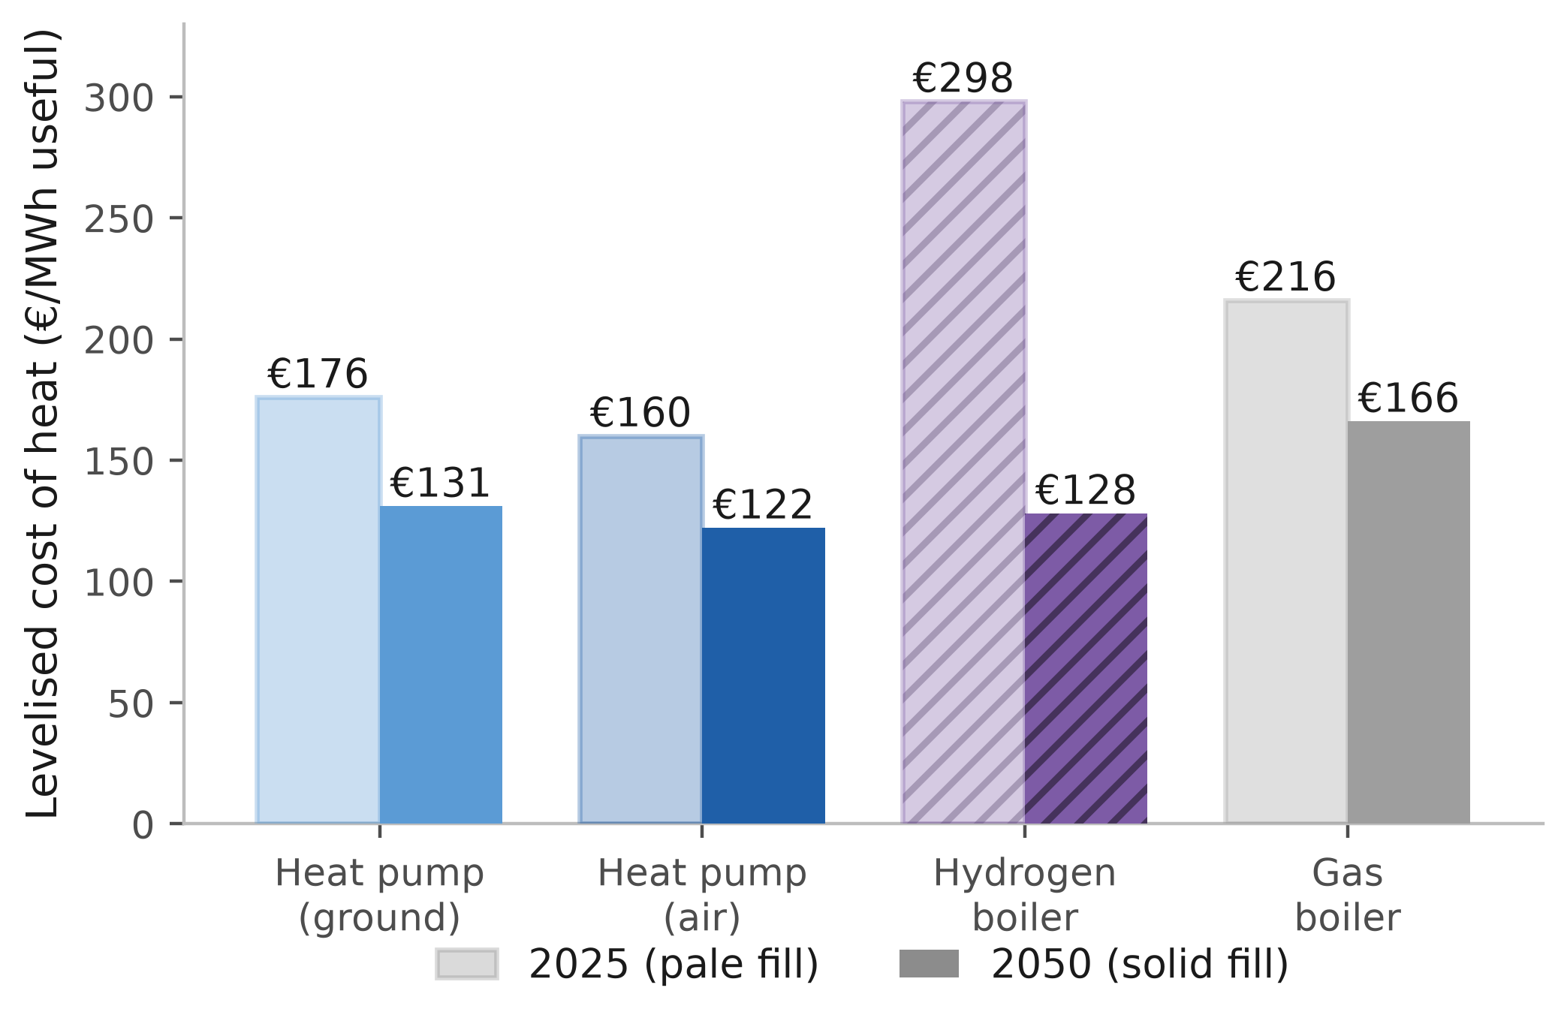
Figure 7: Swiss levelised cost of heat, 2025 and 2050. Stated Policies, on the uncoupled arm. Pale-filled bars are 2025, solid 2050; every bar is labelled. Switzerland has no salt caverns and so pays the higher seasonal storage rate. Not crediting the national reservoir fleet leaves the best heat pump €5.6/MWh below the hydrogen boiler; crediting it widens the gap to €9.6/MWh.
A win in one arena does not carry to another, so what the three tests establish together is the scope of hydrogen’s role rather than a single verdict. The base-load market count is the least robust of the three. It moves from 13 to 29 markets across the hydrogen price paths we sample, and it turns in part on a fiscal asymmetry that policy could remove. The capital-recovery result is the most robust. It rests on the arithmetic of a plant that runs about 139 hours a year, which no efficiency convention disturbs, whereas the confinement to cavern markets holds on the equal-efficiency series alone. The capacity magnitude sits between the two, a property of the one constructed weather year, whereas the recovery failure survives every sensitivity we ran.

4 Conclusions

4.1 Summary of findings
This study screens Europe’s building-heat choice across 29 markets to 2050, pricing hydrogen as a system operator would. The three tests point the same way about hydrogen’s scope, though all three price it through one storage parameter, so the agreement corroborates less than it suggests. Four findings follow.
(1) On base-load levelised cost the best 2050 heat pump delivers €118.5/MWh against €122.8 for the hydrogen boiler and €132.7 for gas, beating gas in 24 of the 29 markets, 19 to 29 across the carbon paths, and hydrogen in 22 on the pro-rata firm-capacity basis, 19 then 17 on cost causation. The all-29 median gap is €15.4/MWh and the demand-weighted mean €1.4/MWh, because the markets hydrogen holds are the large ones.
(2) The seven markets hydrogen holds on base load are the paper’s least robust count. The heat-pump count behind them runs from 13 on a rapid hydrogen cost decline to 29 if hydrogen costs stall, and pricing the molecule blue at the €81/MWh route closes all seven [61], [62]. Levelling the carriers’ fiscal treatment would move the comparison the same way by an amount we do not size.
(3) Repriced on short-run marginal cost, on the high carbon path and the equal-efficiency series, hydrogen wins the power peak in a different seven. All seven are salt-cavern markets on a binary geology screen, and alternative cavern definitions move the count to six or nine, so this is a screening result rather than a physical one. The peaking increment is about 278 GW, roughly 31 per cent of the study area’s 889 GW peak, yet supplies about 0.86 per cent of its electricity. At €600/kW no market recovers the capital, about 9 per cent capacity-weighted in 2050 at the central scarcity premium and 4.4 to 17.4 per cent across the grid, so a standing payment of €31 to 63/kW-yr closes the gap. All of this rests on the single constructed weather year of Section 2.
(4) Policy ambition sets the emissions outcome. From a 2025 baseline of about 644 MtCO₂ the four scenarios reach 352, 231, 10 and 123 MtCO₂ by 2050, which the fossil-phaseout lever leads.

4.2 Policy implications
Four implications follow, each scoped to the model’s cost criterion. (1) Heat pumps lead by the widest margin across the warm south and east, undercutting hydrogen by about €99/MWh in Malta and €88 in Cyprus. Where hydrogen leads, margins are narrow enough that installer capacity, upfront finance and retail electricity taxation decide the outcome. (2) Passing ETS2 through to end users preserves the switching signal, the €11/MWh per €50/tCO₂ wedge quantified above, which social protection can leave intact rather than suppress.
(3) Where a hydrogen peaker is wanted, no private investor is made whole and a technology-neutral mechanism procures unabated gas at the capex assumed here, so a payment conditioned on emissions is what selects hydrogen. Conditioning costs about €172/tCO₂ of displaced gas generation in the central case, a figure that inherits the turbine capital cost, the full-load hours and the scarcity rent, and reverses only if hydrogen-ready machines carry a premium below about 18 per cent. Article 22(4) of the Electricity Regulation supplies no vehicle, so selection rests on that premium (Section 3.4).
(4) A national scope-1 target is not reachable on price alone everywhere, so the four markets where the cap binds at 2050, and three more that bind earlier, are where a complementary instrument bites. The coal-grid Eastern European markets are the clearest case, since heat pumps lead there while the grid is still carbon-intensive.

4.3 Limitations and future work
Seven limitations bound these results, each with its direction in Supplementary Section S2.9. The largest is the weather, whose construction Section 2 sets out and which bounds the power-sector half. The 278 GW fleet, the 139 full-load hours, the €357 bn shortfall and the zero row of Table 2 rest on it, and the cold snap’s assumed length is a choice, two days giving 254 GW and ten days 302 GW. An adequacy assessment would run thirty or more recorded weather years and derive the correlation from data [68], [69], [70], and this study does neither.
Future work should co-optimise renovation depth with technology choice, build the hourly emissions ledger, resolve heterogeneity within NUTS3 regions, and price the cross-sector capacity value a hydrogen turbine might capture. That last could still shift the verdict where cheap hydrogen, cavern geology and cross-sector demand coincide.

CRediT authorship contribution statement
Abdurahman Alsulaiman: Conceptualization, Methodology, Software, Validation, Formal analysis, Data curation, Visualization, Writing – original draft, Writing – review & editing. Ali Alajwad: Conceptualization, Methodology, Software, Validation, Formal analysis, Data curation, Visualization, Writing – original draft, Writing – review & editing.

Funding
[FUNDING STATEMENT TO BE INSERTED BY THE AUTHORS BEFORE SUBMISSION.]

Acknowledgements
The authors thank the Oxford Institute for Energy Studies for access to its gas and hydrogen research programme, and the maintainers of the EUBUCCO, TABULA and Hotmaps databases, without which the regional demand reconstruction would not have been possible.

Declaration of competing interest
The authors declare that they have no known competing financial interests or personal relationships that could have appeared to influence the work reported in this paper.

Data availability
All model code, input-data provenance, country profiles and figure generators are openly available at https://github.com/alajwadha/eu-hydrogen-buildings (MIT licence). Large third-party inputs are retrieved by the included download scripts for Hotmaps, Eurostat and GISCO. Two are not. The UK ONS TS044 accommodation-type table is a manual one-time download, and it is committed to the repository, and the EUBUCCO v0.2 building footprints that drive the bottom-up demand basis are fetched from the EUBUCCO object store by the per-country build scripts. The forward model runs from the committed intermediate CSVs; reproducing the bottom-up build from raw footprints additionally requires that object store and the per-country classification step.

References
[1] International Energy Agency, “Buildings,” IEA, 2022. Available: https://www.iea.org/energy-system/buildings
[2] European Commission, “The European Green Deal,” European Commission, 2020. Available: https://commission.europa.eu/strategy-and-policy/priorities-2019-2024/european-green-deal_en
[3] I. L. Azevedo, M. G. Morgan, and M. C. Moura, “The challenges of deep decarbonization in the buildings sector,” Joule, vol. 6, no. 4, pp. 696–708, 2022.
[4] S. Chatterjee, G. Molnár, B. Kiss, D. Topál, and D. Ürge-Vorsatz, “Navigating the transition: Modelling the path for net-zero European building sector,” Renewable and Sustainable Energy Reviews, 2024, doi: 10.1016/j.rser.2024.114827.
[5] International Energy Agency, “The future of heat pumps,” IEA, Paris, 2022. Available: https://www.iea.org/reports/the-future-of-heat-pumps
[6] M. H. Abbasi et al., “Heat transition in the European building sector: Overview of the heat decarbonisation practices through heat pump technology,” Sustainable Energy Technologies and Assessments, 2021.
[7] J. Lingard, “Residential retrofit in the UK: The optimum retrofit measures necessary for effective heat pump use,” Building Services Engineering Research and Technology, 2020, doi: 10.1177/0143624420975707.
[8] D. Gibb, J. Rosenow, R. Lowes, and N. Hewitt, “Coming in from the cold: Heat pump efficiency at low temperatures,” Joule, 2023, doi: 10.1016/j.joule.2023.08.005.
[9] P. E. Dodds et al., “Hydrogen and fuel cell technologies for heating: A review,” International Journal of Hydrogen Energy, 2015.
[10] D. Bothe and M. Janssen, “The value of hydrogen in the heating market,” Frontier Economics, for FNB Gas, 2021. Available: https://www.frontier-economics.com/media/byojuyut/the-value-of-hydrogen-in-the-heating-market.pdf
[11] European Commission, “REPowerEU plan,” European Commission, Brussels, Communication from the Commission COM(2022) 230 final, May 2022. Available: https://eur-lex.europa.eu/legal-content/EN/TXT/?uri=celex:52022DC0230
[12] European Commission, “Implementing the REPowerEU action plan: Investment needs, hydrogen accelerator and achieving the bio-methane targets,” European Commission Staff Working Document, 2022. Available: https://eur-lex.europa.eu/legal-content/EN/TXT/?uri=SWD:2022:230:FIN
[13] A. Goldthau and R. Youngs, “The EU Energy Crisis and a New Geopolitics of Climate Transition,” JCMS Journal of Common Market Studies, 2023, doi: 10.1111/jcms.13539.
[14] J. Rosenow, “Is heating homes with hydrogen all but a pipe dream? An evidence review,” Joule, vol. 6, no. 10, pp. 2225–2228, 2022, doi: 10.1016/j.joule.2022.08.015.
[15] J. Rosenow, “A meta-review of 54 studies on hydrogen heating,” Cell Reports Sustainability, vol. 1, no. 1, p. 100010, 2024, doi: 10.1016/j.crsus.2023.100010.
[16] D. Cebon, “Hydrogen for heating: A comparison with heat pumps.” 2022. Available: https://h2sciencecoalition.com/blog/hydrogen-for-heating-a-comparison-with-heat-pumps-part-1/
[17] A. Badakhsh and S. M. Bhagavathy, “Caveats of green hydrogen for decarbonisation of heating in buildings,” Applied Energy, 2023, doi: 10.1016/j.apenergy.2023.122152.
[18] C. Baldino, J. O’Malley, S. Searle, and A. Christensen, “Hydrogen for heating? Decarbonization options for households in the European Union in 2050,” International Council on Clean Transportation (ICCT), Mar. 2021. Available: https://theicct.org/publication/hydrogen-for-heating-decarbonization-options-for-households-in-the-european-union-in-2050/
[19] A. Billerbeck et al., “The race between hydrogen and heat pumps for space and water heating: A model-based scenario analysis,” Energy Conversion and Management, 2023, doi: 10.1016/j.enconman.2023.117850.
[20] T. Brown, D. Schlachtberger, A. Kies, S. Schramm, and M. Greiner, “Synergies of sector coupling and transmission reinforcement in a cost-optimised, highly renewable European energy system,” Energy, 2018, doi: 10.1016/j.energy.2018.06.222.
[21] F. Neumann, E. Zeyen, M. Victoria, and T. Brown, “The potential role of a hydrogen network in Europe,” Joule, vol. 7, no. 8, pp. 1793–1817, 2023, doi: 10.1016/j.joule.2023.06.016.
[22] I. Kountouris, R. Bramstoft, T. Madsen, J. Gea-Bermúdez, M. Münster, and D. Keles, “A unified European hydrogen infrastructure planning to support the rapid scale-up of hydrogen production,” Nature Communications, 2024, doi: 10.1038/s41467-024-49867-w.
[23] V. M. Maestre, A. Ortiz, and I. Ortiz, “Transition to a low-carbon buildings stock: Techno-economic and spatial optimization of renewables-hydrogen strategies in Spain,” Journal of Energy Storage, 2022.
[24] D. Huckebrink and V. Bertsch, “Decarbonising the residential heating sector: A techno-economic assessment of selected technologies,” Energy, 2022.
[25] P. Hoseinpoori et al., “A whole-system approach for quantifying the value of smart electrification for decarbonising heating in buildings,” Energy Conversion and Management, 2022.
[26] B. Möller, E. Wiechers, U. Persson, L. Grundahl, R. S. Lund, and B. V. Mathiesen, “Heat Roadmap Europe: Towards EU-Wide, local heat supply strategies,” Energy, 2019, doi: 10.1016/j.energy.2019.04.098.
[27] U. Persson, E. Wiechers, B. Möller, and S. Werner, “Heat Roadmap Europe: Heat distribution costs,” Energy, 2019, doi: 10.1016/j.energy.2019.03.189.
[28] T. Weidner and G. Guillén-Gosálbez, “Planetary boundaries assessment of deep decarbonisation options for building heating in the European Union,” Energy Conversion and Management, 2023, doi: 10.1016/j.enconman.2022.116602.
[29] C. J. Quarton et al., “The curious case of the conflicting roles of hydrogen in global energy scenarios,” Sustainable Energy & Fuels, 2019, doi: 10.1039/c9se00833k.
[30] P. L. Joskow, “Capacity payments in imperfect electricity markets: Need and design,” Utilities Policy, vol. 16, no. 3, pp. 159–170, 2008, doi: 10.1016/j.jup.2007.10.003.
[31] C. J. Quarton and S. Samsatli, “The value of hydrogen and carbon capture, storage and utilisation in decarbonising energy: Insights from integrated value chain optimisation,” Applied Energy, 2019, doi: 10.1016/j.apenergy.2019.113936.
[32] E. Zeyen, V. Hagenmeyer, and T. Brown, “Mitigating heat demand peaks in buildings in a highly renewable European energy system,” Energy, 2021, doi: 10.1016/j.energy.2021.120784.
[33] A. Mellot, C. Moretti, T. Tröndle, and A. Patt, “Mitigating future winter electricity deficits: A case study from Switzerland,” Energy Conversion and Management, 2024, doi: 10.1016/j.enconman.2024.118426.
[34] N. A. Sepulveda, J. D. Jenkins, F. J. de Sisternes, and R. K. Lester, “The role of firm low-carbon electricity resources in deep decarbonization of power generation,” Joule, vol. 2, no. 11, pp. 2403–2420, 2018, doi: 10.1016/j.joule.2018.08.006.
[35] J. E. T. Bistline and G. J. Blanford, “Value of technology in the U.S. Electric power sector: Impacts of full portfolios and technological change on the costs of meeting decarbonization goals,” Energy Economics, vol. 86, p. 104694, 2020, doi: 10.1016/j.eneco.2020.104694.
[36] N. Milojevic-Dupont et al., “EUBUCCO v0.1: European building stock characteristics in a common and open database for 200+ million individual buildings,” Scientific Data, vol. 10, no. 1, p. 147, 2023, doi: 10.1038/s41597-023-02040-2.
[37] T. Loga, B. Stein, and N. Diefenbach, “TABULA building typologies in 20 European countries — Making energy-related features of residential building stocks comparable,” Energy and Buildings, vol. 132, pp. 4–12, 2016, doi: 10.1016/j.enbuild.2016.06.094.
[38] D. G. Caglayan et al., “Technical potential of salt caverns for hydrogen storage in Europe,” International Journal of Hydrogen Energy, vol. 45, no. 11, pp. 6793–6805, 2020, doi: 10.1016/j.ijhydene.2019.12.161.
[39] P. Gabrielli, F. Charbonnier, A. Guidolin, and M. Mazzotti, “Enabling low-carbon hydrogen supply chains through use of biomass and carbon capture and storage: A Swiss case study,” Applied Energy, 2020.
[40] International Energy Agency, “Switzerland energy policy review 2023,” IEA, Paris, 2023. Available: https://www.iea.org/reports/switzerland-2023
[41] Hotmaps Project, “Hotmaps regional heat demand dataset,” Hotmaps, 2020. Available: https://gitlab.com/hotmaps/regional_demand
[42] Eurostat, “CENS_21DWBNO_R3: Dwellings by number of occupants and type of building, NUTS3,” Eurostat, 2021. Available: https://ec.europa.eu/eurostat/databrowser/view/CENS_21DWBNO_R3
[43] Office for National Statistics, “TS044: Accommodation type, Census 2021,” ONS, 2021. Available: https://www.ons.gov.uk/datasets/TS044/editions/2021
[44] Eurostat GISCO, “NUTS reference shapefiles 2021,” Eurostat, 2021. Available: https://gisco-services.ec.europa.eu/distribution/v2/nuts/
[45] Danish Energy Agency, “Technology data for energy plants for electricity and district heating generation,” Danish Energy Agency, Copenhagen, 2023. Available: https://ens.dk/en/our-services/projections-and-models/technology-data
[46] Joint Research Centre, “Long-term (2050) projections of techno-economic performance of low-carbon technologies,” European Commission Joint Research Centre, 2023. Available: https://publications.jrc.ec.europa.eu/repository/bitstream/JRC109006/kjna28859enn.pdf
[47] International Renewable Energy Agency, “Heat pump costs and markets,” IRENA, Abu Dhabi, 2022. Available: https://www.irena.org/-/media/Files/IRENA/Agency/Publication/2022/Nov/IRENA_Heat_Pumps_Costs_Markets_2022.pdf
[48] European Commission, “EU ETS2: Emissions trading for buildings and road transport,” European Commission DG CLIMA, 2024. Available: https://climate.ec.europa.eu/eu-action/eu-emissions-trading-system-eu-ets/ets2-buildings-road-transport-and-additional-sectors_en
[49] European Hydrogen Observatory, “Cost of hydrogen production,” European Hydrogen Observatory / Clean Hydrogen JU, 2024. Available: https://observatory.clean-hydrogen.europa.eu/hydrogen-landscape/production-trade-and-cost/cost-hydrogen-production
[50] Eurostat, “Electricity price statistics, first half 2025,” Eurostat, 2025. Available: https://ec.europa.eu/eurostat/statistics-explained/index.php?title=Electricity_price_statistics
[51] Eurostat, “Natural gas price statistics, first half 2025,” Eurostat, 2025. Available: https://ec.europa.eu/eurostat/statistics-explained/index.php/Natural_gas_price_statistics
[52] K. Calvin et al., “Climate Change 2023: Synthesis Report. Contribution of Working Groups I, II and III to the Sixth Assessment Report of the Intergovernmental Panel on Climate Change [Core Writing Team, H. Lee and J. Romero (eds.)],” Intergovernmental Panel on Climate Change (IPCC), Geneva, Switzerland, 2023, doi: 10.59327/ipcc/ar6-9789291691647.
[53] D. Jones et al., “European electricity review 2024,” Ember, London, Feb. 2024. Available: https://ember-energy.org/latest-insights/european-electricity-review-2024/
[54] European Environment Agency, “GHG emission intensity of electricity generation in europe, indicator ENER 038,” EEA, 2024. Available: https://www.eea.europa.eu/data-and-maps/indicators/overview-of-the-electricity-production-3/assessment
[55] European Commission, “A Clean Planet for All: A European Strategic Long-Term Vision for a Prosperous, Modern, Competitive and Climate Neutral Economy,” European Commission, Brussels, Communication from the Commission COM(2018) 773 final, Nov. 2018. Available: https://eur-lex.europa.eu/legal-content/EN/TXT/?uri=CELEX:52018DC0773
[56] International Energy Agency, “Net Zero Roadmap: A Global Pathway to Keep the 1.5 °C Goal in Reach, 2023 Update,” International Energy Agency, Paris, Sep. 2023. Available: https://www.iea.org/reports/net-zero-roadmap-a-global-pathway-to-keep-the-15-c-goal-in-reach
[57] European Heat Pump Association, “Heat pumps: Key figures and market data,” EHPA, 2023. Available: https://www.ehpa.org/market-data/
[58] A. S. Lord, P. H. Kobos, and D. J. Borns, “Geologic storage of hydrogen: Scaling up to meet city transportation demands,” International Journal of Hydrogen Energy, vol. 39, no. 28, pp. 15570–15582, 2014, doi: 10.1016/j.ijhydene.2014.07.121.
[59] D. D. Papadias and R. K. Ahluwalia, “Bulk storage of hydrogen,” International Journal of Hydrogen Energy, vol. 46, no. 70, pp. 34527–34541, 2021, doi: 10.1016/j.ijhydene.2021.08.028.
[60] M. Talukdar, P. Blum, N. Heinemann, and J. Miocic, “Techno-economic analysis of underground hydrogen storage in Europe,” iScience, vol. 27, no. 1, p. 108771, 2024, doi: 10.1016/j.isci.2023.108771.
[61] IEAGHG, “Low-carbon hydrogen from natural gas: Global roadmap,” IEA Greenhouse Gas R&D Programme, 2022-07, 2022.
[62] R. Dickel, “Decarbonising Germany’s heating sector,” Oxford Institute for Energy Studies, ET29, 2024. Available: https://www.oxfordenergy.org/publications/decarbonising-germanys-heating-sector/
[63] N. Fabra and M. Reguant, “Pass-through of emissions costs in electricity markets,” American Economic Review, vol. 104, no. 9, pp. 2872–2899, 2014, doi: 10.1257/aer.104.9.2872.
[64] D. Newbery, “Missing money and missing markets: Reliability, capacity auctions and interconnectors,” Energy Policy, vol. 94, pp. 401–410, 2016, doi: 10.1016/j.enpol.2015.10.028.
[65] European Union Agency for the Cooperation of Energy Regulators, “Security of EU electricity supply: Report on capacity mechanisms,” ACER, Ljubljana, 2023. Available: https://www.acer.europa.eu/
[66] European Union, “Regulation (EU) 2019/943 of the European Parliament and of the Council of 5 June 2019 on the internal market for electricity (recast).” Official Journal of the European Union L 158, 14.6.2019, pp. 54–124, 2019. Available: https://eur-lex.europa.eu/eli/reg/2019/943/oj
[67] Department for Energy Security and Net Zero, “2024 four year ahead capacity auction (T-4) delivery year 2028/29: Auction monitor report,” UK Government, London, 2025. Available: https://www.gov.uk/government/publications/capacity-market-auction-auction-monitor-report-for-t-4-auction-for-2028-to-2029
[68] I. Staffell and S. Pfenninger, “Using bias-corrected reanalysis to simulate current and future wind power output,” Energy, vol. 114, pp. 1224–1239, 2016, doi: 10.1016/j.energy.2016.08.068.
[69] S. Pfenninger and I. Staffell, “Long-term patterns of European PV output using 30 years of validated hourly reanalysis and satellite data,” Energy, vol. 114, pp. 1251–1265, 2016, doi: 10.1016/j.energy.2016.08.060.
[70] M. Kittel, A. Roth, and W.-P. Schill, “Long-duration electricity storage needs for coping with Dunkelflaute events in Europe,” Nature Communications, vol. 17, p. 4210, 2026, doi: 10.1038/s41467-026-72681-5.

