Graphical abstract

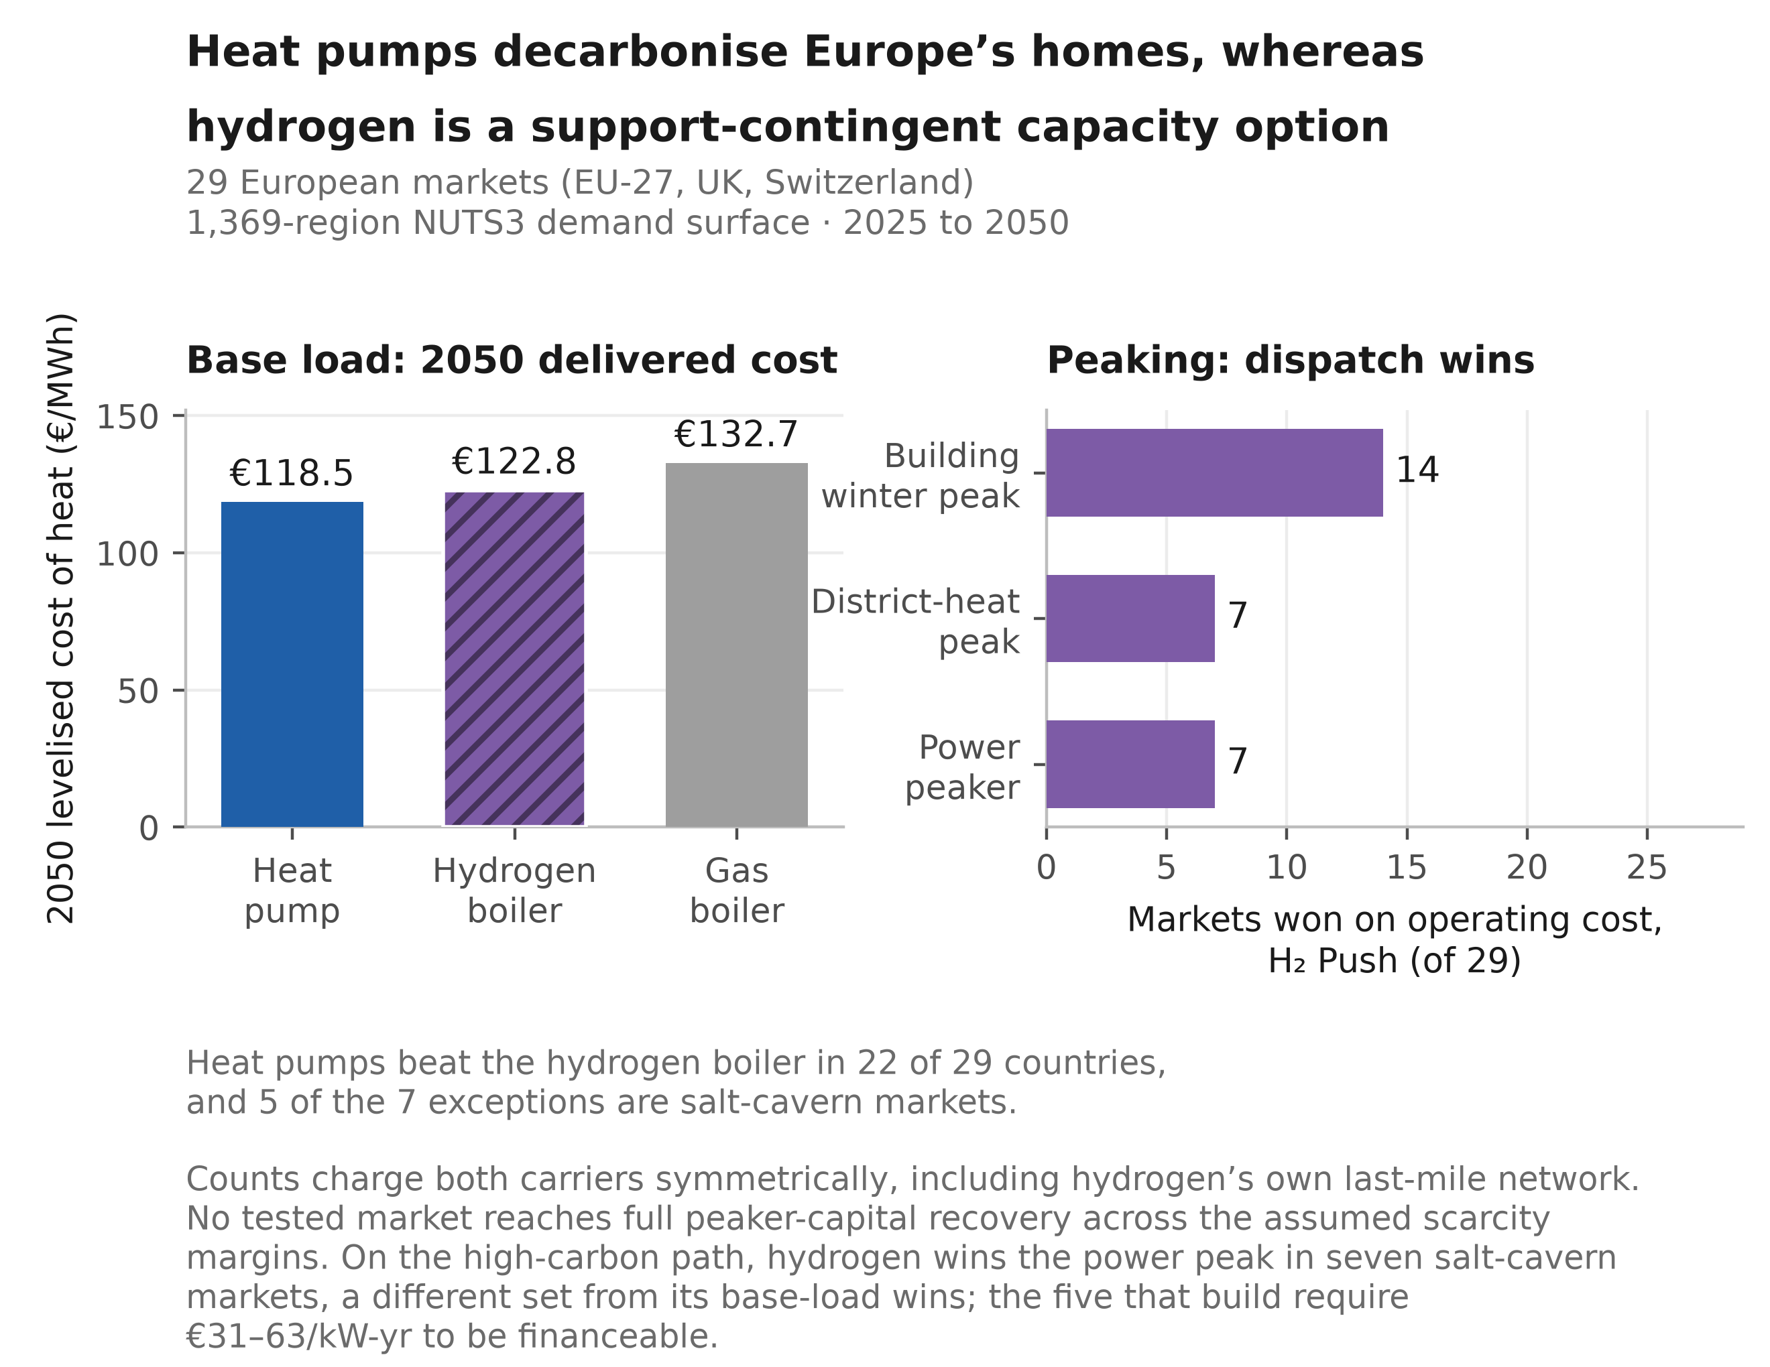

Highlights

• Heat pumps beat hydrogen on 2050 base-load heat cost in 22 of 29 markets
• Hydrogen wins the high-carbon power peak in seven cavern markets at equal efficiency
• No tested market fully recovers peaker capital across the assumed scarcity margins
• At €600/kW turbine capital cost, technology-neutral support favours gas
• Scenario ambition shifts 2050 residential-heating emissions by 342 MtCO₂/yr

Hydrogen in residential heating and the power system: a merit-order and capital-recovery assessment for 29 European markets

Abdurahman Alsulaiman1, Ali Alajwad2,3
1 Oxford Institute for Energy Studies, Oxford, UK
2 RENEW Lab, Johns Hopkins University, Baltimore, MD, USA
3 Cornell University, Ithaca, NY, USA

Corresponding author: Abdurahman Alsulaiman

Abstract
Hydrogen for European residential heating is usually assessed at national resolution or imposed as an adoption share, neither of which tests market-level capital recovery for peak-serving assets. We reconstruct a 1,369-region NUTS3 heat-demand surface across 29 markets, aggregate it to country level, and represent scenario uncertainty with 200 draws per scenario. Four scenarios impose exogenous hydrogen-adoption settings, compared with independently derived winter-peak dispatch support. Three roles are tested: annual levelised cost; cold-snap dispatch across buildings, district heat and power; and peaker capital recovery. At central 2050 parameters, the best heat pump costs €118.5/MWh, versus €122.8/MWh for hydrogen and €132.7/MWh for gas. With firm-generation cost allocated pro rata to heating's annual electricity-demand share, heat pumps beat hydrogen in 22 of 29 markets. Allocation by the change in peaking capacity gives 19 heat-pump wins at the low bound and 17 at the high bound. Heat-pump wins range from 13 to 29 across the hydrogen-price paths tested. On the high-carbon, equal-efficiency series, hydrogen undercuts gas at the power peak in a different set of seven markets, all with salt caverns. No tested market reaches full peaker-capital recovery over the €30--120/MWh scarcity-margin range; capacity-weighted recovery among the five that build is about 9%. At €600/kW for a hydrogen-ready turbine, technology-neutral support favours gas; selecting hydrogen requires an emissions-conditioned premium of about €172/tCO₂ of displaced gas. Operational residential-heating emissions fall from 644 MtCO₂ in 2025 to 10--352 MtCO₂ in 2050. Power-sector quantities rest on one constructed weather year and are screening results, not adequacy estimates.

Keywords: Heat pumps; Hydrogen; Building heat decarbonisation; Seasonal hydrogen storage; Missing money

Nomenclature
$c_{c}^{gas}, c_{c}^{H_{2}}, c_{c}^{HP}$ – Short-run marginal cost of delivered heat from the gas boiler, hydrogen boiler and heat pump in country $c$ (€/MWh-heat)
${COP}_{c}^{cold}$ – Cold-snap heat-pump coefficient of performance in country $c$
${CRF}_{c}$ – Capital-recovery factor at country discount rate $r_{c}$ over the asset life (25 yr for the peaking turbine)
$D_{c}(t)$ – National useful heat demand in country $c$, year $t$ (TWh/yr)
$D_{c}^{0}$ – National base-year (2025) useful heat demand in country $c$ (TWh/yr)
$D^{pk}$ – System peak electricity demand (GW)
$D^{tot}$ – Total electricity demand (TWh/yr)
$(Dw/Pop)_{c,t}$ – Dwellings per capita in country $c$, year $t$
$e_{g}$ – Natural-gas emission factor (=0.202 tCO₂/MWh)
$E_{c}^{pk}$ – Annual energy generated by the firm peaking fleet in country $c$ (TWh)
$f$ – Fixed operating-cost rate on peaking-turbine capital (=2.5 %/yr)
${FLH}_{c}$ – Full-load hours of the hydrogen peaker in country $c$ (h/yr)
$H_{c}$ – Equivalent full-load hours of the peak slice in country $c$ (≈518 h/yr, over a 2,000 h window)
$H_{c}^{2015}$ – Hotmaps 2015 benchmark demand for country $c$ (TWh)
$K^{T}$ – Hydrogen-ready peaking-turbine overnight capital cost (= €600/kW; conventional open-cycle gas = €450/kW). Eq. (2) annualises this cost by applying ${CRF}_{c}+f$
$K_{c}^{pk}$ – Firm peaking-fleet capacity in country $c$ (GW)
$N$ – Monte Carlo / Saltelli sample size
$p_{c}^{gas}$ – Retail gas price in country $c$ (€/MWh)
$p^{gas,w}$ – Winter (backbone) gas price (€/MWh)
$p_{c}^{H_{2}}$ – Delivered hydrogen price in country $c$ (€/MWh)
$p_{c}^{H_{2},bb}$ – Backbone hydrogen price in country $c$ (€/MWh)
${Pop}_{c,t}$ – Projected population of country $c$, year $t$
$r_{c,s}$ – Per-country, per-scenario envelope-renovation rate (%/yr)
$r_{c}$ – Country weighted-average cost of capital (WACC)
$R_{c}$ – Capital recovery of the hydrogen peaker in country $c$, its scarcity rent over its annualised capital-and-fixed-operating charge (dimensionless; Eq. (2))
${SCOP}_{c}$ – Seasonal coefficient of performance of the heat pump in country $c$
$S_{T}$ – Sobol total-order sensitivity index
$t, t_{0}$ – Projection year; base year ($t_{0}=2025$)
$z_{c}, z_{EU}, z_{c}^{idio}$ – Standard-normal shocks (common and idiosyncratic) for sampling renovation rates
$φ_{y}$ – Carbon price (ETS2) in year $y$ (€/tCO₂)
$η_{g}, η_{h}$ – Gas-boiler (0.92) and hydrogen-boiler (0.90) efficiencies
$η_{OCGT}, η_{T}$ – Open-cycle gas turbine and hydrogen turbine electrical efficiencies. The headline winter-peak merit order holds both turbines at an efficiency of 0.40. The capital-recovery layer uses evolving efficiencies: 0.42 for gas and 0.44 for hydrogen by 2050, rising to 0.48 for hydrogen under H2 Push, which assumes an advanced simple-cycle machine
$μ_{c,s}, σ_{c,s}$ – Mean and standard deviation of the sampled renovation rate $r_{c,s}$
$π_{c}^{peak}$ – Derived scarcity (peak) electricity price in country $c$ (€/MWh-e)
$π^{s}$ – Scarcity margin (low/central/high {30,60,120} €/MWh; the sensitivity grid adds 90)
ρ – Cross-country shock correlation: renovation rate (=0.5), fuel prices (=0.75); all other sampled parameters are EU-wide scalars, i.e. ρ=1 implicitly
$a_{c}^{H_{2},dist}$ – Hydrogen last-mile distribution adder in country $c$, charged in the symmetric accounting (median €13.4/MWh)
$σ_{c}$ – Seasonal hydrogen-storage adder, heat side (≈€50–100/MWh-heat)
$σ_{c}^{e}$ – Seasonal hydrogen-storage adder, electricity side (€/MWh-e)
$Δ_{c}^{VM}$ – Vintage-matched deviation of the bottom-up backcast from the Hotmaps 2015 benchmark in country $c$
$Φ_{cap}, Φ_{en}$ – Firm dispatchable peaking fleet’s share of system peak capacity and of generated energy
$c$ – Country index
$s$ – Scenario index
$t, t_{0}, y$ – Year; base year; carbon-price year
$gas, H_{2}, HP$ – Gas-boiler, hydrogen-boiler and heat-pump branches
$pk, peak, cold$ – Peaker; system-peak/scarcity; cold-snap conditions

1 Introduction
Buildings take roughly 40 per cent of final energy in the European Union, most of it burned for space heating and hot water, which places them at the centre of European climate policy [1], [2]. Hundreds of billions of euros of that heating plant will be replaced by 2050, and whether that capital electrifies the heat or reuses the gas network for hydrogen is a choice slow to unwind. A clean option exists, but the difficulty lies in delivery, because heat reaches hundreds of millions of dwellings of differing vintage and fabric whose appliances are replaced only as they fail [3], [4].
European policy has converged on heat pumps as the principal route, and the case is strong. A coefficient of performance (COP) of two to four draws less final energy than any combustion appliance, and the machine decarbonises as the grid does [5], [6]. However, deployment is slowed by frictions that fall unevenly across the stock, among them retrofitting poorly insulated dwellings, distribution-grid reinforcement in dense areas, and performance that degrades in the coldest weather [7], [8]. We price that reinforcement inside the levelised cost of delivered heat, and the same frictions open pockets for a gas-based alternative.
Hydrogen is the alternative most often advanced, and the most contested, because a low-carbon gas could in principle reuse the existing distribution network and the appliance habit of a gas-heated home [9], [10]. REPowerEU raised the EU’s 2030 ambition to 20 Mt of renewable and imported supply, with buildings among the candidate demand centres [11], [12], and the 2022 gas crisis sharpened the appetite for a storable domestic fuel [13]. However, a substantial sceptical literature answers that hydrogen for space heating wastes primary energy, competes for scarce electrolytic supply, and understates the cost of network conversion [14], [15], [16], [17], [18].
The quantitative basis for settling the dispute is thinner than the debate implies, and the gaps fall into three groups. The first is spatial resolution. The continental assessments resolve the building stock in detail but at national resolution, so they cannot see the within-country demand gradient or the storage geology that decide where hydrogen might compete [19], [20]. Sub-national European work exists for the hydrogen network itself [21], [22], spatially explicit studies are mostly single-country [23], [24], [25], and the pan-European mapping resolves heat demand without a dispatch test [26], [27]. The second is the share itself, which studies commonly fix by assumption [28], [29] and price on annual levelised cost, which misstates how a dispatchable fuel competes [30], [31]. The third is a severed link between heat and power, and coupled system studies do model it [32], [33]. However, they report a system optimum rather than the standalone capital-recovery position of a hydrogen peaker market by market, which is the quantity a private investor and a capacity mechanism both need.
This study therefore asks under what conditions, and where, decarbonised hydrogen is competitive against heat-pump electrification in the buildings of the EU-27, the United Kingdom and Switzerland by 2050. Against those strands it adds a quantity each leaves out. The review literature concludes against hydrogen for domestic heat [14], [15] without reporting where the conclusion is close, so we reproduce the ordering in 22 of 29 markets, at an all-29 median of €15.4/MWh in the heat pump’s favour, and price the seven exceptions individually. The sub-national work returns a network plan rather than a plant’s balance sheet [21], [22], so we return a peaker’s standalone capital recovery market by market. The firm-capacity literature establishes that low-carbon systems need clean firm capacity [34], [35] without pricing it when the load is building heat, so we put that at €31–63/kW-yr.
First, where other work imposes a hydrogen share and stops, we impose transparent adoption pathways and then test them against an independent dispatch screen, market by market, exposing the cost and geology regimes a continental average would bury. Second, we recast the question from an energy-share contest into one about capacity and capital, screening the linked tests on one dispatch basis and testing capital recovery on the plant that wins the power peak. To deliver both we assemble a bottom-up techno-economic model of residential heating across the EU-27, the United Kingdom and Switzerland from 2025 to 2050. It reconstructs useful heat demand on a 1,369-region NUTS3 demand surface and aggregates it to the country before any cost test, benchmarking to within −0.8 per cent against an independent regional database [36], [37], and propagates that demand through eight technologies and four scenarios in a 200-draw Monte Carlo.
On the levelised comparison, we charge the heat pump for the low- and medium-voltage reinforcement associated with its winter peak and the hydrogen boiler for its own last-mile network and seasonal store. Each infrastructure term is varied separately in sensitivity analysis. These choices narrow the heat pump’s median margin without reversing its central ordering, although some sensitivity combinations do.
On that accounting the best 2050 heat pump undercuts the gas boiler in 24 of 29 countries and the hydrogen boiler in 22. Repriced on the short-run marginal cost (SRMC) a system operator uses, hydrogen wins the cold-snap peak in a minority of markets that grows with policy ambition, and no tested market reaches full peaker-capital recovery across the assumed scarcity margins, the classic missing-money problem. Switzerland, a high-cost, hydro-rich and cavern-poor system reliant on imports, provides a compact standalone case [38], [39].
The remainder is organised as follows. Section 2 sets out the model and its weather series, Section 3 the three tests and two cross-checks, and Section 4 the conclusions and policy implications.

2 Materials and methods
We assess where decarbonised hydrogen can compete with heat-pump electrification for European building heat using a spatially resolved, bottom-up techno-economic model coupled to a merit-order representation of the power sector. It is a chained simulation rather than a system-wide optimisation, reconstructing useful heat demand region by region, splitting it across eight technologies, pricing each on a levelised basis and then putting hydrogen against its rivals in operating-cost dispatch tests, so hydrogen’s share is set exogenously and then tested, never co-optimised (Supplementary Section S1.1). Coverage spans the EU-27, the United Kingdom and Switzerland. Demand is resolved at the third level of the Nomenclature of Territorial Units for Statistics as a 1,369-region NUTS3 demand surface, then aggregated to country level before the economic tests. The model runs on the milestone years 2025, 2030, 2040 and 2050, with 2025 the common anchor for demand, technology-share and cost trajectories alike (Fig. 1).
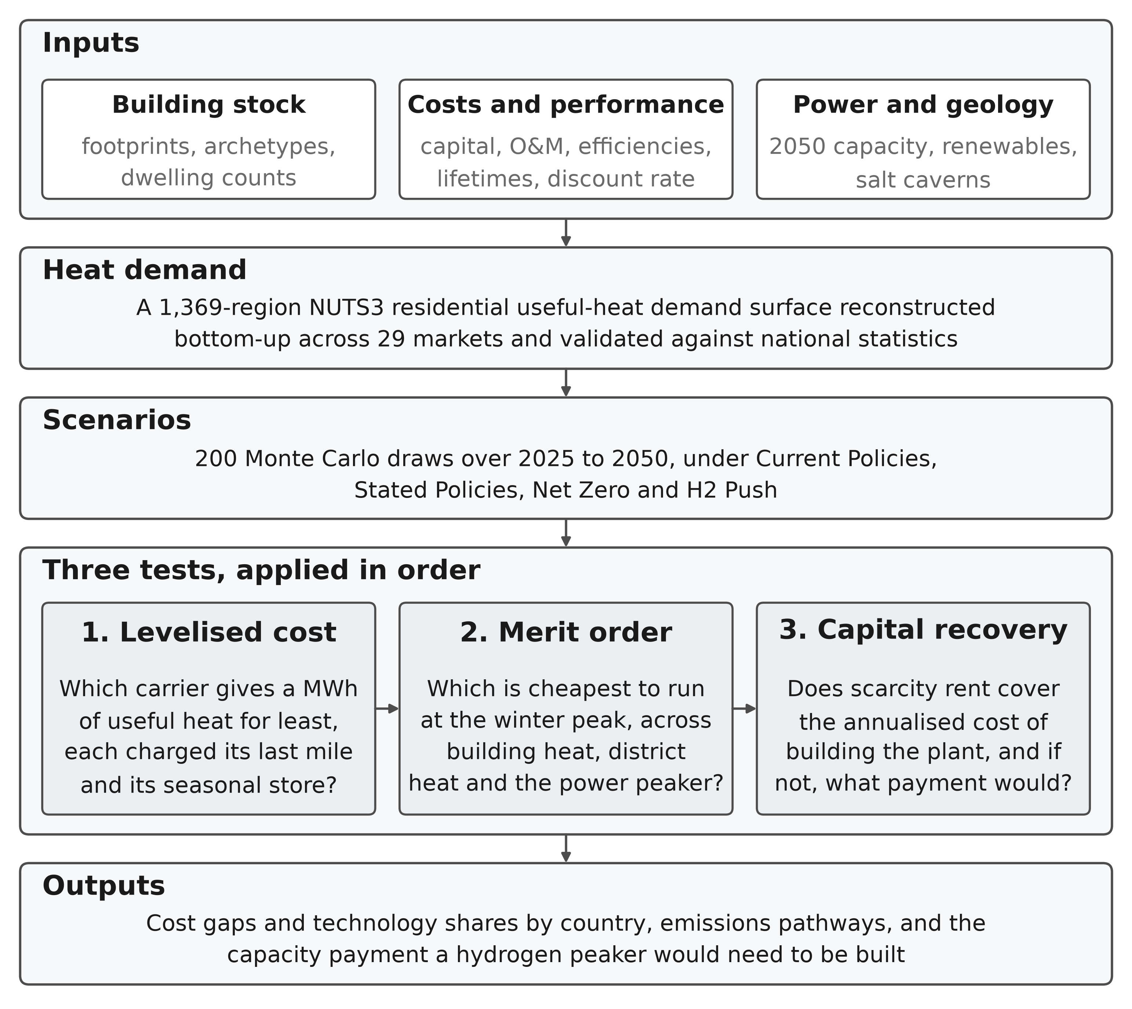
Figure 1: Model architecture. Inputs, the demand reconstruction and the scenario draws feed three tests applied in order.
Note: the tests address distinct operating roles, so a technology may lose the annual comparison and still compete at a cold-snap peak. The first two are cost comparisons at different time scales, annual and peak-hour, whereas the third asks whether the plant that wins the peak can be financed at all. The text below and the Supplementary Information give the data sources, the price paths, the adder bounds and the parameter ranges the boxes summarise.
The demand layer is built before the technology layer. A bottom-up strand reconstructs residential heat from open building footprints and a harmonised archetype typology, while an independent top-down baseline from the Hotmaps regional database [40], with census-derived building-type shares [41], [42], benchmarks it. The bottom-up reconstruction is 0.8 per cent below the benchmark in aggregate, and 28 of the 29 country estimates lie within ±25 per cent. Section 3.1 gives the stricter vintage-matched comparison (Supplementary Section S1.2). National demand is then projected forward from 2025 on a multi-driver ratio identity, with population growth and falling household size adding demand and envelope renovation removing it. Boundary and terrain typologies come from the Eurostat GISCO service [43], and Fig. 2 shows the demand field, whose steep within-border gradient a country-resolution model averages away.
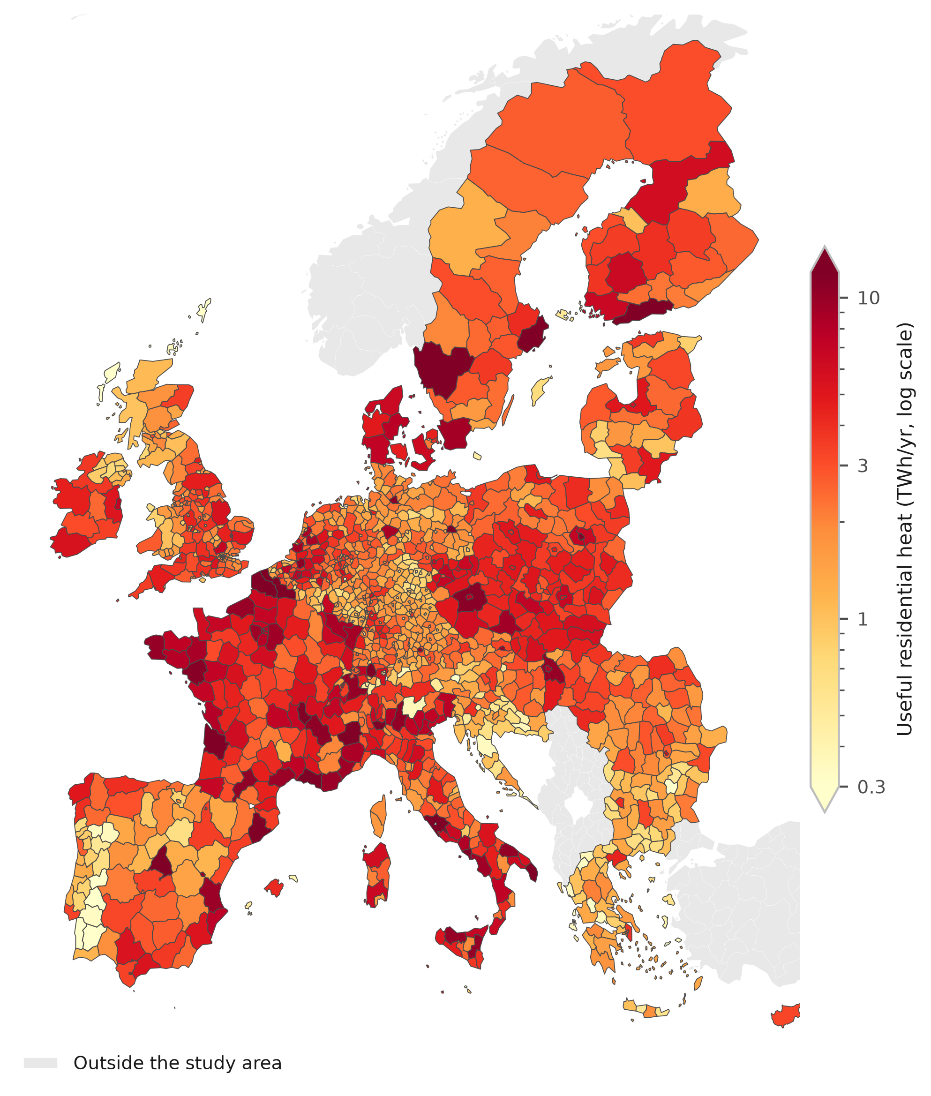
Figure 2: Useful residential heat demand by NUTS3 region, 2025. From the bottom-up build.
Note: the colour scale is logarithmic over 0.3–12 TWh/yr, close to the 2nd and 98th percentiles of the mapped values, and the colourbar arrowheads mark the regions outside that range.
Each of the eight technologies, comprising gas, oil and biomass boilers, a resistance heater, air-source and ground-source heat pumps, district heat and a hydrogen boiler, is priced on a levelised cost of heat that annualises capital at the country weighted-average cost of capital and adds fuel, fixed and variable operating costs, in real EUR₂₀₂₄ throughout (Supplementary Section S1.3). Equipment CAPEX and fixed O&M are expressed per kW of useful-heat output, sized to peak useful-heat demand, and annualised over useful-heat full-load hours (Supplementary Section S1.3). Techno-economic parameters are anchored to the Danish Energy Agency Technology Catalogue [44] and cross-checked against JRC, IEA and IRENA cost data [5], [45], [46]. Fossil fuels carry the second emissions trading system for buildings and road transport (ETS2) from its 2027 launch [47], green hydrogen follows the European Hydrogen Observatory central delivered-cost trajectory [48], and retail gas and electricity prices are Eurostat first-half-2025 figures [49], [50].
An operational CO₂ inventory runs alongside the cost layer on the same technology split, combining direct combustion with attributed electricity and district-heat generation intensities and excluding upstream, infrastructure and embodied emissions. It charges gas and oil fixed combustion factors [51], biomass and hydrogen zero on the European renewable-fuel convention, and electricity and district heat country-by-year intensities that each scenario’s grid lever scales [52], [53]. Those paths are calibrated trajectories rather than published projections, so the emissions levels inherit that calibration whereas the scenario ranking does not (Supplementary Section S1.4). Furthermore, two last-mile network charges apply by default, one to each carrier, so that neither is priced as though its delivery were free. The hydrogen boiler carries a coverage-weighted blend of conversion and new build at a median €13.4/MWh, and the heat pump a low- and medium-voltage reinforcement adder at a median €4.9/MWh, roughly 2.7 times the electric delivery charge before fuel.
Within each draw the observed 2025 country shares are interpolated to the sampled 2050 heat-pump, district-heat, hydrogen and fossil targets using sampled power-law uptake exponents, with NUTS3 feasibility factors scaling the heat-pump and district-heat targets. Among the non-fossil options a cost-responsive component then reallocates share on softmax weights wi,c,t=exp(−LCOHi,c,t/T)/j​exp(−LCOHj,c,t/T) with $T$ set to €50/MWh, blended in on a weight rising linearly from zero in 2025 to 0.50 in 2050. Fossil shares stay policy-defined. Hydrogen is capped at its drawn adoption target and any excess goes first to heat pumps within feasibility and then to district heat. This is a heuristic scenario-allocation rule rather than an estimated choice model or a system-cost optimum (Supplementary Section S1.5).
Levelised cost compares technologies as base-load suppliers, an arena the review literature treats as settled in the heat pump’s favour [14], [15], [19]. Hydrogen’s narrower case is as a peaker serving the cold-snap slice, modelled as a merit-order dispatch among quick-start options whose SRMCs per MWh of useful heat are
$$c_{c}^{gas}=\frac{p_{c}^{gas}+φ_{y} e_{g}}{η_{g}}, c_{c}^{H_{2}}=\frac{p_{c}^{H_{2}}}{η_{h}}+σ_{c}+a_{c}^{H_{2},dist}, c_{c}^{HP}=\frac{π_{c}^{peak}}{{COP}_{c}^{cold}},$$ | (1)
where $φ_{y}$ is the carbon price, η denotes conversion efficiency, $a_{c}^{H_{2},dist}$ is the hydrogen last-mile distribution adder used in the symmetric accounting, and $σ_{c}$ is the seasonal-storage adder, about €50/MWh-heat with domestic salt caverns and €100 without, the two ends spanning the cavern rate and the high-cost non-salt-storage proxy reported in the bulk-storage literature [54], [55] and applied at the higher rate to the markets with no salt resource [56]. Cold-snap heat-pump COP is derated from the seasonal figure, ${COP}_{c}^{cold}=max(0.60 {SCOP}_{c},1.8)$ following the low-temperature field measurements [8], which gives 1.80–2.84 across the 29 markets at a median of 2.04 in 2050. The scarcity electricity price $π_{c}^{peak}$ that prices the heat-pump branch is taken from the power sector’s own merit order, set by the marginal winter unit. A country counts as a hydrogen win where its hydrogen-ready turbine undercuts the gas turbine on SRMC, both machines held at the same efficiency. Winning the dispatch is necessary but not sufficient, because an investor must recover the peaker’s capital from the few hundred hours a year it runs (Eq. (2)). The question therefore shifts from an energy share to one of firm capacity, screened consistently across the building winter peak, district heat and the power sector. Symbols are listed in the nomenclature above.
Four multi-lever scenarios bracket the plausible range of European buildings decarbonisation to 2050. Current Policies freezes today’s implemented measures; Stated Policies delivers announced policy, broadly consistent with the European Commission long-term strategy [57]; Net Zero matches the IEA Net Zero scenario [58]; and H2 Push is a deliberately hydrogen-favourable world along the lines of REPowerEU [11]. Table 1 summarises the eight exogenous levers each scenario sets, which separate them most sharply on renovation and on fossil retreat. Current Policies renovates at 0.70 times the announced-policy rate and still leaves 40 per cent of 2050 heat on fossil fuels, whereas Net Zero renovates at 2.73 times that rate and leaves 5 per cent. H2 Push is the hydrogen-favourable world rather than the most ambitious one, pairing a high carbon price and the rapid hydrogen-price path with a 1.64 times renovation rate and a 15 per cent fossil share. Hydrogen adoption is set at 0, 5, 3 and 8 per cent, so its ordering does not follow climate ambition. That setting is exogenous, and the dispatch screen tests it rather than sets it. Set against the dispatch-supported potential in the final row, which runs 0, 0.6, 7.5 and 9.0 per cent, only Stated Policies places adoption above what the screen supports, a gap Section 3.3 reports as a finding.
Table 1: Scenario lever settings, 2050. Eight exogenous levers per scenario, with the independently derived dispatch-supported potential beneath them.
Lever | Current | Stated | Net Zero | H2 Push
 | Policies | Policies
Envelope rate (vs announced)ª | ×0.70 | ×1.00 | ×2.73 | ×1.64
Carbon-price path | Low | Central | High | High
Hydrogen-price path | Stranded | Central | Central | Rapid
Grid-decarbonisation speedª | ×1.15 | ×1.00 | ×0.70 | ×1.00
Fossil share 2050 (ambition)^{c} | 40% | 27% | 5% | 15%
Heat-pump target 2050^{c} | 40% | 50% | 62% | 46%
District-heat target 2050^{c} | 16% | 18% | 22% | 20%
H₂ adoption setting 2050^{b,c} | 0% | 5% | 3% | 8%
Derived diagnostic; not a lever and not used to set adoption
Dispatch-supported potential^{d} | 0% | 0.6% | 7.5% | 9.0%
ª Multipliers on the announced-policy (Stated Policies) central case.
^{b} An exogenous adoption pathway, not an output of the dispatch screen.
^{c} Share settings are Monte Carlo means rather than hard caps, so realised medians sit slightly above them. Supplementary Table S4 repeats the levers.
^{d} The demand-weighted peak slice the symmetric screen supports, at the central scarcity margin and derate. Stated Policies sets adoption above it (Section 3.3). The sensitivity excluding hydrogen last-mile distribution and using the residential rather than wholesale gas tariff gives 0, 5.1, 7.9 and 9.3 per cent (Supplementary Sections S1.3 and S1.6).
Source: Authors’ contribution.
Weather series for the power layer
The weather construction is the dominant limitation on the power-sector results. The power layer uses one synthetic hourly year rather than reanalysis or metered data. Hourly heat demand is a seasonal profile times a fixed daily shape, amplified over one six-day cold snap in mid-January; onshore wind is an AR(1) process forced down to a lull over those same six days in all 29 countries at once; solar and the non-heat baseline load are deterministic. That construction makes the event perfectly correlated across the study area, and the sizing rule, which takes the fourth-highest residual hour of the year and so admits three hours of lost load, is an order statistic on that one year rather than a loss-of-load expectation over a distribution of weather years.
The firm-fleet requirement varies by about ±9 per cent with the assumed event length. The resulting capacity requirement, full-load hours and cumulative shortfall are conditional on the constructed weather year and should not be interpreted as adequacy estimates.
Three extensions strengthen the power-sector coupling. An explicit unit commitment cross-checks the reduced-form peak-capacity cap, respecting minimum stable output, ramp limits, minimum up and down times and an operating-reserve margin; a myopic rolling-horizon test relaxes perfect foresight in the least-cost linear program; and an endogenous Switzerland treatment couples incremental Swiss heat-pump load back to the EU winter electricity price and credits the Swiss reservoir fleet as firm winter capacity. Parametric uncertainty is characterised with 200 draws per scenario. Each draw samples country renovation-rate shocks; 2050 heat-pump, district-heat, hydrogen and fossil targets; uptake exponents; ground-source heat-pump share; ETS2 pass-through; WACC; heat-pump-feasibility multipliers; and correlated country-carrier fuel-price multipliers. Cross-country shock correlation is 0.5 on renovation and 0.75 on fuel prices, higher on prices because European gas and electricity markets clear against shared hubs whereas renovation policy is national. Results are reported at the 10th, 50th and 90th percentiles. Carbon-price, hydrogen-price and grid-decarbonisation paths remain fixed within each scenario and are evaluated as deterministic axes; equipment CAPEX and performance are varied in deterministic sweeps. A variance-based Sobol screen ranks the four demand drivers, and a regression-based global screen using standardised rank-regression coefficients ranks the cost-side ones. Each extension’s formulation, the sampling distributions and the validation gates are in the Supplementary Information.
The model, the scenario configurations and the analysis code are released in a public repository under an MIT licence, with retrieval scripts for the source datasets, so every test reported below reproduces from the committed intermediate data; rebuilding the regional demand layer from raw building footprints additionally requires the object store named in the data-availability statement.

3 Results and discussion
Three tests organise what follows, applied in order and addressing distinct operating roles, so a peaking win does not overturn a base-load loss. They are annual levelised cost against the heat pump and the gas boiler, where the headline count sits, then the peak hour on operating cost across three arenas, then whether a plant that wins the peak can be financed. Section 3.1 reports the demand, technology-mix and emissions results used by the subsequent tests. Sections 3.5 and 3.6 provide the least-cost and Switzerland cross-checks. Monte Carlo results for demand, technology mix and emissions are reported as medians with percentile bands. The cost, dispatch and capital-recovery tests use central parameters with their governing prices and charges evaluated in deterministic sweeps. Running medians enter and remain within ±1 per cent by draw 139, whereas the deciles do so only by draw 188. Medians are therefore treated as converged and deciles as indicative.

3.1 Heat demand, technology mix and emissions
Fig. 2 presents useful residential heat demand across the NUTS3 regions of the study area at 2025. Useful-heat demand falls only slightly to 2050, because envelope renovation outpaces the growth of the building stock by a narrow margin. We estimate the 2025 base year at about 3,827 TWh, a bottom-up reconstruction reproducing the Hotmaps 2015 regional total to within about 0.8 per cent in aggregate (Section 2). Across the 29 countries, the mean absolute percentage error is 11.6 per cent, the demand-weighted mean absolute percentage error is 9.8 per cent, the root-mean-square error of the percentage deviations is 14.4 percentage points, and the median absolute percentage error is 8.5 per cent. Backcasting to the benchmark’s 2015 vintage produces an aggregate deviation of −8.3 per cent. That layer sets the demand field and the weights every later statistic carries, and subsequent economic parameters are applied at country level, so the model does not resolve subnational cost rankings.
Under Stated Policies median demand declines to 3,483 TWh by 2050, a fall of about 9 per cent, with an 80 per cent Monte Carlo interval of 3,367–3,589 TWh. The four scenarios span a 5 per cent fall under Current Policies (3,651 TWh) to 31 per cent under Net Zero (2,660 TWh), and only the deep-renovation pathway reaches the IEA range of a 30–55 per cent reduction [58]. Demand is held at the 1991–2020 climate normal throughout, and overlaying the projected decline in heating degree days deepens the 2050 Stated Policies fall to 13, 15 or 19 per cent on a low, RCP4.5 or RCP8.5 representative concentration pathway, so the frozen-climate path is conservative.
The scenario lever moves the technology mix; stock variation does not. All four start from the same reconstructed 2025 composition, heat pumps at 8 per cent of useful heat, gas 44, oil 14, biomass 17, district heat 11 and resistance 6. By 2050 the heat-pump share climbs from 29 per cent under Current Policies through 37 per cent under Stated Policies to 49 per cent under Net Zero, and district heat reaches 31 per cent in the deep pathway. Residual fossil falls to zero at the median under Net Zero, below that scenario’s own 5 per cent ambition, though it survives in 49 of its 200 draws. Fig. 3 shows the mixes. Even in the deliberately hydrogen-favourable H2 Push world hydrogen reaches only 8.5 per cent of useful heat at the realised median against an 8 per cent lever setting, the overshoot coming from the sampling of that lever. These settings are adoption pathways the dispatch screen tests rather than sets, and it supports 0, 0.6, 7.5 and 9.0 per cent by demand (Section 3.3), so three of the four sit under it, whereas Stated Policies does not: 5 per cent of announced adoption against 0.6 of operating-cost support. Net Zero sits well under its own because electrification displaces hydrogen for reasons the peak dispatch does not price.
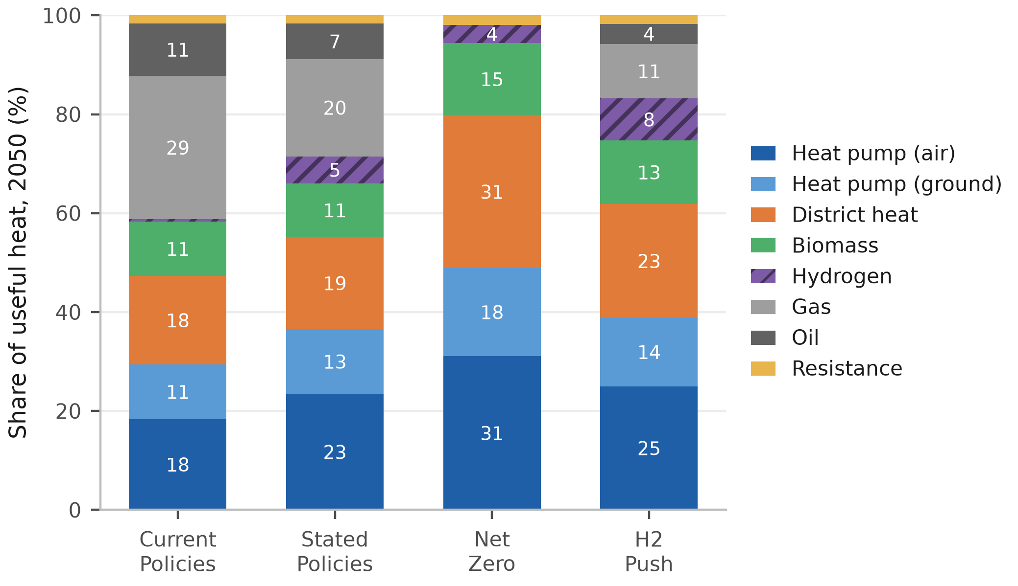
Figure 3: 2050 heating-technology mix by scenario. EU-27, United Kingdom and Switzerland, useful-heat basis. Segments below 2 per cent are unlabelled.
Note: bars are per-technology medians across draws with absent technologies counted as zero, renormalised to 100 per cent from raw sums of 97.5–100.1. Labelled segments are rounded to the nearest point and carry the renormalised shares, so hydrogen’s 8.5 per cent under H2 Push prints as 8, Net Zero’s 3.5 prints as 4, and the two Stated Policies heat-pump segments sum to 36 against the 37 in the text.
Demand moves little across the pathways, whereas emissions fan out from the same reconstructed 2025 baseline of about 644 MtCO₂ to roughly 352, 231, 10 and 123 MtCO₂ by 2050 under Current Policies, Stated Policies, Net Zero and H2 Push respectively. The Net Zero spread is a two-branch mixture that no tail describes, with 151 draws near 10 MtCO₂ and 49 near 70, so its decile band should be read as two outcomes and their probabilities. The same technology set is available in every scenario, so ambition alone separates the outcomes, and the roughly 342 MtCO₂/yr Current Policies to Net Zero gap at 2050 is the value of closing the implementation gap in residential heat, a spread the fossil-phaseout lever leads. Its ranking and sign are invariant to the shared 2025 anchor while the levels scale with it.

3.2 Levelised cost of heat
Fig. 4 presents the levelised cost of heat by component for 2030 and 2050, at the study median for each technology and year. The base-load ordering is close at the median and wide across the 29 countries. Air-source heat pumps and gas boilers reach parity in 2025 at about €156/MWh each, on the Eurostat EU average gas price of €114/MWh including taxes [50] against existing-fleet seasonal COPs of 2.8–4.1 [59], and behind it the best heat pump per country already undercuts gas in 16 of the 29. By 2050 the median best heat pump sits at €118.5/MWh against €132.7/MWh for gas, winning in 24 of the 29. Only the gas boiler pays a carbon price at 2050, so that count runs from 19 markets to 29 across the carbon paths. Each €50/tCO₂ of ETS2 adds about €11/MWh to the gas boiler against a median €0.7/MWh on the heat pump at 2030, because electricity carries only the increment above its 2025 carbon cost, which reaches zero by 2050. The ordering matches in direction the European household comparison of the ICCT [18], which is built on a different accounting.
District heat undercuts both at about €96.5/MWh, though not on the same basis, since it pays no last-mile connection charge here. Charging it the €5,000 per connection our infrastructure bill assigns adds a median €21.0/MWh and takes it from cheaper than the best heat pump in 26 of 29 countries to 7. The hydrogen boiler closes most of the distance without closing it, falling from about €299/MWh in 2025 to €122.8/MWh by 2050. Fuel is the largest cost component for all three technologies. Capital accounts for about 28 per cent of median heat-pump LCOH, while the hydrogen boiler’s network-and-storage component, at about 27 per cent, is comparable to its combined capital and fixed O&M.
With each carrier charged the last-mile network it needs and hydrogen the seasonal store its winter-weighted load requires, hydrogen holds 7 and heat pumps the remaining 22. Across all 29 markets, the median 2050 country gap is +€15.4/MWh, whereas the mean weighted by 2025 country heat demand is +€1.4/MWh, since hydrogen still competes in the large north-western markets (Supplementary Table S6 and Section S2.2). The seasonal store sets how wide those margins are and decides the peaking arena. Space heating draws about three-quarters of its annual energy between October and March, whereas electrolytic production is far flatter. The mismatch is held between seasons at an assumed €1.5/kg with salt caverns and €3.0/kg without, rates consistent in order with those Papadias et al. and Talukdar et al. report for bulk storage [54], [55], [60]. Spread over the annual load, that is about €12/MWh with caverns and €24 without; and charged to the peak slice alone it is the €50 and €100/MWh-heat the dispatch tests use. Cheap geology widens the five cavern margins without selecting the set, since at the non-cavern rate five still hold, though not the same five.
Three caveats bear on the base-load case, and the second is the most consequential. The first is fiscal. The comparison sets a household’s taxed retail electricity price, a 2050 study-area median of about €209/MWh, against hydrogen at roughly €50/MWh delivered and untaxed, a factor of four that a COP near 3.5 does not quite close where electricity is dearest. The difference is levies, network charges and taxes, so it records a policy choice about which carrier bears the system’s cost.
The second is provenance. A detailed assessment of the German heating case concludes the hydrogen realistically supplied to heat would be blue, at about €81/MWh on the blue route we price [61], [62], a €31/MWh wedge over the green price and wider than the €30/MWh by which hydrogen leads in Denmark, its widest win. The blue-hydrogen sensitivity is applied in two ways. A uniform €81/MWh price across all markets removes hydrogen’s advantage in all seven green-hydrogen base-load markets. Scaling each country’s green-hydrogen price by the 81/50 ratio instead leaves Denmark as the sole hydrogen win. The third assumption is firm generating capacity. It is not included in the central heat-pump levelised cost, since electrified heat is charged distribution reinforcement but not the firm capacity the same winter evenings call on, which Section 3.4 costs at €51–66/kW-yr annualised. We therefore report three attribution bounds. Allocating firm-generation cost pro rata to heating’s 9.2 per cent share of annual electricity demand costs €1.0–1.3/MWh over the 1,273 TWh of heat-pump heat and leaves the heat-pump base-load count at 22 of 29. Allocating the entire peaking fleet to heat-pump load is €11.2–14.5/MWh and takes that count to 17 at the low bound and 15 at the high one. Between the two sits allocation by the change in peaking capacity when heat-pump demand is removed, since a peaking asset is built for a peak. Removing the heat-pump load drops the fleet from 278 to 57 GW, so 79.6 per cent of it exists because heat is electrified, far above heating’s 9.2 per cent share of electricity demand, a gap driven by the collapse in COP at the cold-snap peak. Allocating on that share is €8.9–11.5/MWh and takes the count to 19 at the low bound and 17 at the high one, so the count of 22 holds on the pro-rata allocation alone.
The last-mile treatment moves the comparison as much. Sweeping it from free reuse of the gas grid to a dedicated new build takes the count at or below parity for hydrogen from 12 to 3, whereas loading the heat pump at the top of the reinforcement band and charging hydrogen nothing leaves heat pumps cheapest in only 10. The base-load ordering is therefore robust to how dear electricity distribution proves, whereas it is fragile to whether hydrogen is charged for distribution at all. The four pathways carry network bills of €249–506 bn cumulated to 2050, and H2 Push’s hydrogen network does not displace the electricity reinforcement it still requires (Supplementary Table S12). The fiscal treatment of electricity is therefore a first-order buildings-policy question.
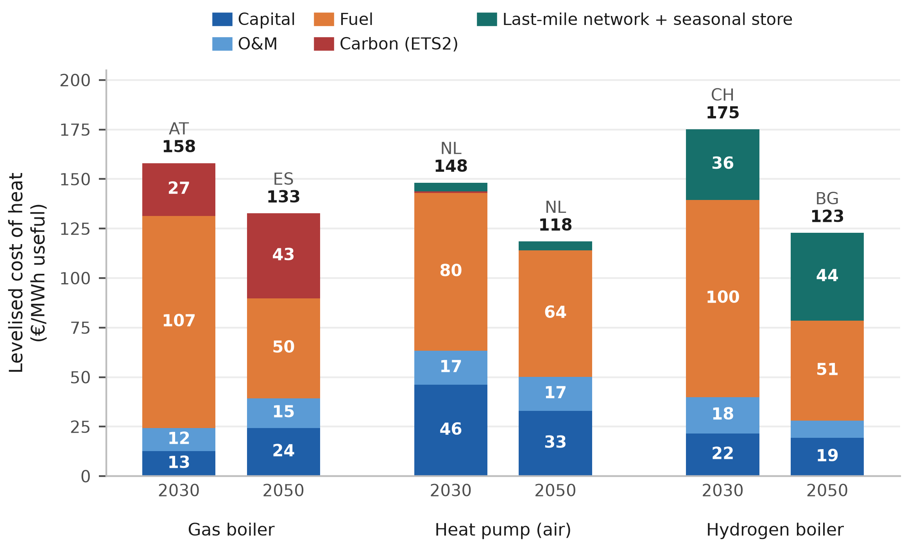
Figure 4: Levelised cost of heat by component, 2030 and 2050. The market at the study median for each technology and year, named above its bar. Air-source heat pump.
Note: the median of 29 markets falls on a market, so each 2050 stack sums to the median reported in the main text. The bars are different markets, so neither the pair nor the distance between two is a trajectory or the study’s median gap, which is the median of the 29 per-country differences. The last band is last-mile network and seasonal store for hydrogen, network reinforcement for the heat pump, nothing for gas. Segments below €11/MWh are unlabelled.

3.3 Power-sector merit order and the cavern markets
Fig. 5 presents H2 Push merit-order prices for Denmark against the study-area peaking fleet sized on the Stated Policies demand path; Fig. 6 identifies the markets in which hydrogen undercuts the gas peaker. To test hydrogen as a cold-snap peaker when air-source heat-pump COP declines, we compare its SRMC with the competing unit in the building, district-heat and power-sector peak calculations. The scarcity electricity price the building peak is judged against comes from the power sector’s merit order, averaging €215–307/MWh, a level driven by the high carbon price on the gas unit that sets it.
On the symmetric accounting used throughout, hydrogen’s win count rises with carbon-pricing ambition in every arena, reaching 14 of 29 countries at the building winter peak, seven in district heating and seven in the power sector under H2 Push. Under the sensitivity excluding hydrogen last-mile distribution and using the residential rather than wholesale gas tariff, the building-winter-peak count becomes 16 and the district-heat-peak count becomes 20. Two levers drive that ordering. Across the first three scenarios the carbon price on the competing gas plant opens the niche, ETS2 at the building peak and the existing power and industry system (ETS1) elsewhere [63]. H2 Push then shares Net Zero’s carbon path and adds only a faster decline in the hydrogen price, so the fuel lever alone drives that rise, whereas the power arena holds at seven because the two turbines face the same carbon price. Hydrogen’s position is therefore set as much by its rival’s fortunes as by its own.
Waste heat sits at the bottom of the district-heat merit order at about €10/MWh, so a gas combined-heat-and-power plant is marginal on a cold day in 20 of the 29 networks, capping the arena at 20, and hydrogen undercuts it in seven of those. Charging both alike means gas enters at the €30/MWh wholesale hub price the district-heat operator actually pays and hydrogen carries its own €13.4/MWh median last-mile adder at the building peak. By contrast, pricing gas at the Eurostat residential retail tariff and charging hydrogen no last-mile network raises the building-peak count from 14 to 16 and the district-heat count from 7 to 20. The slice is thin either way, the top 12–18 per cent of the load over 2,000 hours at about 518 equivalent full-load hours, so sweeping all 20 is about 3 per cent of residential heat (Supplementary Section S2.3). Weighting each country’s building-peak slice by its heat demand gives dispatch-supported potentials of 0, 0.6, 7.5 and 9.0 per cent of study-area residential heat under the four scenarios respectively. These are compared with, rather than imposed on, the exogenous adoption settings of 0, 5, 3 and 8 per cent. The largest mismatch is under Stated Policies, whose setting exceeds its dispatch-supported potential by 4.4 percentage points, compared with 0, 5.1, 7.9 and 9.3 under the sensitivity excluding hydrogen last-mile distribution and using the residential rather than wholesale gas tariff.
The model prices the marginal dispatchable units using literature-based short-run costs for the technologies below them in the merit order. The medians quoted here are H2 Push, and Net Zero holds the same ordering with a narrower cavern advantage. Under the equal-efficiency series used for the headline winner count, the hydrogen turbine’s cross-country median is about €286/MWh-e, approximately €30/MWh-e above the carbon-priced gas peaker at €256/MWh-e (Eq. (1); Fig. 5). Gas is therefore the cheaper firm unit in the typical market. Both turbines are evaluated on the high-carbon path. On the central carbon path, the gas peaker is about €181/MWh-e and the cavern advantage narrows to a few euros, so the headline winner count is conditional on the carbon path, whereas the base-load ordering is not (Supplementary Section S1.3). Under the evolving-efficiency sensitivity, hydrogen receives the higher assumed turbine efficiency; the hydrogen and gas medians converge to approximately €238 and €239/MWh-e, respectively, and the hydrogen winner count rises to 15, or eight without the backbone discount, and is no longer confined to cavern geology. Capital recovery is evaluated separately under the evolving-efficiency assumptions for the five of the seven headline cavern markets that build peaking capacity. The seven-market headline dispatch count and the capital-recovery ratios therefore address different questions. In the seven headline cavern markets, the hydrogen turbine costs €168–184/MWh-e, €72–89/MWh-e below the gas peaker; across the 22 non-cavern markets it is approximately €36/MWh-e more expensive.
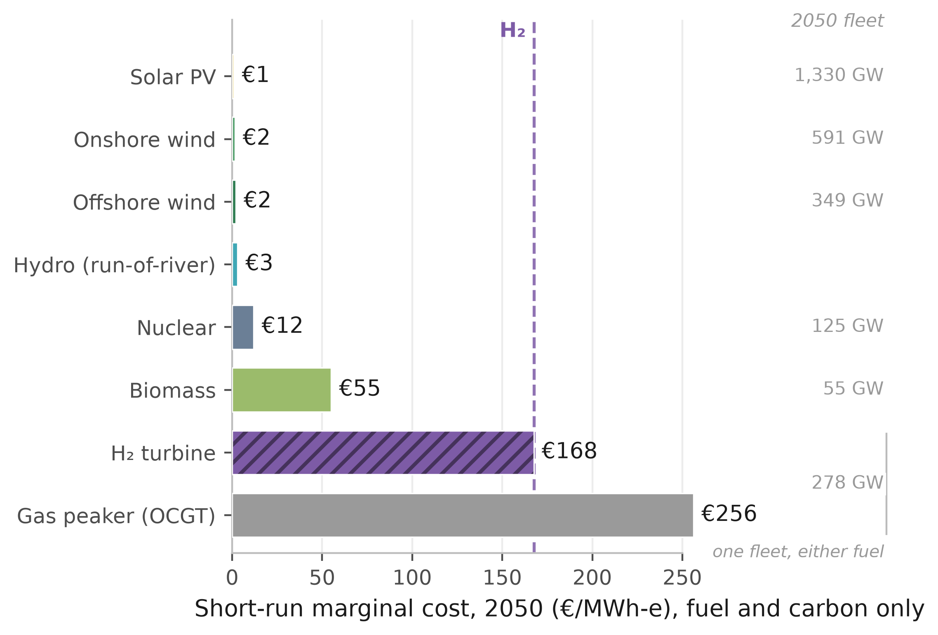
Figure 5: 2050 Denmark merit-order prices under H2 Push, shown against the study-area peaking fleet sized on the Stated Policies demand path. Costs are country-specific; capacities are study-area totals. Short-run marginal cost includes fuel and carbon but excludes capital cost. The headline comparison uses equal turbine efficiencies.
Note: the evolving-efficiency sensitivity puts the two machines at €142 and €241/MWh-e, a different comparison from the medians above. Hydro carries no capacity figure because only a whole-fleet series is available. Omitted from the bars are 3 GW of coal, 421 GW of batteries and 195 GW of combined cycle. Batteries deplete over a multi-day event, so only the combined cycle counts as sustained firm capacity (Supplementary Section S2.4). Dispatchable capacities are model output.
The seven winning markets are the salt-cavern countries, in descending advantage Denmark, the United Kingdom, the Netherlands, Romania and Poland, followed by France and Germany, which are tied (Fig. 6). They are not the seven markets in which hydrogen wins the base-load comparison. Belgium and Ireland hold base load without the power peak and France and Romania the reverse, because retail prices decide part of the base-load set and geology alone the peaking one. The mechanism is the seasonal-storage adder of Section 2 [56]. Of the two exogenous adders only storage moves the count, since the premium cancels between the turbines. The count holds at seven across about €50 to 75/MWh-heat of storage, reaching every market only at €38 and under. The winning set is that two-value geology classification exactly, so the seven is conditional on it. Alternative cavern classifications move it, since including Iberia gives nine and restricting France to its northern basins six. Provenance moves it further. With a uniform blue-hydrogen price of €81/MWh across Europe, the turbine reaches €289/MWh-e and all seven headline power-sector wins reverse. Scaling each country’s green-hydrogen price by the 81/50 ratio instead preserves hydrogen advantages of €30–57/MWh-e in those seven markets (Supplementary Section S1.3).
Both the base-load and the peaking verdicts turn on the cost of storing the molecule between seasons, the peaking one on endowment and the base-load one partly on tax incidence. However, at the central scarcity margin the peaking win covers only about 9 per cent of the plant’s annualised capital charge, because it runs about 139 hours a year.
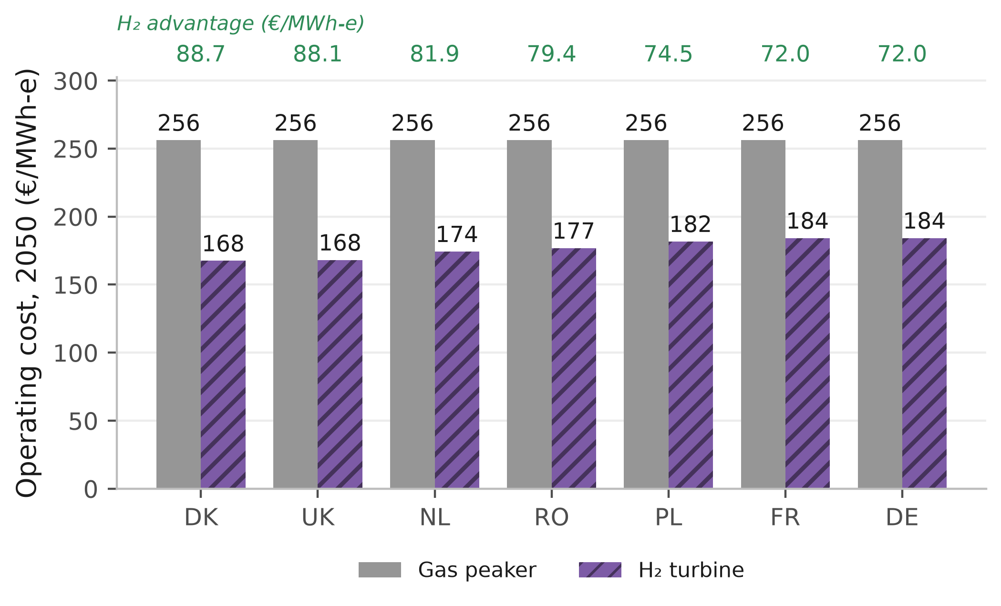
Figure 6: Where hydrogen undercuts the gas peaker, H2 Push 2050. The seven salt-cavern markets, on the equal-efficiency series. The green row above the frame is the advantage, gas minus hydrogen, in €/MWh-e.
Note: gas is €256/MWh-e in all seven on that series, since they share a carbon price and a gas cost, so the spread within them is the delivered hydrogen price alone. The other 22 markets do not undercut.

3.4 Capital recovery of the hydrogen peaker
An investor must also recover the peaker’s capital from the few hours it runs. Under the fixed scarcity-margin screen, a hydrogen unit that is the cheaper firm technology is assigned a price equal to its SRMC plus the assumed scarcity margin $π^{s}$. Its modelled scarcity rent is therefore $π^{s}$, and recovery is
$$R_{c}=\frac{π^{s} {FLH}_{c}/1000}{({CRF}_{c}+f) K^{T}},$$ | (2)
with $FLH$ the peaker’s full-load hours, $K^{T}$ the turbine capital cost, $CRF$ the country’s capital-recovery factor over 25 years and $f=2.5$ per cent a year the fixed operating charge. Because 1 kW operating for $FLH$ hours produces $FLH/1,000$ MWh per year, the numerator is annual scarcity rent in €/kW-yr, matching the annualised capital-and-fixed-operating charge in the denominator. Under the modelled fixed scarcity-margin screen, at the central margin $π^{s}$ of €60/MWh, $R_{c}<1$ in every modelled country and scenario, so no tested market reaches full peaker-capital recovery even where hydrogen’s operating cost wins the cold snap. The shortfall, rather than its size, is the robust result, holding across the tested scarcity-margin range and every weather variant in Supplementary Section S2.9. The five that build average 80 full-load hours weighted by capacity, against 139 for the whole fleet, so their rent covers about 9 per cent of an annualised charge of €51–66/kW-yr in the central case, 4.4–17.4 per cent across the scarcity grid below.
Recovery is a single-year ratio of rent to that year’s capital charge, and the spread tracks utilisation, since Eq. (2) is linear in run hours at a common margin. Five of the seven cavern markets build a peaker in 2050, over run windows from 48 hours in Germany to 343 in Denmark and recoveries from Poland’s 5.1 per cent to Denmark’s 40.0 (Supplementary Section S2.4). No tested market reaches the 100 per cent recovery threshold required for private finance over the €30–120/MWh scarcity-margin range, the classic missing-money problem [30], [64]. Cumulated undiscounted over the 25 years to 2050 the H2 Push peaker loses about €357 bn against €142 bn for an equivalent gas peaker, widening to €563 bn under Current Policies, so the shortfall is not an artefact of the hydrogen-heavy scenario (Supplementary Section S2.4).
An explicit unit-commitment cross-check produces 2.8 GW more peaking capacity and 160 full-load hours, compared with 139 hours in the reduced-form screen. The additional capacity arises from the unit-commitment sizing pass, which adds capacity in Romania. The higher utilisation increases recovered rent and therefore cuts against the missing-money finding.
The peaking fleet is large in capacity but small in annual energy. The firm dispatchable peaking fleet is about 278 GW on the constructed weather year, roughly 31 per cent of the 889 GW system peak, computed on the Stated Policies demand path and priced under each scenario’s fuel and carbon paths, so only the margins move. Using each scenario’s own demand path with the same technology stack and weather year, required peaking capacity ranges from 242 to 278 GW and utilisation from 131 to 148 full-load hours. It is an increment on a firm combined-cycle fleet of about 195 GW, so the combined-cycle-plus-peaker thermal fleet is about 473 GW or 53 per cent of peak, and the increment is what hydrogen competes for. EU pooling takes the requirement to an idealised copperplate lower bound of 239 GW (Supplementary Section S2.4). However, that fleet supplies only 0.86 per cent of the study area’s 4,513 TWh of 2050 electricity demand, or about 1.2 per cent with non-heat demand held flat rather than grown 1.40-fold. It runs about 139 full-load hours a year, so hydrogen’s electricity role is a capacity role, the clean firm backstop for electrified heat rather than a source of kilowatt-hours [34], [35].
Hydrogen wins operating-cost dispatch in up to 7 of 29 district-heat markets under the symmetric treatment and in 20 under the sensitivity excluding hydrogen last-mile distribution and using the residential rather than wholesale gas tariff. The recovery test runs on the power-sector peaker alone, the plant this section prices, and its rent covers at most 40.0 per cent of its annualised capital charge (Table 2). Adequacy is imposed by the sizing rule, leaving the difficulty as one of paying for the capacity.
Table 2: Operating-cost wins by arena against capital recovery. Counts of the 29 markets at 2050.
 | Current | Stated | Net Zero | H2 Push
Arena | Policies | Policies
Markets won on operating cost, of 29
Building winter peakª | 0 | 2 | 7 | 14
District-heat peak | 0 | 0 | 7 | 7
Power peaker^{b} | 0 | 0 | 7 | 7
Power-sector peakers recovering their capital, of 29
Any scenario | 0 | 0 | 0 | 0
ª Computed on the uncoupled series, which prices each country’s heat-pump peak without crediting a national reservoir fleet. Crediting Switzerland’s removes it from the H2 Push count of 14 (Section 3.6).
^{b} The power arena is the seven salt-cavern markets.
Note: every row charges both carriers alike. Under the sensitivity excluding hydrogen last-mile distribution and using the residential rather than wholesale gas tariff, the building-peak and district-heat rows read 0, 4, 9, 16 and 0, 5, 11, 20.
Note: per-arena detail is in Supplementary Table S7.
Source: Authors’ contribution.
Three caveats bound this reading, each widening the recovery without reversing the sign (Supplementary Section S2.9). The first is that the 278 GW requirement and the €357 bn shortfall assume an inflexible heat load; smoothing lowers the requirement to 248.0–265.6 GW at the most generous corner, and the assumed event length alone carries ±9 per cent (Supplementary Tables S9 and S10). The second is that Eq. (2) makes the verdict partly definitional for any low-utilisation peaker, since the storage adder and the delivered hydrogen price both cancel from the rent, leaving it invariant to the very storage condition that decides the other two tests. It is also exactly linear in $π^{s}$, and across the €30, 60, 90 and 120/MWh grid, capacity-weighted recovery runs 4.4, 8.7, 13.1 and 17.4 per cent. Pricing the three shortage hours the sizing standard imposes at the model’s own €8,000/MWh value of lost load, which is paid to no generator here, raises capacity-weighted recovery from 8.7 per cent to about 51 per cent. Recovery remains below 100 per cent, but its estimated magnitude is therefore sensitive to the treatment of shortage hours.
Third, the modelled energy-only scarcity-margin screen does not represent any single real market, and three of the seven markets already operate a capacity mechanism [65]. European law already includes an emissions condition, but it does not bind for a 2050 build under the model assumptions. Article 22(4) of the Electricity Regulation caps a mechanism’s payments at 550 gCO₂/kWh-e and adds a 350 kgCO₂/kWe-yr annual limb that reaches only capacity commissioned before July 2019 [66]. A 2050 build therefore faces the rate limb alone. Using the model’s emission factor, an unabated open-cycle turbine emits about 505 gCO₂/kWh-e, below the 550 gCO₂/kWh-e threshold. Article 22(4) therefore does not distinguish between the technologies in this case (Supplementary Section S2.4).
A deliberate hydrogen-peaker build therefore implies a standing payment, and €31 to 63/kW-yr closes the gap for the winning peakers (Supplementary Table S11). That sits below the £60/kW-yr, roughly €70, at which the 2024 British four-year-ahead auction cleared while procuring 27.3 GW of unabated gas out of 43.1 GW [67]. A clearing price and a modelled revenue requirement are different objects, so this checks magnitude, not validity. A gas peaker in the same markets recovers an even smaller share of its capital, yet needs a smaller payment, €41–52/kW-yr, because a gas turbine costs €450/kW against 600. Weighted by capacity the two are close, €45/kW-yr against 51, and gas is cheaper in four of the five markets that build, so with the hydrogen-ready turbine at $K^{T}$ of €600/kW against €450/kW for gas, a technology-neutral mechanism procures unabated gas ahead of hydrogen, which is what the British auction shows a real mechanism doing.
That conclusion turns on the capex gap and reverses below about €520–540/kW, a premium of roughly 18 per cent over the gas turbine, and published premia for hydrogen-ready machines straddle it. Above it hydrogen is selected only where the mechanism is conditioned on emissions, and that condition costs the payment difference over the gas generation it displaces, about €172/tCO₂ on top of the carbon price the gas plant already pays, rising to roughly €239 once the gas unit’s negative rent is floored at zero (Supplementary Section S2.4). Either way the peaking niche opens only where a standing payment of €31–63/kW-yr is in place. Fuel prices and tax incidence leave it unchanged but move which markets reach it.

3.5 Least-cost cross-check and the national carbon cap
The four scenarios impose technology shares, so a parallel least-cost linear program minimising supply cost against a fixed demand path and a scope-1 emissions cap (Section 2) asks what a cost minimiser would choose. At the −90 per cent cap the 2050 least-cost mix is 52.9 per cent district heat, 45.4 per cent heat pumps, 1.4 per cent residual gas and 0.34 per cent hydrogen, but the program’s per-country hydrogen ceiling is zero in 27 of the 29 and it selects that ceiling exactly in the other two. The resulting mix informs the comparison between district heat and heat pumps, but not hydrogen, because hydrogen is fixed at zero in 27 countries and at its ceiling in the other two. The 52.9 per cent district-heat share is the least-cost solution conditional on excluding new-connection costs, and not an unconstrained system optimum. Supplementary Section S2.8 reports three interpretive bounds. The largest limitation is the omitted district-heat connection charge. The €21.0/MWh of Section 3.2 sits outside this objective, so 52.9 per cent is a share under that boundary, not an optimum.
The discounted present-value system cost differs by only 0.05 per cent between the −75 and −100 per cent caps under this formulation. The carbon price does not do the work everywhere, since the cap binds in Cyprus, Croatia, Poland and the United Kingdom in 2050 at a shadow price of up to €81/tCO₂, and in seven countries at some point on the path. That cap is national while ETS2 is a pooled price, so this is the one result on the heating side that argues for an instrument other than a price.

3.6 Switzerland as a standalone case
Fig. 7 presents the Swiss levelised cost of heat for 2025 and 2050 under Stated Policies, on the uncoupled arm. Switzerland puts the two comparisons side by side more sharply than any other market, and both close the same way. The Swiss heat-pump levelised cost falls to a 2050 band of €122.4–131.1/MWh against a hydrogen boiler at €128.0/MWh and a gas boiler at about €165.9/MWh, so the best Swiss heat pump ends €5.6/MWh below the hydrogen boiler. Swiss retail electricity is expensive and heavily levied, which keeps that margin narrow, but Switzerland also has no salt caverns and so pays the €3.0/kg storage rate. Switzerland’s clean grid limits hydrogen’s carbon advantage, while the absence of salt caverns removes its low-cost-storage advantage.
On the endogenous arm, both turbines purchase fuel at wholesale prices, so retail levy treatment does not affect the peaking comparison. Hydrogen loses the Swiss winter peak in all four scenarios, at €135–236/MWh-heat compared with €62–90/MWh-heat for the heat pump. The uncoupled 29-country comparison prices the H2 Push peak at €155/MWh-heat without crediting the Swiss reservoir fleet, producing a hydrogen win; crediting the reservoir fleet lowers the peak price to €90/MWh-heat and removes that win. The endogenous arm is therefore used for the Swiss peaking verdict, while the uncoupled arm supplies the reported base-load results. The base-load gap is €5.6/MWh on the uncoupled arm and €9.6/MWh on the endogenous arm. For cross-market comparability, the arena counts remain on the uncoupled series: the symmetric H2 Push building-peak count is 14 rather than the endogenous count of 13, and the sensitivity excluding hydrogen last-mile distribution and using the residential rather than wholesale gas tariff gives 16 rather than 15. Coupling is modelled only for Switzerland, and the uncoupled series is the more hydrogen-favourable comparison.
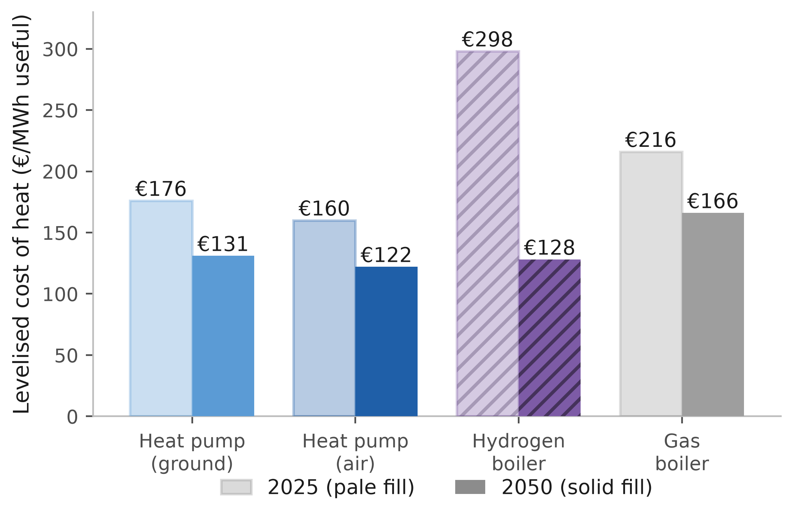
Figure 7: Swiss levelised cost of heat, 2025 and 2050. Stated Policies, on the uncoupled arm. Pale-filled bars are 2025, solid 2050; every bar is labelled. Switzerland has no salt caverns and so pays the higher seasonal storage rate.
A win in one arena does not carry to another, so the three tests together establish the scope of hydrogen’s role rather than a single verdict. The base-load comparison is the least robust of the three: the number of markets in which the heat pump beats hydrogen ranges from 13 to 29 across the hydrogen-price paths tested. That sensitivity turns in part on a fiscal asymmetry that policy could remove. The power-peak win set is conditional on the equal-efficiency comparison and the binary cavern classification. Conditional on entry, the capital-recovery screen is more stable because it depends on utilisation, scarcity margin, WACC, fixed O&M and turbine CAPEX. The peaking-capacity magnitude remains conditional on the single constructed weather year.

4 Conclusions

4.1 Summary of findings
This study screens European residential heat across 29 markets to 2050 in three operating roles. The tests address distinct questions but share some input assumptions. Seasonal-storage assumptions affect the base-load and dispatch rankings. Conditional on entry, however, the capital-recovery ratio contains no fuel- or storage-cost term; it depends on utilisation, scarcity margin, WACC, fixed O&M and turbine CAPEX. Four findings follow.
(1) On central 2050 levelised cost, the best heat pump delivers at €118.5/MWh, compared with €122.8/MWh for the hydrogen boiler and €132.7/MWh for gas. Heat pumps beat gas in 24 of the 29 markets under the central carbon path; the count ranges from 19 to 29 across the carbon paths tested. Against hydrogen, heat pumps win in 22 markets when firm-generation cost is allocated pro rata to heating’s annual electricity-demand share. Allocation by the change in peaking capacity gives 19 heat-pump wins at the low bound and 17 at the high bound. The median 2050 country gap is €15.4/MWh, while the mean weighted by 2025 country heat demand is €1.4/MWh because the hydrogen-favouring markets are relatively large.
(2) Under the central symmetric accounting, hydrogen wins the base-load comparison in seven markets and heat pumps in 22. Across the hydrogen-price paths tested, the number of heat-pump wins ranges from 13 to 29. Dickel [62] concludes that the hydrogen realistically supplied to heat would be blue, at about €81/MWh on the route priced here [61]. A uniform blue-hydrogen price of €81/MWh removes hydrogen’s advantage in all seven central green-hydrogen base-load markets. Scaling each country’s green-hydrogen price by the 81/50 ratio instead leaves Denmark as the sole hydrogen win. Levelling the carriers’ fiscal treatment moves the comparison in the same direction, by an amount outside this study’s scope.
(3) Repriced on SRMC, on the high carbon path and the equal-efficiency series, hydrogen wins the power peak in a different seven. All seven are salt-cavern markets on a binary geology screen, and alternative definitions give six or nine, so the count is a screening result. The peaking increment is about 278 GW, roughly 31 per cent of the study area’s 889 GW peak, yet supplies about 0.86 per cent of its electricity. At a hydrogen-ready turbine capital cost of €600/kW, no tested market reaches full peaker-capital recovery across the assumed scarcity margins. Capacity-weighted recovery is about 9 per cent at the central 2050 margin and ranges from 4.4 to 17.4 per cent across the tested margins. A standing payment of €31–63/kW-yr closes the modelled gap.
(4) Policy ambition sets the emissions outcome. From a 2025 baseline of about 644 MtCO₂, 2050 operational emissions reach 352 MtCO₂ under Current Policies, 231 under Stated Policies, 10 under Net Zero and 123 under H2 Push. The differences are driven principally by the fossil-phaseout lever. The heat-pump share climbs from 29 to 49 per cent across the four, district heat reaches 31 per cent at about €96.5/MWh in the deep pathway, and the dispatch screen supports hydrogen at 0, 0.6, 7.5 and 9.0 per cent of useful heat.

4.2 Policy implications
Four implications follow, each scoped to the model’s cost criterion. (1) Heat pumps lead by the widest margin across the warm south and east, undercutting hydrogen by about €99/MWh in Malta and €88 in Cyprus. (2) Passing ETS2 through to end users preserves the switching signal, the €11/MWh per €50/tCO₂ wedge quantified above, which social protection can leave intact.
(3) Where a hydrogen peaker is wanted, no tested market reaches full capital recovery across the assumed scarcity margins, and the modelled technology-neutral comparison procures unabated gas at the capex assumed here, so a payment conditioned on emissions is what selects hydrogen. Those figures let a capacity-mechanism designer weigh what an emissions condition buys against a technology-neutral auction at the same capital cost. Conditioning costs about €172/tCO₂ of displaced gas generation in the central case, on top of the carbon price the gas plant already pays. The technology-neutral outcome reverses only where hydrogen-ready machines carry a premium below about 18 per cent over the gas turbine. At the assumed gas-turbine emissions intensity, the Article 22(4) threshold does not distinguish the two technologies; selection therefore requires a more restrictive emissions condition or an equivalent premium (Section 3.4).
(4) Within the model, the national scope-1 target is not reached through the price signal alone in every country, so the four markets where the cap binds at 2050, and three more that bind earlier, need a complementary instrument.

4.3 Limitations and future work
Seven limitations and their expected directions are detailed in Supplementary Section S2.9. The largest is the weather construction described in Section 2, which conditions the power-sector results. The 278 GW fleet, the 139 full-load hours, the €357 bn shortfall and the finding that no power-sector peaker reaches full capital recovery in Table 2 rest on it, and the cold snap’s assumed length is a choice, two days giving 254 GW and ten days 302 GW. An adequacy assessment would run thirty or more recorded weather years and derive the correlation from data, as Kittel [68] does for European renewable droughts [69], [70], which is beyond a single constructed year. Nonetheless, the recovery shortfall survives every weather variant tested, so that finding does not rest on the construction.
Future work should co-optimise renovation depth with technology choice, build the hourly emissions ledger, resolve within-region heterogeneity, and price the cross-sector capacity value a hydrogen turbine might capture.

CRediT authorship contribution statement
Abdurahman Alsulaiman: Conceptualization, Methodology, Software, Validation, Formal analysis, Data curation, Visualization, Writing – original draft, Writing – review & editing. Ali Alajwad: Conceptualization, Methodology, Software, Validation, Formal analysis, Data curation, Visualization, Writing – original draft, Writing – review & editing.

Funding
This project has received funding from the European Union’s Horizon 2020 research and innovation programme under the Marie Skłodowska-Curie grant agreement N° 945363.

Acknowledgements
The authors thank the Oxford Institute for Energy Studies for access to its gas and hydrogen research programme, and the maintainers of the EUBUCCO, TABULA and Hotmaps databases, without which the regional demand reconstruction would not have been possible.

Declaration of competing interest
The authors declare that they have no known competing financial interests or personal relationships that could have appeared to influence the work reported in this paper.

Data availability
The model, its input data and the country profiles are openly available at https://github.com/alajwadha/EU-Building-Heat-Model (MIT licence). Large third-party inputs for Hotmaps, Eurostat and GISCO are retrieved by the included download scripts. Two inputs require separate handling: the UK ONS TS044 accommodation-type table is a one-time manual download committed to the repository, whereas the EUBUCCO v0.2 building footprints are fetched from the EUBUCCO object store by the per-country build scripts. The forward model runs from the committed intermediate CSVs; reproducing the bottom-up build from raw footprints additionally requires that object store and the per-country classification step.

References
[1] International Energy Agency, “Buildings,” IEA, 2022. Available: https://www.iea.org/energy-system/buildings
[2] European Commission, “The European Green Deal,” European Commission, 2020. Available: https://commission.europa.eu/strategy-and-policy/priorities-2019-2024/european-green-deal_en
[3] I. L. Azevedo, M. G. Morgan, and M. C. Moura, “The challenges of deep decarbonization in the buildings sector,” Joule, vol. 6, no. 4, pp. 696–708, 2022.
[4] S. Chatterjee, G. Molnár, B. Kiss, D. Topál, and D. Ürge-Vorsatz, “Navigating the transition: Modelling the path for net-zero European building sector,” Renewable and Sustainable Energy Reviews, 2024, doi: 10.1016/j.rser.2024.114827.
[5] International Energy Agency, “The future of heat pumps,” IEA, Paris, 2022. Available: https://www.iea.org/reports/the-future-of-heat-pumps
[6] M. H. Abbasi et al., “Heat transition in the European building sector: Overview of the heat decarbonisation practices through heat pump technology,” Sustainable Energy Technologies and Assessments, 2021.
[7] J. Lingard, “Residential retrofit in the UK: The optimum retrofit measures necessary for effective heat pump use,” Building Services Engineering Research and Technology, 2020, doi: 10.1177/0143624420975707.
[8] D. Gibb, J. Rosenow, R. Lowes, and N. Hewitt, “Coming in from the cold: Heat pump efficiency at low temperatures,” Joule, 2023, doi: 10.1016/j.joule.2023.08.005.
[9] P. E. Dodds et al., “Hydrogen and fuel cell technologies for heating: A review,” International Journal of Hydrogen Energy, 2015.
[10] D. Bothe and M. Janssen, “The value of hydrogen in the heating market,” Frontier Economics, for FNB Gas, 2021. Available: https://www.frontier-economics.com/media/byojuyut/the-value-of-hydrogen-in-the-heating-market.pdf
[11] European Commission, “REPowerEU plan,” European Commission, Brussels, Communication from the Commission COM(2022) 230 final, May 2022. Available: https://eur-lex.europa.eu/legal-content/EN/TXT/?uri=celex:52022DC0230
[12] European Commission, “Implementing the REPowerEU action plan: Investment needs, hydrogen accelerator and achieving the bio-methane targets,” European Commission Staff Working Document, 2022. Available: https://eur-lex.europa.eu/legal-content/EN/TXT/?uri=SWD:2022:230:FIN
[13] A. Goldthau and R. Youngs, “The EU Energy Crisis and a New Geopolitics of Climate Transition,” JCMS Journal of Common Market Studies, 2023, doi: 10.1111/jcms.13539.
[14] J. Rosenow, “Is heating homes with hydrogen all but a pipe dream? An evidence review,” Joule, vol. 6, no. 10, pp. 2225–2228, 2022, doi: 10.1016/j.joule.2022.08.015.
[15] J. Rosenow, “A meta-review of 54 studies on hydrogen heating,” Cell Reports Sustainability, vol. 1, no. 1, p. 100010, 2024, doi: 10.1016/j.crsus.2023.100010.
[16] D. Cebon, “Hydrogen for heating: A comparison with heat pumps.” 2022. Available: https://h2sciencecoalition.com/blog/hydrogen-for-heating-a-comparison-with-heat-pumps-part-1/
[17] A. Badakhsh and S. M. Bhagavathy, “Caveats of green hydrogen for decarbonisation of heating in buildings,” Applied Energy, 2023, doi: 10.1016/j.apenergy.2023.122152.
[18] C. Baldino, J. O’Malley, S. Searle, and A. Christensen, “Hydrogen for heating? Decarbonization options for households in the European Union in 2050,” International Council on Clean Transportation (ICCT), Mar. 2021. Available: https://theicct.org/publication/hydrogen-for-heating-decarbonization-options-for-households-in-the-european-union-in-2050/
[19] A. Billerbeck et al., “The race between hydrogen and heat pumps for space and water heating: A model-based scenario analysis,” Energy Conversion and Management, 2023, doi: 10.1016/j.enconman.2023.117850.
[20] T. Brown, D. Schlachtberger, A. Kies, S. Schramm, and M. Greiner, “Synergies of sector coupling and transmission reinforcement in a cost-optimised, highly renewable European energy system,” Energy, 2018, doi: 10.1016/j.energy.2018.06.222.
[21] F. Neumann, E. Zeyen, M. Victoria, and T. Brown, “The potential role of a hydrogen network in Europe,” Joule, vol. 7, no. 8, pp. 1793–1817, 2023, doi: 10.1016/j.joule.2023.06.016.
[22] I. Kountouris, R. Bramstoft, T. Madsen, J. Gea-Bermúdez, M. Münster, and D. Keles, “A unified European hydrogen infrastructure planning to support the rapid scale-up of hydrogen production,” Nature Communications, 2024, doi: 10.1038/s41467-024-49867-w.
[23] V. M. Maestre, A. Ortiz, and I. Ortiz, “Transition to a low-carbon buildings stock: Techno-economic and spatial optimization of renewables-hydrogen strategies in Spain,” Journal of Energy Storage, 2022.
[24] D. Huckebrink and V. Bertsch, “Decarbonising the residential heating sector: A techno-economic assessment of selected technologies,” Energy, 2022.
[25] P. Hoseinpoori et al., “A whole-system approach for quantifying the value of smart electrification for decarbonising heating in buildings,” Energy Conversion and Management, 2022.
[26] B. Möller, E. Wiechers, U. Persson, L. Grundahl, R. S. Lund, and B. V. Mathiesen, “Heat Roadmap Europe: Towards EU-Wide, local heat supply strategies,” Energy, 2019, doi: 10.1016/j.energy.2019.04.098.
[27] U. Persson, E. Wiechers, B. Möller, and S. Werner, “Heat Roadmap Europe: Heat distribution costs,” Energy, 2019, doi: 10.1016/j.energy.2019.03.189.
[28] T. Weidner and G. Guillén-Gosálbez, “Planetary boundaries assessment of deep decarbonisation options for building heating in the European Union,” Energy Conversion and Management, 2023, doi: 10.1016/j.enconman.2022.116602.
[29] C. J. Quarton et al., “The curious case of the conflicting roles of hydrogen in global energy scenarios,” Sustainable Energy & Fuels, 2019, doi: 10.1039/c9se00833k.
[30] P. L. Joskow, “Capacity payments in imperfect electricity markets: Need and design,” Utilities Policy, vol. 16, no. 3, pp. 159–170, 2008, doi: 10.1016/j.jup.2007.10.003.
[31] C. J. Quarton and S. Samsatli, “The value of hydrogen and carbon capture, storage and utilisation in decarbonising energy: Insights from integrated value chain optimisation,” Applied Energy, 2019, doi: 10.1016/j.apenergy.2019.113936.
[32] E. Zeyen, V. Hagenmeyer, and T. Brown, “Mitigating heat demand peaks in buildings in a highly renewable European energy system,” Energy, 2021, doi: 10.1016/j.energy.2021.120784.
[33] A. Mellot, C. Moretti, T. Tröndle, and A. Patt, “Mitigating future winter electricity deficits: A case study from Switzerland,” Energy Conversion and Management, 2024, doi: 10.1016/j.enconman.2024.118426.
[34] N. A. Sepulveda, J. D. Jenkins, F. J. de Sisternes, and R. K. Lester, “The role of firm low-carbon electricity resources in deep decarbonization of power generation,” Joule, vol. 2, no. 11, pp. 2403–2420, 2018, doi: 10.1016/j.joule.2018.08.006.
[35] J. E. T. Bistline and G. J. Blanford, “Value of technology in the U.S. Electric power sector: Impacts of full portfolios and technological change on the costs of meeting decarbonization goals,” Energy Economics, vol. 86, p. 104694, 2020, doi: 10.1016/j.eneco.2020.104694.
[36] N. Milojevic-Dupont et al., “EUBUCCO v0.1: European building stock characteristics in a common and open database for 200+ million individual buildings,” Scientific Data, vol. 10, no. 1, p. 147, 2023, doi: 10.1038/s41597-023-02040-2.
[37] T. Loga, B. Stein, and N. Diefenbach, “TABULA building typologies in 20 European countries — Making energy-related features of residential building stocks comparable,” Energy and Buildings, vol. 132, pp. 4–12, 2016, doi: 10.1016/j.enbuild.2016.06.094.
[38] P. Gabrielli, F. Charbonnier, A. Guidolin, and M. Mazzotti, “Enabling low-carbon hydrogen supply chains through use of biomass and carbon capture and storage: A Swiss case study,” Applied Energy, 2020.
[39] International Energy Agency, “Switzerland energy policy review 2023,” IEA, Paris, 2023. Available: https://www.iea.org/reports/switzerland-2023
[40] Hotmaps Project, “Hotmaps regional heat demand dataset,” Hotmaps, 2020. Available: https://gitlab.com/hotmaps/regional_demand
[41] Eurostat, “CENS_21DWBNO_R3: Dwellings by number of occupants and type of building, NUTS3,” Eurostat, 2021. Available: https://ec.europa.eu/eurostat/databrowser/view/CENS_21DWBNO_R3
[42] Office for National Statistics, “TS044: Accommodation type, Census 2021,” ONS, 2021. Available: https://www.ons.gov.uk/datasets/TS044/editions/2021
[43] Eurostat GISCO, “NUTS reference shapefiles 2021,” Eurostat, 2021. Available: https://gisco-services.ec.europa.eu/distribution/v2/nuts/
[44] Danish Energy Agency, “Technology data for energy plants for electricity and district heating generation,” Danish Energy Agency, Copenhagen, 2023. Available: https://ens.dk/en/our-services/projections-and-models/technology-data
[45] Joint Research Centre, “Long-term (2050) projections of techno-economic performance of low-carbon technologies,” European Commission Joint Research Centre, 2023. Available: https://publications.jrc.ec.europa.eu/repository/bitstream/JRC109006/kjna28859enn.pdf
[46] International Renewable Energy Agency, “Heat pump costs and markets,” IRENA, Abu Dhabi, 2022. Available: https://www.irena.org/-/media/Files/IRENA/Agency/Publication/2022/Nov/IRENA_Heat_Pumps_Costs_Markets_2022.pdf
[47] European Commission, “EU ETS2: Emissions trading for buildings and road transport,” European Commission DG CLIMA, 2024. Available: https://climate.ec.europa.eu/eu-action/eu-emissions-trading-system-eu-ets/ets2-buildings-road-transport-and-additional-sectors_en
[48] European Hydrogen Observatory, “Cost of hydrogen production,” European Hydrogen Observatory / Clean Hydrogen JU, 2024. Available: https://observatory.clean-hydrogen.europa.eu/hydrogen-landscape/production-trade-and-cost/cost-hydrogen-production
[49] Eurostat, “Electricity price statistics, first half 2025,” Eurostat, 2025. Available: https://ec.europa.eu/eurostat/statistics-explained/index.php?title=Electricity_price_statistics
[50] Eurostat, “Natural gas price statistics, first half 2025,” Eurostat, 2025. Available: https://ec.europa.eu/eurostat/statistics-explained/index.php/Natural_gas_price_statistics
[51] K. Calvin et al., “Climate Change 2023: Synthesis Report. Contribution of Working Groups I, II and III to the Sixth Assessment Report of the Intergovernmental Panel on Climate Change [Core Writing Team, H. Lee and J. Romero (eds.)],” Intergovernmental Panel on Climate Change (IPCC), Geneva, Switzerland, 2023, doi: 10.59327/ipcc/ar6-9789291691647.
[52] D. Jones et al., “European electricity review 2024,” Ember, London, Feb. 2024. Available: https://ember-energy.org/latest-insights/european-electricity-review-2024/
[53] European Environment Agency, “GHG emission intensity of electricity generation in europe, indicator ENER 038,” EEA, 2024. Available: https://www.eea.europa.eu/data-and-maps/indicators/overview-of-the-electricity-production-3/assessment
[54] A. S. Lord, P. H. Kobos, and D. J. Borns, “Geologic storage of hydrogen: Scaling up to meet city transportation demands,” International Journal of Hydrogen Energy, vol. 39, no. 28, pp. 15570–15582, 2014, doi: 10.1016/j.ijhydene.2014.07.121.
[55] D. D. Papadias and R. K. Ahluwalia, “Bulk storage of hydrogen,” International Journal of Hydrogen Energy, vol. 46, no. 70, pp. 34527–34541, 2021, doi: 10.1016/j.ijhydene.2021.08.028.
[56] D. G. Caglayan et al., “Technical potential of salt caverns for hydrogen storage in Europe,” International Journal of Hydrogen Energy, vol. 45, no. 11, pp. 6793–6805, 2020, doi: 10.1016/j.ijhydene.2019.12.161.
[57] European Commission, “A Clean Planet for All: A European Strategic Long-Term Vision for a Prosperous, Modern, Competitive and Climate Neutral Economy,” European Commission, Brussels, Communication from the Commission COM(2018) 773 final, Nov. 2018. Available: https://eur-lex.europa.eu/legal-content/EN/TXT/?uri=CELEX:52018DC0773
[58] International Energy Agency, “Net Zero Roadmap: A Global Pathway to Keep the 1.5 °C Goal in Reach, 2023 Update,” International Energy Agency, Paris, Sep. 2023. Available: https://www.iea.org/reports/net-zero-roadmap-a-global-pathway-to-keep-the-15-c-goal-in-reach
[59] European Heat Pump Association, “Heat pumps: Key figures and market data,” EHPA, 2023. Available: https://www.ehpa.org/market-data/
[60] M. Talukdar, P. Blum, N. Heinemann, and J. Miocic, “Techno-economic analysis of underground hydrogen storage in Europe,” iScience, vol. 27, no. 1, p. 108771, 2024, doi: 10.1016/j.isci.2023.108771.
[61] IEAGHG, “Low-carbon hydrogen from natural gas: Global roadmap,” IEA Greenhouse Gas R&D Programme, 2022-07, 2022.
[62] R. Dickel, “Decarbonising Germany’s heating sector,” Oxford Institute for Energy Studies, ET29, 2024. Available: https://www.oxfordenergy.org/publications/decarbonising-germanys-heating-sector/
[63] N. Fabra and M. Reguant, “Pass-through of emissions costs in electricity markets,” American Economic Review, vol. 104, no. 9, pp. 2872–2899, 2014, doi: 10.1257/aer.104.9.2872.
[64] D. Newbery, “Missing money and missing markets: Reliability, capacity auctions and interconnectors,” Energy Policy, vol. 94, pp. 401–410, 2016, doi: 10.1016/j.enpol.2015.10.028.
[65] European Union Agency for the Cooperation of Energy Regulators, “Security of EU electricity supply: Report on capacity mechanisms,” ACER, Ljubljana, 2023. Available: https://www.acer.europa.eu/
[66] European Union, “Regulation (EU) 2019/943 of the European Parliament and of the Council of 5 June 2019 on the internal market for electricity (recast).” Official Journal of the European Union L 158, 14.6.2019, pp. 54–124, 2019. Available: https://eur-lex.europa.eu/eli/reg/2019/943/oj
[67] Department for Energy Security and Net Zero, “2024 four year ahead capacity auction (T-4) delivery year 2028/29: Auction monitor report,” UK Government, London, 2025. Available: https://www.gov.uk/government/publications/capacity-market-auction-auction-monitor-report-for-t-4-auction-for-2028-to-2029
[68] M. Kittel, A. Roth, and W.-P. Schill, “Long-duration electricity storage needs for coping with Dunkelflaute events in Europe,” Nature Communications, vol. 17, p. 4210, 2026, doi: 10.1038/s41467-026-72681-5.
[69] I. Staffell and S. Pfenninger, “Using bias-corrected reanalysis to simulate current and future wind power output,” Energy, vol. 114, pp. 1224–1239, 2016, doi: 10.1016/j.energy.2016.08.068.
[70] S. Pfenninger and I. Staffell, “Long-term patterns of European PV output using 30 years of validated hourly reanalysis and satellite data,” Energy, vol. 114, pp. 1251–1265, 2016, doi: 10.1016/j.energy.2016.08.060.

