A proposal on

Hostel Finder: Web Application

L5DC – NCC

Softwarica college of IT and e-Commerce

**Submitted to:**

Module leader

Sudip Lal Bajimaya

Date: 7/11/2018

Signature:

**Submitted by:**

Alaka Acharya

20’C’

00169842

Date: 7/11/2018

Contents

1. Introduction 2

1.1 Problem Identification 2

1.2 Justification 2

2. Scope 3

2.1 Aim 3

2.2 Objectives 3

2.3 Features 3

3. Development Methodology 3

3.1 Design Pattern 5

3.2 Architecture 6

4. Scheduling 7

4.1 Work Breakdown Structure (WBS) 7

4.2 Time estimation 7

4.2 Milestone 8

4.4 Gantt Chart 9

5. Risk management 12

5.2 Risk Management Matrix 12

6. Configuration management 13

7. Conclusion 14

8.References 15

# Introduction

In Nepali scenario, hostels are a home away from home for most of the students who migrate to the capital city, Kathmandu or a bigger city for educational or other purposes. While researching the Nepali society, one might find that Nepali parents aren’t comfortable with letting their children living alone in a new city. In such cases, Hostels are a primary choice for accommodations.

Facts say that among 1 lakhs students who pass SEE examination every year, more than 55,000 moves to bigger cities in search of better education opportunities. Among 50% of them choose to stay at hostels. This figure alone shows how big is the market of hostels in Nepal.

As the whole world is getting familiar with digitization, I believe a web application such as hostel finder would be of great help to all the students who want to find a perfect hostel for them. Developers all around the world have attempted to make such applications which are beneficial both from business and service point of view. I believe an application favorable to Nepali market can be an extremely beneficial for students, parents and hostels owners as well.

## 1.1 Problem Identification

In the current situation, students find about hostels mostly through recommendations of friends and somehow through advertisements. This might be confusing as there are many choices to select from and you can’t find the one which is exactly suitable for you. One also might not know about every facilities a hostel provides. As the whole world is getting familiar with digitization, I believe a web application such as hostel finder would be of great help to all the students who want to find a perfect hostel for them.

## 1.2 Justification

Being a student who stays as a hostel myself, I can say that hostels we reside in are a very great part of our lives. The place you stay in not only determines how you think and how you feel, but also plays pivotal role to uplift your morale and boot your mental wellbeing. In this case, shouldn’t the choice of hostel should be made more efficiently by the students? Shouldn’t they get a platform where they get to learn about all the hostels around them and make a correct choice based on their constraints?

The role this proposed web application plays in making the current system more systematic is described subtly in the topics below.

# 2. Scope

## 2.1 Aim

* To create an online portal for assisting students to search a suitable hostel for them.
* To create a platform for hostel owners to advertise and update students about their services.

## 2.2 Objectives

* To provide information about all the hostels across the country in a single platform
* Create an easier way to inform clients about vacancies.
* Let hostels owners
* To alert hostels owner to maintain their standard via regular reviewing
* List out facilities and features of each hostels in an online platform
* Implement the php knowledge learnt from previous modules

## 2.3 Features

Hostel Finder contains of the following features:

* Hostel finder based on GPS
* Custom hostel searches
* User accounts
* Advertisements
* Vacancy announcement
* Vacancy information via SMS
* Hostel information display
* Room booking
* Group booking
* Secure database
* User reviews
* Ratings
* Hostel of the month
* Visitor count

2.4 Limitations

Some functionalities couldn’t be implemented due to time and budget constraints which are as follows:

* No provision of online payment
* No provision of student’s accounts

# Development Methodology

Studying the concept and boundaries of the project, I decided to use Agile methodology to develop the project. Agile methodology aims to minimize the risks in the development projects by dividing the whole-time frame in smaller timeboxes, which are called iterations. Iterations are developed one at a time

The project we are discussing is a solo project, i.e. there is not a group to work on it but is completed by individual students. The fact that this is a solo project done not for academic purposes makes a lot of things vague. Agile is mostly a team focused methodology and works remaining close to real life clients. But as we don’t have a real-life client and not a team, it might be hard to define the boundaries of agile which is embraced to the project.

* Transparency
* Predictable costs and scheduling
* Allows for change
* Focuses on users
* 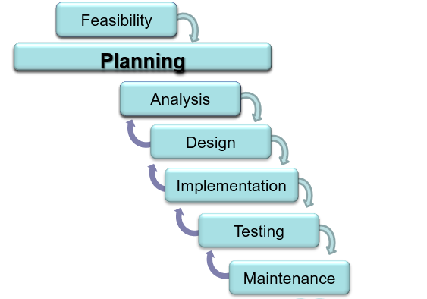Improves quality

Figure 1:Agile development

There are varieties of agile methodologies such as Lean, XP, Feature driven development etc. Among them, I chose to use Kanban as it matches many of my requirements. It focuses on visualization, using techniques such a Kanban board, which is can be an immense help for solo projects.

Kanban

* Work items are represented visually on a Kanban board, which allows to see the state of every piece of work at any time.
* Makes it easier to review processes and ensures continuous improvement
* Attention goes to the most important things

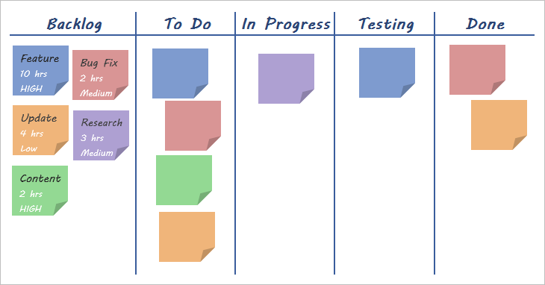

Figure 2:Kanban Board

## 3.1 Design Pattern

The design pattern used in this project is **MVC** or **Model View Controller**. This pattern is divided into three interconnected parts called the model, the view and the controller which are discussed below.

**Model**: This level represents data and business logic to the user. Model is used to store and retrieve data to a database.

**View**: View is responsible for displaying data to the user via user interface. It changes model to the visual representation and present to user.

**Controller**: Controls acts as a link between a user and a system. Takes inputs from view, works with model and returns view. (www.tutorialspoint.com, 2018)

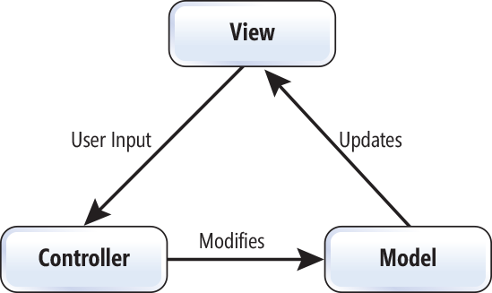

Figure 3:MVC overview

The use of MVC in a web projects such as this might have following benefits:

* MVC supports rapid development
* Modification doesn’t have an impact upon the whole system.
* Supports asynchronous technique
* This model returns data without formatting
* Latest version of MVC Support default responsive web site and mobile templates.

3.2 Architecture  
**3 Tier Architecture** is that unique system of developing web database application which works around the 3-tier model, comprising of database tier at the bottom, the application tier in the middle and the client tier at the top. This comprehensive 3 tier architecture module is the framework for most Web Applications on the Internet. This system helps to separate the Business Logic from the Application, Data Storage and database. Here are some of the benefits we can gather from using this architecture:

* Scalability
* Immediate user response
* Organized programming model
* Client-side state management
* Interoperability
* Offline applications (Arokiait.com, 2018)

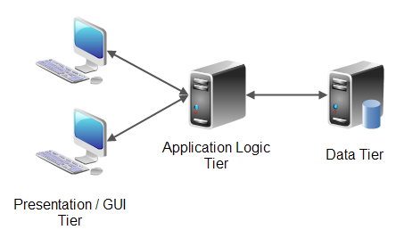

Figure 4:3-tier architecture

# Scheduling

Any project’s success is guaranteed only if time management is handled in the most precise manner. A project comprises of many smaller tasks to be completed, which collectively complete a larger project. Each of these tasks need to be completed in a particular time frame so that the whole project completes within the given deadline. In the following sub-topics, I have demonstrated how and when the tasks are scheduled to complete.

## Work Breakdown Structure (WBS)

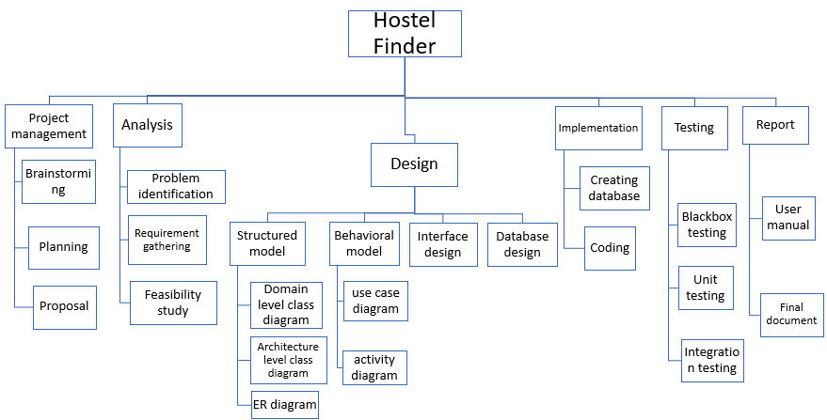WBS is a hierarchical decomposition of a bigger task into smaller manageable sections. It is a visible outline of project divided into smaller chunks. It helps greatly in project planning, management and budget allocation. (Workbreakdownstructure.com, 2018)

Figure 5:Work breakdown structure

## 4.2 Time estimation

|  |  |  |
| --- | --- | --- |
| **WBS** | **Task** | **Estimated time** |
| **1** | **Project management** | **14 days** |
| 1.1 | Brainstorming | 4 days |
| 1.2 | Planning | 5 days |
| 1.3 | Proposal | 5 days |
| **2** | **Analysis** | **25 days** |
| 2.1 | Problem identification | 7 days |
| 2.2 | Requirement gathering | 10 days |
| 2.3 | Feasibility study | 8 days |
| **3** | **Design** | **30 days** |
| 3.1 | Structured model | 6 days |
| 3.1.1 | Create domain level class diagram | 2 days |
| 3.1.2 | Create architecture level class diagram | 2 days |
| 3.1.3 | Create ER diagram | 2 days |
| 3.2 | Behavioral model | 6 days |
| 3.2.1 | Create Use case diagram | 3 days |
| 3.2.2 | Create Activity diagram | 3 days |
| 3.3 | Interface design | 10 days |
| 3.4 | Database design | 8 days |
| **4** | **Implementation** | **20 days** |
| 4.1 | Creating database | 5 days |
| 4.2 | Coding | 15 days |
| **5** | **Testing** | **12 days** |
| 5.1 | Black box testing | 6 days |
| 5.2 | Unit testing | 6 days |
| **6** | **Documentation** | **12 days** |
| 6.1 | User manual | 6 days |
| 6.2 | Final documentation | 8 days |
| **Total** | | **113 days** |

## 4.2 Milestone

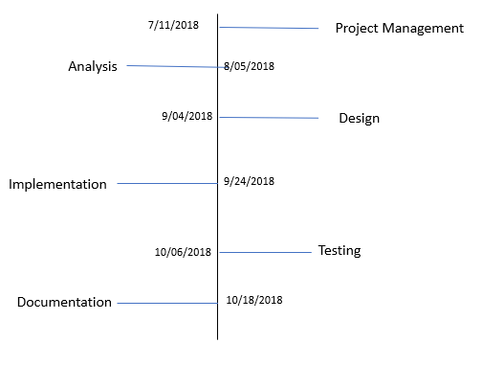Milestones are the markers in a project which depict the change of a stage in development lifecycle. Marking milestones is important because they display key events and make sure you’re progressing. (Teamgantt.com, 2018)

Figure 6:Milestones

**Project Management: 7/11/2018**

This is the most initial phase in the project development, which mostly includes making plans about how the project will be carried out. After doing some brainstorming, gathering ideas and making solid plans, a proposal is written and submitted to the CP module leader.

**Analysis: 8/05/2018**

By the given milestone, I will have thoroughly analyzed the prospects and constraints of the project. I will gather some insights about where the problems lie and where the opportunities of improvement lie.

**Design:** **9/04/2018**

This is a time frame dedicated to designing the project. ER diagrams, class diagram, activity diagram, use-case diagram and many more will be developed. Based on those, UI and database will be designed.

**Implementation:** **9/24/2018**

Within this time frame, I aspire to implement the plans and design to a real life working web application by coding in php and creating a database.

**Testing: 10/06/2018**

Via black box and unit testing, the efficiency and effectiveness of the working model of the project will be tested.

**Documentation: 10/18/2018**

Here, all the work done will be thoroughly documented, accompanied by all the codes, diagrams and will be submitted to the module leader for review.

## 4.4 Gantt Chart

Gantt chart is a graphical tool, widely used in project management, which displays iterations of tasks against time period by which they need to be completed. In the Gantt chart, tasks are shown on a vertical axis and time spent for the task on horizontal axis. (The Economic Times, 2018)

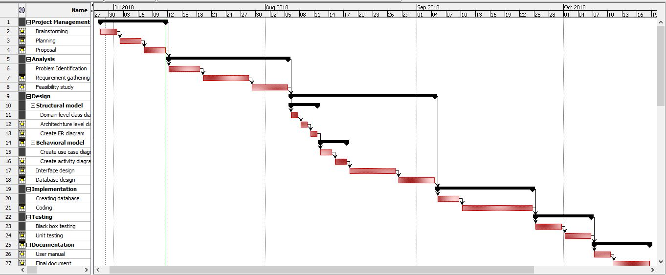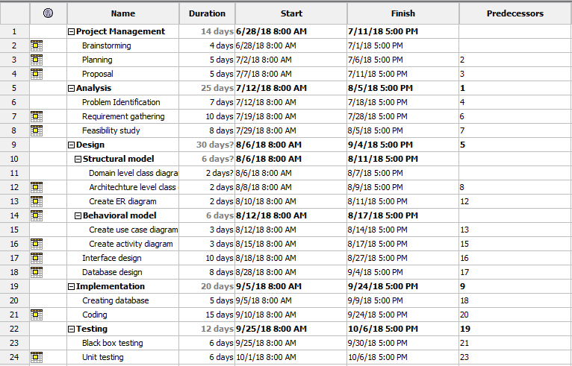

Figure 8:Gantt Chart8

Figure 7:Gantt Chart

# Risk management

5.1 What is risk?

No matter how carefully a project is planned, there always is this thin risk of it running into problems. Risks are simply unavoidable. Though these uncertain problems causing events can not totally be eradicated, a good risk management policy might help a lot to save us in those difficult times. We have to be prudent, foresighted and ready to face those. Risk management is the process of identifying, assessing and controlling those threats. (SearchCompliance, 2018)

## 5.2 Risk Management Matrix

Though abstract terms like ‘risk’ cannot be bound by mathematical values, an attempt is made to demonstrate occurrence of different kinds of risks and their impact upon the project. At first, likelihood and consequences of the risks are given values like this:

|  |  |
| --- | --- |
| **Likelihood** | **Value** |
| Low | 1 |
| Medium | 2 |
| High | 3 |

|  |  |
| --- | --- |
| **Consequence** | **Value** |
| Very low | 1 |
| Low | 2 |
| Medium | 3 |
| High | 4 |
| Very high | 5 |

**Impact=Likelihood*Consequence** is the formula used to calculate the impact a particular risk will cause upon the system.

|  |  |  |  |  |  |
| --- | --- | --- | --- | --- | --- |
|  | **Risk Description** | **Likelihood** | **Consequences** | **Impact** | **Preventive measures** |
| 1 | **Scope creep-**unexpected changes and uncontrolled growth to a project’s scope which can result in additional costs, failure to meet time constraints, even project failure. | 1 | 3 | 3 | Make a definite plan and stick to it. |
| 2 | **Inaccurate project estimating**-The intangible nature of software makes it extremely difficult to estimate and schedule. | 2 | 3 | 6 | Use more than one method to create estimates and search for a midpoint. |
| 3 | **Unstable application** -browser incompatibility, incorrect memory usage, fatal production bugs, and more | 1 | 5 | 5 | Optimize SSL/TLS, Monitor live issues |
| 4 | **Poor Productivity-**  During the lifespan of project, there can be times where productivity of developers | 2 | 5 | 10 | Short iterations, coaching, motivation |
| 5 | **Software and hardware defects** | 3 | 4 | 12 | Scheduled maintenance, Proper backup |

# Configuration management

Configuration management is the process in systems engineering for establishing, maintaining consistency in performance of a product throughout its life. In simple word, it’s about having a record of your systems, what’s happened to those items and the details of the relationships among the items on your list. Configuration management determines clearly about the items that make up the software or system. These items include source code, test scripts, third-party software, hardware, data and both development and test documentation. It ensures that these items are managed carefully, thoroughly and attentively during the entire project and product life cycle. It is sometimes referred to as IT automation. (Sharma, 2018)

Good Configuration Management ensures that the current design and build state of the system is known and recorded; and doesn’t rely on the tacit knowledge of the development team.

In this project configuration management is done by storing all the files and data locally in the local machine and also in GitHub repository (<https://github.com/alakaacharya/Hostel-Finder>)

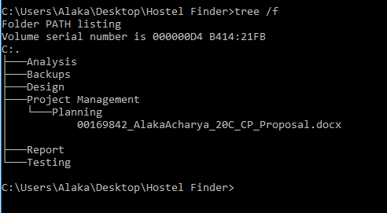All the major files related to every steps of software development life cycles are separately stored. This helps in rolling back changes if ever needed. Finally, copies all the documents are stored in Google Drive for backup.

Figure 10:Directory structure of Hostel Finder in local machine

# Conclusion

I hereby propose to develop a web application called ‘hostel finder’ following the agile principles within the received time frame. I began with a brief introduction of what I aspire to do with the project and what real life problems led me to take this project. I have briefly discussed my aims and objectives from this project. Aim includes the long-term purpose this project intends to achieve. Objectives include how the aims are supposed to be achieved. I have included the salient features the project aims to be embellished with. I have put forward the development methodologies and architectures I am working with and also reasons how they fulfill the necessities of the project.

I have clearly talked about how I am looking forward to stick to the time frame available. Via work break down structure and Gantt chart, I have shown how time is allocated for various chunks of tasks. Project Libre was used to create a Gantt Chat.

Risk management is demonstrated via risk management matrix where some possible risks are mentioned along with their likelihood of their occurrence and the degree of consequences they might invite. Under the heading configuration management, it is discussed about how configuration management of the project is done.

This proposal provides an overview on what steps I am willing to follow in order to complete the project. The idea of the project revolves around a time period of 3 months. With proper guidance and support from module leader, I believe I can single handedly take this project to an end.

# 8.References

The Economic Times. (2018). Definition of Gantt Chart | What is Gantt Chart ? Gantt Chart Meaning - The Economic Times. [online] Available at: https://economictimes.indiatimes.com/definition/gantt-chart [Accessed 7 Jul. 2018].

Teamgantt.com. (2018). What's a Milestone? Why You Need Milestones in Project Plans. [online] Available at: https://www.teamgantt.com/blog/the-how-and-why-of-using-milestones-in-your-project-plan [Accessed 7 Jul. 2018].

Workbreakdownstructure.com. (2018). What is a Work Breakdown Structure - Workbreakdownstructure.com. [online] Available at: http://www.workbreakdownstructure.com/ [Accessed 8 Jul. 2018].

SearchCompliance. (2018). What is risk management? - Definition from WhatIs.com. [online] Available at: https://searchcompliance.techtarget.com/definition/risk-management [Accessed 7 Jul. 2018].

Arokiait.com. (2018). 3-Tier Web Architecture, 3 Tier Web Application Architecture – Arokia IT. [online] Available at: http://www.arokiait.com/3-tier-web-architecture.htm [Accessed 8 Jul. 2018].

Sharma, L. (2018). What is Configuration Management System?. [online] Toolsqa.com. Available at: http://toolsqa.com/software-testing/configuration-management/ [Accessed 7 Jul. 2018].

www.tutorialspoint.com. (2018). Design Patterns MVC Pattern. [online] Available at: https://www.tutorialspoint.com/design_pattern/mvc_pattern.htm [Accessed 8 Jul. 2018].