Name: Alakh Niranjan

API Doc:-

1. User regiser :-

Url :- localhost:8000/api/auth/signup

Method :post

In Raw json:

{

"name": "alakh",

"email": "alakh@qversity.com",

"password": "123456"

}

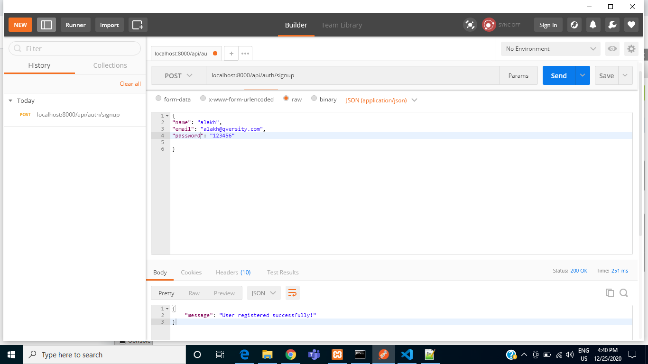

1. User Login:-

Url :- localhost:8000/api/auth/signin

Method :post

In Header :

Content-Type : ‘application/json’

In Raw json:

{

"email": "alakh@qversity.com",

"password": "123456

}

1. Add movies:-

Url : localhost:8000/api/add-movies

Method : post

In Header :

Content-Type : ‘application/json’

x-access-token : “after login get token”

InBody-> Raw Json:

{

"title": "Test42 Movies",

"description": "desc test1 movies",

"duration": "45 Min",

"artists": "Test artics",

"genres": "poltics",

"watchURL":"www.test.com"

}

1. Update movies :-

Url : localhost:8000/api/update-movies

Method : post

In Header :

Content-Type : ‘application/json’

x-access-token : “after login get token”

InBody-> Raw Json:

{

"id": "2",

"title": "Test42 Movies",

"description": "desc test1 movies",

"duration": "45 Min",

"artists": "Test artics",

"genres": "poltics",

"watchURL":"www.test.com"

}

1. Search movies:-

URL: localhost:8000/api/search-movies

Method : post

In Header :

Content-Type : ‘application/json’

x-access-token : “after login get token”

InBody-> Raw Json:

{

"searchby":"Test"

}

1. Get movies with pagination :-

URL: localhost:8000/api/get-movies?page=2&perpage=4

Method : Get

In Header :

Content-Type : ‘application/json’

x-access-token : “after login get token”

1. most voted movie:-

URL: localhost:8000/api/most-voted-movies

Method : Get

In Header :

Content-Type : ‘application/json’

x-access-token : “after login get token”

1. Vote for movies

URL: localhost:8000/api/add-movies-vote

Method : Post

In Header :

Content-Type : ‘application/json’

x-access-token : “after login get token”

{

"user_id":2,

"movie_id": 3,

"vote":"like"

}

1. Un vote for movie :-

URL: localhost:8000/api/movies-unvote

Method : Post

In Header :

Content-Type : ‘application/json’

x-access-token : “after login get token”

{

"vote_id":2

}

1. list all of the user s voted movie:-

URL: localhost:8000/api/voted-movies-list

Method : get

In Header :

Content-Type : ‘application/json’

x-access-token : “after login get token”