# Functional Specification Document

# Your Doctor Program app Project 0.1

|  |  |  |  |
| --- | --- | --- | --- |
| **Document Version** | | 0.1 | |
| **Name:** Srikanth | **Role :**Developer | **Signature** | **Date: 16/12/12** |
| **Prepared by:** Srikanth | | | |
| **Reviewed by:** Revanth | | | |
| **Approved by:** Alakinfotech | | | |

|  |  |  |  |
| --- | --- | --- | --- |
| **Revision History** | | | |
| **Version** | **Date of**  **Release** | **Sections**  **Affected** | **Reasons for change** |
|  |  |  |  |
|  |  |  |  |
|  |  |  |  |
|  |  |  |  |
|  |  |  |  |

**Table of Contents**

1. Introduction 3

2. References 3

3. Definitions and Abbreviations 4

4. System Functionality 4

4.1 YDP Login<Approved> 4

4.1.1 YDP Login Description: 4

4.1.2 User Interface 5

4.1.3 Impact Analysis 7

4.1.4 Additional Points on Testing 7

4.1.5 Constraints 7

4.2 Login YDP using QR-Code<Approved> 7

4.2.1 Login into YDP using QR-Code Description: 7

4.2.2 User Interface: 7

4.2.3 Impact Analysis 7

4.2.4 Additional Points on Testing 7

4.2.5 Constraints 8

4.3 Call to YDP <Approved> 8

4.3.1 Call to YDP Description: 8

4.3.2 User Interface 8

4.3.3 Impact Analysis 10

4.3.4 Additional Points on Testing 10

4.3.5 Constraints 10

4.4 Email YDP <Approved> 10

4.4.1 Email YDP Description: 10

4.4.2 User Interface 11

4.4.3 Impact Analysis 11

4.4.4 Additional Points on Testing 11

4.4.5 Constraints 11

4.5 More about YDP <Approved> 12

4.5.1 More about YDP Description: 12

4.5.2 User Interface 12

4.5.3 Impact Analysis 12

4.5.4 Additional points on Testing 12

4.5.5 Constraints 12

5. Report Layouts 13

6. Functional Decomposition Diagram 13

1. Introduction

YDP mobile app is mainly used for patients who have an active YDP account.YDP app can be used for calling YDP help line with one tap using the app, send email, andgettingdetailed information regarding YDP.

Special function of YDP app is to allow user login on YDP using QR code printed on the YDP QR card.

App decrypts the login data on the QRcode to extract username and password on theYDP card.User don’t need to login to use other functions such as “Call YDP”, ”Email YDP” and ”More About YDP”.

1. References

|  |  |  |
| --- | --- | --- |
| **S.N.** | **Document Name** | **Version & Date** |
|  |  |  |
|  |  |  |
|  |  |  |
|  |  |  |

1. Definitions and Abbreviations

|  |  |  |
| --- | --- | --- |
| **Term** | **Abbreviation** | **Definition** |
| YDP | Your Doctor Program |  |
| NA | Not Applicable |  |

1. System Functionality
   1. YDP Login<Approved>
      1. YDP Login Description:

YDP mobile application is used by only YDP accountholders because YDP app requires username and password of YDP. So only YDP accountholder can get access into Care plan.

There are two ways to login using the app:

One, by using username and password of YDPaccount. Whenever login button is clickedafter enteringusername and password then application gives access to use YDP Care plan. There is logout button on user interface screen_2, which is used to navigateback to login screen.

Second,by using QR code scanning to login in to the application.

**Functionality:**

* Login into YDP, is home screen in YDP application.
* It interacts with user interface of YDP home screen.

* + 1. User Interface

#### iPhone User Interface

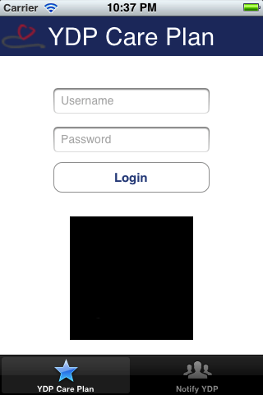

#### Android User Interface

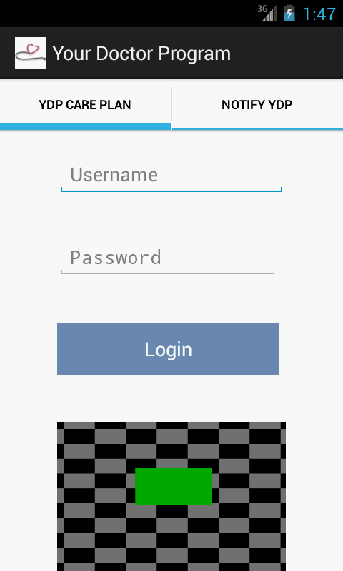

* + 1. Impact Analysis

NA

* + 1. Additional Points on Testing

NA

* + 1. Constraints

NA

* 1. Login YDP using QR-Code<Approved>
     1. Login into YDP using QR-Code Description:

QR-Code isaway to represent data in a image format.

On YDP QR Card, QR-Codestores user login data in 128 bit encryption. The app scans the YDP code image, extracts the data, decrypts it and generates the user data such as username and password, uses the information to login in to the system.User can login either way based on his/her choice. If YDP card is available, they can use QR-Code option or they can manually login.

**Functionality:**

* It relates to the user interface_2.
* Application is integrated with the QRcode for bar code image processing.
  + 1. User Interface:

Refer 4.1.2.1 for IPhone user Interface

Refer 4.1.2.2 for Android userInterface

* + 1. Impact Analysis

NA

* + 1. Additional Points on Testing

NA

* + 1. Constraints

NA

* 1. Call to YDP <Approved>
     1. Call to YDP Description:

‘Call to YDP option’ is enabled on the app by default without having to login.This option allows the user to call YDP service providers.Here default YDP service provider contact number is stored and when ever user clicks on call YDP it automatically calls the number from phone.

This feature enables calling YDP Support without having to search for the phone number.

**Functionality:**

* It relates to the user interface_1.
* It takes admin parameters like username and password, if the both the fields match then Call YDP option will enable to make a call.
  + 1. User Interface

#### IPhone userinterface

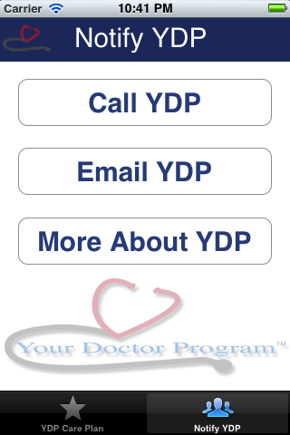

#### Android user interface

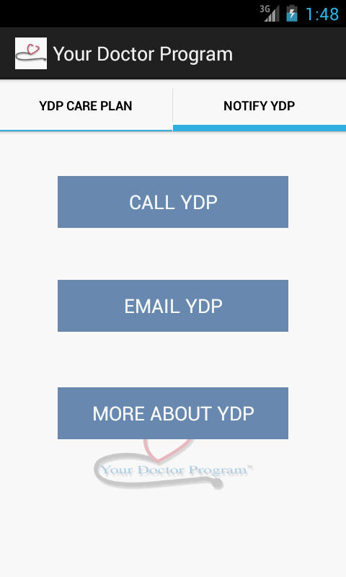

* + 1. Impact Analysis

NA

* + 1. Additional Points on Testing

NA

* + 1. Constraints

NA

* 1. Email YDP <Approved>
     1. Email YDP Description:

Email YDP is a enabled for default and doesn’t require an user to login.Email YDP option allows the user to send email to the YDP Support service by default.

**Functionality:**

* Email YDP, is relates with the home screen (UI_1).
* It integrates with email interface to send email.
  + 1. User Interface

Refer 4.3.2.1 for IPhone user interface

Refer 4.3.2.2 for Android user interface

* + 1. Impact Analysis

NA

* + 1. Additional Points on Testing

NA

* + 1. Constraints

NA

* 1. More about YDP <Approved>
     1. More about YDP Description:

‘More about YDP’ option is enabled by default and doesn’t require user to be logged in. This button on clicking takes the user to Your Doctor Program website so that user can review any information available there.

**Functionality:**

* More about YDP, is relates with the home screen (UI_1).
* It integrates with YDP website.
  + 1. User Interface

Refer 4.3.2.1 for Iphone user interface

Refer 4.3.2.2 for android user interface

* + 1. Impact Analysis

NA

* + 1. Additional points on Testing

NA

* + 1. Constraints

NA

1. Report Layouts

NA

1. Functional Decomposition Diagram

NA