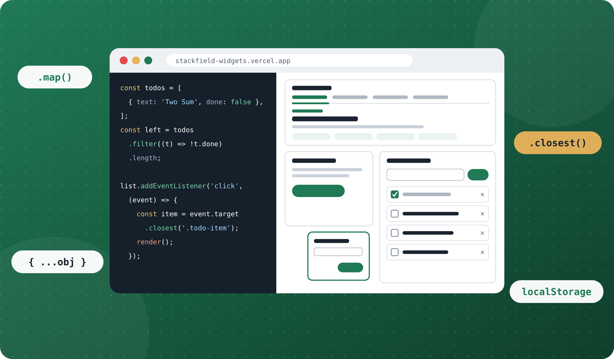
FULL-STACK DEVELOPER HANDBOOK
Week 3
Data, the DOM and Interactive Widgets
Arrays · Objects + JSON · The DOM · Events · Closures · localStorage · Modules
Week 3 of 26 · Days 15–21 · 10 – 16 October 2026
7  daily chapters | 39  diagrams and screenshots | 6  LeetCode problems | 3  working widgets

This book belongs to

START HERE

How to use this book
This handbook holds everything you need for Week 3, in the order you need it. Every lesson explains the idea in plain words first, then shows the code, exactly what it prints (every output in this book was run in Chrome), and other ways to do the same job. Read the day's chapter before you code, keep it open while you build, and use the review pages on Friday.

Every day follows the same shape
Part | What it gives you
Chapter opener | The date, time needed, what you build today and where the code is
Today you will | The skills you'll have by the end of the day
Key terms | The new words, defined in one line each
Lessons | Each idea explained in plain words, with worked examples, output, diagrams and tables
DSA problem | Days 15 to 20: one LeetCode problem a day, explained, then solved two to four ways
Build it, step by step | Exactly what to do today, in order
Must know | The few ideas that matter most. Revise these
Watch out | The mistakes almost everyone makes
More practice | Extra exercises for when you want more; answers at the back
Check yourself | Three questions; answers at the back
Resources | Hand-picked, free links for going deeper, checked before printing
Done when | The checklist that tells you the day is finished

The boxes you'll see
IN PLAIN WORDS
The idea explained with an everyday comparison, before any code.

JS · code you type
const city = 'Dhaka';
console.log(`Hello from ${city}`);
▶ CONSOLE OUTPUT · what you should see
Hello from Dhaka

⇄ MORE WAYS Other ways to do the same job
WAY 1 A different approach, with a note on when to choose it
There is rarely only one right answer. Knowing two or three ways helps you read other people's code.

★ MUST KNOW the ideas to remember from today
- The most important ideas of the day. If you remember nothing else, remember these.

TIP
A shortcut, a better habit or a tool that makes the work easier.

WATCH OUT
A common mistake, and how to avoid it.

QUESTIONS LEARNERS ASK
Q A question beginners often ask at this point?
A short, direct answer.

How to study with it
- Read a lesson, then type the examples yourself. Typing (not copying) is how syntax sticks. Predict the output before you run it.
- Change one thing and run it again. What happens with a different number, an empty string, a narrower window? Most learning happens here.
- Try the task before opening the finished code. Stuck for 20 minutes? Look at only the part you need, close it, then write it yourself.
- End each day with Check yourself and Done when. Then commit, push and mark the day done in your Logbook.

WEEK 3

Contents

Week at a glance 5
The week in pictures 7
Day 15 Arrays: lists of values, and the methods that transform them 9
Saturday 10 October
Day 16 Objects and JSON: modelling real data 34
Sunday 11 October
Day 17 The DOM: select, create and update the page 56
Monday 12 October
Day 18 Events in depth: bubbling, delegation and an accessible modal 74
Tuesday 13 October
Day 19 Closures, timers and localStorage 92
Wednesday 14 October
Day 20 Build day: modules, the finished to-do list, and going live 110
Thursday 15 October
Day 21 Week 3 review: theory stops here 126
Friday 16 October
Quick reference 133
Answers 138
Glossary 143
Notes 145

TIP
Every line above is a link. Click a chapter to jump straight to it, in Word and in the PDF. Links in the Resources tables open in your browser.

OVERVIEW

Week at a glance
The goal of Week 3: learn to work with data (arrays and objects) and to make pages react to people (the DOM and events), by building three widgets almost every web app has: tabs, a modal dialog and a to-do list that remembers your tasks. Plus six LeetCode problems, including the famous Two Sum.
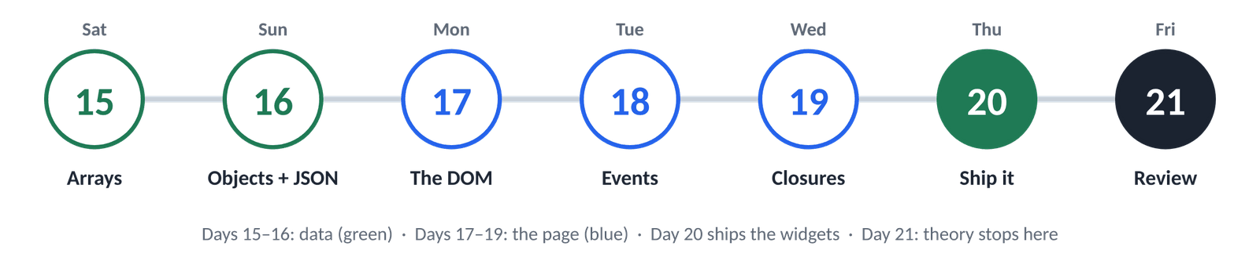
Day | Date | Topic | You build
15 | 10 October | Arrays | 10 array exercises, the plan and static HTML/CSS for three widgets, and Running Sum
16 | 11 October | Objects + JSON | An objects demo, five expense functions, tabs built from data, and Richest Customer Wealth
17 | 12 October | The DOM | A DOM playground with five exercises, working tabs, and Contains Duplicate
18 | 13 October | Events | A character counter, a delegated list, an event lab, the modal dialog and keyboard tabs, and Valid Anagram
19 | 14 October | Closures | Closure exercises, a focus timer, a debounced search, a saved theme, the to-do list (part 1), and Two Sum
20 | 15 October | Ship it | The widgets as ES modules, a to-do list with filters, editing and saving, live on Vercel; and Best Time to Buy and Sell Stock
21 | 16 October | Review | A filterable list from scratch, one problem redone, and the Project 1 plan

By Friday you will be able to
- Store lists and records as arrays and objects, and reshape them with map, filter and reduce
- Copy and update data without surprises: spread, destructuring, references vs copies
- Save data as JSON in localStorage and load it back safely
- Find, create, change and remove any element on a page, safely (no XSS)
- Handle clicks, typing, forms and keys, with bubbling and event delegation
- Build accessible tabs, a modal dialog and a to-do list with the state → render pattern
- Explain closures, timers and debouncing
- Split code into ES modules and deploy it on Vercel

Your daily routine
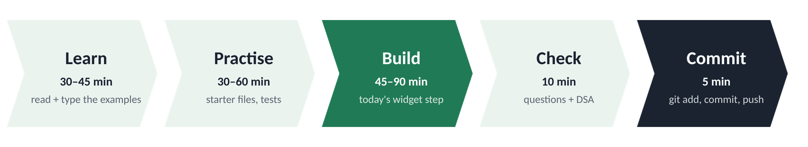
Figure 0.1 · The same five steps every day, about 3 hours in total
- Before: read the chapter opener, "Today you will" and the Key terms (5 minutes).
- During: read a lesson, type its examples in the Console, predict the output, then practise. Try each task before opening the finished code.
- After: answer "Check yourself" without looking, solve the day's LeetCode problem, tick "Done when", then commit and push.

What you need
Tool | Why
VS Code | With Live Server (essential from Day 20: modules need a server) and Prettier
Google Chrome | DevTools: Console, Elements (live DOM, $0), Sources (breakpoints), Application (Local Storage)
Git + GitHub | Commit every day; the widgets get their own repository on Day 20
Vercel | The same free account as Week 2, for the widgets page
LeetCode | One problem a day, Days 15–20
The code folder | fullstack-journey-week03: one finished folder per day, starter and solution files, and tests that print PASS / FAIL

Last week → this week
From Week 2 | How Week 3 builds on it
Functions + callbacks | Every array method takes a callback; closures are functions that remember
getElementById, textContent | The full DOM toolbox: select anything, create and remove elements
addEventListener | The event object, bubbling, delegation, keys, forms and a modal
Strings + numbers | Used inside map and filter; toLocaleString for taka amounts
The debugger | Breakpoints inside callbacks; the Application panel for saved data
Deploying on Vercel | The same flow, now for a site made of ES modules

OVERVIEW

The week in pictures
The widgets page grows every day. Each screenshot is the real code from that day's folder, so you can always see where you're heading.
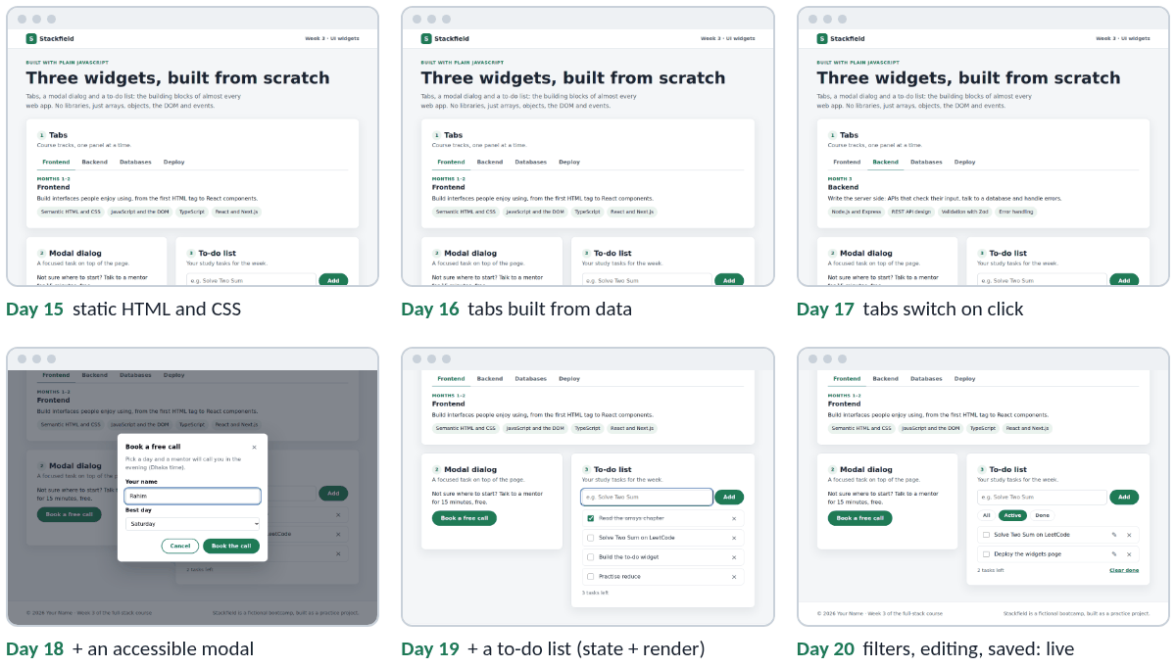
Figure 0.2 · The widgets page on Days 15 to 20
Day | What changes
15 | The plan, then the HTML and CSS only: three widgets that look finished but do nothing yet
16 | The tabs are built from an array of objects instead of hand-written HTML
17 | Clicking a tab shows its panel
18 | One delegated listener and the arrow keys for the tabs; the modal dialog works
19 | The to-do list: add, tick and delete, drawn from an array by one render()
20 | ES modules, filters, editing, empty states and saving; then it goes live on Vercel
21 | Nothing new: you prove it stuck, and plan Project 1

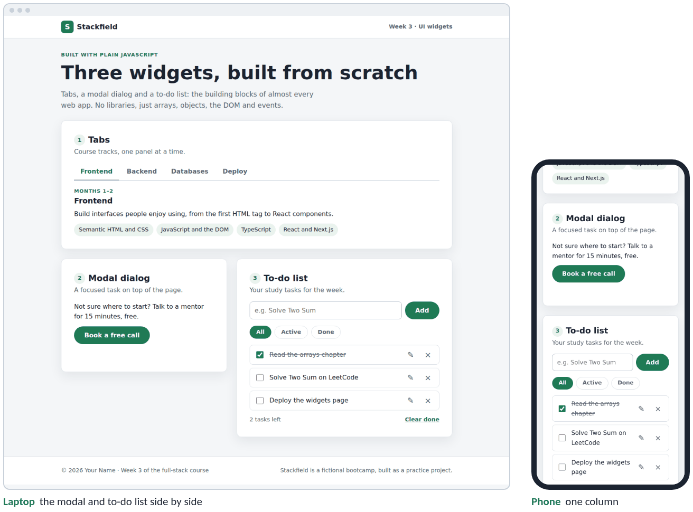
Figure 0.3 · Where you're heading: the finished widgets on a laptop and a phone
TIP
Days 15 and 16 are mostly data work in the Console, so the page barely changes. That's normal. From Day 17 every day adds something you can click, and it all rests on those two days.

DAY  15 | WEEK 3 · SATURDAY 10 OCTOBER  Arrays: lists of values, and the methods that transform them  Almost all data in an app is a list. Today you learn to store lists and reshape them.

TIME  3 hours | YOU BUILD  10 array exercises, the plan and static HTML/CSS for three widgets, and Running Sum | CODE FOLDER  day15-arrays

Today you will
- Create arrays, read items by their index, and use length and at(-1)
- Add and remove items with push, pop, shift, unshift and splice
- Tell slice (copy a part) from splice (cut out or insert)
- Know which methods change the original array and which give you a new one
- Loop with for, for…of and forEach
- Search with includes, indexOf, find, findIndex, some and every
- Transform lists with map, filter and reduce, and chain them
- Sort numbers, text and objects correctly with a compare function
- Remove duplicates with a Set, and copy or join arrays with spread (...)
- Plan the three widgets and write their static HTML and CSS
- Solve LeetCode 1480, Running Sum of 1d Array, three ways

Key terms
Term | Meaning
Array | An ordered list of values in one variable: ['Sat', 'Sun', 'Mon']
Item (element) | One value inside an array
Index | An item's position, counted from 0
length | How many items the array has
Method | A function that belongs to a value: days.push('Tue')
Mutate | Change the original array (instead of making a new one)
Callback | The function you give to map, filter, find…; it runs once per item
Predicate | A callback that answers yes or no (true / false) for each item
Accumulator | The running value that reduce carries from item to item
Compare function | (a, b) => a - b: tells sort which of two items comes first
Set | A collection that keeps only one of each value
Spread (...) | Unpacks an array's items: [...a, ...b], Math.max(...a)

15.1 What an array is
IN PLAIN WORDS
An array is a row of numbered pigeonholes. Each hole holds one value, and the numbers start at 0, not 1. The whole row has one name, so you can pass a list of 5 or 5,000 values around as easily as a single number.

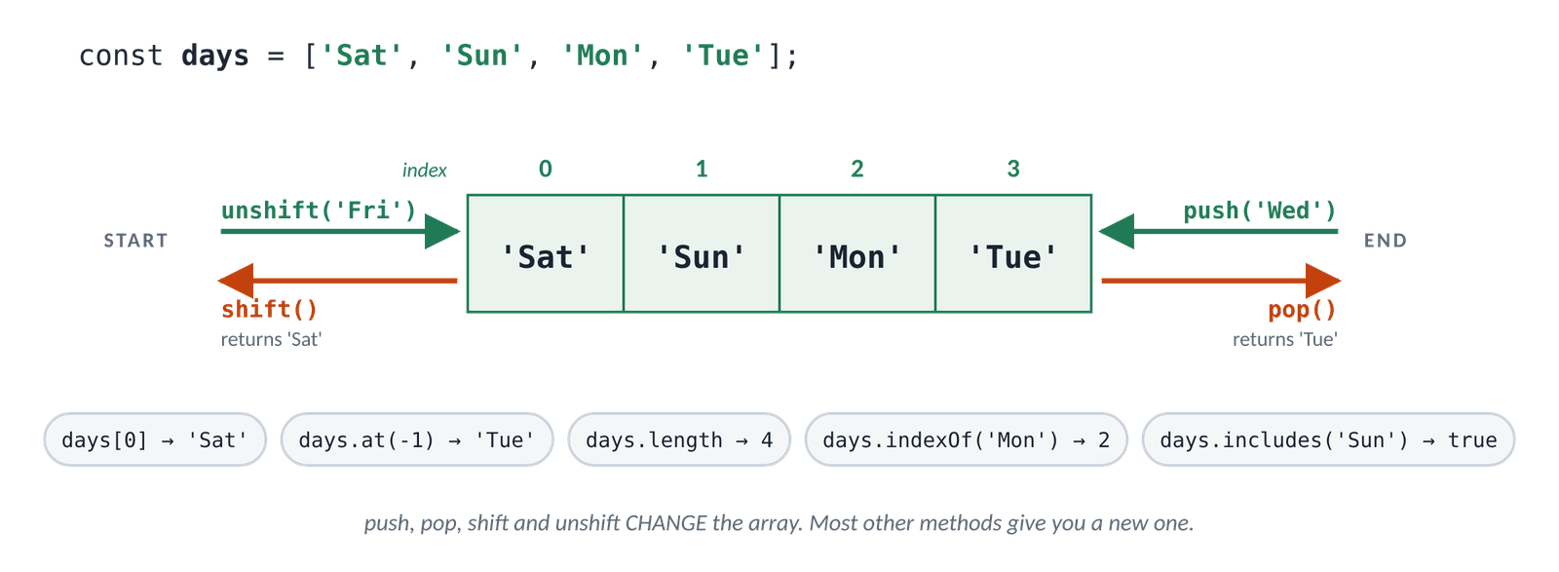
Figure 15.1 · An array: numbered positions, and the four methods that work on its two ends
JS · creating an array and reading items
const days = ['Sat', 'Sun', 'Mon']; // square brackets, items separated by commas
console.log(days);
console.log(days[0]); // the FIRST item is at index 0
console.log(days[2]);
console.log(days.length); // how many items
console.log(days[days.length - 1]); // the last item, the classic way
console.log(days.at(-1)); // the last item, the modern way
console.log(days[5]); // nothing there: undefined, not an error
▶ CONSOLE OUTPUT
['Sat', 'Sun', 'Mon']
Sat
Mon
3
Mon
Mon
undefined

TIP
Chrome shows an array with its length in front, like (3) ['Sat', 'Sun', 'Mon'], and a small triangle (▸) you can click to open it. This book leaves out the (3) to keep the outputs short. Inside a bigger value Chrome shortens nested arrays to Array(3) and objects to {…}; click to open them.

The last index is always length - 1: an array of 3 items has indexes 0, 1 and 2. Forgetting this "off by one" is the most common array bug of all.
JS · any value can go in an array, even another array
const mixed = ['Rahim', 25, true, null]; // any types, even mixed
const grid = [[1, 2, 3], [4, 5, 6]]; // arrays inside an array: a table
console.log(mixed.length, grid.length);
console.log(grid[1]); // the second row
console.log(grid[1][2]); // row 1, then item 2 of that row
console.log(Array.isArray(grid), typeof grid);
▶ CONSOLE OUTPUT
4 2
[4, 5, 6]
6
true object

Changing an item
JS · writing to an index
const colours = ['red', 'green', 'blue'];
colours[1] = 'yellow'; // replace the item at index 1
colours[3] = 'purple'; // the next free index adds an item at the end
console.log(colours);
console.log(colours.length);
▶ CONSOLE OUTPUT
['red', 'yellow', 'blue', 'purple']
4

WATCH OUT
const does not freeze an array. const colours means the name colours always points to the same array, but the items inside can change. colours[0] = 'pink' works; colours = ['pink'] is a TypeError.

⇄ MORE WAYS Five ways to create an array
WAY 1 Square brackets: the usual way
const empty = [];
const primes = [2, 3, 5, 7];
Use this 95% of the time.
WAY 2 Split a string
'html,css,js'.split(',') // ['html', 'css', 'js']
Handy for text from a file, a form or a URL.
WAY 3 Array.from()
Array.from('abc') // ['a', 'b', 'c']
Array.from({ length: 5 }, (_, i) => i + 1) // [1, 2, 3, 4, 5]
Turns "list-like" things into real arrays, and builds number ranges. _ is a name for a parameter you don't use.
WAY 4 Array(n).fill()
Array(3).fill(0) // [0, 0, 0]
A list of the same starting value, e.g. scores for 3 players.
WAY 5 Spread something else
[...'hey'] // ['h', 'e', 'y']
[...new Set([1, 1, 2])] // [1, 2]
... unpacks anything you can loop over into a new array (15.12).

15.2 Adding and removing at the ends
IN PLAIN WORDS
Picture a queue at a bus stop. push adds a person at the back and pop removes the person at the back; unshift squeezes someone in at the front and shift lets the person at the front leave. All four change the queue itself.

JS · push, unshift, pop and shift
const queue = ['Asha', 'Bilal'];
queue.push('Chandni'); // add to the END
console.log(queue);
queue.unshift('Dipu'); // add to the START
console.log(queue);
const lastOut = queue.pop(); // remove from the END, and get it back
const firstOut = queue.shift(); // remove from the START, and get it back
console.log(lastOut, firstOut);
console.log(queue);
console.log(queue.push('Esha', 'Farid')); // adds two; returns the new length
▶ CONSOLE OUTPUT
['Asha', 'Bilal', 'Chandni']
['Dipu', 'Asha', 'Bilal', 'Chandni']
Chandni Dipu
['Asha', 'Bilal']
4

Method | Where | Returns | Example
push(x, …) | adds at the end | the new length | cart.push('pen')
pop() | removes the last | the removed item | const last = stack.pop()
unshift(x, …) | adds at the start | the new length | news.unshift(latest)
shift() | removes the first | the removed item | const next = queue.shift()

⇄ MORE WAYS Two classic shapes built from these methods
WAY 1 A stack: last in, first out
const history = [];
history.push('page 1');
history.push('page 2');
history.pop(); // 'page 2': the newest leaves first
The browser's Back button and every Undo button work like this. You'll use a stack for LeetCode 20 in Week 4.
WAY 2 A queue: first in, first out
const printJobs = [];
printJobs.push('CV.pdf');
printJobs.push('notes.pdf');
printJobs.shift(); // 'CV.pdf': the oldest leaves first
Print queues, customer-support tickets, messages waiting to be sent.

TIP
push and pop are fast. shift and unshift must renumber every other item, so on arrays with hundreds of thousands of items they are slow. For the lists in this course, both are fine.

15.3 slice vs splice: copy a part, or cut it out
Two methods with nearly the same name and very different effects. slice copies a part of the array and leaves the original alone. splice cuts items out of the original (and can insert new ones in the gap).
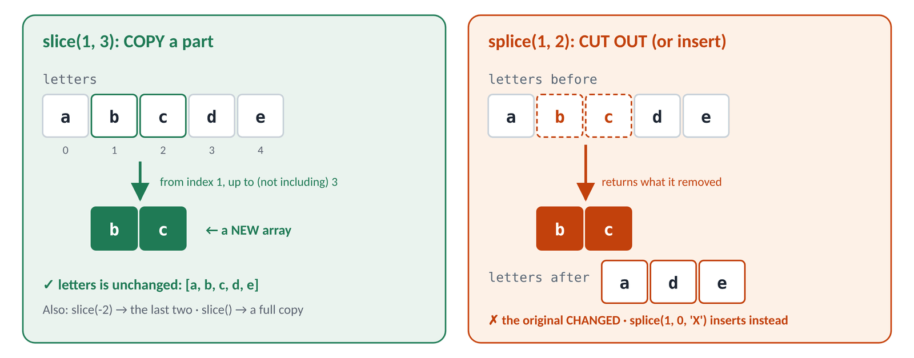
Figure 15.2 · slice(1, 3) copies b and c; splice(1, 2) removes them from the original
JS · slice copies; splice changes the original
const letters = ['a', 'b', 'c', 'd', 'e'];
console.log(letters.slice(1, 3)); // from index 1 up to (not including) 3
console.log(letters.slice(2)); // from index 2 to the end
console.log(letters.slice(-2)); // the last two
console.log(letters); // unchanged

const removed = letters.splice(1, 2); // at index 1, remove 2 items
console.log(removed);
console.log(letters); // CHANGED
letters.splice(1, 0, 'X', 'Y'); // at index 1, remove 0, insert 'X' and 'Y'
console.log(letters);
letters.splice(2, 1, 'Z'); // at index 2, replace 1 item with 'Z'
console.log(letters);
▶ CONSOLE OUTPUT
['b', 'c']
['c', 'd', 'e']
['d', 'e']
['a', 'b', 'c', 'd', 'e']
['b', 'c']
['a', 'd', 'e']
['a', 'X', 'Y', 'd', 'e']
['a', 'X', 'Z', 'd', 'e']

Call | Means | Changes the original?
slice(start, end) | copy from start up to (not incl.) end | No: returns a new array
slice(start) / slice(-n) | copy to the end / the last n | No
slice() | copy everything | No: a quick way to copy
splice(start, count) | remove count items at start | Yes: returns the removed items
splice(start, 0, a, b) | insert a and b at start | Yes
splice(start, 1, x) | replace one item with x | Yes

TIP
Memory trick: splice has an extra p, and it permanently changes the array.

⇄ MORE WAYS Four ways to remove the item at index 2
WAY 1 splice: change the array
list.splice(2, 1);
Fine for a list only you use. The original is changed.
WAY 2 filter by index: a new array
const shorter = list.filter((_, index) => index !== 2);
Keeps every item whose index isn't 2. The original is safe. You'll learn filter in 15.8.
WAY 3 Two slices and spread
const shorter = [...list.slice(0, 2), ...list.slice(3)];
Everything before, then everything after. Also a new array.
WAY 4 toSpliced(): splice without the damage
const shorter = list.toSpliced(2, 1);
Added to JavaScript in 2023 and works in all current browsers. Same arguments as splice, but it returns a new array.

15.4 Change the original, or get a new array?
Every array method either mutates (changes the array you call it on) or returns a new array and leaves the original alone. Knowing which is which prevents a whole family of bugs, and from Month 2 React will insist on the "new array" style.
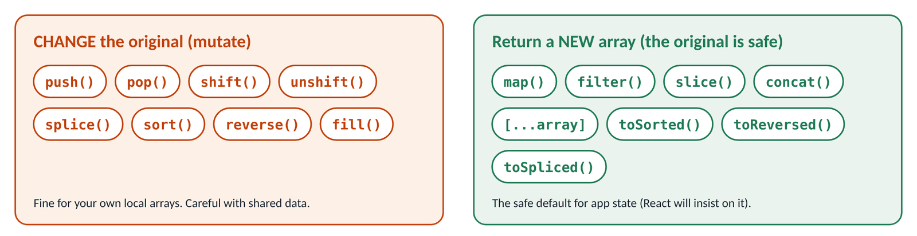
Figure 15.3 · Methods that change the original (left) and methods that give you a new array (right)
JS · = gives a second name; spread gives a copy
const original = [3, 1, 2];
const sameArray = original; // NOT a copy: a second name for the same array
sameArray.push(4);
console.log(original); // changed through the other name!

const copy = [...original]; // a real copy, made with spread
copy.push(5);
console.log(original, copy);
console.log(original === sameArray, original === copy);
▶ CONSOLE OUTPUT
[3, 1, 2, 4]
[3, 1, 2, 4] [3, 1, 2, 4, 5]
true false

IN PLAIN WORDS
A variable holding an array is like a note with a house address on it. const sameArray = original copies the note, not the house: both notes lead to the same house, so a change made through one is visible through the other. [...original] builds a new house with the same furniture.

⇄ MORE WAYS Four ways to copy an array
WAY 1 Spread: [...list]
const copy = [...list];
Short and clear. The most common way today.
WAY 2 slice() with no arguments
const copy = list.slice();
The classic way; you'll see it in older code.
WAY 3 Array.from(list)
const copy = Array.from(list);
Also converts list-like things (such as a NodeList, Day 17).
WAY 4 structuredClone(list): a deep copy
const copy = structuredClone(list);
Also copies the arrays and objects inside the array. The first three only copy the outer list (Day 16 explains "shallow" and "deep").

Mutating method | Safe twin (new array) | Notes
sort() | toSorted() or [...a].sort() | The twins arrived in 2023
reverse() | toReversed() or [...a].reverse()
splice() | toSpliced() | Same arguments
a[i] = x | a.with(i, x) | Replace one item, get a new array
push(x) | [...a, x] | Add to the end
unshift(x) | [x, ...a] | Add to the start

15.5 Looping over an array
JS · four loops, same list
const topics = ['Arrays', 'Objects', 'DOM'];

for (let i = 0; i < topics.length; i++) { // 1. classic for: you control the index
console.log(i, topics[i]);
}
for (const topic of topics) { // 2. for...of: just the items
console.log(topic);
}
topics.forEach((topic, index) => { // 3. forEach: item AND index
console.log(`${index + 1}. ${topic}`);
});
for (const [index, topic] of topics.entries()) { // 4. for...of + entries()
console.log(index, topic);
}
▶ CONSOLE OUTPUT
0 Arrays
1 Objects
2 DOM
Arrays
Objects
DOM
1. Arrays
2. Objects
3. DOM
0 Arrays
1 Objects
2 DOM

Loop | Choose it when… | Can stop early?
for…of | you want each item (your default) | Yes: break, continue, return
forEach | you want item and index and will visit all of them | No: it always visits every item
classic for | you need to skip, go backwards or step by 2 | Yes
for…of + entries() | you want the index but also want break | Yes

WATCH OUT
- return inside a forEach callback only ends that one call, not the loop. To stop at the first match, use for…of with break, or better, find or some (15.6).
- Don't use for…in on arrays. It is for objects, gives the indexes as strings ('0', '1') and can pick up extra keys.

15.6 Searching: is it there, where is it, does anything match?
Most search methods take a callback: a small function that JavaScript calls once for each item. A callback that returns true or false is called a predicate; think of it as a yes/no question you ask about every item.
JS · the search toolbox
const scores = [72, 45, 91, 60, 88, 45];
console.log(scores.includes(91)); // is it there?
console.log(scores.indexOf(45), scores.lastIndexOf(45));
console.log(scores.indexOf(100)); // -1 means "not found"
console.log(scores.find((s) => s > 80)); // the first item that passes
console.log(scores.findIndex((s) => s > 80)); // …and its index
console.log(scores.findLast((s) => s < 50)); // search from the end
console.log(scores.some((s) => s < 50)); // does AT LEAST ONE pass?
console.log(scores.every((s) => s >= 50)); // do ALL pass?
console.log(scores.find((s) => s > 100)); // nothing passes
▶ CONSOLE OUTPUT
true
1 5
-1
91
2
45
true
false
undefined

Your question | Method | Gives you
Is this exact value in the list? | includes(value) | true / false
Where is this exact value? | indexOf(value) | an index, or -1
Which is the first item that…? | find(fn) | the item, or undefined
Where is the first item that…? | findIndex(fn) | an index, or -1
Does any item…? | some(fn) | true / false
Does every item…? | every(fn) | true / false
Which items…? (all of them) | filter(fn) (15.8) | a new array

TIP
some and every stop as soon as they know the answer: some at the first true, every at the first false. On an empty array, some is false and every is true ("no item failed").

QUESTIONS LEARNERS ASK
Q Why not just if (scores.indexOf(91))?
Because indexOf returns 0 when the item is first, and 0 is falsy. Use includes for yes/no, or compare with !== -1.
Q includes can't find my object. Why?
includes and indexOf compare with ===, and two separate objects are never === (Day 16). Use find or some with a callback that compares a key, e.g. users.some((u) => u.id === 7).

15.7 map: change every item
map, filter and reduce are the three methods you'll use more than all the others together. Each takes a callback and returns something new, leaving the original alone.
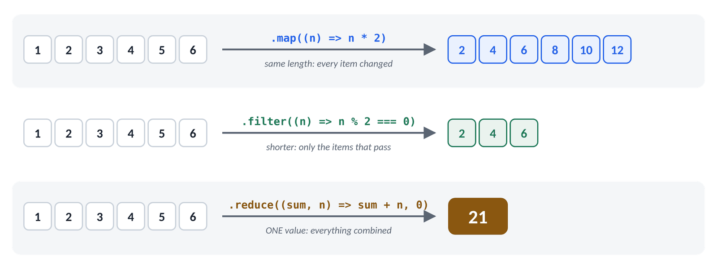
Figure 15.4 · The big three: map keeps the length, filter keeps some items, reduce makes one value
IN PLAIN WORDS
map is a machine on a conveyor belt. Every item goes in, a changed item comes out, and the belt never loses or adds an item: 3 in, 3 out.

JS · map with numbers and strings
const prices = [100, 250, 80];
const onSale = prices.map((price) => price - price / 10); // 10% off
console.log(onSale);
console.log(prices); // the original is unchanged

const names = ['rahim', 'nadia', 'tanvir'];
console.log(names.map((name) => name[0].toUpperCase() + name.slice(1)));
console.log(names.map((name, index) => `${index + 1}. ${name}`));
console.log(names.map((name) => name.length));
▶ CONSOLE OUTPUT
[90, 225, 72]
[100, 250, 80]
['Rahim', 'Nadia', 'Tanvir']
['1. rahim', '2. nadia', '3. tanvir']
[5, 5, 6]

JS · map over a list of objects (more on Day 16)
const students = [
{ name: 'Rahim', score: 72 },
{ name: 'Nadia', score: 91 },
{ name: 'Tanvir', score: 45 },
];
console.log(students.map((s) => s.name));
console.log(students.map((s) => `${s.name}: ${s.score >= 50 ? 'pass' : 'fail'}`));
▶ CONSOLE OUTPUT
['Rahim', 'Nadia', 'Tanvir']
['Rahim: pass', 'Nadia: pass', 'Tanvir: fail']

⇄ MORE WAYS Three ways to double every number
WAY 1 A for loop and push
const doubled = [];
for (const n of numbers) {
doubled.push(n * 2);
}
Works everywhere; you manage the new array yourself.
WAY 2 forEach and push
const doubled = [];
numbers.forEach((n) => doubled.push(n * 2));
A little shorter, same idea.
WAY 3 map
const doubled = numbers.map((n) => n * 2);
One line, and the variable can be const from the start. This is what professionals write.

The missing return
JS · the most common map bug
const broken = [1, 2, 3].map((n) => { n * 2 }); // braces, but no return
console.log(broken);
const fixed = [1, 2, 3].map((n) => { return n * 2; });
console.log(fixed);
const short = [1, 2, 3].map((n) => n * 2); // no braces: returned automatically
console.log(short);
▶ CONSOLE OUTPUT
[undefined, undefined, undefined]
[2, 4, 6]
[2, 4, 6]

WATCH OUT
map is for making a new array. If you only want to do something with each item (log it, add it to the page) and ignore the result, use forEach or for…of.

15.8 filter: keep some items
IN PLAIN WORDS
filter is a sieve. Each item is asked the callback's question; items that answer true fall through into the new array, the rest stay behind. The new array can be shorter, the same length, or empty, but its items are never changed.

JS · filter in five situations
const numbers = [1, 2, 3, 4, 5, 6];
console.log(numbers.filter((n) => n % 2 === 0)); // keep the evens
console.log(numbers.filter((n) => n > 10)); // nothing passes: an empty array

const scores = [72, 45, 91, 60, 88, 45];
console.log(scores.filter((s) => s >= 60).length); // how many passed?

const tags = ['js', '', 'css', null, 'html', undefined];
console.log(tags.filter(Boolean)); // drop empty/missing values

const cart = ['pen', 'book', 'lamp'];
console.log(cart.filter((item) => item !== 'book')); // remove by value
▶ CONSOLE OUTPUT
[2, 4, 6]
[]
4
['js', 'css', 'html']
['pen', 'lamp']

filter(Boolean) passes each item to Boolean(), which returns false for the falsy values from Day 10 ('', 0, null, undefined, NaN, false). It's a well-known shortcut for "remove the empty ones", but careful: it removes 0 too.
⇄ MORE WAYS Three ways to find the passing scores
WAY 1 filter
const passed = scores.filter((s) => s >= 50);
The clearest: it says exactly what it does.
WAY 2 A loop with if
const passed = [];
for (const s of scores) {
if (s >= 50) passed.push(s);
}
Longer, but you can add extra steps (e.g. count the fails at the same time).
WAY 3 reduce
const passed = scores.reduce(
(kept, s) => (s >= 50 ? [...kept, s] : kept), []);
Possible, but harder to read. Use reduce for one value, not for filtering.

15.9 reduce: combine everything into one value
IN PLAIN WORDS
reduce is a snowball rolling down a hill. It starts as the start value you give it, and at each item it picks up a little more. At the bottom you have one snowball: a total, a maximum, a count, or even a whole object.

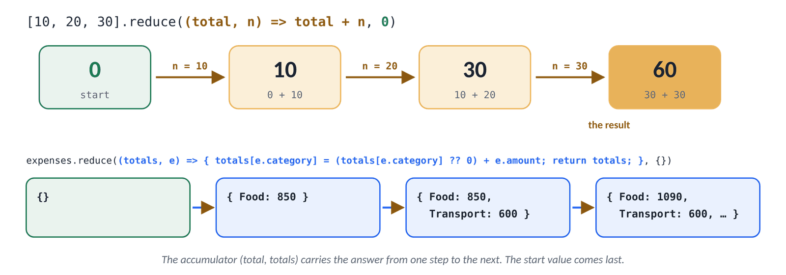
Figure 15.5 · reduce step by step: the accumulator carries the answer from one item to the next
Lap | sum (accumulator) | n (item) | The callback returns…
1 | 0 (the start value) | 10 | 0 + 10 → 10
2 | 10 | 20 | 10 + 20 → 30
3 | 30 | 30 | 30 + 30 → 60, the final result

JS · a sum, a maximum and a count
const numbers = [10, 20, 30];
const total = numbers.reduce((sum, n) => sum + n, 0); // (callback, start value)
console.log(total);

const biggest = numbers.reduce((best, n) => (n > best ? n : best), numbers[0]);
console.log(biggest);

const words = ['js', 'css', 'js', 'html', 'js'];
const counts = words.reduce((tally, word) => {
tally[word] = (tally[word] ?? 0) + 1; // 0 the first time we meet a word
return tally; // ALWAYS return the accumulator
}, {}); // start with an empty object
console.log(counts);

console.log([].reduce((sum, n) => sum + n, 0)); // empty array: the start value
▶ CONSOLE OUTPUT
60
30
{js: 3, css: 1, html: 1}
0

JS · what happens without a start value
[].reduce((sum, n) => sum + n); // no start value, nothing to start from
▶ CONSOLE OUTPUT
Uncaught TypeError: Reduce of empty array with no initial value

⇄ MORE WAYS Three ways to add up an array
WAY 1 for…of and a running total
let total = 0;
for (const n of numbers) {
total += n;
}
Easy to read and to debug with a breakpoint.
WAY 2 forEach
let total = 0;
numbers.forEach((n) => { total += n; });
The same idea as a callback.
WAY 3 reduce
const total = numbers.reduce((sum, n) => sum + n, 0);
One expression, and total can be const.

WATCH OUT
- Always give a start value (the second argument). Without it reduce uses the first item, which crashes on an empty array and gives wrong answers when you reduce objects.
- Always return the accumulator from the callback. Forget it and the next lap gets undefined.

15.10 Chaining: filter, then map, then reduce
Because filter and map return arrays, you can call the next method straight on the result. A chain reads like a recipe: one step per line, top to bottom.
JS · Exercise bonus: a chain, and a real-world one
const doubledEvensTotal = [1, 2, 3, 4, 5, 6]
.filter((n) => n % 2 === 0) // [2, 4, 6]
.map((n) => n * 2) // [4, 8, 12]
.reduce((sum, n) => sum + n, 0); // 24
console.log(doubledEvensTotal);

const results = [
{ name: 'Rahim', score: 72 },
{ name: 'Nadia', score: 91 },
{ name: 'Tanvir', score: 45 },
{ name: 'Mitu', score: 88 },
];
const honours = results
.filter((r) => r.score >= 80) // the top scorers
.map((r) => r.name) // just their names
.join(' and '); // one string
console.log(honours);
const average = results.reduce((sum, r) => sum + r.score, 0) / results.length;
console.log(average);
▶ CONSOLE OUTPUT
24
Nadia and Mitu
74

TIP
To debug a chain, split it into named steps (const evens = …; const doubled = …;) and log each one. Once it works, join it back into a chain if you like.

15.11 Sorting without surprises
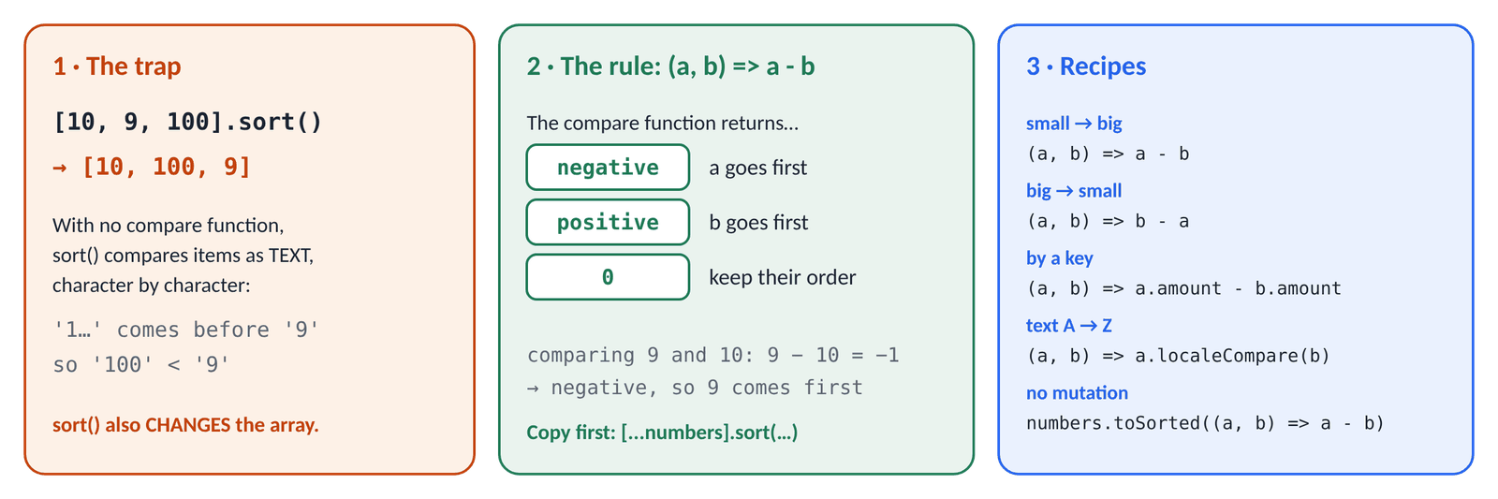
Figure 15.6 · Why [10, 9, 100].sort() goes wrong, the compare-function rule, and ready-made recipes
JS · numbers and text
console.log([10, 9, 100, 1].sort()); // ✗ compared as TEXT
console.log([10, 9, 100, 1].sort((a, b) => a - b)); // small → big
console.log([10, 9, 100, 1].sort((a, b) => b - a)); // big → small

const names = ['nadia', 'Rahim', 'Élodie', 'arif'];
console.log([...names].sort()); // capitals first, accents last
console.log([...names].sort((a, b) => a.localeCompare(b))); // like a dictionary
▶ CONSOLE OUTPUT
[1, 10, 100, 9]
[1, 9, 10, 100]
[100, 10, 9, 1]
['Rahim', 'arif', 'nadia', 'Élodie']
['arif', 'Élodie', 'nadia', 'Rahim']

With no compare function, sort turns every item into text and compares character by character, so '100' comes before '9' just as "apple" comes before "banana". The compare function fixes this: sort gives it two items, a and b, and looks only at the sign of the answer.
compare(a, b) returns | sort puts… | Example with (a, b) => a - b
a negative number | a first | 9 - 10 = -1 → 9 before 10
a positive number | b first | 100 - 9 = 91 → 9 before 100
0 | keeps their order | 5 - 5 = 0

JS · sorting objects by a key
const people = [
{ name: 'Nadia', age: 31 },
{ name: 'Arif', age: 24 },
{ name: 'Mitu', age: 28 },
];
const byAge = [...people].sort((a, b) => a.age - b.age); // copy, then sort
console.log(byAge.map((p) => p.name));
// toSorted() returns a sorted copy
const byName = people.toSorted((a, b) => a.name.localeCompare(b.name));
console.log(byName.map((p) => p.name));
console.log(people.map((p) => p.name)); // untouched
▶ CONSOLE OUTPUT
['Arif', 'Mitu', 'Nadia']
['Arif', 'Mitu', 'Nadia']
['Nadia', 'Arif', 'Mitu']

WATCH OUT
sort changes the original and returns that same array. const sorted = scores.sort(…) sorts scores too. Copy first with [...scores].sort(…), or use toSorted(…).

15.12 Spread, Set and other handy tools
JS · spread, Set, join, flat and reverse
const scores = [72, 45, 91];
console.log(Math.max(...scores), Math.min(...scores)); // spread items into arguments
console.log(Math.max(scores)); // ✗ the array is ONE argument

const morning = ['tea'];
const evening = ['rice', 'dal'];
console.log([...morning, 'lunch', ...evening]); // arrays + single items

console.log([...new Set(['js', 'css', 'js'])]); // remove duplicates
console.log(['2026', '10', '10'].join('-')); // array → string
console.log([[1, 2], [3, 4]].flat()); // flatten one level
console.log([1, 2, 3].reverse()); // changes the original!
▶ CONSOLE OUTPUT
91 45
NaN
['tea', 'lunch', 'rice', 'dal']
['js', 'css']
2026-10-10
[1, 2, 3, 4]
[3, 2, 1]

A Set keeps one of each value
JS · add, has and size
const seen = new Set();
seen.add('js');
seen.add('css');
seen.add('js'); // already there: ignored
console.log(seen.size, seen.has('css'), seen.has('php'));
console.log(seen);
console.log([...seen]); // back to an array
▶ CONSOLE OUTPUT
2 true false
Set(2) {'js', 'css'}
['js', 'css']

A Set answers "have I seen this before?" instantly, however big it is. That makes it the key tool for two of this week's LeetCode problems (Day 17 and, as a Map, Day 19).
More methods you'll meet | Example → result
join(sep) | ['a', 'b'].join(', ') → 'a, b'
concat() | [1].concat([2, 3]) → [1, 2, 3] (same as [...a, ...b])
flat() / flatMap() | [[1], [2]].flat() → [1, 2]
fill(value) | Array(3).fill('-') → ['-', '-', '-']
reverse() / toReversed() | reverse in place / a reversed copy
Array.isArray(x) | the reliable "is it an array?" test
at(i) | at(0) first, at(-1) last, at(-2) second to last

15.13 Practice: the 10 exercises
Open practice/arrays.html with Live Server and write each function in arrays-starter.js until every test prints PASS. Part 1 of arrays-solutions.js (A to E) repeats today's basics with tests; read it first and predict each result.
Function | Example | Use
1 · double(numbers) | [1, 2, 3] → [2, 4, 6] | map
2 · keepEvens(numbers) | [1…6] → [2, 4, 6] | filter and %
3 · sum(numbers) | [10, 20, 30] → 60; [] → 0 | reduce with a start value
4 · max(numbers) | scores → 91 | Math.max(...), reduce or a loop
5 · sortNumbers(numbers) | [10, 9, 100, 1] → [1, 9, 10, 100] | copy, then sort((a, b) => a - b)
6 · unique(items) | [1, 2, 2, 3, 1] → [1, 2, 3] | new Set, or filter + indexOf
7 · findFirstAbove(n, limit) | (scores, 80) → 91 | find
8 · anyFailed / allPassed | true / false | some / every
9 · countAbove(n, limit) | (scores, 60) → 3 | filter then .length
10 · topThree(numbers) | scores → [91, 88, 72] | copy, sort high → low, slice(0, 3)

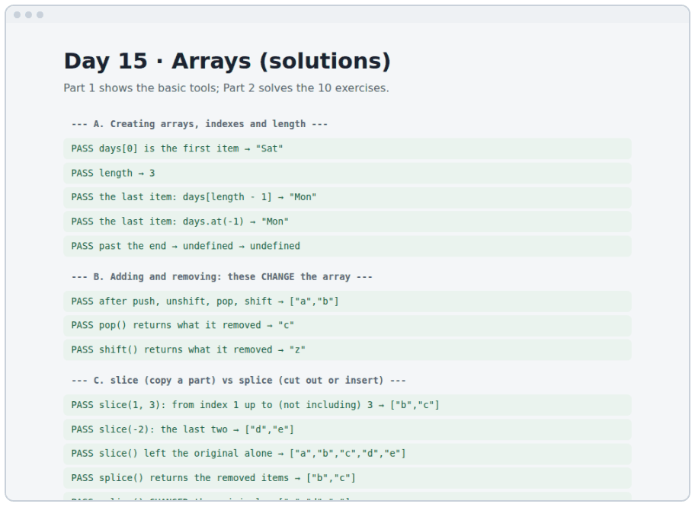
Figure 15.7 · practice/solutions.html: Part 1 of the solutions, every line a PASS
⇄ MORE WAYS Exercise 6 · two ways to remove duplicates
WAY 1 A Set
const unique = (items) => [...new Set(items)];
Short and fast. A Set keeps the first time it meets each value, so the order is kept too.
WAY 2 filter + indexOf
const unique = (items) =>
items.filter((item, index) => items.indexOf(item) === index);
Keeps an item only where it appears for the first time (its first index equals the current index). Slower on long lists, but a good logic exercise.

▶ CONSOLE OUTPUT · the goal: 15 × PASS in arrays.html
PASS double([1, 2, 3]) → [2,4,6]
PASS keepEvens([1…6]) → [2,4,6]
PASS sum([10, 20, 30]) → 60
PASS sum([]) → 0 → 0
…
PASS topThree(scores) → [91,88,72]
PASS scores still in the original order → [72,45,91,60,88,45]

15.14 Plan the three widgets, then build them without JavaScript
This week's output is one page with three widgets that almost every web app has: tabs, a modal dialog and a to-do list. Professionals plan before they code: what each widget does, which states it can be in, and what data it needs. Read widgets/plan.md, then write the HTML and CSS yourself.
Widget | Behaviour | States the CSS must show | Data (from Day 16/19)
Tabs | Click a tab (or press ← →) to show its panel | selected tab: aria-selected="true"; other panels: hidden | an array of track objects
Modal | A button opens a dialog; ×, Cancel, Escape or the backdrop close it | open / closed (built into <dialog>); a thank-you message | the form's fields: name, day
To-do | Add, tick and delete tasks; later filter and edit | done: .is-done (line-through); empty-list message | an array of { id, text, done } objects

HTML · widgets/index.html (Day 15): the tabs, written by hand
<div class="tabs" id="tracks">
<div class="tab-list" role="tablist" aria-label="Course tracks">
<button class="tab" type="button" role="tab" id="tab-frontend"
aria-selected="true" aria-controls="panel-frontend">Frontend</button>
<button class="tab" type="button" role="tab" id="tab-backend"
aria-selected="false" aria-controls="panel-backend"
tabindex="-1">Backend</button>
…
</div>
<div class="tab-panel" role="tabpanel" id="panel-frontend"
aria-labelledby="tab-frontend" tabindex="0">
<p class="panel-meta">Months 1–2</p>
<h3>Frontend</h3>
…
</div>
<div class="tab-panel" role="tabpanel" id="panel-backend"
aria-labelledby="tab-backend" tabindex="0" hidden>…</div>
</div>

Attribute | What it tells the browser and screen readers
role="tablist" / "tab" / "tabpanel" | These buttons are tabs, and these boxes are their panels
aria-selected="true" | This tab is the chosen one (the CSS styles it too)
aria-controls="panel-…" | Which panel this tab shows (JavaScript uses it on Day 17)
aria-labelledby="tab-…" | The panel's name is the text of its tab
tabindex="-1" on the other tabs | Only the selected tab is reached with Tab; arrows move between tabs (Day 18)
hidden | The panel is not shown and not read aloud

CSS · widgets/css/styles.css: every state has a style before any JavaScript exists
/* The selected tab: styled by the same attribute screen readers use */
.tab[aria-selected="true"] {
border-bottom-color: var(--color-primary);
color: var(--color-primary);
}

/* A finished task */
.todo-item.is-done .todo-text {
color: var(--color-muted);
text-decoration: line-through;
}

/* minmax(0, 1fr), not 1fr: stops the tab row from stretching the page on phones */
main { display: grid; grid-template-columns: minmax(0, 1fr); }

TIP
Test your states before writing JavaScript: in DevTools → Elements, double-click aria-selected="false" on a tab and change it to "true", or add the class is-done to a task. If it looks right, the CSS is ready, and tomorrow's scripts only have to switch attributes and classes.

15.15 DSA: LeetCode 1480, Running Sum of 1d Array
The problem. Given an array nums, return a new array where each item is the sum of all items up to and including that position. [1, 2, 3, 4] → [1, 3, 6, 10] (1, 1+2, 1+2+3, 1+2+3+4).
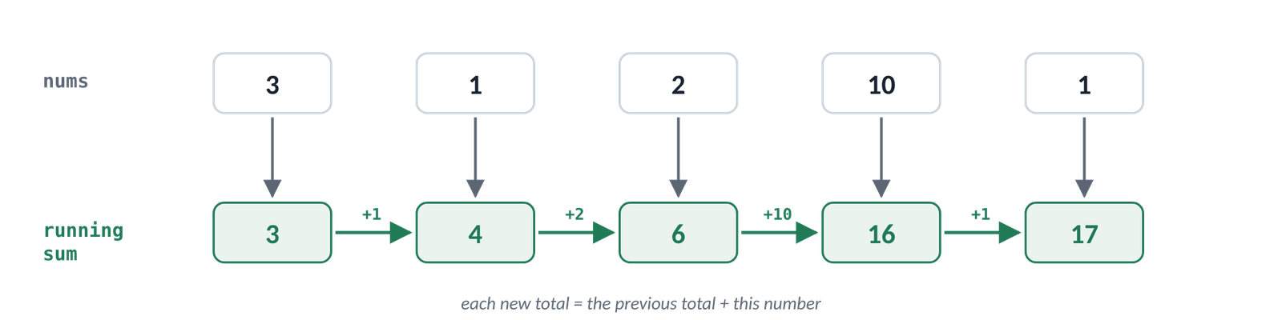
Figure 15.8 · Each new total is the previous total plus the current number
- Understand: the output has the same length as the input, and each item depends on the one before it.
- The slow idea: for each position, add up everything before it again. That repeats a lot of work.
- The key insight: keep a running total. Each step is just total += nums[i], then remember the total. You never re-add earlier numbers.
- Edge cases: one number → the same number; negative numbers work the same way.

⇄ MORE WAYS Running Sum three ways (dsa/1480-running-sum.js)
WAY 1 A new array and a running total
function runningSum(nums) {
const result = [];
let total = 0;
for (const n of nums) {
total += n;
result.push(total);
}
return result;
}
The clearest version. Time O(n), and O(n) extra space for the new array.
WAY 2 In place: each item adds the one before it
function runningSumInPlace(nums) {
for (let i = 1; i < nums.length; i++) {
nums[i] += nums[i - 1]; // nums[i - 1] already holds the sum up to i - 1
}
return nums;
}
No extra array: O(1) extra space. It mutates the input, which LeetCode allows but your own apps usually shouldn't.
WAY 3 map with a total outside the callback
function runningSumMap(nums) {
let total = 0;
return nums.map((n) => (total += n));
}
Short. It works because total += n is an expression whose value is the new total. Clever code is harder to read, so use it only when the team knows the trick.

▶ RESULT
runningSum([1, 2, 3, 4]) → [1, 3, 6, 10]
runningSum([1, 1, 1, 1, 1]) → [1, 2, 3, 4, 5]
runningSum([3, 1, 2, 10, 1]) → [3, 4, 6, 16, 17]

How fast? Each way visits every number once: O(n) time. The running-total idea (also called a prefix sum) comes back often, e.g. "the sum of any range of the array" becomes one subtraction once you have the prefix sums.
TIP
On LeetCode, choose JavaScript, paste the body into var runningSum = function(nums) { … };, then Run and Submit. Locally, open dsa/index.html with Live Server to see every test pass.

Build it, step by step
- Open practice/solutions.html with Live Server and the Console. Read Part 1 (A–E) of arrays-solutions.js, predicting each line before you look.
- Open practice/arrays.html and write the 10 functions in arrays-starter.js until all 15 tests pass.
- Stuck for 20 minutes on one? Read only that exercise in arrays-solutions.js, close it, and write it yourself.
- Read widgets/plan.md. Create widgets/index.html: the header, the tabs (four buttons and four panels), the modal button and the to-do form with three sample tasks.
- Write widgets/css/styles.css mobile-first. Style every state by hand in DevTools: a selected tab, a done task.
- Solve Running Sum of 1d Array on LeetCode, then compare with dsa/1480-running-sum.js.
- Commit: git commit -m "Day 15: array exercises and static widget markup" and push.

★ MUST KNOW the ideas to remember from today
- Indexes start at 0; the last item is length - 1 or at(-1).
- push/pop work on the end, unshift/shift on the start. All four change the array.
- slice copies a part; splice changes the original.
- const stops reassignment, not changes inside the array.
- map → same length, changed items. filter → some items. reduce → one value (give it a start value).
- find gives the first match or undefined; some/every give true/false.
- Numbers need sort((a, b) => a - b), and sort mutates: copy first or use toSorted.
- [...array] copies; [...new Set(array)] removes duplicates.

WATCH OUT
- Off-by-one: list[list.length] is always undefined.
- [10, 9, 100].sort() → [10, 100, 9]: sorted as text.
- A map callback with { } but no return gives [undefined, …].
- Using map when you don't use the new array (use forEach).
- reduce without a start value, or without returning the accumulator.
- const copy = original is not a copy.
- if (list.indexOf(x)) fails when x is at index 0; use includes.

QUESTIONS LEARNERS ASK
Q Which should I learn first: loops or map/filter/reduce?
Both, in that order. Loops show what happens step by step; the methods say the same thing in one line. When a method confuses you, rewrite it as a for…of loop.
Q Are array methods slower than loops?
A tiny bit, and it almost never matters. Write the clearest code first. Chaining three methods on 10 items is instant.
Q Why do so many methods take a function?
Because the method knows how to walk through the array, and only you know what to do with each item. That's the callback idea from Day 11.
Q What is _ in (_, index) => …?
A normal parameter name. By habit, _ means "I have to accept this value to get to the next one, but I don't use it".

More practice
MORE PRACTICE · try each one, then check the Answers at the back
- Given const fruits = ['mango', 'banana', 'lychee'], write code that prints 3 fruits: mango, banana, lychee.
- Make an array of the squares of 1 to 10 without typing them.
- From [' js', 'CSS ', ' Html'], make ['js', 'css', 'html'].
- Count how many words in 'the cat and the hat' have 3 letters.
- Find the longest word in ['grid', 'flexbox', 'css'].
- Write last(arr, n) that returns the last n items, e.g. last([1, 2, 3, 4], 2) → [3, 4].
- Move the first item of an array to the end, without mutating it: [1, 2, 3] → [2, 3, 1].
- Why does [1, 2, 3].includes('2') return false?

Check yourself
- What is the difference between slice and splice?
- Why does [10, 9, 100].sort() give [10, 100, 9], and how do you fix it?
- You need the total price of a cart. Which method would you use, and what start value?
Answer out loud before you turn to the Answers section at the back.
DONE WHEN · tick these off, then mark the day done in your Logbook
- All 15 tests in arrays.html pass with your own code
- The widgets page shows the three widgets, styled, with no JavaScript yet
- Running Sum accepted on LeetCode
- Committed and pushed

Resources
All free. Every name is a link, in Word and in the PDF.
Resource (click to open) | Use it for
javascript.info: Arrays  javascript.info/array | The basics, with tasks at the end
javascript.info: Array methods  javascript.info/array-methods | map, filter, reduce, sort and more, with 13 tasks
MDN: Array  developer.mozilla.org/en-US/docs/Web/JavaScript/Reference/Global_Objects/Array | The full list of methods; each page has live examples
MDN: Array.prototype.map()  developer.mozilla.org/en-US/docs/Web/JavaScript/Reference/Global_Objects/Array/map | map in detail
MDN: Array.prototype.reduce()  developer.mozilla.org/en-US/docs/Web/JavaScript/Reference/Global_Objects/Array/reduce | reduce, including grouping and counting
MDN: Array.prototype.sort()  developer.mozilla.org/en-US/docs/Web/JavaScript/Reference/Global_Objects/Array/sort | Compare functions, and sorting objects
MDN: Spread syntax (...)  developer.mozilla.org/en-US/docs/Web/JavaScript/Reference/Operators/Spread_syntax | Copying, joining and passing arrays as arguments
MDN: Set  developer.mozilla.org/en-US/docs/Web/JavaScript/Reference/Global_Objects/Set | add, has, delete, size
Does it mutate?  doesitmutate.xyz | Every array method, marked "mutates" or not
WAI-ARIA Authoring Practices: Tabs  w3.org/WAI/ARIA/apg/patterns/tabs | How accessible tabs should behave (the plan follows it)
LeetCode 1480: Running Sum of 1d Array  leetcode.com/problems/running-sum-of-1d-array | Today's problem

DAY  16 | WEEK 3 · SUNDAY 11 OCTOBER  Objects and JSON: modelling real data  Arrays hold lists; objects describe things. Together they can model almost anything.

TIME  3 hours | YOU BUILD  An objects demo, five expense functions, tabs built from data, and Richest Customer Wealth | CODE FOLDER  day16-objects

Today you will
- Describe a real thing as an object, and read values with dot and bracket notation
- Add, change and delete keys, and check whether a key exists
- Write methods, and explain what this means inside them
- Unpack values with destructuring, and copy or merge objects with spread
- Explain the difference between a reference and a copy, and make deep copies
- Loop over objects with Object.keys, Object.values and Object.entries
- Answer questions about an array of objects: totals, groups, sorting
- Turn data into text and back with JSON.stringify and JSON.parse
- Read nested data safely with ?. and ??
- Build the tabs from an array of objects instead of hand-written HTML
- Solve LeetCode 1672, Richest Customer Wealth, three ways

Key terms
Term | Meaning
Object | A group of named values: { name: 'Rahim', city: 'Dhaka' }
Key (property) | The name of a value in an object, like name
Value | What a key holds: any type, even an array, an object or a function
Method | A function stored as a value in an object: counter.increment()
this | Inside a method: the object the method was called on
Destructuring | Unpacking values into variables: const { name } = user
Spread / rest | ... unpacks (spread) or collects (rest) keys or items
Reference | A variable holds a link to an object, not the object itself
Shallow / deep copy | Copies only the outer object / copies every level inside it
JSON | A text format for data; how objects travel and get saved
Optional chaining (?.) | Reads a key only if the thing before it isn't null or undefined

16.1 What an object is
IN PLAIN WORDS
An object is a filled-in form. Every box has a label (the key) and an answer (the value). An array answers "what is item number 3?"; an object answers "what is the city?"

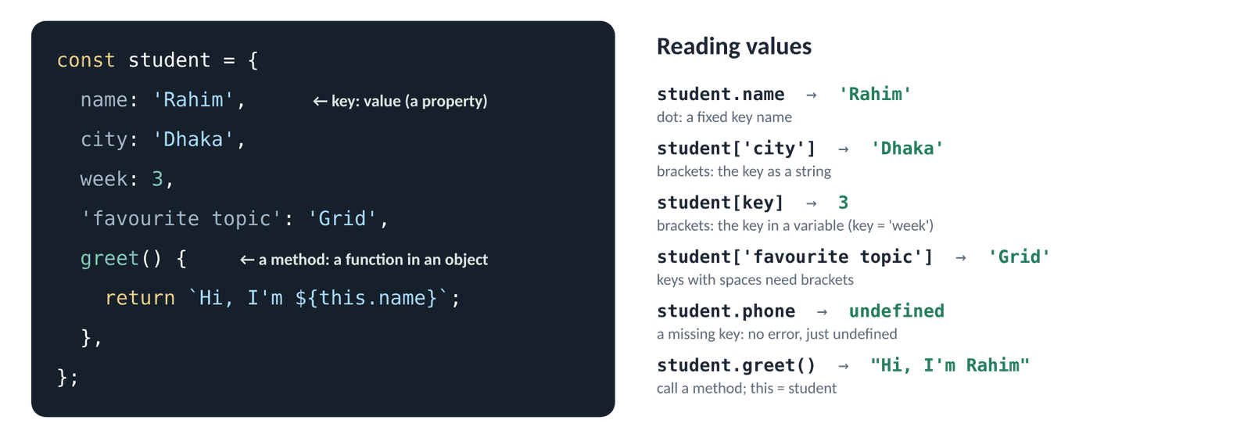
Figure 16.1 · An object literal (left) and the ways to read its values (right)
JS · an object with five keys
const student = {
name: 'Rahim', // key: value, then a comma
city: 'Dhaka',
week: 3,
skills: ['html', 'css'], // a value can be an array…
address: { area: 'Mirpur' }, // …or another object
};
console.log(student.name, student.week);
console.log(student.skills[1], student.address.area);
console.log(student);
▶ CONSOLE OUTPUT
Rahim 3
css Mirpur
{name: 'Rahim', city: 'Dhaka', week: 3, skills: Array(2), address: {…}}

The last line is how Chrome shows an object before you open it: arrays inside become Array(2) and objects inside become {…}. Click the small triangle (▸) to see everything.
 | Array | Object
Holds | an ordered list of similar things | named facts about one thing
You ask | "what is the 3rd item?" | "what is the city?"
Brackets | [ ] | { }
Example | ['Sat', 'Sun', 'Mon'] | { name: 'Rahim', city: 'Dhaka' }
In an app | the list of expenses | one expense

TIP
You've used objects since Day 10 without knowing it: console.log is the log method of the console object, and Math.max is the max method of Math.

16.2 Reading values: dot or brackets
JS · Part A of objects-demo.js
const student = {
name: 'Rahim', city: 'Dhaka', week: 3, 'favourite topic': 'CSS Grid',
};
console.log(student.name); // dot: you know the key
console.log(student['city']); // brackets: the key as a string
const key = 'week';
console.log(student[key]); // brackets: the key is in a variable
console.log(student.key); // ✗ looks for a key called "key"
console.log(student['favourite topic']); // brackets: a key with a space
console.log(student.phone); // a missing key: undefined, no error
▶ CONSOLE OUTPUT
Rahim
Dhaka
3
undefined
CSS Grid
undefined

Use | When
obj.key | You know the key while writing the code, and it's a normal name (your default)
obj['key'] | The key has spaces or dashes, or starts with a digit
obj[variable] | The key is only known when the code runs: from a loop, a click, a form field

A lookup object instead of if / else
JS · brackets with a variable
const dayNames = { sat: 'Saturday', sun: 'Sunday', mon: 'Monday' };
const short = 'sun';
console.log(dayNames[short]);

const prices = { tea: 20, coffee: 60 };
for (const drink of ['tea', 'coffee', 'juice']) {
console.log(drink, prices[drink] ?? 'not on the menu');
}
▶ CONSOLE OUTPUT
Sunday
tea 20
coffee 60
juice not on the menu

A lookup object replaces a long if / else if or switch: the key is the question, the value is the answer. On Day 20 the tabs use one to map key names to moves, and the to-do list uses one for its filters.

16.3 Changing, adding and deleting keys
JS · Part B: objects can grow and shrink
const course = { title: 'Full-stack', weeks: 26 };
course.weeks = 27; // change
course.language = 'JavaScript'; // add: just assign a new key
course['start date'] = '2026-09-26'; // add, with brackets
delete course.language; // remove
console.log(course);
console.log('weeks' in course, 'language' in course);
console.log(Object.hasOwn(course, 'title'));
console.log(Object.keys(course).length); // how many keys
▶ CONSOLE OUTPUT
{title: 'Full-stack', weeks: 27, 'start date': '2026-09-26'}
true false
true
3

⇄ MORE WAYS Three ways to check whether a key exists
WAY 1 The in operator
'email' in user
Short and clear. Also finds keys an object inherits (rarely matters for plain data).
WAY 2 Object.hasOwn()
Object.hasOwn(user, 'email')
Only the object's own keys. The strictest check.
WAY 3 Compare with undefined
user.email !== undefined
Common, but wrong if a key exists and its value is undefined on purpose.

WATCH OUT
A const object can still change inside, like a const array (15.1). const only stops you pointing the name at a different object. Object.freeze(obj) stops changes to the top level, if you ever need that.

16.4 Methods and this
JS · Part C: a method changes its own object
const counter = {
count: 0,
increment() { // a method: a function stored in the object
this.count++; // this = the object before the dot
return this.count;
},
describe() {
return `The count is ${this.count}`;
},
};
counter.increment();
counter.increment();
console.log(counter.count);
console.log(counter.describe());
▶ CONSOLE OUTPUT
2
The count is 2

When you call counter.increment(), JavaScript sets this to the object before the dot, here counter. That's how one method can work with its own object's data.
⇄ MORE WAYS Three ways to write a method, and one that doesn't work
WAY 1 Method shorthand (use this)
const user = {
name: 'Nadia',
greet() { return `Hi, I'm ${this.name}`; },
};
Short, and this works.
WAY 2 A function expression
const user = {
name: 'Nadia',
greet: function () { return `Hi, I'm ${this.name}`; },
};
The older spelling of the same thing.
WAY 3 ✗ An arrow function
const user = {
name: 'Nadia',
greet: () => `Hi, I'm ${this.name}`, // this is NOT user here
};
Arrow functions don't get their own this, so this.name is not 'Nadia'. Use arrows for callbacks, and shorthand for methods.

WATCH OUT
this depends on how a function is called, not where it was written. const inc = counter.increment; inc(); loses the object before the dot, so this is no longer counter. When a method is passed as a callback, wrap it: button.addEventListener('click', () => counter.increment()).

16.5 Shorthand keys and computed keys
JS · Part D, and computed keys
const title = 'Laptop stand';
const price = 1800;
const product = { title, price }; // same as { title: title, price: price }
console.log(product);

const field = 'colour';
const choice = { [field]: 'black' }; // [ ] around a key: use the variable's VALUE
console.log(choice);
▶ CONSOLE OUTPUT
{title: 'Laptop stand', price: 1800}
{colour: 'black'}

Shorthand is everywhere in modern code, e.g. todos.push({ id, text, done: false }) on Day 19. Computed keys are handy for forms: { [input.name]: input.value } turns any field into a key and value.

16.6 Destructuring: unpack values into variables
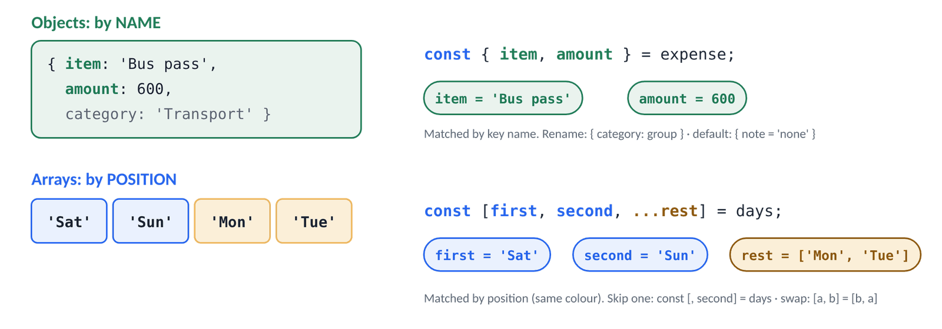
Figure 16.2 · Objects are unpacked by name; arrays are unpacked by position
JS · Part E: objects by name, arrays by position
const expense = { item: 'Bus pass', amount: 600, category: 'Transport' };
const { item, amount } = expense; // pick keys by name
const { category: group } = expense; // rename: category → group
const { note = 'no note' } = expense; // a default for a missing key
console.log(item, amount, group, note);

const [first, second, ...others] = ['Sat', 'Sun', 'Mon', 'Tue']; // by position
console.log(first, second, others);
const [, , third] = ['Sat', 'Sun', 'Mon']; // skip items with commas
console.log(third);

let a = 1;
let b = 2;
[a, b] = [b, a]; // swap two variables in one line
console.log(a, b);
▶ CONSOLE OUTPUT
Bus pass 600 Transport no note
Sat Sun ['Mon', 'Tue']
Mon
2 1

JS · destructuring in parameters, nested objects and loops
function describe({ name, city = 'somewhere' }) { // destructure the argument
return `${name} from ${city}`;
}
console.log(describe({ name: 'Nadia', city: 'Sylhet' }));
console.log(describe({ name: 'Arif' }));

const user = { id: 7, profile: { name: 'Mitu', age: 28 } };
const { profile: { name, age } } = user; // reach inside a nested object
console.log(name, age);

const bills = [{ title: 'Tea', cost: 20 }, { title: 'Bus', cost: 40 }];
for (const { title, cost } of bills) { // destructure in a loop
console.log(title, cost);
}
▶ CONSOLE OUTPUT
Nadia from Sylhet
Arif from somewhere
Mitu 28
Tea 20
Bus 40

⇄ MORE WAYS Three ways to get values out of an object
WAY 1 Dots, one by one
const item = expense.item;
const amount = expense.amount;
Clear, but repetitive when you need several keys.
WAY 2 Destructuring
const { item, amount } = expense;
One line for many keys; the variable names match the keys.
WAY 3 Destructuring in the parameter
function show({ item, amount }) {
return `${item}: ৳${amount}`;
}
show(expense);
The function says exactly which keys it needs. On Day 20 setupModal({ openButton, dialog, status }) works like this, so the order of the arguments never matters.

16.7 Spread and rest: three dots, two jobs
JS · Part F: merge, copy-and-change, remove a key, collect arguments
const defaults = { theme: 'light', language: 'en', fontSize: 16 };
const saved = { theme: 'dark' };
const settings = { ...defaults, ...saved }; // merge: later keys win
console.log(settings);
console.log(defaults.theme); // untouched

const updated = { ...settings, fontSize: 18 }; // copy, then change one key
console.log(updated.fontSize, settings.fontSize);

const { language, ...withoutLanguage } = settings; // rest: "all other keys"
console.log(withoutLanguage);

function total(...numbers) { // rest parameter: any number of arguments
return numbers.reduce((sum, n) => sum + n, 0);
}
console.log(total(1, 2, 3), total(10, 20), total());
▶ CONSOLE OUTPUT
{theme: 'dark', language: 'en', fontSize: 16}
light
18 16
{theme: 'dark', fontSize: 16}
6 30 0

 | Spread: unpacks | Rest: collects
Where | on the right of =, or in a call | on the left of =, or in a parameter list
Objects | { ...a, key: 1 } copies a's keys | const { id, ...others } = a
Arrays | [...list, 4], Math.max(...list) | const [first, ...rest] = list
Functions | add(...pair) | function add(...numbers) {}

⇄ MORE WAYS Three ways to copy an object
WAY 1 Spread
const copy = { ...original };
The usual way. Add keys after it to change them: { ...original, done: true }.
WAY 2 Object.assign()
const copy = Object.assign({}, original);
The older way; you'll see it in older code and libraries.
WAY 3 structuredClone(): a deep copy
const copy = structuredClone(original);
Copies arrays and objects inside it too (16.8). Built into every current browser.

16.8 References and copies
IN PLAIN WORDS
A variable doesn't hold an object; it holds a remote control for it. const b = a hands you a second remote for the same TV: press "volume up" on either and the one TV gets louder. A copy is a second TV.

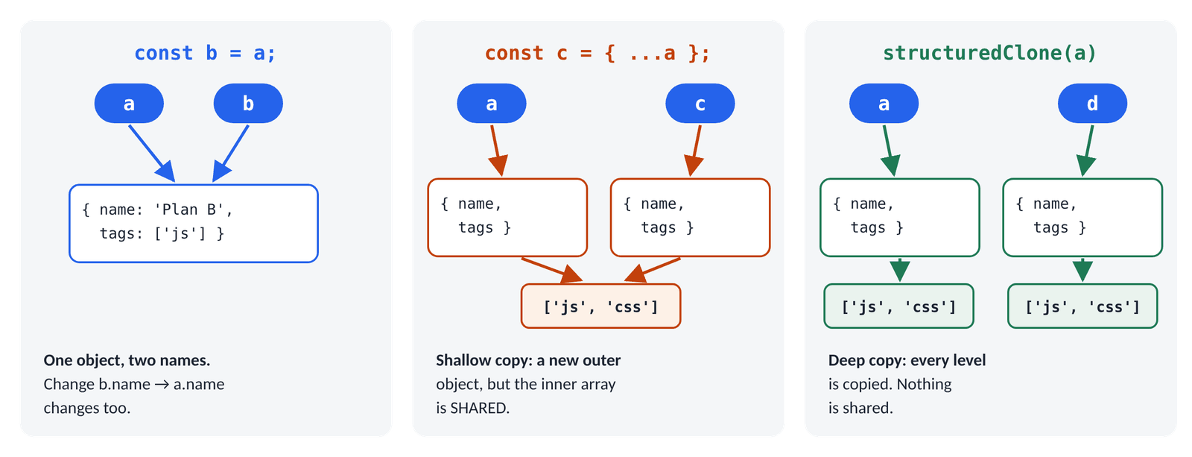
Figure 16.3 · Two names for one object, a shallow copy that still shares the inner array, and a deep copy
JS · Part G: values are copied, objects are shared
let x = 5;
let y = x; // numbers, strings and booleans are COPIED
y = 10;
console.log(x, y);

const original = { name: 'Plan A', tags: ['js'] };
const sameObject = original; // NOT a copy: two names, ONE object
sameObject.name = 'Plan B';
console.log(original.name);
console.log({ n: 1 } === { n: 1 }); // two objects, even if they look alike
console.log(original === sameObject); // the same object

const shallow = { ...original }; // a new outer object…
shallow.tags.push('css'); // …but tags is still SHARED
console.log(original.tags);

const deep = structuredClone(original); // copies every level
deep.tags.push('html');
console.log(original.tags, deep.tags);
▶ CONSOLE OUTPUT
5 10
Plan B
false
true
['js', 'css']
['js', 'css'] ['js', 'css', 'html']

Kind of value | let b = a gives… | Compared with ===
number, string, boolean, null, undefined | an independent copy | by value: 'hi' === 'hi' is true
object, array, function | a second name for the same thing | by identity: only the same object is ===

TIP
To compare two objects by their content, compare their JSON: JSON.stringify(a) === JSON.stringify(b). That's exactly what the test() helper in this week's practice files does. It works for simple data whose keys are in the same order.

16.9 Looping over an object
JS · Part H: keys, values and entries turn an object into arrays
const prices = { tea: 20, coffee: 60, juice: 45 };
console.log(Object.keys(prices)); // the keys, as an array
console.log(Object.values(prices)); // the values
console.log(Object.entries(prices)[0]); // [key, value] pairs; the first one

for (const [drink, cost] of Object.entries(prices)) { // destructure each pair
console.log(`${drink} costs ৳${cost}`);
}
const total = Object.values(prices).reduce((sum, p) => sum + p, 0);
console.log(total);
const cheap = Object.keys(prices).filter((drink) => prices[drink] < 50);
console.log(cheap);
const doubled = Object.fromEntries(
Object.entries(prices).map(([drink, cost]) => [drink, cost * 2]),
);
console.log(doubled);
▶ CONSOLE OUTPUT
['tea', 'coffee', 'juice']
[20, 60, 45]
['tea', 20]
tea costs ৳20
coffee costs ৳60
juice costs ৳45
125
['tea', 'juice']
{tea: 40, coffee: 120, juice: 90}

The trick: Object.keys, values and entries turn an object into an array, and then every array method from Day 15 works. Object.fromEntries turns [key, value] pairs back into an object.
⇄ MORE WAYS Three ways to loop over an object
WAY 1 for…of + Object.entries (use this)
for (const [key, value] of Object.entries(obj)) {
console.log(key, value);
}
Key and value together, and break works.
WAY 2 Object.keys + brackets
Object.keys(obj).forEach((key) => {
console.log(key, obj[key]);
});
Fine when you mostly need the keys.
WAY 3 for…in (older)
for (const key in obj) {
console.log(key, obj[key]);
}
Works on plain objects, but also visits inherited keys. You'll see it in older code.

16.10 Arrays of objects: the shape of real data
Real apps store lists of records: expenses, tasks, users, products. Each record is an object and every object has the same shape (the same keys). Think of it as a table: each object is a row, each key is a column. Open practice/expenses.html; these are the five expenses:
JS · practice/expenses-solutions.js: the data
const expenses = [
{ id: 1, title: 'Rice and lentils', amount: 850,
category: 'Food', date: '2026-09-28' },
{ id: 2, title: 'Bus pass', amount: 600,
category: 'Transport', date: '2026-10-01' },
{ id: 3, title: 'Internet bill', amount: 1200,
category: 'Bills', date: '2026-10-03' },
{ id: 4, title: 'Tea and snacks', amount: 240,
category: 'Food', date: '2026-10-05' },
{ id: 5, title: 'Online course', amount: 1500,
category: 'Learning', date: '2026-09-15' },
];
console.table(expenses); // the Console shows them as a table

(index) | id | title | amount | category | date
0 | 1 | Rice and lentils | 850 | Food | 2026-09-28
1 | 2 | Bus pass | 600 | Transport | 2026-10-01
2 | 3 | Internet bill | 1200 | Bills | 2026-10-03
3 | 4 | Tea and snacks | 240 | Food | 2026-10-05
4 | 5 | Online course | 1500 | Learning | 2026-09-15

JS · questions you can now ask the data
console.log(expenses.length, expenses[1].title);
console.log(expenses.find((e) => e.id === 3).title); // one by id
console.log(expenses.filter((e) => e.category === 'Food').map((e) => e.title));
console.log(expenses.some((e) => e.amount > 1000));
console.log(expenses.map((e) => e.amount));
▶ CONSOLE OUTPUT
5 Bus pass
Internet bill
['Rice and lentils', 'Tea and snacks']
true
[850, 600, 1200, 240, 1500]

Now the five functions of today's practice, a preview of Project 1. Each is pure: it takes the list, returns an answer, and never changes the list.
JS · Exercise 1 · totalAmount(list)
const totalAmount = (list) => list.reduce((total, e) => total + e.amount, 0);
console.log(totalAmount(expenses));
▶ CONSOLE OUTPUT
4390

JS · Exercise 2 · totalsByCategory(list): reduce into an object
function totalsByCategory(list) {
return list.reduce((totals, { category, amount }) => {
totals[category] = (totals[category] ?? 0) + amount; // 0 the first time
return totals;
}, {});
}
console.log(totalsByCategory(expenses));
▶ CONSOLE OUTPUT
{Food: 1090, Transport: 600, Bills: 1200, Learning: 1500}

The bottom half of Figure 15.5 shows this reduce step by step: the accumulator starts as {} and gains one key the first time each category appears.
JS · Exercise 3 · sortByAmount(list, direction)
function sortByAmount(list, direction = 'desc') {
const sorted = [...list].sort((a, b) => a.amount - b.amount); // copy, small → big
return direction === 'desc' ? sorted.reverse() : sorted;
}
console.log(sortByAmount(expenses).map((e) => e.amount));
console.log(sortByAmount(expenses, 'asc')[0].title);
console.log(expenses[0].id); // the original order is untouched
▶ CONSOLE OUTPUT
[1500, 1200, 850, 600, 240]
Tea and snacks
1

JS · Exercise 4 · groupByMonth(list)
function groupByMonth(list) {
const groups = {};
for (const expense of list) {
const month = expense.date.slice(0, 7); // '2026-09-28' → '2026-09'
if (!groups[month]) groups[month] = []; // the first one of that month
groups[month].push(expense);
}
return groups;
}
const byMonth = groupByMonth(expenses);
console.log(Object.keys(byMonth));
console.log(byMonth['2026-09'].map((e) => e.id));
console.log(totalAmount(byMonth['2026-10']));
▶ CONSOLE OUTPUT
['2026-09', '2026-10']
[1, 5]
2040

⇄ MORE WAYS Three ways to group a list
WAY 1 A loop and an object (above)
const groups = {};
for (const e of list) {
(groups[e.category] ??= []).push(e);
}
??= assigns only if the key is still empty: a shortcut for the if line above.
WAY 2 reduce
const groups = list.reduce((acc, e) => {
(acc[e.category] ??= []).push(e);
return acc;
}, {});
The same logic as one expression.
WAY 3 Object.groupBy() (2024)
const groups = Object.groupBy(list, (e) => e.category);
Built in to all current browsers since 2024. Knowing how to write it yourself still matters: it's a common interview task.

JS · Exercise 5 · formatTaka(amount) and a summary line
const formatTaka = (amount) => `৳${amount.toLocaleString('en-IN')}`;
console.log(formatTaka(4390));
console.log(formatTaka(125000)); // Indian grouping: 1,25,000
const [biggest] = sortByAmount(expenses); // destructure the first item
console.log(`Biggest expense: ${biggest.title} (${formatTaka(biggest.amount)})`);
▶ CONSOLE OUTPUT
৳4,390
৳1,25,000
Biggest expense: Online course (৳1,500)

⇄ MORE WAYS Two ways to format money
WAY 1 toLocaleString
(125000).toLocaleString('en-IN') // '1,25,000'
Groups the digits the way people in Bangladesh and India read them (lakh, crore). Add the ৳ sign yourself.
WAY 2 Intl.NumberFormat
new Intl.NumberFormat('en-IN',
{ style: 'currency', currency: 'BDT' }).format(4390) // 'BDT 4,390.00'
Full currency formatting, including decimals. With the bn-BD locale it even uses Bengali digits. You'll use this in Project 1.

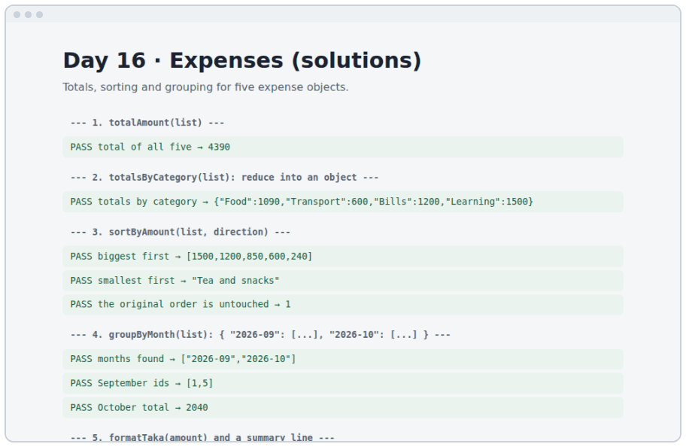
Figure 16.4 · practice/expenses-solutions.html: all five functions, tested

16.11 JSON: data as text
Objects live in your program's memory. To save them (in localStorage, Day 19) or send them (to a server, Month 3) they must become text. JSON (JavaScript Object Notation) is that text format, and every language can read it.
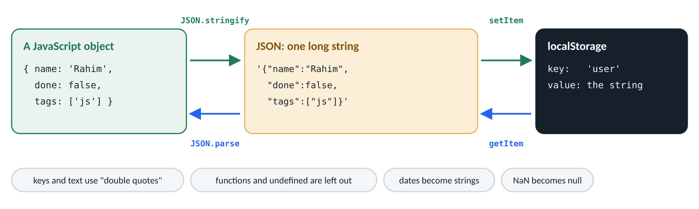
Figure 16.5 · stringify turns an object into a string; parse turns it back into a new object
JS · Part I: stringify and parse
const task = { name: 'Rahim', done: false, tags: ['js'] };
const text = JSON.stringify(task); // object → string
console.log(text);
console.log(typeof text);
const back = JSON.parse(text); // string → a NEW object
console.log(back.tags[0], back === task);
console.log(JSON.stringify(task, null, 2)); // pretty-printed, 2 spaces
▶ CONSOLE OUTPUT
{"name":"Rahim","done":false,"tags":["js"]}
string
js false
{
"name": "Rahim",
"done": false,
"tags": [
"js"
]
}

JSON rule | Example
Keys and strings use double quotes | {"name": "Rahim"}, never {name: 'Rahim'}
Allowed values | strings, numbers, true/false, null, arrays, objects
No functions, no undefined | they are left out of objects
Dates become strings | "1970-01-01T00:00:00.000Z": convert back yourself
NaN and Infinity become null | check numbers before saving
No comments, no trailing commas | [1, 2,] is not valid JSON

JS · what JSON can't hold, and reading broken JSON safely
const odd = { when: new Date(0), say() {}, missing: undefined, bad: NaN };
console.log(JSON.stringify(odd));

try {
JSON.parse("{ name: 'Rahim' }"); // ✗ JSON needs "double quotes"
} catch (error) {
console.log('Could not read it:', error.name);
}
▶ CONSOLE OUTPUT
{"when":"1970-01-01T00:00:00.000Z","bad":null}
Could not read it: SyntaxError

try { … } catch (error) { … } runs the try part; if anything in it throws an error, JavaScript jumps to catch instead of crashing the whole script. Always wrap JSON.parse of saved data like this, because saved text can be broken. Day 20's storage module does exactly that.
TIP
In the Console, copy(JSON.stringify(data, null, 2)) copies any data to your clipboard as nicely formatted JSON. Handy for bug reports and tests.

16.12 Reading nested data safely: ?. and ??
JS · optional chaining and the nullish operator
const user = { profile: { address: null }, settings: { volume: 0 } };
console.log(user.profile.address?.city); // stops at null: undefined
console.log(user.billing?.plan); // missing object: undefined
console.log(user.settings.volume ?? 50); // ?? keeps 0
console.log(user.settings.volume || 50); // || replaces 0
console.log(user.greet?.()); // call it only if it exists
console.log(user.billing.plan); // ✗ without ?.
▶ CONSOLE OUTPUT
undefined
undefined
0
50
undefined
Uncaught TypeError: Cannot read properties of undefined (reading 'plan')

Write | Means | Gives, if the left side is null/undefined
a?.b | read key b, if a exists | undefined (no crash)
a?.[key] | the same, with brackets | undefined
a.fn?.() | call fn, if it exists | undefined
a ?? b | a, unless a is null/undefined | b
a ??= b | give a the value b only if a is null/undefined | (a becomes b)

WATCH OUT
Don't put ?. everywhere "just in case". It hides real bugs: if user should always exist, a crash tells you something is wrong. Use ?. where a value is allowed to be missing, like data from a form, a server or localStorage.

16.13 The tabs, built from data
Yesterday the four tabs were written by hand in the HTML. Today their content moves into an array of objects, and one function builds the buttons and panels from it. Want a fifth tab? Add one object. No HTML changes.
JS · widgets/js/main.js (Day 16), section 1: the data (shortened)
const tracks = [
{
id: 'frontend',
title: 'Frontend',
months: 'Months 1–2',
summary: 'Build interfaces people enjoy using, from the first HTML tag to …',
topics: ['Semantic HTML and CSS', 'JavaScript and the DOM', 'TypeScript', …],
},
{ id: 'backend', title: 'Backend', months: 'Month 3', /* … */ },
// … databases and deploy
];

JS · section 2: build one tab and one panel per object (shortened)
function renderTabs(root, items) {
const list = root.querySelector('.tab-list');
const panels = root.querySelector('.tab-panels');

items.forEach((item, index) => {
const isFirst = index === 0;

const tab = document.createElement('button'); // a new <button>, off the page
tab.className = 'tab';
tab.id = `tab-${item.id}`; // the ids come from the data
tab.textContent = item.title;
tab.setAttribute('role', 'tab');
tab.setAttribute('aria-selected', String(isFirst));
tab.setAttribute('aria-controls', `panel-${item.id}`);
if (!isFirst) tab.tabIndex = -1;
list.append(tab); // now it's on the page

const panel = document.createElement('div');
panel.id = `panel-${item.id}`;
panel.hidden = !isFirst; // only the first panel shows
// … the meta line, heading, summary and the topics (map → <li>)
panels.append(panel);
});
}

renderTabs(document.getElementById('tracks'), tracks);

Some of these lines are tomorrow's topic (the DOM). For today, focus on the data side: one object per tab, forEach over the array, the index decides which tab starts selected, and every id is built from item.id with a template literal.
 | Day 15: HTML by hand | Day 16: built from data
Add a tab | copy 15 lines of HTML, change 8 ids | add one object to tracks
Typos in ids | easy to make, hard to spot | impossible: ids come from one field
Content from a server later | rewrite the HTML | replace the array; nothing else changes
Works without JavaScript | yes | no (fine for an app; a trade-off to know)

⇄ MORE WAYS Three ways to turn the topics array into <li> items
WAY 1 map to elements, then append them all
topicList.append(...item.topics.map((topic) => {
const li = document.createElement('li');
li.textContent = topic;
return li;
}));
What the widget does: map makes the elements, spread passes them to append.
WAY 2 forEach and append one by one
item.topics.forEach((topic) => {
const li = document.createElement('li');
li.textContent = topic;
topicList.append(li);
});
The same result; maybe easier to read at first.
WAY 3 innerHTML with map and join
topicList.innerHTML = item.topics
.map((topic) => `<li>${topic}</li>`)
.join('');
Short. Only safe for text you wrote, never for text a visitor typed (Day 17 shows why).

16.14 DSA: LeetCode 1672, Richest Customer Wealth
The problem. accounts[i][j] is the money customer i has in bank j. A customer's wealth is the sum of their row. Return the largest wealth. [[1, 5], [7, 3], [3, 5]] → 10 (the second customer: 7 + 3).
- Understand: an array of arrays is a table. Each inner array is one customer (a row).
- Plan: for each row, add up its numbers; keep the biggest total seen so far.
- Two loops: an outer loop over customers, an inner loop over that customer's banks.
- Edge cases: one customer; several customers with the same wealth (return the number, not who).

Customer (row) | Sum of the row | Wealth | Richest so far
[1, 5] | 1 + 5 | 6 | 6
[7, 3] | 7 + 3 | 10 | 10
[3, 5] | 3 + 5 | 8 | 10

⇄ MORE WAYS Richest Customer Wealth three ways (dsa/1672-richest-customer-wealth.js)
WAY 1 Two loops
function maximumWealth(accounts) {
let richest = 0;
for (const customer of accounts) {
let wealth = 0;
for (const money of customer) {
wealth += money;
}
if (wealth > richest) richest = wealth;
}
return richest;
}
The clearest. Time O(rows × columns): every number is visited once.
WAY 2 map each row to its sum, then Math.max
function maximumWealthMap(accounts) {
const wealths = accounts.map((customer) =>
customer.reduce((sum, money) => sum + money, 0));
return Math.max(...wealths);
}
Two clear steps: "sum every row", then "take the biggest". Uses an extra array of sums.
WAY 3 One reduce that keeps the maximum
function maximumWealthReduce(accounts) {
return accounts.reduce((richest, customer) => {
const wealth = customer.reduce((sum, money) => sum + money, 0);
return Math.max(richest, wealth);
}, 0);
}
No extra array. A reduce inside a reduce: read the inner one first.

▶ RESULT
maximumWealth([[1, 2, 3], [3, 2, 1]]) → 6
maximumWealth([[1, 5], [7, 3], [3, 5]]) → 10
maximumWealth([[2, 8, 7], [7, 1, 3], [1, 9, 5]]) → 17

How fast? Every number is added once, so the work grows with the total number of cells: O(m × n) for m customers and n banks. You can't do better, because you must look at every number at least once.

Build it, step by step
- Open practice/objects.html and read objects-demo.js part by part (A–I). Predict every PASS line before you read it.
- Open practice/expenses.html and write the five functions in expenses-starter.js until every test passes.
- In the widgets, move the tab content into a tracks array of objects and empty the tabs in the HTML.
- Write renderTabs(root, items) and call it. The page should look exactly like yesterday's.
- Add a fifth track object as a test, check it appears, then remove it.
- Solve Richest Customer Wealth, then compare with dsa/1672-richest-customer-wealth.js.
- Commit: git commit -m "Day 16: objects, expense utilities and data-driven tabs" and push.

★ MUST KNOW the ideas to remember from today
- Dot for known keys; brackets for keys in variables or with spaces.
- A missing key gives undefined; in and Object.hasOwn check whether a key exists.
- In a method, this is the object before the dot. Don't write methods as arrow functions.
- Destructuring: objects by name { a, b }, arrays by position [x, y].
- { ...obj, key: value } copies and changes one key without touching the original.
- const b = a shares the object. Spread is a shallow copy; structuredClone is deep.
- Object.keys / values / entries turn objects into arrays; fromEntries goes back.
- JSON.stringify → string, JSON.parse → new object. Wrap parse in try/catch.

WATCH OUT
- obj.key when you meant obj[key] (a variable).
- Arrow functions as methods: this isn't the object.
- Thinking { ...a } copies the arrays inside a: it doesn't.
- Comparing objects with === to check their content.
- Forgetting return totals in a reduce that builds an object.
- JSON with single quotes or trailing commas.
- Using ?. everywhere and hiding real bugs.

QUESTIONS LEARNERS ASK
Q Can a key be a number?
You can write { 1: 'a' }, but keys are always stored as strings: Object.keys({ 1: 'a' }) is ['1']. For keys of any type, JavaScript has Map (Day 19).
Q What order are keys in?
Normal text keys stay in the order you added them. Keys that look like whole numbers come first, sorted. Don't rely on order for logic; use an array when order matters.
Q Is JSON the same as a JavaScript object?
No. JSON is text that looks like an object literal, with stricter rules. JSON.parse turns the text into a real object.
Q When do I need a deep copy?
When the object has arrays or objects inside it and you will change those inner values in the copy. For flat objects, spread is enough.

More practice
MORE PRACTICE · try each one, then check the Answers at the back
- Create an object book with a title, an author, a year and a method age() that returns how many years old it is in 2026.
- Given const scores = { math: 80, english: 72, physics: 91 }, find the subject with the highest score.
- Swap the keys and values of { a: 1, b: 2 } to get { 1: 'a', 2: 'b' }.
- Remove the password key from a user object without changing the original.
- Count how many expenses each category has: { Food: 2, Transport: 1, … }.
- What does JSON.parse(JSON.stringify({ a: [1, 2] })) give, and is it a deep copy?
- Write pick(obj, keys) so that pick({ a: 1, b: 2, c: 3 }, ['a', 'c']) gives { a: 1, c: 3 }.

Check yourself
- When must you use brackets instead of a dot to read a key?
- After const copy = { ...original }, why can changing copy.tags still change original?
- Why do you need JSON.stringify before saving an object, and what does JSON.parse give back?
Answer out loud before you turn to the Answers section at the back.
DONE WHEN · tick these off, then mark the day done in your Logbook
- You can predict every line of objects-demo.js
- All expense tests pass with your own code
- The tabs are built from the tracks array and look the same as yesterday
- Richest Customer Wealth accepted on LeetCode; committed and pushed

Resources
All free. Every name is a link, in Word and in the PDF.
Resource (click to open) | Use it for
javascript.info: Objects  javascript.info/object | The basics, with small tasks
javascript.info: Object references and copying  javascript.info/object-copy | References, shallow and deep copies
javascript.info: Object methods, "this"  javascript.info/object-methods | Methods and this, step by step
javascript.info: Destructuring assignment  javascript.info/destructuring-assignment | Every destructuring form, with tasks
javascript.info: Object.keys, values, entries  javascript.info/keys-values-entries | Turning objects into arrays and back
javascript.info: JSON methods, toJSON  javascript.info/json | stringify, parse and their options
javascript.info: Optional chaining  javascript.info/optional-chaining | ?. in all its forms
MDN: Working with objects  developer.mozilla.org/en-US/docs/Web/JavaScript/Guide/Working_with_objects | The official guide
MDN: structuredClone()  developer.mozilla.org/en-US/docs/Web/API/Window/structuredClone | Deep copies, and what can't be copied
MDN: Nullish coalescing operator (??)  developer.mozilla.org/en-US/docs/Web/JavaScript/Reference/Operators/Nullish_coalescing | ?? vs ||, with examples
LeetCode 1672: Richest Customer Wealth  leetcode.com/problems/richest-customer-wealth | Today's problem

DAY  17 | WEEK 3 · MONDAY 12 OCTOBER  The DOM: select, create and update the page  The page is a tree of objects. Today you learn to find any branch and change it.

TIME  3 hours | YOU BUILD  A DOM playground with five exercises, working tabs, and Contains Duplicate | CODE FOLDER  day17-dom

Today you will
- Explain the DOM as a tree of objects the browser builds from your HTML
- Find elements with querySelector, querySelectorAll, getElementById and closest
- Read and change text, HTML, form values, attributes and data-* attributes
- Add, remove and toggle classes, and set inline styles when you must
- Create, insert, move and remove elements
- Choose textContent over innerHTML for anything a person typed, and explain XSS
- Render a list from an array, and re-render when the array changes
- Make the tabs switch with aria-selected, tabIndex and hidden
- Solve LeetCode 217, Contains Duplicate, three ways

Key terms
Term | Meaning
DOM | Document Object Model: the page as a tree of objects that JavaScript can change
Node / element | One point in the tree; an element is a node made from a tag
Parent / child / sibling | The element around it / inside it / next to it
Selector | A CSS pattern such as #save, .item or ul > li
NodeList | The list querySelectorAll returns: has forEach, not map
textContent | An element's text, read or written as plain text
innerHTML | An element's content as HTML: writing it creates elements
Attribute | id, class, aria-*, data-*… written in the HTML tag
classList | The object for adding, removing and toggling classes
XSS | Cross-site scripting: a visitor's text becomes code that runs on your page
Render | Build (or rebuild) part of the page from data

17.1 The DOM is a tree
IN PLAIN WORDS
When the browser reads your HTML, it builds a family tree of objects: <html> is the great-grandparent, <body> is its child, and every tag inside is a child, grandchild or sibling. JavaScript can't change your HTML file, but it can change this living tree, and the browser redraws the page straight away.

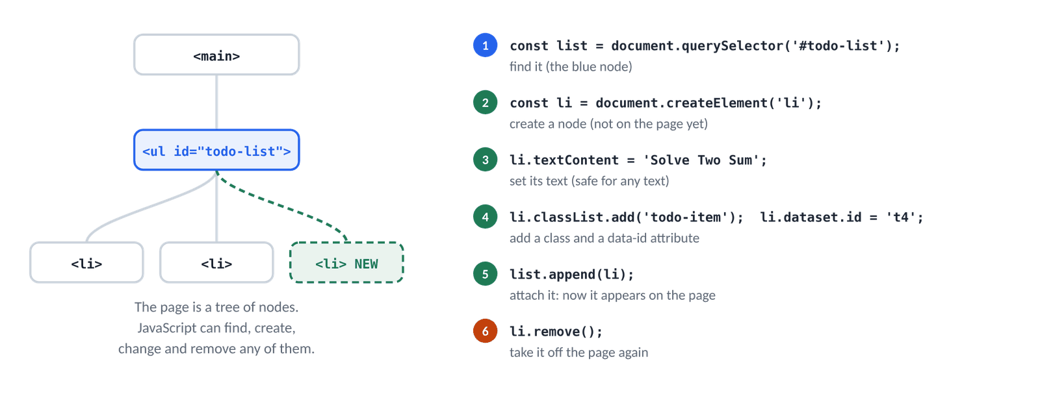
Figure 17.1 · The page as a tree, and the six operations you'll use every day
All the examples in this chapter run on this small page. Type it into practice/dom-lesson.html (or paste it into any page's <body> in DevTools) and try each example in the Console.
HTML · the HTML used by the examples in this chapter
<main id="app">
<h1 class="title">Stackfield</h1>
<ul id="todo-list" class="list">
<li class="item" data-id="t1">Read the arrays chapter</li>
<li class="item done" data-id="t2">Solve Two Sum</li>
<li class="item" data-id="t3">Build the widgets</li>
</ul>
<button id="save" class="button" type="button" aria-pressed="false">Save</button>
<input id="name" value="Rahim">
</main>

JS · walking the tree
const list = document.querySelector('#todo-list');
console.log(list.tagName, list.id, list.className);
console.log(list.children.length); // the three <li> inside
console.log(list.firstElementChild.textContent); // go down
console.log(list.parentElement.id); // go up
console.log(list.children[1].nextElementSibling.textContent); // go sideways
▶ CONSOLE OUTPUT
UL todo-list list
3
Read the arrays chapter
app
Build the widgets

Family word | Gives you
el.parentElement | the element around it
el.children | the elements directly inside it (a live list)
el.firstElementChild / lastElementChild | the first / last child element
el.nextElementSibling / previousElementSibling | the neighbour after / before it
el.closest('.card') | itself or the nearest ancestor that matches (used a lot on Day 18)

TIP
In DevTools → Elements, click any element, then type $0 in the Console: it's that element. $0.textContent = 'Hi' changes it on the spot. It's the fastest way to experiment.

17.2 Finding elements
JS · selecting elements
const title = document.querySelector('.title'); // the first match
const items = document.querySelectorAll('#todo-list .item'); // ALL matches
const save = document.getElementById('save'); // by id (no #)
console.log(title.textContent, items.length, save.textContent);
console.log(document.querySelector('.done').dataset.id);
console.log(document.querySelector('.missing')); // no match: null

items.forEach((item) => console.log(item.dataset.id)); // NodeList has forEach…
console.log(items.map); // …but not map
const texts = [...items].map((item) => item.textContent); // spread → a real array
console.log(texts);
▶ CONSOLE OUTPUT
Stackfield 3 Save
t2
null
t1
t2
t3
undefined
['Read the arrays chapter', 'Solve Two Sum', 'Build the widgets']

Selector | Finds
'#save' | the element with id="save"
'.item' | elements with the class item
'li' | every <li>
'#todo-list .item' | .item anywhere inside #todo-list
'ul > li' | <li> that are direct children of a <ul>
'[data-id="t2"]' | the element whose data-id is t2
'.item:not(.done)' | .item elements without the class done
'button[aria-pressed="true"]' | pressed toggle buttons

⇄ MORE WAYS Four ways to find the same button
WAY 1 getElementById
document.getElementById('save')
The fastest, and clear. Only for ids, and no #.
WAY 2 querySelector with an id
document.querySelector('#save')
Any CSS selector works, so one method covers everything.
WAY 3 querySelector with an attribute
document.querySelector('[aria-pressed]')
Useful when elements have no id or class to hook onto.
WAY 4 Search inside a parent
const app = document.getElementById('app');
app.querySelector('button')
el.querySelector only looks inside el. Widgets use this so two copies on one page don't find each other's parts.

JS · the error you'll meet most this week
const heading = document.querySelector('#titel'); // a typo in the selector
heading.textContent = 'Hello';
▶ CONSOLE OUTPUT
Uncaught TypeError: Cannot set properties of null (setting 'textContent')

WATCH OUT
"Cannot read / set properties of null" means the selector found nothing. Check three things: a typo in the selector, a missing # or ., and whether the script ran before the HTML existed (use defer, as on Day 10).

17.3 Reading and changing content
JS · text, HTML and form values
const title = document.querySelector('.title');
console.log(title.textContent);
title.textContent = 'Stackfield widgets'; // replace the text
console.log(title.textContent);

const first = document.querySelector('.item');
first.innerHTML = 'Read the <strong>arrays</strong> chapter'; // parsed as HTML
console.log(first.textContent); // the text only, tags removed
console.log(first.children.length); // one <strong> was created

const nameInput = document.getElementById('name');
console.log(nameInput.value); // form fields: .value
nameInput.value = 'Nadia';
console.log(nameInput.value);
▶ CONSOLE OUTPUT
Stackfield
Stackfield widgets
Read the arrays chapter
1
Rahim
Nadia

Property | Reads / writes | Use it for
textContent | plain text; writing replaces everything inside | showing any text (your default)
innerHTML | HTML; writing creates elements | HTML you wrote, never visitor text
innerText | only the text you can see (respects CSS) | rarely; it's slower
value | what's in an <input>, <select> or <textarea> | every form field

17.4 Attributes, properties and data-*
JS · attributes, properties and data-*
const save = document.getElementById('save');
console.log(save.getAttribute('aria-pressed')); // attributes are always strings
save.setAttribute('aria-pressed', 'true');
console.log(save.getAttribute('aria-pressed'));
console.log(save.id, save.type); // common ones are properties too
save.disabled = true; // a true/false attribute
console.log(save.hasAttribute('disabled'));
save.hidden = true;
console.log(save.hidden, save.hasAttribute('hidden'));

const item = document.querySelector('[data-id="t2"]');
console.log(item.dataset.id); // data-id → dataset.id
item.dataset.priority = 'high'; // adds data-priority="high"
console.log(item.getAttribute('data-priority'));
▶ CONSOLE OUTPUT
false
true
save button
true
true true
t2
high

In the HTML | In JavaScript | Value
data-id="t2" | el.dataset.id | 't2' (a string)
data-user-name="Mitu" | el.dataset.userName | dashes become camelCase
data-count="3" | Number(el.dataset.count) | convert numbers yourself
hidden, disabled, checked | el.hidden = true | a real boolean
aria-selected="true" | el.getAttribute('aria-selected') | 'true' (a string)

WATCH OUT
getAttribute('aria-pressed') returns the string 'false', and every non-empty string is truthy. if (save.getAttribute('aria-pressed')) is always true. Compare instead: === 'true'.

data-* attributes let you store your own small facts on an element: which task a row shows (data-id), which filter a button sets (data-filter), which size a button picks (data-size). Tomorrow's events read them to know what was clicked.

17.5 Classes and styles
JS · classList and style
const item = document.querySelector('.item');
item.classList.add('done'); // add a class
item.classList.remove('item'); // remove one
console.log(item.className);
console.log(item.classList.contains('done'));
console.log(item.classList.toggle('done')); // was on → now off: false
console.log(item.classList.toggle('done')); // on again: true
item.classList.toggle('urgent', 3 > 5); // on only if the 2nd argument is true
console.log(item.classList.contains('urgent'));

item.style.color = 'crimson'; // an inline style: camelCase names
item.style.backgroundColor = '#fff4e5';
console.log(item.getAttribute('style'));
▶ CONSOLE OUTPUT
done
true
false
true
false
color: crimson; background-color: rgb(255, 244, 229);

classList method | Does
add('a', 'b') | adds one or more classes (no duplicates)
remove('a') | removes a class (no error if it isn't there)
toggle('a') | adds if missing, removes if present; returns true if it's now on
toggle('a', condition) | on if condition is true, off if false: perfect for state
contains('a') | true / false
replace('a', 'b') | swaps one class for another

⇄ MORE WAYS Three ways to change how an element looks
WAY 1 A class (use this most)
row.classList.toggle('is-done', todo.done);
The look stays in the CSS; JavaScript only switches it on or off. Easy to change the design later.
WAY 2 An attribute the CSS also reads
tab.setAttribute('aria-selected', 'true');
/* CSS: .tab[aria-selected="true"] { … } */
One attribute does two jobs: screen readers hear the state, and the CSS styles it. The tabs work like this.
WAY 3 An inline style (for values made in JS)
bar.style.width = `${percent}%`;
card.style.setProperty('--accent', colour);
For numbers JavaScript calculates: a progress bar, a position, a colour the user picked. Not for on/off states.

JS · dom-playground.js, section 2: dark mode is one class on <body>
const themeButton = document.querySelector('#theme-button');
themeButton.addEventListener('click', () => {
const isDark = document.body.classList.toggle('dark'); // true if it's now on
themeButton.setAttribute('aria-pressed', String(isDark));
themeButton.textContent = `Dark mode: ${isDark ? 'on' : 'off'}`;
});

17.6 Creating, inserting and removing elements
JS · create, insert and remove
const list = document.getElementById('todo-list');
const li = document.createElement('li'); // 1. create: not on the page yet
li.className = 'item';
li.textContent = 'Deploy on Vercel'; // 2. fill it in
li.dataset.id = 't4';
list.append(li); // 3. attach it: now it's visible
console.log(list.children.length, list.lastElementChild.textContent);

const heading = document.createElement('li');
heading.textContent = 'This week';
list.prepend(heading); // at the start instead
console.log(list.firstElementChild.textContent);

list.querySelector('[data-id="t2"]').remove(); // take one off the page
console.log([...list.children].map((el) => el.dataset.id ?? '-'));
list.replaceChildren(); // remove EVERYTHING inside
console.log(list.children.length);
▶ CONSOLE OUTPUT
4 Deploy on Vercel
This week
['-', 't1', 't3', 't4']
0

Method | Puts the new element…
parent.append(a, b, 'text') | at the end, inside the parent (several at once)
parent.prepend(a) | at the start, inside the parent
el.before(a) / el.after(a) | just before / after el, as its sibling
el.replaceWith(a) | in place of el
el.remove() | (takes el off the page)
parent.replaceChildren(a, b) | removes everything inside, then adds a and b

Appending an element that is already on the page moves it rather than copying it. To copy an element, use el.cloneNode(true) (true = with everything inside).
⇄ MORE WAYS Three ways to add a new list item
WAY 1 createElement + textContent + append
const li = document.createElement('li');
li.textContent = task;
list.append(li);
Safe for any text, including what a visitor typed. The widgets use this.
WAY 2 insertAdjacentHTML
list.insertAdjacentHTML('beforeend', '<li class="item">Fixed text</li>');
Quick for HTML you wrote. Positions: beforebegin, afterbegin, beforeend, afterend. Same XSS danger as innerHTML.
WAY 3 A <template> and cloneNode
// HTML: <template id="row"><li class="item"><span></span></li></template>
const row = document.getElementById('row').content.cloneNode(true);
row.querySelector('span').textContent = task;
list.append(row);
The structure stays in the HTML where it's easy to read; JavaScript fills in the text. Nice for rows with many parts.

17.7 textContent vs innerHTML: why it matters
JS · textContent shows tags; innerHTML builds them
const title = document.querySelector('.title');
title.textContent = '<b>Rahim</b>';
console.log(title.children.length, title.textContent);
title.innerHTML = '<b>Rahim</b>';
console.log(title.children.length, title.textContent);
▶ CONSOLE OUTPUT
0 <b>Rahim</b>
1 Rahim

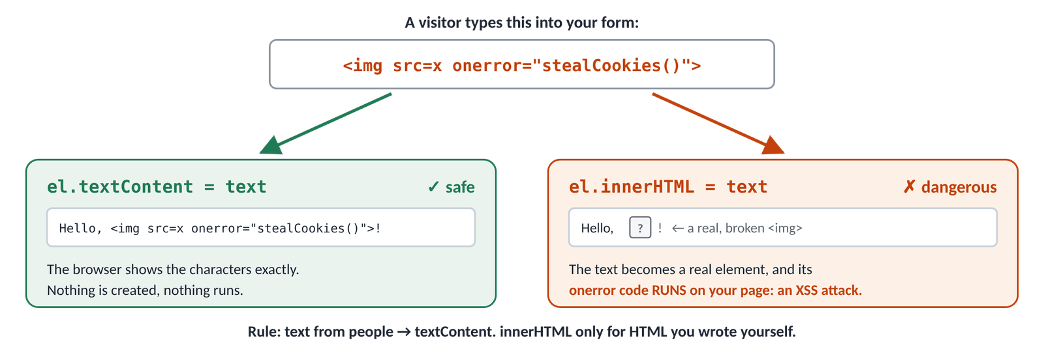
Figure 17.2 · The same visitor text, shown safely with textContent and dangerously with innerHTML
Now imagine a comment box that shows comments with innerHTML. A visitor types <img src="x" onerror="…">. The browser creates a real image; it fails to load; its onerror code runs on your page, for everyone who views the comment. It could read login tokens, change the page or send data elsewhere. This attack is called XSS (cross-site scripting), and it's one of the most common security holes on the web.
★ MUST KNOW the ideas to remember from today
- Text from a person (a form, a URL, a database, an API) → textContent.
- innerHTML only with HTML you wrote in your own code.
- If you ever must show visitor HTML (a rich-text editor), clean it first with a tested library such as DOMPurify.

TRY IT
Open practice/dom-playground.html, section 4. The box already contains <b>Rahim</b>. Compare the two outputs, then type <i>hi</i> and watch the innerHTML line turn italic. That's the first step of an XSS attack, safely in your own page.

17.8 Render a list from an array
IN PLAIN WORDS
The array is the recipe and the list on the page is the cake. You don't fix a cake by sticking bits on; you change the recipe and bake again. In code: change the array, then call one render() function that rebuilds the list from it.

JS · render(): draw the list from the array
const topics = ['Arrays', 'Objects'];
const list = document.getElementById('todo-list');

function render() {
const items = topics.map((topic) => {
const li = document.createElement('li');
li.textContent = topic;
return li;
});
list.replaceChildren(...items); // swap the old <li>s for the new ones
}

render();
console.log(list.children.length);
topics.push('The DOM'); // 1. change the data
render(); // 2. draw again from the data
console.log([...list.children].map((li) => li.textContent));
▶ CONSOLE OUTPUT
2
['Arrays', 'Objects', 'The DOM']

This "change the data, then render" loop is the most important pattern of the week. The to-do list (Day 19) and Project 1 are built on it, and in Month 2 React does exactly this for you, automatically.
⇄ MORE WAYS Three ways to render a list
WAY 1 map to elements + replaceChildren (use this)
list.replaceChildren(...topics.map(createItem));
Safe text, and one call replaces everything. createItem is a function that returns one <li>.
WAY 2 Empty it, then append in a loop
list.textContent = ''; // quick way to empty an element
for (const topic of topics) {
list.append(createItem(topic));
}
The same result in steps; fine and common.
WAY 3 innerHTML from map + join
list.innerHTML = topics.map((t) => `<li>${t}</li>`).join('');
Shortest, but only for your own fixed data (XSS again). You'll see it in many tutorials.

The counter: the same idea with a number
JS · dom-playground.js, section 3
let count = 0; // the state lives in a variable…
const countOutput = document.querySelector('#count');
const minusButton = document.querySelector('#minus');

function renderCount() { // …and the page shows it
countOutput.textContent = count;
minusButton.disabled = count === 0; // no negative numbers
}
const plus = document.querySelector('#plus');
const reset = document.querySelector('#reset');
plus.addEventListener('click', () => { count++; renderCount(); });
minusButton.addEventListener('click', () => { count--; renderCount(); });
reset.addEventListener('click', () => { count = 0; renderCount(); });
renderCount();

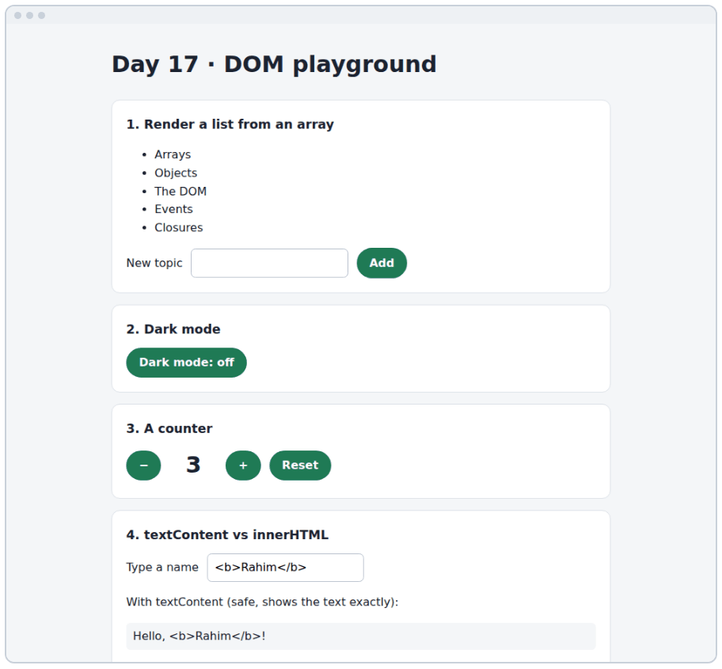
Figure 17.3 · practice/dom-playground.html: a list from an array, dark mode, a counter and the textContent test

17.9 Making the tabs work
The tabs were built from data yesterday. Today one function, selectTab, switches them: the chosen tab gets aria-selected="true" and its panel is shown; every other tab and panel is switched off. The CSS already styles [aria-selected="true"], so no styling code is needed.
JS · selectTab() and one listener per tab (Day 17)
function selectTab(root, selectedTab) {
const tabs = root.querySelectorAll('[role="tab"]');
tabs.forEach((tab) => {
const isSelected = tab === selectedTab; // is this the clicked one?
tab.setAttribute('aria-selected', String(isSelected));
tab.tabIndex = isSelected ? 0 : -1; // only it is in the Tab order
// aria-controls holds the id of this tab's panel
const panel = document.getElementById(tab.getAttribute('aria-controls'));
panel.hidden = !isSelected;
});
}

const root = document.getElementById('tracks');
root.querySelectorAll('[role="tab"]').forEach((tab) => {
tab.addEventListener('click', () => selectTab(root, tab)); // one listener per tab
});

document.getElementById('tab-backend').click(); // .click() = a pretend click
const panels = root.querySelectorAll('[role="tabpanel"]');
console.log([...panels].map((panel) => panel.hidden));
▶ CONSOLE OUTPUT
[true, false, true, true]

On every tab | Selected tab | Other tabs
aria-selected | "true": styled, and announced as "selected" | "false"
tabIndex | 0: reached with the Tab key | -1: skipped by Tab (arrows, Day 18)
its panel's hidden | false: shown | true: hidden from eyes and screen readers

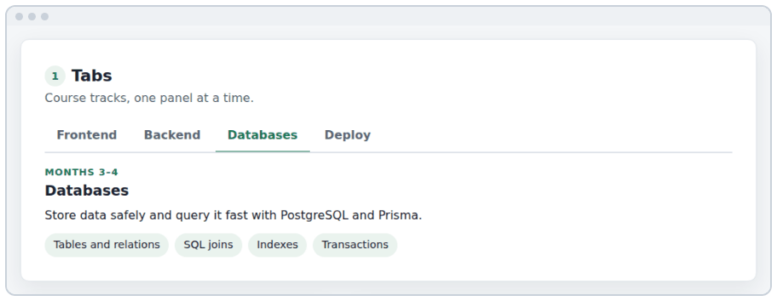
Figure 17.4 · The tabs widget with "Databases" selected
TIP
Buttons already work with the keyboard: Tab to the selected tab and press Enter or Space, and the same click listener runs. That's one reason every clickable thing should be a real <button>, not a <div>.

Four tabs means four listeners here. Tomorrow you'll replace them with one listener on the tab list (event delegation), and add the arrow keys.

17.10 DSA: LeetCode 217, Contains Duplicate
The problem. Return true if any value appears at least twice in the array, false if every value is different. [1, 2, 3, 1] → true; [1, 2, 3, 4] → false.
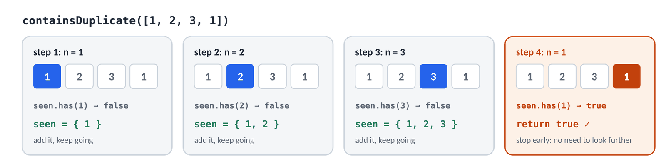
Figure 17.5 · The Set remembers every number it has passed; the second 1 is found at step 4
- The obvious way: compare every pair of numbers. Correct, but slow: 10,000 numbers means about 50 million comparisons.
- Sorting helps: after sorting, equal numbers sit next to each other, so you only compare neighbours.
- The fast way: walk once and keep a Set of the numbers you've seen. Before adding a number, ask the Set: "seen it?" A Set answers instantly.
- Stop early: return true the moment you find a repeat; only return false after the whole array.

⇄ MORE WAYS Contains Duplicate, four ways (dsa/217-contains-duplicate.js)
WAY 1 Compare every pair
function containsDuplicatePairs(nums) {
for (let i = 0; i < nums.length; i++) {
for (let j = i + 1; j < nums.length; j++) { // j starts after i
if (nums[i] === nums[j]) return true;
}
}
return false;
}
Time O(n²): double the input, four times the work. LeetCode's big tests time out.
WAY 2 Sort a copy, then check neighbours
function containsDuplicateSort(nums) {
const sorted = [...nums].sort((a, b) => a - b);
for (let i = 1; i < sorted.length; i++) {
if (sorted[i] === sorted[i - 1]) return true;
}
return false;
}
Time O(n log n), the cost of sorting. No extra memory besides the copy.
WAY 3 A Set of the values seen so far
function containsDuplicate(nums) {
const seen = new Set();
for (const n of nums) {
if (seen.has(n)) return true; // met this value before
seen.add(n);
}
return false;
}
Time O(n): one pass. Uses O(n) extra memory for the Set. The answer interviewers hope for.
WAY 4 One line
const containsDuplicateShort = (nums) => new Set(nums).size !== nums.length;
A Set drops duplicates, so it's smaller than the array if there were any. Neat, but it can't stop early.

Way | Time | For 10,000 numbers | Extra memory
Every pair | O(n²) | ~50,000,000 checks | none
Sort first | O(n log n) | ~130,000 steps | the sorted copy
Set | O(n) | ~10,000 steps | the Set

▶ RESULT
containsDuplicate([1, 2, 3, 1]) → true
containsDuplicate([1, 2, 3, 4]) → false
containsDuplicate([1, 1, 1, 3, 3, 4, 3, 2, 4, 2]) → true

This is your first time vs memory trade-off: the Set makes the code much faster by using extra memory to remember things. You'll make this trade again in Valid Anagram (Day 18) and Two Sum (Day 19).

Build it, step by step
- Make practice/dom-lesson.html with the HTML from 17.1 and try every example in this chapter in the Console.
- Open practice/dom-playground.html. Try each section; in section 4, compare the two outputs.
- Close the files and rebuild the counter from memory in a new page: state variable, renderCount(), three listeners.
- In the widgets, write selectTab(root, tab) and add a click listener to each tab.
- Test with the mouse, then the keyboard (Tab to a tab, Enter). Check aria-selected change in the Elements panel.
- Solve Contains Duplicate, then compare with dsa/217-contains-duplicate.js.
- Commit: git commit -m "Day 17: DOM playground and working tabs" and push.

★ MUST KNOW the ideas to remember from today
- The DOM is the live tree the browser builds from your HTML; changing it changes the page.
- querySelector → first match or null; querySelectorAll → a NodeList (forEach yes, map no).
- textContent for text, value for form fields, innerHTML only for your own HTML.
- classList.add / remove / toggle(name, force) / contains.
- dataset.someName reads and writes data-some-name.
- Create → fill → append. remove() takes it off; replaceChildren() clears.
- Change the data, then render() from the data.
- Attributes are strings: compare getAttribute(…) === 'true'.

WATCH OUT
- A selector typo gives null, then "Cannot read properties of null".
- Forgetting # or . in querySelector.
- Calling map on a NodeList (spread it first).
- innerHTML with text a person typed (XSS).
- Setting styles one by one in JavaScript instead of toggling a class.
- Script in <head> without defer: the elements don't exist yet.

QUESTIONS LEARNERS ASK
Q getElementById or querySelector?
Both are fine. getElementById is a little faster and only for ids; querySelector takes any CSS selector. Pick one style for a project.
Q Is document.body.innerHTML = … a fast way to build a page?
It works, but it throws away every element (and every event listener) inside and rebuilds them. Change only the part that changed.
Q Why does el.style.color return '' when my CSS makes it red?
el.style only shows inline styles. To read the final style from all your CSS, use getComputedStyle(el).color.
Q Is changing the DOM slow?
Each change can make the browser recalculate the layout. Building elements first and adding them in one append(...items) or replaceChildren(...) call is kinder than 100 separate appends.

More practice
MORE PRACTICE · try each one, then check the Answers at the back
- Log the text of every <li> on a page in one line.
- Add the class highlight to every even item in a list (2nd, 4th, …).
- Write el(tag, text, className) that creates an element in one call.
- Build a <table> from expenses (Day 16) with a row per expense and cells for title and amount.
- Make the counter never go above 10 and disable + at 10.
- Move the first item of a list to the end with one line.

Check yourself
- What does querySelectorAll return, and why can't you call map on it straight away?
- Why is element.innerHTML = userInput dangerous, and what should you use instead?
- What three things does selectTab change on each tab and panel?
Answer out loud before you turn to the Answers section at the back.
DONE WHEN · tick these off, then mark the day done in your Logbook
- Every example in this chapter runs in your Console
- All five playground sections work, and you rebuilt the counter from memory
- The tabs switch with the mouse and with Enter
- Contains Duplicate accepted; committed and pushed

Resources
All free. Every name is a link, in Word and in the PDF.
Resource (click to open) | Use it for
javascript.info: Walking the DOM  javascript.info/dom-navigation | parents, children and siblings
javascript.info: Searching: getElement*, querySelector*  javascript.info/searching-elements-dom | Every way to find elements
javascript.info: Modifying the document  javascript.info/modifying-document | create, append, remove, insertAdjacentHTML
javascript.info: Styles and classes  javascript.info/styles-and-classes | classList, style and getComputedStyle
MDN: Document Object Model (DOM)  developer.mozilla.org/en-US/docs/Web/API/Document_Object_Model | What the DOM is, and every part of it
MDN: Element.classList  developer.mozilla.org/en-US/docs/Web/API/Element/classList | All the classList methods
MDN: HTMLElement.dataset  developer.mozilla.org/en-US/docs/Web/API/HTMLElement/dataset | data-* attributes from JavaScript
MDN: Node.textContent  developer.mozilla.org/en-US/docs/Web/API/Node/textContent | textContent vs innerText vs innerHTML
OWASP: Cross Site Scripting (XSS)  owasp.org/www-community/attacks/xss | How XSS attacks work, from the security community
JavaScript30  javascript30.com | 30 free small projects with the DOM and events
LeetCode 217: Contains Duplicate  leetcode.com/problems/contains-duplicate | Today's problem

DAY  18 | WEEK 3 · TUESDAY 13 OCTOBER  Events in depth: bubbling, delegation and an accessible modal  Pages come alive when they react. Today you learn how an event travels, and how to catch it well.

TIME  3 hours | YOU BUILD  A character counter, a delegated list, an event lab, the modal dialog and keyboard tabs, and Valid Anagram | CODE FOLDER  day18-events

Today you will
- Attach and remove listeners, and run a listener only once
- Read the event object: type, target, currentTarget, key
- Choose the right event: click, input, change, submit, keydown, focusout
- Explain capture and bubbling, and why you should rarely stop an event
- Handle a whole list with one delegated listener and closest()
- Stop the browser's own action with preventDefault()
- Read a form with FormData, and let HTML check the input first
- Build an accessible modal with <dialog> and showModal()
- Move between tabs with the arrow keys
- Solve LeetCode 242, Valid Anagram, three ways

Key terms
Term | Meaning
Event | Something that happens: a click, a key press, a form submit
Listener (handler) | The function the browser calls when the event happens
Event object | The details of one event, passed to your listener as event
target | The element where the event started (what was actually clicked)
currentTarget | The element whose listener is running right now
Bubbling | After the target, the event travels up through every ancestor
Capture | The trip down from document to the target, before bubbling
Delegation | One listener on a parent handles events from all its children
Default action | What the browser does by itself: follow a link, submit a form
Modal | A dialog that blocks the rest of the page until it closes
Focus | Which element receives the keyboard; shown by the focus ring

18.1 Events and listeners
IN PLAIN WORDS
You don't stand at the front door all day waiting for guests. You fit a doorbell and decide: "when it rings, open the door". addEventListener fits the doorbell: it tells the browser which event to wait for and which function to run when it happens.

JS · adding, removing and once
const save = document.getElementById('save');
function handleSave(event) {
console.log('clicked:', event.type, event.target.id);
}
save.addEventListener('click', handleSave); // the function, not a call
save.addEventListener('click', () => console.log('a second listener'));
save.click(); // .click() = a pretend click

save.removeEventListener('click', handleSave); // needs the SAME function
save.click();

save.addEventListener('click', () => console.log('only once'), { once: true });
save.click();
save.click();
▶ CONSOLE OUTPUT
clicked: click save
a second listener
a second listener
a second listener
only once
a second listener

Event | Fires when… | Typical use
click | a button or link is activated (mouse, Enter, Space, touch) | buttons, tabs, menus
input | the value of a field changes, on every key | live search, character counters
change | a field is changed and "committed" (leave the box, tick, pick) | checkboxes, selects
submit | a form is sent (Enter or a submit button) | every form
keydown / keyup | a key goes down / up | shortcuts, arrow keys, Escape
focusin / focusout | an element gains / loses focus (these bubble) | saving an edit, validation
pointerenter / pointerleave | the mouse or finger enters / leaves | hover effects CSS can't do
DOMContentLoaded | the HTML has been read | not needed with defer or modules

⇄ MORE WAYS Three ways to run code on a click
WAY 1 addEventListener (use this)
button.addEventListener('click', handleClick);
Any number of listeners per event; can be removed; options such as { once: true }.
WAY 2 The onclick property
button.onclick = handleClick;
Only one handler: a second assignment silently replaces the first. Seen in older code.
WAY 3 An onclick attribute in the HTML (avoid)
<button onclick="handleClick()">Save</button>
Mixes JavaScript into HTML, needs a global function, and is blocked by strict security settings (CSP) on many real sites.

WATCH OUT
save.addEventListener('click', handleSave()) with brackets calls handleSave straight away and passes its result (undefined) as the listener. Pass the function itself: handleSave, or wrap it: () => handleSave(42).

18.2 The event object
Every listener receives one argument: an object describing what happened. Name it event (you'll also see e or evt).
Property / method | Tells you / does
event.type | 'click', 'keydown', 'submit'…
event.target | the element where it started (the thing actually clicked)
event.currentTarget | the element this listener is attached to
event.key / event.code | the key's meaning ('a', 'Enter') / its physical position ('KeyA')
event.shiftKey, ctrlKey, altKey, metaKey | true if that key was held down
event.clientX / clientY | where the pointer was, in pixels
event.preventDefault() | stop the browser's own action (18.7)
event.stopPropagation() | stop the event travelling further (18.4; rarely needed)

18.3 input or change?
JS · input vs change
const city = document.getElementById('city');
city.addEventListener('input', () => console.log('input:', city.value));
city.addEventListener('change', () => console.log('change:', city.value));
▶ CONSOLE OUTPUT · after typing "Dha" and pressing Tab
input: D
input: Dh
input: Dha
change: Dha

Field | input fires… | change fires…
text box, textarea | on every character | when you leave the box, if the value changed
checkbox, radio | when it's ticked | when it's ticked (use change)
select | when an option is picked | when an option is picked
range slider | continuously while dragging | when you let go

EXAMPLE A live character counter (practice/char-counter.js)
JS · the limit lives in the HTML; the script reads it
const bio = document.getElementById('bio');
const counter = document.getElementById('bio-counter');
const max = Number(bio.getAttribute('maxlength')); // the limit in the HTML: 160

function updateCounter() {
const used = bio.value.length;
const left = max - used;
counter.textContent = `${used} / ${max}`;
counter.classList.toggle('is-near', left <= 20 && left > 0); // amber
counter.classList.toggle('is-full', left === 0); // red
}

bio.addEventListener('input', updateCounter); // every change, as you type
updateCounter(); // and once at the start

TIP
Call the update function once at the start as well as in the listener. Then the counter is right even before the first key press, and when the browser refills the field after a reload.

18.4 How an event travels: capture and bubbling
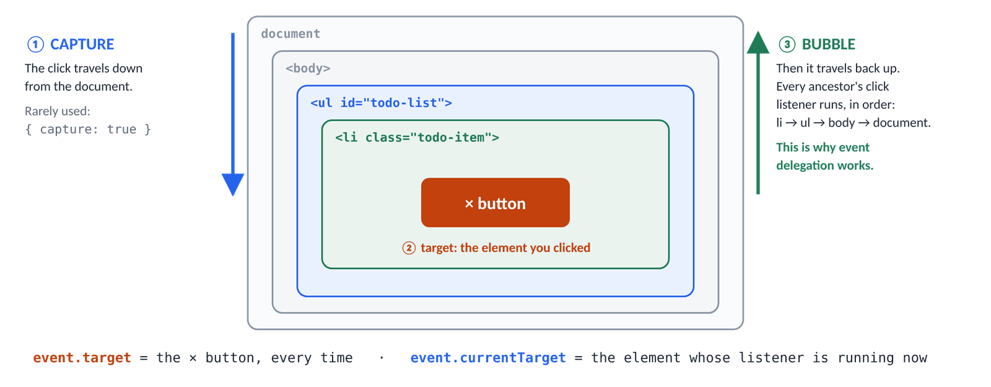
Figure 18.1 · A click travels down to its target (capture), then back up through every ancestor (bubble)
JS · bubbling: one click, three listeners
function logClick(event) {
console.log(`listener on #${event.currentTarget.id} · target: #${event.target.id}`);
}
for (const id of ['outer', 'middle', 'inner']) {
document.getElementById(id).addEventListener('click', logClick);
}
document.getElementById('inner').click();
▶ CONSOLE OUTPUT
listener on #inner · target: #inner
listener on #middle · target: #inner
listener on #outer · target: #inner

One click, three listeners. target stays #inner the whole way (that's where the click started); currentTarget changes as the event bubbles up through #middle and #outer. This is exactly what the event lab shows on the page.
JS · capture first, then stopPropagation
const outer = document.getElementById('outer');
const middle = document.getElementById('middle');
outer.addEventListener('click', () => {
console.log('outer, capture');
}, { capture: true });
outer.addEventListener('click', () => console.log('outer, bubble'));
middle.addEventListener('click', (event) => {
console.log('middle: stopping here');
event.stopPropagation(); // #outer's bubble listener never hears it
});
document.getElementById('inner').click();
▶ CONSOLE OUTPUT
outer, capture
middle: stopping here

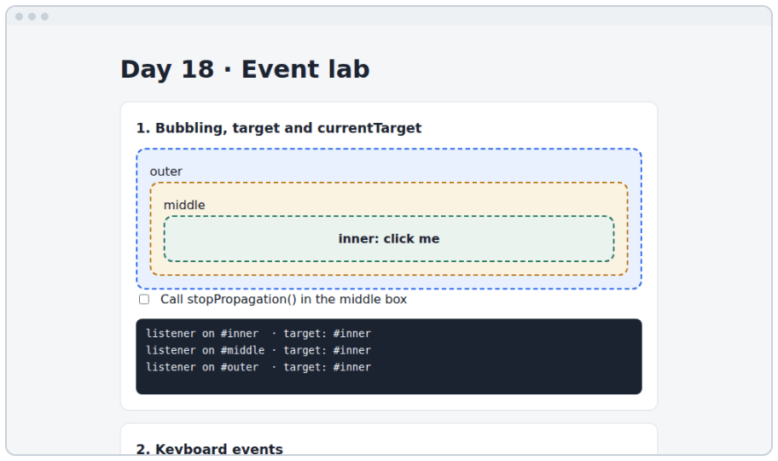
Figure 18.2 · practice/event-lab.html after a click on the inner box
WATCH OUT
Avoid stopPropagation(). Other code may rely on the event reaching the top: delegated listeners, "close the menu when you click outside", analytics. Almost every time, checking event.target in the parent's listener is the better fix.

18.5 Event delegation: one listener for a whole list
IN PLAIN WORDS
A big office doesn't put a guard at every door. One receptionist at the front desk asks each visitor "who are you here to see?". Because clicks bubble up, one listener on a list can handle every item in it, even items that are added later.

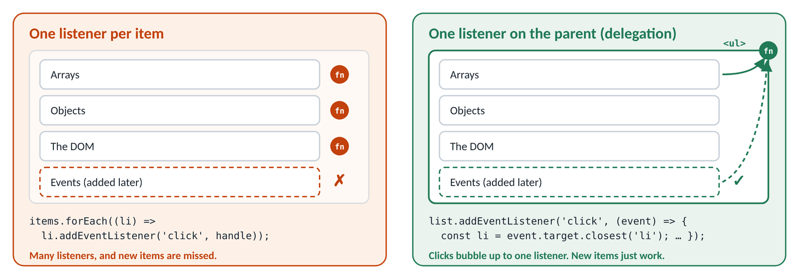
Figure 18.3 · One listener per item misses new items; one listener on the parent catches them all
JS · one listener for the whole list
const list = document.getElementById('lessons');
list.addEventListener('click', (event) => {
const button = event.target.closest('button'); // the clicked button, or null
if (!button) return; // a click on the gap between items
console.log('clicked', button.textContent);
});

const added = document.createElement('li'); // added AFTER the listener
added.innerHTML = '<button type="button"><b>Events</b></button>';
list.append(added);
list.querySelector('b').click(); // a click on the <b> INSIDE the new button
list.querySelector('button').click();
▶ CONSOLE OUTPUT
clicked Events
clicked Arrays

Two details make delegation work. First, event.target might be something inside the button (the <b>, an icon, a <span>), so we walk up with closest('button') to the element we care about. Second, if the click wasn't on a button at all, closest returns null and we stop.
Method | Answers
el.closest('.todo-item') | which .todo-item is this inside? (itself counts; null if none)
el.matches('.todo-toggle') | is this element itself a .todo-toggle? (true / false)
parent.contains(el) | is el somewhere inside parent?

⇄ MORE WAYS Two ways to handle clicks on every list item
WAY 1 One listener per item
list.querySelectorAll('button').forEach((button) => {
button.addEventListener('click', handleClick);
});
Easy to understand, but items added later have no listener, and 500 items means 500 listeners.
WAY 2 One listener on the parent (delegation)
list.addEventListener('click', (event) => {
const button = event.target.closest('button');
if (button) handleClick(button);
});
One listener, and new items just work. The to-do list, the tabs and the filters all use this.

JS · widgets/js/main.js, section 3: the tabs, delegated
// Before (Day 17): four listeners, one per tab
tracksRoot.querySelectorAll('[role="tab"]').forEach((tab) => {
tab.addEventListener('click', () => selectTab(tracksRoot, tab));
});

// After (Day 18): ONE listener on the tab list
list.addEventListener('click', (event) => {
const tab = event.target.closest('[role="tab"]');
if (!tab) return; // the click was on the list, not a tab
selectTab(root, tab);
});

TRY IT
Open practice/delegation.html. Add three lessons with the form, then click them and their × buttons. None of them got a listener of their own, and all of them work.

18.6 Keyboard events
JS · key and code
const city = document.getElementById('city');
city.addEventListener('keydown', (event) => {
console.log(event.key, event.code, event.shiftKey);
});
▶ CONSOLE OUTPUT · after pressing a, Shift+A, Enter, ←, Escape
a KeyA false
Shift ShiftLeft true
A KeyA true
Enter Enter false
ArrowLeft ArrowLeft false
Escape Escape false

 | event.key | event.code
Means | what the key produces | where the key is on the keyboard
Shift + a | 'A' | 'KeyA'
On a French keyboard, the key left of Z | 'q' | 'KeyA'
Use it for | text, Enter, Escape, arrows (almost always) | games (WASD keys by position)

Arrow keys for the tabs
Accessible tabs follow a standard pattern: Tab moves into the tab list and out again; ← → move between tabs; Home / End jump to the first / last. Only the selected tab has tabIndex = 0, so Tab never has to walk through every tab. This is called a roving tabindex.
JS · widgets/js/main.js, section 3: ← → Home End
list.addEventListener('keydown', (event) => {
const tabs = [...list.querySelectorAll('[role="tab"]')]; // a real array
const current = tabs.indexOf(document.activeElement); // the focused tab
if (current === -1) return;
const total = tabs.length;

let next;
if (event.key === 'ArrowRight') next = (current + 1) % total;
else if (event.key === 'ArrowLeft') next = (current - 1 + total) % total;
else if (event.key === 'Home') next = 0;
else if (event.key === 'End') next = total - 1;
else return; // any other key: do nothing

event.preventDefault(); // stop Home/End from scrolling the page
tabs[next].focus();
selectTab(root, tabs[next]);
});

Focused tab (of 4) | Key | next = …
2 (Databases) | → | (2 + 1) % 4 = 3 (Deploy)
3 (Deploy) | → | (3 + 1) % 4 = 0: wraps to Frontend
0 (Frontend) | ← | (0 - 1 + 4) % 4 = 3: wraps to Deploy

total is the number of tabs. The % total makes the index wrap around like a clock: after the last tab comes the first. The + total in the ← line stops the number going negative, because -1 % 4 is -1 in JavaScript, not 3.
⇄ MORE WAYS Two ways to map keys to moves
WAY 1 if / else if (Day 18)
if (event.key === 'ArrowRight') next = …;
else if (event.key === 'ArrowLeft') next = …;
Clear, and easy to add special cases to.
WAY 2 A lookup object (Day 20)
const moves = {
ArrowRight: (current + 1) % tabs.length,
ArrowLeft: (current - 1 + tabs.length) % tabs.length,
Home: 0,
End: tabs.length - 1,
};
const next = moves[event.key];
if (next === undefined) return;
The table of keys is data, so adding a key is one line. Day 20's tabs.js uses this.

18.7 preventDefault: stop the browser's own action
JS · preventDefault on a link
const link = document.getElementById('docs');
link.addEventListener('click', (event) => {
event.preventDefault(); // don't follow the link
console.log('stopped:', event.defaultPrevented);
});
link.click();
console.log(location.pathname); // still on the same page
▶ CONSOLE OUTPUT
stopped: true
/

Default action | Happens on | Stop it when…
Follow the link | click on <a> | JavaScript shows the content instead
Send the form and reload | submit on <form> | JavaScript handles the data (always, this week)
Scroll the page | keydown Space, Home, End, arrows | those keys drive your widget
Tick the box | click on a checkbox | almost never (it confuses people)

WATCH OUT
preventDefault() and stopPropagation() are unrelated. The first stops the browser's action; the second stops the event travelling to other listeners. A form handler needs the first, almost never the second.

18.8 Forms: let HTML check first, then read the data
JS · reading a form with FormData
const form = document.getElementById('call-form');
form.addEventListener('submit', (event) => {
event.preventDefault(); // no page reload
const data = new FormData(form); // every field that has a name
console.log(data.get('name'), data.get('day'));
console.log(Object.fromEntries(data)); // all fields as one object
});
form.requestSubmit(); // like pressing the submit button
▶ CONSOLE OUTPUT
Rahim Sunday
{name: 'Rahim', day: 'Sunday'}

⇄ MORE WAYS Four ways to read a form
WAY 1 Each field's value
const name = document.getElementById('call-name').value;
Fine for one or two fields.
WAY 2 FormData.get()
const data = new FormData(form);
const name = data.get('name');
Reads by the name attribute, so the ids don't matter.
WAY 3 Object.fromEntries(new FormData(form))
const { name, day } = Object.fromEntries(new FormData(form));
Every field in one object, then destructure. Day 20's modal uses this.
WAY 4 form.elements
const name = form.elements.name.value;
The form knows its own fields by name. Handy, but name can clash with built-in properties.

HTML attribute | The browser checks, before submit fires
required | not empty
minlength="3" / maxlength="80" | the length of the text
type="email" / type="url" | the right shape
min / max (numbers, dates) | the range
pattern=".*\S.*" | matches a pattern: here, at least one character that isn't a space

If any check fails, the browser shows its own message, focuses the field and doesn't fire `submit` at all. So by the time your listener runs, the basic checks have passed. Style the states with :invalid / :user-invalid in CSS. required alone accepts " " (only spaces), which is why the modal's name field adds pattern=".*\S.*" and the script still calls trim().

18.9 The modal dialog
A modal puts one focused task on top of the page: here, "Book a free call". Building one by hand used to take 100+ lines (trapping focus, the Escape key, the dark background). The HTML <dialog> element does most of it for you when you open it with showModal().
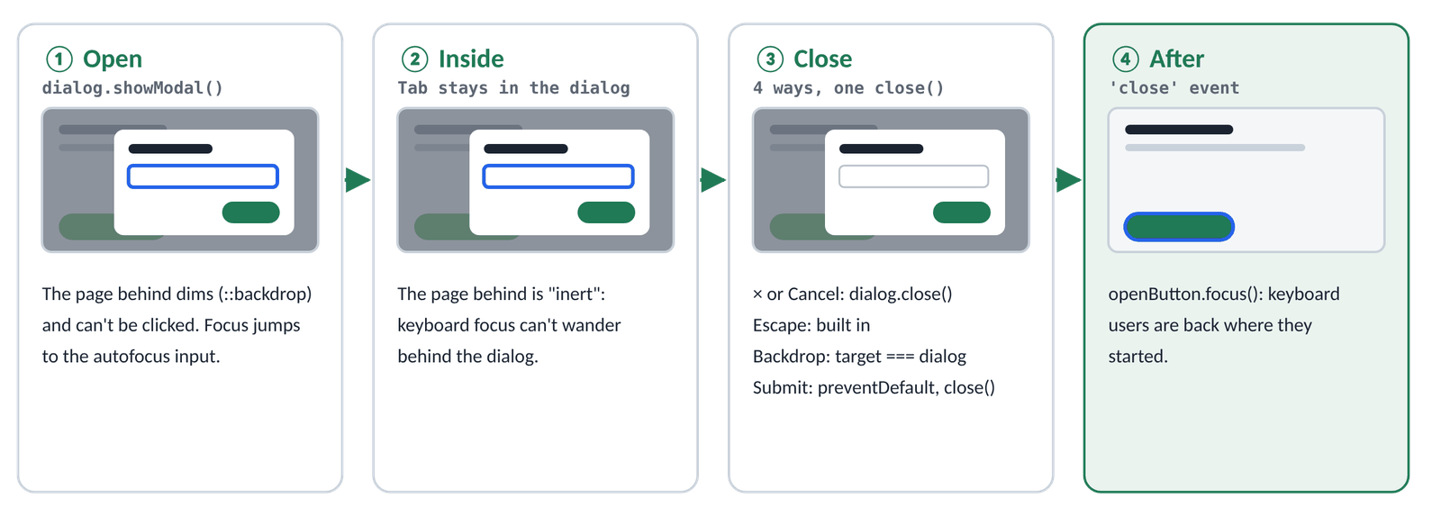
Figure 18.4 · Open, use, close, and give focus back: the four stages of the modal
HTML · widgets/index.html: the modal's HTML
<button class="button" type="button" id="open-call">Book a free call</button>
<p class="form-message" id="call-status" role="status" aria-live="polite"></p>

<dialog class="modal" id="call-dialog" aria-labelledby="call-dialog-title">
<form class="modal-body" id="call-form">
<div class="modal-head">
<h3 id="call-dialog-title">Book a free call</h3>
<button class="icon-button" type="button" id="close-call"
aria-label="Close">×</button>
</div>
<label for="call-name">Your name</label>
<input id="call-name" name="name" required pattern=".*\S.*" autofocus>
<label for="call-day">Best day</label>
<select id="call-day" name="day"><option>Saturday</option> … </select>
<div class="modal-actions">
<button class="button button-ghost" type="button"
id="cancel-call">Cancel</button>
<button class="button" type="submit">Book the call</button>
</div>
</form>
</dialog>

JS · widgets/js/main.js, section 4: the modal
const openButton = document.getElementById('open-call');
const dialog = document.getElementById('call-dialog');
const callForm = document.getElementById('call-form');
const callStatus = document.getElementById('call-status');

openButton.addEventListener('click', () => {
callStatus.textContent = '';
dialog.showModal(); // on top, page behind dimmed and inert, focus inside
});

// × and Cancel
const closeButton = document.getElementById('close-call');
const cancelButton = document.getElementById('cancel-call');
closeButton.addEventListener('click', () => dialog.close());
cancelButton.addEventListener('click', () => dialog.close());

// The dark backdrop: a click there has the <dialog> itself as its target
dialog.addEventListener('click', (event) => {
if (event.target === dialog) dialog.close();
});

// However it closes (buttons, backdrop, Escape, submit): focus back to the opener
dialog.addEventListener('close', () => openButton.focus());

callForm.addEventListener('submit', (event) => {
event.preventDefault(); // the browser already checked required
const data = new FormData(callForm);
const name = data.get('name').trim();
const day = data.get('day');
dialog.close();
callStatus.textContent =
`Thanks, ${name}! A mentor will call you on ${day} evening.`;
callForm.reset();
});

It closes when… | Handled by | Why it matters
× or Cancel is clicked | your click listeners → close() | a visible way out
Escape is pressed | the browser (built into modal dialogs) | keyboard users expect it
the dark backdrop is clicked | event.target === dialog | mouse users expect it
the form is submitted | your submit listener → close() | the task is done
(any of the above) | the close event → openButton.focus() | keyboard users continue where they were

Why does the backdrop test work? The dialog has padding: 0 and the form fills it, so any click inside the box lands on the form or something in it. Only a click on the dark area outside the box reports the <dialog> element itself as event.target.
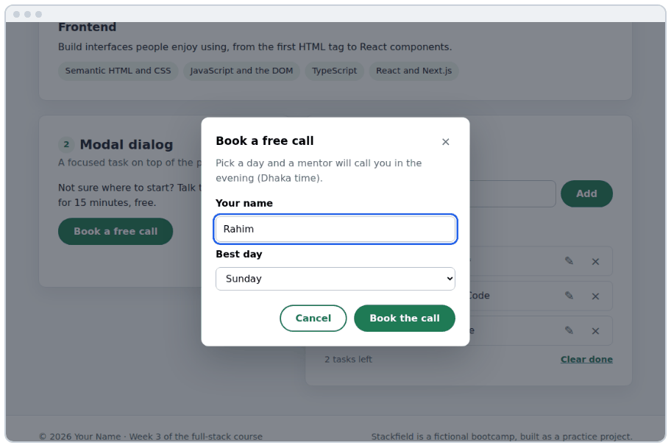
Figure 18.5 · The open modal: the page behind is dimmed and can't be clicked
- Tab to "Book a free call", press Enter: the dialog opens and the name field has focus
- Tab and Shift+Tab stay inside the dialog; the page behind can't be reached
- Escape closes it, and focus is back on "Book a free call"
- Submitting with an empty name (or only spaces) shows the browser's message instead
- A screen reader announces "Book a free call, dialog" when it opens, and the thank-you message after

⇄ MORE WAYS Two ways to close a dialog from a button
WAY 1 A click listener that calls close() (the widget)
cancel.addEventListener('click', () => dialog.close());
Full control, e.g. to ask "discard your changes?" first.
WAY 2 A form with method="dialog"
<form method="dialog">
<button value="cancel">Cancel</button>
<button value="ok">OK</button>
</form>
Any submit button closes the dialog with no JavaScript, and dialog.returnValue tells you which button it was. Great for simple confirm boxes.

WATCH OUT
Use showModal(), not show(). show() opens a non-modal dialog: no backdrop, the page behind stays clickable, and Escape doesn't close it.

18.10 DSA: LeetCode 242, Valid Anagram
The problem. Return true if t uses exactly the same letters as s, the same number of times. "anagram" / "nagaram" → true; "rat" / "car" → false.
- Quick exit: different lengths can never be anagrams. Return false straight away.
- Idea 1, sort: sort the letters of both words; anagrams become the same word ("aaagmnr").
- Idea 2, count: count each letter of s (+1), then take away each letter of t (−1). If a count would go below zero, t has a letter s doesn't have (or has too many of it).
- Why counting is faster: it looks at each letter once, with no sorting.

Step | counts | Note
count "rat" | { r: 1, a: 1, t: 1 } | +1 for each letter of s
take "c" | counts.c is missing (0) | return false: t has a letter s doesn't

⇄ MORE WAYS Valid Anagram three ways (dsa/242-valid-anagram.js)
WAY 1 Sort both and compare
function isAnagramSort(s, t) {
if (s.length !== t.length) return false;
const sortLetters = (word) => word.split('').sort().join('');
return sortLetters(s) === sortLetters(t);
}
Short and easy to trust. Time O(n log n) for the sorting.
WAY 2 Count with an object
function isAnagram(s, t) {
if (s.length !== t.length) return false;
const counts = {};
for (const letter of s) counts[letter] = (counts[letter] ?? 0) + 1;
for (const letter of t) {
if (!counts[letter]) return false; // missing, or already used up
counts[letter]--;
}
return true; // same length + nothing went below 0 = same letters
}
Time O(n). The object's size is limited by the alphabet, so the extra memory is small.
WAY 3 Count with a Map
function isAnagramMap(s, t) {
if (s.length !== t.length) return false;
const counts = new Map();
for (const letter of s) counts.set(letter, (counts.get(letter) ?? 0) + 1);
for (const letter of t) {
if (!counts.get(letter)) return false;
counts.set(letter, counts.get(letter) - 1);
}
return true;
}
The same logic with a Map: a built-in object made for counting and lookups. set, get and has are its main methods; you'll use it tomorrow for Two Sum.

▶ RESULT
isAnagram('anagram', 'nagaram') → true
isAnagram('rat', 'car') → false
isAnagram('listen', 'silent') → true
isAnagram('aacc', 'ccac') → false

Counting patterns like this one (an object or Map of "how many of each") solve a huge family of problems: most frequent word, first unique character, ransom note, group anagrams. When a problem says "same letters", "how many times" or "duplicates", think counting.

Build it, step by step
- Open practice/event-lab.html. Click the inner box; then tick "stopPropagation" and click again. Explain the log out loud.
- Build the character counter and the delegated list yourself, then compare with char-counter.js and delegation.js.
- Replace the four tab listeners with one delegated listener, then add ← → Home End.
- Build the modal: showModal(), ×, Cancel, the backdrop, and focus back to the button on close.
- Test the modal and the tabs with the keyboard only, using the checklist in 18.9.
- Solve Valid Anagram, then compare with dsa/242-valid-anagram.js.
- Commit: git commit -m "Day 18: events practice, delegated tabs and an accessible modal" and push.

★ MUST KNOW the ideas to remember from today
- addEventListener(type, fn): give the function, don't call it.
- target = where it started; currentTarget = whose listener is running.
- Events go down (capture) then up (bubble). Listeners run in the bubble phase by default.
- Delegation: one listener on the parent + event.target.closest(selector).
- input for every keystroke; change for committed changes; submit for forms.
- preventDefault() stops the browser's action; stopPropagation() stops the journey (rarely needed).
- new FormData(form) reads every named field; the browser checks required and pattern first.
- <dialog> + showModal() gives a backdrop, focus trap and Escape; return focus on close.

WATCH OUT
- addEventListener('click', handler()): called immediately.
- Using event.target when the click landed on a child element (use closest).
- Forgetting preventDefault() on submit: the page reloads and your log vanishes.
- removeEventListener with a new arrow function: it removes nothing.
- Using stopPropagation to fix a problem delegation should solve.
- Opening the dialog with show() instead of showModal().

QUESTIONS LEARNERS ASK
Q Why did my console message disappear when I submitted the form?
The page reloaded: submitting a form sends it and loads a new page. event.preventDefault() in the submit listener stops that. In DevTools, the Console setting "Preserve log" keeps messages across reloads.
Q Should I listen for click or keydown on buttons?
click. On a real <button>, Enter and Space already fire click. Use keydown only for extra keys like arrows or Escape.
Q Is it bad to have many listeners?
A few dozen is nothing. Delegation matters for lists that are long or change often, and it makes code simpler because new items need no setup.
Q What does this mean inside a listener?
In a normal function listener, this is event.currentTarget. In an arrow function it isn't. Use event.currentTarget: it's clearer and works with both.

More practice
MORE PRACTICE · try each one, then check the Answers at the back
- Log the x and y position of every click on the page.
- Make a text box that shows its value in upper case in a <p> as you type.
- Press "/" anywhere on the page to focus the search box (like GitHub and YouTube).
- In a delegated list, make a click on the text toggle .done, and a click on × delete the item.
- Add a keyboard shortcut: Ctrl+Enter submits the modal's form.
- Why does -1 % 4 give -1 in JavaScript, and how do you get 3?

Check yourself
- What is the difference between event.target and event.currentTarget?
- What is event delegation, and why is it useful for a list?
- Name three ways the modal can close, and what happens to keyboard focus afterwards.
Answer out loud before you turn to the Answers section at the back.
DONE WHEN · tick these off, then mark the day done in your Logbook
- You can explain the event lab's log, with and without stopPropagation
- The character counter and the delegated list work, built by you
- The tabs use one listener and the arrow keys; the modal passes the keyboard checklist
- Valid Anagram accepted; committed and pushed

Resources
All free. Every name is a link, in Word and in the PDF.
Resource (click to open) | Use it for
javascript.info: Introduction to browser events  javascript.info/introduction-browser-events | Listeners, the event object, and more
javascript.info: Bubbling and capturing  javascript.info/bubbling-and-capturing | target vs currentTarget, with a demo
javascript.info: Event delegation  javascript.info/event-delegation | Delegation patterns, with tasks
javascript.info: Browser default actions  javascript.info/default-browser-action | preventDefault in depth
javascript.info: Keyboard: keydown and keyup  javascript.info/keyboard-events | key vs code, with a key tester
MDN: <dialog>: The Dialog element  developer.mozilla.org/en-US/docs/Web/HTML/Reference/Elements/dialog | showModal, close, ::backdrop and method="dialog"
MDN: FormData  developer.mozilla.org/en-US/docs/Web/API/FormData | Reading forms from JavaScript
MDN: Client-side form validation  developer.mozilla.org/en-US/docs/Learn_web_development/Extensions/Forms/Form_validation | required, pattern and the :invalid styles
WAI-ARIA Authoring Practices: Dialog (Modal)  w3.org/WAI/ARIA/apg/patterns/dialog-modal | How an accessible modal should behave
LeetCode 242: Valid Anagram  leetcode.com/problems/valid-anagram | Today's problem

DAY  19 | WEEK 3 · WEDNESDAY 14 OCTOBER  Closures, timers and localStorage  Functions that remember, code that runs later, and data that survives a reload.

TIME  3 hours | YOU BUILD  Closure exercises, a focus timer, a debounced search, a saved theme, the to-do list (part 1), and Two Sum | CODE FOLDER  day19-closures

Today you will
- Explain a closure in plain words, and use one to keep private state
- Write createCounter, once, makeMultiplier and an id generator
- Answer the classic var vs let loop question
- Schedule code with setTimeout and setInterval, and always cancel it
- Explain why timer callbacks run after the rest of your code
- Debounce a search box, and know when to throttle instead
- Save and load data with localStorage and JSON, safely
- Build the to-do list with one state array and one render()
- Solve LeetCode 1, Two Sum, with a Map

Key terms
Term | Meaning
Closure | A function together with the variables it remembers from where it was created
Lexical scope | A function can use the variables around the place it was written
Factory function | A function that makes and returns other functions or objects
Private state | Data only certain functions can reach, like count in createCounter
Timer id | The number setTimeout / setInterval return; pass it to clear… to cancel
Event loop | How JavaScript runs one task at a time, taking the next from a queue
Debounce | Wait until calls stop for a moment, then run once
Throttle | Run at most once every so many milliseconds
localStorage | A small key–value store in the browser that survives reloads
State | The data that describes what the page should show right now
Map | A built-in key–value collection with set, get, has

19.1 Functions that remember
IN PLAIN WORDS
When a function is created, it packs a backpack with the variables around it. Wherever the function goes later, and however much later it runs, it carries the backpack and can use (and change) what's inside. That backpack is the closure.

JS · Part A of closures-solutions.js: a function that makes functions
function makeGreeter(greeting) {
return function (name) { // this inner function uses greeting…
return `${greeting}, ${name}!`;
};
}
const hello = makeGreeter('Hello'); // makeGreeter has finished here…
const salaam = makeGreeter('Assalamu alaikum');
console.log(hello('Rahim')); // …but greeting is still in the backpack
console.log(salaam('Nadia'));
▶ CONSOLE OUTPUT
Hello, Rahim!
Assalamu alaikum, Nadia!

- makeGreeter('Hello') runs. Its variable greeting is 'Hello'.
- It creates the inner function and returns it. makeGreeter is now finished.
- Normally greeting would be thrown away, but the inner function still uses it, so JavaScript keeps it alive in the backpack.
- Calling hello('Rahim') later uses that remembered greeting. salaam has its own backpack with its own greeting.

You've already used closures without the name: every event listener that uses a variable from outside it (openButton.focus() inside the dialog's close listener) is a closure. So is every map callback that uses a variable like limit.

19.2 Private state: createCounter
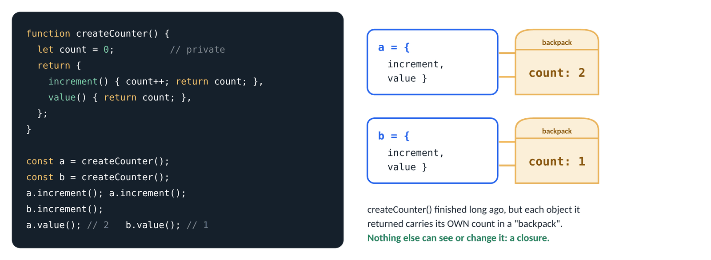
Figure 19.1 · Each counter carries its own backpack with its own count; nothing else can reach it
JS · Exercise 1: createCounter(start)
function createCounter(start = 0) {
let count = start; // only the four functions below can reach this
return {
increment() { count++; return count; },
decrement() { count--; return count; },
reset() { count = start; return count; },
value() { return count; },
};
}
const first = createCounter();
first.increment();
first.increment();
const second = createCounter(10);
second.decrement();
console.log(first.value(), second.value()); // each has its OWN count
console.log(first.count); // private: not a property
console.log(first.reset());
▶ CONSOLE OUTPUT
2 9
undefined
0

⇄ MORE WAYS Three ways to keep a count, from worst to best
WAY 1 A global variable
let count = 0;
function increment() { count++; }
Any code anywhere can change or clash with count, and you can only have one counter.
WAY 2 An object property
const counter = { count: 0, increment() { this.count++; } };
Grouped, but public: counter.count = -500 is allowed from anywhere.
WAY 3 A closure
const counter = createCounter();
counter.increment();
Private (only its own methods can change count), and as many independent counters as you like.

19.3 More closures you'll really use
JS · Exercise 2: once(fn), for "pay" or "submit" buttons
function once(fn) {
let called = false;
let result;
return function (...args) {
if (!called) {
called = true;
result = fn(...args);
}
return result; // later calls return the first result
};
}
let launches = 0;
const launch = once(() => {
launches++;
return 'launched';
});
launch();
launch();
console.log(launches, launch());
▶ CONSOLE OUTPUT
1 launched

JS · Exercises 3 and 4: makeMultiplier and createIdGenerator
const makeMultiplier = (factor) => (n) => n * factor; // an arrow returning an arrow
const triple = makeMultiplier(3);
console.log(triple(5));
console.log([1, 2, 3].map(makeMultiplier(10))); // as a callback

function createIdGenerator(prefix) {
let next = 1;
return () => `${prefix}-${next++}`; // next++ gives the value, THEN adds 1
}
const taskId = createIdGenerator('task');
console.log(taskId(), taskId(), taskId());
console.log(createIdGenerator('note')()); // a new generator starts at 1
▶ CONSOLE OUTPUT
15
[10, 20, 30]
task-1 task-2 task-3
note-1

Pattern | Remembers | Real use
createCounter | a number | likes, cart quantity, steps in a wizard
once | whether it ran, and the result | set things up only once; stop double payments
makeMultiplier | a setting (the factor) | pre-configured helpers: withTax = makeTaxer(0.15)
createIdGenerator | the next number | unique ids for new items
debounce (19.7) | the waiting timer | search boxes, autosave

19.4 var vs let in a loop: a classic interview question
JS · Exercise 5: what do the functions remember?
const withVar = [];
for (var i = 0; i < 3; i++) withVar.push(() => i); // ONE i, shared by all three
const withLet = [];
for (let j = 0; j < 3; j++) withLet.push(() => j); // a NEW j for every lap

console.log(withVar.map((fn) => fn()));
console.log(withLet.map((fn) => fn()));
▶ CONSOLE OUTPUT
[3, 3, 3]
[0, 1, 2]

Each arrow function remembers the variable, not the value it had at the time. With var there is only one i for the whole loop; by the time the functions run, the loop has finished and i is 3, so all three say 3. With let, JavaScript creates a fresh j for every lap, so each function remembers its own. One more reason to never use var.

19.5 Timers: code that runs later
IN PLAIN WORDS
A timer is a kitchen timer. You set it and carry on cooking; when it rings you deal with it. JavaScript doesn't stop and wait: the rest of your code keeps running, and the timer's function runs later.

JS · setTimeout: the order surprises everyone once
console.log('1. start');
setTimeout(() => console.log('3. after 500 ms'), 500);
setTimeout(() => console.log('2. after 0 ms'), 0);
console.log('1b. end of the script');
▶ CONSOLE OUTPUT
1. start
1b. end of the script
2. after 0 ms
3. after 500 ms

Even a 0 ms timer runs after the rest of the script. JavaScript does one thing at a time: it finishes the current job completely, and only then takes the next waiting job (a timer that's due, a click, a key press) from a queue. This is called the event loop. It's why a slow loop freezes the page: clicks queue up but can't run until the loop ends. Week 4 builds on this for fetch and async/await.
JS · setInterval, clearInterval and clearTimeout
let ticks = 0;
const intervalId = setInterval(() => {
ticks++;
console.log('tick', ticks);
if (ticks === 3) {
clearInterval(intervalId); // always stop what you start
console.log('stopped');
}
}, 100);
console.log('this prints first');

const timerId = setTimeout(() => console.log('never shown'), 1000);
clearTimeout(timerId); // cancelled before it ran
▶ CONSOLE OUTPUT
this prints first
tick 1
tick 2
tick 3
stopped

Call | Does
setTimeout(fn, ms) | runs fn once, after at least ms milliseconds; returns an id
clearTimeout(id) | cancels it if it hasn't run yet
setInterval(fn, ms) | runs fn every ms milliseconds until cancelled; returns an id
clearInterval(id) | stops it

WATCH OUT
- The delay is a minimum, not a promise: if the page is busy, the timer runs later. Browsers also slow timers down in background tabs.
- An interval you never clear keeps running (and using the battery) until the page closes. Keep the id and clear it.
- setTimeout(doThing(), 500) calls doThing now. Pass the function: setTimeout(doThing, 500) or setTimeout(() => doThing(42), 500).

TIP
To see the event loop in action, paste the setTimeout example into Loupe (in the Resources), a free visualiser that animates the call stack and the queue.

19.6 A focus timer with setInterval
JS · a pure helper, tested first
function formatTime(totalSeconds) {
const minutes = String(Math.floor(totalSeconds / 60)).padStart(2, '0');
const seconds = String(totalSeconds % 60).padStart(2, '0');
return `${minutes}:${seconds}`;
}
console.log(formatTime(65), formatTime(600), formatTime(0));
▶ CONSOLE OUTPUT
01:05 10:00 00:00

JS · practice/timers.js, section 1 (shortened)
let secondsLeft = 60;
let intervalId = null; // null = not running

function stop() {
clearInterval(intervalId);
intervalId = null;
}

startButton.addEventListener('click', () => {
intervalId = setInterval(() => { // every 1000 ms
secondsLeft--;
if (secondsLeft === 0) stop(); // time's up
renderClock();
if (secondsLeft === 0) clock.textContent = 'Done!';
}, 1000);
renderClock(); // disables Start while running
});
pauseButton.addEventListener('click', () => { stop(); renderClock(); });

intervalId doubles as the state "is it running?": null means stopped. renderClock() uses it to disable Start while running (so a second click can't start a second interval, a classic bug) and to disable Pause while stopped.
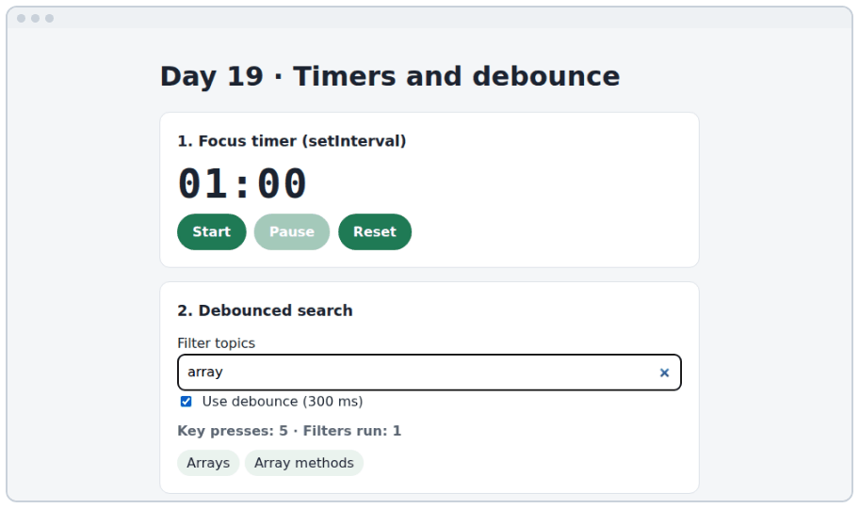
Figure 19.2 · practice/timers.html: the focus timer, and the search box after typing "array"
⇄ MORE WAYS Two ways to count down
WAY 1 Count the ticks (the practice page)
secondsLeft--; // once a second
Simple, and fine for a study timer. Each tick can be a little late, so over an hour it can drift by a few seconds.
WAY 2 Compare with the clock
const endsAt = Date.now() + 60 * 1000;
// in the interval:
const secondsLeft = Math.max(0, Math.ceil((endsAt - Date.now()) / 1000));
Always exact, even if the tab was in the background. Use this for anything important (exams, auctions).

19.7 Debounce: wait until the typing stops
IN PLAIN WORDS
A lift door doesn't close the moment one person walks in. Every new person resets its wait, and it closes only when nobody has come for a few seconds. Debounce does the same for events: every call restarts a short timer, and the real work runs once, after the calls stop.

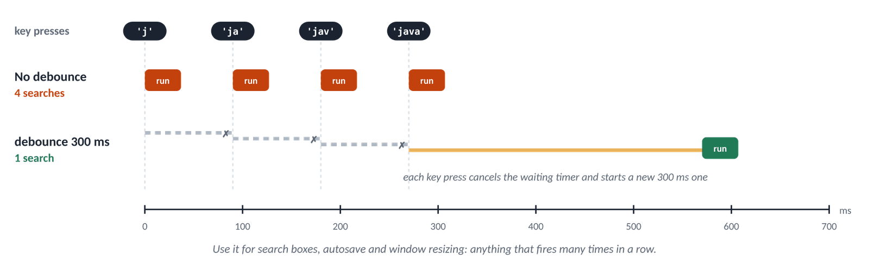
Figure 19.3 · Four quick key presses: four searches without debounce, one search with it
JS · Exercise 6: debounce(fn, ms)
function debounce(fn, ms) {
let timerId; // kept between calls: a closure
return (...args) => {
clearTimeout(timerId); // cancel the previous wait…
timerId = setTimeout(() => fn(...args), ms); // …and start a new one
};
}
const search = debounce((query) => console.log('searching for', query), 300);
search('j');
search('ja');
search('jav');
search('java'); // four calls, no pause between
console.log('typed 4 letters');
▶ CONSOLE OUTPUT
typed 4 letters
searching for java

JS · practice/timers.js, section 2: the same box, with and without debounce
const debouncedFilter = debounce(runFilter, 300);

searchInput.addEventListener('input', () => {
keyPresses++;
if (useDebounce.checked) debouncedFilter(searchInput.value); // waits for a pause
else runFilter(searchInput.value); // runs on every key
});

Typing "array" quickly | Without debounce | With debounce (300 ms)
Key presses | 5 | 5
Times the filter runs | 5 | 1
If each run asked a server | 5 requests, 4 wasted | 1 request

⇄ MORE WAYS Three ways to handle events that fire very often
WAY 1 Run every time
input.addEventListener('input', runFilter);
Fine when the work is cheap, like filtering 20 topics.
WAY 2 Debounce: after a pause
input.addEventListener('input', debounce(runFilter, 300));
Search boxes, autosave, "check if the username is free", window resizing.
WAY 3 Throttle: at most every X ms
function throttle(fn, ms) {
let last = 0;
return (...args) => {
const now = Date.now();
if (now - last >= ms) {
last = now;
fn(...args);
}
};
}
For continuous actions where you want regular updates while they happen: scroll position, dragging, a progress bar.

19.8 localStorage: data that survives a reload
Everything in your variables disappears when the page reloads. localStorage is a small store in the browser, one per website, that keeps strings under keys until the user or your code removes them, even after the computer restarts.
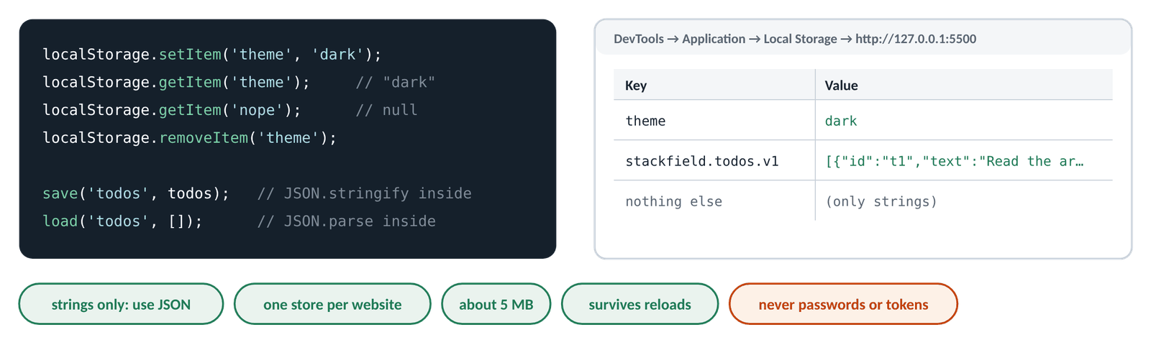
Figure 19.4 · The four localStorage calls, and the same data in DevTools → Application → Local Storage
JS · setItem, getItem, removeItem
localStorage.setItem('theme', 'dark'); // save (key, value)
console.log(localStorage.getItem('theme'));
console.log(localStorage.getItem('nope')); // never saved: null
localStorage.setItem('visits', 3); // numbers become strings!
console.log(localStorage.getItem('visits'), typeof localStorage.getItem('visits'));
localStorage.removeItem('theme');
console.log(localStorage.length); // only 'visits' is left
▶ CONSOLE OUTPUT
dark
null
3 string
1

JS · arrays and objects need JSON
const todos = [{ id: 't1', text: 'Read', done: true }];
localStorage.setItem('todos-bad', todos); // ✗ no JSON
console.log(localStorage.getItem('todos-bad'));
localStorage.setItem('todos', JSON.stringify(todos)); // ✓ save as JSON text
const loaded = JSON.parse(localStorage.getItem('todos'));
console.log(loaded[0].text, loaded.length);
▶ CONSOLE OUTPUT
[object Object]
Read 1

Fact | What it means for you
Strings only | JSON.stringify to save, JSON.parse to load
One store per website (origin) | localhost:5500 and your Vercel site have separate stores
About 5 MB | plenty for settings and to-do lists, not for photos
Readable by any script on the page | never store passwords, tokens or personal data
Can be blocked or full | wrap it in try / catch (Day 20's storage.js)
The user can clear it | always have a default: getItem(…) ?? 'light'

⇄ MORE WAYS Three places to keep data in the browser
WAY 1 A variable
let theme = 'dark';
Gone on reload. Perfect for things that don't need to last.
WAY 2 sessionStorage
sessionStorage.setItem('step', '2');
Same methods as localStorage, but only for this tab, until it closes. Good for a half-filled form.
WAY 3 localStorage
localStorage.setItem('theme', 'dark');
Stays until cleared. Settings, drafts, offline lists. (For big or shared data: a server and database, from Month 3.)

JS · practice/theme.js (shortened): save a choice, read it back
const KEY = 'theme';

function applyTheme(theme) {
document.documentElement.dataset.theme = theme; // <html data-theme="dark">
buttons.forEach((button) => {
button.setAttribute('aria-pressed', String(button.dataset.theme === theme));
});
}

themeButtons.addEventListener('click', (event) => { // delegation again
const button = event.target.closest('button');
if (!button) return;
localStorage.setItem(KEY, button.dataset.theme); // 1. save
applyTheme(button.dataset.theme); // 2. show
});

// On page load: the saved choice, or the operating system's setting
const prefersDark = matchMedia('(prefers-color-scheme: dark)').matches;
const systemTheme = prefersDark ? 'dark' : 'light';
applyTheme(localStorage.getItem(KEY) ?? systemTheme);

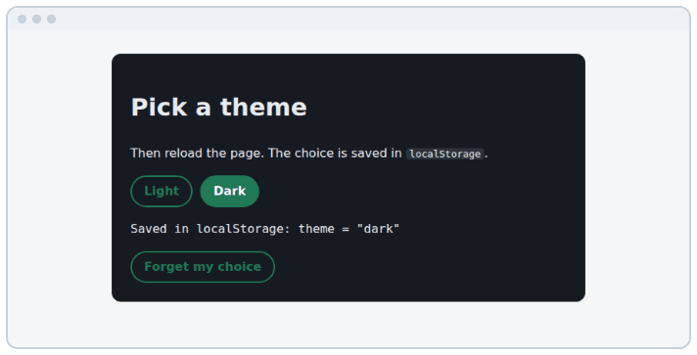
Figure 19.5 · practice/theme.html: choose Dark, reload, and it's still dark
TIP
DevTools → Application → Local Storage → your site shows every saved key. You can edit or delete values there, which is the fastest way to test "what if the saved data is missing or broken?"

19.9 State and render: the to-do list, part 1
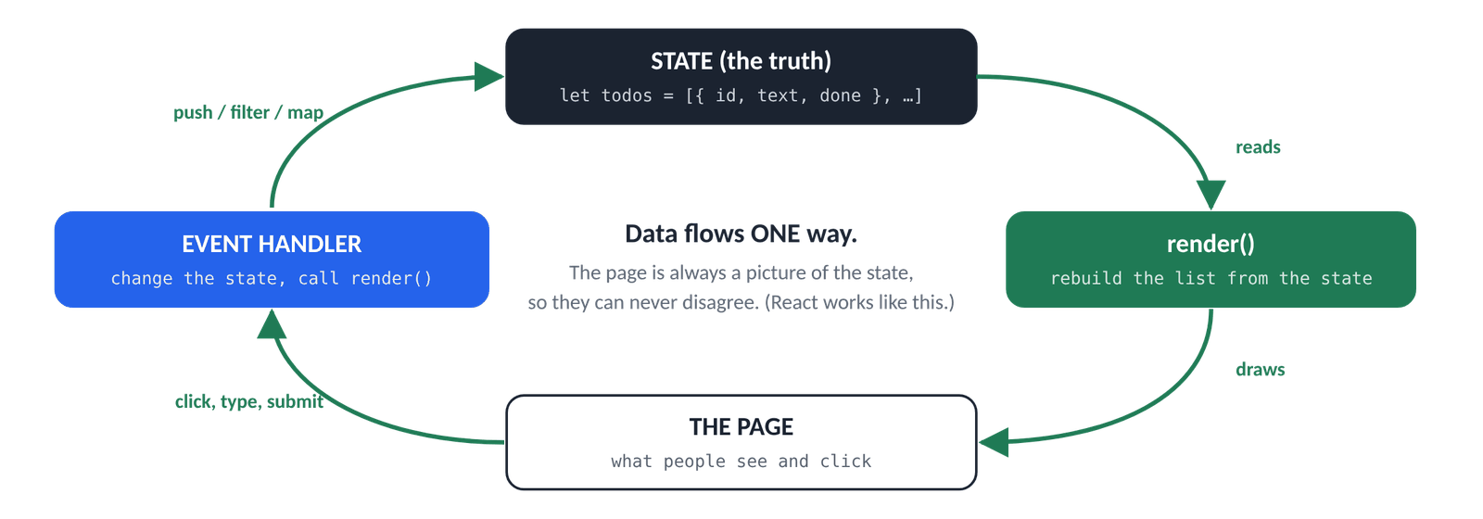
Figure 19.6 · Data flows one way: an event changes the state, render() redraws the page from it
★ MUST KNOW the ideas to remember from today
- The truth lives in the todos array (the state), not in the page.
- Event handlers only change the array…
- …then call render(), which rebuilds the list from the array.

Because the page is always redrawn from the array, the two can never disagree. You never ask the page "is this task done?"; you ask the array. It's the same idea as 17.8, now with objects and three kinds of change.
JS · the three changes, on the data alone
let todos = [
{ id: 't1', text: 'Read the arrays chapter', done: true },
{ id: 't2', text: 'Solve Two Sum', done: false },
];
todos.push({ id: 't3', text: 'Build the to-do widget', done: false }); // add
todos.find((t) => t.id === 't2').done = true; // toggle
todos = todos.filter((t) => t.id !== 't1'); // delete
console.log(todos.map((t) => `${t.done ? '☑' : '☐'} ${t.text}`));
console.log(todos.filter((t) => !t.done).length, 'left');
▶ CONSOLE OUTPUT
['☑ Solve Two Sum', '☐ Build the to-do widget']
1 left

JS · widgets/js/main.js, section 5: one row, and render()
function createTodoItem(todo) {
const item = document.createElement('li');
item.className = 'todo-item';
item.classList.toggle('is-done', todo.done);
item.dataset.id = todo.id; // which task this row shows

const checkbox = document.createElement('input');
checkbox.type = 'checkbox';
checkbox.className = 'todo-toggle';
checkbox.id = `todo-${todo.id}`;
checkbox.checked = todo.done;

const label = document.createElement('label');
label.className = 'todo-text';
label.htmlFor = checkbox.id; // clicking the text ticks the box
label.textContent = todo.text; // safe for any text

const remove = document.createElement('button');
remove.type = 'button';
remove.className = 'icon-button todo-delete';
remove.textContent = '×';
remove.setAttribute('aria-label', `Delete: ${todo.text}`);

item.append(checkbox, label, remove);
return item;
}

function render() {
todoList.replaceChildren(...todos.map(createTodoItem));
const left = todos.filter((todo) => !todo.done).length;
todoCount.textContent = `${left} ${left === 1 ? 'task' : 'tasks'} left`;
}

JS · section 5: three handlers, each "change the array, then render"
// ADD
todoForm.addEventListener('submit', (event) => {
event.preventDefault();
const text = todoInput.value.trim();
if (text === '') return; // ignore empty tasks
todos.push({ id: createId(), text, done: false });
todoInput.value = '';
render();
});

// TOGGLE: one delegated 'change' listener for every checkbox
todoList.addEventListener('change', (event) => {
if (!event.target.matches('.todo-toggle')) return;
const id = event.target.closest('.todo-item').dataset.id;
todos.find((t) => t.id === id).done = event.target.checked;
render();
document.getElementById(`todo-${id}`).focus(); // the old checkbox was replaced
});

// DELETE: one delegated 'click' listener for every × button
todoList.addEventListener('click', (event) => {
const button = event.target.closest('.todo-delete');
if (!button) return;
const id = button.closest('.todo-item').dataset.id;
todos = todos.filter((t) => t.id !== id);
render();
todoInput.focus(); // the row that had focus is gone
});

render();

Event | Changes the array with | Then
submit | todos.push({ id, text, done: false }) | render(), clear the input
change (checkbox) | find(…) then .done = checked | render(), focus the new checkbox
click (×) | todos = todos.filter(…) | render(), focus the input

Why the focus lines? render() throws the old elements away and builds new ones. If the element that had keyboard focus is replaced, focus falls back to the top of the page, and a keyboard user loses their place. Putting focus back on the matching new element (or the input) fixes it.
Where do ids come from? createId() joins the time and a few random characters: Date.now().toString(36) + Math.random().toString(36).slice(2, 6), e.g. 'mgaxv3k0q7zp'. Unique enough for one person's list. (Browsers also have crypto.randomUUID(), but it only works on HTTPS and localhost.)

19.10 DSA: LeetCode 1, Two Sum
The problem. Given nums and a target, return the indexes of the two numbers that add up to target. There is exactly one answer, and you can't use the same item twice. nums = [2, 7, 11, 15], target = 9 → [0, 1] (2 + 7). This is LeetCode's problem number 1 and one of the most-asked interview questions anywhere.
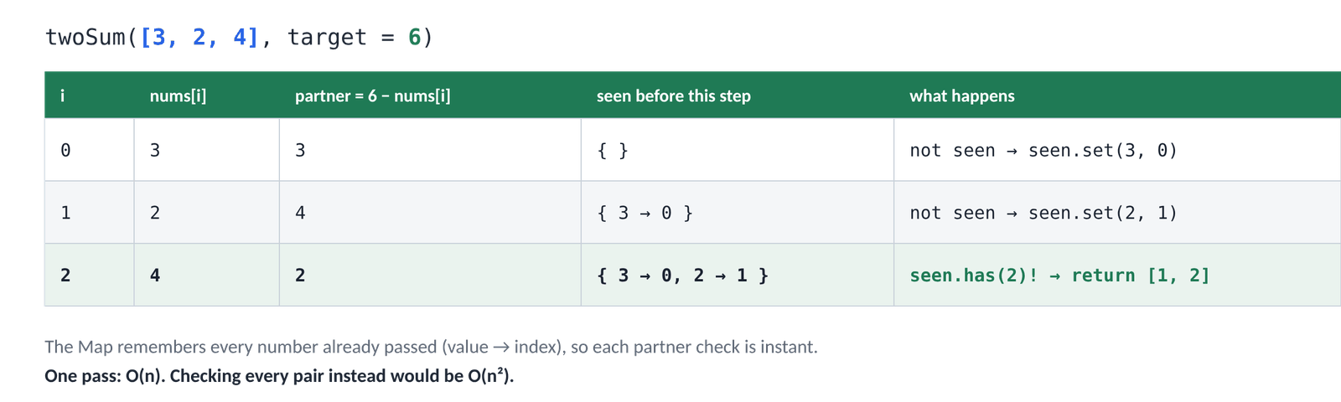
Figure 19.7 · One pass with a Map: at index 2 the partner (2) has already been seen
- Flip the question: for each number, the partner you need is target - number. For 7 and target 9, the partner is 2.
- Slow way: for each number, search the rest of the array for its partner: every pair, O(n²).
- Fast way: walk once, and remember every number you pass in a Map (number → its index). At each number, ask the Map: "have I seen my partner?" If yes, you're done.
- Order matters: check the Map before adding the current number, so a number is never paired with itself.

⇄ MORE WAYS Two Sum three ways (dsa/1-two-sum.js)
WAY 1 Try every pair
function twoSumPairs(nums, target) {
for (let i = 0; i < nums.length; i++) {
for (let j = i + 1; j < nums.length; j++) {
if (nums[i] + nums[j] === target) return [i, j];
}
}
return [];
}
Correct and easy to explain first in an interview. Time O(n²).
WAY 2 One pass with a Map
function twoSum(nums, target) {
const seen = new Map(); // value → its index
for (let i = 0; i < nums.length; i++) {
const partner = target - nums[i];
if (seen.has(partner)) {
return [seen.get(partner), i]; // the partner came earlier
}
seen.set(nums[i], i);
}
return [];
}
Time O(n), extra space O(n). The answer interviewers are waiting for, and the same "remember what you've seen" idea as Contains Duplicate.
WAY 3 The same with a plain object
function twoSumObject(nums, target) {
const seen = {};
for (let i = 0; i < nums.length; i++) {
const partner = target - nums[i];
if (partner in seen) return [seen[partner], i];
seen[nums[i]] = i;
}
return [];
}
Works because the keys are numbers turned into strings. A Map is cleaner: it keeps any type of key as it is.

▶ RESULT
twoSum([2, 7, 11, 15], 9) → [0, 1]
twoSum([3, 2, 4], 6) → [1, 2]
twoSum([3, 3], 6) → [0, 1]
twoSum([-1, -2, -3, -4, -5], -8) → [2, 4]

JS · Map in one minute
const seen = new Map();
seen.set('apple', 3);
seen.set(42, 'a number key'); // any type of key, kept as it is
console.log(seen.get('apple'), seen.has(42), seen.size);
seen.delete('apple');
console.log(seen);
▶ CONSOLE OUTPUT
3 true 2
Map(1) {42 => 'a number key'}

 | Plain object | Map
Keys | strings (numbers become strings) | any value: numbers, objects…
Size | Object.keys(obj).length | map.size
Read / write | obj[key] / obj[key] = v | map.get(key) / map.set(key, v)
Best for | records with known keys (an expense) | lookups and counting (Two Sum, anagrams)

Build it, step by step
- Open practice/closures.html and write the five functions in closures-starter.js until every test passes.
- Open practice/timers.html. Untick "Use debounce" and type quickly; tick it and compare the counters.
- Open practice/theme.html, choose Dark, reload. Find the value in DevTools → Application → Local Storage, then delete it.
- In the widgets, write the to-do list: the todos array, createTodoItem, render, and the three handlers.
- Test: add (and try an empty task), tick, untick, delete, all with the keyboard too.
- Solve Two Sum, then compare with dsa/1-two-sum.js. Explain the Map version out loud.
- Commit: git commit -m "Day 19: closures, timers, localStorage and the to-do list" and push.

★ MUST KNOW the ideas to remember from today
- A closure = a function + the variables it remembers from where it was created.
- Closures give private state (createCounter) and configured helpers (makeMultiplier, debounce).
- In loops, let makes a new variable per lap; var shares one.
- Timer callbacks run after the current code finishes, even with 0 ms.
- Keep timer ids; clearTimeout / clearInterval what you start.
- Debounce = wait for a pause, then run once.
- localStorage stores strings: JSON.stringify to save, JSON.parse to load; never secrets.
- State → render(): handlers change the data, render() redraws the page.

WATCH OUT
- setTimeout(fn(), 500): fn runs immediately.
- Starting a second interval because the Start button wasn't disabled.
- Saving an array without JSON: you get "[object Object]".
- Forgetting that getItem gives null when nothing is saved.
- Changing the page directly in a handler instead of changing the array and rendering.
- Losing keyboard focus after a re-render.

QUESTIONS LEARNERS ASK
Q Do closures use a lot of memory?
Only for the variables they actually keep alive, which is tiny in normal code. It becomes a problem only if you keep huge data alive by accident, e.g. an interval you never clear.
Q Why not just use a global variable instead of a closure?
Globals can be changed by any script on the page and clash with other names. A closure keeps the data private and lets you create as many independent copies as you need.
Q Is rebuilding the whole list on every change slow?
For tens or hundreds of items, no: it's instant. For thousands, you'd update only what changed, which is what React does for you in Month 2.
Q Is localStorage safe?
For preferences and to-do items, yes. For passwords, tokens or personal data, no: any script on the page (including an XSS attack) can read it.

More practice
MORE PRACTICE · try each one, then check the Answers at the back
- Write createToggle() returning a function that returns true, false, true, … on each call.
- Write rateLimit(fn, max) that lets fn run at most max times, then ignores calls.
- Print "3", "2", "1", "Go!" one second apart.
- Count how many times a page has been opened, and show "Visit number N".
- Add "Mark all done" to the to-do list.
- Solve Two Sum when the array is already sorted, without a Map.

Check yourself
- What is a closure? Give an example from this week.
- Why do you need JSON.stringify before saving to localStorage?
- What does debouncing do, and where would you use it?
Answer out loud before you turn to the Answers section at the back.
DONE WHEN · tick these off, then mark the day done in your Logbook
- All closure tests pass, and you can explain createCounter and debounce out loud
- You've seen the debounce difference and found the theme in Local Storage
- The to-do list adds, toggles and deletes, with the mouse and the keyboard
- Two Sum accepted; committed and pushed

Resources
All free. Every name is a link, in Word and in the PDF.
Resource (click to open) | Use it for
javascript.info: Variable scope, closure  javascript.info/closure | The clearest explanation of closures, with pictures
MDN: Closures  developer.mozilla.org/en-US/docs/Web/JavaScript/Guide/Closures | The official guide, with practical examples
javascript.info: Scheduling: setTimeout and setInterval  javascript.info/settimeout-setinterval | Timers, with tasks
javascript.info: Decorators and forwarding  javascript.info/call-apply-decorators | Includes debounce and throttle tasks
javascript.info: LocalStorage, sessionStorage  javascript.info/localstorage | Both stores, with examples
MDN: Window.localStorage  developer.mozilla.org/en-US/docs/Web/API/Window/localStorage | The reference
MDN: Map  developer.mozilla.org/en-US/docs/Web/JavaScript/Reference/Global_Objects/Map | set, get, has, and Map vs Object
Loupe  latentflip.com/loupe | Watch the call stack and queue animate your code
What the heck is the event loop anyway? (video)  youtube.com/watch?v=8aGhZQkoFbQ | Philip Roberts' famous 26-minute talk
LeetCode 1: Two Sum  leetcode.com/problems/two-sum | Today's problem

DAY  20 | WEEK 3 · THURSDAY 15 OCTOBER  Build day: modules, the finished to-do list, and going live  Split the code into tidy files, finish the last features, test like a user, and publish.

TIME  3–4 hours | YOU BUILD  The widgets as ES modules, a to-do list with filters, editing and saving, live on Vercel; and Best Time to Buy and Sell Stock | CODE FOLDER  day20-ship

Today you will
- Split a program into ES modules with export and import
- Explain why modules need a web server, and recognise the CORS error
- Write a small storage module with JSON and try / catch
- Keep all of a widget's data in one state object, and save on every change
- Update arrays of objects without mutating them (map, filter, spread)
- Replace if / else chains with lookup objects
- Finish the to-do list: filters, editing, "Clear done" and empty states
- Test the widgets like a real user, then deploy them on Vercel
- Solve LeetCode 121, Best Time to Buy and Sell Stock, two ways

Key terms
Term | Meaning
Module | A JavaScript file with its own scope that shares only what it exports
export / import | Make a value available to other files / use a value from another file
Named export | export function setupTodo…, imported by the same name in { }
Entry point | The first module the page loads (main.js); it imports the rest
CORS | The browser's rules for loading files from another origin
Immutable update | Making a new array or object with the change, instead of editing the old one
Lookup object | An object that maps a key (a filter name, a key name) to a value or function
Empty state | What a list shows when it has nothing to show
Deploy | Publish the site on a server so anyone can open it

20.1 Why split the code into modules?
IN PLAIN WORDS
A restaurant kitchen has stations: grill, salads, desserts. Each has its own tools, and nobody borrows the grill chef's knife by accident. The head chef calls out orders and each station does its part. Modules are stations: each file keeps its own variables, shares only what it exports, and main.js is the head chef.

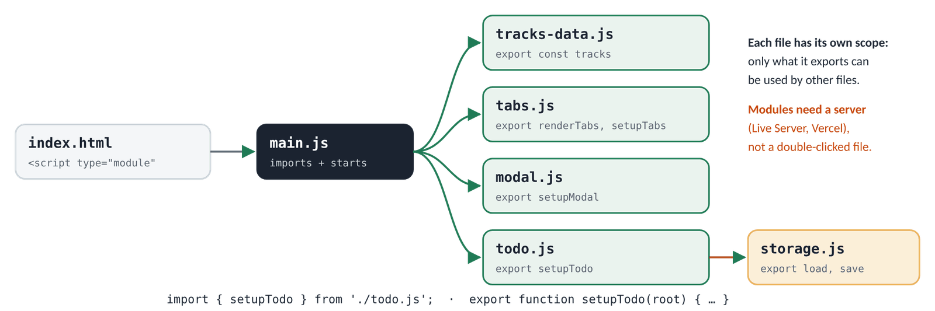
Figure 20.1 · main.js imports one module per widget; todo.js imports storage.js
One 250-line file (Day 19) | Modules (Day 20)
Scroll to find the tabs code | Open tabs.js
Every variable is visible everywhere | Each file has its own scope; only exports are shared
Two widgets both want a variable called list | No clash: each module has its own list
Copy code to reuse it | import { load, save } from './storage.js' anywhere
Helpers anyone can call | selectTab isn't exported, so it stays private to tabs.js

20.2 export and import
JS · what each module shares
// tracks-data.js: the data, nothing else
export const tracks = [ /* … the four track objects … */ ];

// tabs.js: two exports and a private helper
export function renderTabs(root, items) { /* … */ }
export function setupTabs(root) { /* … */ }
function selectTab(root, tab) { /* … */ } // not exported: private to this file

// storage.js
export function load(key, fallback) { /* … */ }
export function save(key, value) { /* … */ }

JS · widgets/js/main.js: the entry point connects the modules
import { tracks } from './tracks-data.js';
import { renderTabs, setupTabs } from './tabs.js';
import { setupModal } from './modal.js';
import { setupTodo } from './todo.js';

// 1. Tabs
const tracksRoot = document.getElementById('tracks');
renderTabs(tracksRoot, tracks);
setupTabs(tracksRoot);

// 2. Modal
setupModal({
openButton: document.getElementById('open-call'),
dialog: document.getElementById('call-dialog'),
status: document.getElementById('call-status'),
});

// 3. To-do list
setupTodo(document.getElementById('todo-title').closest('.widget'));

// 4. The year in the footer
document.getElementById('year').textContent = new Date().getFullYear();

HTML · widgets/index.html: one attribute changes
<!-- Before (Days 16–19) -->
<script src="js/main.js" defer></script>

<!-- After (Day 20): main.js can import other files.
Modules are deferred automatically. -->
<script type="module" src="js/main.js"></script>

Write | Means
export function setupTodo(root) {…} | a named export
import { setupTodo } from './todo.js'; | import it by the same name, in { }
import { load as loadData } from './storage.js'; | import it under a different name
import * as storage from './storage.js'; | everything as one object: storage.load(…)
export default function setupTodo… | a default export (one per file)…
import setupTodo from './todo.js'; | …imported without { }, under any name

⇄ MORE WAYS Named or default exports?
WAY 1 Named exports (this course)
export function setupModal() {}
import { setupModal } from './modal.js';
The name must match, so typos are caught at once, and editors can suggest and auto-import it. A file can export many things.
WAY 2 A default export
export default function setupModal() {}
import openThePopup from './modal.js'; // any name works
Common in React components (Month 2). Flexible, but the same thing can end up with different names in different files.

WATCH OUT
- In the browser, the path needs ./ and the .js ending: './todo.js', not 'todo'. (Build tools let you leave them out later; plain browsers don't.)
- A module's top-level variables are not globals. You can't type tracks in the Console any more. That's the point, but it surprises everyone once. For debugging, add a console.log or a breakpoint.
- Modules always run in strict mode: mistakes that older scripts ignored, such as assigning to an undeclared variable, now throw errors. Good: bugs show up sooner.

20.3 Modules need a web server
Double-click index.html and the widgets are dead. The Console explains:
▶ CONSOLE · a module page opened as a file
Access to script at 'file:///C:/…/widgets/js/main.js' from origin 'null'
has been blocked by CORS policy: Cross origin requests are only supported
for protocol schemes: … http, https.

For security, browsers only load modules over http:// or https://, never from file:// (a page on your disk could otherwise read other files on your disk). The fix is not in your code: open the page through a web server. In VS Code that's Live Server (right-click → Open with Live Server, giving http://127.0.0.1:5500/…), and online it's Vercel.
⇄ MORE WAYS Three ways to run a local web server
WAY 1 Live Server (VS Code)
Right-click index.html → Open with Live Server. It also reloads the page when you save. What this course uses.
WAY 2 Python
python -m http.server 8000 # then open http://localhost:8000
Built in wherever Python is installed. Run it in the folder with index.html.
WAY 3 Node.js
npx serve . # then open the address it prints
Needs Node.js (you'll install it in Month 3 anyway).

20.4 A storage module that never crashes the page
JS · widgets/js/storage.js
export function load(key, fallback) {
try {
const text = localStorage.getItem(key);
return text === null ? fallback : JSON.parse(text); // null = nothing saved yet
} catch (error) {
console.warn(`Could not load "${key}":`, error.message);
return fallback;
}
}

export function save(key, value) {
try {
localStorage.setItem(key, JSON.stringify(value));
} catch (error) {
console.warn(`Could not save "${key}":`, error.message);
}
}

JS · trying load() with good, missing and broken data
function load(key, fallback) {
try {
const text = localStorage.getItem(key);
return text === null ? fallback : JSON.parse(text);
} catch (error) {
console.warn(`Could not load "${key}":`, error.name); // (storage.js: .message)
return fallback;
}
}
localStorage.setItem('demo', JSON.stringify([1, 2]));
console.log(load('demo', [])); // saved data
console.log(load('missing', ['default'])); // nothing saved: the fallback
localStorage.setItem('broken', '{not json'); // someone edited it by hand
console.log(load('broken', [])); // broken: a warning + the fallback
▶ CONSOLE OUTPUT
[1, 2]
['default']
⚠ Could not load "broken": SyntaxError
[]

This copy logs error.name to keep the line short. The real storage.js logs error.message, the full explanation: Expected property name or '}' in JSON at position 1 (line 1 column 2).
What can go wrong | What happens | The widget
Nothing saved yet (first visit) | getItem returns null | uses the sample tasks
The saved text isn't valid JSON | JSON.parse throws → catch | uses the samples, logs a warning
Storage is blocked or full | setItem throws → catch | keeps working, just doesn't save

TIP
The key is 'stackfield.todos.v1'. The prefix avoids clashes with other projects on localhost:5500 (they all share one store). The v1 lets you change the shape of the data later: save under v2 and old, differently-shaped data is simply ignored.

20.5 One state object, saved on every change
Yesterday the list had one piece of state (todos). The finished version needs three: the tasks, which filter is chosen, and which task (if any) is being edited. They live together in one state object, and every change goes through update(), which saves and then renders.
JS · widgets/js/todo.js: the state (shortened)
import { load, save } from './storage.js';

const STORAGE_KEY = 'stackfield.todos.v1';

export function setupTodo(root) {
// … find the form, input, list, empty message, counter and buttons inside root

const state = {
todos: load(STORAGE_KEY, SAMPLE_TODOS), // saved tasks, or the samples
filter: 'all', // 'all' | 'active' | 'done'
editingId: null, // the task being edited, if any
};

function update() { // every change to the tasks ends here
save(STORAGE_KEY, state.todos);
render();
}
// … render(), the actions and the listeners
}

State key | Changed by | Saved?
todos | add, toggle, edit, delete, clear done | yes: update() saves, then renders
filter | the All / Active / Done buttons | no: render() only (starts at All each visit)
editingId | ✎ (start), Enter / Escape / click away (end) | no

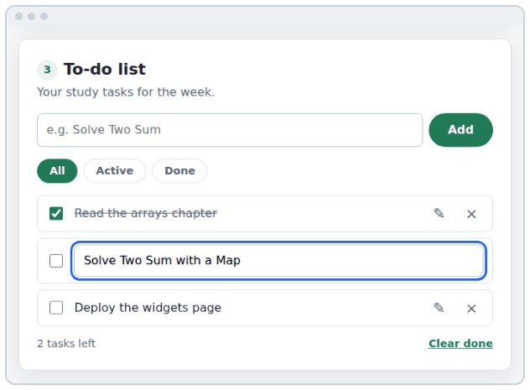
Figure 20.2 · The finished to-do list: filters, a task being edited, "Clear done"

20.6 Changing data without mutating it
On Day 19 the handlers changed the array in place (push, .done = …). The finished list uses the immutable style: every change builds a new array (and new objects for the tasks that changed). It's the style React needs in Month 2, and it makes changes easy to follow.
JS · add, toggle, edit and delete, immutably
let todos = [
{ id: 't1', text: 'Read', done: true },
{ id: 't2', text: 'Code', done: false },
];
const before = todos;
todos = [...todos, { id: 't3', text: 'Ship', done: false }]; // add
todos = todos.map((t) => (t.id === 't2' ? { ...t, done: true } : t)); // toggle
todos = todos.map((t) => (t.id === 't3' ? { ...t, text: 'Ship it' } : t)); // edit
todos = todos.filter((t) => t.id !== 't1'); // delete
console.log(todos.map((t) => `${t.text}: ${t.done}`));
console.log(before.length, before[1].done); // the old array is untouched
▶ CONSOLE OUTPUT
['Code: true', 'Ship it: false']
2 false

Change | Immutable way | Mutating way (Day 19)
Add | [...todos, newTodo] | todos.push(newTodo)
Change one | todos.map((t) => t.id === id ? { ...t, done } : t) | todos.find(…).done = done
Remove one | todos.filter((t) => t.id !== id) | todos.splice(index, 1)
Remove many | todos.filter((t) => !t.done) | a loop of splice (easy to get wrong)

⇄ MORE WAYS Two ways to toggle a task
WAY 1 Mutate: find it and change it
const todo = state.todos.find((t) => t.id === id);
todo.done = done;
Short and fine in small programs. But any other code holding that object sees it change too.
WAY 2 Immutable: map to a new array
state.todos = state.todos.map((todo) =>
(todo.id === id ? { ...todo, done } : todo));
Only the changed task becomes a new object; the rest are reused. You can compare old and new, keep an undo history, and React can tell what changed.

20.7 Filters with a lookup object
JS · a filter name → a test function
const FILTERS = { // one test function per filter
all: () => true,
active: (todo) => !todo.done,
done: (todo) => todo.done,
};
const todos = [
{ text: 'Read', done: true },
{ text: 'Code', done: false },
{ text: 'Ship', done: false },
];
for (const name of Object.keys(FILTERS)) {
console.log(name, todos.filter(FILTERS[name]).map((t) => t.text));
}
▶ CONSOLE OUTPUT
all ['Read', 'Code', 'Ship']
active ['Code', 'Ship']
done ['Read']

Because FILTERS[state.filter] is a function, it can go straight into filter(). The same trick gives each filter its own empty-state message, and FILTERS.active doubles as the "tasks left" counter and the "Clear done" logic.
JS · todo.js: render() with filters and empty states
const EMPTY_MESSAGES = {
all: 'Nothing here yet. Add your first task above.',
active: 'No active tasks. Nice work!',
done: 'No finished tasks yet.',
};

function render() {
const visible = state.todos.filter(FILTERS[state.filter]);
list.replaceChildren(...visible.map(createItem));

empty.hidden = visible.length > 0; // a message, not a blank box
empty.textContent = EMPTY_MESSAGES[state.filter];

const left = state.todos.filter(FILTERS.active).length;
count.textContent = `${left} ${left === 1 ? 'task' : 'tasks'} left`;
clearDone.disabled = !state.todos.some(FILTERS.done);

filterGroup.querySelectorAll('.filter').forEach((button) => {
const isOn = button.dataset.filter === state.filter;
button.setAttribute('aria-pressed', String(isOn));
});
}

HTML · index.html: data-filter says which filter; aria-pressed says which is on
<div class="todo-filters" role="group" aria-label="Show tasks">
<button class="filter" type="button" data-filter="all"
aria-pressed="true">All</button>
<button class="filter" type="button" data-filter="active"
aria-pressed="false">Active</button>
<button class="filter" type="button" data-filter="done"
aria-pressed="false">Done</button>
</div>

⇄ MORE WAYS Three ways to pick the filter function
WAY 1 if / else if
let test;
if (filter === 'active') test = (t) => !t.done;
else if (filter === 'done') test = (t) => t.done;
else test = () => true;
Works; grows longer with every new filter.
WAY 2 switch
switch (filter) {
case 'active': return todos.filter((t) => !t.done);
case 'done': return todos.filter((t) => t.done);
default: return todos;
}
Tidier for many fixed options.
WAY 3 A lookup object (the widget)
const visible = todos.filter(FILTERS[filter]);
Adding a filter ("today", "urgent") is one new line in FILTERS, and nothing else changes.

20.8 Editing a task
Editing is a small state machine. state.editingId holds the id of the task being edited, or null. When render() draws that task, it shows a text box instead of the label and buttons, and puts the cursor in it.
JS · todo.js: the edit flow (shortened)
// In the list's click listener: ✎ was clicked
if (event.target.closest('.todo-edit-button')) {
state.editingId = item.dataset.id;
render(); // createItem() now shows an <input> for it
}

// While editing: Enter saves, Escape cancels
list.addEventListener('keydown', (event) => {
if (!event.target.matches('.todo-edit')) return;
const id = event.target.closest('.todo-item').dataset.id;
if (event.key === 'Enter') saveEdit(id, event.target.value);
if (event.key === 'Escape') cancelEdit();
});

// Clicking somewhere else saves too. 'focusout' bubbles ('blur' doesn't).
list.addEventListener('focusout', (event) => {
if (!event.target.matches('.todo-edit') || state.editingId === null) return;
saveEdit(event.target.closest('.todo-item').dataset.id, event.target.value);
});

function saveEdit(id, text) {
state.editingId = null;
const clean = text.trim();
if (clean !== '') { // an empty edit keeps the old text
state.todos = state.todos.map((t) => (t.id === id ? { ...t, text: clean } : t));
}
update();
}

The person… | Code | Result
clicks ✎ | editingId = id, render() | a text box with the text selected
presses Enter | saveEdit(id, value) | saved (unless empty), back to normal
presses Escape | cancelEdit() | the old text, nothing saved
clicks elsewhere / Tabs away | focusout → saveEdit | saved

Why the `state.editingId === null` check? When Enter saves, render() removes the text box. Removing a focused element fires focusout, which would save a second time. saveEdit sets editingId to null first, so the second call returns early. Small guards like this are what make a widget feel solid.

20.9 Test it like a real user
Before you deploy, spend 15 minutes trying to break the page. Work through this list with the page on Live Server, DevTools open, and the Console visible.
- Keyboard only: reach and use every tab, the modal and every to-do button with Tab, Enter, Space, arrows and Escape
- Add, tick, edit (Enter, Escape, click away), delete and "Clear done"; try an empty task and an empty edit
- Each filter, including the empty-state message for each
- Reload: the tasks are still there. Close the tab and reopen: still there
- DevTools → Application → Local Storage: change the saved value to oops, reload: the samples appear, with one warning
- Add a task called <img src=x onerror=alert(1)>: it shows as text and no alert appears
- Device toolbar at 360px: no sideways scrolling; the tabs scroll inside their row
- No red errors in the Console; Lighthouse Accessibility 90+

20.10 Deploy on Vercel
- Create a new GitHub repository, e.g. stackfield-widgets, and push the widgets folder so that index.html is at the top level of the repository.
- On vercel.com: Add New… → Project → Import your repository → Deploy. There is no build step: it's plain HTML, CSS and JavaScript.
- Open the address Vercel gives you and run the checklist above once more on the live site (and on your phone).
- Add the live link to the repository's README and to your portfolio page from Week 1.

Problem | Why | Fix
404: page not found | index.html isn't at the top level | Set Root Directory in the project settings to the folder that holds it
The page loads, nothing works | a wrong path in an import (letter case matters online!) | match file names exactly: ./todo.js, not ./Todo.js
You still see the old version | your browser cached it | Ctrl+Shift+R (hard reload)
Tasks from Live Server are missing | each site has its own localStorage | expected: the live site starts fresh

Figure 20.3 · The finished widgets page, live: laptop and phone
TIP
Windows doesn't care about capital letters in file names; Vercel's servers do. import … from './Storage.js' works on your laptop and fails online if the file is storage.js. Keep every file name lower-case.

20.11 DSA: LeetCode 121, Best Time to Buy and Sell Stock
The problem. prices[i] is a stock's price on day i. Buy on one day and sell on a later day. Return the biggest profit, or 0 if no trade makes money. [7, 1, 5, 3, 6, 4] → 5 (buy at 1, sell at 6). [7, 6, 4, 3, 1] → 0.
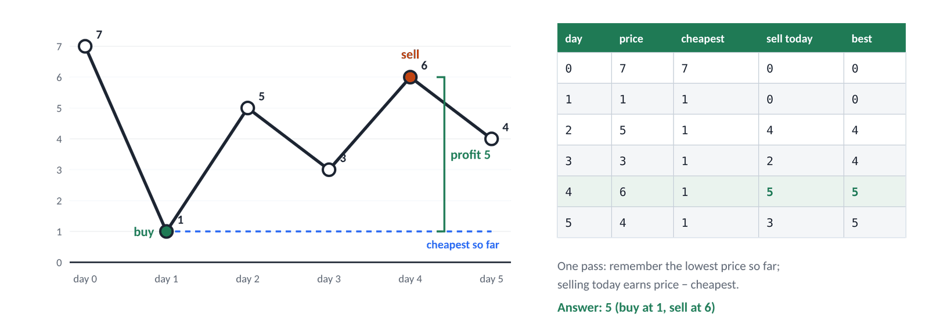
Figure 20.4 · Walking once: remember the cheapest price so far; selling today earns price − cheapest
- Slow way: try every buy day with every later sell day. O(n²).
- Key insight: if you sell today, the best buy day was the cheapest day before today. So you only need to remember one number: the lowest price so far.
- Each day: if today is cheaper than anything before, it's the new best buy day. Otherwise, check whether selling today beats the best profit so far.
- Edge cases: prices that only fall → 0; one day → 0.

⇄ MORE WAYS Best Time to Buy and Sell Stock two ways (dsa/121-best-time-to-buy-and-sell-stock.js)
WAY 1 Every buy day with every later sell day
function maxProfitPairs(prices) {
let best = 0;
for (let buy = 0; buy < prices.length; buy++) {
for (let sell = buy + 1; sell < prices.length; sell++) {
best = Math.max(best, prices[sell] - prices[buy]);
}
}
return best;
}
Obviously correct. Too slow for LeetCode's large tests: 100,000 prices ≈ 5 billion pairs.
WAY 2 One pass: the cheapest price so far
function maxProfit(prices) {
let cheapest = Infinity; // any real price is lower than Infinity
let best = 0;
for (const price of prices) {
if (price < cheapest) {
cheapest = price; // a better day to buy
} else if (price - cheapest > best) {
best = price - cheapest; // selling today beats every earlier plan
}
}
return best;
}
Time O(n), extra space O(1): two variables, whatever the input size.

Day | Price | Cheapest so far | Sell today earns | Best so far
0 | 7 | 7 | 0 | 0
1 | 1 | 1 | 0 | 0
2 | 5 | 1 | 4 | 4
3 | 3 | 1 | 2 | 4
4 | 6 | 1 | 5 | 5
5 | 4 | 1 | 3 | 5

▶ RESULT
maxProfit([7, 1, 5, 3, 6, 4]) → 5
maxProfit([7, 6, 4, 3, 1]) → 0
maxProfit([3, 2, 6, 5, 0, 3]) → 4

The pattern, "walk once and keep the best-so-far", is the same one you used for the maximum in Day 15 and the richest customer on Day 16. Recognising patterns like this is most of what DSA practice is about.

Build it, step by step
- Create tracks-data.js, tabs.js, modal.js, storage.js and todo.js; move each widget's code into its file and add export.
- Make main.js import and start everything; change the script tag to type="module"; open with Live Server.
- Finish the to-do list: filters with aria-pressed, the empty messages, editing (Enter, Escape, click away) and "Clear done".
- Save with storage.js on every change and load on start. Reload to prove it.
- Work through the test checklist in 20.9 and fix what you find.
- Deploy on Vercel and test the live link on your phone.
- Solve Best Time to Buy and Sell Stock; commit: git commit -m "Day 20: widgets as ES modules, finished to-do list, deployed" and push.

★ MUST KNOW the ideas to remember from today
- export shares; import { name } from './file.js' uses. Paths need ./ and .js.
- <script type="module"> is deferred and strict, and needs a web server (not file://).
- Each module has its own scope: no accidental globals.
- Wrap localStorage + JSON.parse in try / catch and always have a fallback.
- One state object; every change → update() = save + render.
- Immutable updates: [...a, x], map with { ...t, key }, filter.
- Lookup objects replace if / else chains (FILTERS[state.filter]).
- Test with the keyboard, after a reload, with broken data, and at 360px before you ship.

WATCH OUT
- Opening a module page by double-clicking it (CORS error).
- Forgetting .js or ./ in an import path, or the wrong capital letters online.
- Expecting module variables to be available in the Console.
- Saving only in some handlers: route every change through update().
- Saving twice when Enter and focusout both fire (guard with editingId).
- A list with no empty state: a blank box looks broken.

QUESTIONS LEARNERS ASK
Q Do I need a bundler like Vite for modules?
Not for a small site: every modern browser loads modules natively. From Month 2, React projects use Vite, which also bundles, minifies and lets you import packages.
Q Why not save the filter too?
You could (add it to what you save). Most apps start each visit on "All", so a task never seems to be missing because a filter was left on.
Q Isn't map over the whole array slower than changing one item?
For a to-do list it makes no difference you could measure. Clear, predictable updates are worth far more.
Q Can two modules import each other?
They can, but it causes confusing bugs. Keep the arrows one way: main.js → widgets → helpers like storage.js.

More practice
MORE PRACTICE · try each one, then check the Answers at the back
- Add a fourth filter, "Today", for tasks created today.
- Show "All done!" in the counter when no tasks are left.
- Make "Clear done" ask "Delete 3 finished tasks?" first.
- Move the modal into a module that can open any dialog: setupModal({ openButton, dialog, onSubmit }).
- Write move(todos, id, direction) that moves a task up or down, immutably.
- Best Time to Buy and Sell Stock II (LeetCode 122): you may trade many times. What's the idea?

Check yourself
- Why does a page with <script type="module"> fail when you double-click it?
- How do you toggle a task's done without mutating the array?
- What does FILTERS[state.filter] give you, and why is it better than an if / else chain?
Answer out loud before you turn to the Answers section at the back.
DONE WHEN · tick these off, then mark the day done in your Logbook
- The widgets are split into modules and work on Live Server
- Filters, editing, "Clear done", empty states and saving all work, and pass the checklist
- The page is live on Vercel, linked from your README and portfolio
- Best Time to Buy and Sell Stock accepted; committed and pushed

Resources
All free. Every name is a link, in Word and in the PDF.
Resource (click to open) | Use it for
javascript.info: Modules, introduction  javascript.info/modules-intro | What modules are and how browsers load them
javascript.info: Export and Import  javascript.info/import-export | Every export and import form
MDN: JavaScript modules  developer.mozilla.org/en-US/docs/Web/JavaScript/Guide/Modules | The complete guide, with examples
MDN: Using the Web Storage API  developer.mozilla.org/en-US/docs/Web/API/Web_Storage_API/Using_the_Web_Storage_API | localStorage and sessionStorage in practice
MDN: try...catch  developer.mozilla.org/en-US/docs/Web/JavaScript/Reference/Statements/try...catch | Handling errors so the page keeps working
TodoMVC  todomvc.com | The same to-do app built in dozens of frameworks: compare with yours
WAI-ARIA Authoring Practices: Keyboard interface  w3.org/WAI/ARIA/apg/practices/keyboard-interface | Roving tabindex and other keyboard patterns
Vercel: Configuring a build  vercel.com/docs/builds/configure-a-build | Including the Root Directory setting
LeetCode 121: Best Time to Buy and Sell Stock  leetcode.com/problems/best-time-to-buy-and-sell-stock | Today's problem

DAY  21 | WEEK 3 · FRIDAY 16 OCTOBER  Week 3 review: theory stops here  Prove it stuck, build one thing from scratch, and plan your first real project.

TIME  2 hours | YOU BUILD  A filterable list from scratch, one problem redone, and the Project 1 plan | CODE FOLDER  day21-review

Today's plan
Time | Block | What you do
30 min | Checkpoint quiz | 10 questions below. Answer out loud first; answers are at the back
30 min | Build task | practice/filter-task.html: a filterable list, from an empty script
45 min | Project 1 plan | Features, a wireframe and the data shape for the Expense Tracker
15 min | Weekly retro | What worked, what was hard, what changes next week

The whole week on one page
Read this table once, slowly. Everything in it is something you should now be able to do or explain.
Topic | Remember
Arrays | Index from 0; length; at(-1); const doesn't freeze the items
Ends of an array | push/pop (end), unshift/shift (start): all mutate
slice vs splice | slice copies a part; splice cuts or inserts in the original
Copy or mutate | [...a], toSorted, with, toSpliced give new arrays; sort, reverse, splice mutate
Searching | includes, indexOf (−1), find (undefined), findIndex, some, every
The big three | map (same length), filter (some items), reduce(fn, start) (one value)
Sorting | (a, b) => a - b for numbers; localeCompare for text; copy first
Set + spread | [...new Set(a)] removes duplicates; Math.max(...a); [...a, ...b]
Objects | Dot for known keys, brackets for variables; in, delete, methods and this
Destructuring | const { a, b: renamed, c = 1 } = obj; const [x, , z, ...rest] = arr
Spread + rest | { ...obj, key: v } copy-and-change; const { id, ...others } = obj; fn(...args)
References | b = a shares; spread is shallow; structuredClone is deep; {} !== {}
Object ↔ array | Object.keys / values / entries, Object.fromEntries
JSON | stringify → text, parse → new object; double quotes; try / catch when parsing
?. and ?? | Read if it exists; default only for null/undefined (keeps 0 and '')
The DOM | querySelector(All), closest; textContent, value, classList, dataset, hidden
Build elements | createElement → fill → append; remove; replaceChildren(...items)
XSS | Visitor text → textContent, never innerHTML
Events | addEventListener(type, fn); target vs currentTarget; input, change, submit, keydown
Bubbling + delegation | One listener on the parent + event.target.closest(sel)
Forms | preventDefault() on submit; new FormData(form); HTML checks required, pattern first
Modal | <dialog> + showModal(); close on ×, Cancel, Escape, backdrop; focus back on close
Closures | A function + the variables it remembers: private state, once, debounce
Timers | setTimeout / setInterval run later; keep the id and clear… it
localStorage | Strings only (JSON); per site; ~5 MB; never secrets; always a fallback
State → render | Handlers change the data; render() redraws from it; restore focus
Modules | export / import { x } from './x.js'; type="module"; needs a server
Immutable updates | [...a, x], map + { ...t, key }, filter
DSA patterns | Running total; best-so-far; Set / Map "seen before"; counting letters

Checkpoint quiz
Answer each question out loud, then check the Answers section.
- What is the difference between map, filter and reduce?
- Why does [10, 9, 100].sort() give [10, 100, 9], and how do you sort numbers correctly?
- What is the difference between slice and splice?
- How do you copy an object and change one key, without changing the original?
- Why do you need JSON.stringify before saving to localStorage?
- Why is element.innerHTML = userInput dangerous, and what should you use instead?
- What is the difference between event.target and event.currentTarget?
- What is event delegation, and why is it useful for a list?
- What is a closure? Give an example from this week.
- What does debouncing do, and where would you use it?

Build task: a filterable list (30 minutes, no copying)
Open practice/filter-task.html with Live Server. The HTML, the CSS and the data (12 resources) are ready; filter-task-starter.js has only the data and five TODOs. Build it with the pattern you used all week: state → work out what to show → render. Compare with filter-task-solution.js only when it works, or after 30 minutes.
It must… | Hint
show one card per resource | createCard(resource) returns an <li class="card">; use textContent
filter by the search text | lower-case both; ''.includes is always true, so an empty box shows all
filter by level | level === 'all' || resource.level === level
show "6 of 12 resources" | a template literal with visible.length and resources.length
show a message when nothing matches | empty.hidden = visible.length > 0
update on every key and choice | input on the search box, change on the select, both call render

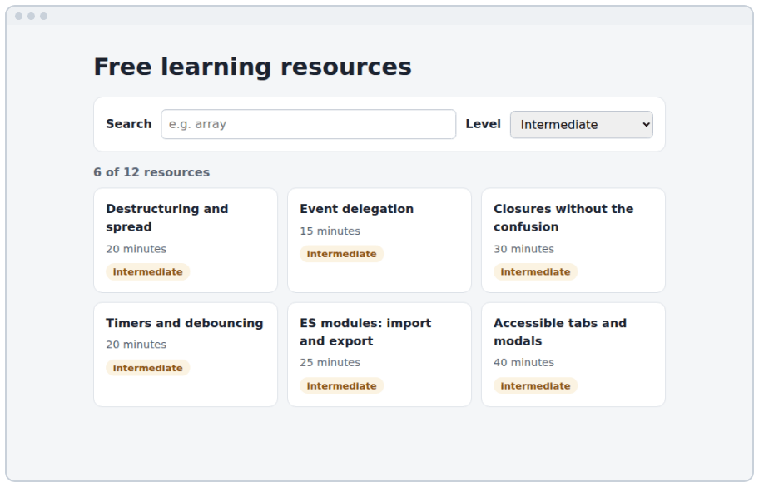
Figure 21.1 · The goal: level "Intermediate" chosen, 6 of 12 resources shown
⇄ MORE WAYS One way to build it (review/filter-task-solution.js)
WAY 1 getVisible: both conditions must pass
function getVisible() {
const query = searchInput.value.trim().toLowerCase();
const level = levelSelect.value;
return resources.filter((resource) => {
const matchesText = resource.title.toLowerCase().includes(query);
const matchesLevel = level === 'all' || resource.level === level;
return matchesText && matchesLevel;
});
}
The controls are the state here: getVisible reads them every time.
WAY 2 createCard: one resource → one element
function createCard({ title, level, minutes }) {
const card = document.createElement('li');
card.className = 'card';
const heading = document.createElement('h2');
heading.textContent = title;
const time = document.createElement('p');
time.textContent = `${minutes} minutes`;
const badge = document.createElement('span');
badge.className = `badge ${level}`;
badge.textContent = level;
card.append(heading, time, badge);
return card;
}
Destructuring in the parameter picks just the three keys it needs.
WAY 3 render + two listeners
function render() {
const visible = getVisible();
cards.replaceChildren(...visible.map(createCard));
summary.textContent = `${visible.length} of ${resources.length} resources`;
empty.hidden = visible.length > 0;
}
searchInput.addEventListener('input', render);
levelSelect.addEventListener('change', render);
render();
Every event simply calls render() again. No event changes the page directly.

TIP
Finished early? Add a third control: "Sort by" (shortest first / longest first). Copy the filtered array, sort it by minutes, then render. Or debounce the search box with your debounce from Day 19.

Redo one problem from memory
Pick the problem from this week that felt hardest and solve it again in a fresh LeetCode editor, without looking. Then say its pattern out loud: patterns are what you carry to new problems.
Problem | Pattern | The key line
1480 · Running Sum | running total (prefix sum) | total += n; result.push(total);
1672 · Richest Customer Wealth | best so far, over rows | richest = Math.max(richest, wealth)
217 · Contains Duplicate | a Set of "seen" values | if (seen.has(n)) return true;
242 · Valid Anagram | counting with an object / Map | counts[letter] = (counts[letter] ?? 0) + 1
1 · Two Sum | a Map of "seen" values | if (seen.has(target - n)) …
121 · Best Time to Buy and Sell | best so far + cheapest so far | best = Math.max(best, price - cheapest)

Plan Project 1: the Expense Tracker
From tomorrow you learn inside projects. Week 4 builds Project 1, an expense tracker, and almost every function it needs you wrote this week. Read the example plan in project1-plan/README.md, then write your own version: features, a wireframe and the shape of your data. Planning first is how you avoid rewriting half the app on day three.

1 · Features (version 1 must have)
- Add an expense: title, amount, category, date
- See all expenses in a list, newest first; delete one
- The total, and the total per category
- Filter by category and by month
- Everything saved in localStorage

Later (version 2): edit an expense, a bar chart per category, export to CSV, and exchange rates from a real API with fetch (Week 4).

2 · A wireframe
TEXT · project1-plan/README.md: laptop layout (one column on phones)
┌────────────────────────────────────────────────────────────────────┐
│ Expense Tracker Total this month Tk 4,390 │
├──────────────────────┬─────────────────────────────────────────────┤
│ Add an expense │ [All categories ▾] [October ▾] │
│ Title [ ] │ 05 Oct Tea and snacks Food Tk 240 × │
│ Amount [ ] │ 03 Oct Internet bill Bills Tk 1,200 × │
│ Category [Food ▾] │ 01 Oct Bus pass Transport Tk 600 × │
│ Date [10/05 ] │ │
│ [Add expense] │ By category: Food Tk 1,090 · Bills … │
└──────────────────────┴─────────────────────────────────────────────┘

3 · The data
JS · the data shape
// One expense
const example = {
id: 'm2x9k1ab', // createId(): unique
title: 'Bus pass',
amount: 600, // a NUMBER in taka: convert the input with Number()
category: 'Transport', // one of CATEGORIES
date: '2026-10-01', // the <input type="date"> format: easy to sort and slice
};

// The state of the whole app
const state = {
expenses: [], // loaded from localStorage
filters: { category: 'all', month: '2026-10' },
};

const CATEGORIES = ['Food', 'Transport', 'Bills', 'Learning', 'Other'];

You already wrote… | This week, where
totalAmount, totalsByCategory, groupByMonth | Day 16 · expenses practice
formatTaka | Day 16 · toLocaleString('en-IN')
load(key, fallback) / save(key, value) | Day 20 · storage.js
state → render(), delegated delete | Days 19–20 · the to-do list
filters with a lookup object | Day 20 · FILTERS
a form read with FormData | Day 18 · the modal

TIP
Keep the plan in the project's README. Tick features off as you build them, and write down every decision you make (e.g. "amounts are whole taka"). Future you, and anyone reviewing your portfolio, will thank you.

Weekly retro
What worked this week?
What was hard?
One thing I'll do differently in Week 4
Hours studied this week

Are you ready for Week 4?
Quiz score | What to do next
9–10 correct | Ready for Week 4 and Project 1. Keep the same routine.
6–8 correct | Re-read the chapters for the questions you missed, redo their "More practice", then retry the quiz.
Below 6 | Redo those days before starting the project. Project 1 uses arrays of objects, the DOM, events and localStorage every day.

Coming up in Week 4
Week 4 · Asynchronous JavaScript and Project 1 (17–23 October). You'll learn how JavaScript waits without freezing (promises, async / await), load real data from the web with fetch, handle errors and loading states, and build and ship Project 1: the Expense Tracker you planned today. Plus five more LeetCode problems, starting with Valid Parentheses (a stack!).
TIP
Week 4 leans on Day 19 (timers and the event loop) and Day 16 (JSON). If either still feels shaky, spend 20 minutes on its "More practice" before Saturday.

DONE WHEN · tick these off, then mark the day done in your Logbook
- Quiz score of 9 or more (after a re-read if needed)
- The filterable list works, built without copying
- Your Project 1 plan is written in its README
- Widgets page live, 6 LeetCode problems solved, and all seven days marked done in your Logbook

BACK OF THE BOOK

Quick reference
Everything you typed this week, on a few pages. Keep them open while you code.

Array methods
Method | Returns | Changes the array?
push(x) / unshift(x) | the new length | yes
pop() / shift() | the removed item | yes
splice(i, n, …add) | the removed items | yes
sort(fn) / reverse() | the same array | yes
slice(start, end) | a copy of part | no
map(fn) | a new array, same length | no
filter(fn) | a new array of the items that pass | no
reduce(fn, start) | one value | no
find(fn) / findIndex(fn) | the first match / its index (or undefined / −1) | no
some(fn) / every(fn) | true / false | no
includes(x) / indexOf(x) | true / false; an index or −1 | no
join(sep) | a string | no
toSorted / toReversed / toSpliced / with | a changed copy | no
forEach(fn) | undefined (for side effects) | no

Array recipes
JS · copy, then adapt
const total = items.reduce((sum, item) => sum + item.price, 0);
const names = users.map((user) => user.name);
const adults = users.filter((user) => user.age >= 18);
const user = users.find((u) => u.id === id);
const hasAdmin = users.some((u) => u.role === 'admin');
const sorted = [...numbers].sort((a, b) => a - b); // small → big
const byName = [...users].sort((a, b) => a.name.localeCompare(b.name));
const unique = [...new Set(list)];
const biggest = Math.max(...numbers);
const lastItem = list.at(-1);
const counts = words.reduce((acc, w) => {
acc[w] = (acc[w] ?? 0) + 1;
return acc;
}, {});
const range = Array.from({ length: 5 }, (_, i) => i + 1); // [1, 2, 3, 4, 5]

Objects
Code | Does
obj.key / obj['key'] / obj[variable] | read a value
obj.key = v / delete obj.key | add or change / remove a key
'key' in obj / Object.hasOwn(obj, 'key') | does the key exist?
Object.keys(obj) / values / entries | arrays of keys / values / [key, value] pairs
Object.fromEntries(pairs) | pairs → an object
{ title, price } | shorthand for { title: title, price: price }
{ [name]: value } | a computed key
structuredClone(obj) | a deep copy
obj?.a?.b / obj.fn?.() | read or call only if it exists
value ?? fallback | fallback only for null / undefined

Destructuring, spread and rest
JS · the three-dot family
const { name, age = 18, city: town } = user; // pick, default, rename
const { profile: { email } } = user; // nested
const [first, second, ...rest] = list; // by position, rest collects
[a, b] = [b, a]; // swap
function show({ title, amount }) { … } // in a parameter

const copy = { ...obj }; // shallow copy
const changed = { ...obj, done: true }; // copy and change one key
const merged = { ...defaults, ...saved }; // later keys win
const { password, ...safe } = user; // everything except password
const joined = [...a, ...b];
function total(...numbers) { … } // any number of arguments

JSON and localStorage
Code | Does
JSON.stringify(value) | data → a JSON string
JSON.stringify(value, null, 2) | the same, pretty-printed
JSON.parse(text) | a JSON string → new data (throws on bad text)
localStorage.setItem(key, JSON.stringify(v)) | save
JSON.parse(localStorage.getItem(key)) | load (getItem gives null if missing)
localStorage.removeItem(key) / .clear() | delete one / everything for this site
try { … } catch (error) { … } | keep going when something throws

The DOM
Code | Does
document.querySelector('.item') | first match, or null
document.querySelectorAll('li') | all matches (NodeList: forEach, or spread for map)
el.closest('.card') / el.matches('.card') | nearest ancestor that matches / is it a match?
el.textContent = text | set text safely
input.value | what a form field holds
el.classList.toggle('is-done', done) | class on if done, off if not
el.dataset.id | reads data-id
el.setAttribute('aria-selected', 'true') | set an attribute (strings)
el.hidden = true | hide it
document.createElement('li') | a new element (not on the page yet)
parent.append(a, b) / prepend / before / after | insert
el.remove() / parent.replaceChildren(...items) | remove / replace everything inside

Events
Code | Does
el.addEventListener('click', fn) | run fn on each click
{ once: true } / { capture: true } | run once / listen on the way down
event.target / event.currentTarget | where it started / whose listener runs
event.target.closest('.todo-item') | the delegation pattern
event.key | 'Enter', 'Escape', 'ArrowRight', 'a'…
event.preventDefault() | no link navigation / no form reload
new FormData(form) + Object.fromEntries | every named field as an object
dialog.showModal() / dialog.close() | open / close a modal <dialog>
input / change / submit / keydown / focusout | the events used this week

Patterns from this week
JS · the shapes you'll reuse in every project
// State → render
const state = { items: load('app.items.v1', []), filter: 'all' };
function update() { save('app.items.v1', state.items); render(); }
function render() { list.replaceChildren(...state.items.map(createItem)); }

// Delegation
list.addEventListener('click', (event) => {
const row = event.target.closest('.item');
if (!row) return;
if (event.target.closest('.delete')) deleteItem(row.dataset.id);
});

// Immutable updates
state.items = [...state.items, newItem]; // add
state.items = state.items.map((i) => (i.id === id ? { ...i, done } : i)); // change
state.items = state.items.filter((i) => i.id !== id); // remove

// Debounce
function debounce(fn, ms) {
let timerId;
return (...args) => {
clearTimeout(timerId);
timerId = setTimeout(() => fn(...args), ms);
};
}

This week's LeetCode problems
* Valid Anagram's counts hold at most 26 letters, however long the words are.
Problem | Best idea | Time | Extra space
1480 · Running Sum of 1d Array | running total | O(n) | O(1) in place
1672 · Richest Customer Wealth | sum rows, best so far | O(m × n) | O(1)
217 · Contains Duplicate | Set of seen values | O(n) | O(n)
242 · Valid Anagram | count letters | O(n) | O(1)*
1 · Two Sum | Map value → index | O(n) | O(n)
121 · Best Time to Buy and Sell Stock | cheapest so far | O(n) | O(1)

DevTools for this week
Where / keys | Does
Console: $0 | the element selected in the Elements panel
Console: copy(value) | copies any value to the clipboard
Console: console.table(array) | an array of objects as a table
Elements: double-click an attribute | edit it live (test aria-selected, hidden, classes)
Elements → Event Listeners tab | which listeners an element has
Application → Local Storage | see, edit and delete saved keys
Sources: breakpoint inside a callback | pause inside map, filter or a listener
Console setting "Preserve log" | keep messages when the page reloads

Where to practise more
Resource (click to open) | Use it for
javascript.info  javascript.info | Every chapter ends with small tasks and solutions
JavaScript30  javascript30.com | 30 small DOM and events projects, free
Exercism: JavaScript  exercism.org/tracks/javascript | Exercises with free mentor feedback
freeCodeCamp  freecodecamp.org/learn | Free, step-by-step JavaScript projects in the browser
NeetCode roadmap  neetcode.io/roadmap | LeetCode problems grouped by pattern (start with "Arrays & Hashing")
MDN: JavaScript Guide  developer.mozilla.org/en-US/docs/Web/JavaScript/Guide | The reference to check any detail

BACK OF THE BOOK

Answers
Try every question on your own first. Reading an answer before trying teaches much less than getting it wrong and then checking.

Day 15 · Arrays
Q1. What is the difference between slice and splice?
slice(start, end) returns a copy of part of the array and leaves the original unchanged. splice(start, count, …items) removes and/or inserts items in the original, and returns the removed items.
Q2. Why does [10, 9, 100].sort() give [10, 100, 9], and how do you fix it?
Without a compare function sort compares items as text, and '1' comes before '9'. Use [...numbers].sort((a, b) => a - b) (or toSorted).
Q3. You need the total price of a cart. Which method would you use, and what start value?
reduce, with 0 as the start value: cart.reduce((sum, item) => sum + item.price, 0).
MORE PRACTICE
P1. Given const fruits = ['mango', 'banana', 'lychee'], write code that prints 3 fruits: mango, banana, lychee.
console.log(fruits.length + ' fruits: ' + fruits.join(', ')); A template literal works too. join(', ') puts a comma and a space between the items.
P2. Make an array of the squares of 1 to 10 without typing them.
Array.from({ length: 10 }, (_, i) => (i + 1) ** 2) → [1, 4, 9, …, 100].
P3. From [' js', 'CSS ', ' Html'], make ['js', 'css', 'html'].
list.map((s) => s.trim().toLowerCase()).
P4. Count how many words in 'the cat and the hat' have 3 letters.
text.split(' ').filter((w) => w.length === 3).length → 4 (the, cat, the, hat).
P5. Find the longest word in ['grid', 'flexbox', 'css'].
words.reduce((longest, w) => (w.length > longest.length ? w : longest), '') → 'flexbox'. Or sort a copy by length, big first, and take [0].
P6. Write last(arr, n) that returns the last n items, e.g. last([1, 2, 3, 4], 2) → [3, 4].
const last = (arr, n) => arr.slice(-n); (watch out: slice(-0) is slice(0), the whole array, so handle n = 0 with an if if you need it).
P7. Move the first item of an array to the end, without mutating it: [1, 2, 3] → [2, 3, 1].
const rotated = [...arr.slice(1), arr[0]];
P8. Why does [1, 2, 3].includes('2') return false?
includes compares with ===, and the string '2' is not the number 2.

Day 16 · Objects + JSON
Q1. When must you use brackets instead of a dot to read a key?
When the key is in a variable (obj[key]), or isn't a valid name: it has spaces or dashes, or starts with a digit (obj['favourite topic']).
Q2. After const copy = { ...original }, why can changing copy.tags still change original?
Spread makes a shallow copy: a new outer object, but tags still points to the same array. Use structuredClone(original) for a deep copy, or copy the array too: { ...original, tags: [...original.tags] }.
Q3. Why do you need JSON.stringify before saving an object, and what does JSON.parse give back?
Storage and networks only carry text, so the object must become a string. JSON.parse turns the string back into a new object with the same data (not the same object).
MORE PRACTICE
P1. Create an object book with a title, an author, a year and a method age() that returns how many years old it is in 2026.
const book = { title: '…', author: '…', year: 2008, age() { return 2026 - this.year; } }; → book.age() is 18.
P2. Given const scores = { math: 80, english: 72, physics: 91 }, find the subject with the highest score.
Object.entries(scores).sort((a, b) => b[1] - a[1])[0][0] → 'physics'. Or loop over the entries and keep the best.
P3. Swap the keys and values of { a: 1, b: 2 } to get { 1: 'a', 2: 'b' }.
Object.fromEntries(Object.entries(obj).map(([k, v]) => [v, k])).
P4. Remove the password key from a user object without changing the original.
const { password, ...safeUser } = user; then use safeUser.
P5. Count how many expenses each category has: { Food: 2, Transport: 1, … }.
expenses.reduce((acc, e) => { acc[e.category] = (acc[e.category] ?? 0) + 1; return acc; }, {}).
P6. What does JSON.parse(JSON.stringify({ a: [1, 2] })) give, and is it a deep copy?
A new object { a: [1, 2] } with a new inner array: yes, a deep copy, but it loses functions, undefined values and dates. structuredClone is the better tool.
P7. Write pick(obj, keys) so that pick({ a: 1, b: 2, c: 3 }, ['a', 'c']) gives { a: 1, c: 3 }.
const pick = (obj, keys) => Object.fromEntries(keys.map((k) => [k, obj[k]]));

Day 17 · The DOM
Q1. What does querySelectorAll return, and why can't you call map on it straight away?
A NodeList: a list-like object, not a real array. It has forEach and length, but not map or filter. Spread it first: [...nodeList].map(…) (or Array.from).
Q2. Why is element.innerHTML = userInput dangerous, and what should you use instead?
The browser turns the text into real HTML, so a visitor could inject elements whose code runs on your page (XSS). Use textContent, which always shows text as text.
Q3. What three things does selectTab change on each tab and panel?
aria-selected ("true" only on the chosen tab), tabIndex (0 for the chosen tab, −1 for the others) and the panel's hidden (false only for the chosen tab's panel).
MORE PRACTICE
P1. Log the text of every <li> on a page in one line.
console.log([...document.querySelectorAll('li')].map((li) => li.textContent));
P2. Add the class highlight to every even item in a list (2nd, 4th, …).
document.querySelectorAll('li:nth-child(even)').forEach((li) => li.classList.add('highlight')); or check index % 2 === 1 in forEach.
P3. Write el(tag, text, className) that creates an element in one call.
function el(tag, text, className = '') { const e = document.createElement(tag); e.textContent = text; e.className = className; return e; }
P4. Build a <table> from expenses (Day 16) with a row per expense and cells for title and amount.
For each expense: const tr = document.createElement('tr'); then append two td elements with textContent set; append each tr to the tbody. Or map to rows and use tbody.replaceChildren(...rows).
P5. Make the counter never go above 10 and disable + at 10.
In renderCount: plusButton.disabled = count === 10;, and guard the listener: if (count < 10) count++;.
P6. Move the first item of a list to the end with one line.
list.append(list.firstElementChild);: appending an element that's already on the page moves it.

Day 18 · Events
Q1. What is the difference between event.target and event.currentTarget?
target is the element where the event started (what was actually clicked). currentTarget is the element whose listener is running now; it changes as the event bubbles up.
Q2. What is event delegation, and why is it useful for a list?
One listener on a parent handles events from all its children, because events bubble up. It needs fewer listeners and works for items added later, which is exactly what a changing list needs.
Q3. Name three ways the modal can close, and what happens to keyboard focus afterwards.
Any three of: ×, Cancel, Escape, a click on the backdrop, submitting the form. In every case the close event runs openButton.focus(), so focus returns to "Book a free call".
MORE PRACTICE
P1. Log the x and y position of every click on the page.
document.addEventListener('click', (e) => console.log(e.clientX, e.clientY));
P2. Make a text box that shows its value in upper case in a <p> as you type.
input.addEventListener('input', () => { output.textContent = input.value.toUpperCase(); });
P3. Press "/" anywhere on the page to focus the search box (like GitHub and YouTube).
document.addEventListener('keydown', (e) => { if (e.key === '/' && document.activeElement !== search) { e.preventDefault(); search.focus(); } });: preventDefault stops the "/" being typed into the box.
P4. In a delegated list, make a click on the text toggle .done, and a click on × delete the item.
In one listener: const item = e.target.closest('li'); if (!item) return; if (e.target.closest('.delete')) item.remove(); else item.classList.toggle('done');: see delegation.js.
P5. Add a keyboard shortcut: Ctrl+Enter submits the modal's form.
On the form: form.addEventListener('keydown', (e) => { if (e.key === 'Enter' && e.ctrlKey) form.requestSubmit(); });. requestSubmit() still runs the required checks.
P6. Why does -1 % 4 give -1 in JavaScript, and how do you get 3?
JavaScript's % keeps the sign of the left number. Add the length first: (-1 + 4) % 4 → 3.

Day 19 · Closures
Q1. What is a closure? Give an example from this week.
A function that remembers the variables from the place where it was created, even after that outer function has finished. Example: createCounter() returns methods that share a private count; debounce keeps its timerId between calls.
Q2. Why do you need JSON.stringify before saving to localStorage?
localStorage only stores strings. JSON.stringify turns arrays and objects into a string; without it you save "[object Object]". JSON.parse turns the string back into data.
Q3. What does debouncing do, and where would you use it?
It waits until calls stop for a set time, then runs once with the latest value. Use it for search boxes, autosave, username checks and window resizing.
MORE PRACTICE
P1. Write createToggle() returning a function that returns true, false, true, … on each call.
function createToggle() { let on = false; return () => (on = !on); }
P2. Write rateLimit(fn, max) that lets fn run at most max times, then ignores calls.
function rateLimit(fn, max) { let calls = 0; return (...args) => { if (calls < max) { calls++; return fn(...args); } }; }
P3. Print "3", "2", "1", "Go!" one second apart.
Either a setInterval that counts down and clears itself at 0, or three setTimeouts with delays 1000, 2000, 3000 (and 4000 for "Go!").
P4. Count how many times a page has been opened, and show "Visit number N".
const visits = Number(localStorage.getItem('visits') ?? 0) + 1; localStorage.setItem('visits', visits);
P5. Add "Mark all done" to the to-do list.
todos.forEach((t) => { t.done = true; }); render(); (or todos = todos.map((t) => ({ ...t, done: true })), the Day 20 style).
P6. Solve Two Sum when the array is already sorted, without a Map.
Two pointers from both ends: sum too small → left++; too big → right-- (LeetCode 167).

Day 20 · Ship it
Q1. Why does a page with <script type="module"> fail when you double-click it?
Browsers only load modules over http(s). Opened from file://, the import is blocked by the CORS rules. Use Live Server locally, and Vercel online.
Q2. How do you toggle a task's done without mutating the array?
state.todos = state.todos.map((t) => (t.id === id ? { ...t, done: !t.done } : t));: a new array, with a new object only for the task that changed.
Q3. What does FILTERS[state.filter] give you, and why is it better than an if / else chain?
The test function for the chosen filter, ready to pass to filter(). Adding a filter is one line of data instead of another branch of logic, and the same object can be used for counts and empty messages.
MORE PRACTICE
P1. Add a fourth filter, "Today", for tasks created today.
Save createdAt: Date.now() on new tasks; add a today test to FILTERS that compares toDateString() of createdAt and of now; add a button and an empty message.
P2. Show "All done!" in the counter when no tasks are left.
In render(), choose the text with a ternary: left === 0 ? 'All done!' : …, with the usual "N tasks left" text in the other branch.
P3. Make "Clear done" ask "Delete 3 finished tasks?" first.
if (!confirm('Delete ' + n + ' finished tasks?')) return; before changing the state. (A second <dialog> is the nicer way.)
P4. Move the modal into a module that can open any dialog: setupModal({ openButton, dialog, onSubmit }).
Accept a callback onSubmit(data) and call it instead of writing the thank-you text inside the module.
P5. Write move(todos, id, direction) that moves a task up or down, immutably.
Copy with [...todos], then swap the item with its neighbour: [a[i], a[j]] = [a[j], a[i]].
P6. Best Time to Buy and Sell Stock II (LeetCode 122): you may trade many times. What's the idea?
Add up every rise: for each day, if prices[i] > prices[i - 1], add the difference. That captures every profitable stretch.

Day 21 · Checkpoint quiz
Q1. What is the difference between map, filter and reduce?
map changes every item (same length); filter keeps some items (a shorter array); reduce combines all items into one value.
Q2. Why does [10, 9, 100].sort() give [10, 100, 9], and how do you sort numbers correctly?
Without a compare function sort compares items as text, and '1' comes before '9'. Use [...numbers].sort((a, b) => a - b) (or toSorted).
Q3. What is the difference between slice and splice?
slice(start, end) returns a copy of part of the array and leaves it unchanged; splice(start, count, …items) removes and/or inserts items in the original.
Q4. How do you copy an object and change one key, without changing the original?
const copy = { ...original, key: newValue };: a shallow copy. Use structuredClone first if you will change nested data.
Q5. Why do you need JSON.stringify before saving to localStorage?
localStorage only stores strings. JSON.stringify turns arrays and objects into a string; JSON.parse turns it back.
Q6. Why is element.innerHTML = userInput dangerous, and what should you use instead?
The browser turns the text into real HTML, so a visitor could inject code that runs on your page (XSS). Use textContent.
Q7. What is the difference between event.target and event.currentTarget?
target is the element where the event started (what was actually clicked); currentTarget is the element whose listener is running.
Q8. What is event delegation, and why is it useful for a list?
One listener on a parent handles events from all its children, because events bubble up. It works for items added later and needs fewer listeners.
Q9. What is a closure? Give an example from this week.
A function that remembers the variables from where it was created, e.g. createCounter() returning functions that share a private count, or debounce keeping its timerId.
Q10. What does debouncing do, and where would you use it?
It waits until calls stop for a set time, then runs once. Use it for search boxes, autosave and window resizing.

BACK OF THE BOOK

Glossary
Term | Meaning
Accumulator | The running value reduce passes from one item to the next
aria-pressed / aria-selected | Attributes that tell screen readers a button is on / a tab is chosen
Array | An ordered list of values, indexed from 0
Bubbling | An event travelling up from its target through every ancestor
Callback | A function passed to another function, to be called by it
Capture | The first phase of an event, travelling down to the target
Closure | A function plus the variables it remembers from where it was created
Compare function | (a, b) => … telling sort which item goes first
CORS | Browser rules for loading files across origins; why modules need a server
currentTarget | The element whose event listener is running
data-* attribute | Your own attribute on an element, read with el.dataset
Debounce | Run a function only after calls have stopped for a set time
Deep copy | A copy that also copies every nested array and object
Default action | What the browser does on its own, e.g. following a link
Delegation | One listener on a parent handling events from its children
Destructuring | Unpacking values from objects or arrays into variables
Dialog (modal) | A box on top of the page that must be closed before going back
DOM | The page as a tree of objects that JavaScript can read and change
Empty state | The message a list shows when there is nothing in it
Entry point | The first module a page loads; it imports the others
Event loop | How JavaScript runs one task at a time from a queue
Event object | The details of an event, passed to the listener
Factory function | A function that creates and returns objects or functions
FormData | An object that reads all named fields of a form
Immutable update | Building a new array or object instead of changing the old one
Index | An item's position in an array, starting at 0
JSON | A text format for data, with double-quoted keys and strings
localStorage | A per-site key–value store of strings that survives reloads
Lookup object | An object used as a table: a key in, a value or function out
Map | A key–value collection whose keys can be any type
Method | A function stored in an object and called with a dot
Module | A file with its own scope that shares values with export
Mutate | Change a value in place
NodeList | The list-like result of querySelectorAll
Optional chaining | ?.: stop and give undefined if the left side is null or undefined
Predicate | A callback that returns true or false for each item
Prefix sum | A running total of an array: each item is the sum so far
Reference | What a variable holds for an object: a link to it, not a copy
Render | Build part of the page from data
Rest | ... collecting the remaining items, keys or arguments
Roving tabindex | Only the active item in a group can be reached with Tab
Set | A collection that holds each value only once
Shallow copy | A new outer object or array whose inner values are still shared
Spread | ... unpacking an array's items or an object's keys
State | The data that describes what the page should show
target | The element where an event started
this | Inside a method, the object before the dot
Throttle | Run a function at most once every so many milliseconds
XSS | Cross-site scripting: visitor text running as code on your page

BACK OF THE BOOK

Notes
Questions to ask, bugs you fixed, ideas for your projects.

