

Developing SQL Databases

Getting Started

# Overview

Database development is more than just creating a table with rows and columns.  This course introduces features and technologies for developing a database.  It includes topics including logical table design, table implementation, implementing data integrity with constraints, creating indexes, and designing and implementing views.

To complete the labs in this course, you will need to set up a lab environment that includes the

**AdventureWorksLT** sample database. This document explains how to achieve this using Microsoft Azure SQL Database, a cloud-based relational database service. This is the recommended environment for the labs as it requires minimal software installation and configuration on your computer. However, if you prefer, you can install a local instance of SQL Server Express and download and attach the sample database – there are instructions at the end of this document for doing this.

Each module in this course consists of:

* An online video presentation.
* A hands-on lab.

The recommended approach for this course is to complete each module in turn; first watching the online presentation, then completing the lab, and finally answering the review questions for that module. Then, when you’re comfortable with what you’ve learned, move onto the next module and repeat the process. You can complete the course as quickly or slowly as you want, though we recommend pacing yourself to ensure that you absorb the lessons from each module before progressing to the next one.

Each lab consists of a document that contains a number of progressively complex challenges, which you should be able to complete by using the information that was presented in the online presentation as well as the references to further information that are provided in the lab itself. Suggested solution scripts are provided for each lab.

What You’ll Need

* A web browser
* A Microsoft account
* A Microsoft Azure subscription
* A Microsoft Windows* computer with either of the following tools installed:
* Microsoft SQL Server Management Studio
* Microsoft Visual Studio

**\*** The labs were written and tested on Microsoft Windows. If you are using a non-Windows computer, you can install a third-party SQL Server client application for your platform. Microsoft provides no endorsement or support for non-Microsoft client tools, and you install and use them at your own discretion. There are some suggestions for using SQL Server client tools on Linux and Mac OS X at the end of this document.

# Creating a Free Trial Azure Subscription

If you already have a Microsoft Azure subscription, you can skip this section. Otherwise, follow these steps to create a free trial subscription, which includes enough free credit in your local currency to complete the labs. You will need to provide a valid credit card number for verification, but you will not be charged for Azure services – for more information, see the frequently asked questions in the Azure sign-up page.

1. If you already have a Microsoft account that has not already been used to sign up for a free Azure trial subscription, you’re ready to get started. If not, don’t worry, just create a new Microsoft account at [https://signup.live.com.](https://signup.live.com/)
2. After you’ve created a Microsoft account, browse to <https://aka.ms/edx-DAT215.1-az> [a](http://aka.ms/edx-dat201x-az)nd click the

**Free Trial** link. Then follow the instructions to sign up for a free trial subscription to Microsoft Azure. You’ll need to sign-in with your Microsoft account if you’re not already signed in. Then you’ll need to:

* 1. Enter your cellphone number and have Microsoft send you a text message to verify your identity.
  2. Enter the code you have been sent to verify it.
  3. Provide valid payment details – don’t worry, your credit card won’t be charged for any services you use during the trial period, and the account is automatically deactivated at the end of the trial period unless you explicitly decide to keep it active.

# Create an Azure SQL Database

Now that you have an Azure subscription, you can create an Azure SQL Database instance to use in the labs.

1. Browse to [http://portal.azure.com.](http://portal.azure.com/) If you are prompted to sign in, do so with the Microsoft account that is associated with your Azure subscription.
2. At the bottom of the Hub menu (the vertical bar on the left), click **New** (represented by a  symbol if the menu is minimized), and then in the **New** blade that appears, click **Databases**, and then click **SQL Database**.

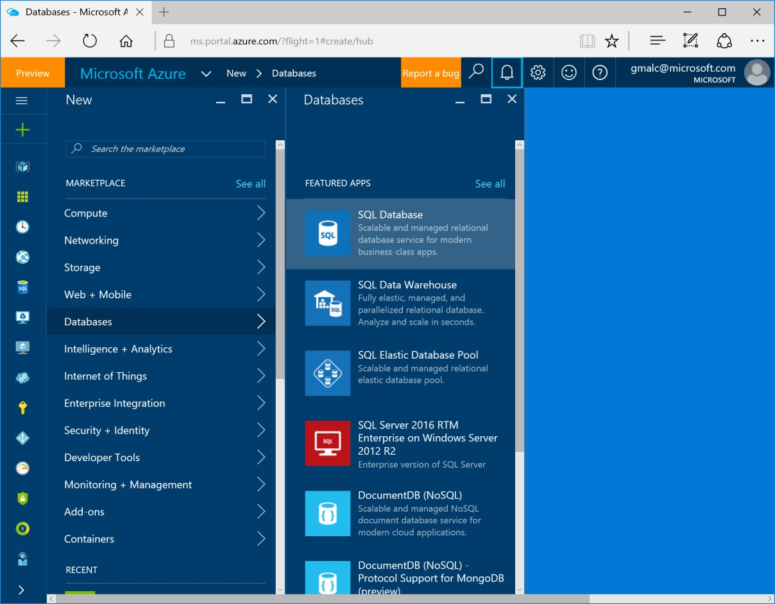

1. In the **SQL Database** blade:
2. Enter the name **AdventureWorksLT**
3. In the **Subscription** box, ensure that your subscription is listed.
4. In the **Resource group** section, ensure that **New** is selected, and enter ***sqlgroup*** as the new resource group name.
5. In the **Select Source** list, select **Sample**.
6. In the **Select sample** section, ensure that **AdventureWorksLT[V12]** is selected.
7. Click **Server**. Then click **Create a new server** and enter the following details and click **OK**.
   * A unique **Server name** for your server (a pink exclamation mark will be displayed if the name you have entered is invalid or already in use, otherwise a green tick is shown)
   * A user name you want to assign to the **Server admin login**. This can be your name or some other name you’ll remember easily – however, you cannot use “Administrator”.
   * A **Password** for your server administrator account. This must meet the password complexity rules for Azure SQL database, so for example it cannot be blank or “password”.
   * The **Location** where your server should be hosted. Choose the location nearest to you.

**Note**: At the time of writing, the latest version of Azure SQL Database is V12. If this version is available in your regions, select it.

* + Leave the option to allow Azure services to access the server selected (this opens an internal firewall port in the Azure datacenter to allow other Azure services to use the database).

1. In the **Pricing Tier** section, select **Basic**.
2. Ensure that your selections are similar to those below, and click **Create**.

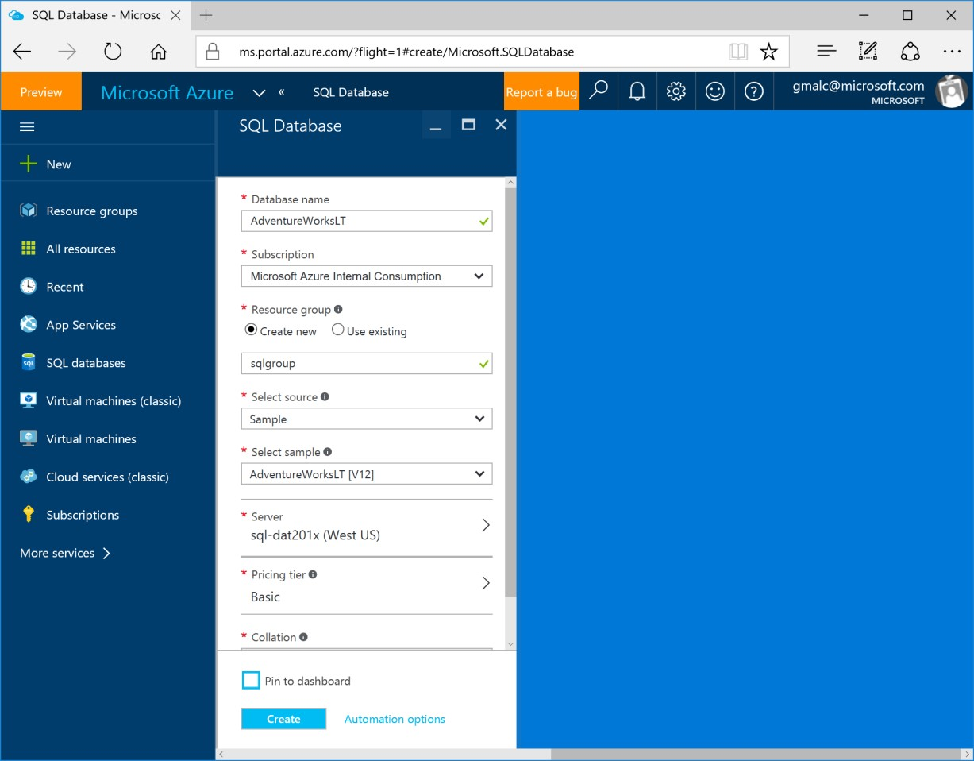

4. After a short time, your SQL Database will be created, and a notification is displayed on the dashboard. To view the blade for the database, click **All Resources**, and then click the **AdventureWorksLT** database.

# Configure Firewall Rules for your Azure SQL Database Server

1. In the **AdventureWorksLT** blade, under **Essentials**, click the server name for your database server (which should be in the format ***server_name*.database.windows.net**).
2. In the blade for your SQL server, under **Essentials**, click **Show firewall settings**.
3. In the Firewall settings blade, click the **Add client IP** icon to create a firewall rule for your client computer, and then click **Save**.

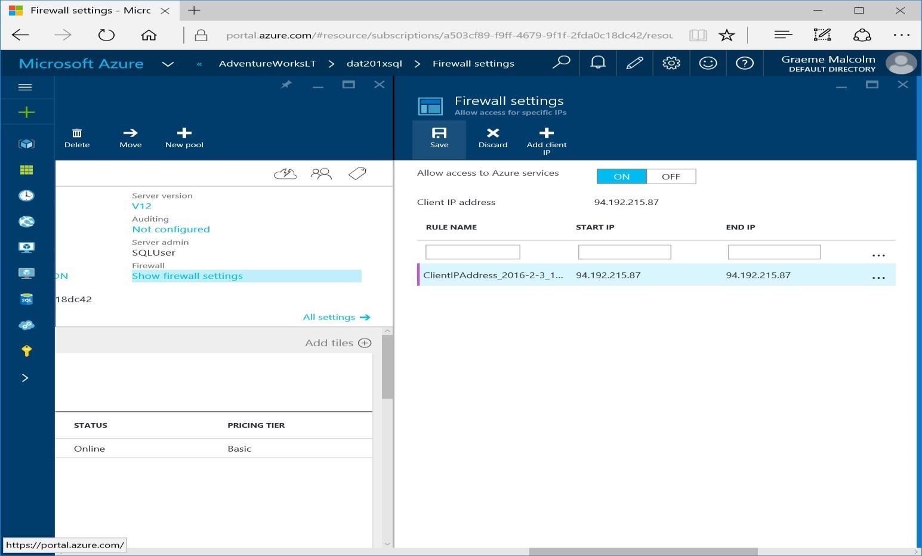

**Note**: Azure SQL Database uses firewall rules to control access to your database. If your computer’s public-facing IP address changes (or you want to use a different computer), you’ll need to repeat this step to allow access. Alternatively, you can modify the firewall settings for your Azure SQL Database server to allow a range of IP addresses – see the [Azure SQL Database documentation f](https://azure.microsoft.com/en-us/documentation/articles/sql-database-configure-firewall-settings/)or details of how to do this.

# Installing and Connecting from a Client Tool

You can use either of the following tools to develop your Transact-SQL queries.

**Note**: These tools are designed for Microsoft Windows. If you are using a non-Windows computer, you can install a third-party SQL Server client application for your platform. See the notes at the end of this document for more details.

## Microsoft SQL Server Management Studio

SQL Server Management Studio is the primary management tool for Microsoft SQL Server, and you can also use it to manage and query Azure SQL Database. If you do not already have SQL Server Management Studio installed, you can download it from <https://aka.ms/edx-DAT215.1-ssms>[.](https://aka.ms/edx-dat201x-ssms)

When the download is complete, run the executable file to extract the installation files to a folder on your computer and start the setup wizard, then use the SQL Server installation center to perform a new standalone installation of SQL server and install only the management tools.

After installing SQL Server Management Studio, you can start it and connect to your Azure SQL Database server by selecting the option to use SQL Server authentication, specifying the fully-qualified name of your Azure SQL Database server (**<*your_server_name*>.database.windows.net**), and entering your user name in the format **<*your_user_name*>@<*your_server_name*>** and password, as shown here:

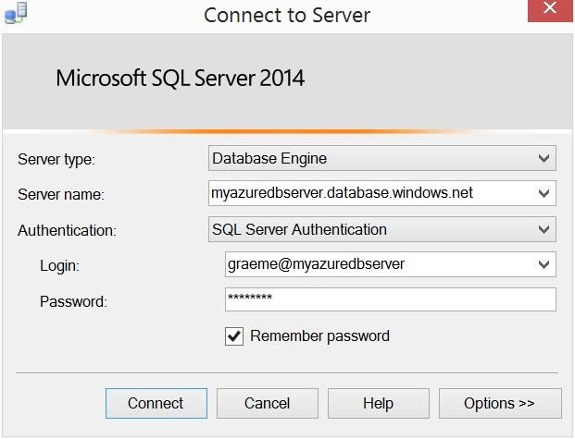

After connecting, you can create a new query and run it by clicking **Execute**, and you can save and open Transact-SQL scripts. Be sure to select the **AdventureWorksLT** database when running your queries as shown here:

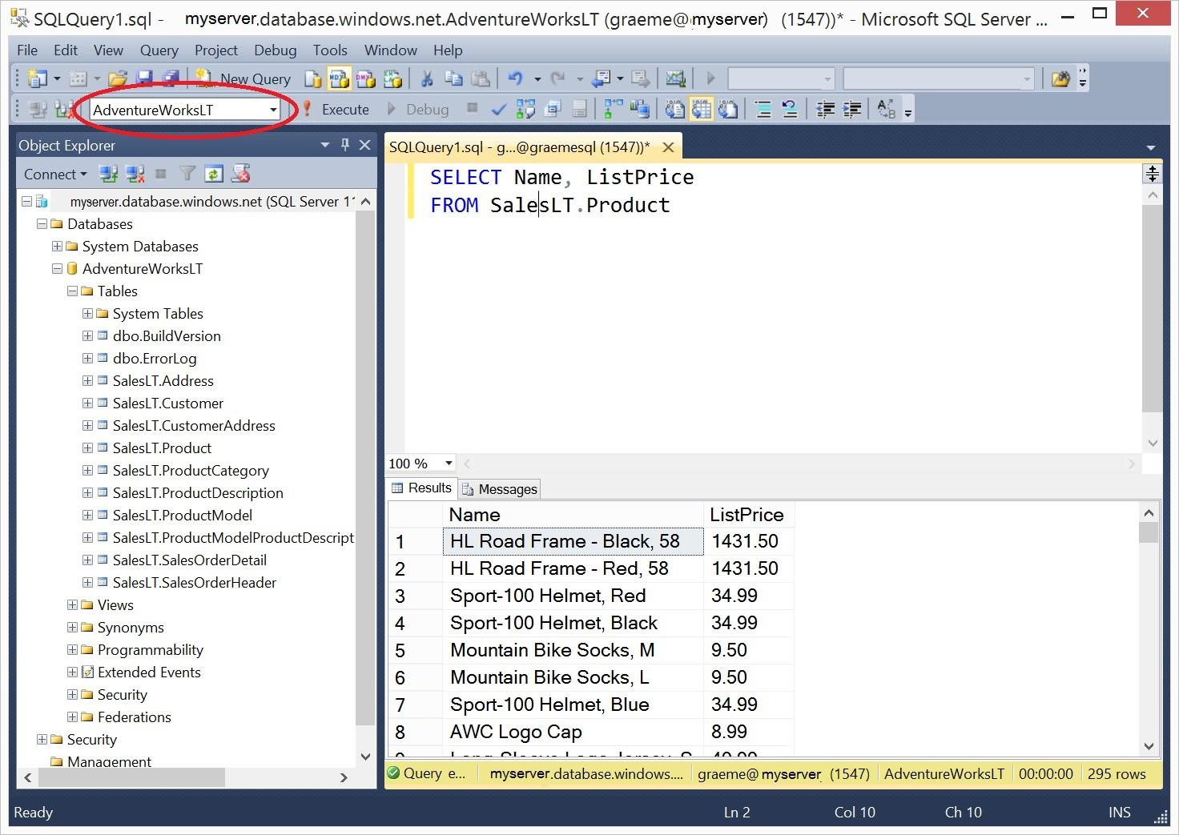

## Microsoft Visual Studio

If you are primarily a developer, you may prefer to use Visual Studio to create your Transact-SQL queries. Visual Studio is a comprehensive software development environment for all kinds of software projects, including database development. You can download the free Community edition of Visual Studio from <http://aka.ms/edx-DAT215.1-vs> and install it on your Windows computer.

When you install Visual Studio, be sure to select the option to include the **SQL Server Data Tools** optional component. Then, in the Server Explorer pane, you can create a data connection to your Azure SQL database server using the **Microsoft SQL Server (SqlClient)** data source as shown here.

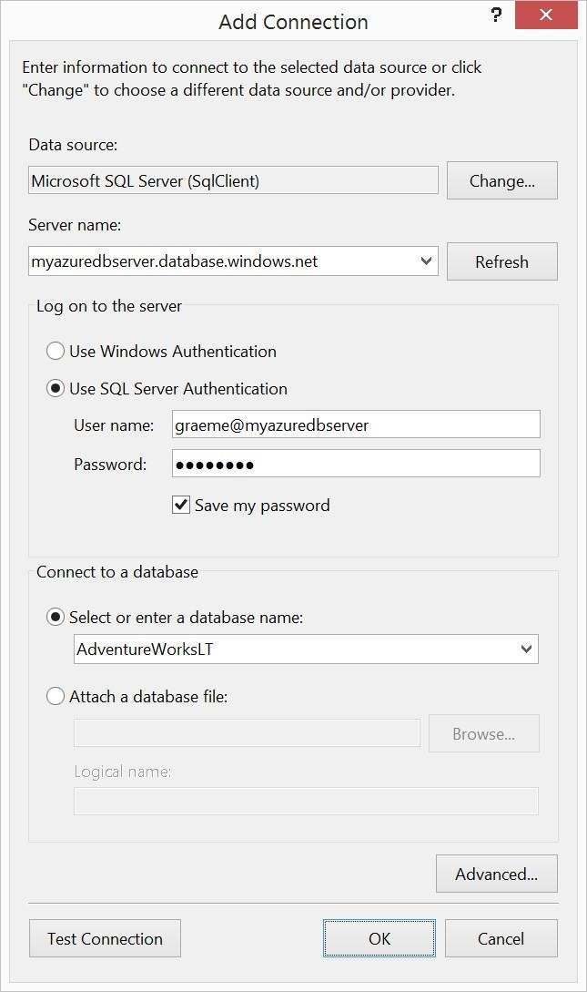

After you have created a data connection, you can view database objects in the Server Explorer window.

You can also create and save Transact-SQL scripts and run queries, as shown here.

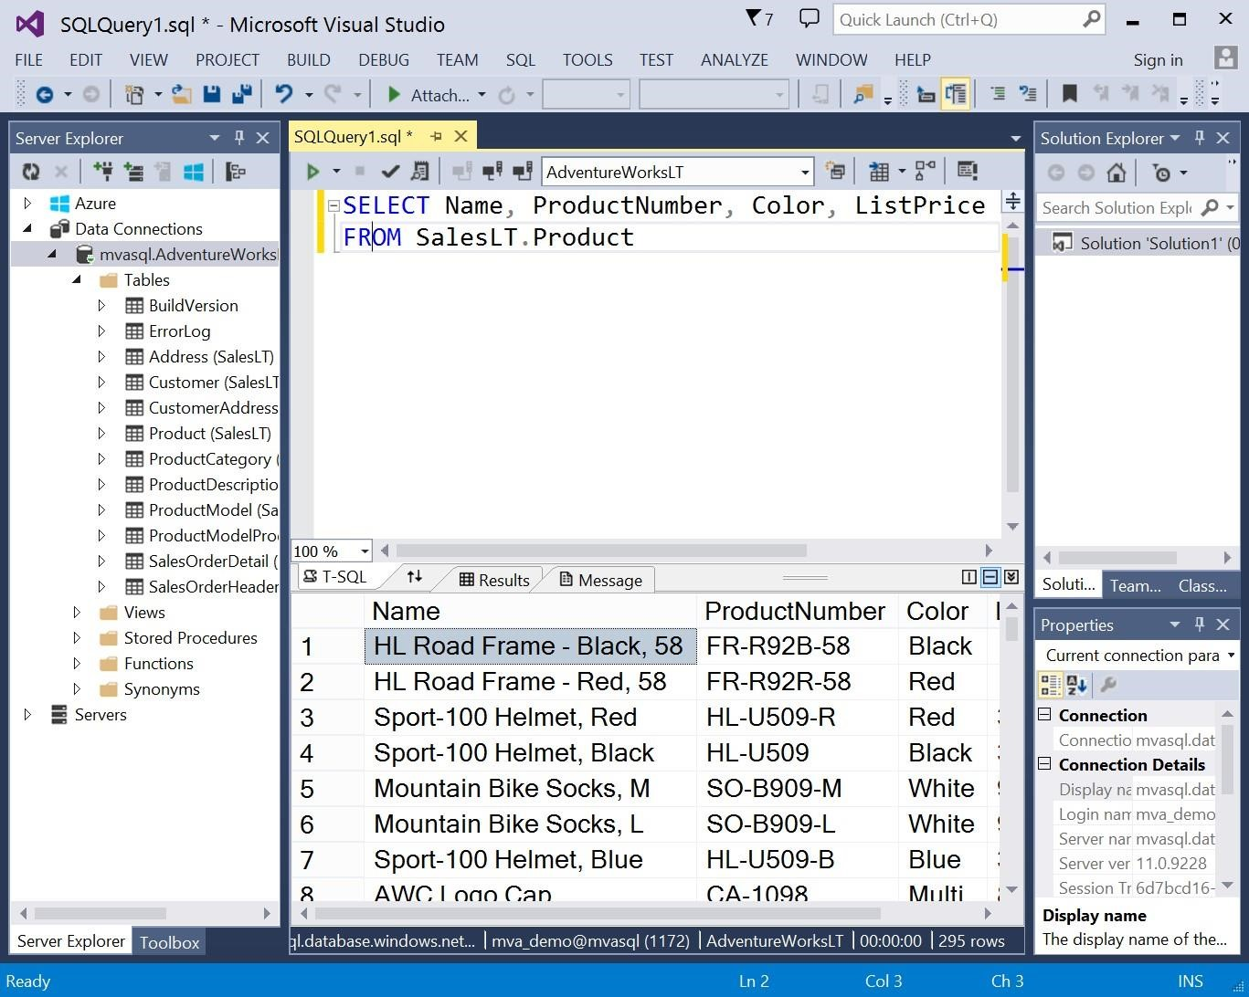

# Alternative Client Tools for Non-Windows Computers

If you are using a non-Windows computer, you will be unable to install SQL Server Management Studio or Visual Studio. However, you can use the following options to perform the labs. Microsoft provides no endorsement or support for non-Microsoft client tools, and you install and use them at your own discretion.

If you are using a Mac OS X computer, you can:

* Use virtualization software such as Parallels to install a virtualized instance of Windows on your Mac, then install SQL Server Management Studio or Visual Studio and connect to Azure SQL Database.
* Install a third-party SQL Server client GUI tool such as Talend Open Studio for Data Integration

[(https://www.talend.com/download/talend-open-studio](https://www.talend.com/download/talend-open-studio) - be sure to download the **Data**

**Integration** tool) or NaviCat for SQL Server

[(http://www.navicat.com/download/navicat-for-sqlserver),](http://www.navicat.com/download/navicat-for-sqlserver) or the command line cross-platform sqlcli tool* ([https://www.npmjs.com/package/sql-cli)](https://www.npmjs.com/package/sql-cli) and connect to Azure SQL Database.

If you are using Linux, you can install a third-party SQL Server client GUI tool such as Talend Open Studio for Data Integration (<https://www.talend.com/download/talend-open-studio>- be sure to download the **Data Integration** tool) or the command line cross-platform sql-cli tool*

[(https://www.npmjs.com/package/sql-cli)](https://www.npmjs.com/package/sql-cli) and connect to Azure SQL Database.

*Note that the cross-platform sql-cli tool is a command-line interface, and does not support many of the features in graphical tools such as SQL Server Management Studio. In particular, you may need to enter Transact-SQL statements on a single line. To view help for the sql-cli tool, enter the command **mssql -h**.

## Troubleshooting Connection Errors

After you have installed a client tool, you can connect to Azure SQL Database across the Internet. To establish a connection, you must use the following connection information:

* **Server**: <*server_name*>.database.windows.net
* **Authentication Mode**: SQL Server authentication (sometimes called *Native* authentication)
* **Login**: <*user_name*>@<*server_name*> (you can omit @<*server_name*> in some Windows based clients)
* **Port**: 1433 (this is the default in most SQL Server client tools) Most connection errors are caused by:
* Incorrect server name or login credentials – check for typing mistakes and capitalization.
* Firewall restrictions – ensure that you have created a firewall rule for your Azure SQL Database server that permits access from your local computer. If this doesn’t work, try creating a firewall rule for a range of IP addresses – as a last resort, try 0.0.0.0 to 255.255.255.255 (which allows access from any Internet-connected computer – this is not recommended for a real production server, but should be OK if your server only contains the sample database for the labs in this course).

If configuring the firewall in Azure still doesn’t resolve the issue, there may be a firewall on your local network or computer that’s preventing the connection. If you’re using a school or corporate network, speak to your network administrator. If you have a firewall enabled on your local computer, refer to the documentation provided by the supplier and enable outbound connections to port 1433 from your client tool. Alternatively, you may be able to temporarily disable your firewall to establish the connection, and then re-enable it after you are connected – if you choose to do this, you do so at your own risk.

# Alternative Setup using SQL Server Express

The labs in this course are designed to work with Azure SQL Database. For the best experience, sign up for a free Azure trial subscription and follow the instructions provided above. If you are unable to create an Azure subscription, you can use the following instructions to install SQL Server Express on a Windows computer, and deploy a sample database that is similar to the one used in the labs.

**Note**: These instructions assume you are familiar with Windows and comfortable installing software.

## Install SQL Server Express

1. Browse to <https://aka.ms/edx-DAT215.1-sql> [a](http://aka.ms/edx-dat201x-sql)nd download and run the installer.
2. Choose a **Custom** installation option, and download the installation media to your local computer.
3. If the **SQL Server Installation Center** window does not appear, in the folder where you extracted the files, run **Setup.exe**. Then, in the **SQL Server Installation Center** window, on the **Installation** page, click **New SQL Server stand-alone installation or add features to an existing installation**.
4. In the SQL Server Setup window; if there are any issues, resolve them by installing any prerequisite software or making any required configuration changes. Then re-run setup.
5. On the **License Terms** page, accept the license terms and click **Next**.
6. On the **Feature Selection** page, select all features and ensure that the installation location has sufficient disk space. Then click **Next**.
7. On the **Instance Configuration** page, select **Default instance** and click **Next** (note, if you wish, you can install a named instance instead of a default instance – if you do this, when you connect to your SQL Server instance you must specify the name **(local)*instance_name***.)
8. On the **Server Configuration** page, do not change the default selections (unless you are comfortable configuring service accounts). Just click **Next**.
9. On the **Database Engine Configuration** page, select **Mixed Mode (SQL Server authentication and Windows authentication)**, enter a suitable password for the system administrator account (and make a note of it!), and click **Next**.
10. When installation is complete. Click **Close**.
11. Close the SQL Server Installation center window.
12. Pin the **SQL Server 2016 Management Studio** app to the taskbar – this will make it easier to find when you want to use it.

## Install the AdventureWorks Sample Database

1. Browse to [https://github.com/Microsoft/sql-server-samples/releases/tag/adventureworks](https://na01.safelinks.protection.outlook.com/?url=https%3A%2F%2Fgithub.com%2FMicrosoft%2Fsql-server-samples%2Freleases%2Ftag%2Fadventureworks&data=04%7C01%7CPete.Harris%40microsoft.com%7C0bc60dcd3e3d46854e4808d584415e70%7C72f988bf86f141af91ab2d7cd011db47%7C1%7C0%7C636560338672215661%7CUnknown%7CTWFpbGZsb3d8eyJWIjoiMC4wLjAwMDAiLCJQIjoiV2luMzIiLCJBTiI6Ik1haWwifQ%3D%3D%7C-2&sdata=LolsQymzcyBNd5VSOhi1DvHUviJv%2BHINw7AMPrzG6po%3D&reserved=0) [,](http://msftdbprodsamples.codeplex.com/releases/view/55330) and click the link to download **AdventureWorks2012.BAK**. Save the **AdventureWorks2012.BAK** file to the **Backup** folder for the SQL Server

Express instance you installed (by default, this is C:\Program Files\Microsoft SQL

Server\MSSQL12.MSSQLSERVER\MSSQL\Backup). Note, you may be prompted to confirm that you want to grant your user account permission to access this location.

1. Start SQL Server Management Studio, and when prompted, enter or select the following options and click **Connect**:
   * **Server type**: Database Engine
   * **Server name**: (local) (or (local)*instance_name* if you installed a named instance)
   * **Authentication**: SQL Server Authentication
   * **Login**: sa
   * **Password**: *The password you specified during installation*
2. If the Object Explorer pane is not visible, on the **View** menu, click **Object Explorer**. Then in Object Explorer, right-click **Databases** and click **Restore Database**.
3. In the **Restore Database** dialog box, under the **Source**, select **Device** and click the button to the right to select the file and click **Add**. Browse to the folder where you downloaded **AdventureWorks2012.bak**, select it, and click **OK**.
4. In **Select backup** devices, click **OK** and, in **Restore Database – AdventureWorks2012**, click **OK**.
5. When the restore has completed, click **OK**.
6. In Object Explorer, expand the databases folder and verify that the **AdventureWorks2012** database is listed.
7. On the toolbar, click **New Query**. Then in the **Available Databases** list, ensure that **AdventureWorks2012** is selected and type the following query: SELECT * FROM Production.Product;
8. On the toolbar, click **Execute**, and verify that a table of product data is returned.
9. Close SQL Server Management Studio without saving any files.

**NOTE: In any labs or demonstrations, you will have to update the schema names, for example, if you search through Object Explorer, you will see that there is no SalesLT.Product table, but there is a Production.Product table and you must reference this instead.**