Packages going to install in this stage
1.Visual studio code editor
1.CUDA 10
2.QT Creator
3.Opencv3.4.1

Visual studio code editor
Ubuntu software center →Visual studio center

Step1 : Remove other unused apt packages
sudo apt autoremove

Step2 :Upgrade all installed apt packages to the latest versions
sudo apt-get update
sudo apt-get upgrade

Step3 :Install dependencies based on nvidia Installing OpenCV Guide
sudo apt-get install build-essential make cmake cmake-curses-gui \g++ libavformat-dev libavutil-dev \libswscale-dev libv4l-dev libeigen3-dev \libglew-dev libgtk2.0-dev

Step4 :Install dependencies for gstreamer stuffs
sudo apt-get install libdc1394-22-dev libxine2-dev \libgstreamer1.0-dev \libgstreamer-plugins-base1.0-dev

Step5 :Sudo Install additional dependencies
sudo apt-get install libjpeg8-dev libjpeg-turbo8-dev libtiff5-dev \libjasper-dev libpng12-dev libavcodec-dev
sudo apt-get install libxvidcore-dev libx264-dev libgtk-3-dev \libatlas-base-dev gfortran

Step6 : remove existing python-numpy apt package as well for using newer version of numpy
sudo apt-get purge python-numpy

Step7: Install dependencies for python3
sudo apt-get install python3-dev python3-pip python3-tk
sudo pip3 install numpy
sudo pip3 install matplotlib

Step8 :install dependencies for python2
sudo apt-get install python-dev python-pip python-tk
sudo pip2 install numpy

Step8 :Install Qt5 dependencies
sudo apt-get install qt5-default

Step9 :Install Prerequisites for CUDA
sudo apt-get install -y build-essential cmake gfortran git pkg-config
sudo apt-get install -y python-dev software-properties-common wget vim
sudo apt-get autoremove

Step10 :Download CUDA
You can download Nvidia cuda toolkit from here:-https://developer.nvidia.com/cuda-toolkit

Step10.1 :diretct link to download latest(CUDA10.0 while documentation time):-
https://developer.nvidia.com/cuda-downloads?target_os=Linux&target_arch=x86_64&target_distro=Ubuntu&target_version=1604&target_type=deblocal

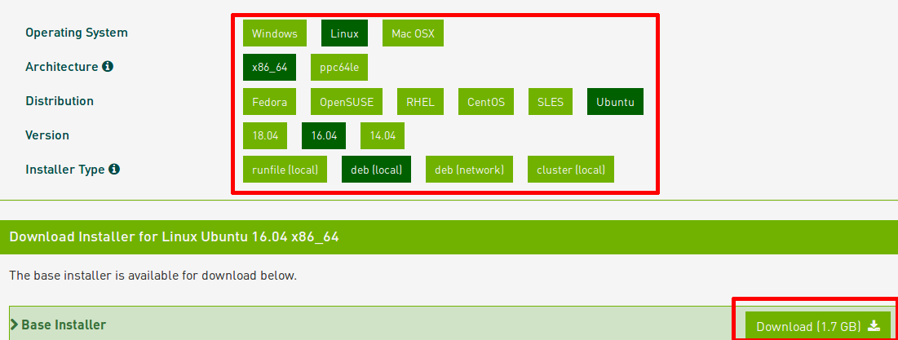
or

find it in this folder

Step10.2 :Install repository meta-data
cd Downloads #Navigate into the folder where u have downloaded the CUDA tool kit
sudo dpkg -i cuda-repo-ubuntu1604-10-0-local-10.0.130-410.48_1.0-1_amd64.deb

Step10.3 :Install the CUDA public GPG key
Generic :`sudo apt-key add /var/cuda-repo-<version>/7fa2af80.pub`

For CUDA 10.0 : sudo apt-key add /var/cuda-repo-10-0-local-10.0.130-410.48/7fa2af80.pub

Step10.4 :Update the Apt repository cache
sudo apt-get update
Step10.5 :Install CUDA
sudo apt-get install cuda
Step10.6 :Reboot
sudo reboot

Step10.7 :Add in basrc
sudo gedit /etc/bash.bashrc
Goto the end of file and add following lines
export PATH=$PATH:/usr/local/cuda-10.0/bin
export LD_LIBRARY_PATH=$LD_LIBRARY_PATH:/usr/local/cuda-10.0/lib64
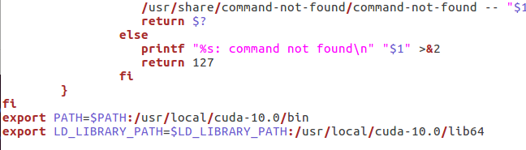
Step10.8 :Check cuda versions
nvcc -V

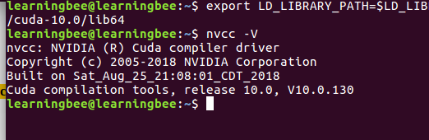

Step11 : ownload opencv-3.4.0 source code
or
find it in this folder

wget https://github.com/opencv/opencv/archive/3.4.1.zip
wget https://github.com/opencv/opencv_contrib/archive/3.4.1.zip

Step12: Extract the files

Step13: Move opencv_contrib folder into Opencv -3.4.1 folder

Step 14:Build opencv from source

cd opencv-3.4.1/
mkdir build
cd build

With cuda support
Change the directory of opencv (blue coloured) as in your system
copy paste the entire block

cmake -D CMAKE_BUILD_TYPE=RELEASE \ -D CMAKE_INSTALL_PREFIX=/usr/local \
-D WITH_CUDA=ON \ -D CUDA_NVCC_FLAGS=”-D_FORCE_INLINES –expt-relaxed-constexpr”\ -D WITH_CUBLAS=ON -D ENABLE_FAST_MATH=ON -D CUDA_FAST_MATH=ON \
-D ENABLE_NEON=ON -D WITH_LIBV4L=ON -D BUILD_TESTS=OFF \
-D BUILD_PERF_TESTS=OFF -D BUILD_EXAMPLES=ON \
-D OPENCV_EXTRA_MODULES_PATH=/home/learningbee/opencv-3.4.1/opencv_contrib-3.4.1/modules \
-D BUILD_opencv_java=OFF \
-D BUILD_opencv_python2=ON \
-D BUILD_opencv_python3=ON \
-D CUDA_TOOLKIT_ROOT_DIR=/usr/local/cuda-10.0 \
-D WITH_QT=ON -D WITH_OPENGL=ON ..

Without cuda support
Change the directory of opencv (blue coloured) as in your system
copy paste the entire block

cmake -D CMAKE_BUILD_TYPE=RELEASE -D CMAKE_INSTALL_PREFIX=/usr/local -D OPENCV_EXTRA_MODULES_PATH=/home/learningbee/opencv_contrib-3.4.1/modules -D ENABLE_NEON=ON -D ENABLE_VFPV3=ON -D BUILD_TESTS=OFF -D INSTALL_PYTHON_EXAMPLES=OFF -D BUILD_EXAMPLES=OFF -D WITH_V4L=ON -D WITH_OPENGL=ON -D WITH_TBB=ON ..
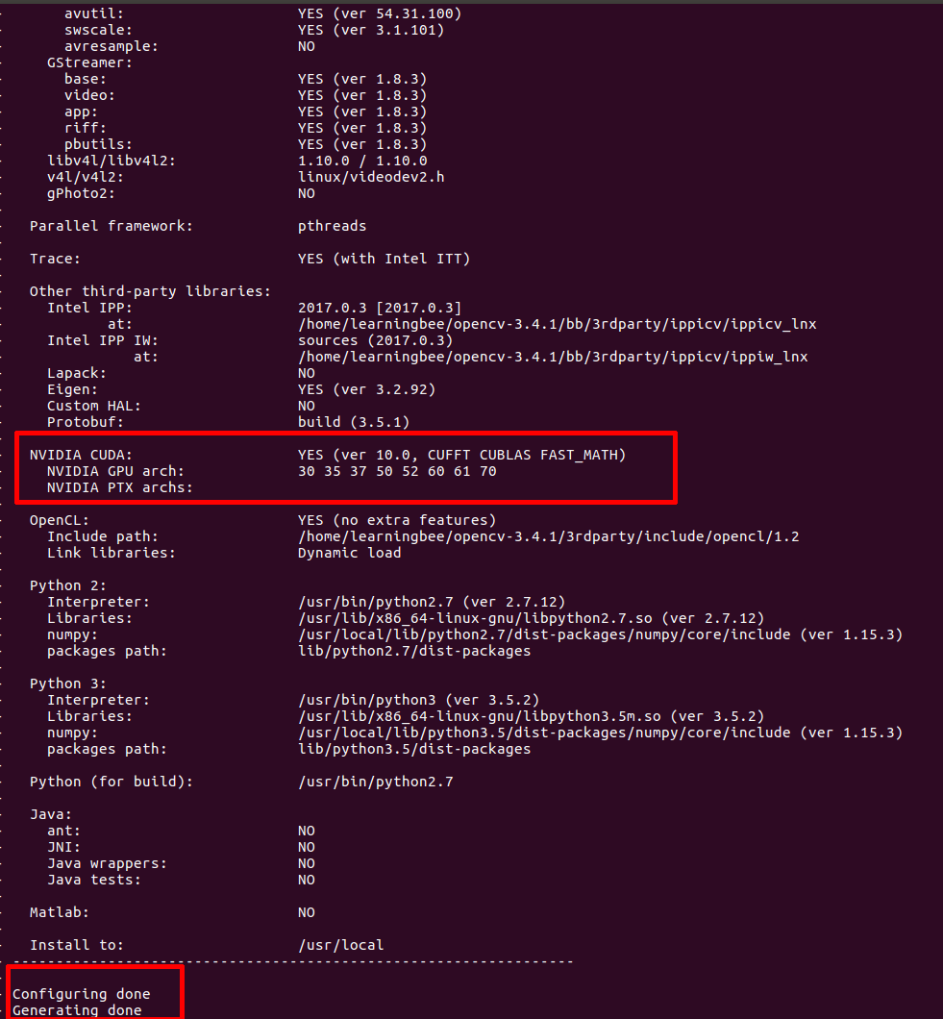

NOTE:Make sure you have got CUDA suuport

Step15 :compile and install OpenCV
make -j4
sudo make install

Step16 :add lib path “ /usr/local/lib”

Step16.1:Open Opencv.conf
sudo gedit /etc/ld.so.conf.d/opencv.conf

step16.2 :Add the the path
/usr/local/lib

Step16.3 :Save
cntl+x
sudo ldconfig
Step17 :Running sample code
cd /home/learningbee/opencv-3.4.1/samples/cpp

g++ -o facedetect facedetect.cpp `pkg-config opencv --cflags –libs`

. /facedetect

