AI-POWERED
NETWORK ANOMALY DETECTION
& INTRUSION INTELLIGENCE PLATFORM
Complete Project Blueprint
Designed for internship delivery + final-year capstone + portfolio deployment
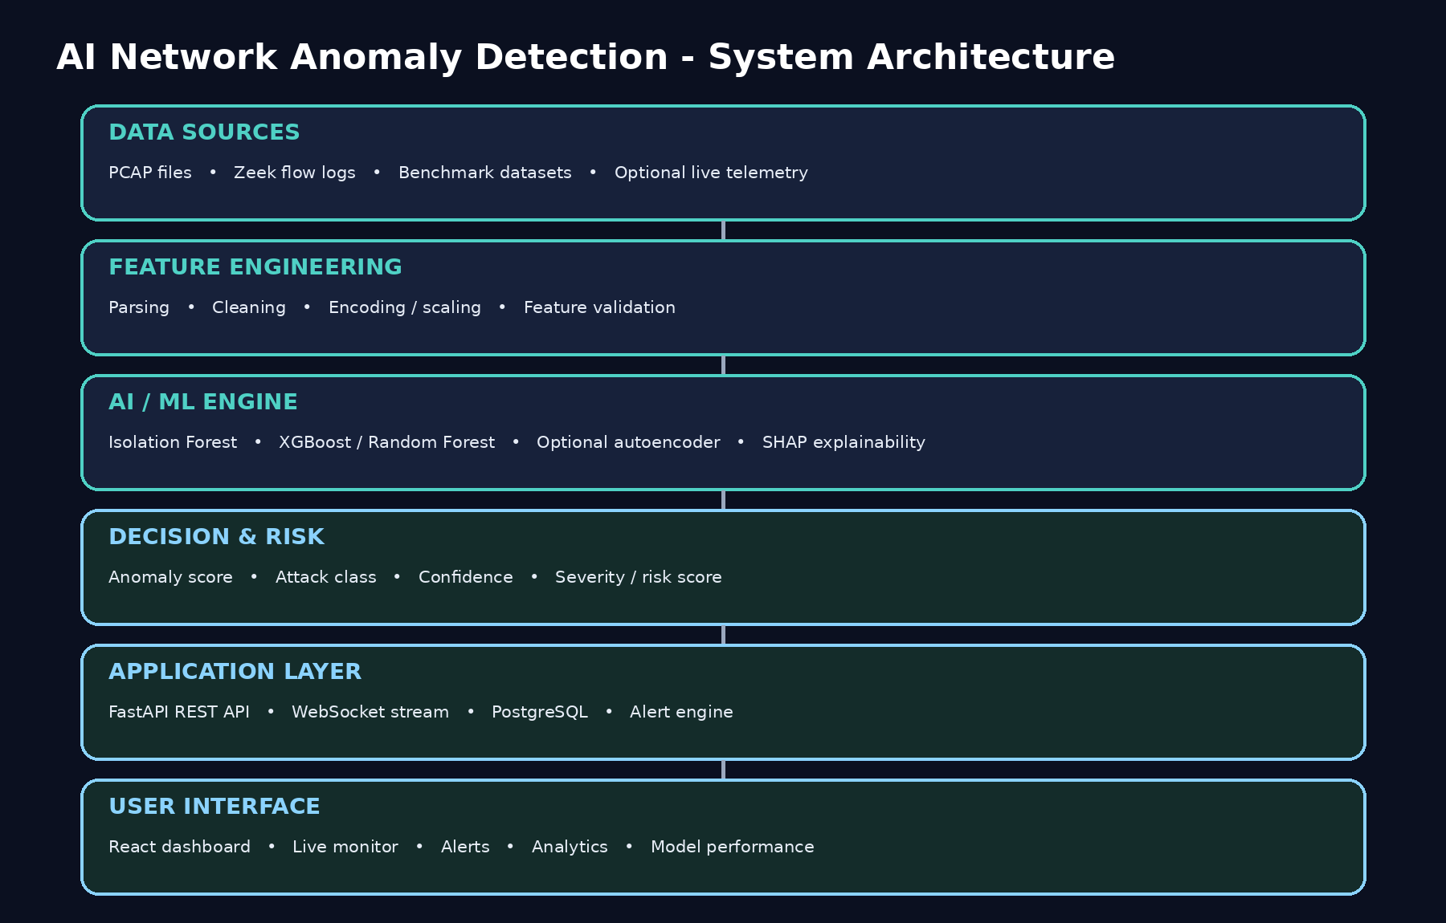
Recommended product form
Build a browser-based security operations dashboard with a Python ML backend. The primary product is a web platform; a mobile app is not recommended for the core project because live monitoring, investigation tables, charts and model analytics are naturally desktop/web workflows.

Table of Contents
1. Executive Summary
2. Project Vision and Scope
3. Threat and Anomaly Taxonomy
4. Recommended Technology Stack
5. System Architecture
6. Functional Modules
7. Machine Learning Design
8. Data and Dataset Strategy
9. Feature Engineering Plan
10. Detection and Risk-Scoring Logic
11. Web Application Design
12. Database Design
13. Backend API Specification
14. Real-Time Streaming Architecture
15. Explainable AI
16. Security and Privacy Controls
17. Development Roadmap
18. Testing and Evaluation Plan
19. Deployment and DevOps
20. Research / Capstone Component
21. Internship Deliverables
22. Project Documentation Pack
23. Risk Register and Mitigations
24. Future Enhancements
25. Resume / Presentation Positioning
26. Suggested Viva Questions
27. References and Official Resources

1. Executive Summary
Project purpose. The proposed system is a production-style web platform that detects abnormal and malicious network behavior using a hybrid machine-learning pipeline. It combines unsupervised anomaly detection, supervised attack classification, explainable AI, risk scoring, persistent alert history, and a real-time security dashboard. The goal is to turn network telemetry into actionable security intelligence rather than returning a simple binary prediction.
Core capstone question
Can a hybrid detection architecture combine broad anomaly detection with known-attack classification well enough to improve visibility into both familiar attacks and traffic patterns that do not closely match the training classes?

What the finished system should do
• Ingest benchmark datasets, PCAP-derived flow records, or Zeek-generated network telemetry.
• Clean and validate network-flow features through a repeatable preprocessing pipeline.
• Flag unusual behavior with an anomaly detector such as Isolation Forest.
• Classify known attack patterns with a supervised model such as XGBoost, with Random Forest as a baseline.
• Combine anomaly score, class confidence, and contextual rules into a severity/risk score.
• Store detections and alerts in PostgreSQL for historical investigation.
• Expose REST APIs and WebSocket streams through FastAPI.
• Display live traffic, anomalies, alert details, analytics, and model performance in a React dashboard.
• Provide explainability so an analyst can see the features that contributed most strongly to a prediction.
• Be containerized with Docker and documented well enough for internship handover and capstone evaluation.

Success criteria
Area | Success criterion
Detection | The pipeline reliably separates benign, known malicious, and anomalous/unknown behavior under the chosen evaluation protocol.
ML quality | Precision, recall, F1, confusion matrix and false-positive behavior are reported instead of accuracy alone.
Engineering | The ML pipeline is callable through an API and the dashboard works without notebooks.
Real time | The system can consume streaming flow records and update the UI without a full page refresh.
Explainability | Alerts include anomaly score, predicted class/confidence, and top contributing features.
Reproducibility | Training, evaluation and deployment steps can be repeated from a clean environment.
Documentation | Architecture, API, data dictionary, model card and user guide are included.

2. Project Vision and Scope

2.1 Problem statement
Traditional rule/signature-driven intrusion detection is useful for known patterns, but network environments also contain noisy, evolving and previously unseen behaviors. The project therefore treats security monitoring as a combination of anomaly detection, attack classification and investigation support. The platform is intended as a defensive monitoring system and research prototype, not as a replacement for a full enterprise SIEM/IDS stack.

2.2 In scope
• Network-flow based detection rather than full payload inspection as the primary ML input.
• Known attack classification for common classes represented in the selected datasets.
• Unknown/anomalous behavior detection using an unsupervised or semi-supervised detector.
• Live or near-real-time ingestion through Zeek/flow logs in the advanced phase.
• Dashboards, alert management, analytics, audit history and model performance views.
• Explainability, model/version metadata, evaluation and deployment documentation.

2.3 Out of scope
• Offensive automation, exploit generation, credential theft or attack execution.
• Guaranteed identification of every possible cyberattack.
• Payload decryption or deep packet inspection as the default production behavior.
• Mobile app as the primary interface.
• A claim that the model can detect zero-day attacks with certainty.

2.4 Personas
Persona | Needs
Student / ML developer | Train models, compare experiments, inspect metrics and reproduce results.
Security analyst | Review alerts, inspect evidence, filter by source/destination/time, and investigate suspicious flows.
Project mentor / faculty | See architecture, research rationale, experimental methodology and measurable outcomes.
Internship reviewer | See code quality, deployment readiness, documentation and engineering decisions.

3. Threat and Anomaly Taxonomy
The project should explicitly separate a network anomaly from a named attack. An anomaly is behavior that deviates from learned/expected behavior; an attack class is a label assigned when the traffic resembles a known pattern. The platform must preserve that distinction in the UI and reports.

3.1 Primary classes
Category | Meaning | Typical evidence / features | Role in project
Benign | Expected/legitimate traffic. | Normal packet/flow rates, common ports, expected durations and byte ratios. | Baseline and negative class.
DoS / DDoS | Traffic intended to exhaust a service or resource. | Very high packet/byte rates, repeated connections, concentration on a target. | Known-attack classification.
Port Scan | Systematic probing of ports/services. | Many destination ports, many short flows, low payload volume per connection. | Known-attack classification.
Brute Force | Repeated authentication attempts. | High connection/attempt frequency to authentication services, bursty patterns. | Known-attack classification.
Botnet | Traffic associated with compromised hosts coordinating or communicating with external control infrastructure. | Periodic callbacks, unusual remote endpoints, flow timing patterns. | Known-attack class where dataset supports it.
Web Attack | Malicious interaction with web services. | Abnormal HTTP request patterns and flow characteristics; payload details depend on telemetry available. | Known-attack class where dataset supports it.
Infiltration / lateral activity | Suspicious post-compromise movement or internal reconnaissance. | Unexpected east-west communication, unusual service usage, abnormal host relationships. | Advanced classification / anomaly analysis.
Unknown anomaly | Behavior that is unusual but does not confidently map to a known attack class. | High anomaly score, low class confidence, feature values far from learned benign patterns. | Key differentiator of the capstone.

3.2 Recommended final categories in the dashboard
• NORMAL
• DOS/DDOS
• PORT SCAN
• BRUTE FORCE
• BOTNET
• WEB ATTACK
• INFILTRATION / OTHER KNOWN
• UNKNOWN ANOMALY
Important modeling principle
Do not force an unknown anomaly into a known attack class just because the classifier must choose something. Preserve a distinct unknown/low-confidence outcome when anomaly evidence is strong but class confidence is weak.

4. Recommended Technology Stack
The stack below is chosen for balance: strong ML support, fast API development, a modern frontend, relational persistence, straightforward deployment, and enough industry relevance to make the project useful for both an internship and a capstone.
Layer | Recommended technology | Why this is the best fit
Frontend | React + TypeScript + Vite | Component-based UI, strong ecosystem, type safety, fast development and excellent fit for dashboards.
Styling | Tailwind CSS | Fast, consistent responsive UI without maintaining a large custom CSS layer.
Charts | Recharts | Good fit for time-series, distributions, trend and interactive dashboard charts.
Backend API | Python + FastAPI | Native fit for the ML stack, async support, clean API contracts and automatic OpenAPI documentation.
Data science | Pandas + NumPy | Industry-standard tooling for tabular network data processing and vectorized transformations.
ML baseline | scikit-learn | Excellent baseline algorithms, preprocessing and evaluation utilities.
Primary supervised model | XGBoost | Strong performance on structured/tabular data and useful feature-importance tooling.
Baseline supervised model | Random Forest | Interpretable benchmark and robust baseline for comparison.
Anomaly model | Isolation Forest | Simple, fast and well suited as an initial unsupervised anomaly detector for tabular flow features.
Deep anomaly option | PyTorch autoencoder | Useful as an advanced research experiment if Isolation Forest is not sufficient.
Explainability | SHAP | Feature-level explanations for tree-based models and comparison of global vs local importance.
Network telemetry | Zeek + PCAP workflow | Strong fit for generating structured network logs without making the dashboard depend on raw packet payloads.
Database | PostgreSQL | Reliable relational storage for flows, alerts, model versions, users and audit records.
Real time | WebSockets | Push detection events to the React dashboard with low-latency updates.
Containerization | Docker + Docker Compose | Reproducible local setup and a clear path to deployment.
Testing | pytest + FastAPI TestClient + Playwright | Covers ML utilities, backend APIs and browser workflows.
Version control | Git + GitHub | Collaboration, issue tracking, versioning and internship-ready repository hygiene.

4.1 Why not a mobile app?
The core user workflow is monitoring and investigation: dense tables, timelines, filters, model metrics, alert detail and network analytics. A responsive web dashboard supports desktop use and can still be opened on a phone. A native mobile app would increase scope without strengthening the core ML/security objective.

4.2 Optional additions after the core system works
• Redis for caching/queues if live ingestion becomes heavy.
• Celery or another task queue if large file analysis needs background processing.
• MinIO/S3-compatible object storage for large PCAP or dataset artifacts.
• Prometheus/Grafana for infrastructure metrics, not as a replacement for the project dashboard.

5. System Architecture

5.1 Architecture layers
Layer | Responsibility | Primary components
Data ingestion | Acquire benchmark or live network-flow records. | CSV/Parquet, Zeek logs, PCAP-derived flow data.
Preprocessing | Apply the exact transformations used during training. | Pandas, validation schema, encoder/scaler artifacts.
Detection | Generate anomaly score and attack probabilities. | Isolation Forest, XGBoost/Random Forest.
Decision | Translate model outputs into operational severity. | Thresholds, confidence gates, correlation rules.
Persistence | Store flows, alerts, model metadata and audit events. | PostgreSQL + SQLAlchemy/SQLModel.
API / streaming | Serve predictions and push live events. | FastAPI, WebSockets.
Presentation | Visualize the security state. | React, TypeScript, Tailwind, Recharts.

5.2 Key design principle: separate offline training from online inference
The training environment should be reproducible and isolated from the live application. Model artifacts, feature schemas, thresholds and metadata are exported after training. The running API loads the approved model version and performs inference only; it should not retrain merely because a user opens the dashboard.

6. Functional Modules

Module 1 - Dataset & Data Ingestion
Upload benchmark CSVs, parse Zeek records, validate schema, and record dataset metadata.

Module 2 - Preprocessing & Feature Pipeline
Clean missing/infinite values, encode categoricals, scale where needed, and preserve feature ordering.

Module 3 - Anomaly Detector
Isolation Forest baseline; optional autoencoder experiment.

Module 4 - Attack Classifier
XGBoost primary model; Random Forest and Logistic Regression as baselines.

Module 5 - Hybrid Decision Engine
Combine anomaly score, predicted class, confidence and rules into an operational result.

Module 6 - Risk Scoring
Map signals to severity: LOW, MEDIUM, HIGH, CRITICAL.

Module 7 - Alert Management
Create, acknowledge, investigate and resolve alerts.

Module 8 - Analytics Dashboard
Traffic trends, attack distribution, anomalies by time, top talkers, protocols, ports and severity.

Module 9 - Explainability
Show feature contributions and a human-readable explanation for selected alerts.

Module 10 - Model Registry / Metadata
Track model name, version, training data, metrics, features and thresholds.

Module 11 - Real-Time Monitor
Consume Zeek/stream events, score them and update the UI using WebSockets.

Module 12 - Authentication & Roles
Protect analyst/admin functions and maintain audit logs.

7. Machine Learning Design

7.1 Recommended model strategy
Problem | Model | Purpose
Known attack classification | Logistic Regression baseline | Simple baseline and sanity check.
Known attack classification | Random Forest baseline | Robust non-linear benchmark and feature importance.
Known attack classification | XGBoost | Primary supervised model for final classifier.
Unknown/anomalous behavior | Isolation Forest | Primary unsupervised anomaly detector.
Unknown/anomalous behavior | Autoencoder (optional) | Advanced experiment for representation-based anomaly detection.

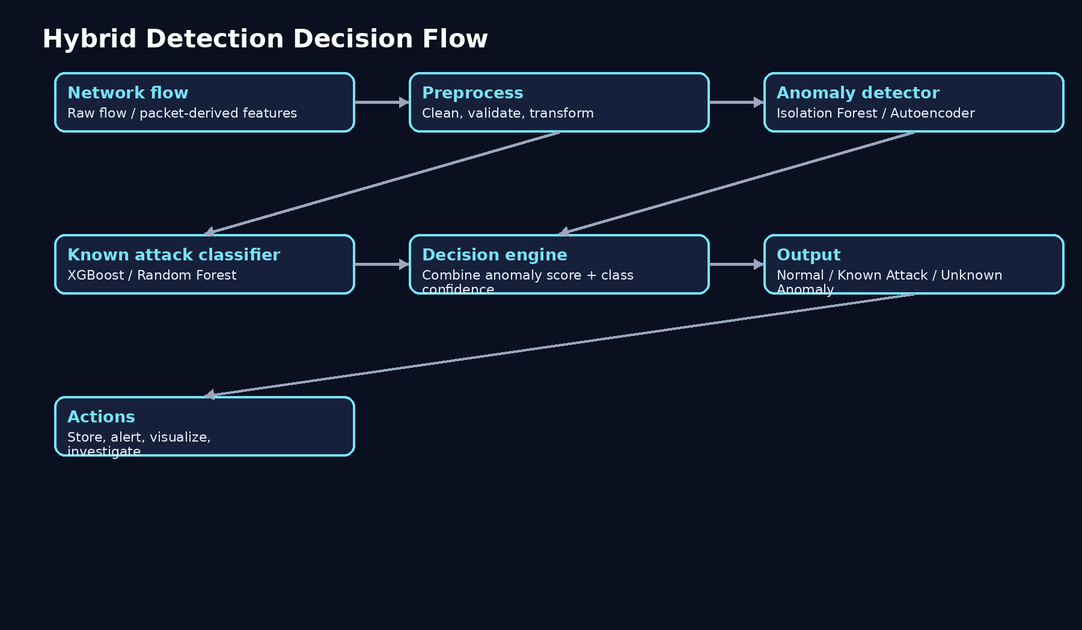

7.2 Training pipeline
1. Define label taxonomy and feature list.
2. Load dataset and create a reproducible split.
3. Remove duplicates and invalid/infinite rows.
4. Handle missing values according to a documented policy.
5. Encode categorical values and scale numeric features where the chosen model benefits from it.
6. Train baselines.
7. Tune/compare the primary supervised model.
8. Train anomaly model using benign traffic or the defined semi-supervised strategy.
9. Calibrate decision thresholds on validation data instead of using arbitrary values.
10. Evaluate on held-out data and preserve the test set for final reporting.
11. Export model, preprocessing pipeline, feature schema and threshold configuration as one versioned artifact set.

7.3 Example inference contract
input = { timestamp, src_ip, dst_ip, src_port, dst_port, protocol, flow_features... }
anomaly_score = anomaly_model.score(sample_features)
class_probs = classifier.predict_proba(sample_features)
decision = risk_engine(anomaly_score, class_probs, context)
return { status, attack_type, confidence, anomaly_score, severity, explanation }

7.4 What not to claim
• Do not claim that the system detects every zero-day attack.
• Do not treat a benchmark test score as proof of production security.
• Do not compare models using accuracy alone when classes are imbalanced.

8. Data and Dataset Strategy

8.1 Primary development dataset
Use CICIDS2017 as the initial benchmark because it provides labeled network traffic and is commonly used in intrusion-detection experimentation. The project can later be stress-tested with UNSW-NB15 or another independent dataset to examine generalization.

8.2 Dataset workflow
• Download from an authoritative/official source and record the exact source and date in the project README.
• Keep raw data immutable; create processed copies for experimentation.
• Create a data dictionary listing feature name, type, meaning and preprocessing rule.
• Check class distribution before training.
• Avoid leakage by preventing duplicate or near-duplicate flows from crossing train/test boundaries when the dataset structure requires special handling.
• Record all preprocessing and feature-selection decisions.

8.3 Data folders
data/raw/ # original datasets, never modified in-place
data/processed/ # cleaned/encoded data
data/samples/ # small safe demo datasets
data/metadata/ # data dictionary + provenance

8.4 Data governance
Operational rule
Use only authorized datasets and lab traffic. Do not place real credentials, personally identifiable information, confidential logs, or customer network data in the repository.

9. Feature Engineering Plan
The model should rely primarily on flow-level features that can be reproduced consistently in both benchmark and live settings. The exact feature list must be frozen before final evaluation so the reported results are reproducible.
Feature family | Examples | Why it matters
Volume | Total bytes, packets, forward/backward bytes | Captures traffic intensity and asymmetry.
Rate | Packets/sec, bytes/sec, flow rate | Useful for floods, scans and bursts.
Duration | Flow duration | Separates short probes from longer sessions.
Packet statistics | Mean/std/min/max packet length | Captures shape of traffic rather than only totals.
Directionality | Forward/backward packet ratio | Helps distinguish request-heavy vs response-heavy behavior.
Ports / protocol | Destination port, source port, protocol | Useful for service targeting and scans.
Connection behavior | Unique destinations, unique ports, failed/successful pattern where available | Supports reconnaissance and unusual host behavior.
Temporal context | Recent anomaly counts, burstiness, rolling rates | Improves operational scoring without changing the core classifier.

9.1 Feature engineering rules
• Keep the transformation pipeline identical during training and inference.
• Never use a feature in production that cannot be reproduced from live telemetry.
• Document why high-cardinality identifiers such as raw IP addresses are included or excluded.
• Avoid learning dataset-specific artifacts such as row order or source-file identifiers.
• Use feature versioning so model v2 is not accidentally run with a v1 schema.

10. Detection and Risk-Scoring Logic

10.1 Hybrid decision logic
The decision engine is the bridge between ML metrics and operational behavior. It should not simply forward one model output. A practical decision can combine anomaly evidence, class confidence, severity priors and recent context.
Signal | Example use | Effect
Anomaly score | Distance from learned normal behavior. | Raises risk when traffic is strongly abnormal.
Class probability | Model confidence for a known attack class. | Supports attack-type labeling.
Rule/context signal | Known sensitive port, repeated source behavior, burst within a short window. | Adds operational context.
Historical correlation | Same source repeatedly triggers anomalies. | Raises severity when behavior persists.
Asset context (optional) | Target is a critical server vs ordinary lab host. | Allows severity to reflect business impact.

10.2 Example severity mapping
Severity | Illustrative condition | UI treatment
LOW | Weak anomaly, low confidence, little repetition. | Informational event.
MEDIUM | Moderate anomaly or a repeated suspicious pattern. | Analyst review recommended.
HIGH | Strong anomaly or high-confidence known attack. | Priority investigation.
CRITICAL | Very strong malicious signal with high confidence and/or repeated target impact. | Immediate escalation in the lab workflow.

Thresholds must be tuned experimentally
The numeric thresholds should be chosen from validation results and documented. Avoid hard-coding arbitrary values such as "0.90 = critical" without measuring false-positive and false-negative behavior.

11. Web Application Design

11.1 Pages
Page | Main purpose | Key UI elements
Dashboard | High-level security state. | KPI cards, anomaly trend, attack distribution, recent alerts, risk summary.
Live Monitor | Near-real-time observation. | Flow stream, pause/resume, filters, live counters, connection status.
Alerts | Investigation queue. | Severity, attack type, source/destination, timestamps, acknowledge/resolve.
Threat Detail | Explain a single detection. | Anomaly score, confidence, top features, timeline, related events.
Upload & Analyze | Run benchmark/demo analysis. | File upload, progress, result summary, export.
Analytics | Explore historical behavior. | Time filters, protocol charts, top talkers, port activity, anomaly density.
Models | Show ML quality and versions. | Metrics, confusion matrix, training date, feature schema, model status.
Settings / Admin | Manage configuration. | Users, thresholds, model activation, audit logs.

11.2 Dashboard wireframe
[HEADER] System status | time | user
[KPI CARDS] Total flows | Normal | Anomalies | High/Critical alerts
[CHART 1] Traffic & anomaly trend over time
[CHART 2] Attack distribution
[TABLE] Recent alerts
[MAP/NETWORK GRAPH - optional] Source to destination relationships

11.3 Frontend component structure
src/
components/ # cards, charts, tables, filters, badges
pages/ # Dashboard, LiveMonitor, Alerts, ThreatDetail, Analytics, Models
api/ # typed API clients
hooks/ # websocket + data fetching hooks
types/ # shared TypeScript types
utils/ # formatting, validation, constants

12. Database Design

12.1 Core tables
Table | Key fields | Purpose
users | id, email, password_hash, role, created_at | Authentication and role control.
network_flows | id, timestamp, src/dst, ports, protocol, selected features | Persist processed flow records.
detections | id, flow_id, model_version, anomaly_score, predicted_class, confidence, severity | Store ML outputs.
alerts | id, detection_id, status, assigned_to, created_at, resolved_at | Operational investigation lifecycle.
model_versions | id, name, version, metrics, feature_schema, artifact_path, active | Track models and reproducibility.
audit_logs | id, user_id, action, entity, timestamp, metadata | Security and change traceability.

12.2 Relationships
users 1 ---- N audit_logs
network_flows 1 ---- N detections
detections 1 ---- 0..1 alerts
model_versions 1 ---- N detections

12.3 Data retention
For a student deployment, define a simple retention policy. Keep full flow records only as long as needed for the demo; keep aggregated statistics and alert records longer. The policy should be configurable so the same application can later adapt to larger data volumes.

13. Backend API Specification
Method | Endpoint | Purpose | Auth
POST | /api/v1/predict | Score one flow or feature vector. | Analyst
POST | /api/v1/analyze-file | Process uploaded CSV/flow file. | Analyst
GET | /api/v1/dashboard/summary | Return headline metrics. | Analyst
GET | /api/v1/alerts | List/filter alerts. | Analyst
GET | /api/v1/alerts/{id} | Get alert detail and explanation. | Analyst
POST | /api/v1/alerts/{id}/acknowledge | Acknowledge alert. | Analyst
POST | /api/v1/alerts/{id}/resolve | Resolve alert. | Analyst/Admin
GET | /api/v1/analytics/timeseries | Return aggregated trends. | Analyst
GET | /api/v1/models | List model versions and metrics. | Analyst
POST | /api/v1/models/{id}/activate | Activate approved model version. | Admin
GET | /api/v1/health | Health/readiness endpoint. | Public or internal
WS | /api/v1/ws/live | Push new detections to connected clients. | Analyst

13.1 Example prediction response
{
"status": "ANOMALY",
"attack_type": "PORT_SCAN",
"confidence": 0.96,
"anomaly_score": 0.93,
"severity": "HIGH",
"model_version": "xgb-1.0",
"top_features": ["unique_destination_ports", "flow_rate", "flow_duration"],
"explanation": "Traffic shows short repeated connections across many destination ports."
}

13.2 Backend project layout
backend/app/
main.py
api/routes_predict.py
api/routes_alerts.py
api/routes_analytics.py
services/preprocessing.py
services/inference.py
services/risk_engine.py
services/explanations.py
db/models.py
db/session.py
schemas/
core/config.py

14. Real-Time Streaming Architecture
Real-time capability is an advanced phase, not the starting point. Begin with offline CSV analysis and API inference. After the model and web application are stable, add Zeek/flow ingestion and WebSockets.
Network / lab telemetry
↓
Zeek
↓
structured flow logs
↓
feature adapter
↓
inference service
↓
risk + alert engine
↓
PostgreSQL + WebSocket
↓
React live monitor

14.1 Streaming requirements
• Handle malformed/incomplete flow records without crashing the stream.
• Expose ingestion/processing health status.
• Use bounded queues or backpressure so bursts do not exhaust memory.
• Deduplicate events when the upstream source can resend records.
• Keep the live UI eventually consistent with the persisted alert history.
• Allow the operator to pause the browser stream without stopping backend detection.

14.2 Lab-only real-time demonstration
For demonstration, you can run Zeek on authorized lab traffic or a controlled PCAP replay environment. The system should show the same flow through collection, inference, alert generation and UI update. Keep the experiment clearly labeled as a controlled defensive lab workflow.

15. Explainable AI
Explainability is valuable because security alerts need evidence. For tree-based classifiers such as XGBoost, SHAP can provide global feature importance and local per-alert contributions. The UI should translate those contributions into plain language rather than exposing raw mathematical terms only.

15.1 Alert explanation example
Why this flow was flagged
The flow produced an unusually high destination-port diversity, a short duration across many connections, and a packet-rate pattern unlike the learned benign baseline. The classifier also assigned high probability to PORT SCAN.

15.2 Recommended explanation views
• Top features for the selected alert.
• Global importance across the test set.
• Comparison of benign vs anomalous feature distributions.
• Confidence and anomaly score side-by-side.
• A short natural-language explanation generated from deterministic feature rules, not free-form hallucination.

15.3 Explainability caveat
Feature importance is an explanation of model behavior, not proof of causality. The report should explicitly say that SHAP identifies how features contribute to the model output, not that a single feature “caused” the attack.

16. Security and Privacy Controls

16.1 Application security
• Hash passwords with a strong password hashing algorithm; never store plain-text credentials.
• Use role-based authorization for administrative actions.
• Validate uploaded files and enforce file-size and row limits.
• Do not execute uploaded content. Treat CSV/PCAP uploads as untrusted data.
• Use parameterized queries/ORM protections.
• Apply CORS and secure headers appropriately for the deployment.
• Log authentication failures and privileged actions.
• Keep secrets in environment variables or a secret manager, never in Git.

16.2 ML security
• Version preprocessing and model artifacts together.
• Validate feature schema before inference.
• Monitor feature drift when moving from benchmark data to live data.
• Document the training dataset and known limitations.
• Treat model output as a detection signal, not automatic authorization or blocking.

16.3 Privacy
Real network data can contain sensitive addresses, hostnames and operational details. Keep live-traffic demonstrations inside an authorized lab. Sanitize or anonymize data before adding it to a public GitHub repository.

17. Development Roadmap
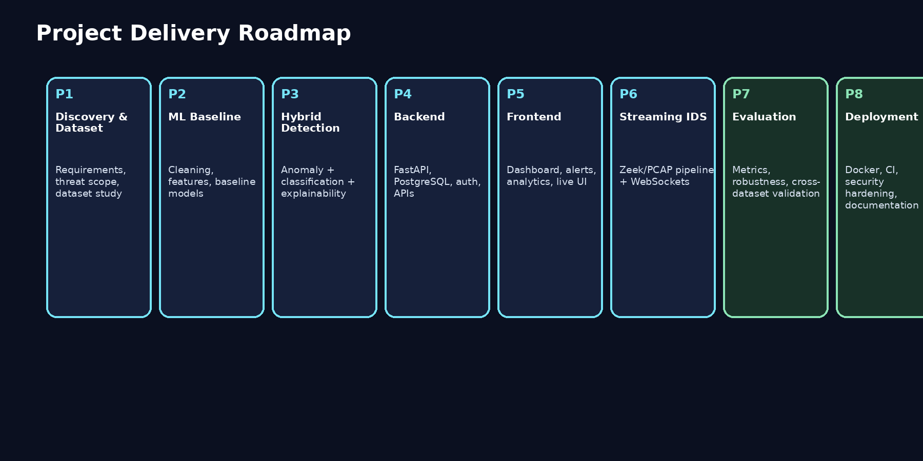

17.1 Detailed phase plan
Phase | Deliverable
Phase 1: Discovery | Finalize problem statement, threat taxonomy, dataset and evaluation plan.
Phase 2: Data pipeline | Build loading, cleaning, feature selection, data dictionary and reproducible preprocessing.
Phase 3: ML baseline | Train Logistic Regression, Random Forest and Isolation Forest; establish baseline metrics.
Phase 4: Primary models | Train XGBoost, tune thresholds, add hybrid decision logic and compare against baselines.
Phase 5: Explainability | Add SHAP/global importance/local alert explanations.
Phase 6: Backend | Implement FastAPI, database models, prediction API, alert API and model metadata.
Phase 7: Frontend | Build dashboard, upload flow, alerts, analytics and model pages.
Phase 8: Integration | Connect frontend/backend/database and add authentication.
Phase 9: Real time | Add Zeek + streaming adapter + WebSockets.
Phase 10: Hardening | Testing, Docker, deployment, documentation, demo scripts and final report.

17.2 Practical sequence for your first implementation
• Install Python, Node.js, Git and Docker.
• Create repository and clean project structure.
• Download and inspect the primary dataset.
• Build preprocessing pipeline and data dictionary.
• Train baseline ML models in notebooks/scripts.
• Convert the best pipeline into a reusable Python module.
• Expose inference through FastAPI.
• Build React dashboard against mocked/API data.
• Connect real inference to the dashboard.
• Add PostgreSQL persistence.
• Add live Zeek/WebSocket mode.
• Finish evaluation, documentation and deployment.

18. Testing and Evaluation Plan

18.1 ML evaluation
Metric | Why report it
Accuracy | Simple headline metric, but only meaningful alongside class distribution.
Precision | Measures how many flagged predictions are correct; important for analyst workload.
Recall | Measures how many actual attacks are detected; important for missed threats.
F1 score | Balances precision and recall.
Confusion matrix | Shows which attack classes are being confused.
PR-AUC / ROC-AUC | Useful when comparing probabilistic classifiers; PR-AUC is often more informative with imbalance.
False-positive rate | Important for operational usability.
Detection latency | Important in streaming mode.
Throughput | Flows/events processed per second in the deployed configuration.

18.2 Experiments worth reporting
• Baseline vs tuned supervised models.
• Anomaly detector threshold sensitivity.
• Hybrid system vs classifier-only behavior on unknown/anomalous samples.
• Feature ablation: remove selected feature groups and measure impact.
• Cross-dataset validation to test generalization.
• Latency/throughput measurement of the inference API.
• False-positive analysis: manually inspect top false alerts.

18.3 Software testing
Layer | Tests
Preprocessing | Schema validation, missing values, infinite values, feature ordering.
ML inference | Valid sample, malformed sample, expected output schema, model version check.
API | Status codes, auth, validation, filters, pagination, WebSocket handshake.
Database | Constraints, relationships, alert lifecycle, audit events.
Frontend | Dashboard loading, filters, alert details, error state, live update.
End-to-end | Upload file -> inference -> database -> alert -> UI.

19. Deployment and DevOps

19.1 Local deployment
docker compose up --build
services: frontend | backend | postgres

19.2 Production-style deployment target
Use a managed frontend host for the React application and a container-capable host for FastAPI and PostgreSQL. The exact provider is less important than having a reproducible Docker setup, environment configuration, HTTPS, database backups, health checks and a clear deployment README.

19.3 CI/CD
• Run lint and unit tests on pull requests.
• Build the backend and frontend on push.
• Build a Docker image for release.
• Run a smoke test against a temporary environment or local container stack.
• Tag releases with model/application versions.

19.4 Environment variables
DATABASE_URL=...
JWT_SECRET=...
MODEL_PATH=...
WS_ALLOWED_ORIGINS=...
APP_ENV=development|production

20. Research / Capstone Component

20.1 Recommended research question
Can a hybrid network-security detection architecture combining unsupervised anomaly detection with supervised attack classification reduce the limitations of classifier-only monitoring, particularly for traffic that is unusual but poorly represented by known labels?

20.2 Hypotheses
• H1: A hybrid system will identify some high-anomaly / low-class-confidence events that a classifier-only system would force into a known class.
• H2: XGBoost will outperform simpler supervised baselines on the selected tabular network-flow dataset, subject to the chosen preprocessing and split strategy.
• H3: Explainability will improve analyst interpretability by exposing the features most responsible for a detection.

20.3 Experimental design
Experiment | Independent variable | Outcome
E1 | Supervised model choice | Precision, recall, F1, latency.
E2 | Anomaly threshold | Unknown detection rate vs false positives.
E3 | Hybrid vs classifier-only | Detection coverage and confusion behavior.
E4 | Feature groups | Performance change after ablation.
E5 | Dataset shift | Performance when evaluated on a second dataset / traffic source.
E6 | Explanation quality | Example-based analyst interpretation and consistency checks.

20.4 Capstone novelty angle
The novelty does not need to be a brand-new ML algorithm. For a student capstone, a well-designed hybrid pipeline, reproducible evaluation, explainability, live telemetry integration and a measurable comparison between detection strategies can constitute a meaningful engineering/research contribution when the limitations are clearly stated.

21. Internship Deliverables
Deliverable | What it proves
Working web platform | Product engineering and integration.
ML experiment report | Data science methodology and model evaluation.
API documentation | Backend quality and interface design.
Dockerized deployment | DevOps / reproducibility.
Model card | Responsible ML documentation and limitations.
Architecture diagram | Systems thinking.
Demo dataset + demo script | Ability to present the system consistently.
Issue tracker / commit history | Professional software development process.
Final internship report | Communication and handover skills.

21.1 Professional GitHub repository structure
ai-network-anomaly-platform/
backend/
frontend/
ml/
data/README.md
docs/
tests/
docker-compose.yml
README.md
LICENSE

21.2 README must include
• Project overview and architecture image.
• Technology stack and why each technology was chosen.
• Setup instructions.
• Dataset provenance and license/usage notes.
• Training/evaluation commands.
• How to start the full application.
• API endpoint list.
• Screenshots.
• Known limitations.
• Future work.

22. Project Documentation Pack
Treat documentation as a deliverable, not an afterthought. The following set gives you a strong internship handover and final-year capstone submission pack.
Document | Contents
SRS / Requirements | Problem, users, functional/non-functional requirements, assumptions and constraints.
Architecture document | System context, components, data flows, deployment topology.
Data dictionary | Feature name, type, meaning, source, preprocessing rule.
ML experiment log | Dataset version, split, features, model, parameters, metrics, notes.
Model card | Intended use, training data, metrics, limitations, known failure modes.
API spec | Endpoints, request/response schemas, errors and authentication.
DB schema | Tables, keys, relationships, retention policy.
Test report | Unit, API, frontend, integration, performance and ML evaluation results.
User guide | How an analyst uses the dashboard.
Deployment guide | Environment setup, Docker, secrets, health checks and rollback.
Final report | Introduction, literature review, methodology, implementation, experiments, results, limitations, conclusion.

23. Risk Register and Mitigations
Risk | Impact | Mitigation
Dataset imbalance | High | Use class-aware metrics, stratified methods where appropriate, class weighting/resampling experiments.
Data leakage | Very high | Review split strategy, duplicate handling and feature provenance.
Too many false positives | High | Tune thresholds, analyze false alerts and add contextual correlation.
Live telemetry mismatch | High | Design a canonical feature schema and validate that every live feature can be reproduced.
Project becomes too large | High | Deliver in phases; complete offline ML + web app before real-time streaming.
Hardware limitations | Medium | Use efficient tabular models first; sample data during iteration; keep training artifacts versioned.
Model overfitting | High | Use held-out testing, regularization, cross-validation where appropriate, and second-dataset validation.
UI becomes cosmetic | Medium | Drive every chart from real backend metrics and document the underlying data query.
Deployment secrets leak | Critical | Use environment variables, secret storage and repository scans.
Unsupported security claims | High | Clearly label the product as a research/prototype defensive monitoring platform and document limitations.

24. Future Enhancements
• Streaming feature aggregation over rolling windows.
• Graph-based modeling of host-to-host communication.
• Sequence models for temporal behavior.
• Online/continual learning with drift monitoring.
• Model ensemble and calibrated probability outputs.
• STIX/TAXII threat-intelligence integration in a later phase.
• Automatic ticket/case creation for alerts.
• RBAC with organization/project scoping.
• Object storage for large PCAP archives.
• Kubernetes deployment only if scale genuinely requires it.
• A mobile companion app only as an optional second product, not the core capstone.
Priority rule
Do not add new technologies just to make the stack look larger. Every new component should solve a demonstrated problem, improve measurable capability, or support a research question.

25. Resume / Presentation Positioning

25.1 Suggested project title on resume
AI-Powered Network Anomaly Detection & Intrusion Intelligence Platform

25.2 Suggested resume bullets
• Designed and implemented a hybrid network-security detection platform combining unsupervised anomaly detection and supervised attack classification on network-flow telemetry.
• Built a FastAPI + React + PostgreSQL web application with real-time WebSocket monitoring, alert management, analytics and model performance dashboards.
• Implemented explainable ML workflows using feature-level attribution to surface evidence behind suspicious network-flow predictions.
• Containerized the application with Docker and established reproducible training/evaluation workflows, API tests and deployment documentation.

25.3 Presentation structure
1. Problem and motivation
2. Threat taxonomy and data
3. Architecture
4. ML methodology
5. Hybrid decision logic
6. Dashboard demonstration
7. Evaluation and results
8. Explainability
9. Real-time demo
10. Limitations and future work

26. Suggested Viva Questions

Why is this anomaly detection and not just classification?
Because the system includes an unsupervised detector that can flag unusual behavior even when a known attack label is not confidently available.

Why use flow features instead of raw packets?
Flow features are compact, scalable and easier to reproduce in live telemetry. Raw payload processing adds complexity and privacy concerns.

Why XGBoost?
It is strong on structured/tabular data and provides useful feature-importance tooling; it is also practical for an internship-scale implementation.

Why Isolation Forest?
It is a practical baseline for unsupervised anomaly detection and is efficient on tabular features.

Why not deep learning from day one?
The project prioritizes a measurable baseline and reproducible engineering first. Deep models can be evaluated as an extension rather than a requirement.

What is the difference between precision and recall?
Precision measures correctness among flagged positives; recall measures how many actual positives are found.

How do you detect unknown anomalies?
Use anomaly evidence plus a low-confidence classification gate rather than forcing every event into a known class.

How do you avoid data leakage?
Use careful splits, duplicate analysis, feature provenance and a held-out test set that is not used for tuning.

What makes this project capstone-level?
The combination of research experiments, hybrid detection, explainability, real-time telemetry, full-stack integration and reproducible evaluation.

What are the limitations?
Dataset shift, false positives, dependence on available telemetry, benchmark realism and the inability to guarantee detection of every novel attack.

27. References and Official Resources
Resource | URL | Use in project
CICIDS2017 / Canadian Institute for Cybersecurity | https://www.unb.ca/cic/datasets/ids-2017.html | Primary benchmark reference for labeled intrusion-traffic experiments.
UNSW-NB15 | https://research.unsw.edu.au/projects/unsw-nb15-dataset | Independent dataset for generalization experiments.
Zeek documentation | https://docs.zeek.org/ | Network security monitoring and structured telemetry.
FastAPI documentation | https://fastapi.tiangolo.com/ | Python API framework.
React documentation | https://react.dev/ | Frontend framework.
Vite documentation | https://vite.dev/ | Frontend development/build tooling.
PostgreSQL documentation | https://www.postgresql.org/docs/ | Relational database.
scikit-learn documentation | https://scikit-learn.org/ | Preprocessing, evaluation and ML baselines.
XGBoost documentation | https://xgboost.readthedocs.io/ | Gradient-boosted tree model.
SHAP documentation | https://shap.readthedocs.io/ | Model explainability.
Docker documentation | https://docs.docker.com/ | Containerization and reproducible deployment.

Final implementation checklist
• □ Problem statement approved
• □ Threat taxonomy frozen
• □ Dataset provenance recorded
• □ Data dictionary complete
• □ Baseline models trained
• □ Primary models selected
• □ Hybrid decision logic implemented
• □ Explainability added
• □ FastAPI implemented
• □ PostgreSQL integrated
• □ React dashboard complete
• □ Authentication and audit controls added
• □ WebSocket live mode working
• □ Docker Compose works from a clean clone
• □ Evaluation report complete
• □ Second-dataset validation attempted
• □ User guide complete
• □ Final presentation/demo script complete

