1. Intro

Python is a general-purpose programming language that has become extremely popular for data science. Its popularity is on the rise mainly because of Python’s ease of use and simple syntax, due to which people without any extensive programming background can easily adapt it to their needs. Python also provides great functionality when dealing with mathematics, statistics and scientific functions, all of which are heavily used in machine learning and data science.

1. Lab Objectives

* Explore Python language fundamentals, including basic syntax, variables, and types
* Create and manipulate regular Python lists
* Use functions and import packages
* Build Numpy arrays, and perform interesting calculations
* Create and customize plots on real data
* Supercharge your scripts with control flow, and get to know the Pandas DataFrame

1. Getting Started with Jupyter Notebook

Jupyter Notebook is an amazing tool for developing and presenting data science projects. A notebook integrates code and its output into a single document that combines visualizations with narrative text, along with mathematical equations and other rich media. It provides an intuitive workflow that allows iterative and supports rapid development.

Notebooks are increasingly getting popular choice at the heart of contemporary data science, analysis, and increasingly science at large.

The name, Jupyter, comes from the core supported programming languages that it supports: Julia, Python, and R.

Jupyter Notebooks are a spin-off project from the IPython project, which used to have an IPython Notebook project itself.

* 1. Running Jupyter

Start a new Terminal session from the lab VM.

<pic>

Start the notebook application by entering the following command:

$ jupyter notebook

When you first start the notebook server, your browser will open to the notebook dashboard. The dashboard serves as a home page for the notebook. Its main purpose is to display the notebooks and files in the current directory.

Here is a screenshot of the dashboard page for the OML4Py directory in the Jupyter repository:

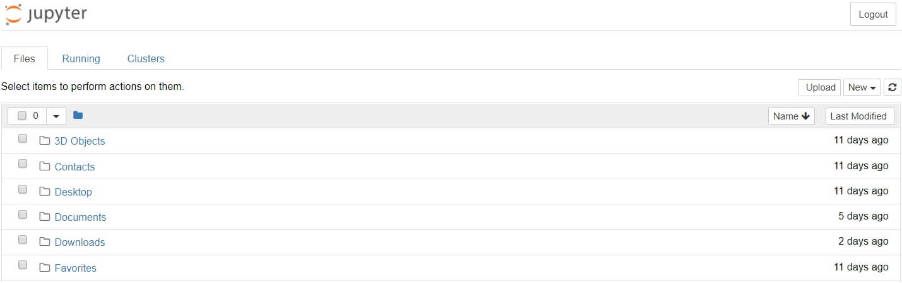

Note: Jupyter’s Notebooks and dashboard are web apps, and Jupyter starts up a local Python server to serve these apps to your web browser, making it essentially platform independent and opening the door to easier sharing on the web.

* The top of the notebook list displays clickable breadcrumbs of the current directory. By clicking on these breadcrumbs or on sub-directories in the notebook list, you can navigate your file system.
* To create a New notebook, go to the New -> Python 3 menu item.

Enter some code in the first cell:

print("hello world")

and press Shift-Enter to actually run the cell yielding

hello world

1. Python Basics