Question 3
Part A
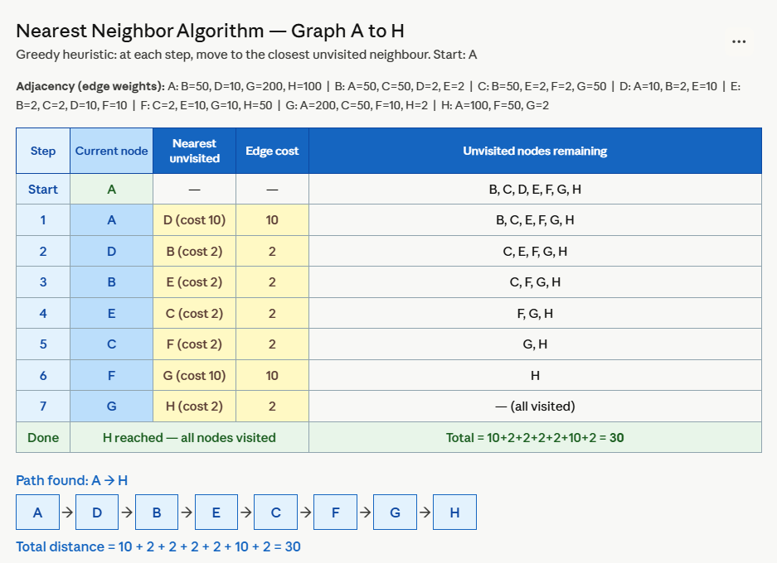

Part B
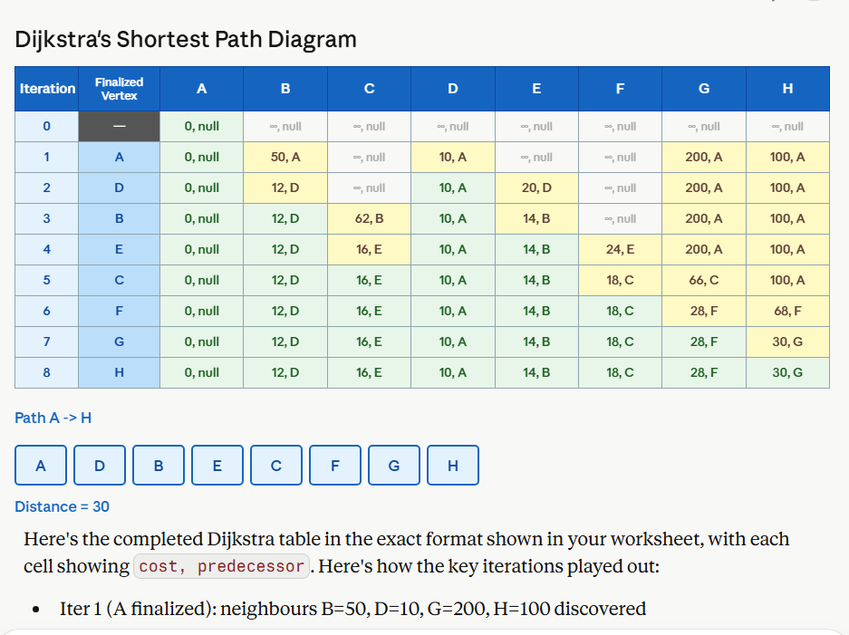

Question 4
Expected answers:
a) Visit order: A → B → C → D → E → F → G → H → I → J → K → L
b) BFS path: A → D → H → K → L
c) 4 edges (this is the shortest path)
