What is HTML?

* HTML stands for Hyper Text Markup Language
* HTML is the standard markup language for creating Web pages
* HTML describes the structure of a Web page
* HTML consists of a series of elements
* HTML elements tell the browser how to display the content
* HTML elements label pieces of content such as "this is a heading", "this is a paragraph", "this is a link", etc.

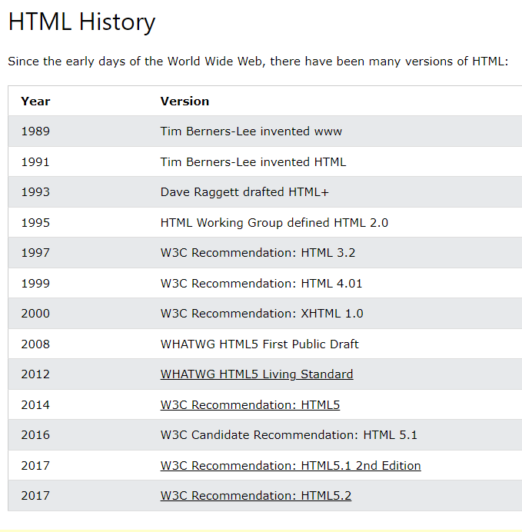

# Difference between HTML and HTML5

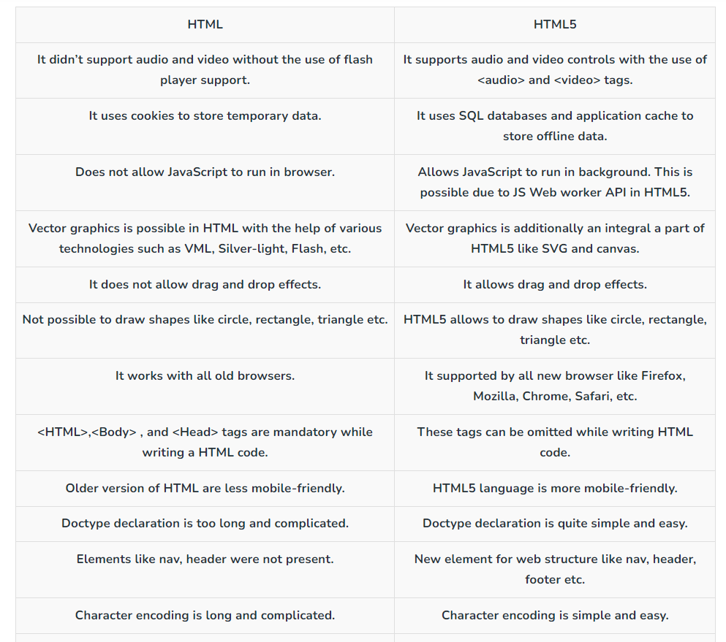

<!DOCTYPE html>  
<html>  
<head>  
<title>Page Title</title>  
</head>  
<body>  
  
<h1>My First Heading</h1>  
<p>My first paragraph.</p>  
  
</body>  
</html>

### Example Explained

* The <!DOCTYPE html> declaration defines that this document is an HTML5 document
* The <html> element is the root element of an HTML page
* The <head> element contains meta information about the HTML page
* The <title> element specifies a title for the HTML page (which is shown in the browser's title bar or in the page's tab)
* The <body> element defines the document's body, and is a container for all the visible contents, such as headings, paragraphs, images, hyperlinks, tables, lists, etc.
* The <h1> element defines a large heading
* The <p> element defines a paragraph

# HTML Basic Examples

## HTML Documents

All HTML documents must start with a document type declaration: <!DOCTYPE html>.

The HTML document itself begins with <html> and ends with </html>.

The visible part of the HTML document is between <body> and </body>.

## HTML Headings

HTML headings are defined with the <h1> to <h6> tags.

<h1> defines the most important heading. <h6> defines the least important heading:

## HTML Paragraphs

HTML paragraphs are defined with the <p> tag:

### Example

<p>This is a paragraph.</p>  
<p>This is another paragraph.</p>

## HTML Links

HTML links are defined with the <a> tag:

### Example

<a href="https://www.nhptheme.com">nhpTheme</a>

The link's destination is specified in the href attribute.

Attributes are used to provide additional information about HTML elements.

You will learn more about attributes in a later chapter.

## HTML Images

HTML images are defined with the <img> tag.

The source file (src), alternative text (alt), width, and height are provided as attributes:

### Example

<img src="example.jpg" alt="example.com" width="104" height="142">

## Empty HTML Elements

HTML elements with no content are called empty elements.

The <br> tag defines a line break, and is an empty element without a closing tag:

### Example

<p>This is a <br> paragraph with a line break.</p>

# HTML Attributes

* All HTML elements can have **attributes**
* Attributes provide **additional information** about elements
* Attributes are always specified in **the start tag**
* Attributes usually come in name/value pairs like: **name="value"**

## The href Attribute

The <a> tag defines a hyperlink. The href attribute specifies the URL of the page the link goes to:

The lang Attribute

You should always include the lang attribute inside the <html> tag, to declare the language of the Web page. This is meant to assist search engines and browsers.

The following example specifies English as the language:

<!DOCTYPE html>  
<html lang="en">  
<body>  
...  
</body>  
</html>

## The title Attribute

The title attribute defines some extra information about an element.

The value of the title attribute will be displayed as a tooltip when you mouse over the element:

### Example

<p title="I'm a tooltip">This is a paragraph.</p>

## We Suggest: Always Use Lowercase Attributes

The HTML standard does not require lowercase attribute names.

The title attribute (and all other attributes) can be written with uppercase or lowercase like **title** or **TITLE**.

However, W3C **recommends** lowercase attributes in HTML, and **demands** lowercase attributes for stricter document types like XHTML.

## We Suggest: Always Quote Attribute Values

The HTML standard does not require quotes around attribute values.

However, W3C **recommends** quotes in HTML, and **demands** quotes for stricter document types like XHTML.

### Good:

<a href="https://www.nhptheme.com/motu/">Visit Motu Theme</a>

### Bad:

<a href= https://www.nhptheme.com/motu/> Visit Motu Theme</a>

Sometimes you have to use quotes. This example will not display the title attribute correctly, because it contains a space:

### Example

<p title=About Repto Theme>

## Solution - The HTML <pre> Element

The HTML <pre> element defines preformatted text.

The text inside a <pre> element is displayed in a fixed-width font (usually Courier), and it preserves both spaces and line breaks:

<pre>  
  My Bonnie lies over the ocean.  
  
  My Bonnie lies over the sea.  
  
  My Bonnie lies over the ocean.  
  
  Oh, bring back my Bonnie to me.  
</pre>