Task 2: Dynamic Data Visualization
This section builds upon the cleaned dataset, utilizing ggplot2 to craft dynamic visualizations that communicate high-level trends and statistical anomalies to non-technical stakeholders.

2.1 Price Distribution (Histogram)
A density-overlaid histogram confirms the concentration of market transactions within the middle-tier housing bracket.
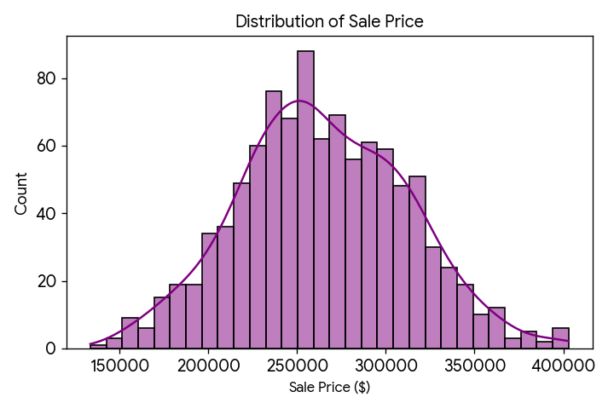
ggplot(data, aes(x = SalePrice)) +
geom_histogram(aes(y = ..density..), bins = 30, fill = "purple", alpha = 0.6) +
geom_density(color = "black", size = 1) + theme_minimal()

2.2 Feature Relationships (Scatter Plot)
Plotting Living Area against Sale Price, while using a Viridis color scale to represent Overall Quality, adds multidimensional insight. A clear positive correlation is visible.
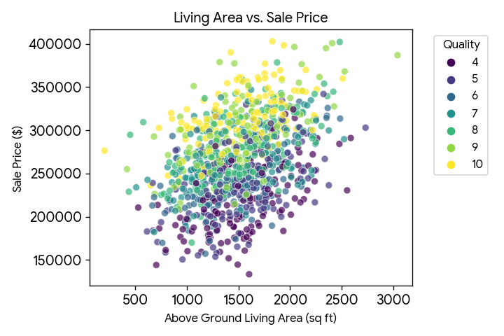

2.3 Categorical Insights (Bar Graph)
Neighborhoods were aggregated by average sale price. Using `coord_flip()` enhances readability, quickly showcasing geographic price premiums.
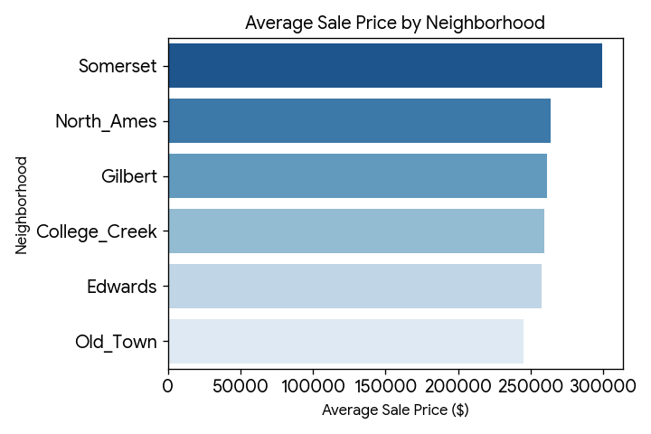
ggplot(nb_avg, aes(x = reorder(Neighborhood, AvgPrice), y = AvgPrice)) +
geom_bar(stat = "identity", fill = "steelblue") + coord_flip() + theme_minimal()

2.4 Temporal Trends (Line Chart)
By plotting Year Built against Average Sale Price with a LOESS smoothing line, we observe a steady upward trajectory in valuations for modern constructions.
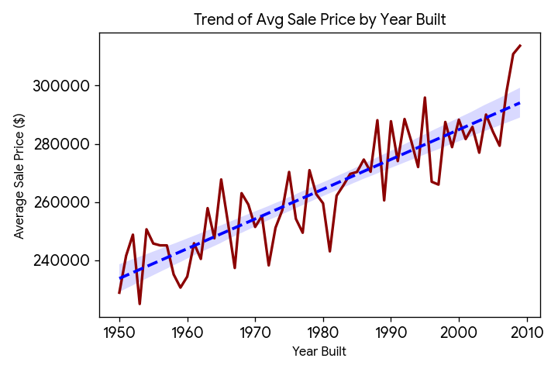
ggplot(yearly_avg, aes(x = YearBuilt, y = AvgPrice)) +
geom_line(color = "darkred", size = 1) +
geom_smooth(method = "loess", se = FALSE, color = "blue", linetype = "dashed")

